Game Design theory

Concept 1

Game Title – Panic Builder

M.C Escher “Tower of Babble” (1928)

Source- https://en.wikipedia.org/wiki/Tower_of_Babel_(M._C._Escher)

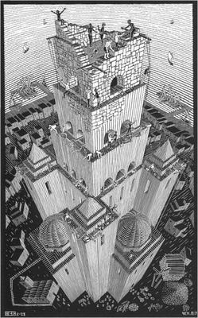

Game Overview- Create a building which gets harder the taller it is

Game Concept- Player places building pieces, which creates a maze. Player must complete the maze to get to the next floor. If the player fails to complete a level with the allotted time they restart the level.

Gameplay- Player is given building pieces at random, in the beginning they are large so there are less needed to complete a floor, the pieces get progressively smaller so more is needed. This is done by clicking and dragging the pieces onto the floor. Once the floor is done, the player enters a first person character which must get from start to finish within the time frame. When building the level the player is timed and must quickly place them otherwise the tower will fall.

Concept 2

Game Title- Potato Roll

Vincent Van Gogh “The Potato Eaters” (1885)

Source- https://en.wikipedia.org/wiki/The_Potato_Eaters

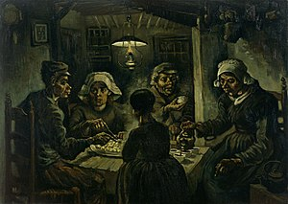

Game Overview- Play as a potato, try and get outside before being eaten.

Game Concept- You roll along the table trying to get to the end whilst avoiding obstacles.

Gameplay- 3D game, play as a potato you must roll on top of the table, avoiding the onslaught of forks and knives trying to get you. Once you reach the end of the table you fall out of a window and win. The table length increases as well as the number of obstacles as you progress through levels.

Concept 3

Game title-

Georges Seurat “A Sunday on La Grande Jatte”(1884)

Source- https://www.wikidata.org/wiki/Q1044742

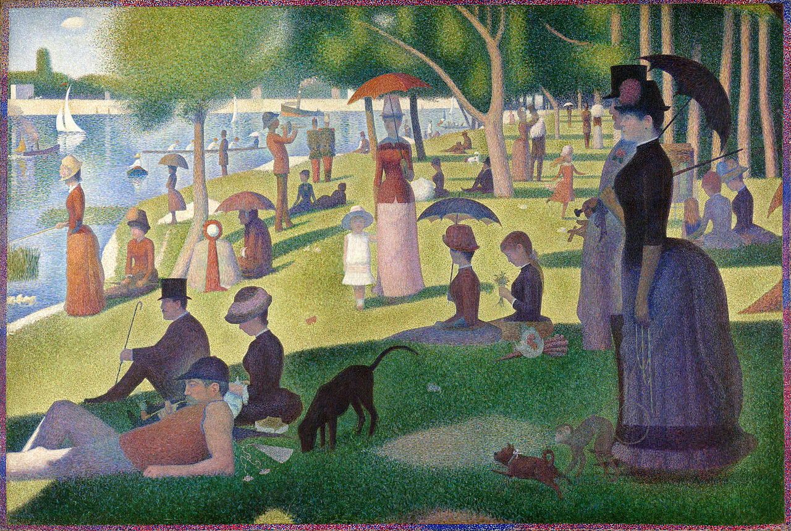

Game Overview- First person in a boat of which is in a park.

Game concept- You row a boat along the river and observe the events around you.

Gameplay- You follow the river in your boat whilst free to move the camera