**User Guide: Banking System with React & Node.js**

**1. Introduction**

This document provides a step-by-step guide on using the Asset-x banking system with a React frontend and a Node.js backend. Users will learn how to sign up, manage accounts, and perform transactions securely.

**2. Setting Up the Project**

To get started, install Node.js and create a React project:   
1. Install Node.js from https://nodejs.org/   
2. Create a new React project: `npx create-react-app bank-frontend`   
3. Set up a backend: `mkdir bank-backend && cd bank-backend && npm init -y`

**3. User Signup & Account Creation**

Users must first sign up and create an account. The backend API provides an endpoint:- `POST /api/signup` - Creates a new account.

- `POST /api/login` - Authenticates users and returns a token.

**4. Performing Transactions**

Once logged in, users can perform the following transactions:- `POST /api/deposit` - Deposit money into an account.  
- `POST /api/withdraw` - Withdraw money from an account.- `GET /api/balance` - Check account balance.

**5. Testing the System**

Users can test the banking system using tools like Postman to make API requests. Ensure correct authentication by including the token in requests.

**6. Security & Best Practices**

For security, users should:  
- Use strong passwords.

- Enable two-factor authentication (2FA).  
- Avoid sharing login credentials.

**7. ER-Diagram**

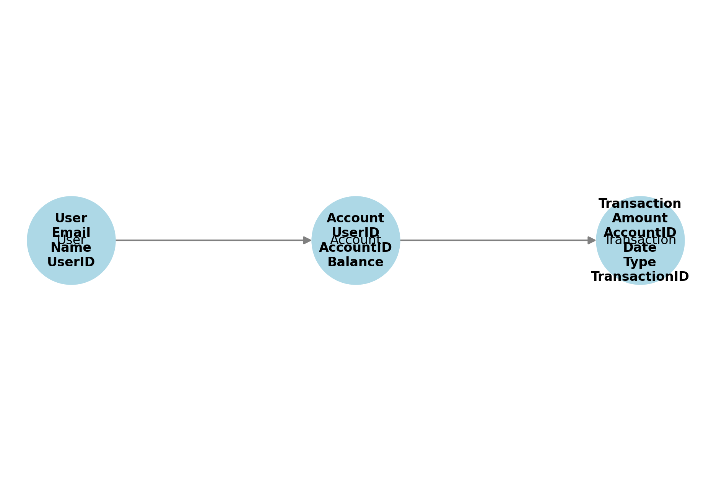

**8. User Flow**

1. The user signs up and creates an account.

2. Upon registration, the system assigns an account to the user.

3. The user can deposit money using the **Deposit API**.

4. The user can withdraw money using the **Withdraw API**. 5. The user can check their balance using the **Balance API**.

**9. Key Features**

1. **User API** - Allows users to sign up and authenticate. 2. **Account API** - Creates an account for a registered user. 3. **Deposit API** - Deposits money into an account.

4. **Withdraw API** - Withdraws money from an account. 5. **Balance API** - Fetches the current balance of an account.