# MIP – Edit Run Plan

**Created By:** Danielle Holet

**Date Requested:** 3/23/2016

**Requested By:**

**Related Business Requirement (s):** BR19

**Priority:** Low

**Status:** Analysis

**Technical Approver:** Sreeja, Ravi, Uday

**Business Approver:**

**Baselined / Approved Date:**

=======================================================================

**Full Description:**

User has the ability to edit the Run Plan in the location that will be used for Production runs.

**Current State**: Run Plan is managed in Excel on the SharePoint site and manually loaded to MOR.

**Future State:** Run Plan will be managed in a single location.

**Objectives:** Allow the modelers to manage their run plan in a single location with increased efficiency.

Goal is to have the Run Plan managed via the Portal. If the Portal is not ready we would still like to make the following column changes to the Run Plan that will be managed via the Sharepoint Point site.

1. Remove the following columns on the Run Plan– Approvers, Expected_Run_Date, Model_Run_Dependencies, Model_Code_Version, Model_Parameters,Execution_Script, Manual_Automated_Results
2. Add the following columns to the Run Plan:
   1. Include in Aggregation – Y/N field. Identifies if Run should be included in Aggregation.
   2. Aggregation Plan will no longer be needed.

Sample Excel Run Plan – new format:

[Run Plan](https://team.wss.pncbank.com/TO/APMandRiskTechnology/Asset%20Management%20Projects/CCAR/SCPI%20%20WK2/DFAST%202016%20and%20CCAR%202017/DFAST%202016%20and%20CCAR%202017%20SDLC/Analysis%20Phase/DFAST2016_PNC_Consolidated_RunPlan.xlsx)

**Functional Requirements:**

1. User selects a forecast_Purpose.
   1. Forecast_Purpose drop-down should be populated with CCAR2016, DFAST2016
      1. MOR table is STG_FORECAST_PURPOSE.FORECAST_PURPOSE.
2. User Selects a Forecast_Type.
   1. Forecaset_Type drop-down should be populated with choices PNC or FRB (potential add to DB)
3. User selects one or many models to edit the run plan for.
   1. Model should be populated with STG_MODEL.OUTPUT_MODEL_NAME (new column to be added)
4. User should have the ability to Add, Delete, Edit or Copy a row.
   1. UI implementation -- Display 4 options for each row of data:
      1. Add feature adds a new record to the table. Record should be added to the bottom of the table.
      2. Edit / Copy / Remove feature. User should first select a row and then select a button.
         1. Edit button allows the row to be edited
         2. Copy button copies that row to the bottom with fields editable
         3. Remove button allows user to remove a row
5. User is allowed to edit /add/remove records for current Forecast Purpose only
6. User can only add / edit records for their model - based on roles
7. Users should no longer see the following data points when editing a Run Plan. – Approvers, Expected_Run_Date, Model_Run_Dependencies, Model_Code_Version, Model_Parameters,Execution_Script, Manual_Automated_Results
8. Add the following columns to the Run Plan UI:
   1. Include in Aggregation – Y/N field. Identifies if Run should be included in Aggregation.
   2. Approval Status – Identified the status of the approval of the Run. Options are Published, Pending Approval, Pending Publish
   3. Created By – ID of user that created the Run
   4. Created Date / Time – Date and Time stamp of when record was created
   5. Approver Name – Name of user that approved the row
   6. Aprroved – Checkbox (or something similar) to identify if Run was approved.
   7. Aprroved Date / Time
   8. Approved Comments – text entry for user to enter comments on approval
9. Run Plan should be used to create Aggregation Plan -- See F_NF_Approve_Aggregation_Plan
10. eMail should be sent each time a the Run Plan is saved with Changes. (If edit happened in Portal)
11. UI Implementation Features–
    1. Data is retrieved from Run Plan Table (STG_MODEL_RUN_PLAN) in MOR
    2. Data is saved to Run Plan Table in MOR ((STG_MODEL_RUN_PLAN)
    3. User cannot edit forecast purpose / forecast type in Run Plan when selecting Edit or Add- It should be populated from the drop-down selection above
    4. User can select zero, one or many models from Model drop-down
    5. User must select one forecast purpose and one forecast type
    6. When user adds a new records system verifies that the Run_ID is not a duplicate of an existing Run_ID for the select Forecast_Purpose and Forecast_Type
    7. When a new Run is added to the Run Plan an email should be sent to the Aggregation Team.
       1. email Subject – “New Run Added for XXX Model”
       2. email Body – The following user xxx added Run ID xxx to the Model xxx on date/time stamp
    8. The following checks should be performed when a user is adding or editing a run plan:

|  |  |  |  |  |
| --- | --- | --- | --- | --- |
| **Field Name** | **Field Type** | **Field Checks** | **Message if failed** | **Possible Values for drop-down** |
| MRMG_Model_ID | Populate based on Model Name selected. |  |  |  |
| Model_Name | Drop-Down | None |  | Model Names from Model Table |
| Funded _Unfunded | Drop-Down | None |  | Funded Unfunded Both |
| New_Volume_Included | Drop-Down | None |  | Y N |
| Scenario | Drop-Down | Verify against list of scenarios | Scenario name must be Base, Adverse, Severely Adverse, L Scenario, All. | Base Adverse Severely Adverse L Scenario Liquidity All |
| Run_ID | Text Entry | Verify it is not a duplicate of an existing Run_ID Verify format of Run_ID. | Run ID already existing. Please pick a new name. Run ID must be in the following format: <Forecast_Purpose>_<MRMGID>_RXXX |  |
| Run_Type | Drop-Down | None |  | Basic iRisk iRisk Impact Overlay Liquidity Sensitivity |
| Run_Name | Text Entry | None |  |  |
| Run_Description | Text Entry | None |  |  |
| Include in Aggregation | Drop-Down | Verify Y or N |  | Y N |
| Approval Status | Drop-Down | None |  | Published  Pending Approval  Pending Publish |
| Created By |  |  | System populated – user cannot edit |  |
| Created by date time |  |  | System populated – user cannot edit |  |
| Approver Name |  |  | Name of the person approving - |  |
| Approved | Checkbox |  |  |  |
| Approved Date / Time |  |  | Sysetm populated based on when Approved was selected | Y N |
| Approved Comments | Text |  |  |  |

**Sample Run Plan:**

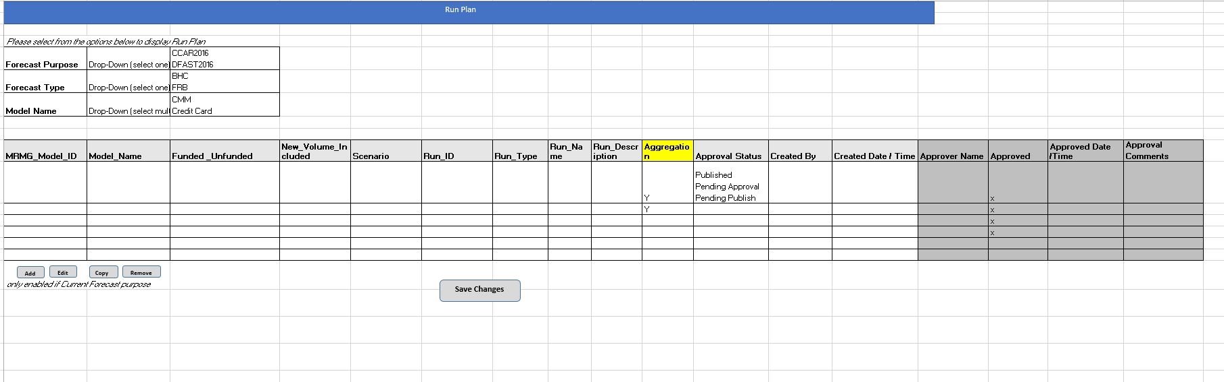

**MOR Table will require the following changes:**

1. Add the following columns to STG_MODEL_RUN_PLAN
   1. Include in Aggregation – Y/N field. Identifies if Run should be included in Aggregation.
   2. Approval Status – Identified the status of the approval of the Run. Options are Published, Pending Approval, Pending Publish
   3. Created By – ID of user that created the Run
   4. Created Date / Time – Date and Time stamp of when record was created
   5. Approver Name – Name of user that approved the row
   6. Aprroved – Checkbox (or something similar) to identify if Run was approved.
   7. Aprroved Date / Time
   8. Approved Comments – text entry for user to enter comments on approval
2. Add the following column to the STG_MODEL table.
   1. “Output_Model_Name” - This is the model name as found in the output dimsum results.
      * 1. Text Field = 60 characters
3. Do we need to add a table for “Forecast_type”?? or should this be in the forecast_purpose table?

**Process Flow:**

Link to process flow: [Process Flow](http://projects.pnc.com/sites/TechnologyProjects/amp/Asset%20Management%20Projects/CCAR/SCPI%20%20WK2/DFAST%202016%20and%20CCAR%202017/DFAST%202016%20and%20CCAR%202017%20SDLC/Analysis%20Phase/DFAST2016_Process_Flow.vdx)

Link to Excel View: [Control Pane](http://projects.pnc.com/sites/TechnologyProjects/amp/Asset%20Management%20Projects/CCAR/SCPI%20%20WK2/DFAST%202016%20and%20CCAR%202017/DFAST%202016%20and%20CCAR%202017%20SDLC/Analysis%20Phase/Control_Panel.xlsx)l

**Non-Functional Requirements:**

* Need to provide link to users roles and access.

**Design:**

* Portal Feature
* MOR Updates
  + Run Plan Table
  + Model Table
* eMail capability

**Testing:**