**Home Heaven**

Waterfall Deliverables -Part 2/2

**Document 6: Use Case Diagram, Activity Diagram, and Use Case Specification Document Use Case Diagram**

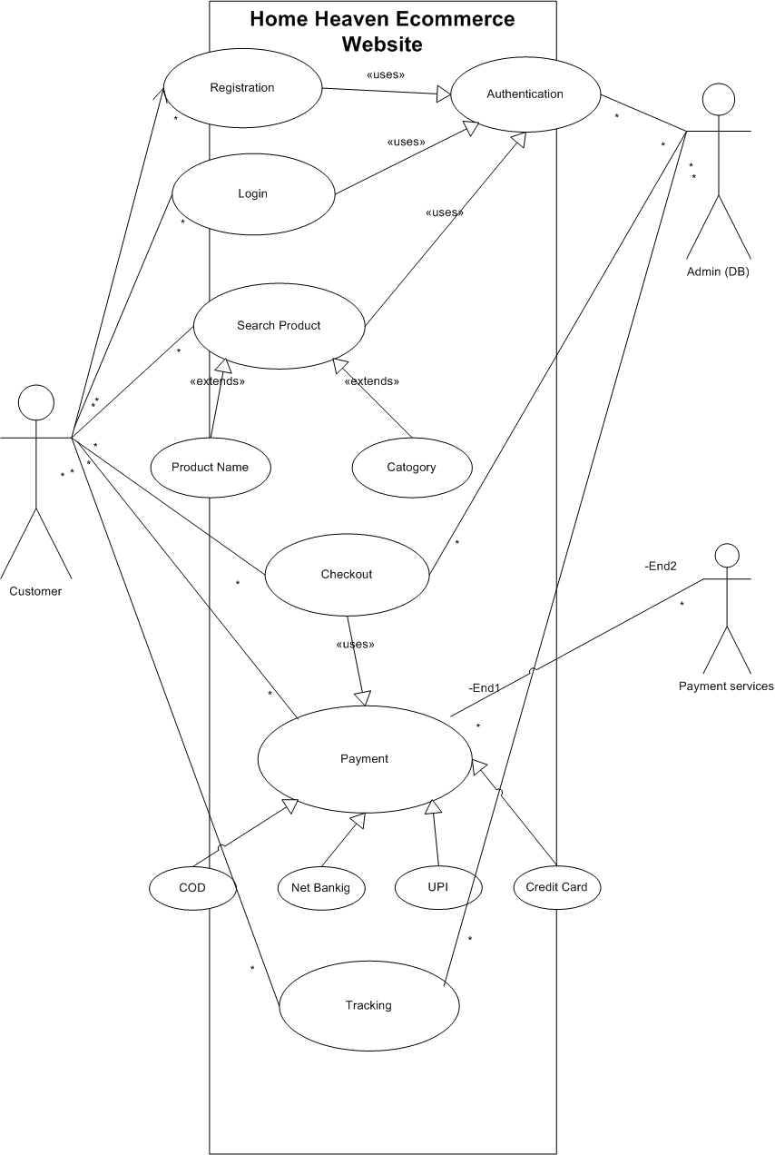

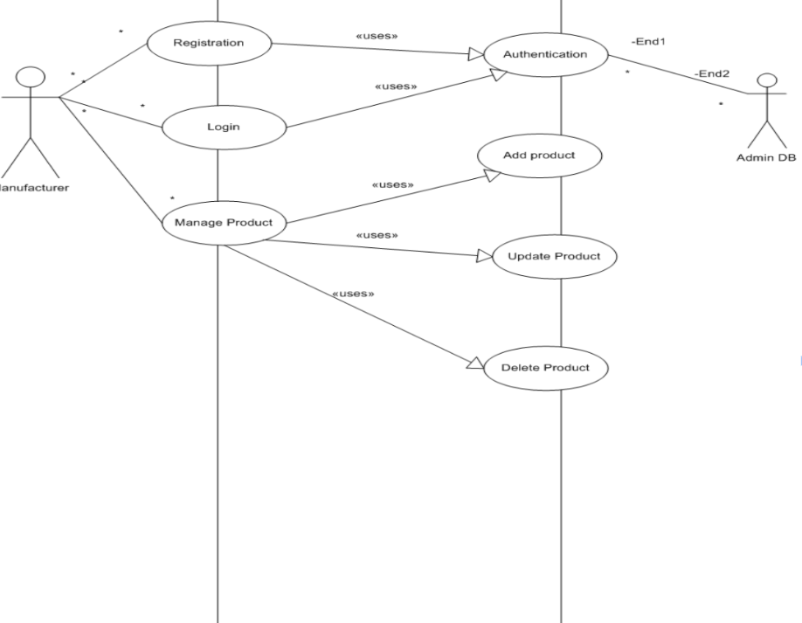

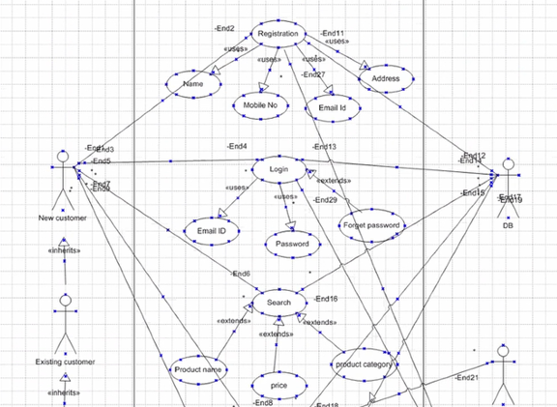

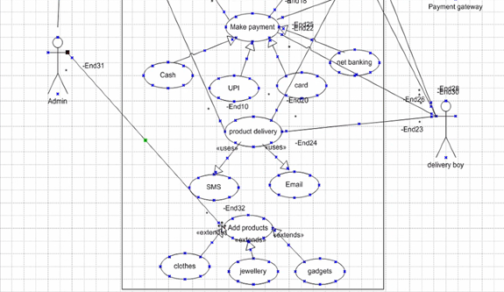

**Activity Diagram**

**1. Registration Page**

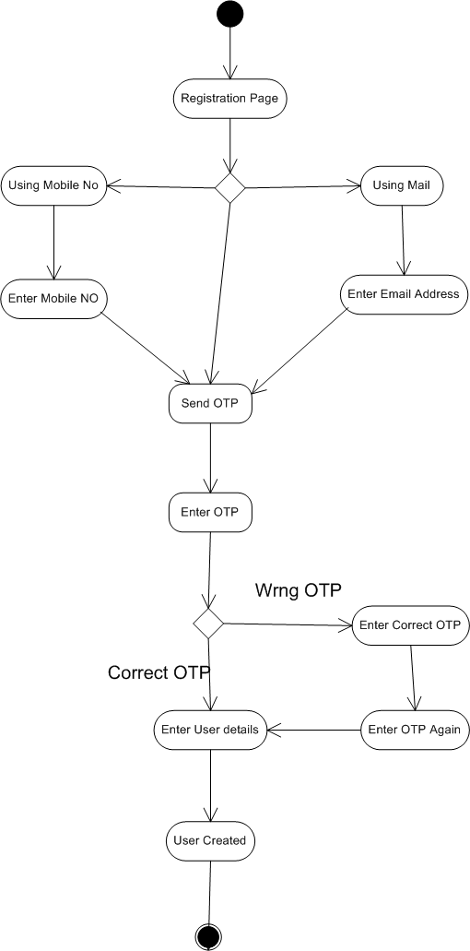

**2.Login Page**

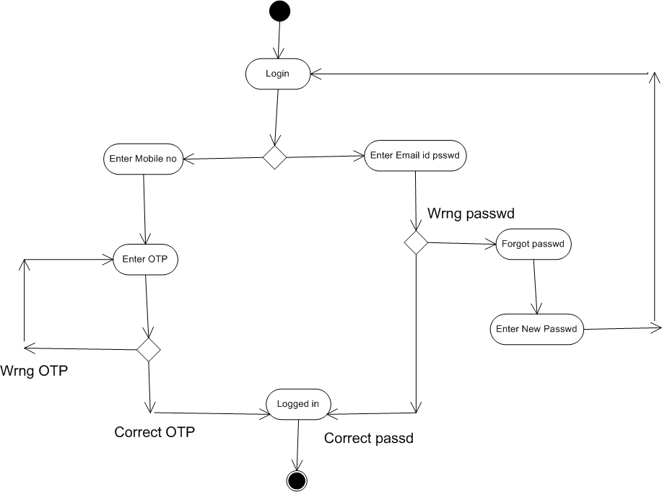

**3. BuyingProducts**

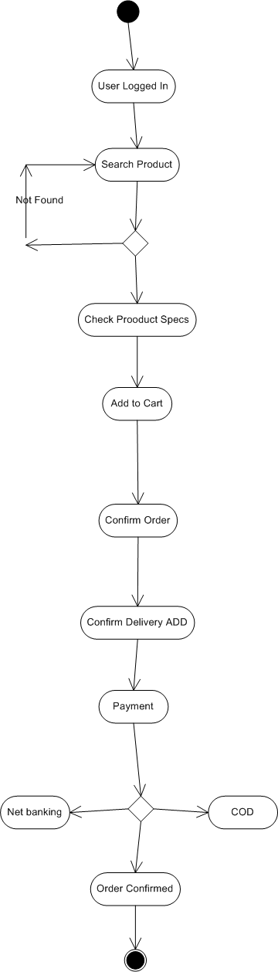

**4. Order Cancellation**

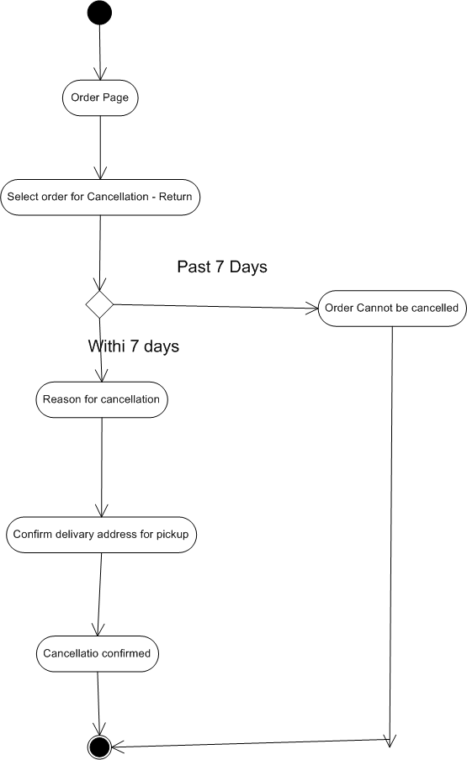

**5. Adding or Updating product**

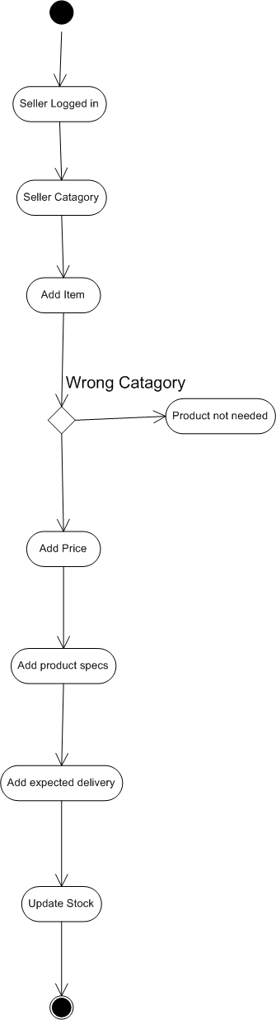

**Home Heaven E-Commerce Website - Use Case Specification Document**

## **User Buying Products**

| Use Case Name | User Buying Products |
| --- | --- |
| Use Case Description | This use case explains how a customer purchases products from the e-commerce store. |
| Primary Actors | Customer |
| Secondary Actors | Database/Admin |
| Basic Flow | User logs in.  User searches for a product.  Application displays available products.  User adds a product to the cart.  User selects delivery location.  User chooses a payment method.  Order is placed successfully, and confirmation is sent. |
| Alternate Flow | Invalid user credentials - User validation fails.  Product out of stock - User is notified and shown similar products.  Payment server not responding - Transaction fails, and user is notified. |
| Exceptional Flows | Order cancellation before confirmation.  Payment deducted but order not placed - Refund initiated. |
| Pre-Conditions | User must have an active internet connection and a registered account. |
| Post-Conditions | Successful purchase confirmation or failure due to technical/financial issues. |
| Assumptions | Users can navigate the e-commerce site and payment system is operational. |
| Constraints | Payment processing depends on third-party banks. |
| Dependencies | Requires valid user authentication and stock availability. |
| Inputs and Outputs | Inputs: User login, product selection, payment details.  Outputs: Order confirmation, invoice, SMS notifications. |
| Business Rules | Users must be logged in to purchase products.  Orders cannot be placed for out-of-stock items. |
| Miscellaneous Information | Order history is stored for customer reference. |

## **User Registration**

| Use Case Name | User Registration |
| --- | --- |
| Use Case Description | This use case describes how a user registers in the e-commerce store. |
| Primary Actors | Customer |
| Secondary Actors | Database/Admin |
| Basic Flow | User enters details (name, email, phone number, address).  Application sends OTP to the mobile number.  User enters OTP for verification.  System validates and creates the account. |
| Alternate Flow | Incorrect OTP entered - User is prompted to enter the correct OTP.  Email or phone number already registered - User is notified. |
| Exceptional Flows | Server failure during registration. |
| Pre-Conditions | User must have a valid email and mobile number. |
| Post-Conditions | A new user account is created, or an error message is displayed. |
| Assumptions | User details provided are valid and unique. |
| Constraints | OTP is valid for a limited time. |
| Dependencies | Email and SMS service availability. |
| Inputs and Outputs | Inputs: User details, OTP.  Outputs: Registration confirmation, SMS notification. |
| Business Rules | Users cannot register with duplicate phone numbers or emails. |
| Miscellaneous Information | User registration logs are stored for tracking. |

## **User Payment Process**

| Use Case Name | User Payment Process |
| --- | --- |
| Use Case Description | This use case describes how the user completes a payment after selecting a product. |
| Primary Actors | Customer |
| Secondary Actors | Admin, Bank |
| Basic Flow | User selects a payment method.  User enters payment details.  System processes payment and confirms. |
| Alternate Flow | Incorrect card details entered - Payment fails.  Insufficient funds - Transaction declined. |
| Exceptional Flows | Payment gateway timeout or failure. |
| Pre-Conditions | User must have a valid payment method and sufficient funds. |
| Post-Conditions | Payment is completed or fails with a reason. |
| Assumptions | Payment gateways are functional. |
| Constraints | Bank response time affects transaction speed. |
| Dependencies | External banking services. |
| Inputs and Outputs | Inputs: Payment details.  Outputs: Transaction confirmation or failure message. |
| Business Rules | Users must verify payments via OTP. |
| Miscellaneous Information | Payment logs are stored securely. |

## **Seller Product Management**

| Use Case Name | Seller Product Management |
| --- | --- |
| Use Case Description | This use case describes how a seller adds or updates products on the portal. |
| Primary Actors | Seller/Manufacturer |
| Secondary Actors | Database/Admin |
| Basic Flow | Seller logs in.  Seller selects product category.  Seller enters product details and submits. |
| Alternate Flow | Incorrect product category selected - Error displayed. |
| Exceptional Flows | Server failure during product upload. |
| Pre-Conditions | Seller must have an active account. |
| Post-Conditions | Product is listed successfully. |
| Assumptions | Sellers provide accurate product details. |
| Constraints | Product pricing must comply with platform rules. |
| Dependencies | Seller verification required. |
| Inputs and Outputs | Inputs: Product details.  Outputs: Product listing confirmation. |
| Business Rules | Prices must align with regional policies. |
| Miscellaneous Information | Product updates are logged. |

## **Order Cancellation**

| Use Case Name | Order Cancellation |
| --- | --- |
| Use Case Description | This use case describes how users cancel or return an order. |
| Primary Actors | Customer |
| Secondary Actors | Seller, Admin |
| Basic Flow | User selects an order to cancel.  System requests cancellation reason.  System confirms cancellation. |
| Alternate Flow | Cancellation period expired - Cancellation denied. |
| Exceptional Flows | Technical issues preventing cancellation. |
| Pre-Conditions | Order must be eligible for cancellation. |
| Post-Conditions | Order is cancelled or user is notified of failure. |
| Assumptions | Sellers accept cancellations as per policy. |
| Constraints | Refund time varies by payment method. |
| Dependencies | Seller approval required. |
| Inputs and Outputs | Inputs: Order details, reason for cancellation.  Outputs: Cancellation confirmation, refund status. |
| Business Rules | Refunds processed based on seller policies. |
| Miscellaneous Information | Cancellation logs stored for tracking. |

**Document 7- Screens and pages Please follow the following steps to create the mock-ups**

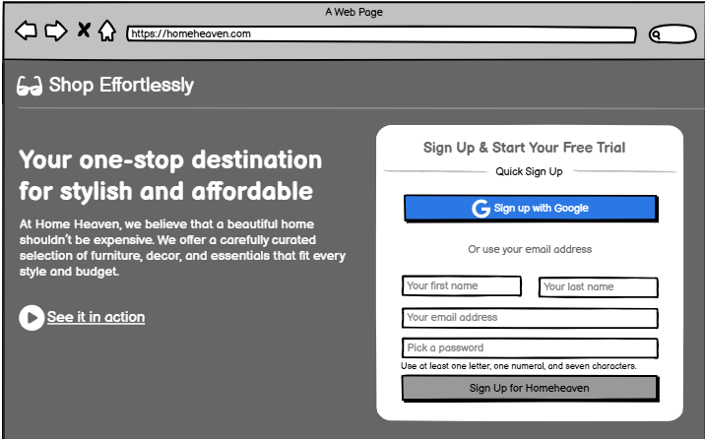

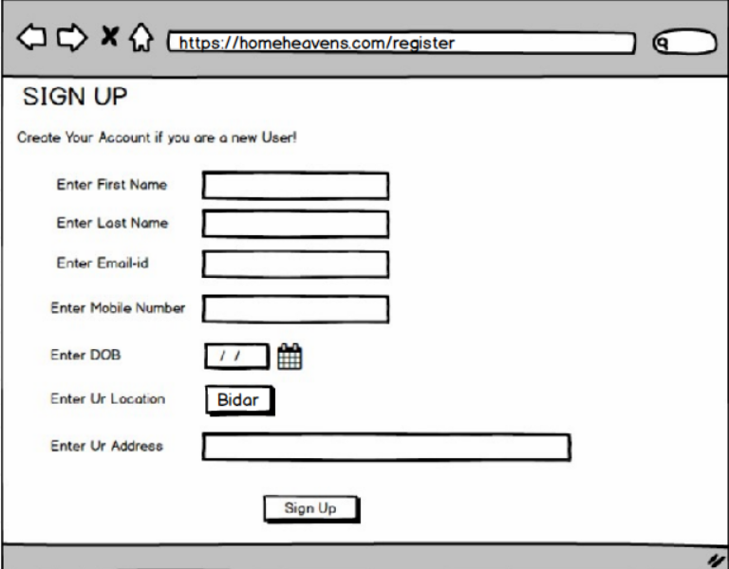

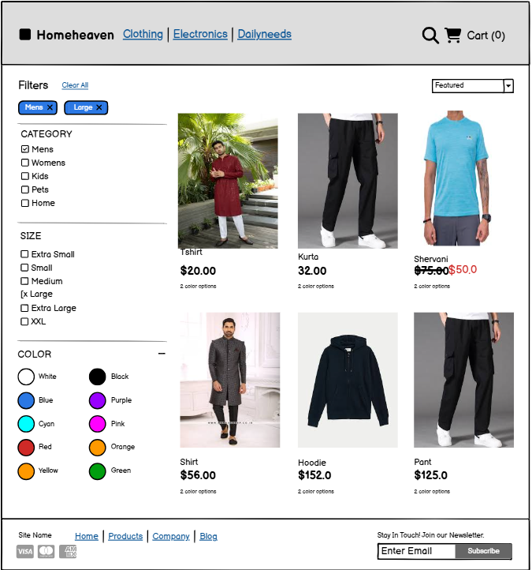

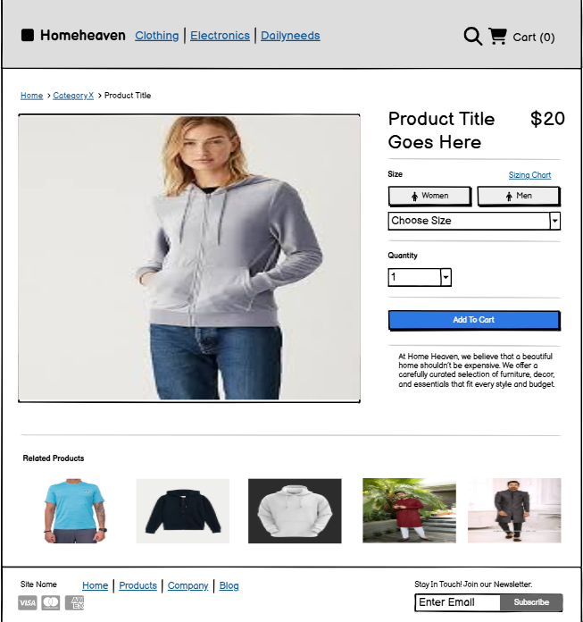

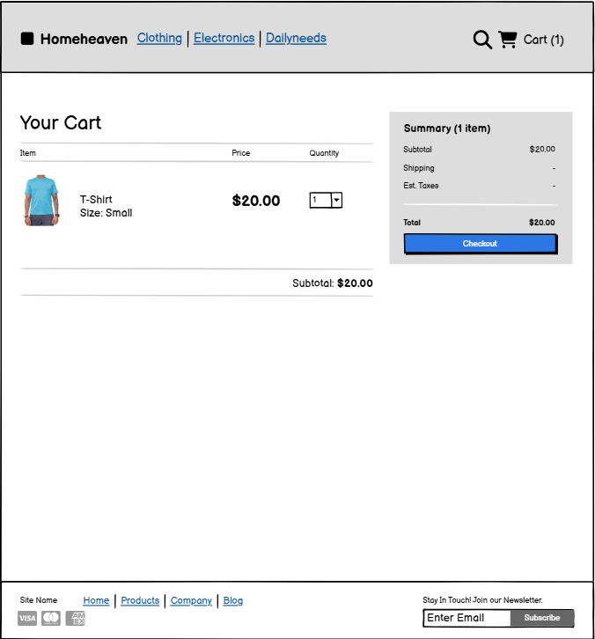

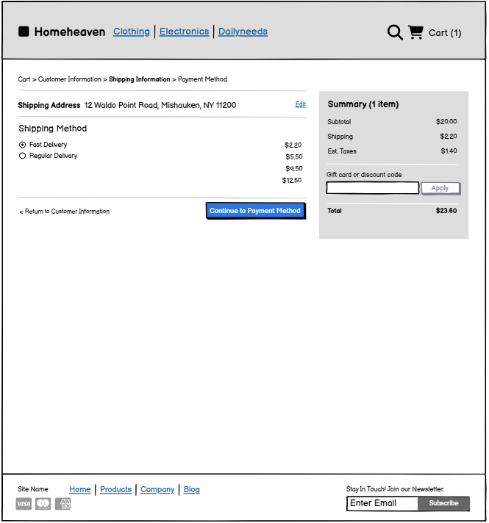

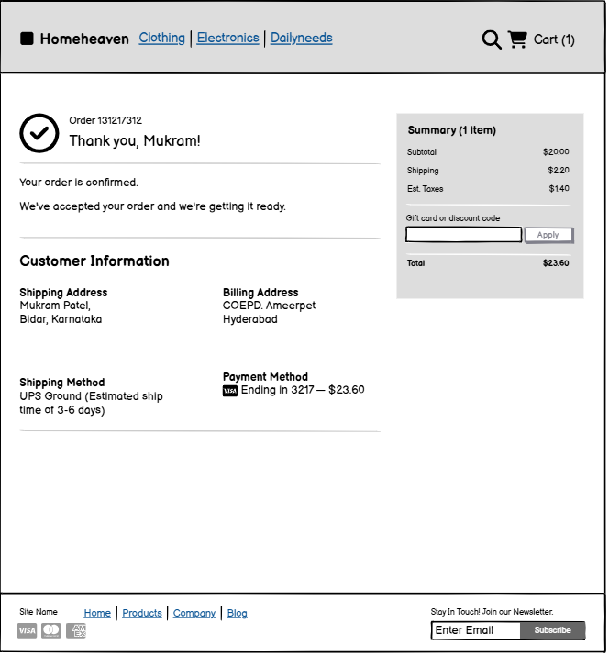

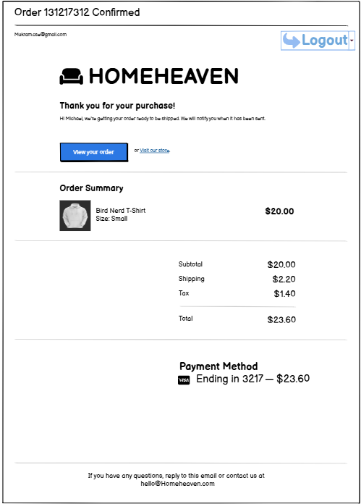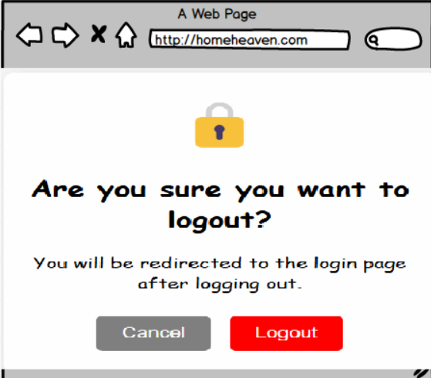

**Document 8-**

**Tools-Visio and Axure Write a paragraph on your experience using Visio and Axure for the project.**

During the project, I utilized **Microsoft Visio** and **Axure RP** to create detailed visual representations and interactive prototypes. With **Visio**, I designed process flow diagrams, data flow diagrams, and system architecture models, which helped in understanding and communicating complex workflows effectively. Its drag-and-drop interface and pre-built templates made it easy to create structured diagrams that aligned with business and technical requirements. On the other hand, **Axure RP** was instrumental in developing interactive wireframes and high-fidelity prototypes for the **Home Heaven e-commerce website**. Using Axure, I created prototypes that demonstrated user navigation, page interactions, and system functionalities, allowing stakeholders to visualize the end product before development. Both tools significantly improved requirement gathering, stakeholder communication, and design validation, ensuring a smooth transition from planning to implementation.

# **Document 9- BA experience**

## **1. Requirement Gathering:**

### **Techniques:**

* **Interviews** with stakeholders including customers, vendors, and internal teams
* **Surveys** to collect feedback on user preferences and pain points
* **Market Research** to analyze industry trends and competitors
* **Observation** of existing eCommerce platforms and customer behavior

### **Activities:**

* Conducted one-on-one interviews with business owners and customers to understand their expectations
* Distributed surveys to collect insights on shopping preferences, payment methods, and delivery expectations
* Analyzed competitors' platforms to identify gaps and opportunities
* Documented functional and non-functional requirements
* Used the **MoSCoW** technique to prioritize features
* Created prototypes to gather feedback on design and functionality

### **Challenges:**

* Gathering diverse requirements from multiple stakeholders
* Aligning business objectives with customer expectations
* Managing resistance to new eCommerce technology from traditional sellers
* Ensuring seamless integration with third-party payment and logistics providers

### **Steps to Overcome Challenges:**

* Established a clear communication plan to engage stakeholders throughout the process
* Used requirement prioritization techniques to balance business and customer needs
* Conducted workshops to resolve conflicting requirements
* Provided documentation and training to ensure smooth adoption of the new system

### **2. Requirement Analysis:**

* **UML diagrams** were created to visually describe the requirements for key modules like **user authentication, product search, cart management, and checkout processes**.
* **Activity diagrams** were used to map out **order processing, payment transactions, and inventory updates**.
* These diagrams were communicated with the team; some members suggested changes, which I incorporated after proper evaluation.
* Prepared **Business Requirement Specification (BRS)** and **Software Requirement Specification (SRS)** documents for the project.

### **3. Design:**

* **Use case diagrams** were used as a base to prepare **test cases for user journeys**, including **product browsing, adding to cart, and checkout process**.
* Communicated with the client on **design and solution documents**, ensuring alignment with business objectives.
* Wrote **both positive and negative test cases** to cover different scenarios, such as **successful and failed transactions**.
* Ensured that no test case was missed, as overlooking any scenario could **impact project development later**.
* Prepared **test data** for different scenarios, such as **product availability, payment failures, and discount applications**.
* Updated the **Requirements Traceability Matrix (RTM)** to ensure all requirements were covered during development and testing.

### **4. Development:**

* **Organized JAD (Joint Application Development) sessions** with developers and testers to discuss project functionalities.
* **Clarified queries** from the tech team during the coding phase.
* Managed situations where some team members did not **agree with the approach** by having **one-on-one discussions**, explaining how their concerns could impact the project, and fostering a collaborative environment.
* Referred to **diagrams and requirement documents** to assist developers in coding different modules like **order management, payment gateway integration, and customer support**.
* Conducted **regular meetings** with the technical team and the client, ensuring project alignment. If team members missed a meeting, I **recorded sessions and followed up with one-on-one discussions**.

### **5. Testing:**

* Prepared **test cases from use cases** related to the e-commerce functionalities.
* Conducted **high-level testing**, covering both functional and non-functional aspects.
* **Requested test data** from the client for real-world scenarios, ensuring comprehensive testing.
* Updated **RTM** to validate that all requirements were met.
* Obtained **sign-off from the client** after successfully completing testing.
* Prepared the client for **User Acceptance Testing (UAT)** by guiding them through the key test scenarios.

### **6. Deployment:**

* Forwarded the **RTM to the client**, ensuring it was attached to the **project closure document**.
* Coordinated with the client to **finalize and share end-user manuals**, providing necessary documentation for reference.
* Planned and organized **training sessions** to help stakeholders understand system functionalities.
* Ensured that all relevant **stakeholders attended the training sessions**, addressing any queries they had before project handover.