Access Management Framework

**High Level Design Document**

Contents

1. Introduction 3

2. System Architecture 3

3. Components and Modules 3

3.1 Member Management 3

3.1.1 Member Registration 3

3.1.1.1 Use Case 3

4. Data Flow 4

5. User Interfaces 4

6. Communication Protocols 4

7. Security Considerations 4

8. Error Handling 4

9. Performance Considerations 4

10. Testing Strategy 4

11. Dependencies 4

12. Deployment and Release Strategy 4

13. Operational Considerations 4

14. Compliance and Regulations 5

15. Glossary 5

16. References 5

1. Introduction

TODO.

1. System Architecture

TODO.

1. Components and Modules
   1. Member Management
      1. Member Registration
         1. Use Case

|  |  |  |
| --- | --- | --- |
| **1: Member Registration** | | |
| **Use Case Number** | 1 | |
| **Use Case Name** | Member Registration | |
| **References** | **Reference Type** | **Reference** |
| FRSD | 4.3.1.1 |
|  |  |
| **System** | This use case occurs within an application where individuals or organizations can become members. The registration process allows individuals or organizations to provide their information and become members of the Application. | |
| **Actors** | * An Individual or an Organization | |
|  | |
| **Use Case Goal** | The purpose of this use case is to describe the process by which an individual or an organization can register as a member. | |
| **Primary Actors** | * An Individual or an Organization | |
|  | |
| **Preconditions** | * Registrant must have an email Id | |
| * The Email id is not already registered within the application | |
| * Registrant should have access to his email account | |
|  | |
| **Basic Flow** | * Take email Id as Input * Send OTP to provided email id * Validate OTP * Create Member | |
| **Alternative Flows** | **Alternative Flow No** | **Alternative Flow** |
| 1 | * **Email id already registered**. * Inform Registrant |
| 2 | * **Invalid OTP** * Inform Registrant |
| **Notes** |  | |
| **Dependencies** |  | |

* + - 1. Class Diagram

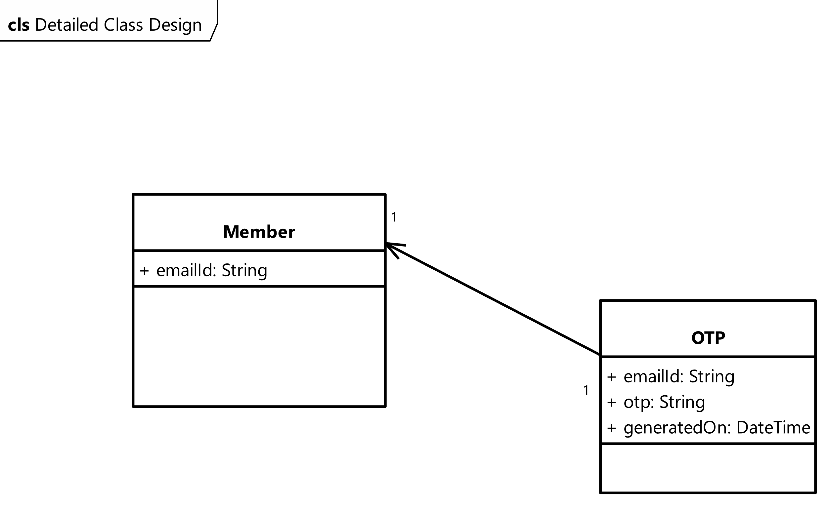

1. Data Flow

TODO.

1. User Interfaces

TODO.

1. Communication Protocols

TODO.

1. Security Considerations

TODO.

1. Error Handling

TODO.

1. Performance Considerations

TODO.

1. Testing Strategy

TODO.

1. Dependencies

TODO.

1. Deployment and Release Strategy

TODO.

1. Operational Considerations

TODO.

1. Compliance and Regulations

TODO.

1. Glossary

TODO.

1. References

TODO.