Cross-Modal Transfer Learning for Solar Panel Defect Detection
Generated from results folder: /content/drive/MyDrive/Solar Data/results
Report generated on: 2025-12-13 03:17:00

1. Included Artifacts
JSON files found: 23
PNG files found: 18
TXT files found: 2

2. Key Text Outputs

FINAL_REPORT.txt
================================================================================
CROSS-MODAL SOLAR PANEL DEFECT DETECTION - FINAL REPORT
================================================================================
Report Generated: 2025-12-05 04:16:53
PHASE 1: THERMAL CLASSIFICATION (PV-Multi-Defect)
--------------------------------------------------------------------------------
Macro Precision: 0.9412
Macro Recall: 0.9656
Macro F1-Score: 0.9521
Per-Class Performance:
black_border:
Precision: 0.9512
Recall: 1.0000
F1-Score: 0.9750
Support: 39
broken:
Precision: 0.7222
Recall: 0.8667
F1-Score: 0.7879
Support: 15
hot_spot:
Precision: 0.9968
Recall: 0.9968
F1-Score: 0.9968
Support: 312
no_electricity:
Precision: 1.0000
Recall: 0.9643
F1-Score: 0.9818
Support: 28
normal:
Precision: 0.9870
Recall: 1.0000
F1-Score: 0.9935
Support: 76
scratch:
Precision: 0.9900
Recall: 0.9660
F1-Score: 0.9779
Support: 206
Training Epochs: 22
Best Validation Accuracy: 0.9940
Final Training Loss: 0.0546
Final Validation Loss: 0.0209
PHASE 2: CROSS-MODAL TRANSFER LEARNING (ELPV)
--------------------------------------------------------------------------------
Transfer Learning Model (Thermal -> ELPV):
Training Epochs: 30
Best Validation Accuracy: 0.8528
Final Training Loss: 0.4212
Final Validation Loss: 0.2849
Baseline Model (Trained from scratch on ELPV):
Training Epochs: 19
Best Validation Accuracy: 0.9061
Final Training Loss: 0.2872
Final Validation Loss: 0.2512
Transfer Learning vs Baseline Comparison:
Transfer Best Val Acc: 0.8528
Baseline Best Val Acc: 0.9061
Absolute Improvement: -0.0533
Relative Improvement: -5.88%
✗ Transfer learning did NOT improve performance
PHASE 3: GRAD-CAM EXPLAINABILITY
--------------------------------------------------------------------------------
Grad-CAM validation results not found.
================================================================================
DATASET STATISTICS
================================================================================
PV-Multi-Defect (Thermal) Dataset:
hot_spot: 1455 samples
scratch: 956 samples
no_electricity: 126 samples
black_border: 179 samples
broken: 68 samples
normal: 349 samples
Total training samples: 3133
ELPV Dataset:
functional: 1262 samples
defective: 574 samples
Total training samples: 1836
================================================================================
KEY FINDINGS
================================================================================
1. Thermal defect classification achieved 95.21% macro F1-score
2. Worst-case recall across all defect types: 86.67%
3. Transfer learning showed minimal benefit (-5.33% change)
================================================================================
END OF REPORT
================================================================================

transfer_comparison.txt
TRANSFER vs BASELINE COMPARISON
============================================================
Transfer Learning F1: 0.7870
Baseline F1: 0.8795
Improvement: -0.0925
Relative Improvement: -10.52%

3. Baseline Models (ImageNet → Thermal)

Baseline Training History (baseline_history.json)
Metric | Value
Best Val Accuracy | 90.61%
Best Val Acc Epoch | 17
Best Val Loss | 0.2272
Best Val Loss Epoch | 14
Final Train Accuracy | 87.42%
Final Val Accuracy | 89.09%
Final Train Loss | 0.2872
Final Val Loss | 0.2512

Baseline Test Metrics (test_metrics.json)
Metric | Value
Test Accuracy | N/A
Macro Precision | 94.12%
Macro Recall | 96.56%
Macro F1 | 95.21%
Per-class metrics:
Class | Precision | Recall | F1 | Support
black_border | 95.12% | 100.00% | 97.50% | 39
broken | 72.22% | 86.67% | 78.79% | 15
hot_spot | 99.68% | 99.68% | 99.68% | 312
no_electricity | 100.00% | 96.43% | 98.18% | 28
normal | 98.70% | 100.00% | 99.35% | 76
scratch | 99.00% | 96.60% | 97.79% | 206

4. EfficientNet-B1 Thermal Baseline

B1 Training History (efficientnet_b1_history.json)
Metric | Value
Best Val Accuracy | 99.70%
Best Val Acc Epoch | 33
Best Val Loss | 0.0098
Best Val Loss Epoch | 41
Final Train Accuracy | 97.03%
Final Val Accuracy | 99.55%
Final Train Loss | 0.0420
Final Val Loss | 0.0124

B1 Thermal Metrics (el_thermal_b1_metrics.json)
Metric | Value
Test Accuracy | N/A
Macro Precision | 92.79%
Macro Recall | 97.35%
Macro F1 | 94.59%
Per-class metrics:
Class | Precision | Recall | F1 | Support
black_border | 97.50% | 100.00% | 98.73% | 39
broken | 63.64% | 93.33% | 75.68% | 15
hot_spot | 99.68% | 100.00% | 99.84% | 312
no_electricity | 96.43% | 96.43% | 96.43% | 28
normal | 100.00% | 98.68% | 99.34% | 76
scratch | 99.49% | 95.63% | 97.52% | 206

5. EfficientNet-B3 Thermal Baseline

B3 Training History (efficientnet_b3_history.json)
Metric | Value
Best Val Accuracy | 99.70%
Best Val Acc Epoch | 16
Best Val Loss | 0.0117
Best Val Loss Epoch | 20
Final Train Accuracy | 97.00%
Final Val Accuracy | 99.70%
Final Train Loss | 0.0388
Final Val Loss | 0.0147

B3 Test Metrics (efficientnet_b3_metrics.json)
Metric | Value
Test Accuracy | N/A
Macro Precision | 95.36%
Macro Recall | 96.72%
Macro F1 | 95.98%
Per-class metrics:
Class | Precision | Recall | F1 | Support
black_border | 97.50% | 100.00% | 98.73% | 39
broken | 76.47% | 86.67% | 81.25% | 15
hot_spot | 99.68% | 99.68% | 99.68% | 312
no_electricity | 100.00% | 96.43% | 98.18% | 28
normal | 100.00% | 100.00% | 100.00% | 76
scratch | 98.53% | 97.57% | 98.05% | 206

6. Transfer Learning (ELPV → Thermal)

Transfer Training History (transfer_history.json)
Metric | Value
Best Val Accuracy | 85.28%
Best Val Acc Epoch | 23
Best Val Loss | 0.2825
Best Val Loss Epoch | 29
Final Train Accuracy | 81.59%
Final Val Accuracy | 85.03%
Final Train Loss | 0.4212
Final Val Loss | 0.2849

B1 EL→Thermal Metrics (el_thermal_b1_metrics.json)
Metric | Value
Test Accuracy | N/A
Macro Precision | 92.79%
Macro Recall | 97.35%
Macro F1 | 94.59%
Per-class metrics:
Class | Precision | Recall | F1 | Support
black_border | 97.50% | 100.00% | 98.73% | 39
broken | 63.64% | 93.33% | 75.68% | 15
hot_spot | 99.68% | 100.00% | 99.84% | 312
no_electricity | 96.43% | 96.43% | 96.43% | 28
normal | 100.00% | 98.68% | 99.34% | 76
scratch | 99.49% | 95.63% | 97.52% | 206

B3 EL→Thermal Training History (el_thermal_b3_history.json)
Metric | Value
Best Val Accuracy | 99.55%
Best Val Acc Epoch | 25
Best Val Loss | 0.0163
Best Val Loss Epoch | 27
Final Train Accuracy | 94.29%
Final Val Accuracy | 99.26%
Final Train Loss | 0.0828
Final Val Loss | 0.0176

7. Bidirectional Transfer Summary
Loaded: bidirectional_transfer_final_report.json
Bidirectional JSON present, but schema is custom; raw stored in file.

8. Figures and Plots
transfer_vs_baseline_comparison.png
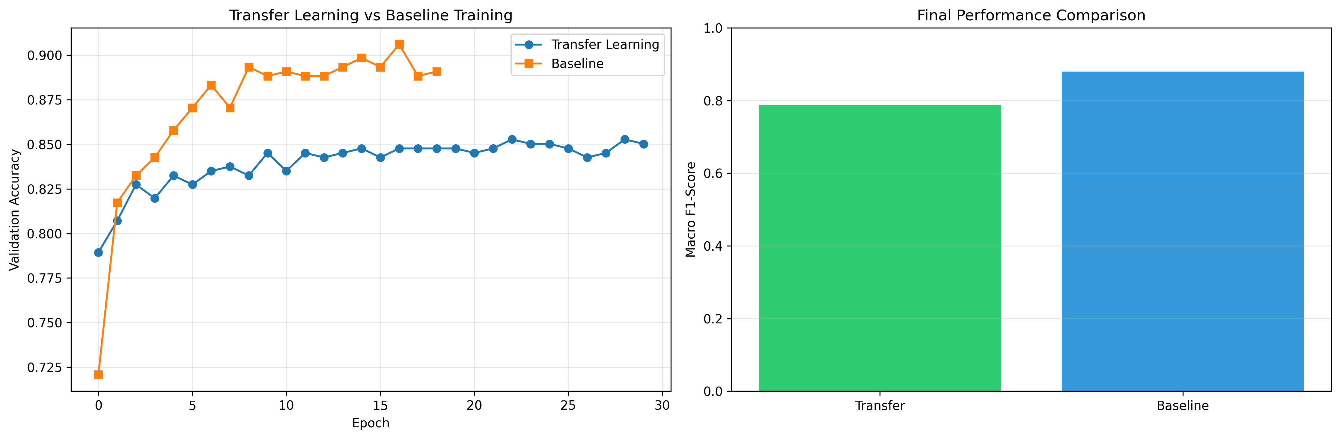
bidirectional_transfer_complete_analysis.png
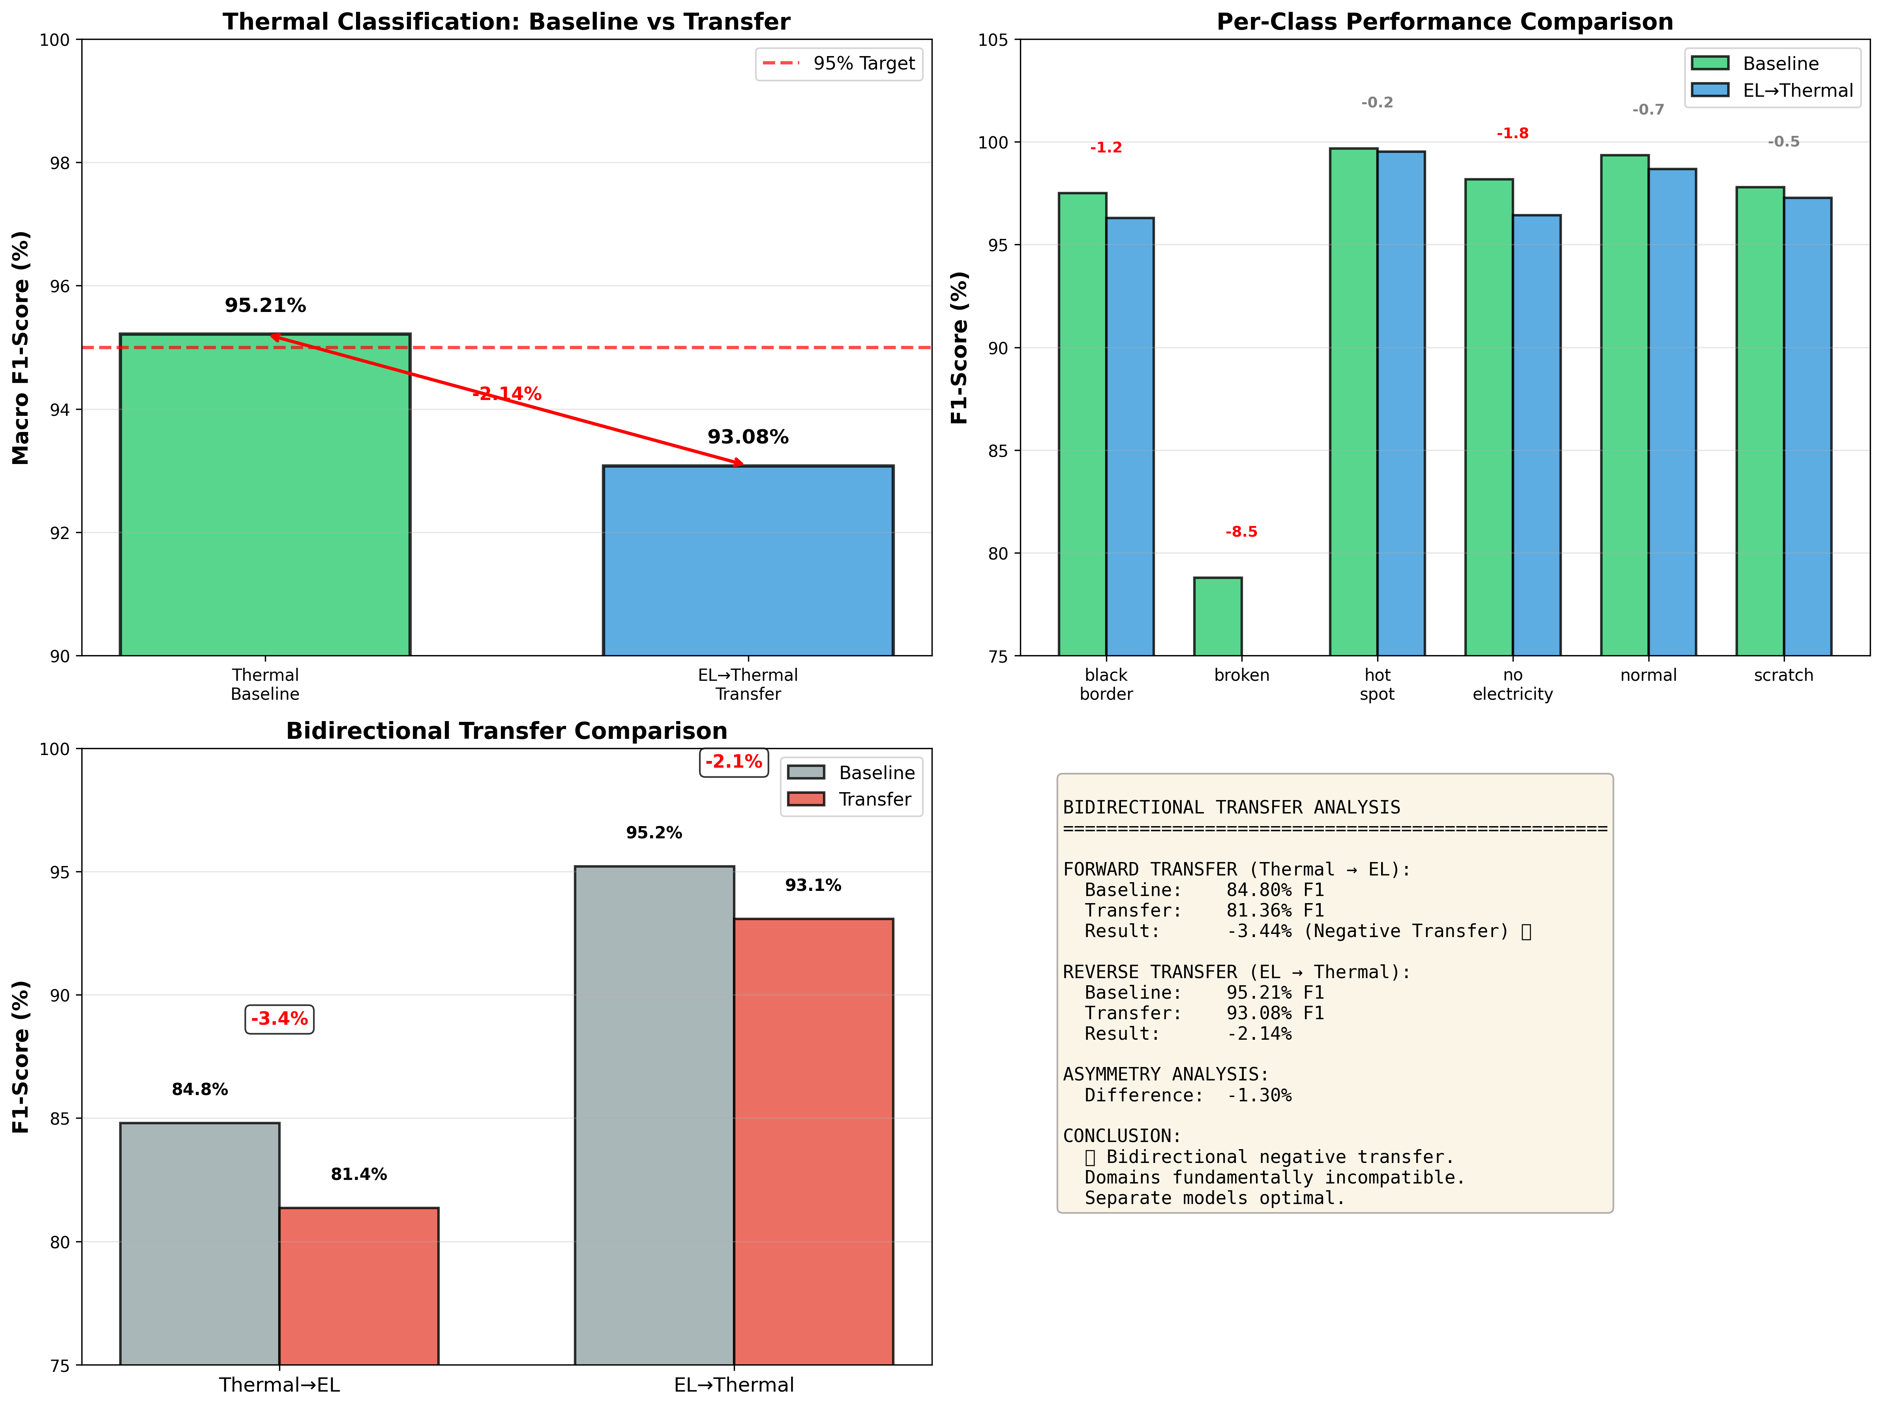
training_curves.png
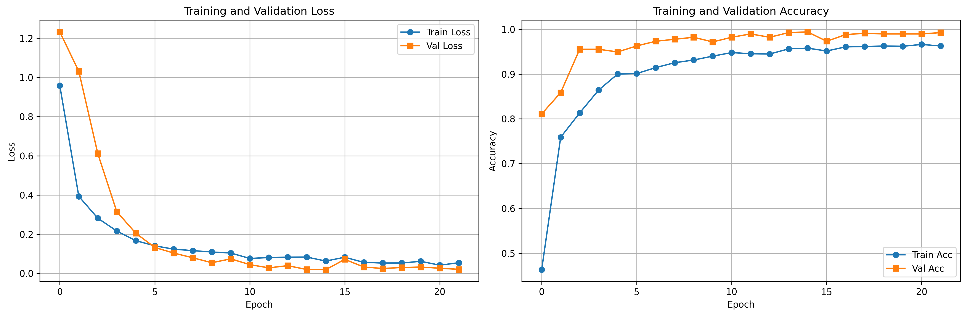
baseline_curves.png
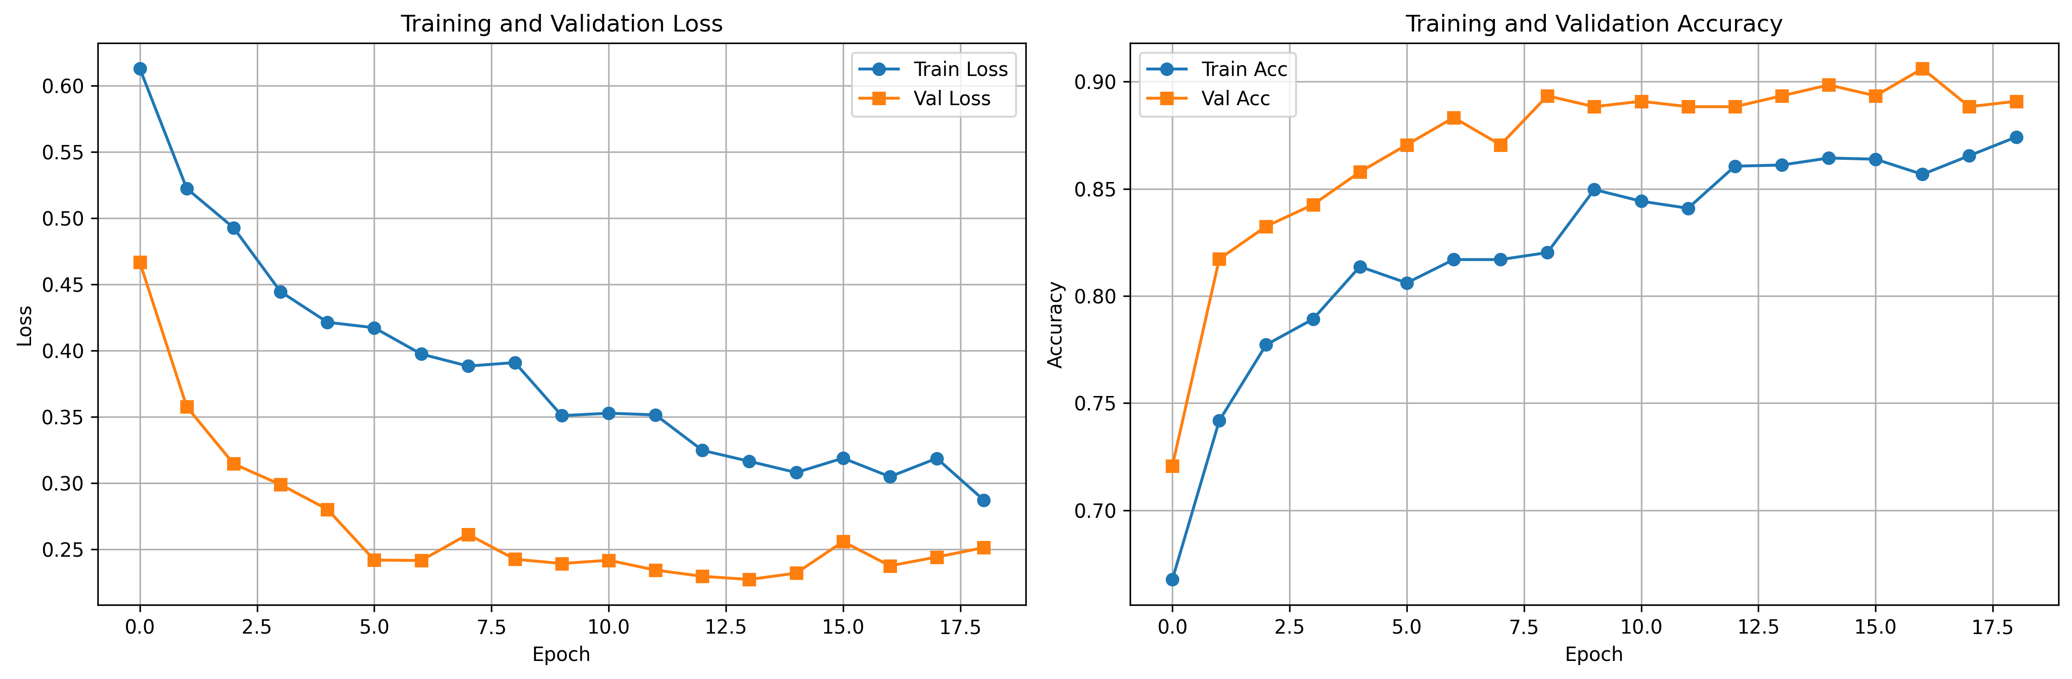
transfer_curves.png
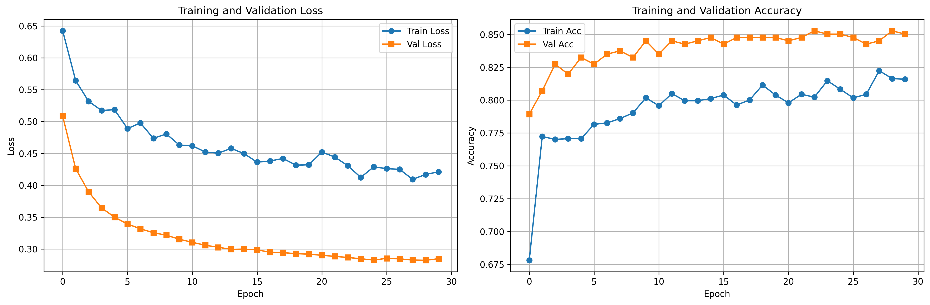
el_thermal_training_comparison.png
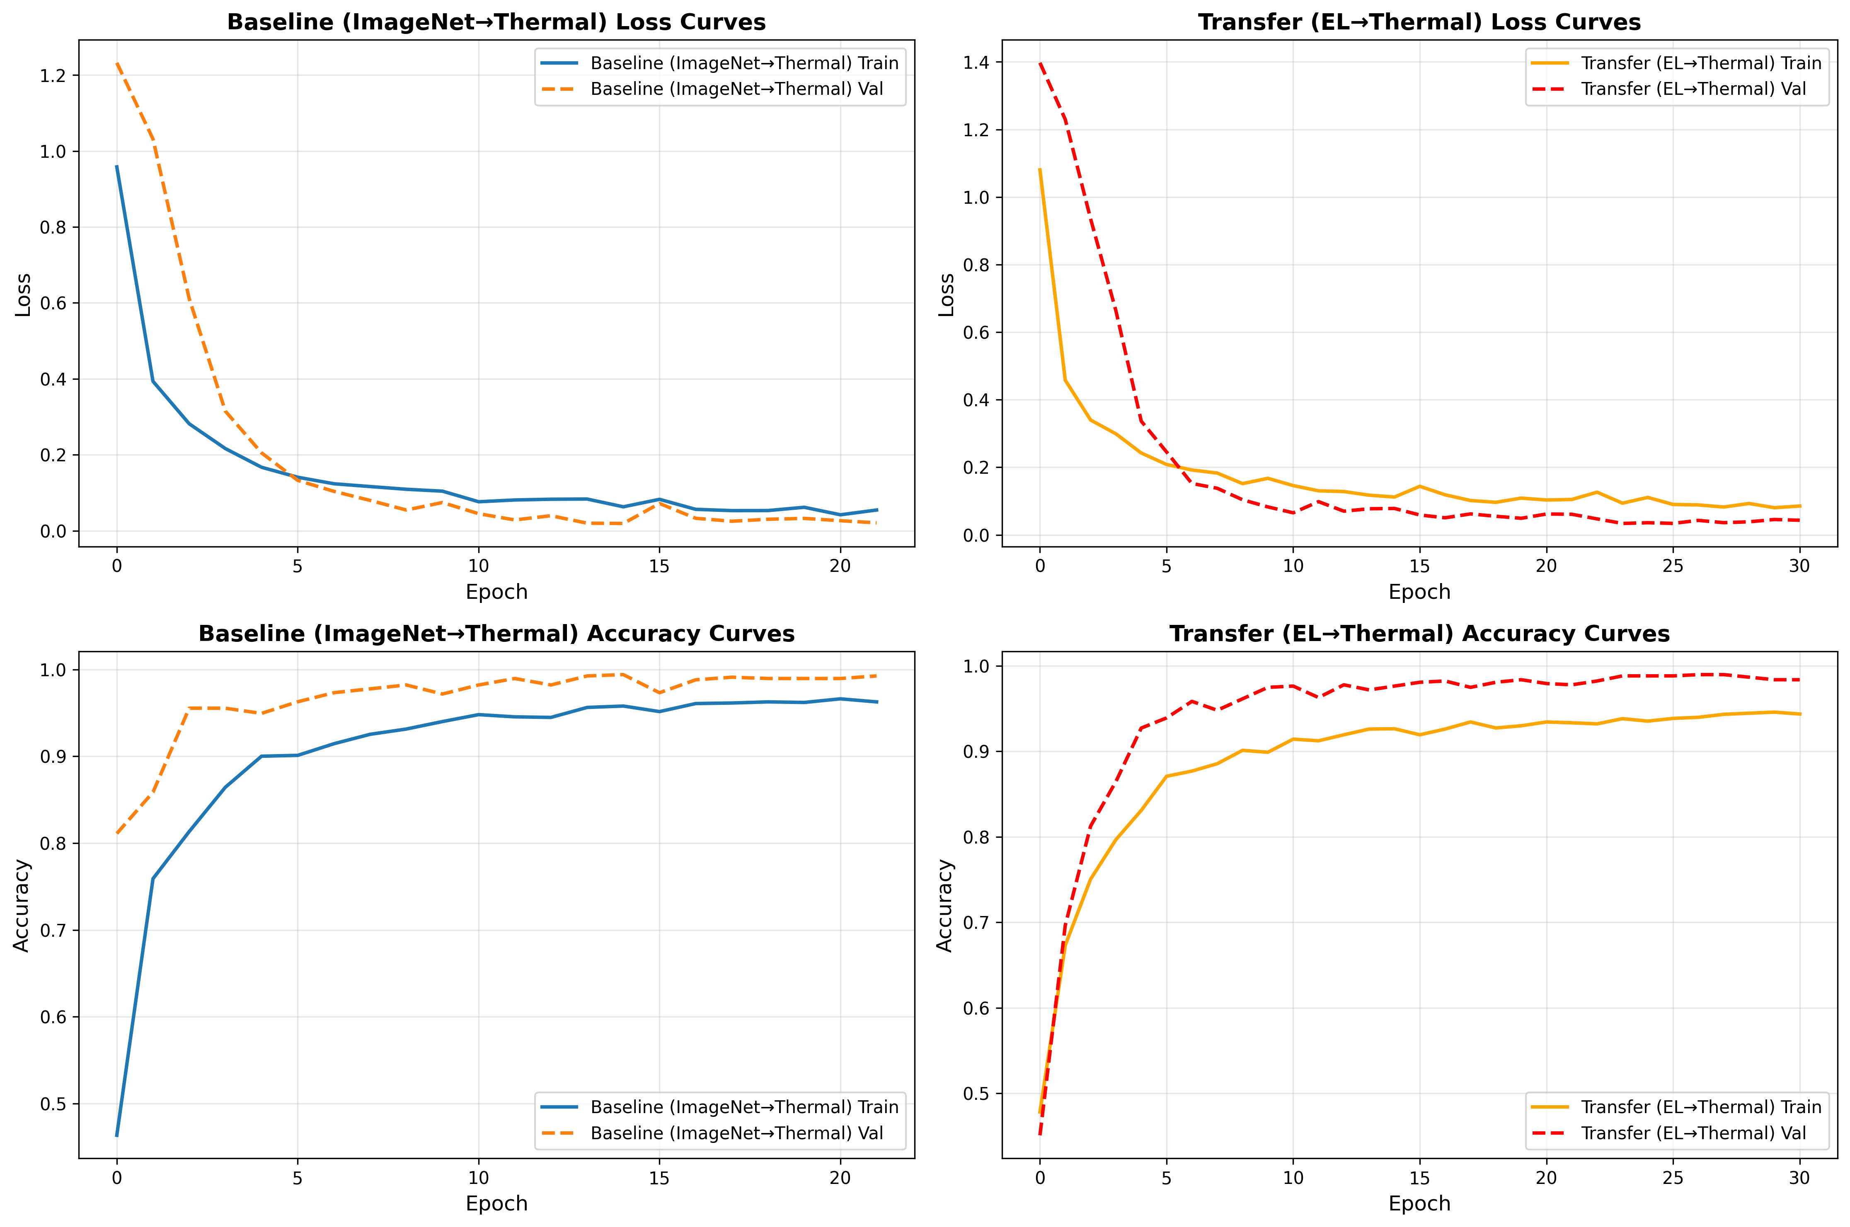
confusion_matrix.png
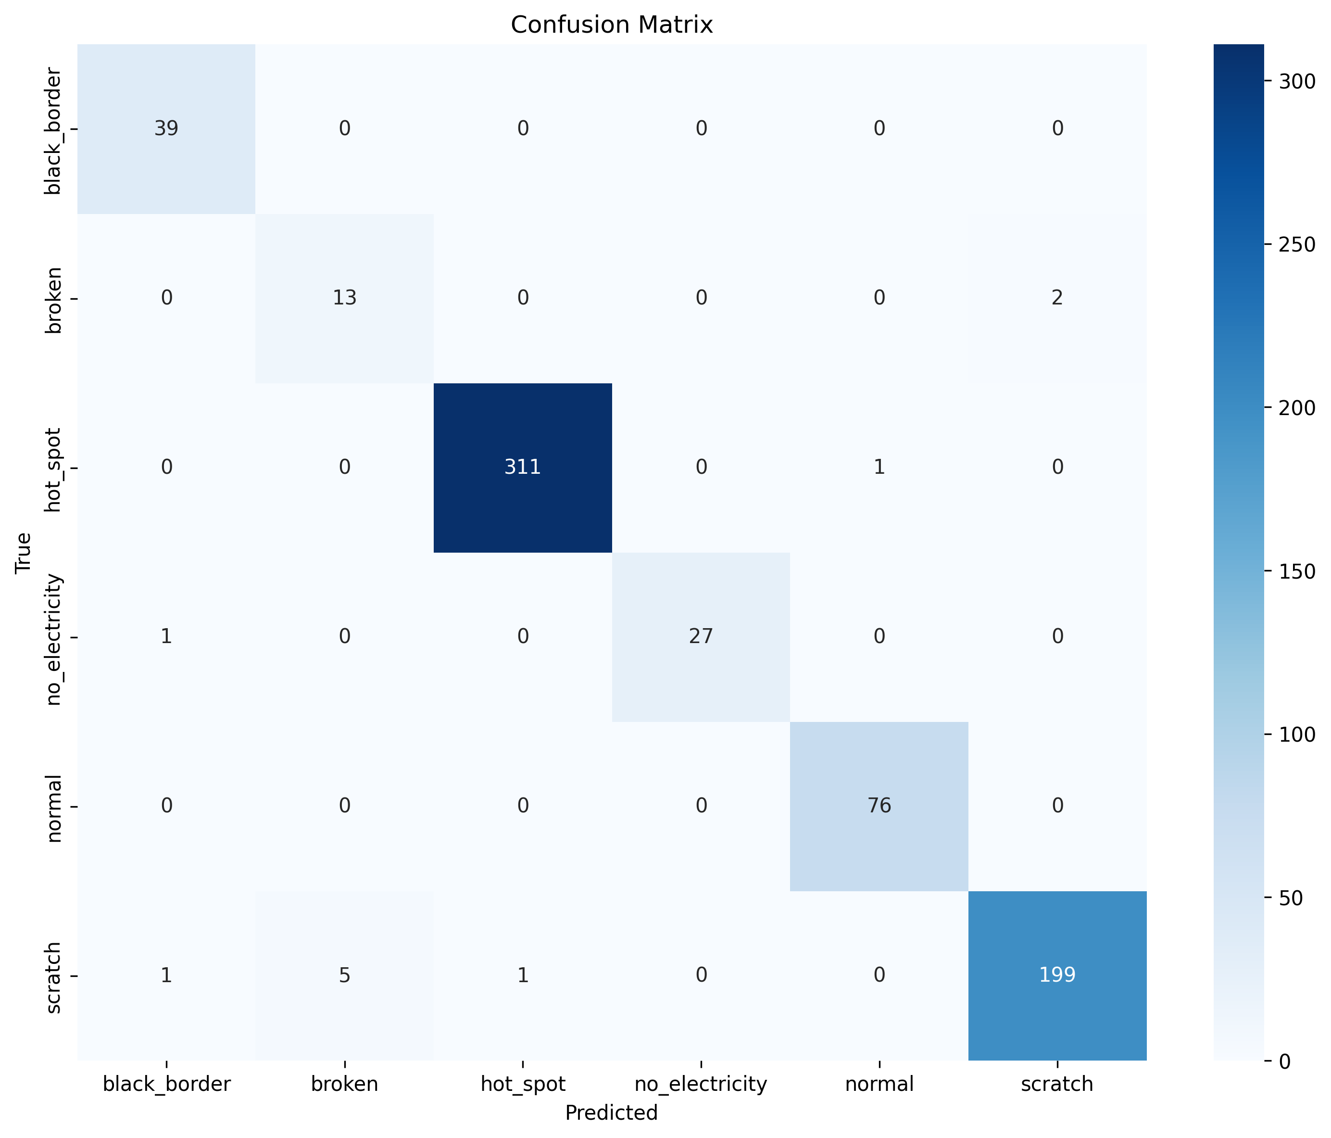
baseline_confusion_matrix.png
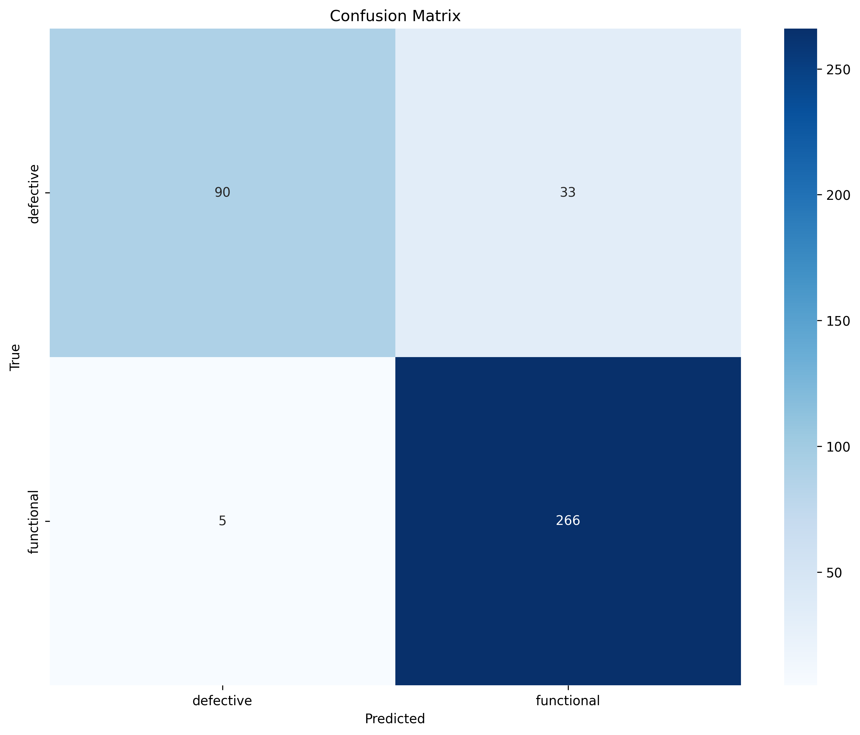
transfer_confusion_matrix.png
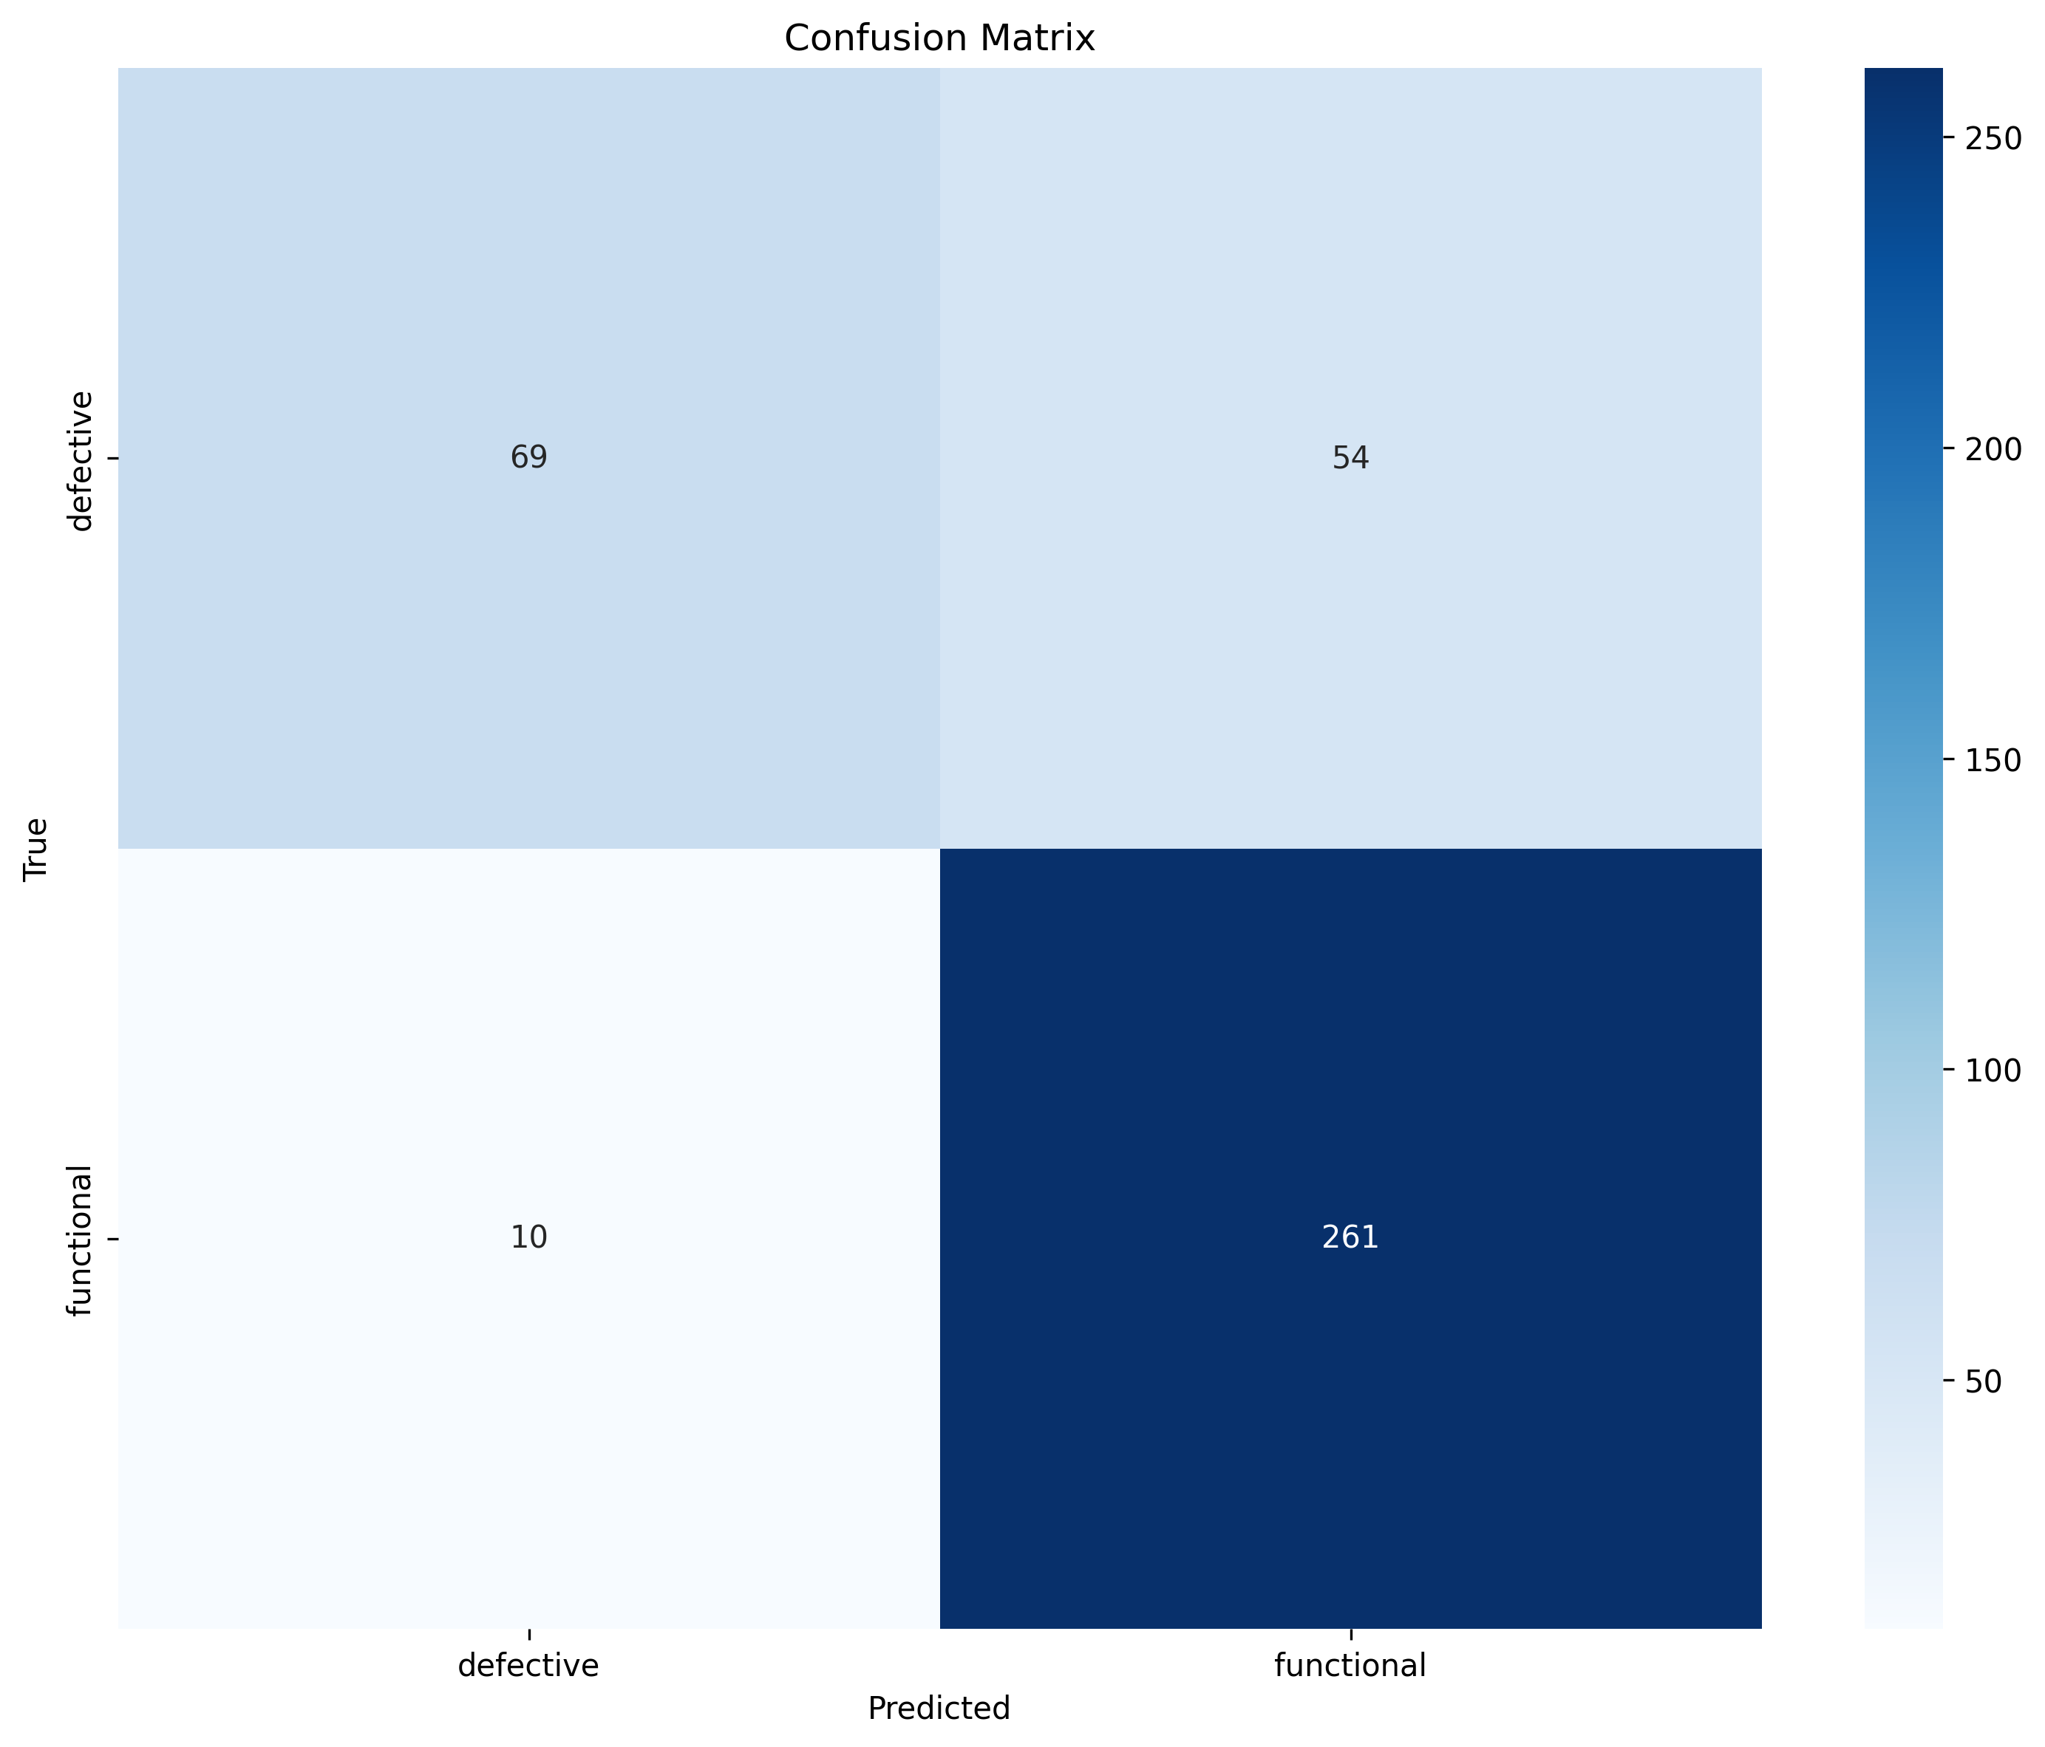
efficientnet_b1_confusion_matrix.png
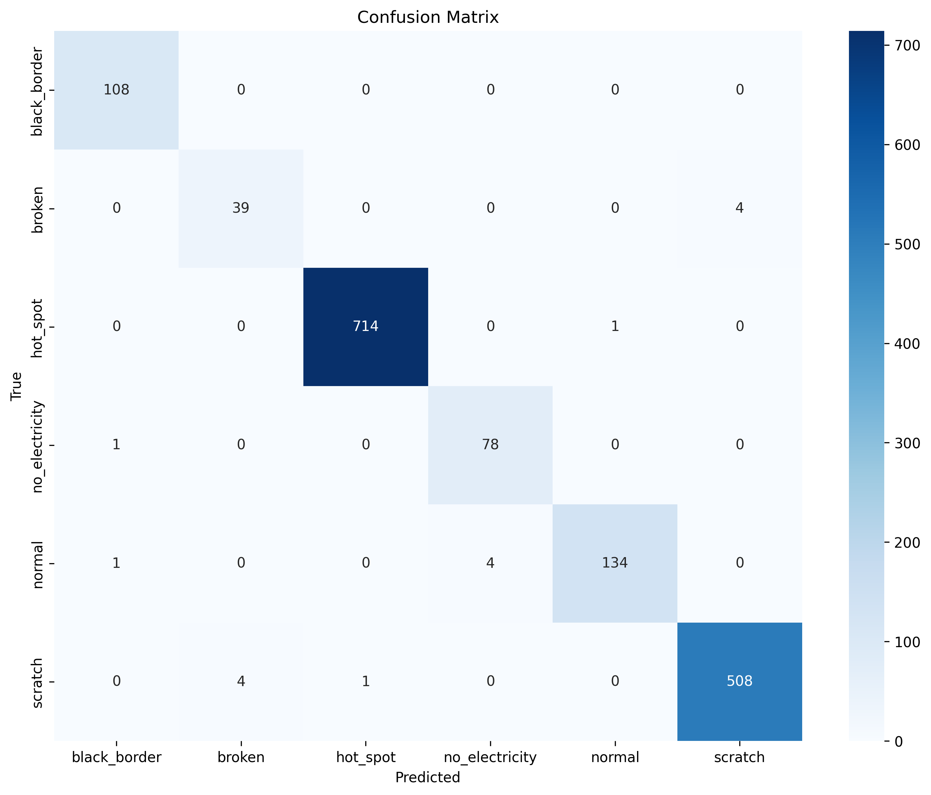
efficientnet_b3_confusion_matrix.png
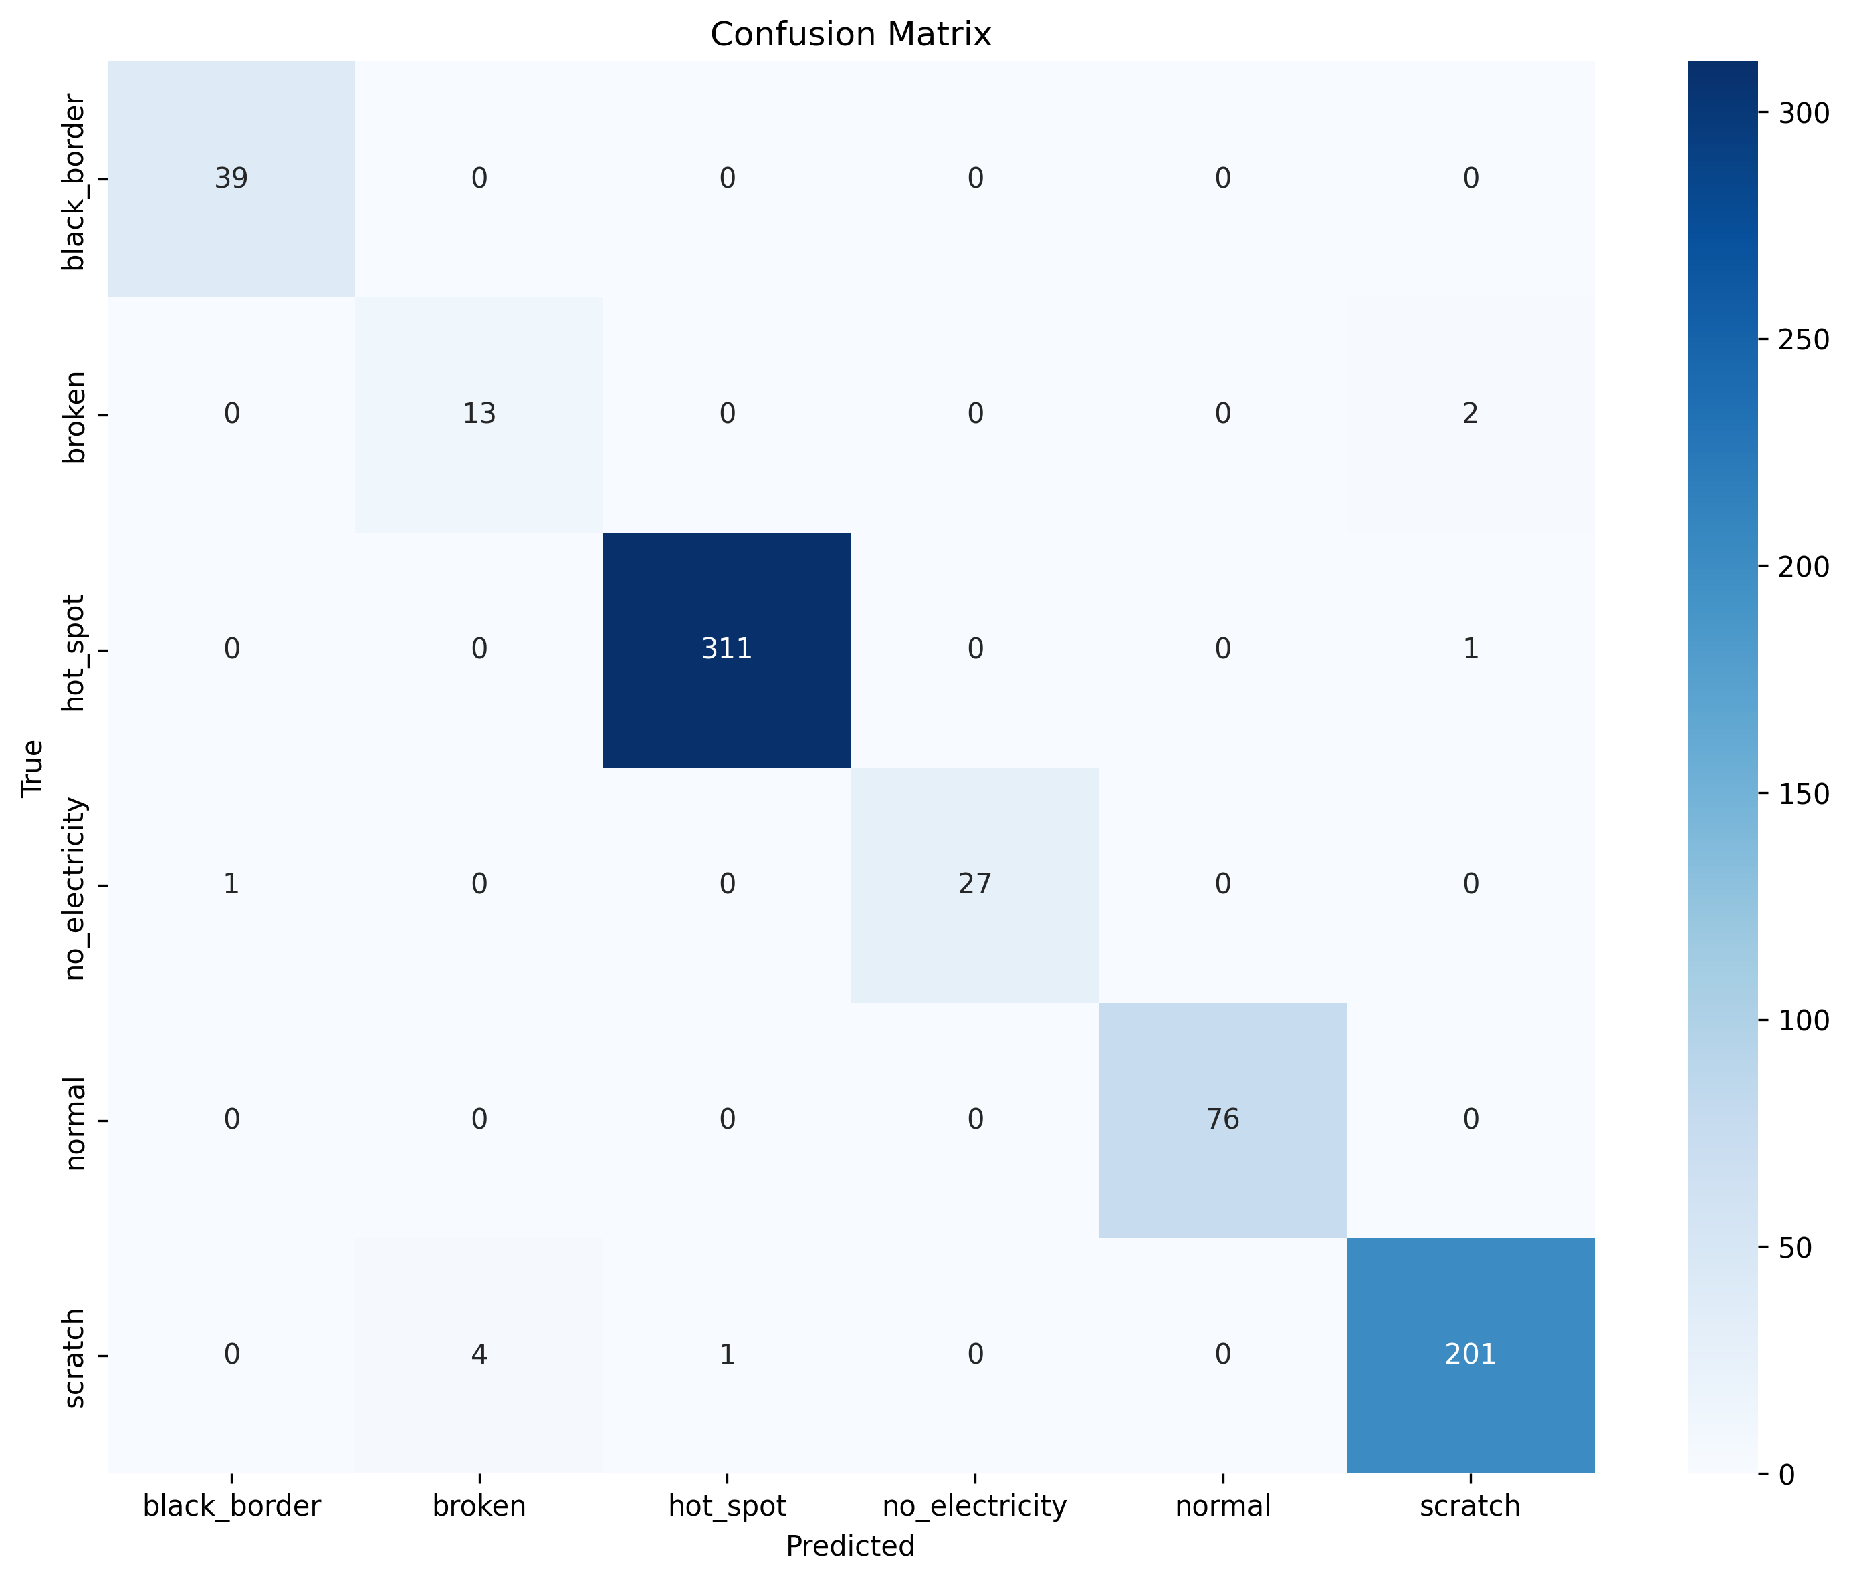
el_to_thermal_confusion_matrix.png
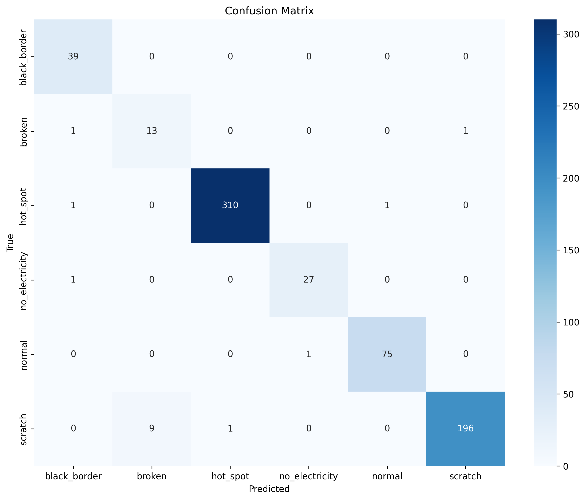
el_thermal_b1_transfer_confusion_matrix.png
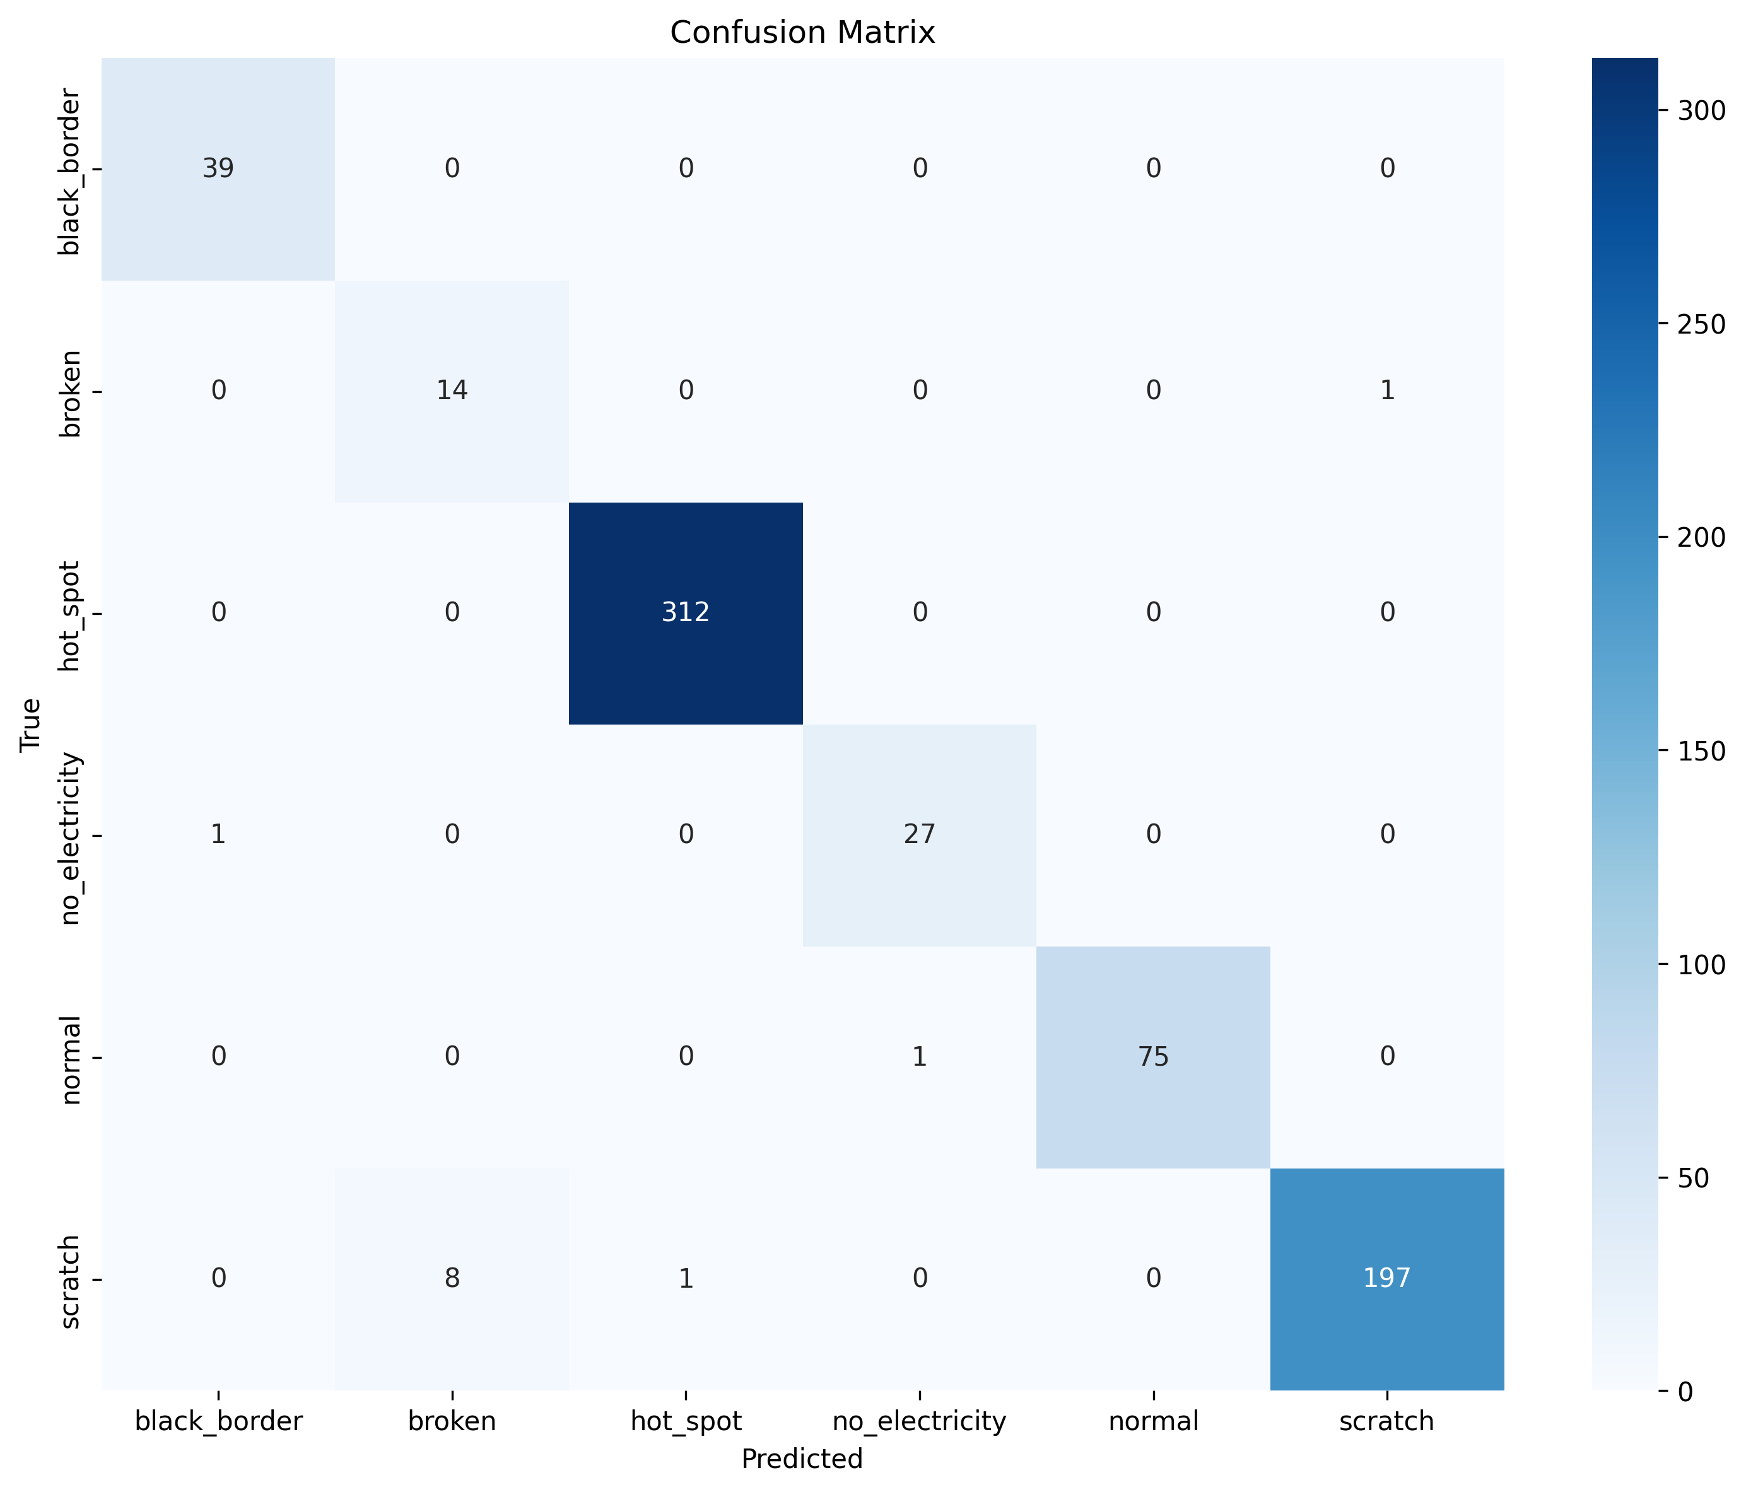
b1_baseline_vs_transfer_top2.png
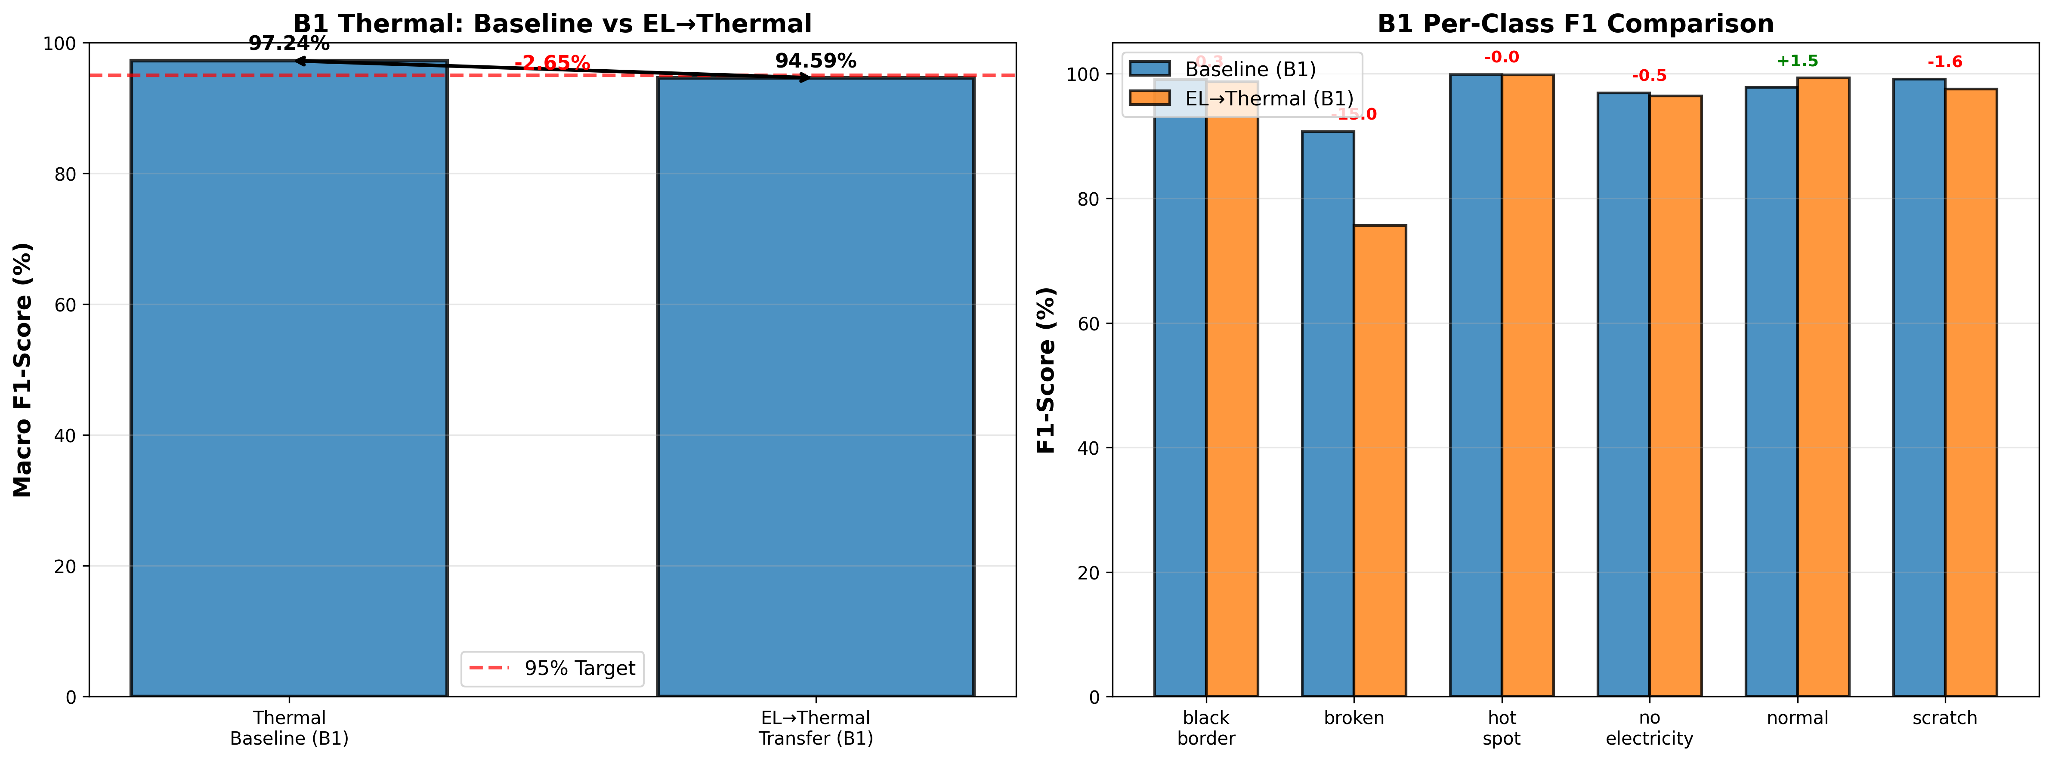
elpv_data_distribution.png
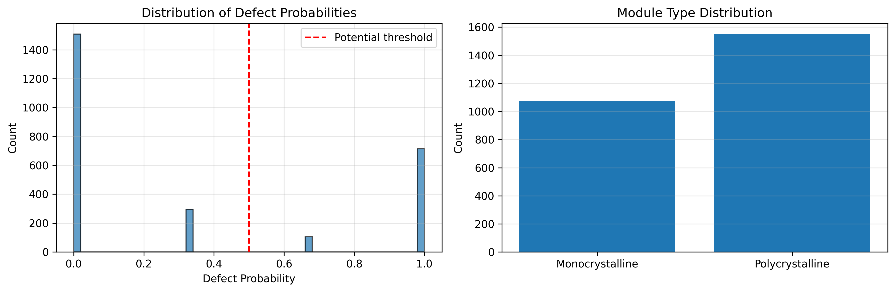
el_to_thermal_matched_aug_confusion_matrix.png
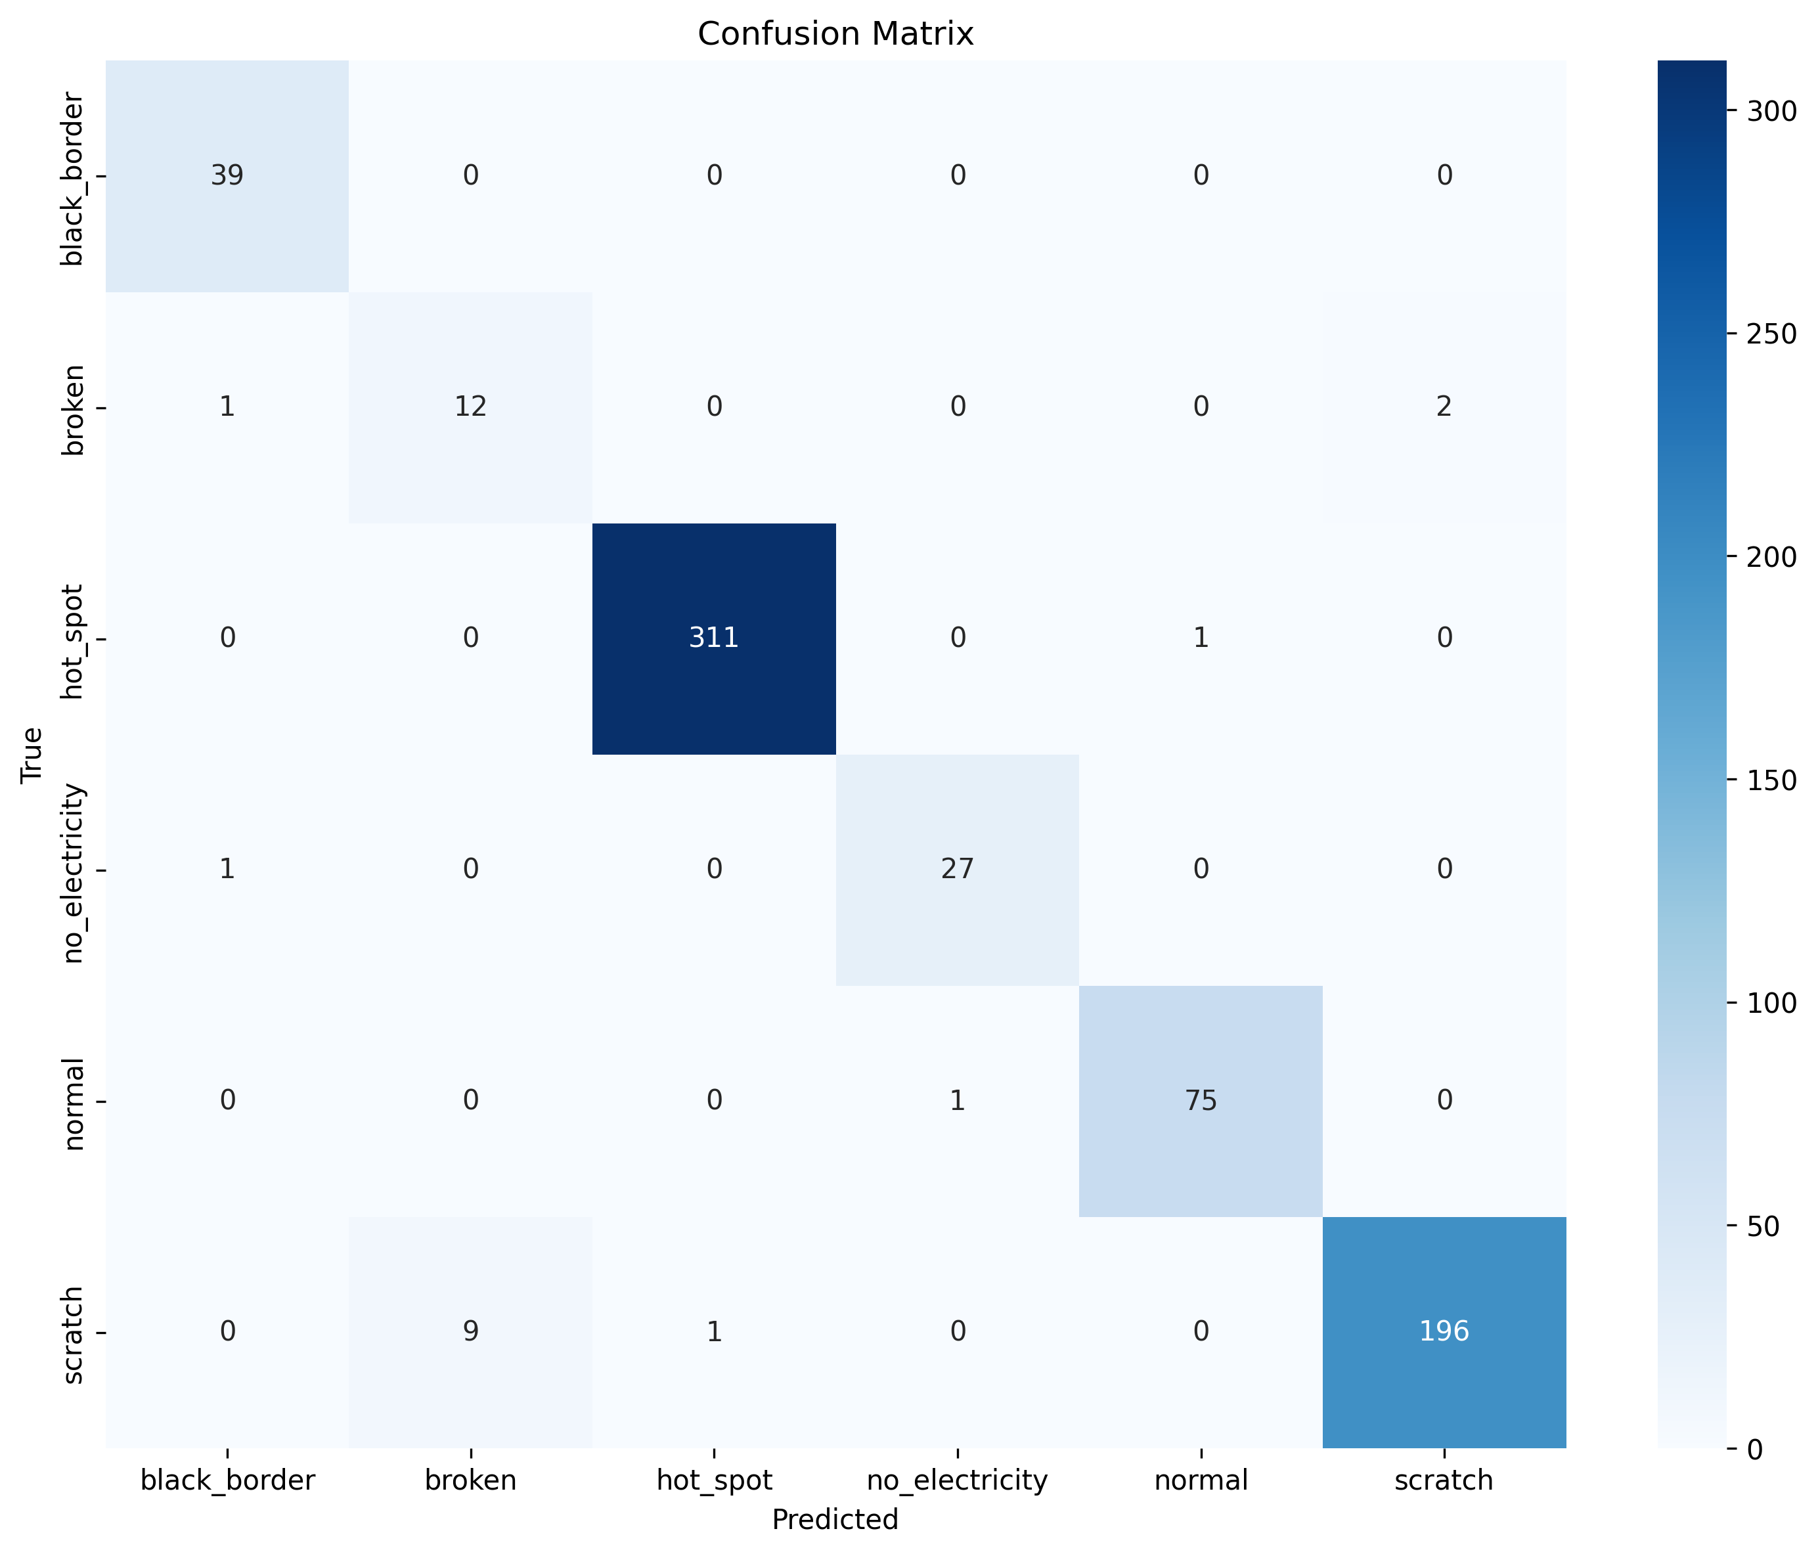
elpv_baseline_matched_confusion_matrix.png
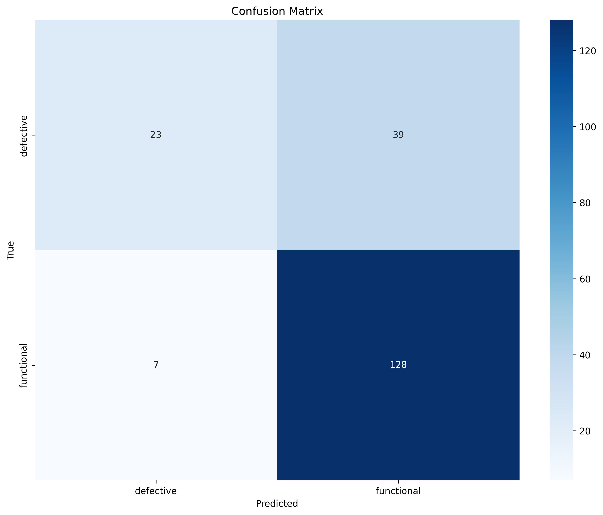
elpv_matched_aug_confusion_matrix.png
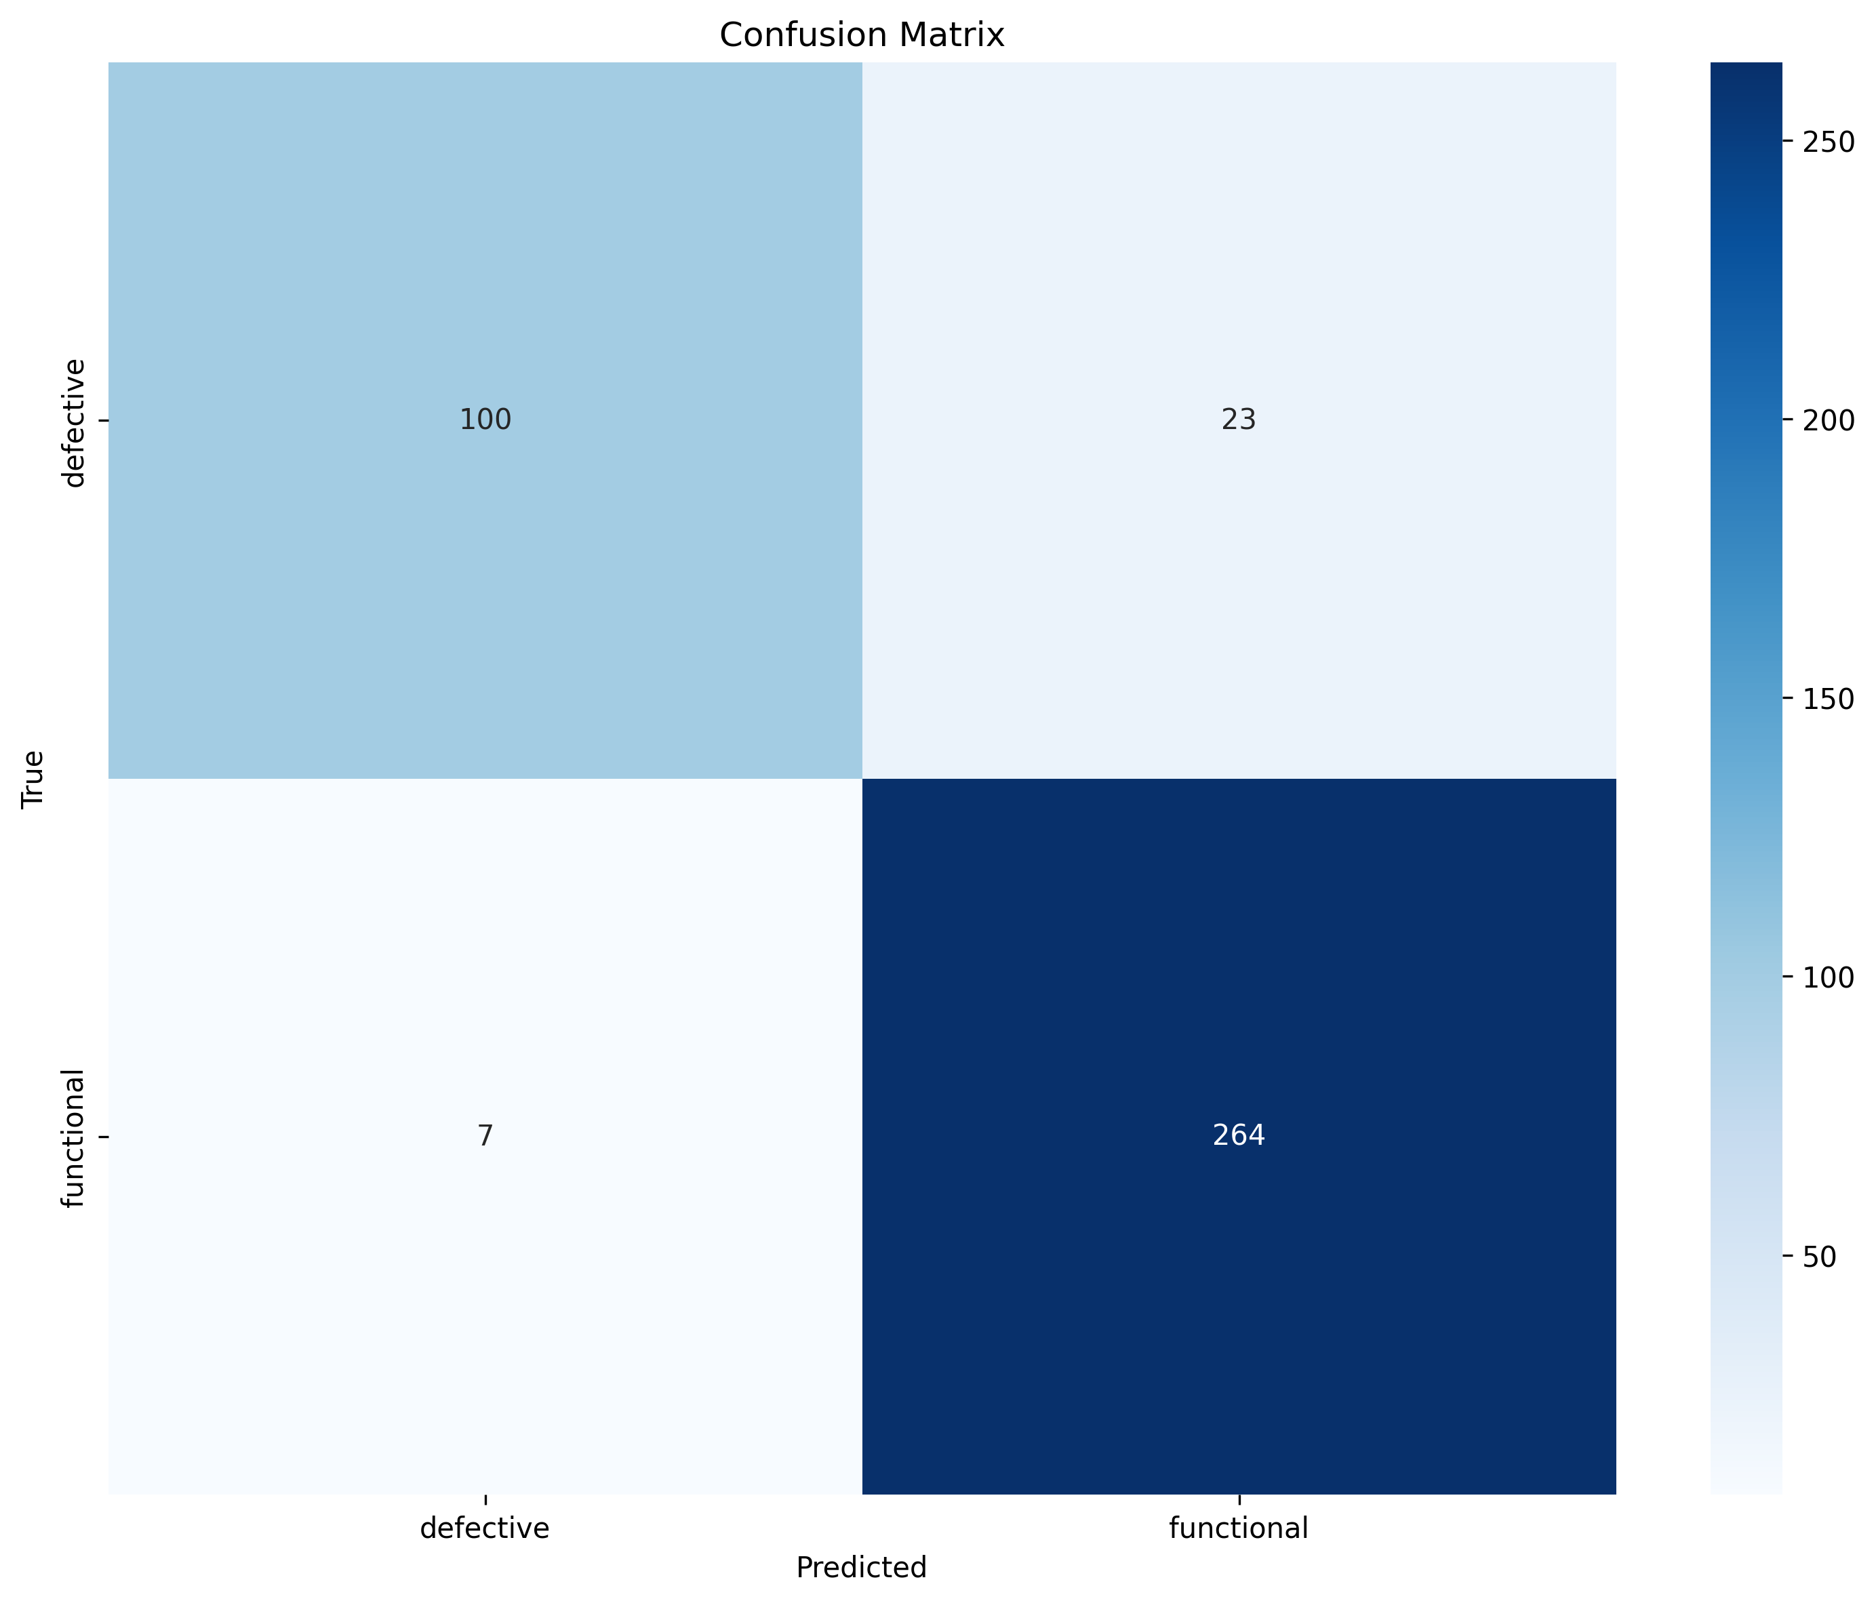

9. Auto-Summary (Generated)
This report aggregates baseline and transfer-learning experiments from the results directory. Baseline models measure thermal-only performance (ImageNet initialization → thermal training), while transfer models evaluate cross-modal transfer from ELPV (EL images) to thermal defect classification. Use the tables above (test accuracy + macro F1) and the comparison plots/confusion matrices to justify generalization behavior, failure modes, and whether transfer approaches baseline performance as model capacity increases.

