**Introduction**

The importance of placement system is increasing day by day, but applicants are facing so many problems. This project is an attempt to minimize the problems of an applicant to find a correct job. An online job portal only for the students of UIU.A web-based application which brings the right recruiters and right job seekers meet.

**Why this project?**

Can be used widely by job seekers to find suitable job matching their skills. The students will not need to search multiple websites as all the Engineering jobs will be listed in this single website. To get an idea about the current state of job market . To help the users to know about their preferred job field. To know which skills are required by the employers.

**Modules**

* User Profile
* Jobs
* Workshops
* Alumni
* Ask and Answer Forum

**User Profile**

* Create and Edit profile information
* Post Resume
* Search preferred jobs as per his/her area of interest
* Apply for jobs
* Receive email alerts on acceptance of Resume by the employers
* **Participants-** Job seekers, Employers

**Jobs**

* Show list of jobs available
* Search by Skills
* Filters-
  + Degree - Bachelor of Science, Master of Science, Doctor of Philosophy
  + Department - Computer Science and Engineering, Electrical and Electronic Engineering
  + Field -Web development, Networking, Software, IT etc.
* Sort by- Hot jobs ( the field in which no. of jobs is greater, will appear earlier in the job list )
* **Participants-** Users (Students/ Alumni), Admin

**Workshops**

* Show list of workshops in upcoming days
* Sort by relevant fields
* Register for the workshops (if needed)
* Get notifications of workshops on interested fields
* **Participants-** Users (Students/Job seekers), Admin

**Alumni**

* Show the list of UIU students and Alumni in different job sectors
* Apply for jobs through Alumni
* **Participants-** Users (Students, Alumni), Admin

**Ask and Answer Forum**

* A plot for the users to ask questions to know about their interested areas
* The Admin and Alumni can give answers to the questions
* The users can also reply
* Multiple answers may be given to a single question
* **Participants-** Users (Students, Alumni), Admin

**Results**

* **User Profile** 
  + The users will be able to describe their skills so that they can find job circulars matching with their skills
  + The employers will be able to see the resumes and profiles of the applicants and select the one that matches their requirements
* **Jobs**
  + Increased filtering
  + See only the jobs in interested fields rather than irrelevant jobs
  + Get an idea about jobs that have better opportunities
* **Workshops**
  + To remain up-to-date with the events, workshops, training programs or seminars on their interested fields
* **Alumni**
  + Get an idea about the job placements of UIU students and Alumni
  + Get motivated to work in different fields of job
* **Ask and Answer forum**
  + To create a plot for the Users to ask questions on their preferred fields
  + To provide solutions to their confusions
  + To make them aware about the real conditions of the corporate world through discussing with the experienced people

**Future Plans**

* To fetch jobs from all the available job portals within the country
* To avoid duplication of jobs
* To handle the security issues
* To create a module for Employers

**Data Flow Diagram**

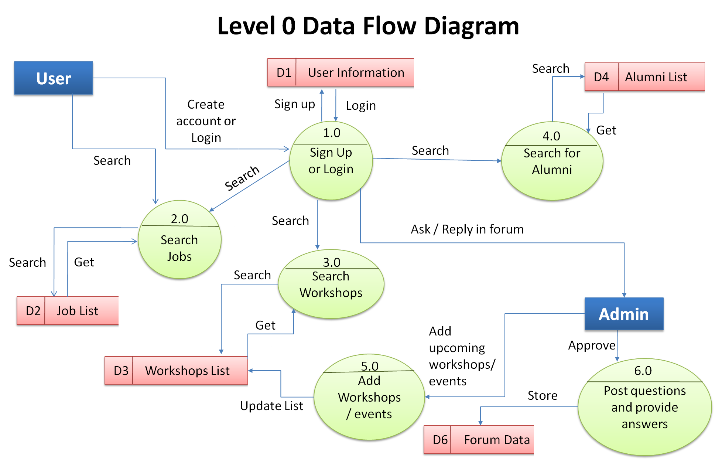

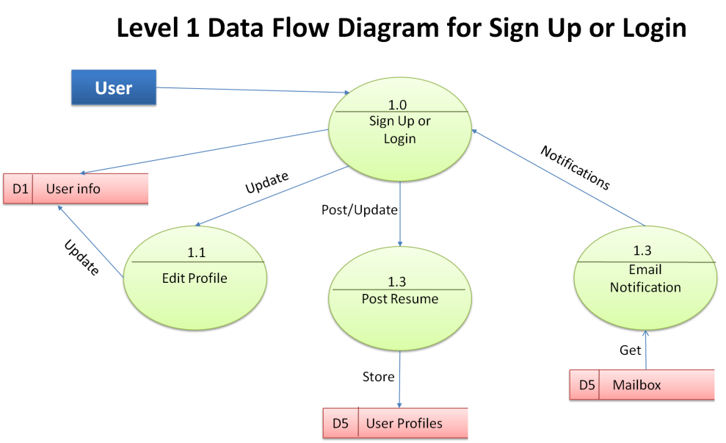

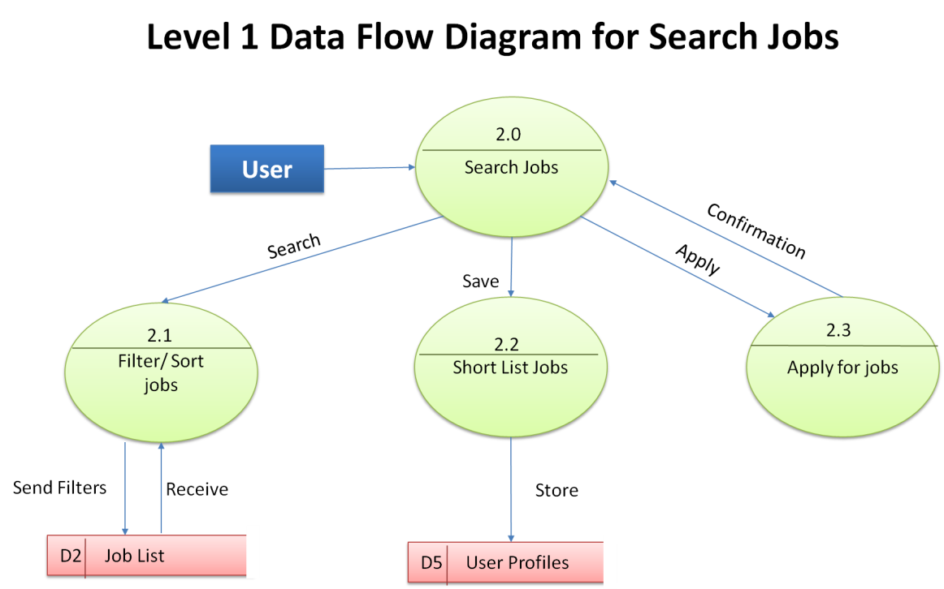

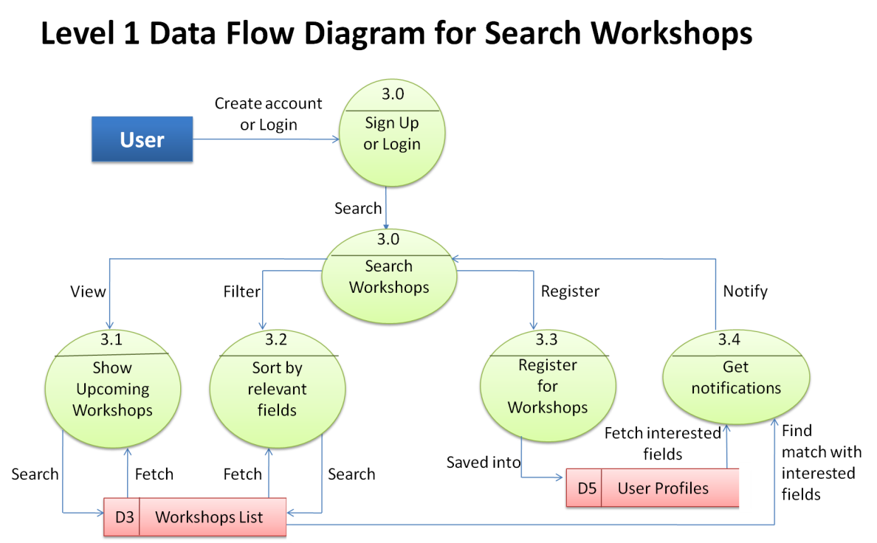

**Use Case**

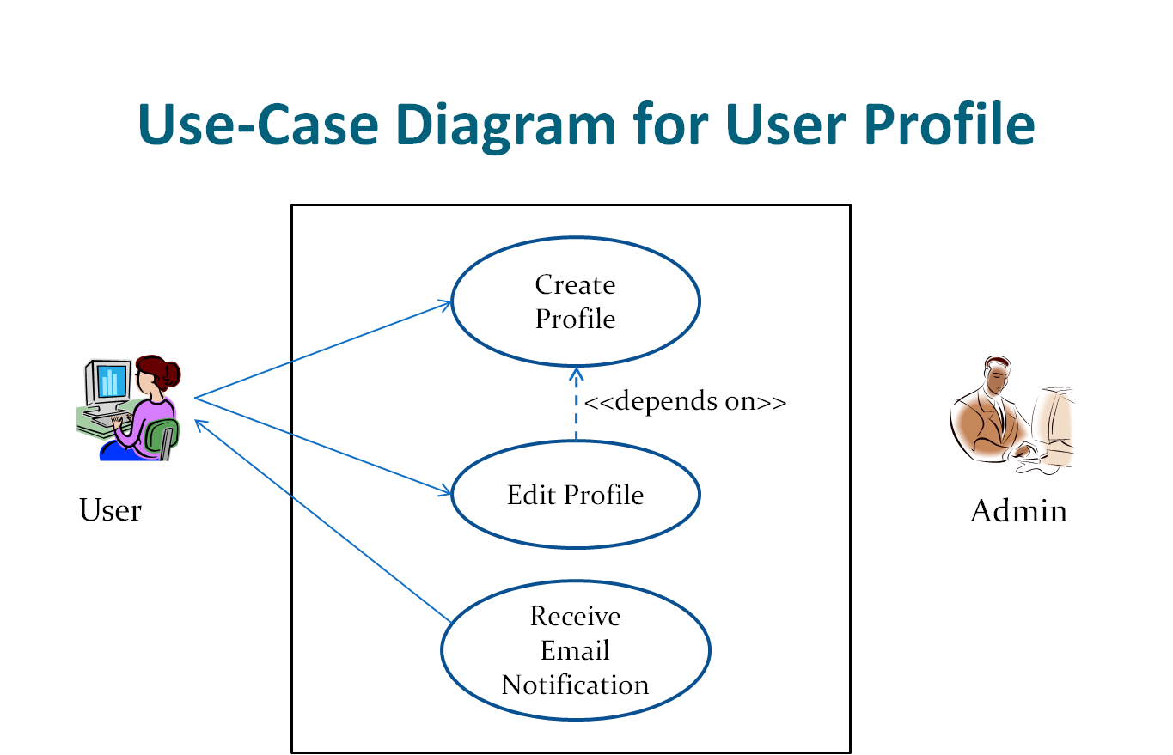

**1.1 CREATE PROFILE**

|  |  |
| --- | --- |
| Use-Case Name | Create Profile |
| Use-Case ID | 1.1 |
| Priority | High |
| Description | User signs up (creates profile) in the website to access other features rather than only searching jobs |
| Trigger | User |

**1.1 TYPICAL COURSE OF EVENTS**

|  |  |
| --- | --- |
| **Actor Actions** | **System Response** |
| 1. Selects Sign Up option | 2. Shows the Sign Up page |
| 3. Provides necessary information in the input fields |  |
| 4. Submit | 5. Receives submission request |
|  | 6. Profile created successfully |
| 8. View Homepage | 7. Shows Homepage |

**1.1 ALTERNATE COURSE OF EVENTS**

|  |  |
| --- | --- |
| **Actor Actions** | **System Response** |
| 1. User tries to sign up providing invalid input or leaving any compulsory field empty | 2. Denies submission |
|  | 3. Shows error message indicating necessary corrections |
| 4.Provides valid input and resubmits filling all compulsory fields | 5. Receives submission request |
|  | 6. Profile created successfully |

**1.2 EDIT PROFILE**

|  |  |
| --- | --- |
| **Use-Case Name** | **Edit Profile** |
| Use-Case ID | 1.2 |
| Priority | Medium |
| Description | User edits profile to update profile information |
| Trigger | User |

**1.2 TYPICAL COURSE OF EVENTS**

|  |  |
| --- | --- |
| **Actor Actions** | **System Response** |
| 1. Selects Edit Profile option | 2. Shows the Edit Profile page |
| 3. Updates information and submits | 4. Receives submission request |
|  | 5. Profile edited successfully |

**1.2. Alternate Course of events**

|  |  |
| --- | --- |
| **Actor Action** | **System Response** |
| 1. User tries edit profile providing invalid input or leaving any compulsory field empty. | 2. Denies submission |
|  | 3. Shows error message indicating necessary corrections. |
| 4.Provieds valid input and resubmits filling all compulsory fields | 5. Receives submission request |
|  | 6. Profile edited successfully |

**1.3 RECEIVE EMAIL NOTIFICATION**

|  |  |
| --- | --- |
| **Use-Case Name** | **Receive Email Notification** |
| Use-Case ID | 1.3 |
| Priority | High |
| Description | User receives email notification whenever any of his/her application is accepted by any employer/company |
| Trigger | System |

**1.3 TYPICAL COURSE OF EVENTS**

|  |  |
| --- | --- |
| **Actor Actions** | **System Response** |
|  | 1. System gets to know whenever any application is accepted |
|  | 2. Sends message to user’s email account as well as user profile |
| 3. Receives notification in email account as well as job portal account |  |

**1.3 ALTERNATE COURSE OF EVENTS**

|  |  |
| --- | --- |
| **Actor Actions** | **System Response** |
|  | 1. May not know about application acceptance or message may not be sent due to system failures |
| 2. Does not receive any notification |  |
|  | 3. Recover from system failures and resend message |
|  | 4. Message sent successfully |
| 5. Receive notification in email account as well as user account in job portal |  |
| 6. If notification not received within 24 hours, receives email from the Employee/Organization |  |

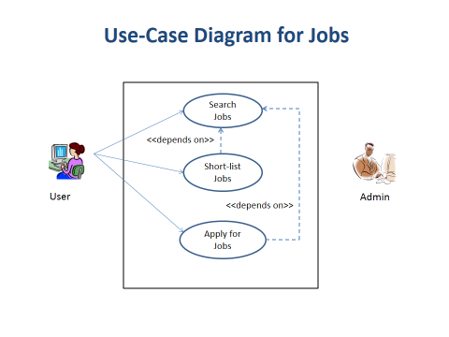

**2.1 SEARCH JOBS**

|  |  |
| --- | --- |
| **Use-Case Name** | **Search Jobs** |
| Use-Case ID | 2.1 |
| Priority | High |
| Description | User searches for jobs providing filters according to their will. They can also sort the jobs by their desirable sequence. |
| Trigger | User |

**2.1 TYPICAL COURSE OF EVENTS**

|  |  |
| --- | --- |
| **Actor Actions** | **System Response** |
| 1. Provide filters and/or sorting options and search for jobs |  |
|  | 2. Fetches jobs according to the filters provided, sorts the job list by user’s desired sequence (if provided) |
|  | 3. Shows job list |
| 4. View job list |  |
| Alternative Course of Events | Filters might not work correctly and might fetch unnecessary/unwanted jobs |

**2.2 SHORT-LIST JOBS**

|  |  |
| --- | --- |
| **Use-Case Name** | **Short-List Jobs** |
| Use-Case ID | 2.2 |
| Priority | Medium |
| Description | User can short-list any job they like so that they can view or apply for them whenever they want |
| Trigger | User |
| Typical Course of Events | User selects Short-List Job option for their desired job and the system saves the job in the database |

**2.3 APPLY FOR JOBS**

|  |  |
| --- | --- |
| **Use-Case Name** | **Apply for Jobs** |
| Use-Case ID | 2.3 |
| Priority | High |
| Description | User can apply for any job within the deadlines |
| Trigger | User |

**2.3 TYPICAL COURSE OF EVENTS**

|  |  |
| --- | --- |
| **Actor Actions** | **System Response** |
| 1. User applies for his/her selected job |  |
|  | 2. Sends application to the Employer/Company |
|  | 3. Sends confirmation to the User |
| 4. Receives confirmation |  |

**2.3 ALTERNATE COURSE OF EVENTS**

|  |  |
| --- | --- |
| **Actor Actions** | **System Response** |
|  | 1. May not send application due to system failures |
|  | 2. Sends error message to the user |
| 3. Receives error message |  |
| 4. Re-apply | 5. Resend application |
|  | 6. If sent successfully, sends confirmation to the User |
| 7. Receive confirmation |  |

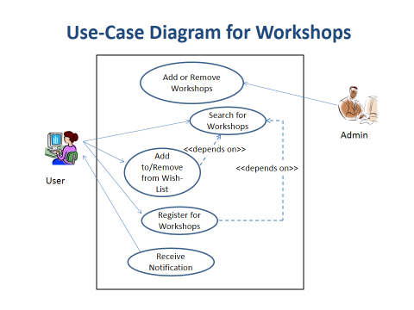

**3.1 ADD OR REMOVE WORKSHOPS**

|  |  |
| --- | --- |
| **Use-Case Name** | **Add or Remove Workshops** |
| Use-Case ID | 3.1 |
| Priority | High |
| Description | Admin adds or removes workshops to the database |
| Trigger | Admin |

**3.1 TYPICAL COURSE OF EVENTS**

|  |  |
| --- | --- |
| **Actor Actions** | **System Response** |
| 1. Admin logs in |  |
| 2. Add workshops to/ remove from the workshop list |  |
|  | 3. Update workshop list on database |
|  | 4. Send confirmation |
| 5. Receive confirmation |  |

**3.1 ALTERNATE COURSE OF EVENTS**

|  |  |
| --- | --- |
| **Actor Actions** | **System Response** |
|  | 1. May not update because of system failure |
| 2. Receives error message |  |
| 3. Try to update again |  |
|  | 4. Receives request and tries to recover from system failure |
|  | 5. If updated successfully, sends confirmation to the admin |
| 7. Receives confirmation |  |

**3.2 SEARCH FOR WORKSHOPS**

|  |  |
| --- | --- |
| **Use-Case Name** | **Search for workshops** |
| Use-Case ID | 3.2 |
| Priority | High |
| Description | User searches for workshops. User can also provide interested field / keyword |
| Trigger | User |

**3.2 TYPICAL COURSE OF EVENTS**

|  |  |
| --- | --- |
| **Actor Actions** | **System Response** |
| 1.Search for workshops |  |
|  | 2. Fetch workshops from database, filter if keyword provided |
|  | 3. Show workshop list |
| 4. View workshop list |  |

**3.2 ALTERNATE COURSE OF EVENTS**

|  |  |
| --- | --- |
| **Actor Actions** | **System Response** |
| 1. Gets ‘No workshops found’ message. |  |
|  | 2.System suggests other workshops related to user’s Wish-list |
| 3. View suggested workshop list |  |

. **3.3 ADD TO OR REMOVE FROM WISH-LIST**

|  |  |
| --- | --- |
| **Use-Case Name** | **Add to wish list** |
| Use-Case ID | 3.3 |
| Priority | High |
| Description | User Adds/ Removes workshop to his/her Wish-list |
| Trigger | User |

**3.3 TYPICAL COURSE OF EVENTS**

|  |  |
| --- | --- |
| **Actor Actions** | **System Response** |
| 1. Adds workshop to or Removes from Wish-list |  |
|  | 2.Updates the Wish-list on database |
|  | 3. Sends confirmation |
| 4. Receives confirmation |  |

**3.4 REGISTER FOR WORKSHOPS**

|  |  |
| --- | --- |
| **Use-Case Name** | **Register for Workshops** |
| Use-Case ID | 3.4 |
| Priority | Medium |
| Description | User registers for workshops |
| Trigger | User |

**3.4 TYPICAL COURSE OF EVENTS**

|  |  |
| --- | --- |
| **Actor Actions** | **System Response** |
| 1. Fills up Registration Form and Submits |  |
|  | 2. Receives request |
|  | 3. Approves request and sends confirmation to the User and the Event Organization |
| 4. Receives confirmation |  |

**3.4 ALTERNATE COURSE OF EVENTS**

|  |  |
| --- | --- |
| **Actor Actions** | **System Response** |
| 1. Submits Registration Form leaving any compulsory field empty or providing invalid input | 2. Denies submission |
|  | 3. Shows error message indicating necessary corrections |
| 4. Receives error message and Resubmits providing necessary inputs |  |
|  | 5. Receives request |
|  | 6. Accepts request and sends confirmation |
| 7. Receives confirmation |  |

**3.5 RECEIVE NOTIFICATION**

|  |  |
| --- | --- |
| **Use-Case Name** | **Receive Notification** |
| Use-Case ID | 3.5 |
| Priority | High |
| Description | User gets notification about any upcoming events/workshops that are related to their interested fields provided in their profiles |
| Trigger | System |

**3.5 TYPICAL COURSE OF EVENTS**

|  |  |
| --- | --- |
| **Actor Actions** | **System Response** |
|  | 1. Gets to know about any upcoming event/workshop on User’s interested field |
|  | 2. Notify User about the suggested workshops and/or about the workshops saved in the User’s Wish-List |
| 3. Receives notifications |  |

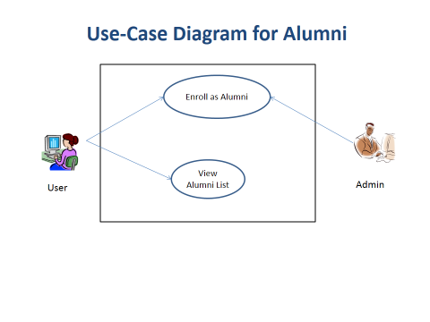

**4.1 ENROLL AS ALUMNI**

|  |  |
| --- | --- |
| **Use-Case Name** | **Enroll As Alumni** |
| Use-Case ID | 4.1 |
| Priority | Medium |
| Description | User enrolls as Alumni to stay connected |
| Trigger | User |

**4.1 TYPICAL COURSE OF EVENTS**

|  |  |
| --- | --- |
| **Actor Actions** | **System Response** |
| 1. Enroll as Alumni |  |
|  | 2. Receives request |
|  | 3. Approves request and sends confirmation to the user |
| 4. Receives confirmation |  |

**4.1 ALTERNATE COURSE OF EVENTS**

|  |  |
| --- | --- |
| **Actor Actions** | **System Response** |
| 1. Submits Enrollment Form leaving any compulsory field empty or providing invalid input | 2. Denies submission |
|  | 3. Shows error message indicating necessary corrections |
| 4. Receives error message and Resubmits providing necessary inputs |  |
|  | 5. Receives request |
|  | 6. Accepts request and sends confirmation |
| 7. Receives confirmation |  |

**4.2 VIEW ALUMNI LIST**

|  |  |
| --- | --- |
| **Use-Case Name** | **View Alumni List** |
| Use-Case ID | 4.2 |
| Priority | High |
| Description | Users can view the list of Alumni |
| Trigger | User |

**4.2 TYPICAL COURSE OF EVENTS**

|  |  |
| --- | --- |
| **Actor Actions** | **System Response** |
| 1. Requests to see the list of Alumni |  |
|  | 2. Receives request and shows list of Alumni from database |
| 3. View list of Alumni |  |

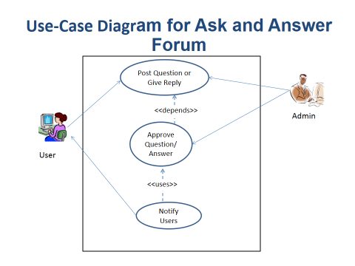

**5.1 POST QUESTION OR GIVE REPLY**

|  |  |
| --- | --- |
| Use-Case Name | Post Question Or Give Reply |
| Use-Case ID | 5.1 |
| Priority | Medium |
| Description | Users can request to post questions or give reply to asked questions. |
| Trigger | User |

**5.1 TYPICAL COURSE OF EVENTS**

|  |  |
| --- | --- |
| **Actor Actions** | **System Response** |
| 1. Post question to the Forum |  |
|  | 2.Receives request and sends request to the Admin for approval |
| 3. View question and/or answer if approved by the Admin |  |
| Alternate Course of Events | Posting question/reply can be delayed during inactive phase of the Admin |

**5.2 APPROVE QUESTION / ANSWER**

|  |  |
| --- | --- |
| **Use-Case Name** | **Approve Question/ Answer** |
| Use-Case ID | 5.2 |
| Priority | High |
| Description | Admin approves or discards requests to post question or answer |
| Trigger | Admin |

**5.2 TYPICAL COURSE OF EVENTS**

|  |  |
| --- | --- |
| **Actor Actions** | **System Response** |
|  | 1. Receives request from user and send request to Admin for approval |
| 2.Receives request and approves |  |
|  | 3. Question/ Answer posted successfully |

**5.2 ALTERNATE COURSE OF EVENTS**

|  |  |
| --- | --- |
| **Actor Actions** | **System Response** |
|  | 1. Receives request from the user and sends request to the Admin for approval |
| 2. Receives requests | 3. Requests will be buffered until Admin’s approval |

**5.3 Notify Users**

|  |  |
| --- | --- |
| **Use-Case Name** | **Notify Users** |
| Use-Case ID | 5.3 |
| Priority | High |
| Description | Users will get notification when any question is posted or any reply is given to their asked question |
| Trigger | System |

**5.3 TYPICAL COURSE OF EVENTS**

|  |  |
| --- | --- |
| **Actor Actions** | **System Response** |
|  | 1.Send notifications to users when any question is posted |
| 2. .Receive notifications |  |
|  | 3. If any reply is given, notify the User who has asked the question |
| 4. Receive notifications |  |