

**Dharmsinh Desai University, Nadiad**

**Faculty of Technology**

**Department of Computer Engineering**

**B. Tech. CE Semester – VI**

Subject: (CE – 620) **Object Oriented Software Engineering**

Project Title**: *Coursera***

By:

Name: **Vishnu H. Paregi**

Roll No: **CE076**

ID: **17CEUSF133**

Name: **Muktan R. Patel**

Roll No: **CE091**

ID: **17CEUOS118**

Guided By:

**Prof. Pinkal C. Chavda**

Asst. Professor, CE Dept.,

Dharmsinh Desai University



Dharmsinh Desai University, Nadiad

Faculty of Technology, Department of Computer Engineering

**CERTIFICATE**

This is to certify that Advanced Technologies project entitled “**Coursera**” is the bonafied report of work carried out by

1. **Paregi Vishnu H. (17CEUSF133)**

**2)** **Patel Muktan R. (17CEUOS118)**

Of Department of Computer Engineering, Semester VI, academic year 2019-20,

under our supervision and guidance.

|  |  |
| --- | --- |
| Guide | HOD |
|  |  |
| **Prof. Pinkal C. Chavda** | **Dr. C. K. Bhensdadia** |
| Assistant Professor of | Head of the Department of |
| Department of Computer | Department of Computer |
| Engineering, Dharmsinh Desai University, Nadiad. | Engineering, Dharmsinh Desai University, Nadiad. |

**Overview**

**Coursera** is the learning platform where course Tutors/Organisation from various regions can uploads courses and decide fees for that courses and provide them to the learners. The students from various regions can buy the course and learn from it. User can buy any course for certificate along with learning or he/she can only learn that course without any charge by auditing the course.

**Content**

|  |  |  |
| --- | --- | --- |
| **1.** | **Introduction** |  |
| **2.** | **Software Requirement Specification** |  |
| **3.** | **Design Documents** |  |
| **4.** | **Implements Details** |  |
| **5.** | **Testing Details** |  |
| **6.** | **Work Flow** |  |
| **7.** | **Conclusion** |  |
| **8.**  **9.** | **Limitations and Future Extensions**  **Bibliography** |  |
|  |  |  |

**Introduction**

**Coursera is the platform which simply connects the tutors from various regions and students from various regions who want to learn new skills and get knowledge. Coursera provides facility to tutors to upload and manage their course materials on one platform and decide fees for their content on the other end students or say learners can buy or learn various courses from one platform and manage their progress.**

**Coursera provides dashboard for tutors to track their courses and students progress while students can develop their profile learning from coursera. Coursera also welcomes the organizations who have many tutors for one course or say team of tutors.**

***Technology Used:***

* **Windows form application for designing the desktop application.**
* **MSSQL database to save data.** into toggles

***Platform Used:***

* **Visual Studio 2017 as a platform to device the whole code.**

***Tools Used:***

* **We used Github as a version control method and to manage the project.**

**Software Requirement Specification**

**Coursera**

**R1 Manage user/admin/tutor/organisation account**

**R1.1 LOGIN**

**Description -** user enters the login credentials and user is allowed to access account if credentials are correct

**Input -** user credentials

**Output -** authentication message

**R1.2 SIGNUP**

**Description -** provided user credentials user account is created

**Input -** user credentials

**Output -** creation of user account

**R1.3 Edit Profile**

**Description -** changes in details of user credentials are given by user and respective changes are made in account by system

**Input -** user credential updates

**Output -** affirmation message

**R2 Search and audit Courses**

**R2.1 search by navigation**

**Input -** user selections

**Output -** navigated courses

**R2.2 search by keyword**

**Input -** user entered keyword

**Output -** relevant courses

**R2.3 View course**

**Input -** user selection

**Output -** course information

**R2.4 Audit course**

**Description -** user audits selected course so he/she can see the content of the course

**Input -** user selection

**Output -** unlocked course content

**R3 Buy course**

**R3.1 select course**

**Input -** filtering criteria

**Output -** filtered courses

**R3.2 pay for course**

**Input -** payment credentials

**Output -** affirmation and unlock course

**R4 User History/Progress**

**R4.1 completed courses**

**Input -** user selection

**Output -** list of inactive courses

**R4.2 active courses**

**Input -** user selection

**Output -** list of active courses

**R4.3 owned courses**

**Input -** user selection

**Output -** list of active courses

**R5 Feedback**

**Description -** give feedback and rating to the course

**Input -** user feedback and rating

**Output -** feedback submission alert

**R6 Add courses**

**R6.1 Review course info**

**Description -** review course information that consist course description, prerequisites and FAQs

**Input -** course info

**Output -** affirmation/rejection

**R6.2 Review course content**

**Description -** review course video or text content

**Input -** course content

**Output -** affirmation/rejection

**R6.3 Add reviewed course**

**Input -** admin click

**Output -** Affirmation

**R7 Statistics**

**R7.1 View courses and its reviews**

**Description -** admin can watch courses and reviews provided

**Input -** selection criteria

**Output -** filtered courses and their reviews

**R7.2 View Users**

**Description -** statistics for admin

**Input -** filtering criteria

**Output -** filtered users

**R7.3 View Tutor**

**Description -** statistics for admin

**Input -** filtering criteria

**Output -** filtered users

**R7.4 View course takers**

**Description -** statistics for tutor/organization

**Input -** user clicks

**Output -** list of course takers

**R7.5 View User feedback**

**Description -** tutor/admin/organization selects the course for which he/she wants to see the feedbacks

**Input -** select course

**Output -** User feedback

**R8 Provide New Course**

**Description -** User provides new course and it is send for review to the admin and admin accepts or rejects it.

**R8.1 provide course info**

**Input -** course info

**Output -** affirmation

**R8.2 provide course content**

**Input -** course content

**Output -** affirmation

**R8.3 Send request**

**Input -** request for adding new course

**Output -** request sent alert

**R8.4 Check status**

**Description -** tutor clicks for checking the status of requested courses

**Input -** tutor clicks

**Output -** status information

**R9 Request update course**

**R9.1 provide updated course info**

**Input -** course info

**Output -** affirmation

**R9.2 provide updated course content**

**Input -** course content

**Output -** affirmation

**R9.3 Send update request**

**Input -** request for updating course

**Output -** request sent alert

**R9.4 Status of Requested update in course**

**Description -** tutor clicks for checking the status of request for update courses

**Input -** tutor clicks

**Output -** status information of update requests

**R10 Discussion forum**

**Description -** there is discussion forum for each course where all learner can ask questions and answer the question and view Q&A

**R10.1 ask question**

**Input -** question

**Output -** question posted alert

**R10.2 answer question**

**Input -** answer to a question

**Output -** answer posted alert

**R10.3 search/navigate question and answer**

**Input -** search/navigate answer

**Output -** searched Q&A

**R10.4 View Q&A**

**Input -** User click

**Output -** Question and answer

**NON FUNCTIONAL REQUIREMENTS:**

**SOFTWARE:** Visual Studio

**OS:** Windows

**Design Documents**

1. **Use Case Diagram**

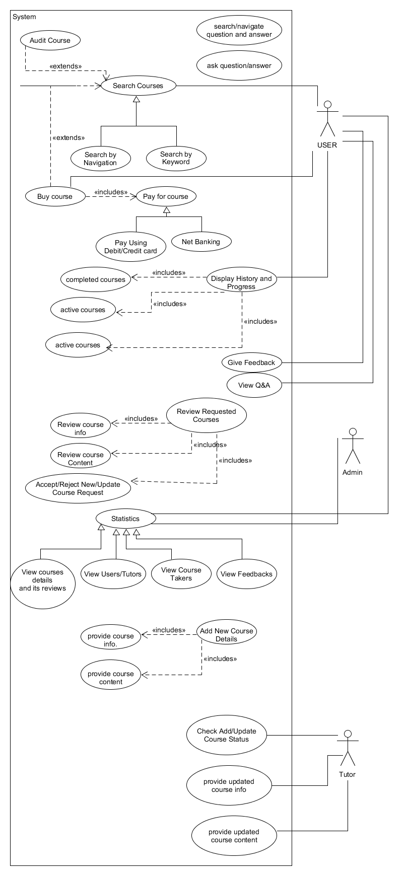

Figure 1 : Use Case Diagram

1. **Class Diagram**

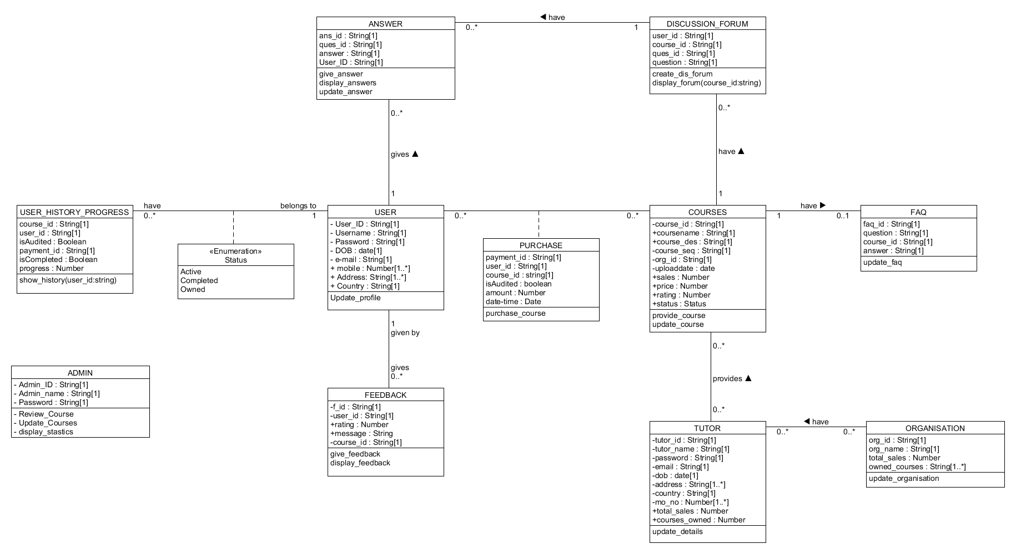

Figure 2 : Class Diagram

1. 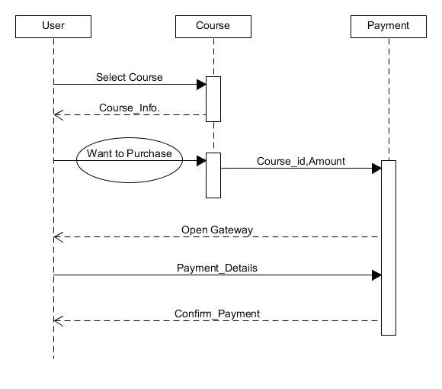**Sequence Diagrams**

Figure 3 : Course_Payment

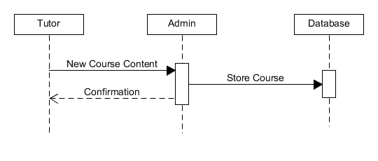

Figure 4 : Tutor_Upload_New_Course

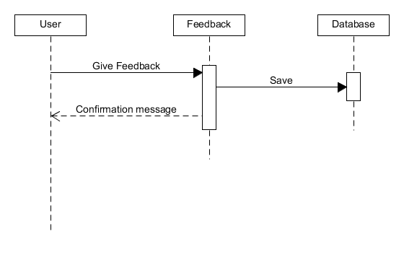

Figure 5 : User_Feedback

1. 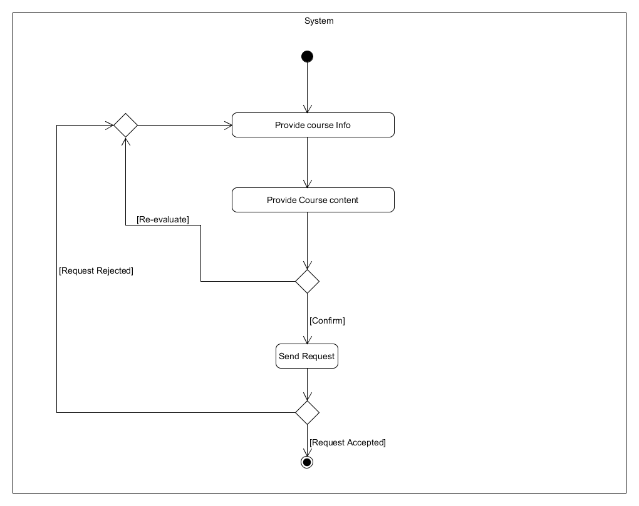 **Activity Diagrams**

Figure 6 : Add_New_Course

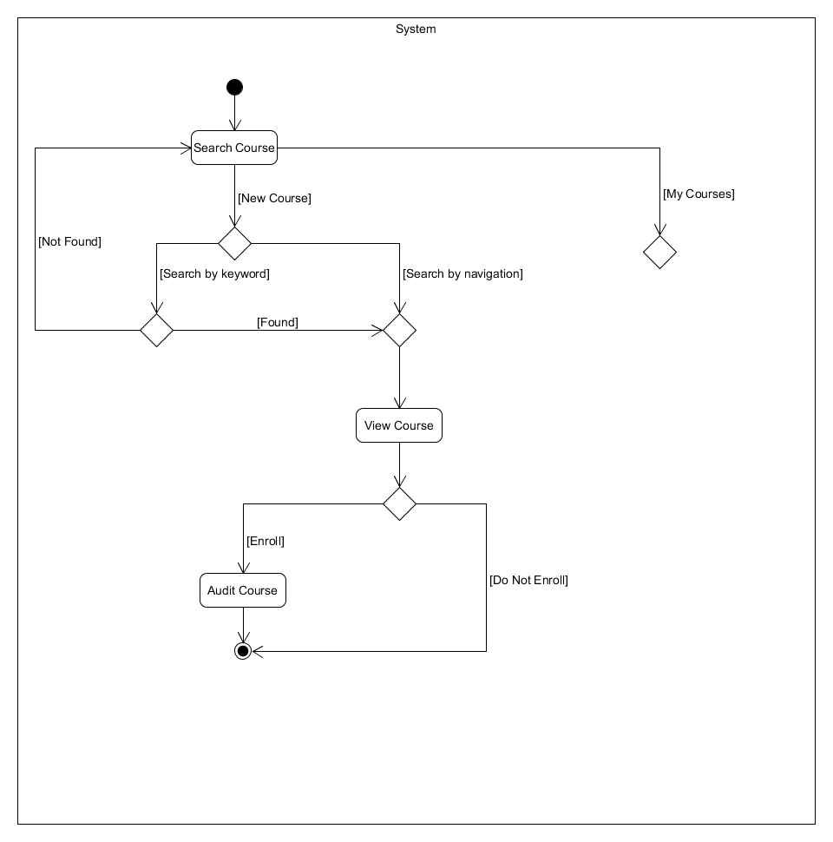

Figure 7 : Search_Audited_Course

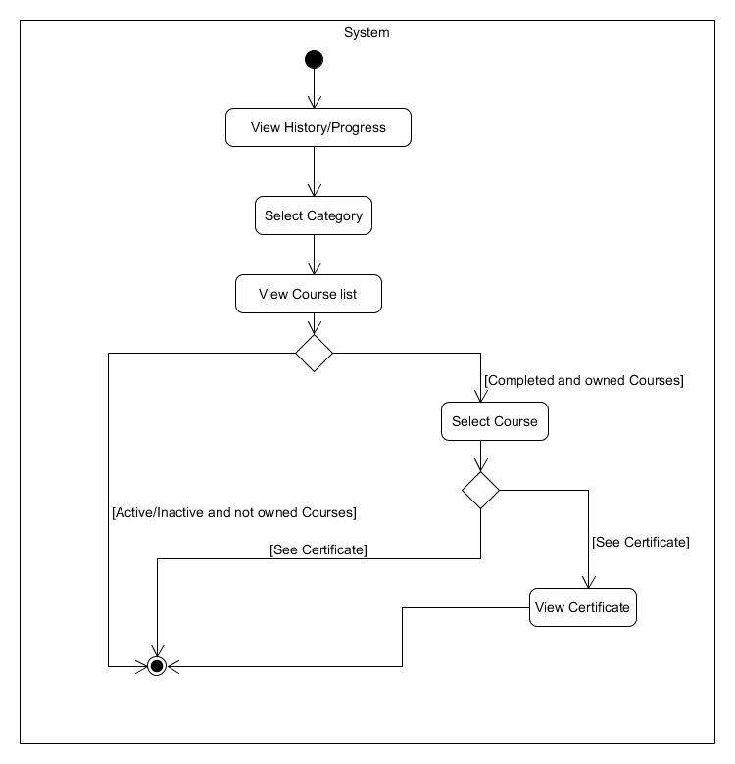

Figure 8 : User_Progress

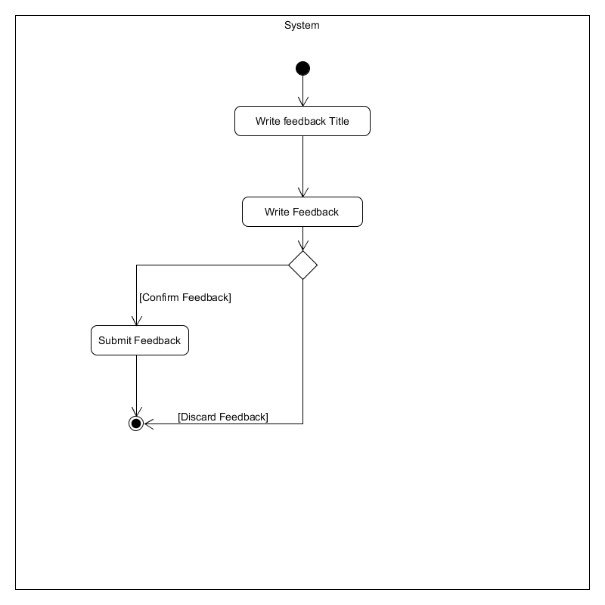

Figure 9 : Feedback

1. **State Diagrams**

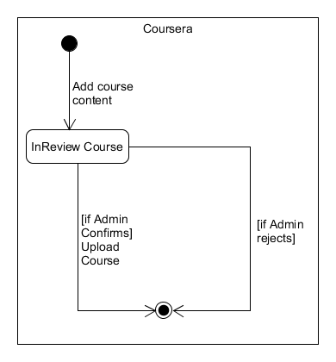

Figure 10 : Add_Course

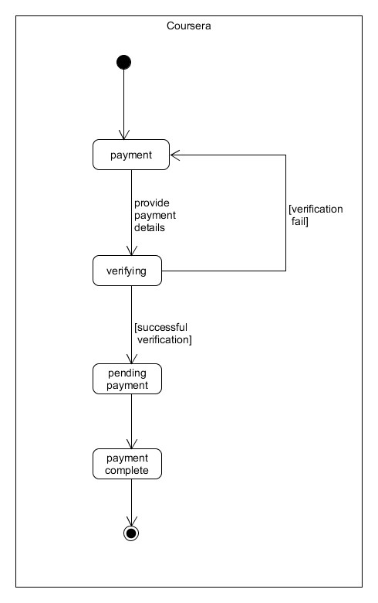

Figure 11 : Payment

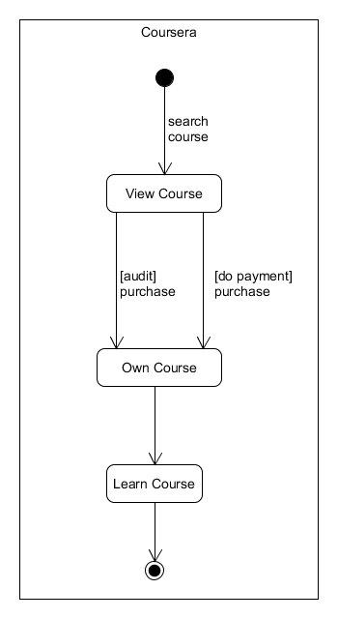

Figure 12 : Access_Course

1. **E-R Diagram**

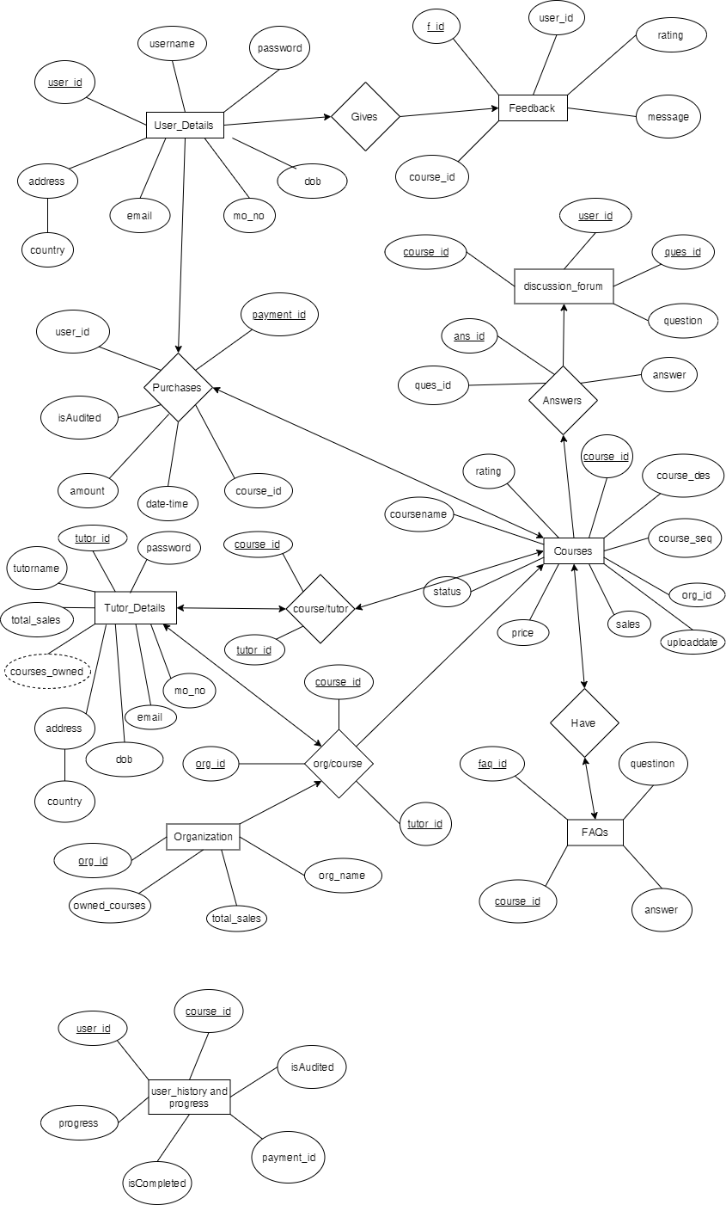

Figure 13 : E-R Diagram

1. **Data Dictionary**

|  |  |  |  |  |  |  |  |  |
| --- | --- | --- | --- | --- | --- | --- | --- | --- |
| User_Details | | | | | | | | |
| Sr. No. | Field Name | Data Type | Width | Required | Unique | PK/FK | Referenced Table | Description |
| 1 | user_id | varchar2 | 32 | Yes | Yes | PK |  |  |
| 2 | username | varchar2 | 32 | Yes |  |  |  |  |
| 3 | password | varchar2 | 32 | Yes |  |  |  |  |
| 4 | email | varchar2 | 32 | Yes |  |  |  |  |
| 5 | mo_no | Number | 10 | Yes |  |  |  |  |
| 6 | address | varchar2 | 50 |  |  |  |  |  |
| 7 | country | varchar2 | 10 |  |  |  |  |  |
| 8 | dob | Date |  | Yes |  |  |  |  |
|  |  |  |  |  |  |  |  |  |
| Tutor_Details | | | | | | | | |
| Sr. No. | Field Name | Data Type | Width | Required | Unique | PK/FK | Referenced Table | Description |
| 1 | tutor_id | varchar2 | 32 | Yes | Yes | PK |  |  |
| 2 | tutor_name | varchar2 | 32 | Yes |  |  |  |  |
| 3 | password | varchar2 |  | Yes |  |  |  |  |
| 4 | email | varchar2 | 50 | Yes |  |  |  |  |
| 5 | dob | Date |  | Yes |  |  |  |  |
| 6 | address | varchar2 | 50 |  |  |  |  |  |
| 7 | country | varchar2 | 10 |  |  |  |  |  |
| 8 | mo_no | Number | 10 | Yes |  |  |  |  |
| 9 | total_sales | Number | 10 |  |  |  |  |  |
| 10 | org_id | varchar2 | 32 |  |  | FK | Organization |  |
|  |  |  |  |  |  |  |  |  |
|  |  |  |  |  |  |  |  |  |
| Courses | | | | | | | | |
| Sr. No. | Field Name | Data Type | Width | Required | Unique | PK/FK | Referenced Table | Description |
| 1 | course_id | varchar2 | 32 | Yes | Yes | PK |  |  |
| 2 | coursename | varchar2 | 32 | Yes |  |  |  |  |
| 3 | course_des | varchar2 | 500 | Yes |  |  |  |  |
| 4 | course_seq | varchar2 | 1000 | Yes |  |  |  |  |
| 5 | org_id | varchar2 | 32 |  |  | FK | Organization |  |
| 6 | uploaddate | Date |  |  |  |  |  |  |
| 7 | sales | varchar2 | 6 |  |  |  |  |  |
| 8 | price | Number | 6 | Yes |  |  |  |  |
| 9 | rating | Number | 1 |  |  |  |  |  |
| 10 | status | varchar2 | 32 | Yes |  |  |  |  |
|  |  |  |  |  |  |  |  |  |
| Organization | | | | | | | | |
| Sr. No. | Field Name | Data Type | Width | Required | Unique | PK/FK | Referenced Table | Description |
| 1 | org_id | varchar2 | 32 | Yes | Yes | PK |  |  |
| 2 | org_name | varchar2 | 32 |  |  |  |  |  |
| 3 | total_sales | Number | 6 |  |  |  |  |  |
|  |  |  |  |  |  |  |  |  |
| Feedback | | | | | | | | |
| Sr. No. | Field Name | Data Type | Width | Required | Unique | PK/FK | Referenced Table | Description |
| 1 | f_id | varchar2 | 32 | Yes | Yes | PK |  |  |
| 2 | user_id | varchar2 | 32 |  |  | FK | User_Details |  |
| 3 | rating | Number | 1 |  |  |  |  |  |
| 4 | message | varchar2 | 1000 |  |  |  |  |  |
| 5 | course_id | varchar2 | 32 |  |  | FK | Courses |  |
|  |  |  |  |  |  |  |  |  |
| Purchases | | | | | | | | |
| Sr. No. | Field Name | Data Type | Width | Required | Unique | PK/FK | Referenced Table | Description |
| 1 | payment_id | varchar2 | 32 | Yes | Yes | PK |  |  |
| 2 | user_id | varchar2 | 32 | Yes |  | FK | User_Details |  |
| 3 | isAudited | bool |  | Yes |  |  |  |  |
| 4 | amount | Number | 6 | Yes |  |  |  |  |
| 5 | date-time | Date |  | Yes |  |  |  |  |
|  |  |  |  |  |  |  |  |  |
| FAQs | | | | | | | | |
| Sr. No. | Field Name | Data Type | Width | Required | Unique | PK/FK | Referenced Table | Description |
| 1 | faq_id | varchar2 | 32 | Yes |  | PK |  |  |
| 2 | questions | varchar2 | 32 | Yes |  |  |  |  |
| 3 | course_id | Number | 6 | Yes |  | PK/FK | Courses |  |
| 4 | answer | Number | 4 | Yes |  |  |  |  |
|  |  |  |  |  |  |  |  |  |
| course/tutor | | | | | | | | |
| Sr. No. | Field Name | Data Type | Width | Required | Unique | PK/FK | Referenced Table | Description |
| 1 | course_id | varchar2 | 32 | Yes |  | PK /FK | Courses |  |
| 2 | tutor_id | varchar2 | 32 | Yes |  | PK/FK | Tutor_Details |  |
|  |  |  |  |  |  |  |  |  |
| discussion_forum | | | | | | | | |
| Sr. No. | Field Name | Data Type | Width | Required | Unique | PK/FK | Referenced Table | Description |
| 1 | user_id | varchar2 | 32 | Yes |  | PK/FK | User_Details |  |
| 2 | course_id | varchar2 | 32 | Yes |  | PK/FK | Courses |  |
| 3 | ques_id | varchar2 | 32 | Yes |  | PK |  |  |
| 4 | question | varchar2 | 1000 | Yes |  |  |  |  |
|  |  |  |  |  |  |  |  |  |
| Answers | | | | | | | | |
| Sr. No. | Field Name | Data Type | Width | Required | Unique | PK/FK | Referenced Table | Description |
| 1 | ans_id | varchar2 | 32 | Yes |  | PK |  |  |
| 2 | ques_id | varchar2 | 32 | Yes |  | FK | discussion_forum |  |
| 3 | answer | varchar2 | 1000 | Yes |  |  |  |  |
|  |  |  |  |  |  |  |  |  |
| user_history and progress | | | | | | | | |
| Sr. No. | Field Name | Data Type | Width | Required | Unique | PK/FK | Referenced Table | Description |
| 1 | course_id | varchar2 | 32 | Yes |  | PK/FK | courses |  |
| 2 | user_id | varchar2 | 32 | Yes |  | PK/FK | Use_Details |  |
| 3 | isAudited | bool |  | Yes |  |  |  |  |
| 4 | payment_id | varchar2 | 32 |  |  | FK | Purchases |  |
| 5 | isCompleted | bool |  | Yes |  |  |  |  |
| 6 | progress | Number | 3 |  |  |  |  |  |

Table 1 : Data Dictionary

**Implementation Details**

**Sign In And Sign Up Form:**

Sign In and Sign Up form is for new and existing user to enter into site created in design phase of form with simple database operations.

**User Homepage:**

It consists of three sub parts. First, is display the available courses which is not purchased yet. Second, it displays purchased or audited courses. Third shows the progress of user in every course.

**Tutor Homepage:**

Currently it shows only one option for add new course. By clicking that button tutor can add new course step by step.

**Testing**

***Testing Methods:***

* **We performed smoke testing for each and every form.**
* **Performed integration testing**

**Screen-Shots**

**Conclusion**

Windows form application is easy to create and use. We can design form as per our need. MSSQL database is much easier to use. If the users of application is limited to windows OS then windows form application is best for desktop application creation.

**Limitation and Future Extension**

**Limitations:**

* Searching is not available right now.
* Actual payment system was not performed.
* Discussion forum is currently not available.
* Feedback form not available.

**Future Extension:**

* Dashboard of tutors must provide deeper analysis.
* Creating a recommendation system for user for showing better course recommendation.

**Bibliography**

**Stack Overflow:** <https://stackoverflow.com/>