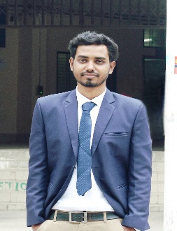**CURRICULUM VITAE**

Md Muktasur Rahman Mahin

B.Sc. Honors(Physics)

Email Address:[phy1912039brur@gmail.com](mailto:phy1912039brur@gmail.com)

|  |
| --- |
| **Career Objective** |

To secure a challenging position in a reputable organization  to expand my learnings,

knowledge,skill,talent and utilize my technical,branding,marketing experiences sincerely for the better achievement of the organization.

|  |
| --- |
| **Experience** |

1.Campus Ambassador

   MONOSEBA-organization of humanity and mental health well- being

**Duties**

* Serve mental health awareness
* Arrange session about mental health
* Share mental health post on facebook

2.Teaching

* 2 years experience.

|  |
| --- |
| **ICT Qualification** |

* Power point
* Ms Excel
* Spreadsheet and google docs

|  |
| --- |
| **Educational Qualification** |

|  |  |  |  |  |  |
| --- | --- | --- | --- | --- | --- |
| **Name of the Exam** | **Institution name** | **Group** | **GPA** | **Passing year** | **Board** |
| SSC | Sthapondighi High School | Science | 5.00 | 2017 | Rajshahi |
| HSC | Rajshahi Govt. City Collage,Rajshahi | Science | 4.83 | 2019 | Rajshahi |
| B.A honors(4th year,2nd semester) | Begum Rokeya University , Rangpur | Science | studying | N/A | N/A |

|  |  |  |  |  |
| --- | --- | --- | --- | --- |
| **Language** | **Reading** | **Writing** | **Listening** | **Speaking** |
| Bangla | Excellent | Excellent | Excellent | Excellent |
| English | Excellent | Good | Good | Good |

|  |
| --- |
| **Language Proficiency** |

|  |
| --- |
| **Personal Information** |

**Full Name                           :** Md Muktasur Rahman Mahin

**Father’s Name                   :** Md. Abdul Khalek

**Mother’s Name                  :** Mst. Mabiya Begum

**Present Address               :** Park more,Rangpur

**Permanent Address          :** Village :Mustigor ; Upazila :Singra

                                              District :Natore   ; Division :Rajshahi

**Date of Birth                      :** 17-08-2001

**Nationality                         :** Bangladeshi

**Marital Status                    :** Unmarried

**Religion                             :** Islam

**Blood Group                     :** B positive(B+)

|  |
| --- |
| **Reference** |

**Name :** Mst. Muntaha Begum

Owner of X trade Limited

**Contact** **:**  muntmst00@gmail.com

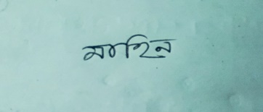

**Signature**