Decoding the Entropy of Urban Form: Shannon–Simpson Diversity and Rank–Dominance Diagnostics of Local Climate Zones in Bhopal, India, from the Global 100 m LCZ Map
Abstract
Local Climate Zone (LCZ) maps are increasingly used to describe the thermal relevance of urban form, yet most Indian applications report class maps without a quantitative account of how the LCZ mosaic is composed. This study extracts the LCZ structure of Bhopal, India, from the global 100 m LCZ map and evaluates it with areal, distributional and information-theoretic statistics. After reprojection to WGS 84 / UTM 43N (95.16 m pixels) and clipping to the study boundary, 13 of the 17 LCZ classes were detected over 411.49 km². Low plants (LCZ 14; 35.61%) and open low-rise (LCZ 6; 32.44%) dominate, and only 4 classes account for more than 80% of the mapped area. Built types (LCZ 1–10) occupy 54.24% and land-cover types 45.76%, while open built forms exceed compact forms by a factor of 3.57. Shannon entropy (H = 1.669 nats), evenness (J = 0.651), Gini–Simpson diversity (0.747) and a Gini coefficient of 0.686 indicate a moderately diverse but strongly dominance-skewed mosaic. Raster-code statistics (mean 9.90, median 9, SD 4.41 after excluding background) are reported only as descriptors of categorical codes. A compositional comparison with the independent 10 m Esri land-cover map of 2017, which is not an accuracy assessment, gives 84.7% proportional overlap of harmonised built, vegetated, bare and water groups (Jensen–Shannon divergence 0.027 bits); the LCZ map assigns 12.5 percentage points more area to built types, as expected from its neighbourhood-scale class definitions. The workflow provides a reproducible statistical baseline for LCZ-based heat-risk planning in Bhopal.
Keywords: Local Climate Zones; urban morphology; Shannon entropy; landscape composition; Bhopal
1. Introduction
Urban climate research has long relied on a binary contrast between “urban” and “rural” observation sites, a simplification that conceals large differences in surface structure, cover and human activity within both categories. The Local Climate Zone (LCZ) scheme was introduced to replace this binary with 17 standard zone types, ten built and seven land-cover classes, defined at the local scale (10² to 10⁴ m) by their surface structure and cover (Stewart & Oke, 2012). Subsequent evaluation with temperature observations and model simulations showed that the scheme discriminates thermally meaningful differences among zones (Stewart et al., 2014), which established LCZ classes as a common language for urban heat studies, planning and modelling.
The World Urban Database and Access Portal Tools (WUDAPT) initiative operationalised the scheme by combining freely available satellite imagery, crowd-sourced training areas and supervised classification into a repeatable protocol for mapping cities worldwide (Bechtel et al., 2015). The protocol was later scaled to a continental LCZ map of Europe (Demuzere et al., 2019) and then to a global 100 m LCZ map produced with random forest models trained on a very large set of labelled areas (Demuzere et al., 2022). The global product makes it possible to examine the LCZ structure of any city, including cities for which no locally trained classification exists, using a consistent legend and method.
In India, LCZ mapping has had to address heterogeneous built form and limited data. Kotharkar and Bagade (2018) documented the stages and difficulties of LCZ delineation in Nagpur, and later linked LCZ classes to outdoor thermal comfort (Kotharkar, Bagade, & Agrawal, 2019) and to the drivers of canopy-layer urban heat islands (Kotharkar, Bagade, & Ramesh, 2019). Multi-city work has shown that seasonal land surface temperature (LST) differs by about 3–4 °C between urban LCZs in major Indian metropolitan areas (Saxena & Agrawal, 2023), and the first multi-temporal LCZ mapping in India documented rapid change in the built LCZ classes of Pune (Saha et al., 2025).
Bhopal, the capital of Madhya Pradesh, has recently received focused LCZ attention. Mistry and Mehrotra (2023) related daytime LST to LCZ classes using Landsat imagery and reported a cool-island pattern in which urban LCZs were cooler than rural ones; Mistry and Mehrotra (2025a, 2025b) showed that landscape-pattern metrics of LCZ patches, such as patch and edge density, are associated with surface temperature; Mistry and Mehrotra (2026) assessed peak summer surface heat with thermal field variance indices; and Dwivedi and Soni (2026) quantified the cooling effect of blue-green infrastructure across local urban zones. These studies explain how temperature varies among zones, but they do not report how the LCZ mosaic itself is composed: how much area each zone occupies, how evenly area is distributed among zones, and how strongly the mosaic is dominated by a few classes. The present study complements them by applying the standardised global LCZ product to a compositional analysis, which allows direct comparison with other cities covered by the same map.
This study addresses that gap. Its objectives are (i) to quantify the area and proportion of every LCZ class in Bhopal from the global 100 m LCZ map; (ii) to report descriptive statistics of the LCZ raster, namely the mean, median and standard deviation (SD), with an explicit treatment of background pixels and of the categorical nature of LCZ codes; and (iii) to characterise the composition of the LCZ mosaic with information-theoretic diversity, evenness and dominance indices. The results provide a reproducible statistical baseline against which future locally trained or multi-temporal LCZ maps of Bhopal can be compared.
2. Study area
Bhopal is the capital of Madhya Pradesh in central India and a tier-2 city with a composite climate (Mistry & Mehrotra, 2026). Its urban form combines a dense historic core, planned residential sectors and institutional campuses with large lakes and a rapidly expanding peri-urban fringe. The analysis covers the study-area raster clipped to the Bhopal boundary in WGS 84 / UTM zone 43N (EPSG:32643), whose rectangular extent spans 731,111–759,754 m E and 2,557,602–2,583,200 m N (301 × 269 pixels; 733.20 km²). Within this rectangle, 411.49 km² carry a valid LCZ code, and the remainder (321.71 km²; 43.88%) lies outside the boundary and is coded 0 (Section 3.2; Fig. 1).
The same boundary yields 411.3584 km² of valid pixels in the 10 m land-cover layer used for cross-checking (Section 3.7). The two valid areas differ by only 0.13 km² (0.03%) despite a tenfold difference in pixel size. This indicates that both layers were clipped to the same study area; the residual difference is consistent with rasterising the same boundary at different pixel sizes.
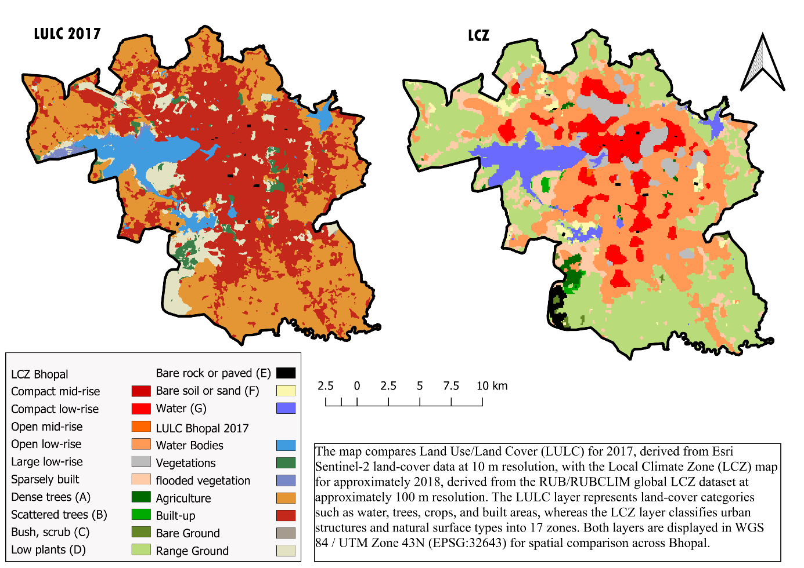
Fig. 1. Land use/land cover in 2017 from the 10 m Esri/Impact Observatory product (left; Karra et al., 2021) and Local Climate Zones from the global LCZ map, nominal year 2018 (right; Demuzere et al., 2022), for the Bhopal study area in WGS 84 / UTM zone 43N; LCZ colours follow the standard LCZ key. Source: own elaboration in QGIS 3.44.
3. Data and methods
3.1. Data
The LCZ data were taken from the global LCZ map of Demuzere et al. (2022), which represents the nominal year 2018 at a resolution of about 100 m in geographic coordinates (EPSG:4326), is archived at https://doi.org/10.5281/zenodo.6364594, and applies the 17-class scheme of Stewart and Oke (2012) worldwide. The map was generated with random forest classifiers trained on labelled LCZ training areas and earth-observation inputs, and its quality was assessed by bootstrap cross-validation and by a thematic benchmark against independent data for 150 functional urban areas (Demuzere et al., 2022). A local accuracy for Bhopal cannot be inferred from this global evaluation. Using a global product does, however, ensure that the Bhopal results share a legend and method with every other city covered by the map.
The map was accessed in Google Earth Engine as the image collection RUB/RUBCLIM/LCZ/global_lcz_map/latest. The collection was mosaicked, and its LCZ_Filter band, the morphologically filtered classification recommended for general use (rather than the raw LCZ band), was clipped to the study boundary and exported as a GeoTIFF at a scale of 100 m.
For an independent compositional comparison, the 2017 layer of the 10m Annual Land Use Land Cover (9-class) product was used. It was produced by Impact Observatory, Microsoft and Esri from Sentinel-2 imagery with a deep-learning segmentation model (Karra et al., 2021) and is distributed through the Esri Living Atlas (https://livingatlas.arcgis.com/landcoverexplorer). Its legend codes water (1), trees (2), flooded vegetation (4), crops (5), built area (7), bare ground (8), snow/ice (9), clouds (10) and rangeland (11); values 3 and 6 are unused because rangeland merges the former grass and scrub classes. The clipped layer (LULC_2017_clipped.tif; 2,850 × 2,550 pixels of 10 m) contains seven of these classes.
3.2. Pre-processing
The exported raster was processed in QGIS 3.44. It was reprojected to WGS 84 / UTM zone 43N with nearest-neighbour resampling, which keeps the categorical codes intact, giving square pixels of 95.1595 m; this cell size results from reprojection and is not the native resolution of the product. It was then clipped to the study boundary, and pixels outside the boundary received the value 0. Value 0 was treated as background on two grounds: zero-valued pixels sampled with the Identify Features tool all fell outside the boundary, and the resulting valid LCZ area agrees within 0.03% with the valid area of the independently clipped 10 m layer (Section 2). The classes were styled with the standard LCZ colour key (e.g., LCZ 1 compact high-rise #8C0000; LCZ 7 lightweight low-rise #FAEE05), and pixel frequencies were extracted with the Raster layer unique values report tool (Fig. 2).
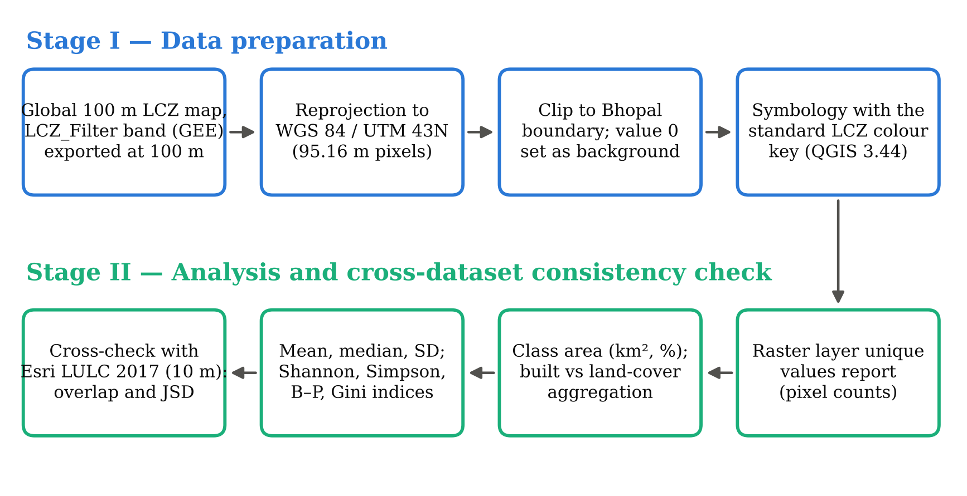
Fig. 2. Methodological workflow of the study. Source: own elaboration.
3.3. Areal quantification
For each LCZ class i with pixel count n_{i}, area and percentage share were computed as
$A_{i}=\frac{n_{i}×Δx×Δy}{{10}^{6}}$ (1)
$P_{i}=\frac{A_{i}}{\sum_{j=1}^{S}{A_{j}}}×100$ (2)
where Δx = Δy = 95.1595 m is the pixel size, A_{i} is in km², and S = 13 is the number of LCZ classes present (Eqs. 1–2). Classes were further aggregated into built (LCZ 1–10) and land-cover (LCZ 11–17) types following Stewart and Oke (2012), and into six morphological groups: compact (1–3), open (4–6), other built (7–10), vegetated (11–14), bare (15–16) and water (17).
3.4. Descriptive statistics of the LCZ raster
Descriptive statistics of the raster band were computed from the frequency table, treating each pixel as an observation with value x_{k} (the LCZ code, 0–17) occurring n_{k} times among N pixels (n_{k} = 0 for absent codes):
$x̄=\frac{1}{N}\sum_{k=0}^{17}{n_{k}x_{k}}$ (3)
$SD=\sqrt{\frac{1}{N}\sum_{k=0}^{17}{n_{k}{(x_{k}−x̄)}^{2}}}$ (4)
Eq. 4 is the population SD (divisor N); the sample SD (divisor N − 1) is also listed. The median is the value at the middle position, or the mean of the two middle positions, of the N ordered pixel values, and the quartiles are the values at ordered positions ⌈0.25N⌉ and ⌈0.75N⌉ (nearest-rank rule). Statistics are reported both including value 0 (the default in QGIS layer properties) and excluding it, because background pixels shift every moment of the distribution. LCZ codes are category labels rather than measurements, so these values describe where the mass of the code distribution lies and must not be read as physical quantities such as temperature or building height.
3.5. Distribution of class areas
To describe how area is spread among classes, the mean, median, population SD, coefficient of variation (CV = SD / mean × 100) and moment skewness g₁ of the 13 class areas were calculated, with quartiles from linear interpolation between order statistics and skewness as the population moment coefficient (Eq. 5):
$g_{1}=\frac{\frac{1}{S}\sum_{i=1}^{S}{{(A_{i}−Ā)}^{3}}}{{SD}^{3}}$ (5)
3.6. Composition indices
With p_{i} = P_{i} / 100, the information content of the LCZ mosaic was measured with Shannon entropy (Shannon, 1948) and its normalised form, the evenness J (also known as Pielou’s evenness), computed against both the observed number of classes and the full 17-class scheme:
$H=−\sum_{i=1}^{S}{p_{i}lnp_{i}}$ (6)
$J=\frac{H}{ln S}$ (7)
Concentration was measured with the Gini–Simpson index, its reciprocal form (the effective number of equally abundant classes; Simpson, 1949), the Hill number of order one, the Berger–Parker dominance index and the Gini coefficient of class areas sorted in ascending order (A₍₁₎ ≤ … ≤ A_{(S)}):
$D=1−\sum_{i=1}^{S}{{p_{i}}^{2}}, N_{2}=\frac{1}{\sum_{i=1}^{S}{{p_{i}}^{2}}}, N_{1}=e^{H}$ (8)
$BP=\max_{i}p_{i}, Gini=\frac{\sum_{i=1}^{S}{(2i−S−1)A_{(i)}}}{S\sum_{i=1}^{S}{A_{i}}}$ (9)
Eqs. 6–8 use natural logarithms, so H is expressed in nats. The Gini coefficient follows the sorted-rank form of Eq. 9, whose maximum for S classes is (S − 1)/S. A rank–dominance curve, the cumulative share of area plotted against class rank, summarises these indices graphically: the further the curve lies above the line of perfect evenness, the more the mosaic is dominated by a few classes.
3.7. Cross-dataset compositional comparison
Because no local reference data were available, the LCZ composition was compared with the 10 m LULC map at the level of four harmonised groups: built (LCZ 1–10 vs built area), vegetated (LCZ 11–14 vs trees, flooded vegetation, crops and rangeland), bare (LCZ 15–16 vs bare ground) and water (LCZ 17 vs water). With a_{g} and b_{g} the group shares of the two layers, compositional agreement was measured by the proportional overlap O (Eq. 10) and by the Jensen–Shannon divergence (Lin, 1991; Eq. 11), which uses base-2 logarithms and is therefore expressed in bits:
$O=\sum_{g=1}^{4}{min(a_{g},b_{g})}$ (10)
$JSD=\frac{1}{2}\sum_{g=1}^{4}{a_{g}\log_{2}\frac{a_{g}}{m_{g}}}+\frac{1}{2}\sum_{g=1}^{4}{b_{g}\log_{2}\frac{b_{g}}{m_{g}}}, m_{g}=\frac{a_{g}+b_{g}}{2}$ (11)
O ranges from 0 (no common composition) to 1 (identical composition), and JSD from 0 (identical) to 1. The two layers differ in class semantics, spatial resolution and reference year, so this comparison tests whether broad area proportions are consistent; it is not an accuracy assessment, which would require independent reference samples and a confusion matrix. The same areal statistics, raster-code statistics and composition indices (Sections 3.3–3.6) were computed for the LULC layer.
3.8. Verification
All statistics were computed with a Python script that reads only the QGIS frequency report. Two internal checks were passed: (i) the area column of the report equals pixel count × pixel area for every class; and (ii) the total pixel count equals the raster dimensions (301 × 269 = 80,969). The same checks were applied to the LULC layer, whose valid and NoData pixels (4,113,584 + 3,153,916) sum to its 2,850 × 2,550 dimensions; its code mean, median and SD reproduce the values obtained independently by the authors. These checks establish arithmetic consistency only, not classification accuracy. The script, frequency tables and outputs are provided as Supplementary Material S1.
4. Results
4.1. Spatial pattern of Local Climate Zones
Fig. 1 shows the LCZ structure of Bhopal. Of the 17 standard classes, 13 occur in the study area; compact high-rise (LCZ 1), open high-rise (LCZ 4), lightweight low-rise (LCZ 7) and heavy industry (LCZ 10) were not detected in the global product. Their absence from a 100 m map does not prove that such forms are absent from Bhopal, because small or fragmented areas can be absorbed into neighbouring classes.
In the LCZ map (Fig. 1, right), compact low-rise (LCZ 3) forms clustered patches in the north-central and central parts of the city east of the Upper Lake, interspersed with large low-rise (LCZ 8) patches. Open low-rise (LCZ 6) forms a continuous matrix around this core and extends towards the south and south-east, and sparsely built zones (LCZ 9) mark the transition to the rural fringe. The Upper Lake forms the largest water body (LCZ 17) in the west-central part, with smaller water bodies to its east and south. Low plants (LCZ 14) dominate the northern, western and southern periphery, while dense trees (LCZ 11) and bare rock or paved surfaces (LCZ 15) occur in small patches near the south-western boundary. The 10 m map (Fig. 1, left) shows the same core–periphery structure, with a continuous built-area block in the centre surrounded by cropland.
4.2. Areal composition
Table 1 and Fig. 3b give the area of each class. Low plants (LCZ 14) form the largest class, with 146.55 km² (35.61%), followed by open low-rise (LCZ 6; 133.48 km², 32.44%). Together these two classes cover 68.05% of the mapped area. Compact low-rise (LCZ 3; 9.06%), sparsely built (LCZ 9; 7.94%), water (LCZ 17; 5.69%) and large low-rise (LCZ 8; 4.65%) form a middle tier, while the remaining seven classes each occupy less than 2.1%. Mid-rise forms are almost absent: compact mid-rise (LCZ 2) and open mid-rise (LCZ 5) together cover only 0.643 km².
Table 1. Area and share of Local Climate Zone classes in Bhopal
LCZ | Class name | Type | Pixels | Area (km²) | Share (%) | Rank
LCZ 2 | Compact mid-rise | Built | 26 | 0.235 | 0.06 | 13
LCZ 3 | Compact low-rise | Built | 4,117 | 37.281 | 9.06 | 3
LCZ 5 | Open mid-rise | Built | 45 | 0.407 | 0.10 | 12
LCZ 6 | Open low-rise | Built | 14,741 | 133.485 | 32.44 | 2
LCZ 8 | Large low-rise | Built | 2,112 | 19.125 | 4.65 | 6
LCZ 9 | Sparsely built | Built | 3,609 | 32.681 | 7.94 | 4
LCZ 11 | Dense trees (A) | Land cover | 415 | 3.758 | 0.91 | 8
LCZ 12 | Scattered trees (B) | Land cover | 183 | 1.657 | 0.40 | 10
LCZ 13 | Bush, scrub (C) | Land cover | 167 | 1.512 | 0.37 | 11
LCZ 14 | Low plants (D) | Land cover | 16,184 | 146.551 | 35.61 | 1
LCZ 15 | Bare rock or paved (E) | Land cover | 334 | 3.024 | 0.74 | 9
LCZ 16 | Bare soil or sand (F) | Land cover | 925 | 8.376 | 2.04 | 7
LCZ 17 | Water (G) | Land cover | 2,584 | 23.399 | 5.69 | 5
Total | 13 classes |  | 45,442 | 411.492 | 100.00
Note: Area = pixels × 95.1595² m²; shares calculated from unrounded areas. LCZ 1, 4, 7 and 10 not detected. Source: own calculation from the global LCZ map (Demuzere et al., 2022).
At the first level of aggregation, built LCZs cover 223.21 km² (54.24%) and land-cover LCZs 188.28 km² (45.76%), a built-to-land-cover ratio of 1.19 (Fig. 3d). Within the built fabric, open forms (LCZ 4–6; 133.89 km²) are 3.57 times as extensive as compact forms (LCZ 1–3; 37.52 km²), and the other built group, made up of large low-rise and sparsely built areas, adds 51.81 km². Among land-cover types, vegetated classes (153.48 km²) far exceed water (23.40 km²) and bare surfaces (11.40 km²). These proportions describe the composition of the classified map; they are not direct measurements of impervious-surface fraction.
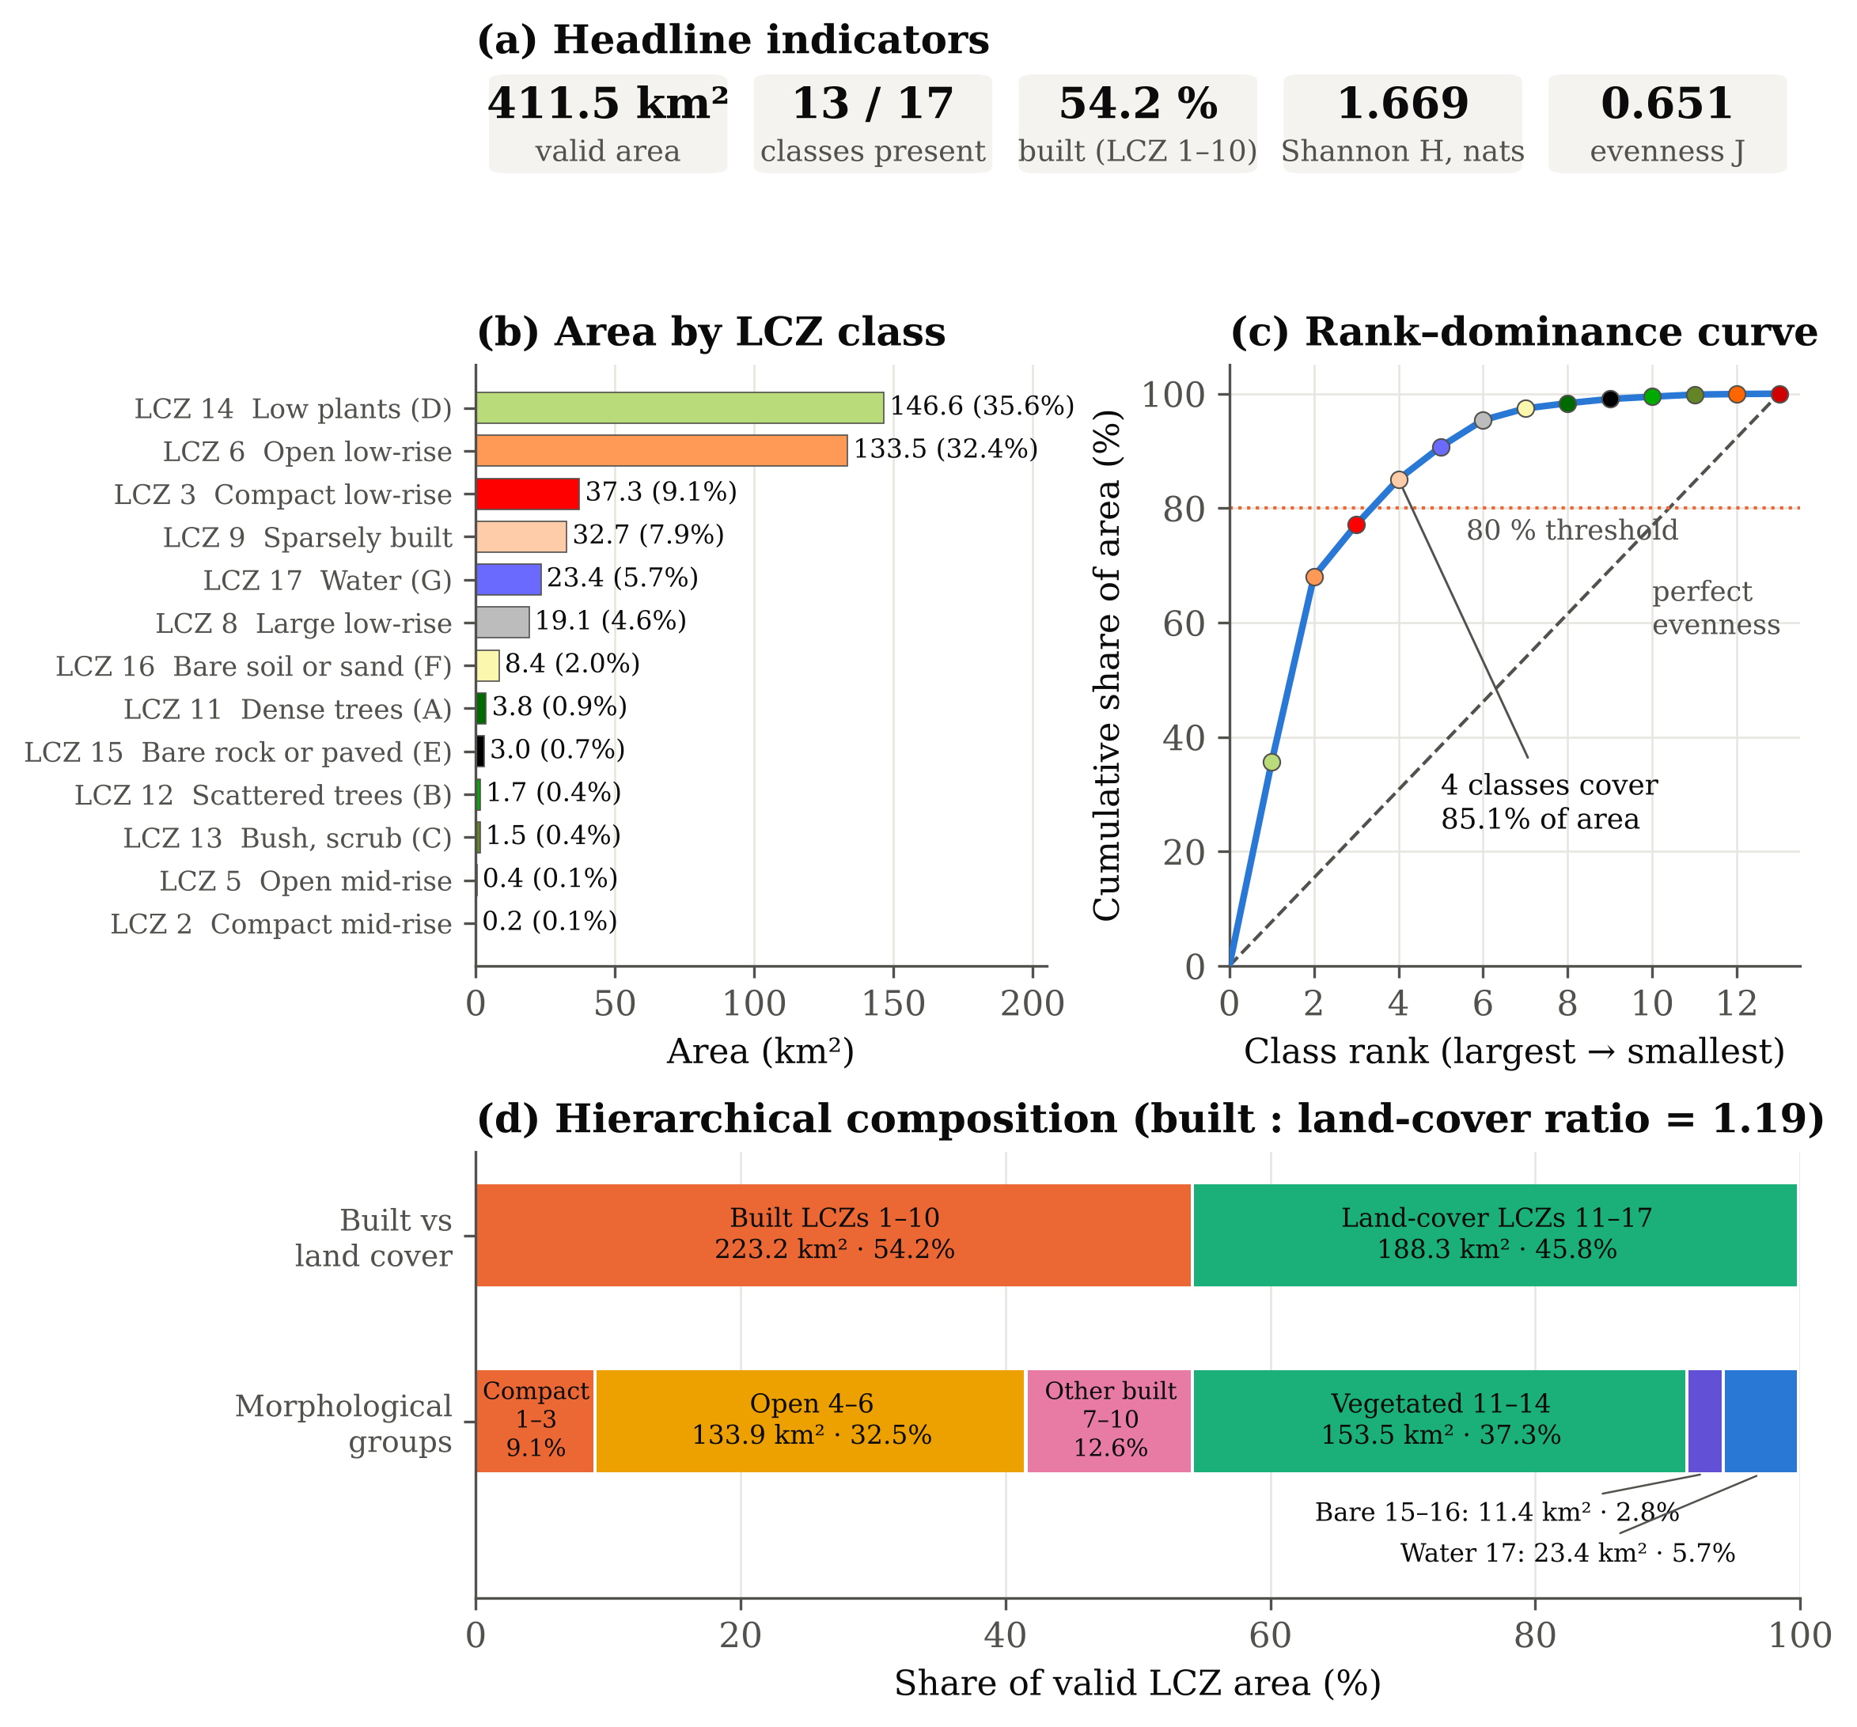
Fig. 3. LCZ composition dashboard for Bhopal: (a) headline indicators; (b) area of each LCZ class in the standard LCZ colours; (c) rank–dominance curve against the line of perfect evenness; (d) hierarchical composition by built/land-cover type and morphological group. Source: own elaboration.
4.3. Descriptive statistics of the LCZ raster
Table 2 reports the raster-band statistics requested for a standard raster summary. Including background pixels, the mean code is 5.5539, the median 6 and the SD 5.9166; the mode is 0 because background is the single most frequent value. Excluding background, the mean rises to 9.8961, the median to 9, and the SD falls to 4.4051, while the mode becomes 14 (low plants). The gap between mean and median, and the bimodal frequency distribution in Fig. 4a with peaks at LCZ 6 and LCZ 14, show that the central-tendency statistics fall between two dominant classes rather than on a typical class. Excluding background is therefore essential, and even then the mean and SD summarise the position of the code distribution rather than any physical property of the city.
Table 2. Descriptive statistics of the LCZ raster band (LCZ codes)
Statistic | Including value 0 | Excluding value 0
Pixels (N) | 80,969 | 45,442
Minimum | 0 | 2
Maximum | 17 | 17
Mean | 5.5539 | 9.8961
Median | 6 | 9
Mode | 0 | 14
First quartile (Q1) | 0 | 6
Third quartile (Q3) | 12 | 14
SD (population) | 5.9166 | 4.4051
SD (sample) | 5.9167 | 4.4052
Coefficient of variation (%) | 106.53 | 44.51
Note: Values 1–17 are category codes; statistics describe the code distribution only. Value 0 = background outside the study boundary. Source: own calculation.
4.4. Distribution of class areas
The class areas are strongly right-skewed (Table 3). The mean class area is 31.653 km² (7.69% of the mapped area), but the median is only 8.376 km² (2.04%), and the SD of 47.830 km² gives a coefficient of variation of 151.1%. The positive skewness (g1 = 1.685) confirms that a few large classes coexist with many small ones, so the median describes a typical class better than the mean.
Table 3. Descriptive statistics of LCZ class areas
Statistic | Class area (km²) | Class share (%)
Number of classes | 13 | 13
Mean | 31.653 | 7.692
Median | 8.376 | 2.036
SD (population) | 47.830 | 11.624
SD (sample) | 49.783 | 12.098
Coefficient of variation (%) | 151.1 | 151.1
Minimum | 0.235 | 0.057
First quartile (Q1) | 1.657 | 0.403
Third quartile (Q3) | 32.681 | 7.942
Maximum | 146.551 | 35.615
Skewness (g1) | 1.685 | 1.685
Total | 411.492 | 100.000
Note: Computed over the 13 detected classes; SD of shares in percentage points. Source: own calculation.
4.5. Diversity, evenness and dominance
Shannon entropy of the LCZ mosaic is 1.6695 nats, against a maximum of 2.5649 for 13 equally abundant classes, giving an evenness of 0.651 (0.589 relative to the full 17-class scheme; Table 4, Fig. 4c). The Gini–Simpson index (0.747) implies that two randomly chosen pixels belong to different classes in about three of four cases, yet the effective number of classes is only 5.31 (Hill N1) or 3.96 (inverse Simpson), well below the 13 classes present. Dominance is high: the Berger–Parker index shows that one class (LCZ 14) holds 35.6% of the area, the Gini coefficient of class areas is 0.686, and the rank–dominance curve (Fig. 3c) crosses 80% at only 4 classes. Entropy is higher within the built classes (H = 1.117) than within the land-cover classes (H = 0.818), meaning that the built fabric is more internally differentiated than the surrounding land cover, which is dominated by low plants.
Table 4. Composition indices of the Bhopal LCZ mosaic
Index | Value | Range / reference
Shannon entropy H (nats) | 1.6695 | max ln 13 = 2.5649
Evenness J (13 observed classes) | 0.6509 | 0–1
Evenness J (17-class scheme) | 0.5893 | 0–1
Gini–Simpson diversity D | 0.7474 | max 1 − 1/13 = 0.9231
Inverse Simpson N2 (effective classes) | 3.959 | 1–13
Hill number N1 = e^H (effective classes) | 5.309 | 1–13
Berger–Parker dominance BP | 0.3561 | 1/13–1
Gini coefficient of class areas | 0.6863 | 0–(S−1)/S
Classes covering ≥ 80% of area | 4 | 1–13
Shannon H, built classes only | 1.1169 | max ln 6 = 1.7918
Shannon H, land-cover classes only | 0.8175 | max ln 7 = 1.9459
Note: Natural logarithms used throughout. Source: own calculation.
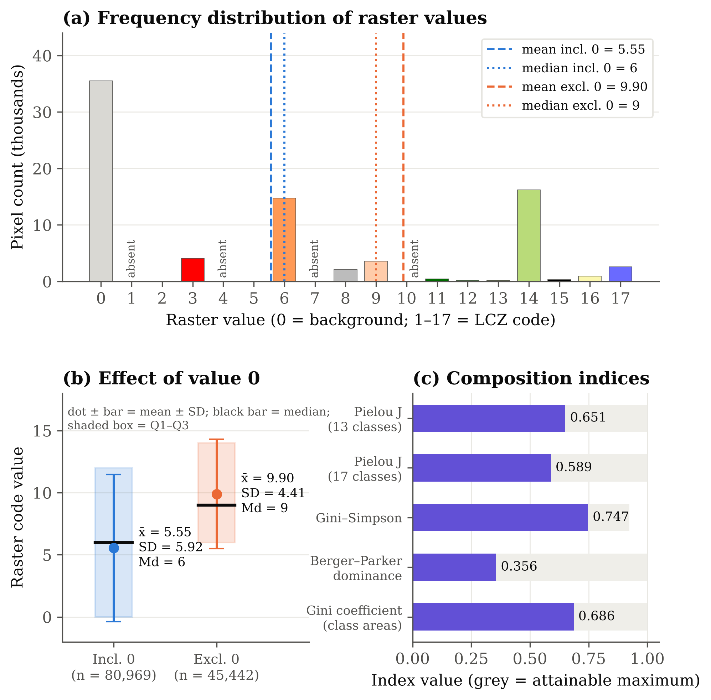
Fig. 4. Statistical dashboard of the LCZ raster: (a) pixel frequency of each raster value with mean and median including and excluding background; (b) mean ± SD, median and interquartile range of LCZ codes with and without value 0; (c) composition indices against their attainable maxima. Source: own elaboration.
4.6. Statistics of the 10 m land-cover layer
The 10 m LULC layer covers a rectangle of 726.75 km², of which 411.3584 km² (56.60%) is valid and 315.3916 km² is NoData outside the boundary. Each pixel represents 100 m² (Eq. 1 with Δx = Δy = 10 m). Built area (171.57 km²; 41.71%) and crops (164.22 km²; 39.92%) together cover 81.63% of the city, followed by rangeland (8.53%) and water (6.90%; Table 5, Fig. 5a). The class codes have a mean of 6.0001, a median of 7 and an SD of 2.2466 (Table 6). As for the LCZ raster, these values summarise categorical codes only. The class areas are again right-skewed (mean 58.77 km², median 28.40 km²), and the LULC mosaic is less diverse than the LCZ mosaic (H = 1.249 vs 1.669; Fig. 5c–d) because its legend has fewer classes. Its evenness (J = 0.642) is, however, almost identical to that of the LCZ map (0.651).
Table 5. Area and share of land-cover classes in the 10 m Esri LULC 2017 layer
Value | Class | Pixels | Area (km²) | Share (%)
1 | Water | 283,984 | 28.3984 | 6.90
2 | Trees | 87,395 | 8.7395 | 2.12
4 | Flooded vegetation | 31,277 | 3.1277 | 0.76
5 | Crops | 1,642,194 | 164.2194 | 39.92
7 | Built area | 1,715,671 | 171.5671 | 41.71
8 | Bare ground | 2,141 | 0.2141 | 0.05
11 | Rangeland | 350,922 | 35.0922 | 8.53
Total | 7 classes | 4,113,584 | 411.3584 | 100.00
Note: Area = pixels × 100 m². Classes 9 (snow/ice) and 10 (clouds) absent. Source: own calculation from Karra et al. (2021) data.
Table 6. Descriptive statistics of the 10 m LULC layer
Statistic | Raster codes | Class areas (km²)
Valid pixels / classes | 4,113,584 | 7
Minimum | 1 | 0.214
Maximum | 11 | 171.567
Mean | 6.0001 | 58.765
Median | 7 | 28.398
Mode | 7 | –
SD (population) | 2.2466 | 70.055
SD (sample) | 2.2466 | 75.668
Coefficient of variation (%) | 37.44 | 119.2
Shannon H / evenness J | 1.2487 / 0.6417 | –
Gini–Simpson D / Berger–Parker BP | 0.6541 / 0.4171 | –
Note: NoData excluded; codes are category labels. Source: own calculation.
4.7. Compositional consistency between the LCZ and land-cover maps
After harmonisation, the two layers share 84.7% of their composition, and the Jensen–Shannon divergence is only 0.027 bits (Table 7, Fig. 5b). Water agrees most closely (5.69% vs 6.90%). The largest difference is that the LCZ map assigns 12.54 percentage points more of the city to built types and correspondingly less to vegetated types (14.04 points). Bare surfaces cover 2.77% in the LCZ map but only 0.05% in the LULC map. The overlap measures the similarity of the two area compositions, not the proportion of correctly classified pixels, and the built-area difference reflects differing class definitions rather than an error of either map.
Table 7. Harmonised comparison of the LCZ (100 m) and LULC 2017 (10 m) layers
Group | LCZ codes | LULC codes | LCZ (km²) | LULC (km²) | LCZ (%) | LULC (%) | Δ (pp)
Built | 1–10 | 7 | 223.214 | 171.567 | 54.24 | 41.71 | +12.54
Vegetated | 11–14 | 2, 4, 5, 11 | 153.479 | 211.179 | 37.30 | 51.34 | −14.04
Bare | 15–16 | 8 | 11.401 | 0.214 | 2.77 | 0.05 | +2.72
Water | 17 | 1 | 23.399 | 28.398 | 5.69 | 6.90 | −1.22
Note: Δ = LCZ share − LULC share in percentage points. Overlap O = 0.8474; JSD = 0.0266 bits. Source: own calculation.
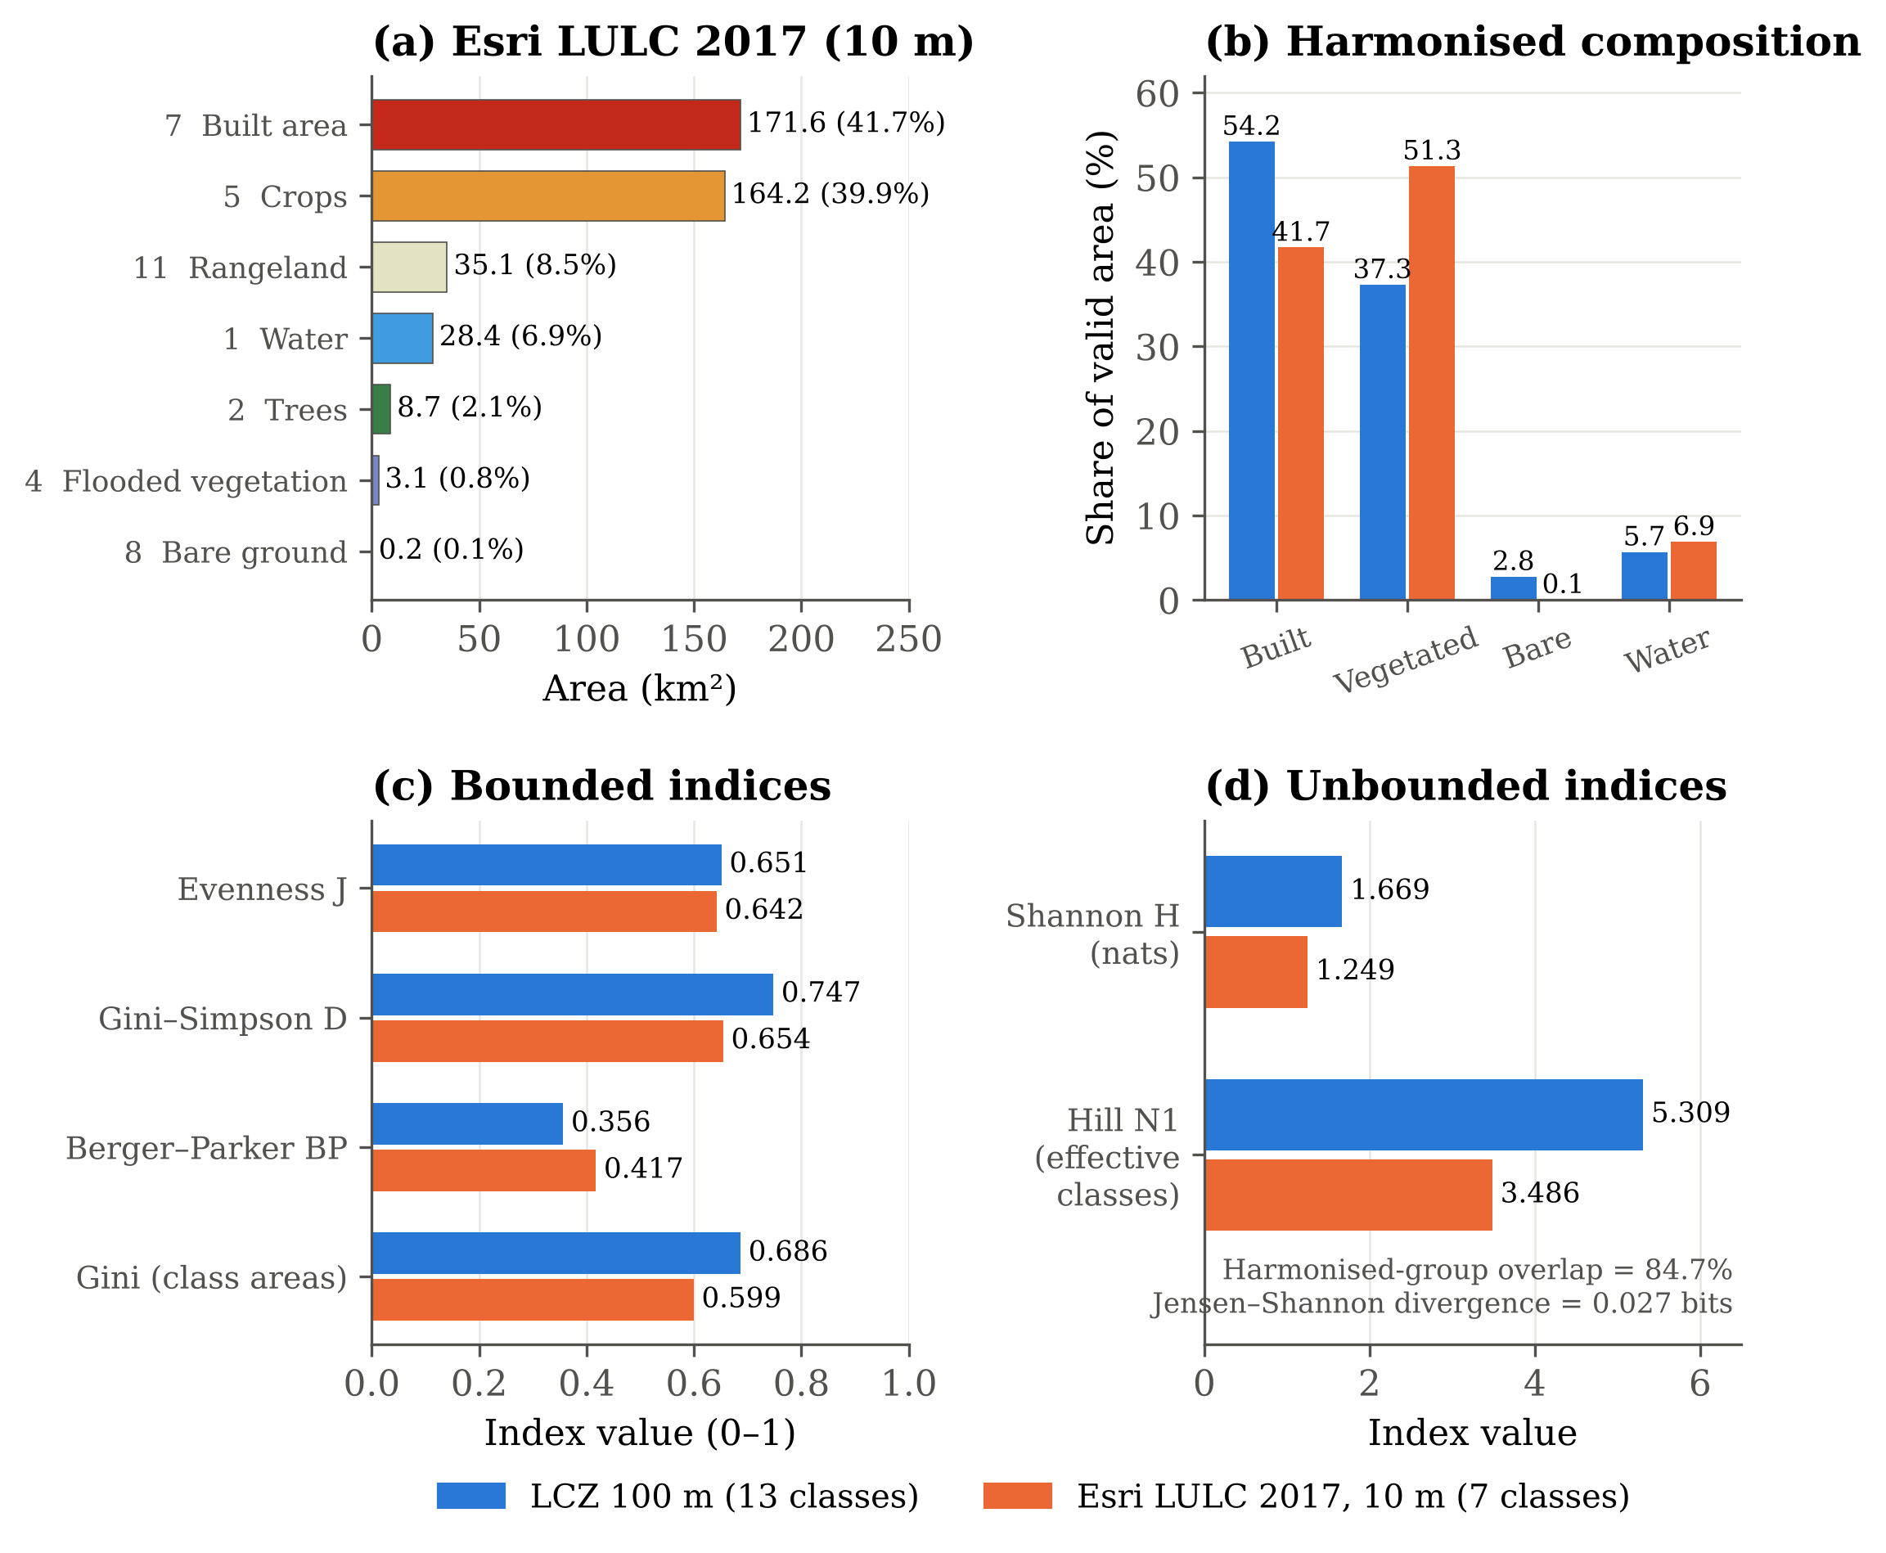
Fig. 5. Cross-dataset compositional comparison of the LCZ map (nominal year 2018, 100 m) and the Esri LULC map (2017, 10 m): (a) LULC class areas in the product legend colours; (b) harmonised group shares; (c) bounded and (d) unbounded composition indices. The comparison concerns area proportions only and is not a pixel-by-pixel accuracy assessment. Source: own elaboration.
5. Discussion
The Bhopal LCZ mosaic is dominated by low-rise forms. Open low-rise (LCZ 6) is the main built class, and compact low-rise (LCZ 3) is the only compact class of any extent. This mirrors the LCZ structure reported for Nagpur, where compact and open low-rise and sparsely built classes, with their sub-classes, account for most of the built land cover (Kotharkar, Bagade, & Agrawal, 2019), and suggests that the low-rise categories are the most relevant for central Indian cities. Mid- and high-rise classes, which drive much of the LCZ-temperature literature in compact Asian cities, are almost absent here.
The composition indices add information that a class map cannot convey. A Gini–Simpson value of 0.75 on its own would suggest a diverse city, but the effective number of classes (about 5) and the Berger–Parker value show that this diversity is concentrated in a small number of dominant zones. For heat-risk planning this matters, because intervention priorities are set by the zones that cover most of the city. In their locally classified LCZ map, Mistry and Mehrotra (2025a) found the highest daytime land surface temperature (42.9 °C) in compact low-rise LCZ 3, which covers 9.1% of the area here. LCZ 3 is therefore a spatially limited but thermally critical class, whereas LCZ 6 combines a large area with moderate density and is the class where cumulative gains from greening and cool-surface measures would be largest.
Water (LCZ 17; 5.69%) and dense or scattered trees (LCZ 11–12) are small in area but important for the city's thermal regulation. In Landsat-derived daytime land surface temperature for Bhopal, the water LCZ was 3–5 °C cooler than other classes (Mistry & Mehrotra, 2023), and major water bodies cooled their surroundings by 1.76 °C on average over 2.64 km (Dwivedi & Soni, 2026). The dominance of low plants (LCZ 14) at the urban fringe is consistent with the daytime surface cool island of Bhopal, in which rural surroundings were up to 3 °C warmer than the core in pre-monsoon summer (Mistry & Mehrotra, 2023, 2026). At the national scale, open mid-rise (LCZ 5) had the highest seasonal land surface temperature among built classes in major metropolitan cities (Saxena & Agrawal, 2023). Its near-absence in Bhopal suggests that the thermal hierarchy of LCZs in tier-2 cities may differ from that of the metros and should be tested locally.
Methodologically, the study shows how the conventional raster summary statistics (mean, median and SD) can be reported for a categorical raster without misrepresenting it. Such statistics are only interpretable once background is removed, and even then they describe the code distribution rather than urban properties. The class-area distribution and the composition indices are the substantive quantitative results. Because they are computed from a standardised global map (Demuzere et al., 2022), they can be reproduced for other Indian cities and compared directly, which is not possible with locally trained classifications that use different training areas and class sets (Bechtel et al., 2015; Demuzere et al., 2019).
The compositional comparison shows broad agreement and also where the two systems diverge by design. LCZ built classes describe whole neighbourhoods at the local scale and therefore include their gardens, trees and open ground (Stewart & Oke, 2012), whereas the 10 m built-area class labels individual built-up pixels (Karra et al., 2021). The 12.5-point excess of built area in the LCZ map is therefore expected, and it most plausibly comes from open low-rise and sparsely built zones (LCZ 6 and 9), which by definition contain substantial pervious cover. The bare-surface discrepancy follows from the legends: LCZ 15 includes paved surfaces, which the land-cover map counts as built area, and seasonally bare fields may appear as crops in an annual land-cover composite. The close agreement for water, the class whose definition is most similar in both systems, together with an overlap of 84.7%, indicates broad compositional consistency, while the differences are associated with class definitions, spatial resolution and reference year.
5.1. Limitations
Six limitations apply. First, the results inherit the classification uncertainty of the global LCZ map, and no independent accuracy assessment with local reference data was carried out, so producer's and user's accuracies for Bhopal are unknown. Second, at 100 m resolution small or fragmented zones, such as informal lightweight settlements or isolated high-rise blocks, can be absorbed into neighbouring classes, so the non-detection of LCZ 1, 4, 7 and 10 does not establish their absence. Third, reprojection resampled the 100 m grid to 95.16 m pixels, which changes pixel counts slightly although nearest-neighbour resampling preserves the class codes. Fourth, the analysis is a single snapshot and cannot capture the kind of rapid LCZ transitions documented for Pune (Saha et al., 2025). Fifth, the 10 m cross-check uses a 2017 map whose date may not coincide with that of the LCZ product, and its class semantics differ, so it supports consistency rather than accuracy. Sixth, the composition indices depend on the analytical extent and the number of classes, so comparisons with other cities should use the same boundary definition and index formulation.
6. Conclusions
This study provides the first quantitative compositional account of Local Climate Zones in Bhopal based on the standardised global 100 m LCZ map. Thirteen of the 17 LCZ classes were detected over 411.49 km². Low plants and open low-rise dominate, together covering 68.1% of the area, and built types slightly exceed land-cover types (54.2% vs 45.8%). Shannon entropy of 1.669 nats, an evenness of 0.651 and a Gini coefficient of 0.686 describe a moderately diverse but strongly dominance-skewed mosaic in which four classes cover more than 80% of the city. Raster-code statistics are reported both with and without background and are explicitly limited to the code distribution. An independent 10 m land-cover map of 2017 shares 84.7% of its harmonised composition with the LCZ map, indicating broad compositional consistency rather than classification accuracy. The reproducible workflow and the verified statistics provide a baseline for future work linking LCZ composition to land surface temperature, validating the global map with local reference data and tracking LCZ change in Bhopal over time.
Data availability
The global LCZ map is openly available at https://doi.org/10.5281/zenodo.6364594 and in Google Earth Engine (RUB/RUBCLIM/LCZ/global_lcz_map/latest); the 10 m land-cover map is available through the Esri Living Atlas. The frequency tables, processing scripts and derived statistics are provided as Supplementary Material S1.
Conflict of interest
The authors declare no conflict of interest.
References
Bechtel, B., Alexander, P. J., Böhner, J., Ching, J., Conrad, O., Feddema, J., Mills, G., See, L., & Stewart, I. (2015). Mapping local climate zones for a worldwide database of the form and function of cities. ISPRS International Journal of Geo-Information, 4(1), 199–219. https://doi.org/10.3390/ijgi4010199
Demuzere, M., Bechtel, B., Middel, A., & Mills, G. (2019). Mapping Europe into local climate zones. PLOS ONE, 14(4), Article e0214474. https://doi.org/10.1371/journal.pone.0214474
Demuzere, M., Kittner, J., Martilli, A., Mills, G., Moede, C., Stewart, I. D., van Vliet, J., & Bechtel, B. (2022). A global map of local climate zones to support earth system modelling and urban-scale environmental science. Earth System Science Data, 14(8), 3835–3873. https://doi.org/10.5194/essd-14-3835-2022
Dwivedi, A., & Soni, R. (2026). Spatiotemporal effects of blue-green infrastructure on land surface temperature across local geo-urban zones in Bhopal. Theoretical and Applied Climatology, 157, Article 493. https://doi.org/10.1007/s00704-026-06420-7
Karra, K., Kontgis, C., Statman-Weil, Z., Mazzariello, J. C., Mathis, M., & Brumby, S. P. (2021). Global land use / land cover with Sentinel 2 and deep learning. In 2021 IEEE International Geoscience and Remote Sensing Symposium IGARSS (pp. 4704–4707). IEEE. https://doi.org/10.1109/IGARSS47720.2021.9553499
Kotharkar, R., & Bagade, A. (2018). Local climate zone classification for Indian cities: A case study of Nagpur. Urban Climate, 24, 369–392. https://doi.org/10.1016/j.uclim.2017.03.003
Kotharkar, R., Bagade, A., & Agrawal, A. (2019). Investigating local climate zones for outdoor thermal comfort assessment in an Indian city. Geographica Pannonica, 23(4), 318–328. https://doi.org/10.5937/gp23-24251
Kotharkar, R., Bagade, A., & Ramesh, A. (2019). Assessing urban drivers of canopy layer urban heat island: A numerical modeling approach. Landscape and Urban Planning, 190, Article 103586. https://doi.org/10.1016/j.landurbplan.2019.05.017
Lin, J. (1991). Divergence measures based on the Shannon entropy. IEEE Transactions on Information Theory, 37(1), 145–151. https://doi.org/10.1109/18.61115
Mistry, R., & Mehrotra, S. (2023). Spatio-temporal variation of the daytime surface temperature in local climate zones, forming cool island in Bhopal. Journal of the Indian Society of Remote Sensing, 51, 713–731. https://doi.org/10.1007/s12524-022-01658-w
Mistry, R., & Mehrotra, S. (2025a). Impact of urban climate landscape patterns on thermal environment in local climate zones of Bhopal City. Computational Urban Science, 5, Article 47. https://doi.org/10.1007/s43762-025-00217-6
Mistry, R., & Mehrotra, S. (2025b). Influence of landscape patterns of local climate zones on thermal environment of Bhopal City (Abstract ICUC12-1066). 12th International Conference on Urban Climate, Rotterdam, the Netherlands. https://doi.org/10.5194/icuc12-1066
Mistry, R., & Mehrotra, S. (2026). Assessing peak summer surface heat and urban thermal variability using UTFVI and surface heat intensity: A case study of Bhopal City. Journal of the Indian Society of Remote Sensing. Advance online publication. https://doi.org/10.1007/s12524-026-02447-5
Saha, L., Patil, A., Dhorde, A., Demuzere, M., & Singh, B. B. (2025). Assessing thermal environmental changes of a semi-arid city using multi-temporal LCZ approach: A case study of Pune, India. Environmental Monitoring and Assessment, 197, Article 1070. https://doi.org/10.1007/s10661-025-14466-9
Saxena, S., & Agrawal, S. (2023). Seasonal variations in land surface temperature based on local climatic zone in the major metropolitan cities of India. Spatial Information Research, 31, 609–623. https://doi.org/10.1007/s41324-023-00527-z
Shannon, C. E. (1948). A mathematical theory of communication. Bell System Technical Journal, 27(3), 379–423. https://doi.org/10.1002/j.1538-7305.1948.tb01338.x
Simpson, E. H. (1949). Measurement of diversity. Nature, 163, 688. https://doi.org/10.1038/163688a0
Stewart, I. D., & Oke, T. R. (2012). Local climate zones for urban temperature studies. Bulletin of the American Meteorological Society, 93(12), 1879–1900. https://doi.org/10.1175/BAMS-D-11-00019.1
Stewart, I. D., Oke, T. R., & Krayenhoff, E. S. (2014). Evaluation of the ‘local climate zone’ scheme using temperature observations and model simulations. International Journal of Climatology, 34(4), 1062–1080. https://doi.org/10.1002/joc.3746

