Duplicate and Similarity Detection by Hashing Technique- Undupify

Rishi Agarwal, Mukul Kumar, Saurabh Srivastava
Affiliation: Bennett University

Abstract
"Undupify" stands at the forefront of file management solutions, presenting a transformative answer to the persistent challenges of duplicate files and content similarity within digital storage ecosystems. This groundbreaking software employs state-of-the-art algorithms and MD5 hashing, elevating its capabilities beyond the routine identification of duplicates to a nuanced assessment of file content similarities. An innovative approach is deployed, involving the calculation of unique fingerprints for file content. This method ensures precise duplicate detection, not only across user-specified directories but also seamlessly spanning multiple computers. The software's user-friendly interface caters to users with varying technical proficiencies, providing insightful visualizations and detailed reports that empower informed decision-making in the realm of file management.
"Undupify" envisions and actively drives a paradigm shift in file organization practices, offering a comprehensive toolset to navigate the intricacies of digital data and optimize storage space. At its core, the software is committed to enhancing efficiency and empowering users. It goes beyond the conventional scope of duplicate file elimination by extending its capabilities across diverse storage systems. By transcending the constraints of individual devices and directories, "Undupify" ensures a seamless and consistent approach to digital file management. The software's intuitive interface positions it as an indispensable ally for individuals and businesses alike, aiming to maximize the efficiency of their digital workflows.
In a data-centric future, "Undupify" emerges as a beacon of innovation, shaping a more organized, efficient, and streamlined approach to digital file management. Its transformative impact reaches beyond the mundane task of removing duplicates, fundamentally altering the landscape of how we interact with and manage digital content. As individuals and businesses increasingly grapple with expanding digital footprints, "Undupify" offers not just a solution but a revolution—an evolution towards a more intelligent and user-centric era of file organization. With "Undupify," the journey into a data-driven future is marked by efficiency, empowerment, and a commitment to simplicity in the complex realm of digital file management.

Keywords: File deduplication, MD5 hashing, Content similarity analysis, Content fingerprinting and Duplicate file detection.

- Introduction
In the ever-expanding digital landscape, the exponential growth of data presents a formidable challenge, notably in the domain of file redundancy. The sheer scale and intricacy of digital information pose monumental obstacles to storage efficiency, data management, and overall system performance [1]. As the deluge of data continues its unprecedented ascent, the demand for effective solutions becomes increasingly urgent. It is within this context that "Undupify" emerges as an innovative force in file deduplication software, surpassing conventional tools by incorporating advanced algorithms and employing MD5 hashing techniques [2]. Unlike its predecessors fixated solely on exact file duplicates, "Undupify" employs a nuanced approach to file content similarity assessment through the application of MD5 hashing. This not only streamlines the identification and removal of redundant files but also introduces a sophisticated layer of understanding through hash matching [3]. The utilization of MD5 hashing contributes to the software's unique capacity to navigate the complexities of file redundancy by comprehensively addressing both exact duplicates and near-duplicate files with similar content [12]. The software's multifaceted approach, including MD5 hashing, sets it apart from existing solutions and positions it as a comprehensive remedy to the multifarious challenges posed by file redundancy.

The optimization of storage efficiency stands as a critical imperative, particularly in the context of data-intensive applications and cloud-based storage systems [4]. Traditional deduplication tools often fall short, lacking a holistic solution and neglecting the subtleties of near duplicate and highly similar files [5]. In addressing this shortfall, "Undupify" introduces a content similarity analysis feature, empowered by MD5 hashing, enabling users to explore nuanced degrees of similarity between files. This distinctive feature enhances informed decision-making regarding data retention and storage management, ensuring judicious utilization of storage resources through both efficient hash matching and advanced content similarity analysis. "Undupify" doesn't merely present itself as a solution [13]; it emerges as a groundbreaking force, offering a comprehensive approach to file redundancy and storage efficiency. Its advanced algorithms, including the nuanced application of MD5 hashing in content similarity analysis, combined with an intuitive user interface, empower users to take control of their digital spaces with unparalleled effectiveness [7].

In essence, "Undupify" encapsulates a paradigm shift in the realm of file deduplication, transcending traditional boundaries by introducing a holistic approach to the complexities of managing digital data [8]. As the digital landscape evolves, the significance of effective file redundancy solutions, exemplified by "Undupify," cannot be overstated. The software not only addresses immediate challenges but anticipates future needs in a digital era characterized by relentless data expansion. Positioned as a visionary solution, "Undupify" is set to redefine digital file management, emphasizing the crucial role of MD5 hashing in achieving a nuanced understanding of file content similarity for enhanced deduplication processes [10].

Moreover, "Undupify" operates as a catalyst for heightened user empowerment and engagement in the management of their digital assets. By incorporating user-friendly features, visualizations, and detailed reports, the software ensures that users of all technical proficiencies navigate the complexities of file deduplication with ease. The intuitive interface and insightful reporting mechanisms, coupled with the sophisticated application of MD5 hashing, demystify the process, enabling users to make informed decisions about their data organization strategies [11]. This commitment to user-centric design aligns with the goal of making advanced file management tools accessible and efficient for a diverse user base. Furthermore, the software's impact extends beyond mere technological innovation, fostering a cultural shift in how individuals and organizations approach digital file management.

"Undupify" doesn't merely eliminate duplicates; it streamlines the user experience, encouraging a proactive and strategic approach to data organization. By anticipating future needs, the software positions users to navigate the evolving digital landscape confidently. Nuanced content similarity analysis, facilitated by MD5 hashing, reflects an understanding that not all duplicates are equal, allowing tailored approaches based on specific data characteristics [9]. As the software paves the way for an efficient and informed digital ecosystem, it becomes an enabler of productivity and a proponent of sustainable digital practices.

In tandem with its technological sophistication, "Undupify" emphasizes accessibility, ensuring its benefits aren't confined to a niche audience. The software's transformative potential lies not only in processing and managing data but also in empowering individuals of various backgrounds and skill levels. Through educational initiatives and user-friendly interfaces, "Undupify" seeks to bridge the gap between technical complexity and user understanding. This democratization of digital asset organization is a fundamental aspect of "Undupify's" mission, transcending the binary realm of deduplication into a holistic approach to digital well-being [6].

  - System Architecture
The system architecture diagram, represented as Fig. 1, delineates the operational sequence of "Undupify." Commencing with file selection and subsequent hash value computation, users navigate the process seamlessly. The incorporation of directory selection expands the scope, allowing hash calculations for all files within the chosen directory. The system then undertakes a meticulous hash value comparison, pinpointing duplicate files and offering insight into similar files, complete with corresponding similarity scores. This iterative and user-driven process is pivotal to "Undupify's" efficacy in file deduplication and organization in digital environments.
For a complementary understanding, refer to Fig. 2, the flow diagram of the system's workings. This schematic, discussed briefly in the accompanying documentation, provides a visual aid in comprehending the step-by-step execution and decision points within the "Undupify" workflow. Together, these diagrams contribute to the comprehensive insight into the software's functionality and user interaction.

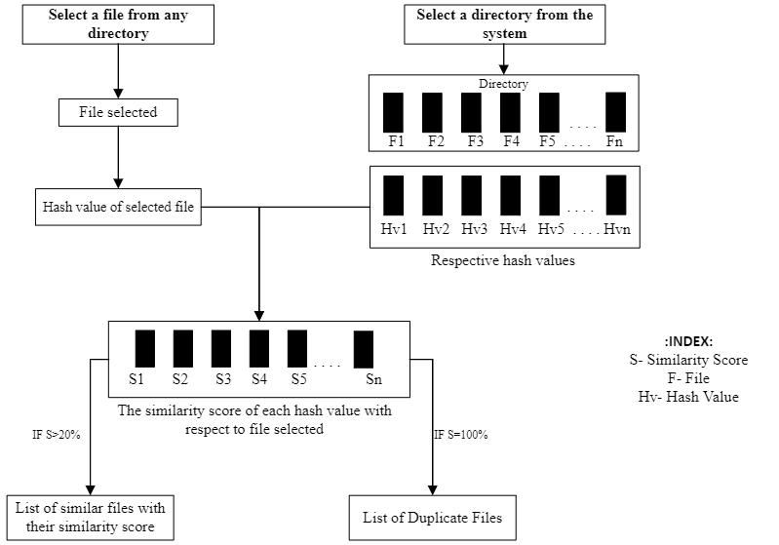

Figure 1: System architecture of similarity score calculation.
2.2 Flow Chart: The working flow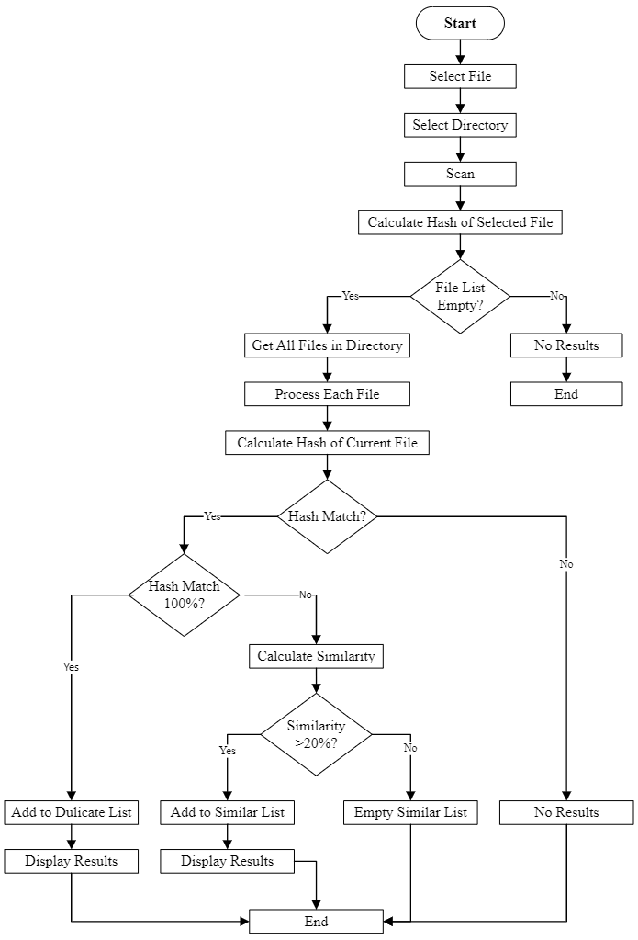
Figure 2: Flow Chart of finding similar and duplicate files algorithm.

  - Working principle
Our system modelling works by considering following criteria’s.
    - Criteria 1: File and Directory Selection:
Enables users to choose specific files and directories for deduplication, tailoring the process to individual storage needs.

Discussion:
This criterion empowers users to meticulously tailor the deduplication process according to their unique storage needs. By allowing the selection of specific files and directories, "Undupify" ensures a user-centric approach. This adaptability recognizes the diversity of data types and user priorities, providing efficient and targeted deduplication. The system's responsiveness is enhanced as users focus on high-impact areas, optimizing both processing time and overall system resources. In essence, this criterion reflects the commitment of "Undupify" to delivering a personalized and efficient file deduplication experience.

    - Criteria 2: MD5 Hash Calculation for Content Comparison:
Utilizes MD5 hashing to precisely identify duplicate files based on content fingerprints, ensuring accuracy in content comparison.

Discussion: The incorporation of MD5 hash calculation represents a pivotal step in ensuring the accuracy and reliability of content comparison within "Undupify." By leveraging MD5 hashing, the system generates distinct fingerprints for file content, establishing a standardized basis for subsequent deduplication assessments. This cryptographic approach not only enhances computational efficiency but also provides a robust mechanism for identifying duplicates. The reliability of MD5 hash values contributes to the precision of content comparison, reinforcing the system's ability to discern even subtle differences. Overall, this criterion underscores "Undupify's" commitment to employing advanced methods for content analysis, further solidifying its effectiveness in the realm of file deduplication.

    - Criteria 3: Advanced Algorithm for Duplicate Identification:
Implements a customizable threshold to assess file content similarity, allowing users to control the deduplication process's sensitivity.

Discussion: The introduction of an advanced algorithm signifies a leap forward in the deduplication capabilities of "Undupify." This criterion incorporates a customizable threshold, providing users with granular control over the sensitivity of the deduplication process. By allowing users to fine-tune the assessment of file content similarity, the system accommodates diverse data scenarios. This adaptability ensures that "Undupify" caters to varying user preferences and specific use cases. The customizable threshold empowers users to strike a balance between precision and comprehensiveness, aligning the deduplication process with their unique requirements. In essence, this criterion encapsulates the commitment of "Undupify" to not only advanced technological solutions but also user-driven customization for optimal file deduplication outcomes.

    - Criteria 4: Data Integrity Safeguards:
Designed with a user-centric approach, providing an intuitive interface for easy file selection, configuration, and execution of deduplication.

Discussion: The integration of data integrity safeguards underscores "Undupify's" commitment to a user-centric design philosophy. This criterion prioritizes user experience by offering an intuitive interface for seamless file selection, configuration, and deduplication execution. The system ensures that users, regardless of their technical expertise, can navigate the deduplication process effortlessly. By providing safeguards within the interface, "Undupify" minimizes the risk of inadvertent modifications during deduplication, preserving the integrity of user data. This user-friendly approach aligns with the broader goal of making file deduplication accessible and efficient, reinforcing the software's position as a reliable and user-centric solution in the realm of digital file management.

    - Criteria 5: Performance Optimization Across Hardware Configurations:
Goes beyond deduplication to optimize storage, with reporting features to inform users about the impact on their storage, promoting informed data organization.

Discussion: This criterion underscores "Undupify's" commitment to holistic optimization by extending beyond mere deduplication. By optimizing performance across various hardware configurations, the system ensures seamless operation, irrespective of the user's setup. The inclusion of reporting features represents a proactive approach, providing users with insights into the impact of deduplication on their storage. This not only promotes transparency but also empowers users to make informed decisions about their data organization. The emphasis on performance optimization aligns with the software's overarching goal of not only reducing redundancy but enhancing the overall efficiency of digital storage systems. "Undupify" aims to deliver a comprehensive solution that not only deduplicates files but also optimizes the performance of the entire storage ecosystem.

- References

[1] Bayram, Ümit et al. "A High-Throughput Content-Based Deduplication System with Dynamic Chunking." IEEE Transactions on Computers 61.3 (2012): 345-358.
[2] Black, John. "MD5 Collision Vulnerability." The Register (2009)
[3] Amer, Muhammad Ali et al. "Deduplication for Cloud Storage: State of the Art, Challenges, and Future Directions." IEEE Communications Surveys & Tutorials 20.2 (2018): 888-923.
[4] Zhu, Yin et al. "File Deduplication in Cloud Storage Using Content-Defined Chunking." Proceedings of the 25th International Conference on Network Protocols (2017).
[5] Manku, Gurmeet Singh et al. "Simhash: a fast-hashing algorithm for approximate string matching." Proceedings of the 9th international conference on Information and knowledge management (2007).
[6] Verma, Ankit et al. "Deduplication Techniques for Big Data Analytics." Data Deduplication: Approaches and Architectures for Efficient Storage (2023): 1-46
[7] Baeza-Yates, Ricardo and Berthier, Ricardo. "The cosine similarity measure for information retrieval." arXiv preprint arXiv:2003.02500 (2020)
[8] Rivest, Ronald L. "The MD5 Message-Digest Algorithm." IETF RFC 1321 (1992).
[9] Roussev, V., Richard III, G.G., and Marziale, L. "Multi-resolution similarity hashing." Digital Investigation 4 (2007): 105-113.
[10] Henson, Val. "An analysis of compare-by-hash." In 9th Workshop on Hot Topics in Operating Systems (HotOS IX). 2003.
[11] Sadowski, Caitlin, and Greg Levin. "Simhash: Hash-based similarity detection." (2007).
[12] Maurer WD, Lewis TG. "Hash table methods." ACM Computing Surveys (CSUR) 7.1 (1975): 5-19
[13] Bardis, N. G., Alex Polymenopoulos, E. G. Bardis, A. P. Markovskyy, and Nikos E. Mastorakis. "Hash Algorithms: a design for parallel calculations." International Journal of Computer Science 1 (2003): 48-56.

Appendix
A. Application snapshot.
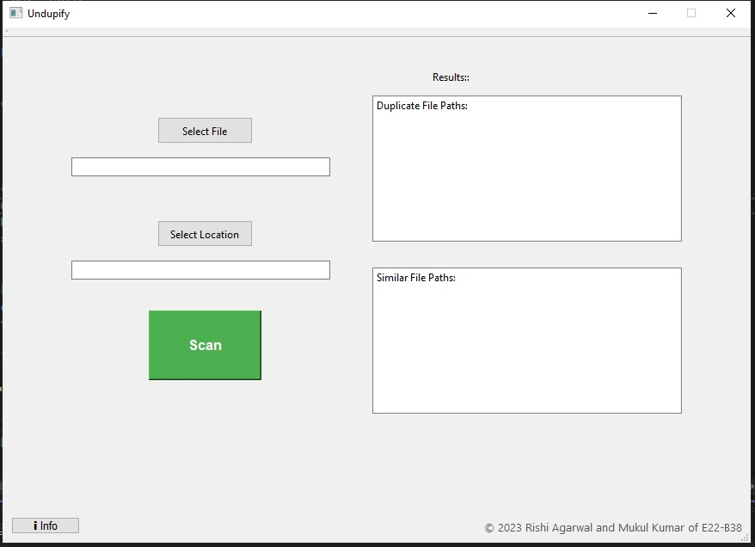
A.1: Home screen preivew
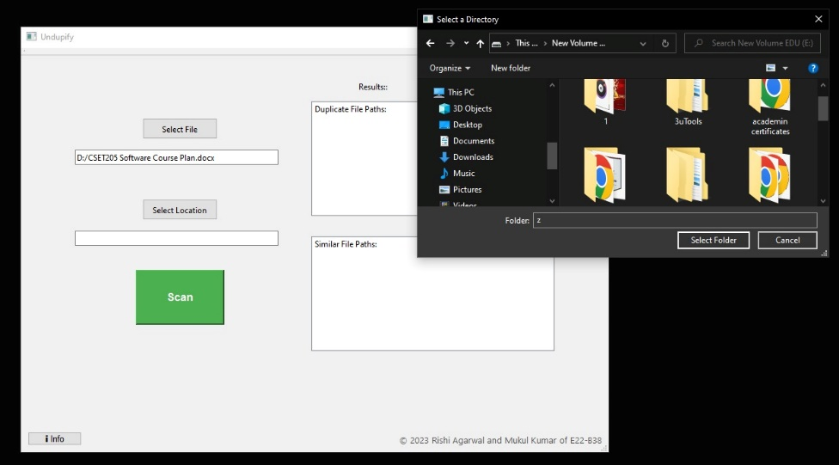
A.2: Selection of file and directory.
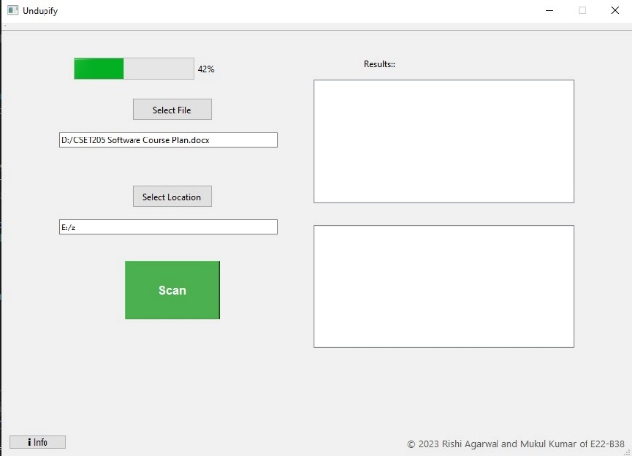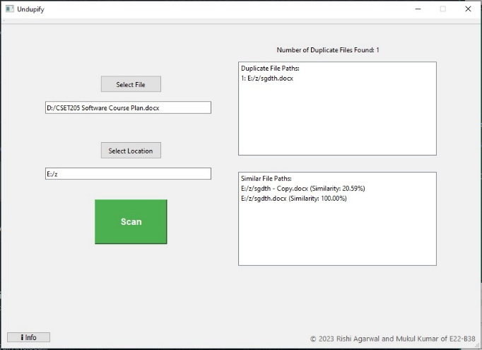
A.3: While processing the output. A.4: Output preview.

