The given dataset was split into two separate CSVs for each dataset. Below is the scatter plot for Dataset (1).
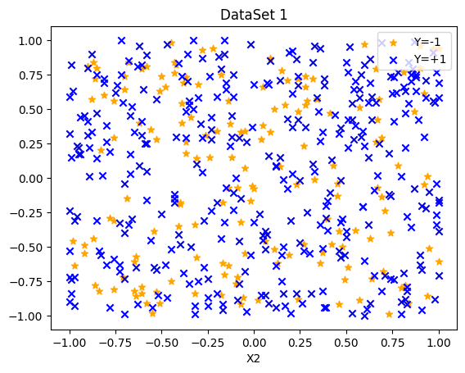
Dataset (1) #id:24-24-1
Ans. i(a)
The features of dataset were augmented to polynomial features and a logistic regression model with L2 penalty was trained with different values of C ranging from 0.01 to 100. For a particular C value, different orders of polynomial feature ranging from 1 to 10 were used. The Dataset (1) looks noisy and imbalanced, using accuracy can be misleading, thus, as a performance metric, F1_score (combines Precision & Recall) for each model was calculated using k-fold cross validation, where k=5. Below graphs show F1_score across different orders of polynomial features (Q) for all C values taken.
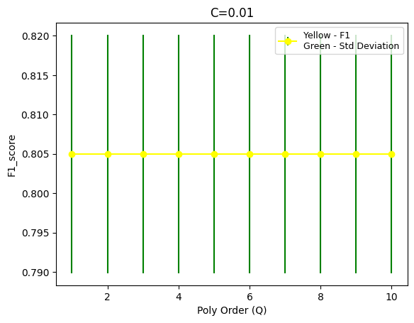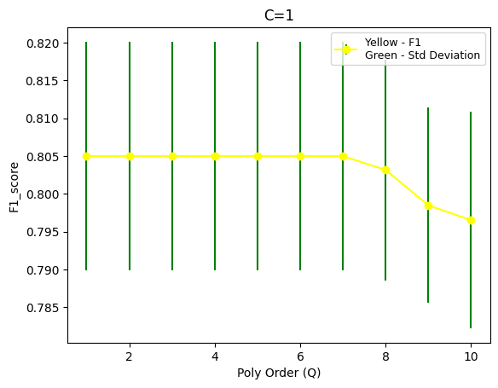
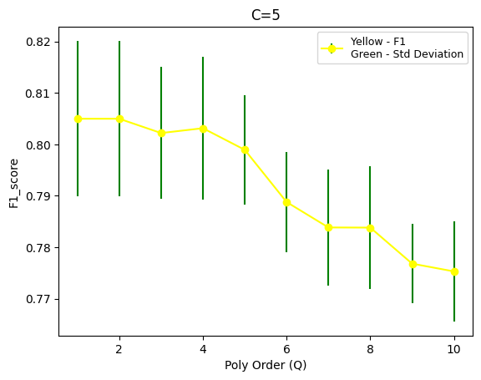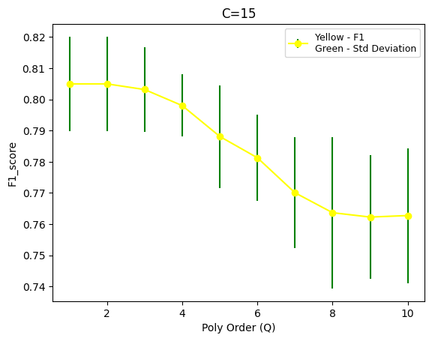
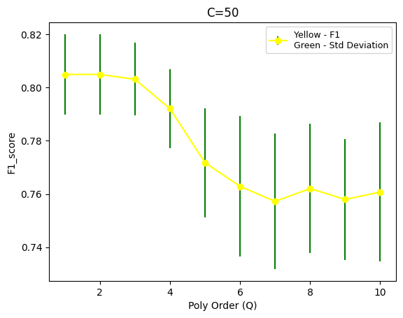 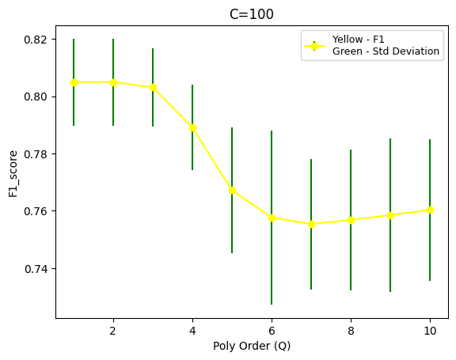
Initially I picked C=5, and checked f1_score for all degrees. Increase in the polynomial degree also doesn’t help improve F1_score, it rather makes the model worse and can include over-fitting. Thus, going with a simple model with 2 degree of polynomial is a good choice.

C: 0.01, Degree: 1 -> F1: 80.50% (+/- 1.51%)  C: 0.01, Degree: 2 -> F1: 80.50% (+/- 1.51%)  C: 0.01, Degree: 3 -> F1: 80.50% (+/- 1.51%)  C: 0.01, Degree: 4 -> F1: 80.50% (+/- 1.51%)  C: 0.01, Degree: 5 -> F1: 80.50% (+/- 1.51%)  C: 0.01, Degree: 6 -> F1: 80.50% (+/- 1.51%)  C: 0.01, Degree: 7 -> F1: 80.50% (+/- 1.51%)  C: 0.01, Degree: 8 -> F1: 80.50% (+/- 1.51%)  C: 0.01, Degree: 9 -> F1: 80.50% (+/- 1.51%)  C: 0.01, Degree: 10 -> F1: 80.50% (+/- 1.51%) | C: 1, Degree: 1 -> F1: 80.50% (+/- 1.51%)  C: 1, Degree: 2 -> F1: 80.50% (+/- 1.51%)  C: 1, Degree: 3 -> F1: 80.50% (+/- 1.51%)  C: 1, Degree: 4 -> F1: 80.50% (+/- 1.51%)  C: 1, Degree: 5 -> F1: 80.50% (+/- 1.51%)  C: 1, Degree: 6 -> F1: 80.50% (+/- 1.51%)  C: 1, Degree: 7 -> F1: 80.50% (+/- 1.51%)  C: 1, Degree: 8 -> F1: 80.32% (+/- 1.46%)  C: 1, Degree: 9 -> F1: 79.85% (+/- 1.29%)  C: 1, Degree: 10 -> F1: 79.65% (+/- 1.43%)
C: 5, Degree: 1 -> F1: 80.50% (+/- 1.51%)  C: 5, Degree: 2 -> F1: 80.50% (+/- 1.51%)  C: 5, Degree: 3 -> F1: 80.22% (+/- 1.28%)  C: 5, Degree: 4 -> F1: 80.31% (+/- 1.39%)  C: 5, Degree: 5 -> F1: 79.89% (+/- 1.06%)  C: 5, Degree: 6 -> F1: 78.88% (+/- 0.98%)  C: 5, Degree: 7 -> F1: 78.38% (+/- 1.13%)  C: 5, Degree: 8 -> F1: 78.38% (+/- 1.19%)  C: 5, Degree: 9 -> F1: 77.68% (+/- 0.77%)  C: 5, Degree: 10 -> F1: 77.53% (+/- 0.97%) | C: 15, Degree: 1 -> F1: 80.50% (+/- 1.51%)  C: 15, Degree: 2 -> F1: 80.50% (+/- 1.51%)  C: 15, Degree: 3 -> F1: 80.32% (+/- 1.37%)  C: 15, Degree: 4 -> F1: 79.80% (+/- 1.00%)  C: 15, Degree: 5 -> F1: 78.81% (+/- 1.64%)  C: 15, Degree: 6 -> F1: 78.13% (+/- 1.37%)  C: 15, Degree: 7 -> F1: 77.01% (+/- 1.78%)  C: 15, Degree: 8 -> F1: 76.37% (+/- 2.43%)  C: 15, Degree: 9 -> F1: 76.23% (+/- 1.98%)  C: 15, Degree: 10 -> F1: 76.28% (+/- 2.16%)
C: 50, Degree: 1 -> F1: 80.50% (+/- 1.51%)  C: 50, Degree: 2 -> F1: 80.50% (+/- 1.51%)  C: 50, Degree: 3 -> F1: 80.32% (+/- 1.37%)  C: 50, Degree: 4 -> F1: 79.21% (+/- 1.49%)  C: 50, Degree: 5 -> F1: 77.18% (+/- 2.06%)  C: 50, Degree: 6 -> F1: 76.29% (+/- 2.65%)  C: 50, Degree: 7 -> F1: 75.72% (+/- 2.55%)  C: 50, Degree: 8 -> F1: 76.20% (+/- 2.43%)  C: 50, Degree: 9 -> F1: 75.79% (+/- 2.28%)  C: 50, Degree: 10 -> F1: 76.07% (+/- 2.62%) | C: 100, Degree: 1 -> F1: 80.50% (+/- 1.51%)  C: 100, Degree: 2 -> F1: 80.50% (+/- 1.51%)  C: 100, Degree: 3 -> F1: 80.32% (+/- 1.37%)  C: 100, Degree: 4 -> F1: 78.91% (+/- 1.49%)  C: 100, Degree: 5 -> F1: 76.72% (+/- 2.20%)  C: 100, Degree: 6 -> F1: 75.77% (+/- 3.04%)  C: 100, Degree: 7 -> F1: 75.54% (+/- 2.28%)  C: 100, Degree: 8 -> F1: 75.69% (+/- 2.46%)  C: 100, Degree: 9 -> F1: 75.85% (+/- 2.69%)  C: 100, Degree: 10 -> F1: 76.03% (+/- 2.48%)
For q=2, it can be seen that increasing the value of C has no positive affect on F1_score of the model. Thus, going with value of C having moderate regularization i.e., C=1.
Thus, choosing C=1 and Q=2 for logistic regression model, below scatter plots shows predictions done by this model.
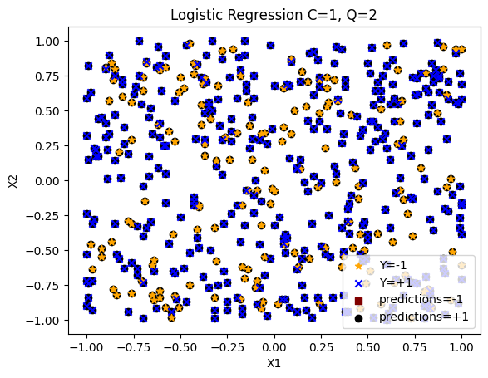
As seen above, this mode is not good enough, has low F1_score and is unable to predict for -1 class.
Ans. i(b)
A K-Nearest Neighbours classifier model was trained for different values of K ranging from 1 to 120. F1_score for each model was calculated using k-fold cross validation, where k=5. Below graph shows F1_score for different K-values considered.
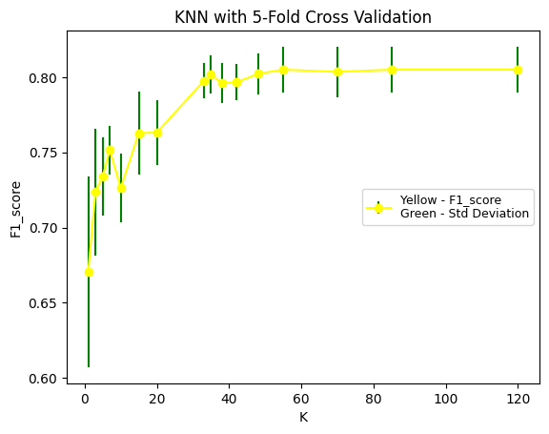 | K:1 -> F1: 67.05% (+/- 6.33%)  K:3 -> F1: 72.36% (+/- 4.21%)  K:5 -> F1: 73.39% (+/- 2.61%)  K:7 -> F1: 75.16% (+/- 1.60%)  K:10 -> F1: 72.63% (+/- 2.29%)  K:15 -> F1: 76.28% (+/- 2.77%)  K:20 -> F1: 76.32% (+/- 2.16%)  K:33 -> F1: 79.75% (+/- 1.18%)  K:35 -> F1: 80.18% (+/- 1.25%)  K:38 -> F1: 79.60% (+/- 1.32%)  K:42 -> F1: 79.65% (+/- 1.21%)  K:48 -> F1: 80.22% (+/- 1.36%)  K:55 -> F1: 80.50% (+/- 1.51%)  K:70 -> F1: 80.35% (+/- 1.67%)  K:85 -> F1: 80.50% (+/- 1.51%)  K:120 -> F1: 80.50% (+/- 1.51%)
I started with having K value as 1, which got me 67% F1_score and around 6% deviation. So, I incremented K gradually to improve F1_score and decrease deviation. As I increased K, the F1_score increased gradually till K reached 55 (expect for a dip around 40). K being 55 gave the highest F1_score of 80.50% with deviation of 1.51%. Increasing K beyond 55 did not make a difference in F1_score nor in standard deviation. This may be due to data being noisy with high overlapping and no clear pattern or separation.
Thus, choosing K=55 for KNN model, below scatter plots shows predictions done by this model.
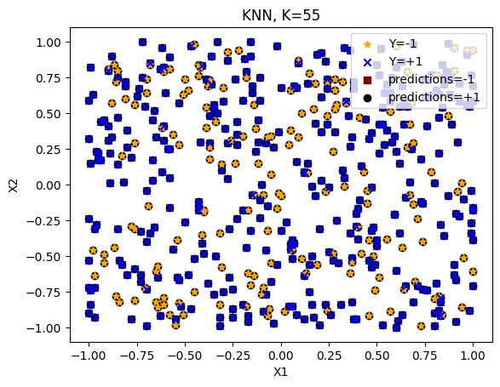
As seen in above graph, KNN with 55 also does not perform well and is unable to predict class -1.
Ans. i(c)
Confusion matrix gives you a clear idea of your predictions. It is a 2x2 table having 4 values.
TP - True Positive – Datapoint is positive and predicted as positive
TN -True Negative – Datapoint is negative and predicted as negative
FP - False Positive – Datapoint is negative but predicted as positive
FN - False Negative – Datapoint is positive but predicted as negative
For logistic regression, KNN and baseline models, below are results of confusion matrix used on full training dataset.

Logistic Regression (C=1, Q=2) | KNN (K=55)
   | Predicted -1 | Predicted +1
  Actual -1 | 0 | 165
  Actual +1 | 0 | 341
   | Predicted -1 | Predicted +1
  Actual -1 | 0 | 165
  Actual +1 | 0 | 341
Most Frequent Dummy Classifier | Random Classifier
   | Predicted -1 | Predicted +1
  Actual -1 | 0 | 165
  Actual +1 | 0 | 341
   | Predicted -1 | Predicted +1
  Actual -1 | 88 | 77
  Actual +1 | 163 | 178

As seen from the above matrix, none of the model is predicting class -1. Only random classifier was able to predict some of the true negative values. Logistic regression and KNN models are behaving as most frequent dummy classifiers.
As K=55 failed to predict -1 class, I checked confusion matrix for lower values of K and found K=42 predicting some points from -1 class and having almost same F1_score and deviation.
KNN (K=42)  F1_score - 79.65% (+/- 1.21%) | 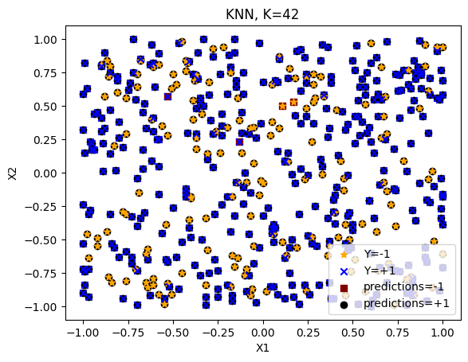
   | Pred -1 | Predict +1
  Actual -1 | 2 | 163
  Actual +1 | 2 | 339
Thus, updating KNN model to K=42 and using new KNN model for ROC curve.
Ans. i(d)
Below is the ROC curve for all the classifiers
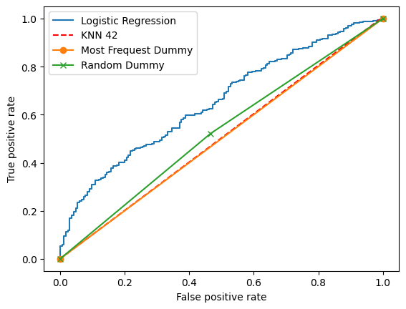
According to ROC curve performance of Logistic Regression > Random > KNN > Most Frequent. On average all the models make a 45-degree line on the curve which shows poor performance for all classifiers
Ans. i(e)
Looking at the confusion matrix and ROC curve, all classifiers have performed poorly on dataset.
Looking at ROC curve, logistic regression model looks a better but fails to predict -1 class as seen in confusion matrix.
KNN 42 was able to predict couple of -1 class points but has a flat diagonal line in ROC and could not beat Random classifier.
Thus, for the given dataset I would not recommend using any of the above classifiers.
Dataset (2) #id:24-48-24-1
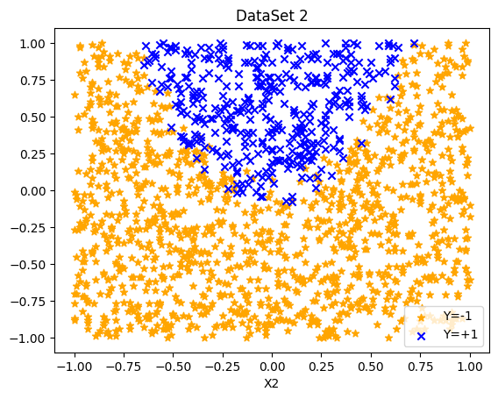
Ans. ii(a)
Similar to above dataset, features of dataset (2) were augmented to polynomial features and a logistic regression model with L2 penalty was trained with different values of C ranging from 0.1 to 50. For a particular C value, different orders of polynomial feature ranging from 1 to 7 were used. F1_score (combines Precision & Recall) for each model was calculated using k-fold cross validation, where k=5. Below graphs show F1_score across different orders of polynomial features (Q) for all C values taken.
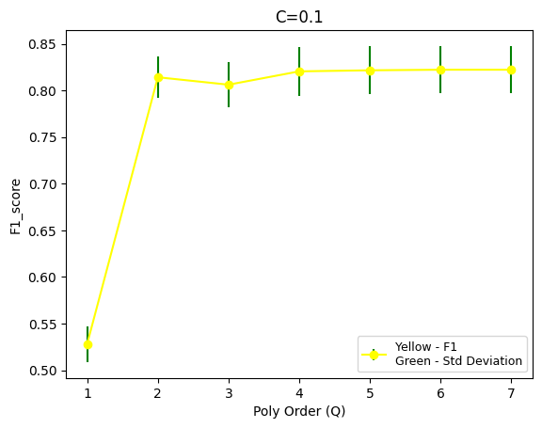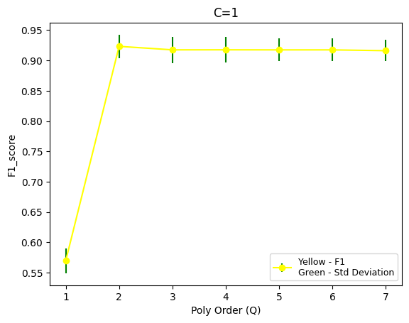
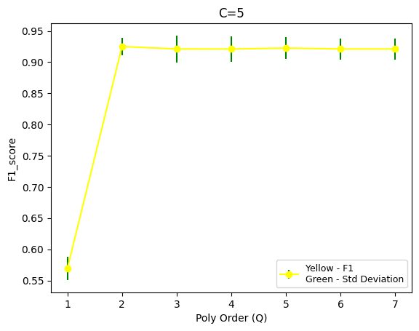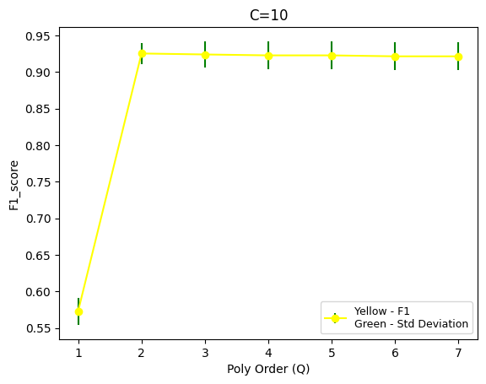
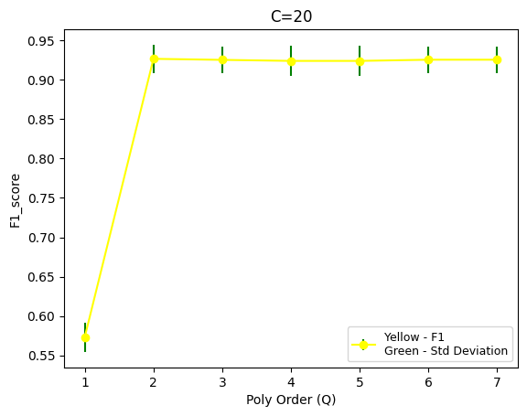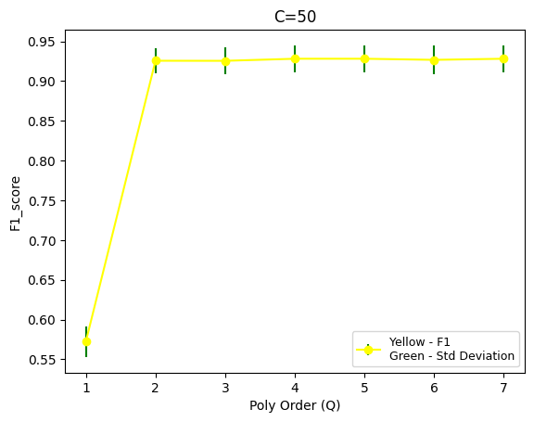
As you can see from above graphs, starting with lower C value 0.1, gave us low f1_score of around 80% and higher deviation. Increasing C till 10 increased the f1_score to around 92%, after which the score remained stable. For C=10, we get highest f1_score of 92.52% and lower deviation of only 1.43%. Other C values like 20 also have similar f1_score but slightly higher deviation. Thus, taking C as 10 which gives good balance of score and stability.
C: 0.1, Degree: 1 -> F1: 52.80% (+/- 1.93%)  C: 0.1, Degree: 2 -> F1: 81.42% (+/- 2.22%)  C: 0.1, Degree: 3 -> F1: 80.62% (+/- 2.44%)  C: 0.1, Degree: 4 -> F1: 82.05% (+/- 2.64%)  C: 0.1, Degree: 5 -> F1: 82.16% (+/- 2.58%)  C: 0.1, Degree: 6 -> F1: 82.22% (+/- 2.54%)  C: 0.1, Degree: 7 -> F1: 82.22% (+/- 2.54%) | C: 1, Degree: 1 -> F1: 56.98% (+/- 2.06%)  C: 1, Degree: 2 -> F1: 92.33% (+/- 1.91%)  C: 1, Degree: 3 -> F1: 91.75% (+/- 2.16%)  C: 1, Degree: 4 -> F1: 91.76% (+/- 2.09%)  C: 1, Degree: 5 -> F1: 91.75% (+/- 1.89%)  C: 1, Degree: 6 -> F1: 91.75% (+/- 1.89%)  C: 1, Degree: 7 -> F1: 91.61% (+/- 1.76%)
C: 5, Degree: 1 -> F1: 56.91% (+/- 1.84%)  C: 5, Degree: 2 -> F1: 92.50% (+/- 1.44%)  C: 5, Degree: 3 -> F1: 92.11% (+/- 2.14%)  C: 5, Degree: 4 -> F1: 92.10% (+/- 2.03%)  C: 5, Degree: 5 -> F1: 92.25% (+/- 1.79%)  C: 5, Degree: 6 -> F1: 92.11% (+/- 1.67%)  C: 5, Degree: 7 -> F1: 92.11% (+/- 1.67%) | C: 10, Degree: 1 -> F1: 57.29% (+/- 1.87%)  C: 10, Degree: 2 -> F1: 92.52% (+/- 1.43%)  C: 10, Degree: 3 -> F1: 92.39% (+/- 1.77%)  C: 10, Degree: 4 -> F1: 92.26% (+/- 1.92%)  C: 10, Degree: 5 -> F1: 92.26% (+/- 1.92%)  C: 10, Degree: 6 -> F1: 92.13% (+/- 1.89%)  C: 10, Degree: 7 -> F1: 92.13% (+/- 1.89%)
C: 20, Degree: 1 -> F1: 57.29% (+/- 1.87%)  C: 20, Degree: 2 -> F1: 92.68% (+/- 1.79%)  C: 20, Degree: 3 -> F1: 92.54% (+/- 1.63%)  C: 20, Degree: 4 -> F1: 92.41% (+/- 1.87%)  C: 20, Degree: 5 -> F1: 92.41% (+/- 1.87%)  C: 20, Degree: 6 -> F1: 92.56% (+/- 1.66%)  C: 20, Degree: 7 -> F1: 92.56% (+/- 1.66%) | C: 50, Degree: 1 -> F1: 57.22% (+/- 1.92%)  C: 50, Degree: 2 -> F1: 92.56% (+/- 1.60%)  C: 50, Degree: 3 -> F1: 92.55% (+/- 1.71%)  C: 50, Degree: 4 -> F1: 92.81% (+/- 1.68%)  C: 50, Degree: 5 -> F1: 92.81% (+/- 1.68%)  C: 50, Degree: 6 -> F1: 92.68% (+/- 1.79%)  C: 50, Degree: 7 -> F1: 92.81% (+/- 1.68%)
For any particular value of C, after polynomial degree 2, there is not significant increase in f1_score. Thus, taking a lower degree polynomial makes a better choice to avoid chances of overfitting with higher degree. Degree 2 is the optimal choice in this case.
Thus, choosing C=10 & Q=2 for logistic regression model, below scatter plots shows predictions done by this model.
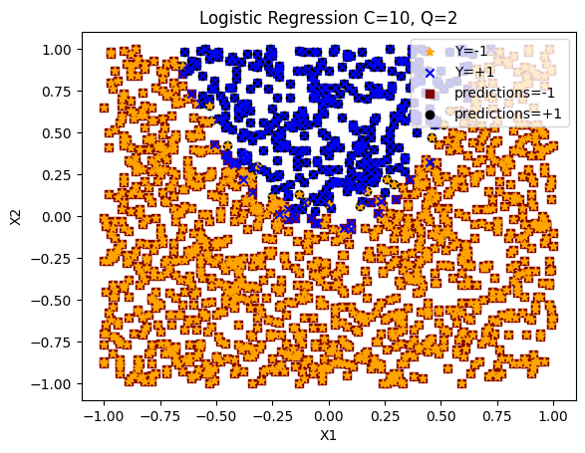
The model predictions look good, correctly classifying both +1 and -1 classes
Ans. ii(b)
A K-Nearest Neighbours classifier model was trained for different values of K ranging from 1 to 20. F1_score for each model was calculated using k-fold cross validation, where k=5. Below graph shows F1_score for different K-values considered.

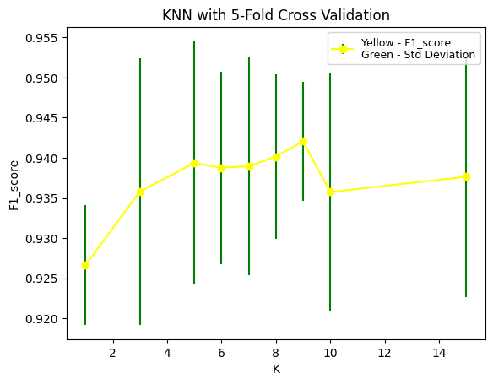 | K:1 -> F1: 92.66% (+/- 0.74%)  K:3 -> F1: 93.58% (+/- 1.66%)  K:5 -> F1: 93.93% (+/- 1.52%)  K:6 -> F1: 93.88% (+/- 1.20%)  K:7 -> F1: 93.89% (+/- 1.36%)  K:8 -> F1: 94.02% (+/- 1.02%)  K:9 -> F1: 94.20% (+/- 0.74%)  K:10 -> F1: 93.57% (+/- 1.48%)  K:15 -> F1: 93.76% (+/- 1.49%)  K:20 -> F1: 93.01% (+/- 0.86%)
As K is increased from 1 to 9, we see a gradual increase in f1_score and gradual decrease in standard deviation. This is good, it shows that model is fitting data well. Maximum f1_score of 94.20% combined with lowest deviation of 0.74% is achieved at K=9. Increasing k above 9, slightly decreases f1_score and also adds instability. Increasing k beyond that might make the model underfit as the decision boundary would be too smooth.
Thus, k=9, seems the right choice for our KNN model.
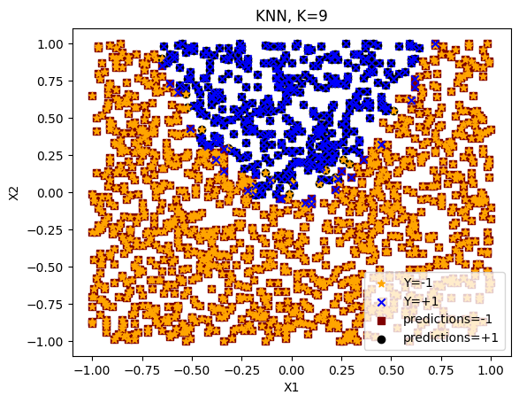
The KNN 9 predictions also look good, correctly classifying both +1 and -1 classes
Ans. ii(c)
Let’s take a look at the confusion matrix for both chosen logistic regression and KNN models against baseline models.
For logistic regression, KNN and baseline models, below are results of confusion matrix used on full training dataset.

Logistic Regression (C=10, Q=2) | KNN (K=9)
   | Predicted -1 | Predicted +1
  Actual -1 | 1227 | 19
  Actual +1 | 32 | 350
   | Predicted -1 | Predicted +1
  Actual -1 | 1228 | 18
  Actual +1 | 23 | 359
Most Frequent Dummy Classifier | Random Classifier
   | Predicted -1 | Predicted +1
  Actual -1 | 1246 | 0
  Actual +1 | 382 | 0
   | Predicted -1 | Predicted +1
  Actual -1 | 620 | 626
  Actual +1 | 163 | 201

Most Frequent Dummy Classifier f1_score: 0.00%
Random Classifier f1_score: 33.25%
Logistic Regression f1_score: 93.21%
KNN (k=9) f1_score: 94.60%
From the confusion matrix you can see that for logistic regression and KNN models, most of the points fall in True Positive and True Negative category. They also have significantly high f1_scores as compared to the baseline classifiers.

Ans. ii(d)
Below is the ROC curve for all the classifiers
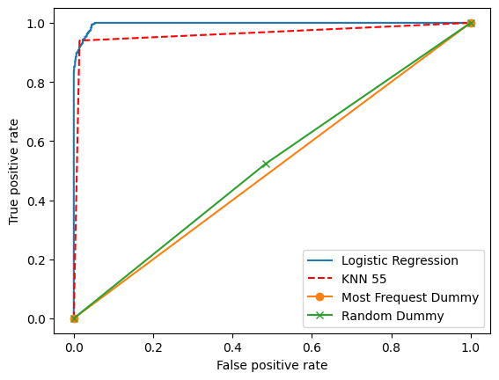

Ans. ii(e)
The ROC curve shows strength of chosen logistic regression and KNN models. Both have lines going towards the ideal top left corner (0,1) of the curve having high true positive rate and low false positive rate. Both the models also comfortabely beat the baseline models which have their lines almost at 45 degree on the curve. Logistic regression marginally has more area under the ROC curve and moves slightly sharper towards the top-left corner as compared to KNN.
Both these models also have a strong confusion matrix with very less point in false positive/negative category.
KNN model performs marginally better than logistic regression model with lesser smaller number of points in false positive/negative category compared to logistic regression model. KNN also achieves higher f1_score of 94.60% as compared to 93.21% of logistic regression.
Thus, although both models are good for our data, I would recommend using KNN due to its higher f1_score and lesser misclassified points.
Finally, I also checked accuracy score for our chosen models to confirm my recommendation of KNN.
Logistic Regression Accuracy 96.86%
KNN K=9 Accuracy 97.48%
As KNN also has a slightly better accuracy score I would confirm my recommendation for KNN model.

Appendix:

import numpy as np
import pandas as pd

# Dataset1 --- id:24-24-24-1
data_frame = pd.read_csv("week4_1.csv", header=None)

print(data_frame.head)
import matplotlib.pyplot as plt

X1 = data_frame.iloc[:,0]
X2 = data_frame.iloc[:,1]
X = np.column_stack((X1,X2))
y = data_frame.iloc[:,2]

n_one = plt.scatter(X1[y<0], X2[y<0], marker='*' , color='orange', label='Y=-1')
p_one = plt.scatter(X1[y>0], X2[y>0], marker='x' , color='blue', label='Y=+1')
plt.xlabel("X1")
plt.xlabel("X2")
plt.legend(handles=[n_one,p_one], loc="upper right")
plt.title("DataSet 1")
plt.show()
from sklearn.preprocessing import PolynomialFeatures
from sklearn.linear_model import LogisticRegression
from sklearn.model_selection import KFold
from sklearn.metrics import f1_score

k_fold = KFold(n_splits=5)

degrees = [1,2,3,4,5,6,7,8,9,10]
C = [0.01, 1, 5, 15, 50,100]

for c in C:

mean_f1=[]
std_=[]

for degree in degrees:
temp=[]
poly_F = PolynomialFeatures(degree)
X_poly = poly_F.fit_transform(X)
log_reg = LogisticRegression(C=c, penalty='l2', max_iter=1000)

for train, test in k_fold.split(X_poly):
log_reg.fit(X_poly[train], y[train])
pred = log_reg.predict(X_poly[test])
temp.append(f1_score(y[test],pred))

print(f"C: {c}, Degree: {degree} -> F1: {np.array(temp).mean():.2%} (+/- {np.array(temp).std():.2%})")

mean_f1.append(float(np.array(temp).mean()))
std_.append(float(np.array(temp).std()))

plt.errorbar(degrees,mean_f1,yerr=std_,ecolor='green',fmt='-o' , label="Yellow - F1\nGreen - Std Deviation",color="yellow")
plt.xlabel("Poly Order (Q)")
plt.ylabel("F1_score")
plt.legend(fontsize=9)
plt.title(f"C={c}")
plt.show()
poly_F = PolynomialFeatures(2)
X_poly = poly_F.fit_transform(X)
log_reg = LogisticRegression(C=1, penalty='l2', max_iter=1000)
log_reg.fit(X_poly, y)
lr_predict = log_reg.predict(X_poly)

predict_n = plt.scatter(X1[lr_predict<0],X2[lr_predict<0], marker='s', color='maroon',label='predictions=-1')
predict_p = plt.scatter(X1[lr_predict>0],X2[lr_predict>0], marker='o', color='black', label='predictions=+1')

n_one = plt.scatter(X1[y<0], X2[y<0], marker='*' , color='orange', label='Y=-1')
p_one = plt.scatter(X1[y>0], X2[y>0], marker='x' , color='blue', label='Y=+1')

plt.xlabel("X1")
plt.ylabel("X2")
plt.legend(handles=[n_one,p_one, predict_n, predict_p], loc="lower right")
plt.title("Logistic Regression C=1, Q=2")
plt.show()
# i(b)
from sklearn.neighbors import KNeighborsClassifier

# K = [1,5,10,20,30,45,60,80,150,200]
K = [1,3,5,7,10,15,20,33,35,38,42,48,55,70,85,120]

kn_f1 =[]
kn_std = []

for k in K:
kn_model = KNeighborsClassifier(n_neighbors=k)
temp = []
for train,test in k_fold.split(X):
kn_model.fit(X[train], y[train])
pred = kn_model.predict(X[test])
temp.append(f1_score(y[test],pred))

kn_f1.append(float(np.array(temp).mean()))
kn_std.append(float(np.array(temp).std()))

print(f"K:{k} -> F1: {np.array(temp).mean():.2%} (+/- {np.array(temp).std():.2%})")

plt.errorbar(K,kn_f1,yerr=kn_std,ecolor='green',fmt='-o' , label="Yellow - F1_score\nGreen - Std Deviation",color="yellow")
plt.xlabel("K")
plt.ylabel("F1_score")
plt.legend(fontsize=9,loc='center right')
plt.title("KNN with 5-Fold Cross Validation")
plt.show()
# i(b)
k55_model = KNeighborsClassifier(n_neighbors=55)
k55_model.fit(X,y)
K55_predict = k55_model.predict(X)

predict_n = plt.scatter(X1[K55_predict<0],X2[K55_predict<0], marker='s', color='maroon',label='predictions=-1')
predict_p = plt.scatter(X1[K55_predict>0],X2[K55_predict>0], marker='o', color='black', label='predictions=+1')

n_one = plt.scatter(X1[y<0], X2[y<0], marker='*' , color='orange', label='Y=-1')
p_one = plt.scatter(X1[y>0], X2[y>0], marker='x' , color='blue', label='Y=+1')

plt.xlabel("X1")
plt.ylabel("X2")
plt.legend(handles=[n_one,p_one, predict_n, predict_p], loc="upper right")
plt.title("KNN, K=55")
plt.show()
# i(c)
from sklearn.metrics import confusion_matrix

def Confusion_Matrix(model,X,y):
model.fit(X,y)
y_pred = model.predict(X)
cm = confusion_matrix(y,y_pred)
f1 = f1_score(y,y_pred)

return cm,f1,y_pred

# LogReg cm
cm_lr, lr_f1 , _= Confusion_Matrix(log_reg,X_poly,y)
print("Log Reg Confusion Matrix: \n", cm_lr)
print(f"F1_score: {lr_f1:.2%}")

# K55 cm
cm_knn55, knn55_f1, _ = Confusion_Matrix(k55_model,X,y)
print("KNN 55 Confusion Matrix: \n", cm_knn55)
print(f"F1_score: {knn55_f1:.2%}")

# Trying K=42 for checking confusion matrix
k42_model = KNeighborsClassifier(n_neighbors=42)
k42_model.fit(X,y)
K42_predict = k42_model.predict(X)

predict_n = plt.scatter(X1[K42_predict<0],X2[K42_predict<0], marker='s', color='maroon',label='predictions=-1')
predict_p = plt.scatter(X1[K42_predict>0],X2[K42_predict>0], marker='o', color='black', label='predictions=+1')
n_one = plt.scatter(X1[y<0], X2[y<0], marker='*' , color='orange', label='Y=-1')
p_one = plt.scatter(X1[y>0], X2[y>0], marker='x' , color='blue', label='Y=+1')

plt.xlabel("X1")
plt.ylabel("X2")
plt.legend(handles=[n_one,p_one, predict_n, predict_p], loc="lower right")
plt.title("KNN, K=42")
plt.show()

# K=42 cm
cm_knn42, knn42_f1 , _ = Confusion_Matrix(k42_model,X,y)
print("KNN 42 Confusion Matrix: \n", cm_knn42)
print(f"F1_score: {knn42_f1:.2%}")

# Baseline Classifier

from sklearn.dummy import DummyClassifier

most_frequent_Dummy = DummyClassifier(strategy="most_frequent")
random_Dummy = DummyClassifier(strategy="uniform")

cm_most, most_f1 , most_pred = Confusion_Matrix(most_frequent_Dummy,X,y)
print("Most Frequent Dummy Confusion Matrix: \n", cm_most)
print(f"F1_score: {most_f1:.2%}")

cm_random, random_f1 , random_pred= Confusion_Matrix(random_Dummy,X,y)
print("Random Dummy Confusion Matrix: \n", cm_random)
print(f"F1_score: {random_f1:.2%}")
# i(d)

from sklearn.metrics import roc_curve

FP, TP, _ = roc_curve(y,log_reg.decision_function(X_poly))
plt.plot(FP,TP, label='Logistic Regression')

FP, TP, _ = roc_curve(y,K55_predict)
plt.plot(FP,TP, label='KNN 55',linestyle='--',color='red')

FP, TP, _ = roc_curve(y,most_pred)
plt.plot(FP,TP, label='Most Frequest Dummy', marker='o')

FP, TP, _ = roc_curve(y, random_pred)
plt.plot(FP,TP, label='Random Dummy' ,marker='x')

plt.xlabel('False positive rate')
plt.ylabel('True positive rate')
plt.legend()
plt.show()
import numpy as np
import pandas as pd

# Dataset (2) #id:24-48-24-1
data_frame = pd.read_csv("week4_2.csv", header=None)
print(data_frame.head)

import matplotlib.pyplot as plt

X1 = data_frame.iloc[:,0]
X2 = data_frame.iloc[:,1]
X = np.column_stack((X1,X2))
y = data_frame.iloc[:,2]

n_one = plt.scatter(X1[y<0], X2[y<0], marker='*' , color='orange', label='Y=-1')
p_one = plt.scatter(X1[y>0], X2[y>0], marker='x' , color='blue', label='Y=+1')
plt.xlabel("X1")
plt.xlabel("X2")
plt.legend(handles=[n_one,p_one], loc="lower right")
plt.title("DataSet 2")
plt.show()
from sklearn.preprocessing import PolynomialFeatures
from sklearn.linear_model import LogisticRegression
from sklearn.model_selection import KFold
from sklearn.metrics import f1_score

k_fold = KFold(n_splits=5)

degrees = [1,2,3,4,5,6,7]
C = [ 0.1, 1, 5, 10, 20, 50 ]

for c in C:

mean_f1=[]
std_=[]

for degree in degrees:
temp=[]
poly_F = PolynomialFeatures(degree)
X_poly = poly_F.fit_transform(X)
log_reg = LogisticRegression(C=c, penalty='l2', max_iter=1000)

for train, test in k_fold.split(X_poly):
log_reg.fit(X_poly[train], y[train])
pred = log_reg.predict(X_poly[test])
temp.append(f1_score(y[test],pred))

print(f"C: {c}, Degree: {degree} -> F1: {np.array(temp).mean():.2%} (+/- {np.array(temp).std():.2%})")

mean_f1.append(float(np.array(temp).mean()))
std_.append(float(np.array(temp).std()))

plt.errorbar(degrees,mean_f1,yerr=std_,ecolor='green',fmt='-o' , label="Yellow - F1\nGreen - Std Deviation",color="yellow")
plt.xlabel("Poly Order (Q)")
plt.ylabel("F1_score")
plt.legend(fontsize=9, loc="lower right")
plt.title(f"C={c}")
plt.show()
poly_F = PolynomialFeatures(2)
X_poly = poly_F.fit_transform(X)
log_reg = LogisticRegression(C=10, penalty='l2', max_iter=1000)
log_reg.fit(X_poly, y)
lr_predict = log_reg.predict(X_poly)

predict_n = plt.scatter(X1[lr_predict<0],X2[lr_predict<0], marker='s', color='maroon',label='predictions=-1')
predict_p = plt.scatter(X1[lr_predict>0],X2[lr_predict>0], marker='o', color='black', label='predictions=+1')

n_one = plt.scatter(X1[y<0], X2[y<0], marker='*' , color='orange', label='Y=-1')
p_one = plt.scatter(X1[y>0], X2[y>0], marker='x' , color='blue', label='Y=+1')

plt.xlabel("X1")
plt.ylabel("X2")
plt.legend(handles=[n_one,p_one, predict_n, predict_p], loc="upper right")
plt.title("Logistic Regression C=10, Q=2")
plt.show()
# ii(b)
from sklearn.neighbors import KNeighborsClassifier

# K = [1,5,10,20,30,45,60,80,150,200]
K = [1,3,5,6,7,8,9,10,15,20]

kn_f1 =[]
kn_std = []

for k in K:
kn_model = KNeighborsClassifier(n_neighbors=k)
temp = []
for train,test in k_fold.split(X):
kn_model.fit(X[train], y[train])
pred = kn_model.predict(X[test])
temp.append(f1_score(y[test],pred))

kn_f1.append(float(np.array(temp).mean()))
kn_std.append(float(np.array(temp).std()))

print(f"K:{k} -> F1: {np.array(temp).mean():.2%} (+/- {np.array(temp).std():.2%})")

plt.errorbar(K,kn_f1,yerr=kn_std,ecolor='green',fmt='-o' , label="Yellow - F1_score\nGreen - Std Deviation",color="yellow")
plt.xlabel("K")
plt.ylabel("F1_score")
plt.legend(fontsize=9,loc='upper right')
plt.title("KNN with 5-Fold Cross Validation")
plt.show()
# ii(b)
k9_model = KNeighborsClassifier(n_neighbors=9)
k9_model.fit(X,y)
K9_predict = k9_model.predict(X)

predict_n = plt.scatter(X1[K9_predict<0],X2[K9_predict<0], marker='s', color='maroon',label='predictions=-1')
predict_p = plt.scatter(X1[K9_predict>0],X2[K9_predict>0], marker='o', color='black', label='predictions=+1')

n_one = plt.scatter(X1[y<0], X2[y<0], marker='*' , color='orange', label='Y=-1')
p_one = plt.scatter(X1[y>0], X2[y>0], marker='x' , color='blue', label='Y=+1')

plt.xlabel("X1")
plt.ylabel("X2")
plt.legend(handles=[n_one,p_one, predict_n, predict_p], loc="lower right")
plt.title("KNN, K=9")
plt.show()
# ii(c)
from sklearn.metrics import confusion_matrix

def Confusion_Matrix(model,X,y):
model.fit(X,y)
y_pred = model.predict(X)
cm = confusion_matrix(y,y_pred)
f1 = f1_score(y,y_pred)

return cm,f1,y_pred

# LogReg cm
cm_lr, lr_f1 , _= Confusion_Matrix(log_reg,X_poly,y)
print("Log Reg Confusion Matrix: \n", cm_lr)
print(f"F1_score: {lr_f1:.2%}")

# KNN 9 cm
cm_knn9, knn9_f1 , knn9_predict = Confusion_Matrix(k9_model,X,y)
print("KNN 9 Confusion Matrix: \n", cm_knn9)
print(f"F1_score: {knn9_f1:.2%}")

# Baseline Classifier

from sklearn.dummy import DummyClassifier

most_frequent_Dummy = DummyClassifier(strategy="most_frequent")
random_Dummy = DummyClassifier(strategy="uniform")

cm_most, most_f1 , most_pred = Confusion_Matrix(most_frequent_Dummy,X,y)
print("Most Frequent Dummy Confusion Matrix: \n", cm_most)
print(f"F1_score: {most_f1:.2%}")

cm_random, random_f1 , random_pred= Confusion_Matrix(random_Dummy,X,y)
print("Random Dummy Confusion Matrix: \n", cm_random)
print(f"F1_score: {random_f1:.2%}")
# ii(d)

from sklearn.metrics import roc_curve

FP, TP, _ = roc_curve(y,log_reg.decision_function(X_poly))
plt.plot(FP,TP, label='Logistic Regression')

FP, TP, _ = roc_curve(y,knn9_predict)
plt.plot(FP,TP, label='KNN 55',linestyle='--',color='red')

FP, TP, _ = roc_curve(y,most_pred)
plt.plot(FP,TP, label='Most Frequest Dummy', marker='o')

FP, TP, _ = roc_curve(y, random_pred)
plt.plot(FP,TP, label='Random Dummy' ,marker='x')

plt.xlabel('False positive rate')
plt.ylabel('True positive rate')
plt.legend()
plt.show()

from sklearn.metrics import accuracy_score

knn9_acc = accuracy_score(y,K9_predict)
print(knn9_acc)

logreg_acc = accuracy_score(y,lr_predict)
print(logreg_acc)

