**Report**

**Title – Security –System**

Project Security system is designed for the High building, office where only some Authorised person can enter the room. This system focus on to make the building or Office more secure and safe.

IN this system a Atemga328 is used to control all the function of the security system, in this 2 layer security system is used 1 is door unlocking using proper authentication and passcode And 2 is Piezo sensor which get trigger when some pressure is applied to it .

Working-

Atmega328 is used for controlling all the operation in security system. In atmega328 the input that is door unlocking using pass code and piezo sensor is connected to B1 pin of atmega328.and output pin is C6 where buzzer and led light is connected , that will be in security room.

When the person enter the room using proper passcode the door unlock and piezo sensor will not get trigger, this piezo sensor will be under each tiles in the room. But when person enter the room without using proper authentication the piezo senor will get trigger and as soon as pressure will be applied to that tile the alarm will be raised in “SERUCITY ROOM” by blinking the led and the buzzer. And alert the security guard.

BLOCK DIAGRAM.

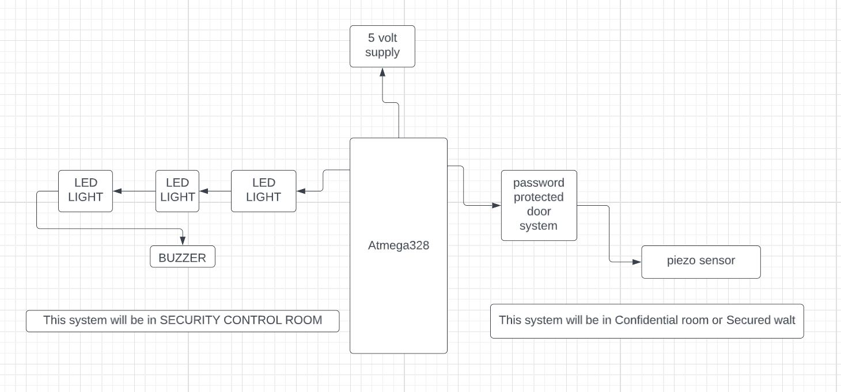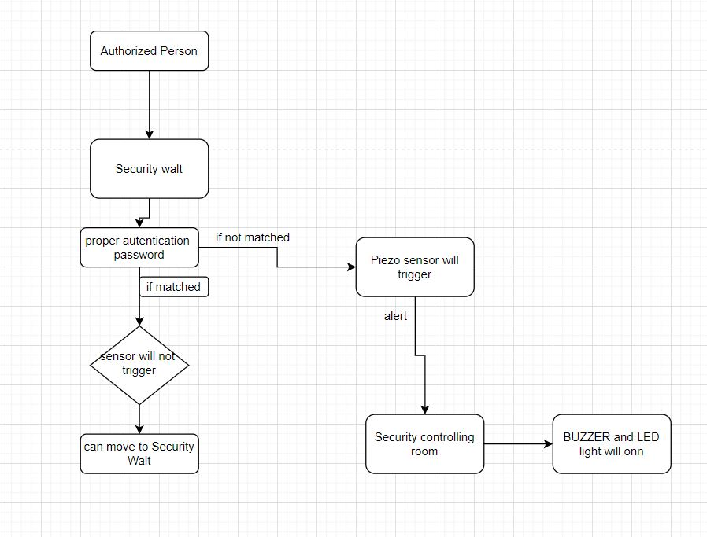

FLOWCHART

CKT DIAGRAM

