**RESTAURANT SUGGESTION   
SYSTEM**

**14/11/2020 IBM CAPSTONE PROJECT**

***Restaurant suggestion system is an ML model developed to demonstrate as a capstone project to IBM via Coursera.***

***It recommends restaurants based on user preferences.***

**TABLE OF CONTENTS**

|  |  |
| --- | --- |
| **TOPIC** | **PAGE** |
| **Introduction section** | **3** |
| **Data section** | **5** |
| **Methodology** | **8** |
| **Result section** | **10** |
| **Conclusion section** | **10** |

1. **Introduction :**

**Problem background:**

Chennai formerly known as Madras, is the capital of the Indian state of Tamil Nadu. Located on the Coromandel Coast of the Bay of Bengal, it is one of the largest cultural, economic and educational centres of south India. According to the 2011 Indian census, it is the sixth-most populous city and fourth-most populous urban agglomeration in India.

The first thing that comes to our mind while talking about Chennai cuisine is the early morning special ‘Filter Coffee’ and the all-time favourite ‘Thayir Sadam’ (curd rice). Other than that, the city has a variety of cuisine to offer food lovers – from the typical Idly-Sambhar to the spicy Chettinad dishes. While the authentic multi-cuisine restaurants are famous for their specific delicacies, carts selling steaming hot Idly-Chutney-Sambhar to office goers, small stalls selling Poli and Mini-Samosa at street corners and the Sundal, Bajji and Chat stalls at the beaches still remain the people’s choice.

Now most of the people in chennai can experience a variety of cuisine like South Indian, North Indian, Muslim food, Chinese and Western fast food,etc which are a few of the very popular ones.

**Problem description:**

As a person who loves to travel and visit soo many places, one might particularly be intersted in that place's cuisines too. Food and Travel are the best combination to ensure a happy and satisfied trip. If a person he/she loved the food at a place they're more likely to suggest that place to friend,colleage or another person which benefits the customer by giving them satisfaction and the profits to the restaurant. In such scenarios, we need to find restaurants at place and reasonable cost.

Few important points that must be addressed:

1. Nearest restaurants having the best feedbacks and reviews.
2. The different types of foods are available in the restaurant.
3. How many similar restaurants are available near me?
4. Comparing similar restaurants by price and their uniqueness/speciality.

Expectations from this system is to get answers for the previous requirements in such a way that it handles all the work of suggesting restaurants based on certain preferences like:

Types of restaurants present in a particular area. Location/Address of the similar restaurants present based on preference to particular food. How do different restaurants rank with respect to my preference.

**Target Audience**

The major target audience for this project would absolutely anybody who are willing to try out new food, explore or you can say foodies who love food. It can also benefit people who are looking forward to try a particular type of food, and there are few people who like to eat at restaurants based on their rank or stars. Hence, we can conclude this project is for everyone who are exploring different places or similar places looking for restaurants.

**Success Rate**

There are many people who love to travel and take a break from their stressed routine lives, and the best option is travelling and having the best food. With the generation of technology beside us now, one can easily get his/her smartphone to ask suggestions about where to go for a meal. Computers can store data for long and with the developement of ML and AI algorithms data keeps updating and evaluates to much better results as days keep passing by.

# **2. Data:**

### **Data requirements :**

For finding the requirements for this project model we will primarily need a lot of data classified into :

1. geographical coordinates of the restaurant.
2. Population of the neighborhood where the restaurant is located.
3. Average income of neighborhood to know how much is the restaurant worth.

With more detailed explaination, the requirements are as follows:

1. Latitude and Longitude are necessary to point the restaurants's coordinates and generate a map displaying all the restaurants pin-point with markers respectively.
2. The population of a neighbourhood is a crucial factor in determining a restaurant's growth and amount of customers who turn up to eat. Logically, the more the people of a neighbourhood, the more people will be interested to walk openly into a restaurant and less the population, less number of people frequently visit a restaurant.
3. Income of a neighborhood is also very important factor as population was. Income is directly proportional to richness of a neighborhood. If people in a neighborhood earns more than an average income, then it is very much possible that they will spend more however not always true with very less probability.

### **Data collection :**

There are many people who love to travel and take a break from their stressed routine lives, and the best option is travelling and having the best food. With the generation of technology beside us now, one can easily get his/her smartphone to ask suggestions about where to go for a meal. Computers can store data for long and with the developement of ML and AI algorihtms data keeps updating and evaluates to much better results as days keep passing by.

Taking the list by copying the neigbourhood areas into an excel file, Chennai has 4 Direction classifications and 82 neighbourhoods. After this i have used the python geolocator library to extract data for every neighbourhood in the dataframe and displayed them as follows :

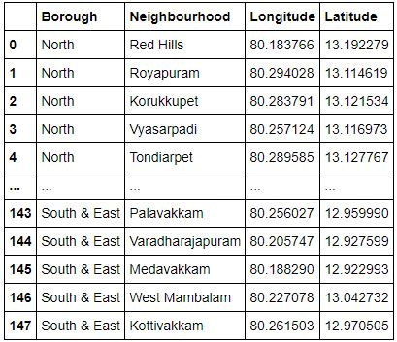

Population is another aspect where we can determine the number of people that might visit a restaurant in that particular area. Finding the population was convenient as a basic setup from this link. This may not be accurate but can conveniently estimate as close prediction.

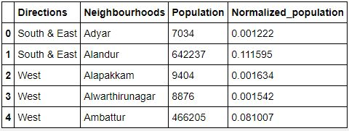

Income by neighborhood is again easy to find out given that it’s readily available. But in case of Chennai it is not the case. The given value may not be accurate but can suffice for our demonstrating project.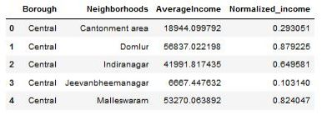

1. **Foursquare API:**

Use of foursquare is focused to fetch nearest venue locations so that we can use them to form a cluster. Foursquare API leverages the power of finding nearest venues in a radius (in my case: 2000mts) and also corresponding coordinates, venue location and names. After calling, the following data frame is created:

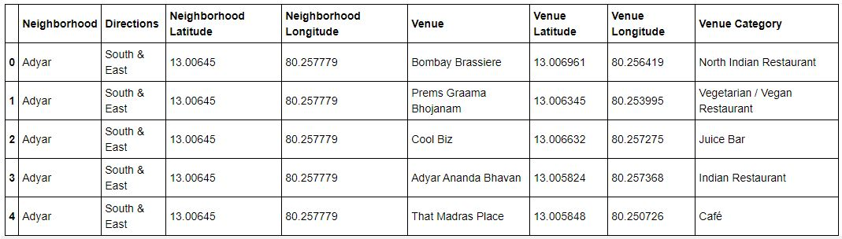

**3.Methodology** :

Exploratory analysis: Scrapping the data from different sources and then combining it to form a single-ton dataset is a difficult task. To do so, we need to explore the current state of dataset and then list up all the features needed to be fetched. Exploring the dataset is important because it gives you initial insights and may help you to get partial idea of the answers that you are looking to find out from the data. While exploring the dataset,

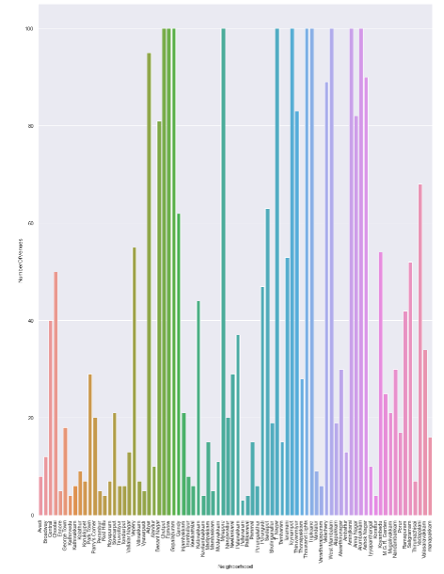

Also while producing graph for number of cluster, I produced a graph to explore all the values for n_clusters and then finding the best by exploring the elbow graph.

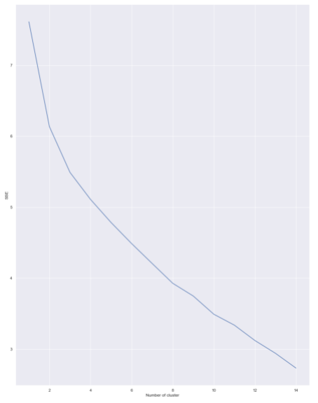

**Inferential analysis:**

Most important factors while building the recommender system were population and income. They are the most import factor because they have a nonlinear relationship according to our dataset. It needed to make some inferential analysis to understand this nonlinear relationship. As the amount of population increases, it does not necessarily mean that average income of a Page 9 neighbourhood will also increase. It is true to most of the case but also many cases differ to follow this trend. Similarly, a neighbourhood with less number of people may not necessarily have less average income. It is possible to have less number of people and more income and vice versa.

1. **Result :**

The result of the suggestion system is that it produces a list of top restaurants and the most common venue item that the user can enjoy. During the runtime of the model, a simulation was done by taking ‘Mylapore’ as the neighbourhood and then processed through our model so that it could recommend neighbourhoods with similar characters as that of ‘Mylapore’. The following image shows the result:

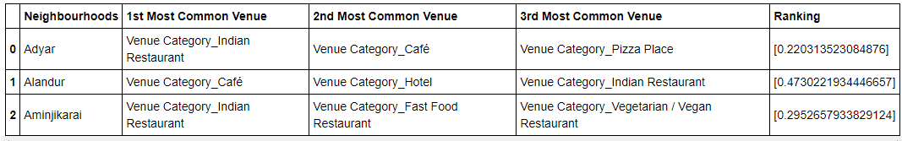

1. **Conclusion :**

The suggestion system is a system that considers factors such as population, income and makes use of Foursquare API to determine nearby venues. It is a powerful data driven model whose efficiency may decrease with more data but accuracy will increase. It will help users to finish their hunger by providing the best recommendation to fulfil all their needs.