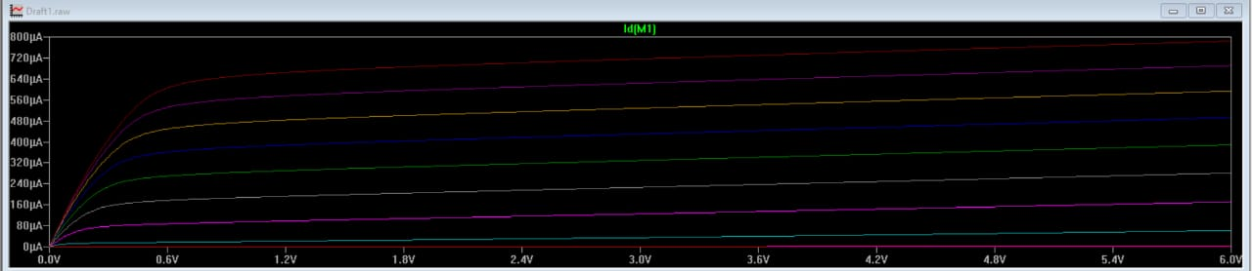
CMOS ID vs Vds

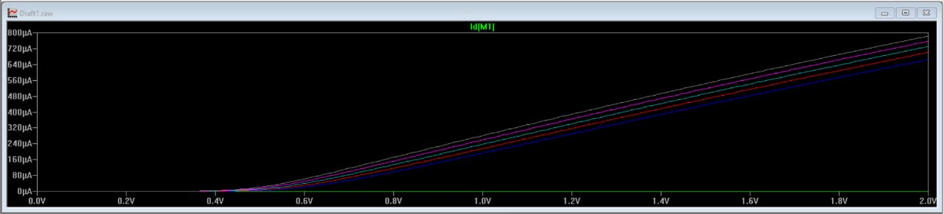
CMOS ID vs Vgs

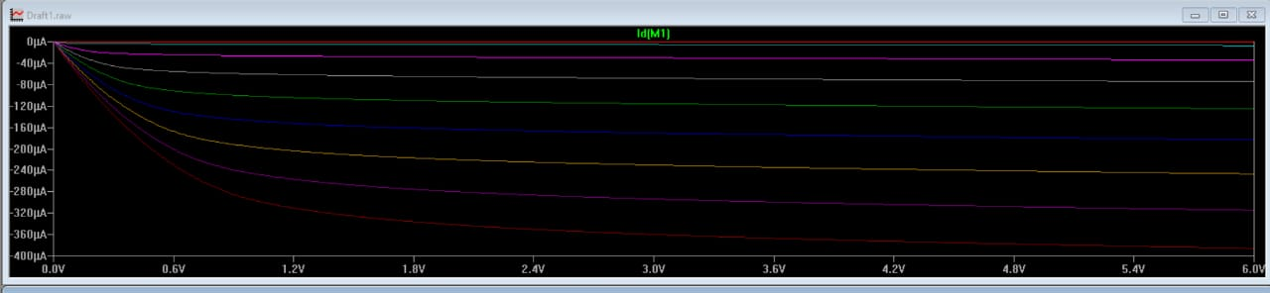
PMOS ID vs Vds

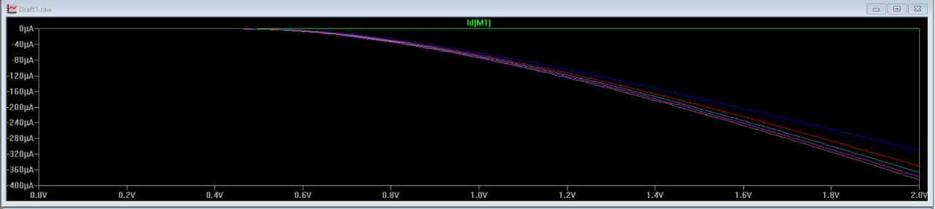
PMOS ID vs Vgs

