AI-Powered Educational Infrastructure Analysis of Meghalaya
Prepared using Python, Pandas, Matplotlib and Google Gemini AI

District Charts
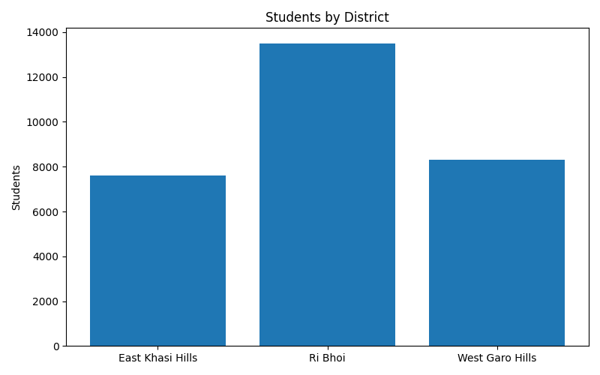
Figure 1: Students by District
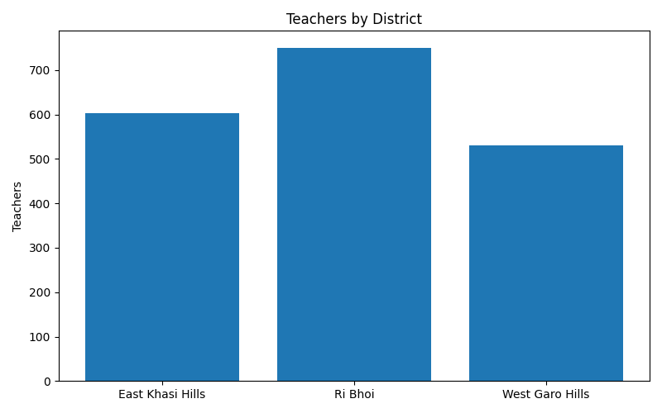
Figure 2: Teachers by District
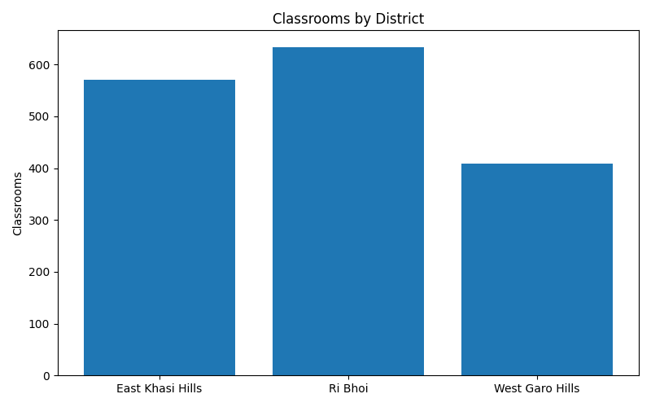
Figure 3: Classrooms by District

AI Generated Policy Report
## Policy Report: Analysis of Education Sector in Select Meghalaya Districts
**To:** Chief Secretary, Government of Meghalaya
**From:** Senior Education Policy Analyst
**Date:** October 26, 2023
**Subject:** Assessment and Policy Recommendations for Education Infrastructure and Teacher Resources in East Khasi Hills, Ri Bhoi, and West Garo Hills Districts
---
### 1. Executive Summary
This report presents an analytical overview of the education landscape in three key districts of Meghalaya: East Khasi Hills, Ri Bhoi, and West Garo Hills, based on provided student, teacher, and infrastructure data. The analysis highlights critical aspects of resource allocation, infrastructure availability, and teacher deployment, revealing disparities and areas requiring urgent policy intervention. While East Khasi Hills demonstrates relatively better student-teacher and student-classroom ratios, Ri Bhoi faces significant challenges with higher student populations straining existing resources. West Garo Hills shows a mid-range performance but with infrastructure concerns. Key findings include varying resource efficiency, potential for overcrowding, and the need for strategic investment in both human resources and physical infrastructure. Recommendations focus on targeted infrastructure development, teacher recruitment, professional development, and standardized resource allocation frameworks to foster equitable and quality education across the state.
### 2. Data Overview
The analysis is based on the following key metrics for each district: number of students in regular classes (`class_students`), pre-primary students (`pre_primary_students`), total teachers (`total_teachers`), and available classrooms (`class_rooms`). An additional metric, `school_name`, appears to indicate the number of schools or school units within each district based on the context of the provided data (e.g., 167 schools in East Khasi Hills). For a comprehensive assessment of resource strain, total student population is calculated as the sum of `class_students` and `pre_primary_students`.
**Table 1: District Education Dataset Summary**
| District Name | Class Students | Pre-Primary Students | Total Students (Calculated) | Total Teachers | Class Rooms | School Units |
| :--------------- | :------------- | :------------------- | :-------------------------- | :------------- | :---------- | :----------- |
| East Khasi Hills | 7,603 | 3,135 | 10,738 | 603 | 570 | 167 |
| Ri Bhoi | 13,513 | 2,794 | 16,307 | 751 | 634 | 166 |
| West Garo Hills | 8,307 | 1,478 | 9,785 | 531 | 409 | 167 |
| **Total** | **29,423** | **7,407** | **36,830** | **1,885** | **1,613** | **500** |
### 3. Key Findings
* **Significant Student Population Variation:** Ri Bhoi district has the highest total student population (16,307), substantially exceeding East Khasi Hills (10,738) and West Garo Hills (9,785).
* **Varying Resource Ratios:** East Khasi Hills exhibits the most favorable student-to-teacher and student-to-classroom ratios, suggesting better resource availability per student compared to the other two districts.
* **Infrastructure Strain in Ri Bhoi:** Despite having a high number of school units and teachers, Ri Bhoi shows the highest student-to-classroom ratio, indicating potential overcrowding and infrastructure deficit.
* **Early Childhood Education (ECE) Disparity:** East Khasi Hills leads in pre-primary student enrollment (3,135), while West Garo Hills has the lowest (1,478), highlighting varying focus or access to ECE across districts.
* **West Garo Hills Infrastructure Concern:** While having a moderate student population, West Garo Hills has the fewest classrooms, leading to a high student-to-classroom ratio.
### 4. Infrastructure Assessment
Effective learning environments require adequate classroom facilities. This assessment focuses on the student-to-classroom ratio, providing insights into potential overcrowding and the need for new constructions or renovations.
**Table 2: Student-to-Classroom Ratios**
| District Name | Total Students | Class Rooms | Student-to-Classroom Ratio | Implication |
| :--------------- | :------------- | :---------- | :------------------------- | :--------------------------------------------------------------------------------- |
| East Khasi Hills | 10,738 | 570 | 18.84 | Most favorable, potentially conducive learning environments. |
| Ri Bhoi | 16,307 | 634 | 25.72 | Highest ratio, indicating significant overcrowding risk and infrastructure deficit. |
| West Garo Hills | 9,785 | 409 | 23.92 | High ratio, suggesting a considerable need for more classrooms. |
**Observations:**
* East Khasi Hills maintains a relatively healthy student-to-classroom ratio, aligning well with recommendations for conducive learning spaces.
* Ri Bhoi faces the most acute challenge, with nearly 26 students per classroom, which is likely to impede effective teaching and learning, and suggests severe overcrowding.
* West Garo Hills also shows a concerning ratio of nearly 24 students per classroom, indicating that despite a lower overall student population than Ri Bhoi, its infrastructure is significantly less developed relative to its needs.
* The data also shows that `pre_primary_students` constitute a substantial portion of the total student population (e.g., 29% in East Khasi Hills, 17% in Ri Bhoi, 15% in West Garo Hills). This suggests a need for classrooms designed for early childhood learning, which may differ from standard classrooms and may require specific policy attention.
### 5. Teacher Resource Assessment
The quality of education is directly linked to the availability and effectiveness of teachers. This section evaluates the student-to-teacher ratio as a key indicator of teacher workload and potential for individualized attention.
**Table 3: Student-to-Teacher Ratios**
| District Name | Total Students | Total Teachers | Student-to-Teacher Ratio | Implication |
| :--------------- | :------------- | :------------- | :----------------------- | :------------------------------------------------------------------------------- |
| East Khasi Hills | 10,738 | 603 | 17.81 | Highly favorable, suggesting manageable class sizes and potential for quality instruction. |
| Ri Bhoi | 16,307 | 751 | 21.71 | Higher ratio, indicating potential for increased teacher workload and larger class sizes. |
| West Garo Hills | 9,785 | 531 | 18.43 | Favorable ratio, but needs to be considered in conjunction with classroom availability. |
**Observations:**
* East Khasi Hills again leads with the most favorable student-to-teacher ratio, implying smaller class sizes and potentially more direct teacher-student interaction.
* Ri Bhoi's ratio of 21.71 students per teacher is higher, suggesting teachers might be stretched, particularly in primary grades where lower ratios are often recommended.
* West Garo Hills presents a surprisingly good student-to-teacher ratio, which is only slightly higher than East Khasi Hills. This indicates that while the district has adequate teachers for its student population, the critical bottleneck appears to be the lack of sufficient classrooms to accommodate these students and teachers effectively.
### 6. District Comparison
A comparative analysis highlights the unique challenges and relative strengths of each district:
**Table 4: Comparative Performance Metrics**
| Metric | East Khasi Hills | Ri Bhoi | West Garo Hills | Observation |
| :--------------------------- | :--------------- | :-------- | :-------------- | :----------------------------------------------------------------------------------------------------------------------------------------------------------------------------------------------------------------------------------------------------------------------------------------------------------------------------------------------------- |
| Total Student Population | Moderate | Highest | Lowest | Ri Bhoi carries the largest student burden, requiring substantial resource allocation. |
| Pre-Primary Students (%) | 29.2% | 17.1% | 15.1% | East Khasi Hills demonstrates a stronger emphasis or access to early childhood education, while West Garo Hills shows the least penetration. This indicates potential disparity in early learning opportunities. |
| Student-to-Teacher Ratio | Best (17.81) | Worst (21.71) | Good (18.43) | East Khasi Hills and West Garo Hills are well-staffed in terms of teachers relative to student numbers. Ri Bhoi requires attention to teacher recruitment to improve this ratio. |
| Student-to-Classroom Ratio | Best (18.84) | Worst (25.72) | Poor (23.92) | East Khasi Hills is adequately equipped with classrooms. Ri Bhoi and West Garo Hills both face significant challenges with classroom availability, suggesting widespread overcrowding regardless of student population size. West Garo Hills' situation is particularly acute given its relatively lower student population but disproportionately fewer classrooms. |
| **Overall Resource Strain** | Low | High | Medium-High | Ri Bhoi experiences high strain across both teacher and classroom resources. West Garo Hills' strain is primarily due to infrastructure deficit, despite a reasonable teacher ratio. East Khasi Hills is relatively well-resourced. |
**Key Comparative Insights:**
* **Ri Bhoi:** This district stands out as the most resource-strained. It has the largest student body, the highest student-to-teacher ratio, and the highest student-to-classroom ratio. This combination indicates a severe need for increased investment in both human resources (teachers) and physical infrastructure (classrooms).
* **West Garo Hills:** Despite having a manageable student-to-teacher ratio, its low number of classrooms results in a very high student-to-classroom ratio. This suggests that while there are enough teachers, they may not have adequate spaces to teach, potentially leading to large multi-grade classes in single rooms or limited space per student. This is a critical infrastructure bottleneck.
* **East Khasi Hills:** This district appears to be the best-resourced among the three, with favorable ratios for both teachers and classrooms. Its high pre-primary enrollment also suggests a robust early childhood education component. Future policies here might focus on quality enhancement and innovation rather than basic resource provision.
### 7. Policy Recommendations
Based on the detailed analysis, the following policy recommendations are proposed to address the identified challenges and foster equitable, quality education across the selected districts of Meghalaya:
1. **Targeted Infrastructure Development Program:**
* **Priority for Ri Bhoi and West Garo Hills:** Launch an accelerated program for the construction of new classrooms and renovation of existing ones in Ri Bhoi and West Garo Hills. Given the high student-to-classroom ratios, a minimum target of reducing the ratio to below 20:1 should be established.
* **Pre-Primary Infrastructure:** Allocate specific funds and design standards for dedicated pre-primary classrooms, especially in West Garo Hills to boost ECE enrollment and provide age-appropriate learning environments.
* **Multi-Purpose Spaces:** Consider developing multi-purpose halls or flexible learning spaces that can serve as additional classrooms, particularly in emergencies or for extracurricular activities, to maximize infrastructure utility.
2. **Strategic Teacher Recruitment and Deployment:**
* **Focus on Ri Bhoi:** Conduct a targeted teacher recruitment drive for Ri Bhoi district to reduce the student-to-teacher ratio to below 20:1, aligning with national norms and promoting smaller class sizes.
* **Addressing Subject-Specific Gaps:** Beyond overall numbers, a qualitative assessment should identify subject-specific teacher shortages (e.g., Science, Math, English) and recruit accordingly, particularly for secondary education levels.
* **Incentives for Remote Areas:** Introduce attractive incentive packages (e.g., housing allowances, hardship pay, faster promotion tracks) for teachers willing to serve in remote or underserved areas, especially in districts like West Garo Hills, to ensure equitable distribution.
3. **Enhancement of Early Childhood Education (ECE):**
* **Universal ECE Access:** Develop a comprehensive strategy to expand access to quality pre-primary education, particularly focusing on West Garo Hills and Ri Bhoi, where enrollment is comparatively lower. This includes establishing new ECE centers or integrating pre-primary sections into existing schools.
* **ECE Teacher Training:** Invest in specialized training programs for ECE teachers to ensure age-appropriate pedagogy and learning methodologies are implemented consistently.
4. **Data-Driven Resource Allocation Framework:**
* **Standardized Norms:** Establish clear, standardized norms for student-to-teacher and student-to-classroom ratios across all districts, taking into account geographical factors and student demographics.
* **Regular Monitoring and Evaluation:** Implement a robust system for regular collection, analysis, and reporting of education data at the district and sub-district levels to enable timely interventions and adaptive policy-making.
* **Resource Mapping:** Conduct a detailed resource mapping exercise in all schools to identify specific infrastructure gaps, teacher vacancies, and equipment needs.
5. **Quality Enhancement and Professional Development:**
* **Continuous Professional Development:** While some districts may have good teacher ratios, continuous professional development programs are crucial across all districts to upgrade teaching skills, introduce innovative pedagogies, and integrate technology into learning.
* **Learning Outcomes Focus:** Shift policy focus from mere input provision to improving learning outcomes. This requires developing robust assessment systems and providing targeted support to schools and teachers based on student performance data.
### 8. Conclusion
The analysis of education data from East Khasi Hills, Ri Bhoi, and West Garo Hills districts reveals a mixed but generally challenging landscape. While East Khasi Hills demonstrates relative strength in resource allocation, Ri Bhoi faces significant strain on both infrastructure and teacher resources. West Garo Hills, despite a reasonable teacher availability, is severely hampered by a critical shortage of classrooms.
Addressing these disparities is paramount to achieving equitable and quality education across Meghalaya. The proposed policy recommendations, centered on targeted infrastructure development, strategic teacher recruitment, bolstering early childhood education, and establishing a data-driven resource allocation framework, offer a roadmap for sustainable improvement. Proactive implementation of these policies, coupled with continuous monitoring and evaluation, will be instrumental in transforming the educational ecosystem and ensuring every child in Meghalaya has access to a conducive and enriching learning environment.

