Here is a list of common abbreviations and definitions related with the Data Delivery Digital Supply Chain team.
- 3PL: Third-party Logistics - a 3PL provider manages crucial supply chain operations such as warehousing, inventory management, picking, packing, and shipping
- AOS: Associate Order System or Automated Ordering System
- ASN: Advanced Shipping Notice
- BOPIS: Buy Online/Pick-Up In Store
- BORIS: Buy Online/Return In Store
- CAB: Change Advisory Board - it is a group that evaluates, approves, and prioritizes proposed changes to IT systems to minimize disruption. It is a key part of the ITIL framework's Change Management process, acting as a control and review body to assess risks, ensure proper documentation, and schedule changes effectively
- CAR: Customer Activity Repository
- CRO: Costa Rica Office
- DC: Distribution Center
- DD: Data Delivery
- DF: Data Factory
- DMP: Data Maturity Program
- DSD: Direct Store Delivery - Most vendors ship their goods to our DCs, but in some cases they ship directly to the stores. Those vendors are referred to as DSD vendors
- DSV: Dropship Vendor
- EDI: Electronic Data Interchange
- EDI ISA: Interchange Control Header
- EDW: Enterprise Data Warehouse
- EIM: Enterprise Information Management
- FC: Fulfillment Center
- FMF: Fetch My Freight
- FOB: Free On Board - Relates to the point where ownership and the responsibility for shipping costs pass on goods when they are being shipped via container ship. The moment the products have crossed the ship's rail at the port they become PetSmart's responsibility
- FTE: Full-Time Employee
- IDoc: Intermediate Document, is an SAP document format for business transaction data transfers. It is similar to XML in purpose but differs in syntax.
- ISPU: In-Store Pick-Up
- KT: Knowledge Transfer
- MABD: Must Arrive By Date.
- MAO: Manhattan Active Omni - This is PetSmart’s Order Management System for AOS, BOPIS and SFS.
- MDS: Master Delivery Schedule - serves as the system of record for critical store delivery attributes (receiving windows, delivery schedules, equipment requirements, etc.) feeding RELEX and SAP to enable accurate store order generation and route planning. Store Delivery Information is stored and updated in an Excel file.
- MFT: Managed File Transfer - For PetSmart we use Cleo Harmony as our MFT service.
- MLMQ: Multi-Line Multi-Quantity
- MLSQ: Multi-Line Single-Quantity
- MSBD: Must Ship By Date
- MSTR: MicroStrategy - Business Intelligence Application used in PetSmart for reporting purposes
- NZ: Netezza - Deprecated Data Warehouse Solution. It is being migrated into Databricks.
- PAW: PetSmart Analytical Warehouse - This is a MSTR reporting tool that connects to Snowflake for enterprise level data.
- PADB: Purchase Authorization Database.
- PB: Proprietary Brand
- PODS: Pet Owner Data Store - this is the system of record for pet profile data.
- PPAC: Pet Parent Assistance Center. PPAC handles Vet Diet and online US processing for Pets Hotel (this is the same team handling both).
- PPLT: Pet Parent Lookup Tool
- Proship: This is a software solution for handling third-party multi-carrier shipments (Doordash, Uber, UPS, Fedex, etc.).
- PVS: PetSmart Veterinary Services
- ODS: Operational Data Store
- OMS: Order Management System
- RDC: Regional Distribution Center
- RTS: Returned-To-Shelf
- RTV: Return to Vendor
- Rx: Pharmacy
- SAP: Systems, Applications and Products - third-party enterprise software system we use to control our inventory. There are many other systems we use that send and/or receive data from SAP regularly.
- SC: Supply Chain
- SCC: Salesforce Commerce Cloud
- SCI: Supply Chain Intelligence - Manhattan Active Supply Chain Intelligence is a reporting and analytics tool designed for supply chain operational decisions. It provides actionable insights by enabling ad-hoc reporting, interactive dashboards, and alerting mechanisms to streamline logistics processes and enhance warehouse management.
- SDD: Same Day Delivery
- SIM: Store Inventory Management
- SLMQ: Single-Line Multi-Quantity
- SLSQ: Single-Line Single-Quantity
- S&S: Stationery and Supplies
- SFS: Ship-From-Store
- SNOW: Shortcut for Service Now (do not confuse with Snowflake ).
- STH: Ship-To-Home
- STO: Stock Transport Order - a specialized SAP document used to request and track the transfer of inventory between two locations.
- TLMS: Transportation Lifecycle Management System
- UF: Uber Freight
- UOM: Unit Of Measure
- VD: Vet Diet
- WCS: Warehouse Conveyor System
- WMS: Warehouse Management System
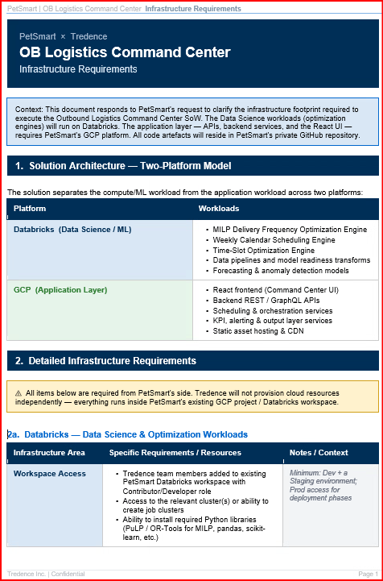
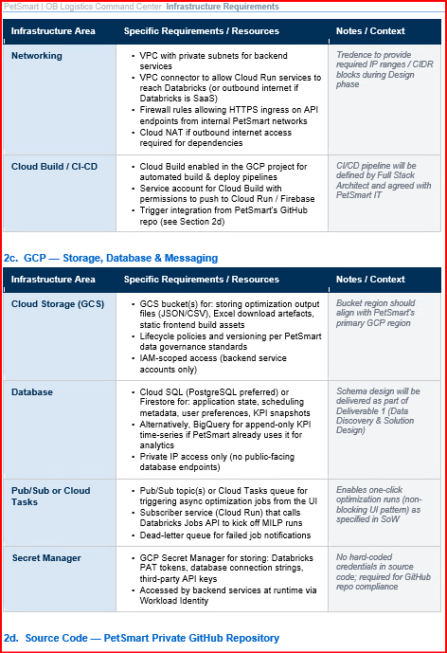
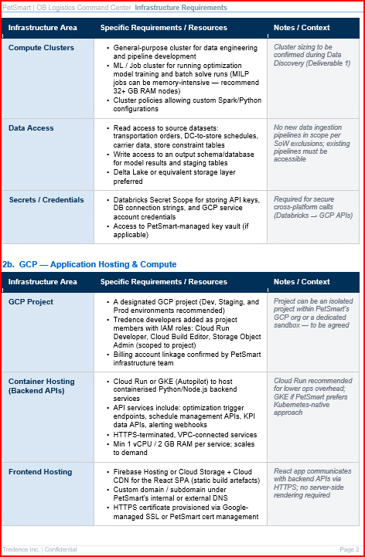
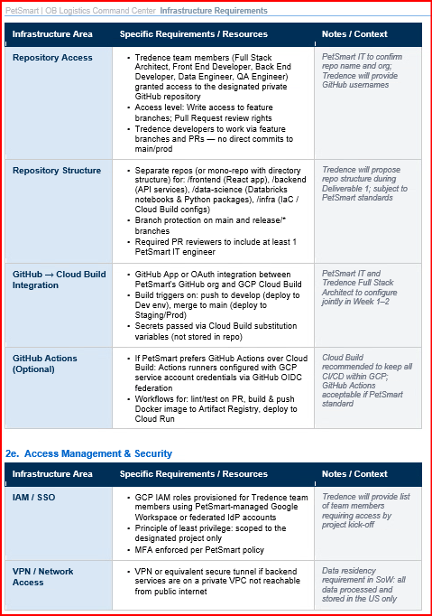

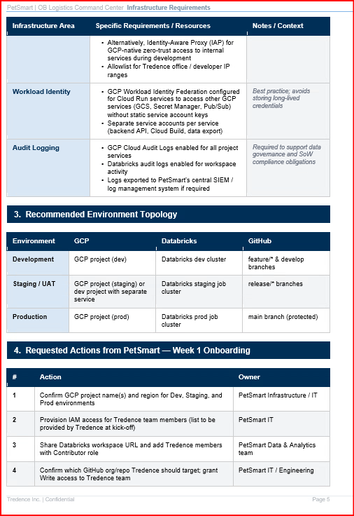
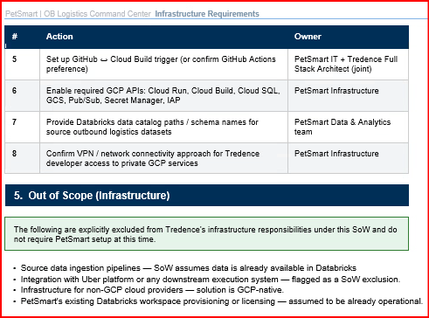

STATEMENT OF WORK
Foundation & Core Optimization Module build for Outbound Logistics Command Center
For
Petsmart

April 2026

This Statement of Work (the “Order”, “SOW”, or “Service Order”) is made subject to and will be governed by the terms and conditions of the Master Provider Agreement by and between TREDENCE Inc , with its principal office located at 1900 Camden Avenue, #1966, San Jose, CA, 95124 (“Tredence”, “Vendor”, “Supplier”) and PetSmart LLC, with its principal office located at 19601 N. 27th Avenue, Phoenix, Arizona 85207 ( “Customer”) dated December 4th, 2025 (“Agreement”). The effective date of this SOW is May 4th, 2026 (“Effective Date”).
This SOW is intended to supplement the Agreement and is subject in all respects to the terms of the Agreement. In the event of any conflict between the terms of this SOW and the Agreement, the terms of the Agreement shall govern unless the SOW expressly sets forth the provision of the Agreement with which it is inconsistent.
- DESCRIPTION OF SERVICES
  - Timely completion of defined deliverables listed above as per acceptance criteria determined in the sole discretion of Petsmart Technology leadership team and communicated to Vendor.
Background – Petsmart is aiming to unlock value in their Outbound Transportation by enabling always on-planning while improving execution reliability. While there is a plan in place to drive execution efficiency through a “Uber action plan”, they are also looking to improve tactical transportation planning by automating scenario modeling, optimize delivery frequency and master-calendar logic, and cost/service trade-offs visibility.
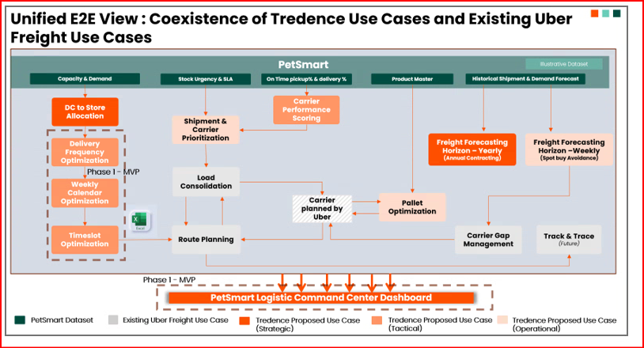

a. Under this SOW, Tredence will provide the following services and deliverables to the PetSmart Team (the, “Services”):
Proposed Solution
The MVP Logistics Command Center will introduce a unified, data-driven decision layer that empowers planners with visibility, control, and optimization capabilities across outbound logistics.
At its core, the solution combines:
- A centralized UI for outbound shipment visibility and delivery calendar management
- A Delivery Frequency Optimization engine to determine optimal DC-to-store delivery cadence
- A Weekly Calendar Scheduling engine to translate optimized plans into weekly executable schedules
- A Timeslot optimization engine to consider store constraints and create an hourly delivery schedule
Together, these components create a closed-loop system where planners can analyze, optimize, and operationalize decisions within a single platform.
Key Capabilities
1. End-to-End Visibility & Control
The Command Center provides a unified view of outbound shipments and delivery schedules, enabling planners to monitor operations and make informed decisions in real time.
2. Optimization-Driven Planning
MILP-based models allow planners to independently run optimization scenarios for delivery frequency, calendar days, hourly schedules and routing strategies, balancing cost, service levels, and operational constraints.
Exception Management & KPI Governance
The system includes:
- DC-to-store delivery KPIs
- Exception-based alerting
- Performance tracking to improve carrier accountability and operational discipline
Planner Efficiency & Automation
Manual effort is reduced through:
- One-click optimization runs
- Automated output generation (UI + Excel downloads)
- Streamlined workflows supported by a modern web interface

b. Acceptance Criteria. The Services outlined in the bullet points of Section 1(a) above shall not be considered completed under this SOW until each of the following have occurred:

- Conduct knowledge transfer sessions with Petsmart stakeholders to ensure they have a deep understanding of the new system’s functionality, workflows, and best practices.
- Deliver comprehensive project documentation, including technical design documents, process workflows, and a detailed user manual for the New System, ensuring Petsmart has a complete reference guide for future use and updates.

c. Exclusions

- The Services described above will not include any type of source data ingestion into the data platform
- The MVP will also not include integrations with downstream systems (like Uber platform)

d. Assumptions

- PetSmart shall provide required access to required workspace to build and deploy the solution within PetSmart’s cloud environment
- Availability to key stakeholders at the required points in the project is critical.
- Feedback on deliverables and sign offs will be provided 3-5 business days
- COMPANY RESPONSIBIILTIES
  - Provide access to all relevant data sets, tools, and technologies in the development environment necessary to support the PetSmart Technology Team in carrying out their tasks as set forth in Section 1 above; for clarity, development access will be granted to Vendor as part of this SOW to the extent such access is necessary for Vendor to perform its obligations hereunder.
  - Provide the necessary support from Petsmart Technology, Technical and Business teams to gather solution requirements and discuss solution output / results.
  - Agree to a standard and consistent meeting cadence throughout the support lifecycle.

- SOW TERM

Duration: 14 Weeks
Start Date: May 4, 2026
Completion Date: August 07, 2026
- DELIVERABLES
# | Deliverables | Description | Target Finish
1 | Data Discovery & Solution Design | Assess current outbound logistics, transportation planning, and scheduling processes; analyze data sources, baseline performance, constraints, SLAs, and KPIs; and define phased integration approach. | 15-May-26
2 | MILP Optimization Engine | Production-grade optimization model to determine optimal DC-to-store delivery frequency based on cost, demand, and service constraints. | 03-July-26
3 | Weekly Calendar Optimization Engine | Backend engine that converts optimized delivery frequency outputs into weekly delivery calendars aligned with operational constraints. | 10-July-26
4 | Time-Slot Optimization Engine | Optimizing delivery time slots for stores based and schedule aligned with operational constraints with slot priorities | 17-July-26
5 | Logistics Command Center (UI + Frontend) | Web-based application providing outbound shipment visibility and delivery calendar for DC-to-store operations. Includes UX/UI design (dashboards, alerts, scheduling flows, optimization controls) and React-based frontend for visualization and user interaction. | 24-July-26
6 | KPI, Alerting & Output Layer | Implementation of DC-to-store KPI dashboards, exception-based alerting, optimization triggers, and output generation (UI views and Excel downloads). | 24-July-26
7 | Hypercare Support | Post-deployment stabilization support including issue resolution, performance monitoring, user support, and system tuning during initial production rollout. | 07-August-26

- PROJECT TEAM
The team to complete this project will consist of a mix of functional and technical roles necessary for the project
Tredence Core Team Includes
- Data Science Lead: Leads ML and optimization model development, ensuring accuracy, scalability, and technical alignment.
- SCM SME: Ensures business alignment, supply chain constraints and operational realities
are correctly reflected in solution design
- Full Stack Architect: Defines overall application architecture and ensures scalable integration of frontend, backend, and models.
- Front End Developer: Builds React-based UI for dashboards, scheduling, and optimization views.
- Back End Developer: Develops APIs, scheduling services, and integration layers.
- QA Engineer: Executes testing and validation of UI, APIs, and model outputs.
- Data Scientist: Develops forecasting, anomaly detection, and supporting ML models.
- Data Engineer: Builds and maintains data pipelines for ingestion, transformation, and model readiness.

- Project Timeline
PROJECT PLAN FOR PHASE 1 (MVP) OF O/B LOGISTICS COMMAND CENTER
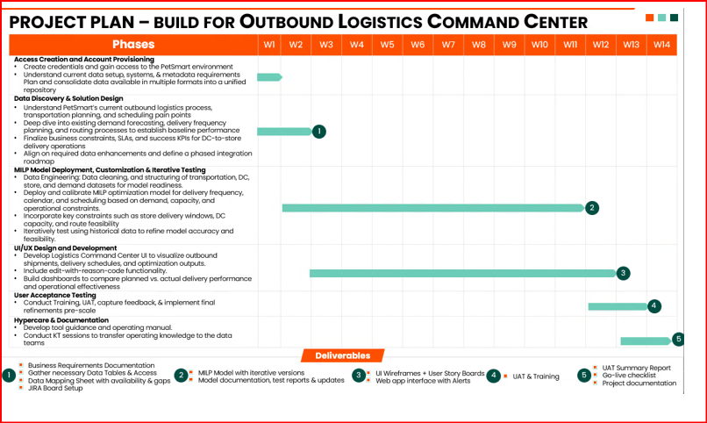
Governance:

Executive Steering Committee -
- Executive leadership team gives support and commitment for the success of the project
- Provides sign off on technology decisions and helps solve obstacles
- Acts as the highest escalation point – if a raised issue is not addressed within 4/5 working days

Review with Program Manager (Weekly)
- Liaison between Management and core teams
- Ensures expected business outcomes are aligned across teams
- Provide necessary support to project team to navigate through different organization challenges (access to data, business connect, technology, etc.)
- Second Point of Escalation - if a raised issue is not addressed within 3 working days

Delivery Team (daily standups) -
- Ground team that collaborates to deliver incrementally
- Mix of skill-sets within the team is ramped-up or ramped-down depending on the program increment planned
- First Point of Escalation – if a raised issue is not addressed within 1 day
Expected Time Commitment from Petsmart Stakeholders:

- Supply Chain and Transportation SME –
  - 3-4 hours a week during Discovery and Design (WK 1-3) & for UAT (WK 10-12)
- Program Manager –
  - 6-8 hours a week through the course of the 12 weeks
- IT, Data and Analytics teams –
  - 3-4 hours a week through the WK 1-3 & 1-2 hours for the remaining period (WK 4-12)

- FEES
In consideration of Tredence performing for Petsmart the Services described in this SOW and providing the Work Product described in this SOW (such Work Product shall include, without limitation, all data, models, documentation, code, and other materials created under Section 1 of this SOW), and, provided they are performed and provided in accordance with the Agreement and this SOW, Petsmart shall pay for such Services and Work Product at the rates set forth below.
In consideration of the mutual agreements and covenants set forth herein and, in the Agreement, Customer and Tredence agree as follows:
Criteria for Invoicing Milestone achievement:
Invoice No. | Description / Milestone | How & When invoice to be issued | Amount  (USD)
1 | Down-payment due before project commences to support resource planning. | Upon written acceptance by the Customer and signature of this SOW. | $ 100,000
2 | Performance based Fee: Acceptance of Accuracy benchmark achieved in UAT | 10% of logistics spend savings for 3 years post project completion*  Key KPIs measured –  - Transportation cost reduction (Weightage 50%)  - Labor handling cost reduction (Weightage: 30%)  - DC Holding cost reduction (Weightage: 20%)  Performance linked pay out calculation  Sum [(Actual KPI – Baseline KPI)] * 10%  How will we measure KPI improvement  Compare logistics costs to service similar demand (# of DCs, # of stores, # of pallets transported) pre and post project. | Based on savings delivered
* Assumption is feasible model output will be consumed and not manually changed. In case of manual changes to a feasible model, estimated or identified savings will be considered. Identified savings will be measured using outputs of the what-if scenario planner.
Petsmart will share actual costs incurred pre and post project and demand serviced data with Tredence on a quarterly basis. Performance based fee will be paid quarterly and within sixty (60) days following the end of each calendar quarter.
FACILITIES AND LOCATION OF SERVICES.
For the avoidance of doubt and subject to the paragraph below, (i) the reference to “Onshore” in the chart above shall refer to the United States or Canada, and “Offshore” refers to India (ii) all individuals involved in the provision of the Services under this SOW shall be located only in the United States, Canada, and India, and shall perform the Services remotely from the Vendor’s United States, Canada, and India Delivery Offices set forth in the table below:
US Office Address: | 1900 Camden Ave, #66, San Jose, CA 95124
Canada Address: | 390 Bay St. Toronto, ON MSH 1W2, Canada
India Address: | 11th Floor, Building 2, Prestige Tech Park IV, Amane Bellandur Khane Village, Varthur Hobli, Kadubeesanahalli, Bangalore, India 560103
Vendor will perform the Services and produce the Work Product under this SOW remotely from locations within the United States; provided, however, Vendor shall be permitted to allocate resources located in Canada and India (“Resources Located Abroad”). Company hereby agrees that Vendor may allow access to the minimum necessary Company data and information to Vendor’s Resources Located Abroad solely and necessary to support the Services hereunder, but may not allow such access to any other persons located outside the continental United States of America. For clarity, (i) Company’s data and information may be viewed in Canada and India by Vendor’s Resources Located Abroad solely to support the Services, (ii) no source code accessed by the Resources Located Abroad shall contain encryption functionality, and (iii) Vendor’s Resources Located Abroad are employees of Tredence. Moreover, Company’s data and information shall not be stored, persisted, or otherwise processed anywhere outside the United States of America, including, but not limited to Canada and India. In addition, Vendor agrees that its Resources Located Abroad are prohibited, for any reason, from downloading Company’s data and information or storing Company’s data and information locally. Vendor agrees that its Resources Located Abroad will only access Company’s data and information from approved Company and/or Vendor controlled devices and/or systems.
IN WITNESS WHEREOF, the Parties have caused this SOW to be executed and delivered by their respective, duly authorized representatives as of the last date of signature.

