jenkins
To install jenkins manually
1.sudo apt update
2.sudo apt install openjdk-17-jdk -y
3.sudo apt update -y
4.sudo apt install maven -y
5.sudo wget -O /etc/apt/keyrings/jenkins-keyring.asc \
https://pkg.jenkins.io/debian-stable/jenkins.io-2026.key
6.echo "deb [signed-by=/etc/apt/keyrings/jenkins-keyring.asc]" \
https://pkg.jenkins.io/debian-stable binary/ | sudo tee \
/etc/apt/sources.list.d/jenkins.list > /dev/null
7.sudo apt update
8.sudo apt install Jenkins
9.systemctl status Jenkins
Install Jenkins from git repository
wget https://raw.githubusercontent.com/akshu20791/Deployment-script/refs/heads/main/jenkins.sh
chmod 700 jenkins.sh
./jenkins.sh
#Use below lines if if different java versions are installed
update-java-alternatives -l
sudo update-alternatives --config java
select 1
java --version
sudo systemctl restart sonar

Tomcat

wget https://dlcdn.apache.org/tomcat/tomcat-9/v9.0.115/bin/apache-tomcat-9.0.115.zip
apt install unzip -y
unzip apache-tomcat-9.0.115.zip
cd apache-tomcat-9.0.115
now we need to change the default port of tomcat from 8080 to 9090
cd conf
ls
vi server.xml
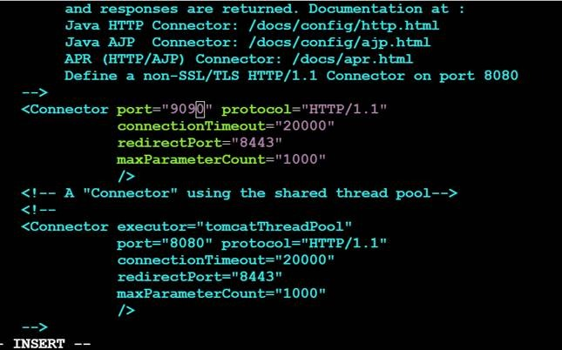
cd ..
cd bin
ls
chmod +x *.sh
./startup.sh
#visudo : this file gives the user the root (sudo) permission to perform a tasks…we will give jenkins the sudo permissions to perform the tasks
visudo
#add jenkins ALL=(ALL:ALL) NOPASSWD: ALL
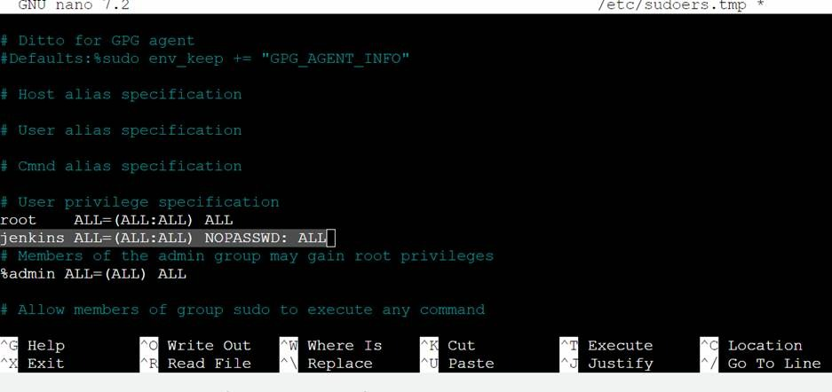
press ctrl x and y and then enter to come out of the nano editor
service jenkins restart

Sonarqube
https://medium.com/@deshdeepakdhobi/how-to-install-and-configure-sonarqube-on-aws-ec2-ubuntu-22-04-c89a3f1c2447
sudo apt update
sudo apt upgrade -y
sudo apt install -y openjdk-17-jdk
java -version
sudo sh -c 'echo "deb http://apt.postgresql.org/pub/repos/apt/ `lsb_release -cs`-pgdg main" /etc/apt/sources.list.d/pgdg.list'
wget -q https://www.postgresql.org/media/keys/ACCC4CF8.asc -O - | sudo apt-key add –
sudo apt install postgresql postgresql-contrib -y
sudo systemctl enable postgresql
sudo systemctl start postgresql
sudo systemctl status postgresql
psql –version
sudo -i -u postgres
createuser ddsonar
psql
ALTER USER ddsonar WITH ENCRYPTED password '1234';
CREATE DATABASE ddsonarqube OWNER ddsonar;
GRANT ALL PRIVILEGES ON DATABASE ddsonarqube to ddsonar;
\l
\du
\q
exit
sudo apt install zip -y
sudo wget https://binaries.sonarsource.com/Distribution/sonarqube/sonarqube-10.0.0.68432.zip
sudo unzip sonarqube-10.0.0.68432.zip
sudo mv sonarqube-10.0.0.68432 sonarqube
sudo mv sonarqube /opt/
sudo groupadd ddsonar
sudo useradd -d /opt/sonarqube -g ddsonar ddsonar
sudo chown ddsonar:ddsonar /opt/sonarqube -R
sudo nano /opt/sonarqube/conf/sonar.properties
#Uncomment the lines, and add the database user and Database password
sonar.jdbc.username=ddsonar
sonar.jdbc.password=1234
#Below these two lines, add the following line of code.
sonar.jdbc.url=jdbc:postgresql://localhost:5432/ddsonarqube
sudo nano /opt/sonarqube/bin/linux-x86-64/sonar.sh
#Add the following line
RUN_AS_USER=ddsonar
sudo nano /etc/systemd/system/sonar.service
[Unit]
Description=SonarQube service
After=syslog.target network.target
[Service]
Type=forking
ExecStart=/opt/sonarqube/bin/linux-x86-64/sonar.sh start
ExecStop=/opt/sonarqube/bin/linux-x86-64/sonar.sh stop
User=ddsonar
Group=ddsonar
Restart=always
LimitNOFILE=65536
LimitNPROC=4096
[Install]
WantedBy=multi-user.target
#Paste above lines in sonar.service
sudo systemctl enable sonar
sudo systemctl start sonar
sudo systemctl status sonar
sudo nano /etc/sysctl.conf
#add these at the end
vm.max_map_count=262144
fs.file-max=65536
ulimit -n 65536
ulimit -u 4096
sudo reboot
10) Access SonarQube Web Interface
i) Access SonarQube in a web browser at your server’s IP address on port 9000.
For example, http://IP:9000
Note: the default username and password are admin and admin respectively.
ii) Change the Old password with a New one.
Log in with username admin and password admin. In the next step, SonarQube will prompt you to change your password. CHANGE THE PASSWORD.
Sonar Scanner plugin download for sonarqube

