1. Explore and preprocess EDA.
2. Loaded the Excel data set
3. Understand the data like data types, Missing Value, variance in data
4. Understand the features and there roles
5. ****uniqueid****: Identifier for the vehicle (seems consistent, likely only one vehicle's data).
6. ****ts****: Timestamp of the data point.
7. ****lat****: Latitude coordinate of the vehicle.
8. ****lng****: Longitude coordinate of the vehicle.
9. ****frequency****: Unclear from the provided data (all zeros in this case).
10. ****temperature****: Temperature data.
11. ****refuel****: Refuel status (boolean, all false in this case).
12. ****odo_distance****: Odometer distance reading.
13. ****RAWFUELLEVEL****: Raw fuel level
14. Plotted the histogram for all the features and found out the insights noted in Jupiter notebook.
15. After carefully observing the data and prediction condition i understand it’s **anomaly detection.**
16. After doing some pre-processing and data cleaning Found some 0’s value in rowfuellevel which I believe should be only condition when vehical in stable and not in use long time. So, I tried to predict the rowfuellevel value by linearRegression and polymonicalregression model but model dose not able to provide a good score.
17. So finally dropped the 0’s value rowfuellevel record from the data.
18. Design and implement ML algorithms or statistical models to accurately detect events.

· **Clear Objectives**: Define clear objectives for event detection, ensuring alignment with business or research goals. Whether it's anomaly detection, predictive maintenance, or real-time monitoring, clarity on objectives is essential for designing appropriate models.

· **Data Quality and Preprocessing**: The success of any ML model hinges on the quality of data. Therefore, prioritize data quality assessment, cleaning, and preprocessing to ensure the robustness and reliability of our models.

· **Model Selection and Evaluation**: Choose appropriate ML algorithms or statistical models based on the nature of the data and the specific requirements of event detection. Evaluate models rigorously using relevant metrics to ensure they meet performance benchmarks. In this case I comes with anomaly detection algorithms like **Isolation Forest ensemble model**.

· **Iterative Development**: Embrace an iterative development process to refine models continuously. This includes fine-tuning parameters, exploring different algorithms, and incorporating feedback from domain experts to enhance model accuracy and relevance. I have implemented the model on all the data set and checked the performance of model and the tried with re-sampling the data like removing the 0s value record and then tried with resampling the data on hourly basis and then checked with on daily basis and implemented

1. Develop strategies to reduce false events in event detection.

**Iterative Development**: Embrace an iterative development process to refine models continuously. This includes fine-tuning parameters, exploring different algorithms, and incorporating feedback from domain experts to enhance model accuracy and relevance. I have implemented the model on all the data set and checked the performance of model and the tried with re-sampling the data like removing the 0s value record and then tried with resampling the data on hourly basis and then checked with on daily basis and implemented

1. Identify patterns and anomalies in the data that may indicate pilferage incidents. 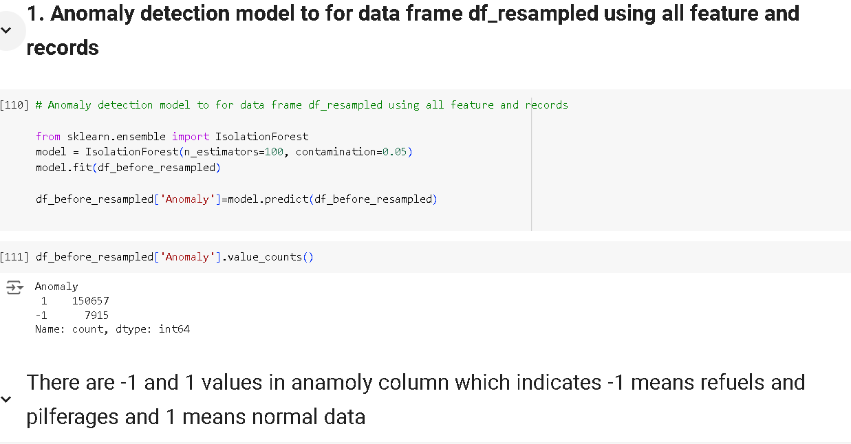
2. Develop predictive models to identify potential refuel and pilferage incidents in real-time or near real-time.

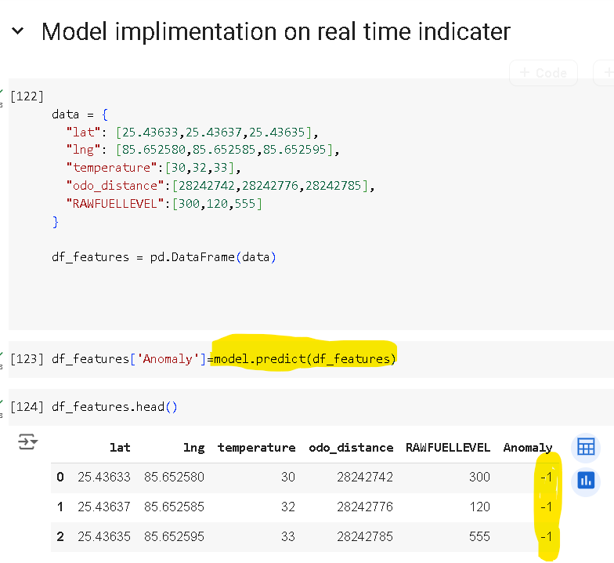

9. Visualization for fuel level trend, which involves detected refuels and pilferages with their event of time.

