/*1. WAP to find the largest element of an array.*/
#include <stdio.h>
int main()
{
int n, i, max;
printf("Enter the number of elements in the array: ");
scanf("%d", &n);
int arr[n];
printf("Enter the elements of the array: ");
for (i = 0; i < n; i++)
{
scanf("%d", &arr[i]);
}
max = arr[0];
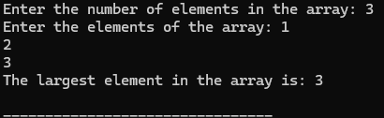
for (i = 1; i < n; i++)
{
if (arr[i] > max)
{
max = arr[i];
}
}
printf("The largest element in the array is: %d\n", max);
return 0;
}

/*2. WAP to find the smallest element of an array using dynamic memory allocation and pointers.*/
#include <stdio.h>
#include <stdlib.h>
int main()
{
int n, i, min;
printf("Enter the number of elements in the array: ");
scanf("%d", &n);
int *arr = (int *)malloc(n * sizeof(int));
if (arr == NULL)
{
printf("Memory allocation failed\n");
return 1;
}
printf("Enter the elements of the array: ");
for (i = 0; i < n; i++)
{
scanf("%d", &arr[i]);
}
min = arr[0];
for (i = 1; i < n; i++)
{
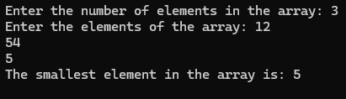
if (arr[i] < min)
{
min = arr[i];
}
}
printf("The smallest element in the array is: %d\n", min);
free(arr);
return 0;
}

/*3. WAP to sort an array in ascending order.*/
#include <stdio.h>
int main()
{
int n, i, j, temp;
printf("Enter the number of elements in the array: ");
scanf("%d", &n);
int arr[n];
printf("Enter the elements of the array: ");
for (i = 0; i < n; i++)
{
scanf("%d", &arr[i]);
}
for (i = 0; i < n - 1; i++)
{
for (j = 0; j < n - i - 1; j++)
{
if (arr[j] > arr[j + 1])
{
temp = arr[j];
arr[j] = arr[j + 1];
arr[j + 1] = temp;
}
}
}
printf("The sorted array in ascending order is: ");
for (i = 0; i < n; i++)
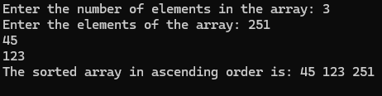
{
printf("%d ", arr[i]);
}
printf("\n");
return 0;
}

/*4. Write a program in C to find the sum of rows and columns of a matrix.*/
#include <stdio.h>
int main()
{
int m, n, i, j;
printf("Enter the number of rows and columns of the matrix: ");
scanf("%d %d", &m, &n);
int matrix[m][n];
printf("Enter the elements of the matrix: ");
for (i = 0; i < m; i++)
{
for (j = 0; j < n; j++)
{
scanf("%d", &matrix[i][j]);
}
}
printf("The matrix is:\n");
for (i = 0; i < m; i++)
{
for (j = 0; j < n; j++)
{
printf("%d ", matrix[i][j]);
}
printf("\n");
}

printf("Sum of rows:\n");
for (i = 0; i < m; i++)
{
int sum = 0;
for (j = 0; j < n; j++)
{
sum += matrix[i][j];
}
printf("Row %d: %d\n", i + 1, sum);
}

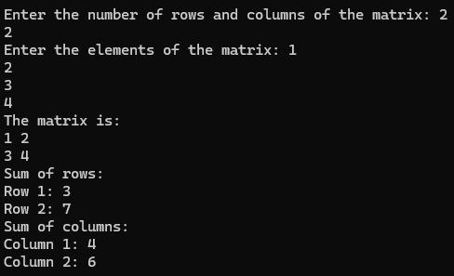
printf("Sum of columns:\n");
for (j = 0; j < n; j++)
{
int sum = 0;
for (i = 0; i < m; i++)
{
sum += matrix[i][j];
}
printf("Column %d: %d\n", j + 1, sum);
}
return 0;
}

/*5. Write a program in C to display the lower triangular elements of a given square matrix*/
#include <stdio.h>
int main()
{
int n, i, j;
printf("Enter the order of the square matrix: ");
scanf("%d", &n);
int matrix[n][n];
printf("Enter the elements of the matrix: ");
for (i = 0; i < n; i++)
{
for (j = 0; j < n; j++)
{
scanf("%d", &matrix[i][j]);
}
}
printf("The lower triangular elements of the matrix are:\n");
for (i = 0; i < n; i++)
{
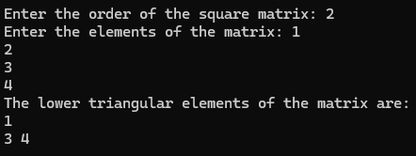
for (j = 0; j <= i; j++)
{
printf("%d ", matrix[i][j]);
}
printf("\n");
}
return 0;
}

/*6. Write a program in C to find the product of two matrices.*/
#include <stdio.h>
int main() {
int r1, c1, r2, c2, i, j, k;
printf("Enter rows and columns for first matrix: ");
scanf("%d %d", &r1, &c1);
printf("Enter rows and columns for second matrix: ");
scanf("%d %d", &r2, &c2);

if (c1 != r2) {
printf("Incompatible matrix dimensions\n");
return 1;
}

int matrix1[r1][c1], matrix2[r2][c2], result[r1][c2];

printf("Enter elements of first matrix:\n");
for (i = 0; i < r1; i++) {
for (j = 0; j < c1; j++) {
scanf("%d", &matrix1[i][j]);
}
}

printf("Enter elements of second matrix:\n");
for (i = 0; i < r2; i++) {
for (j = 0; j < c2; j++) {
scanf("%d", &matrix2[i][j]);
}
}

for (i = 0; i < r1; i++) {
for (j = 0; j < c2; j++) {
result[i][j] = 0;
}
}

for (i = 0; i < r1; i++) {
for (j = 0; j < c2; j++) {
for (k = 0; k < c1; k++) {
result[i][j] += matrix1[i][k] * matrix2[k][j];
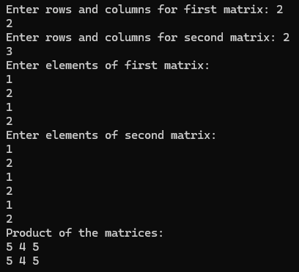
}
}
}

printf("Product of the matrices:\n");
for (i = 0; i < r1; i++) {
for (j = 0; j < c2; j++) {
printf("%d ", result[i][j]);
}
printf("\n");
}

return 0;
}

/*7. Write a program using an array of structures to store the data for ten employees with fields (e_sn, f_name, l_name, address, mobile_no) and display the records in an appropriate format.*/
#include <stdio.h>
#include <string.h>
#define MAX_EMPLOYEES 10
struct Employee {
int e_sn;
char f_name[50];
char l_name[50];
char address[100];
char mobile_no[15];
};
int main() {
struct Employee employees[MAX_EMPLOYEES];
int i;

for (i = 0; i < MAX_EMPLOYEES; i++) {
printf("Enter details for employee %d:\n", i + 1);
printf("Employee Serial Number: ");
scanf("%d", &employees[i].e_sn);
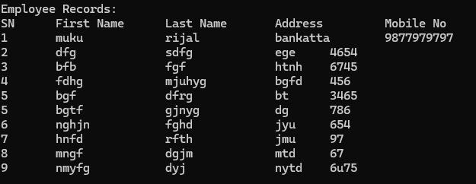
printf("First Name: ");
scanf("%s", employees[i].f_name);
printf("Last Name: ");
scanf("%s", employees[i].l_name);
printf("Address: ");
scanf(" %[^\n]", employees[i].address);
printf("Mobile Number: ");
scanf("%s", employees[i].mobile_no);
}

printf("\nEmployee Records:\n");
printf("SN\tFirst Name\tLast Name\tAddress\t\tMobile No\n");
for (i = 0; i < MAX_EMPLOYEES; i++) {
printf("%d\t%s\t\t%s\t\t%s\t%s\n", employees[i].e_sn, employees[i].f_name, employees[i].l_name, employees[i].address, employees[i].mobile_no);
}

return 0;
}

/*8. Write a program that defines an array of integers with dynamic memory allocation and computes the sum of the array using a function of your own.*/
#include <stdio.h>
#include <stdlib.h>

int computeSum(int *arr, int size) {
int sum = 0;
for (int i = 0; i < size; i++) {
sum += arr[i];
}
return sum;
}

int main() {
int n, i;
printf("Enter the number of elements: ");
scanf("%d", &n);

int *arr = (int *)malloc(n * sizeof(int));
if (arr == NULL) {
printf("Memory allocation failed\n");
return 1;
}
printf("Enter the elements: ");
for (i = 0; i < n; i++) {
scanf("%d", &arr[i]);
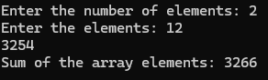
}
int sum = computeSum(arr, n);
printf("Sum of the array elements: %d\n", sum);
free(arr);
return 0;
}

/*9. WAP to find the sum of an array using a user-defined function.*/
#include <stdio.h>
int sum(int arr[], int size) {
int total = 0;
for (int i = 0; i < size; i++) {
total += arr[i];
}
return total;
}
int main() {
int size;
printf("Enter the size of the array: ");
scanf("%d", &size);
int arr[size];
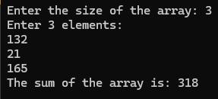
printf("Enter %d elements:\n", size);
for (int i = 0; i < size; i++) {
scanf("%d", &arr[i]);
}
int result = sum(arr, size);
printf("The sum of the array is: %d\n", result);
return 0;
}

/*10. Write a program to find whether a given string is a palindrome using a user-defined function.*/
#include <stdio.h>
#include <string.h>
int isPalindrome(char str[]) {
int left = 0;
int right = strlen(str) - 1;
while (left < right) {
if (str[left] != str[right]) {
return 0;
}
left++;
right--;
}
return 1;
}
int main() {
char str[100];
printf("Enter a string: ");
fgets(str, sizeof(str), stdin);
str[strcspn(str, "\n")] = '\0';
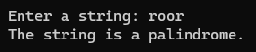
if (isPalindrome(str)) {
printf("The string is a palindrome.\n");
} else {
printf("The string is not a palindrome.\n");
}
return 0;
}

/*11. Write a program to swap two numbers using a function swap(int, int) with:
a> Pass by value
b> Pass by reference */
#include <stdio.h>
void swapByValue(int a, int b) {
int temp = a;
a = b;
b = temp;
}
void swapByReference(int *a, int *b) {
int temp = *a;
*a = *b;
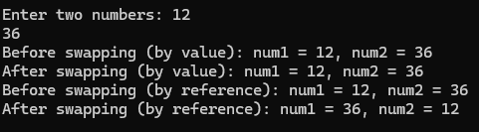
*b = temp;
}
int main() {
int num1, num2;
printf("Enter two numbers: ");
scanf("%d %d", &num1, &num2);
printf("Before swapping (by value): num1 = %d, num2 = %d\n", num1, num2);
swapByValue(num1, num2);
printf("After swapping (by value): num1 = %d, num2 = %d\n", num1, num2);
printf("Before swapping (by reference): num1 = %d, num2 = %d\n", num1, num2);
swapByReference(&num1, &num2);
printf("After swapping (by reference): num1 = %d, num2 = %d\n", num1, num2);
return 0;
}

/*12. Write a program to pass an array to a function using a pointer and return an array from a function using a pointer.*/
#include <stdio.h>
void passArray(int *arr, int size) {
printf("Array elements passed to the function: ");
for (int i = 0; i < size; i++) {
printf("%d ", arr[i]);
}
printf("\n");
}
int* returnArray(int size) {
static int arr[100];
printf("Enter %d elements for the array: ", size);
for (int i = 0; i < size; i++) {
scanf("%d", &arr[i]);
}
return arr;
}
int main() {
int size;
printf("Enter the size of the array: ");
scanf("%d", &size);
int arr[100];
printf("Enter %d elements for the array: ", size);
for (int i = 0; i < size; i++) {
scanf("%d", &arr[i]);
}
passArray(arr, size);
int *returnedArr = returnArray(size);
printf("Array elements returned from the function: ");
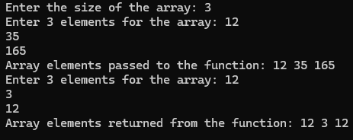
for (int i = 0; i < size; i++) {
printf("%d ", returnedArr[i]);
}
printf("\n");
return 0;
}

/*13. Write a program that illustrates the similarity between arrays and pointers.*/
#include <stdio.h>
int main() {
int arr[5] = {1, 2, 3, 4, 5};
int *ptr = arr;
printf("Array elements using array indexing: ");
for (int i = 0; i < 5; i++) {
printf("%d ", arr[i]);
}
printf("\nArray elements using pointer arithmetic: ");
for (int i = 0; i < 5; i++) {
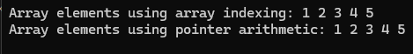
printf("%d ", *(ptr + i));
}
printf("\n");
return 0;
}

/*14. Write a program in C to find the factorial of a given integer using recursion.*/
#include <stdio.h>
int factorial(int n) {
if (n == 0)
return 1;
else
return n * factorial(n-1);
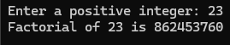
}
int main() {
int num;
printf("Enter a positive integer: ");
scanf("%d", &num);
printf("Factorial of %d is %d\n", num, factorial(num));
return 0;
}

/*15. Write a program to find the first ten numbers in the Fibonacci series using recursion.*/
#include <stdio.h>
int fibonacci(int n) {
if (n <= 1) {
return n;
}
return fibonacci(n - 1) + fibonacci(n - 2);
}

int main() {
printf("The first 10 numbers in the Fibonacci series are:\n");
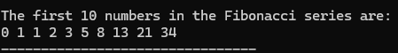
for (int i = 0; i < 10; i++) {
printf("%d ", fibonacci(i));
}
return 0;
}

/*16. Write a program to find the number of times the vowel 'e' appears in a given string.*/
#include <stdio.h>
#include <string.h>
int main() {
char str[100];
int count = 0;
int i;

printf("Enter a string: ");
fgets(str, sizeof(str), stdin);

for (i = 0; i < strlen(str); i++) {
if (str[i] == 'e' || str[i] == 'E') {
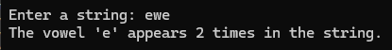
count++;
}
}
printf("The vowel 'e' appears %d times in the string.\n", count);
return 0;
}

/*17. Write a program defining a structure to store the data for a student with fields (roll_no, f_name, l_name, address, mobile_no) and display the record in an appropriate format.*/
#include <stdio.h>
#include <string.h>
struct Student {
int roll_no;
char f_name[50];
char l_name[50];
char address[100];
long long mobile_no;
};
int main() {
struct Student s;

printf("Enter roll number: ");
scanf("%d", &s.roll_no);
scanf("%*c");

printf("Enter first name: ");
fgets(s.f_name, sizeof(s.f_name), stdin);
s.f_name[strcspn(s.f_name, "\n")] = 0;

printf("Enter last name: ");
fgets(s.l_name, sizeof(s.l_name), stdin);
s.l_name[strcspn(s.l_name, "\n")] = 0;

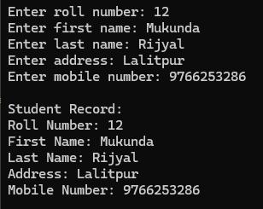
printf("Enter address: ");
fgets(s.address, sizeof(s.address), stdin);
s.address[strcspn(s.address, "\n")] = 0;

printf("Enter mobile number: ");
scanf("%lld", &s.mobile_no);

printf("\nStudent Record:\n");
printf("Roll Number: %d\n", s.roll_no);
printf("First Name: %s\n", s.f_name);
printf("Last Name: %s\n", s.l_name);
printf("Address: %s\n", s.address);
printf("Mobile Number: %lld\n", s.mobile_no);

return 0;
}

/*18. Write a program defining a union to store the data for a student with fields (roll_no, f_name, l_name, address, mobile_no). Illustrate the property of unions by accessing only one data member at a time.*/
#include <stdio.h>
#include <string.h>
union Student {
int roll_no;
char f_name[50];
char l_name[50];
char address[100];
long long mobile_no;
};
int main() {
union Student s;

printf("Enter roll number: ");
scanf("%d", &s.roll_no);
printf("Roll Number: %d\n", s.roll_no);

printf("Enter first name: ");
scanf("%s", s.f_name);
printf("First Name: %s\n", s.f_name);

printf("Enter last name: ");
scanf("%s", s.l_name);
printf("Last Name: %s\n", s.l_name);
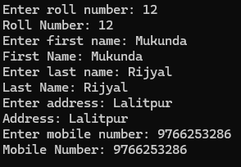
printf("Enter address: ");
scanf("%s", s.address);
printf("Address: %s\n", s.address);

printf("Enter mobile number: ");
scanf("%lld", &s.mobile_no);
printf("Mobile Number: %lld\n", s.mobile_no);

return 0;
}

/*19. Write a program to prompt the user to input a filename and read the content of the file, then display it on the screen.*/
#include <stdio.h>
int main() {
char filename[100];
char ch;
FILE *file;

printf("Enter the filename to read: ");
scanf("%s", filename);

file = fopen(filename, "r");
if (file == NULL) {
perror("Error opening file");
return 1;
}

printf("Content of the file:\n");
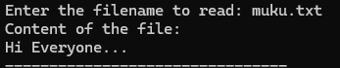
while ((ch = fgetc(file)) != EOF) {
putchar(ch);
}
fclose(file);
return 0;
}

/*20. Write a program to read from a text file and count the number of lines and characters in that file.*/
#include <stdio.h>
int main() {
char filename[100];
FILE *file;
int lines = 0, characters = 0;
char ch;
printf("Enter the filename to read: ");
scanf("%s", filename);

file = fopen(filename, "r");
if (file == NULL) {
perror("Error opening file");
return 1;
}
while ((ch = fgetc(file)) != EOF) {
characters++;
if (ch == '\n') {
lines++;
}
}

if (characters > 0 && ch != '\n') {
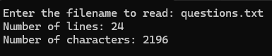
lines++;
}
printf("Number of lines: %d\n", lines);
printf("Number of characters: %d\n", characters);

fclose(file);
return 0;
}

/*21. Write a program to read a text file and copy all contents into a new file.*/
#include <stdio.h>
int main() {
char source_filename[100], dest_filename[100];
FILE *source_file, *dest_file;
char ch;
printf("Enter the source filename: ");
scanf("%s", source_filename);
printf("Enter the destination filename: ");
scanf("%s", dest_filename);
source_file = fopen(source_filename, "r");
if (source_file == NULL) {
perror("Error opening source file");
return 1;
}
dest_file = fopen(dest_filename, "w");
if (dest_file == NULL) {
perror("Error opening destination file");
fclose(source_file);
return 1;
}
while ((ch = fgetc(source_file)) != EOF) {
fputc(ch, dest_file);
}
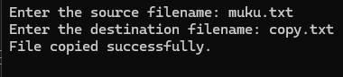
printf("File copied successfully.\n");
fclose(source_file);
fclose(dest_file);
return 0;
}

