**Code Explainer + Interview Prep Assistant: Detailed Project Report**

**1. Introduction**

The "Code Explainer + Interview Prep Assistant" is an innovative, AI-powered tool designed to address significant challenges faced by students and job seekers in understanding code and preparing for technical interviews. In today's competitive landscape, merely solving coding problems is often insufficient; a deep, contextual understanding of solutions, efficient performance analysis, and the ability to articulate thought processes are crucial. This project aims to bridge these gaps by providing a comprehensive, interactive platform that leverages artificial intelligence to enhance learning, optimize code, and simulate interview scenarios effectively.

**2. Project Overview and Features**

This project integrates a suite of functionalities to create an all-in-one learning and preparation environment:

* **Multi-language Code Editor with VS Code-like interface:** Utilizes streamlit_ace to provide a familiar and intuitive coding environment, supporting various programming languages. This allows users to write and edit code directly within the platform.
* **Code Runner using Piston API for multiple languages:** Integrates with the Piston API to enable real-time execution of user-submitted code across a wide range of programming languages, providing instant feedback on code correctness and output.
* **Code Explanation using LLM with line-by-line insights:** Employs advanced Large Language Models (LLMs) to generate clear, concise, and context-aware explanations for code snippets. This includes breaking down complex logic line-by-line, highlighting key variables, loops, recursion, and overall algorithm flow.
* **Time & Space Complexity Estimation:**
* **Heuristic analysis:** Estimates complexity based on common algorithmic patterns and operations.
* **Cyclomatic Complexity for Python:** Provides a metric for the structural complexity of Python code, indicating the number of independent paths through the code.
* **Graphical Complexity Visualization with Matplotlib:** Visualizes the estimated time and space complexity using Matplotlib, helping users intuitively understand the performance implications of their code as input size grows.
* **Interview Preparation Add-ons:**
* **Mock whiteboard questions:** Generates realistic coding challenges similar to those encountered in technical interviews.
* **Trade-offs discussions:** Prompts users to consider and explain design trade-offs (e.g., space vs. time, different data structures).
* **Difficulty-based questions:** Provides interview questions tailored to specific difficulty levels.
* **Edge Case Generator and Bug Finder:** Automatically suggests challenging edge test cases for user-provided code and identifies common bugs or potential vulnerabilities, along with recommendations for fixes.
* **Voice-to-Text Q&A with SpeechRecognition:** Allows users to interact with the assistant using voice commands, enabling a more natural and hands-free experience for asking questions and receiving explanations.
* **Function Call Graphs for Python with NetworkX:** Generates visual representations of function calls within Python code using NetworkX, helping users understand the execution flow and dependencies between different functions.
* **What-if Analyzer with pre-defined scenarios:** Enables users to explore the behavior of their code under various pre-defined "what-if" scenarios, helping them understand how changes in input or conditions affect output and performance.

**3. Challenges and Limitations**

Developing a sophisticated AI-powered assistant like this comes with inherent challenges and limitations:

* **Accuracy and Hallucination of LLM Explanations:** While powerful, Large Language Models (LLMs) can sometimes generate incorrect, misleading, or overly generalized explanations. This is particularly true for highly complex, niche, or ambiguous code snippets. Ensuring consistent accuracy and preventing "hallucinations" (where the AI generates confident but false information) remains a significant technical hurdle.
* **Limitations of Automated Complexity Analysis:** Heuristic analysis and Cyclomatic Complexity, while useful indicators, may not always precisely capture the true runtime and memory behavior for all algorithms. This is especially challenging for code with complex data dependencies, dynamic execution paths, or highly optimized low-level operations. Providing truly accurate best, average, and worst-case complexities across all possible scenarios can be difficult.
* **Realism and Nuance in Interview Simulation:** Replicating the full nuance of a human-led technical interview is a complex task for an AI. This includes interpreting non-verbal cues, adapting to unexpected or creative responses, and evaluating problem-solving approaches that extend beyond just code correctness. The mock interview might lack the subtle adaptability and human empathy of a live interviewer.
* **Dependency on External APIs and Services:** The project relies on external services such as the Piston API for code execution and potentially other APIs for LLM access. This introduces dependencies on third-party providers, which can lead to issues like increased latency, unexpected cost implications, strict rate limits on usage, or potential service disruptions, all of which are outside the project's direct control.
* **Scope and Scalability for Diverse Codebases:** While the project aims to support multiple languages, analyzing extremely large and complex enterprise-level codebases or highly specialized domain-specific languages might pose significant challenges. These challenges include excessive processing time, high resource consumption (CPU/memory), and the difficulty in providing sufficiently deep and relevant insights across such a vast and varied spectrum of code.
* **Ethical Considerations and Bias:** As an AI-powered tool trained on vast datasets, there is an inherent risk of inheriting biases present in the training data. This could inadvertently lead to biased explanations, unfair feedback in interview simulations, or perpetuate existing inequalities. Ensuring fairness, transparency, and ethical use, particularly in a high-stakes context like interview preparation, is a continuous and critical challenge requiring careful monitoring and mitigation strategies.

**4. Flowchart and Workflow**

The project's workflow can be visualized as a series of interconnected modules, each handling a specific aspect of the user's interaction and code processing.

**Overall Workflow**

1. **User Input:** The user interacts with the web-based interface (Streamlit application).
2. **Code Submission/Interaction:** User inputs code, asks questions (text/voice), or initiates interview simulations.
3. **Processing & Analysis:** The system processes the input using various internal modules and external APIs.
4. **Output Generation:** The system generates explanations, complexity analyses, interview questions, or bug reports.
5. **User Output:** The results are displayed back to the user in the UI.

**Detailed Workflow 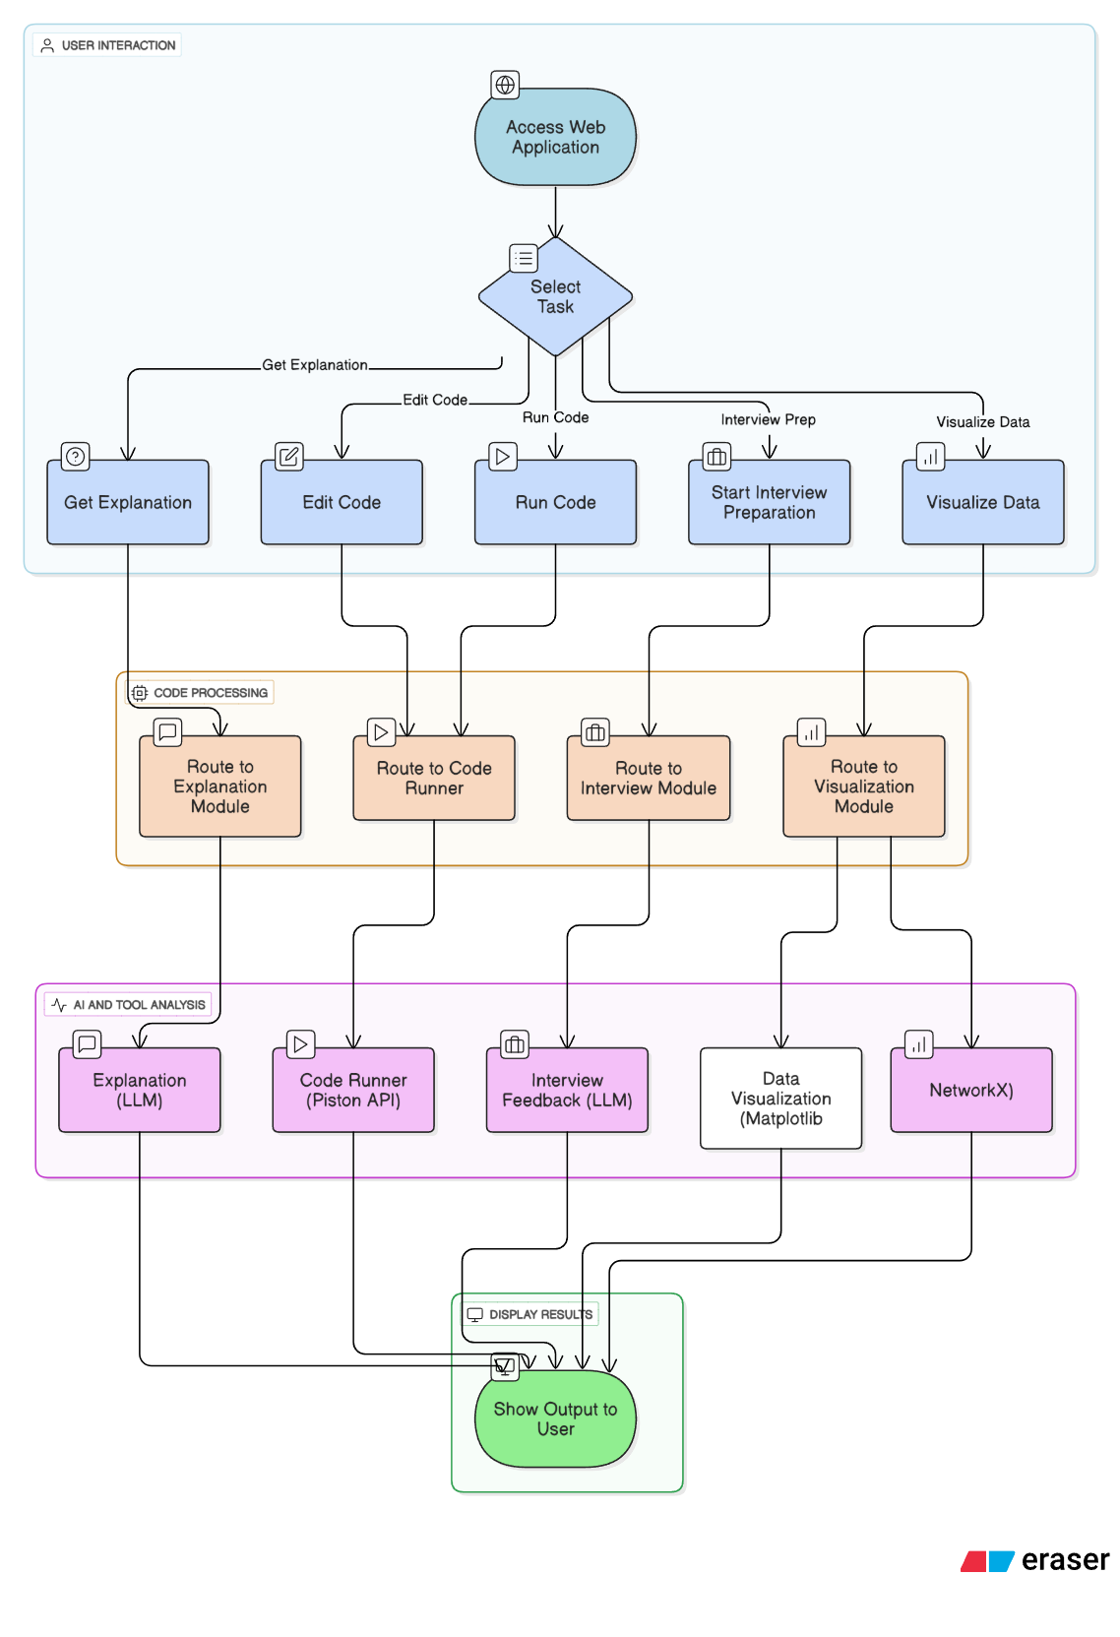t)**

**5. References**

Here are some relevant research papers and resources that underpin the concepts and technologies used in your project:

**1. Artificial Intelligence in Code Optimization and Refactoring**

* **Relevance:** This paper investigates the deployment of AI in code optimization and its performance, exploring how AI can enhance system performance, code readability, and reduce technical debt. It directly supports your project's goals related to code optimization and improving code quality.
* **Source:** ResearchGate (Publication).
* **Link:** <https://www.researchgate.net/publication/389884213_Artificial_Intelligence_in_Code_Optimization_and_Refactoring>

1. **Towards automated scaffolding of learners' code comprehension process**

* **Author:** Priti Oli
* **Relevance:** This dissertation extensively explores the use of Large Language Models (LLMs) for generating code explanations and assessing student understanding, which is highly relevant to your "Code Explanation using LLM with line-by-line insights" feature.
* **Source:** Electronic Theses and Dissertations, University of Memphis Digital Commons (2024).
* **Link:** <https://digitalcommons.memphis.edu/cgi/viewcontent.cgi?article=4722&context=etd>

1. **Designing Conversational AI to Support Think-Aloud Practice in Technical Interview Preparation for CS Students**

* **Relevance:** This paper directly addresses the application of conversational AI (often powered by LLMs) to facilitate "think-aloud practice" for technical interview preparation. This is crucial for your "Interview Preparation Add-ons" and "Voice-to-Text Q&A" features.
* **Source:** arXiv.org (July 2025).
* **Link:** <https://arxiv.org/html/2507.14418v1>

1. **2024 IEEE International Conference on Big Data (BigData)**

* **Relevance:** As a major IEEE conference, its proceedings often include papers on foundational AI, machine learning, and data analysis techniques that underpin projects like yours, particularly those involving large language models, complex data processing, and performance analysis.
* **Source:** IEEE Xplore (Conference Proceedings).
* **Link:** <https://www.proceedings.com/content/078/078509webtoc.pdf> (Table of Contents)

1. **Analyzing the Behavior of LLMs as a Coding Assistant for Computer Science Students: A Systematic Review of the Literature**

* **Relevance:** This systematic review provides a comprehensive overview of how LLMs are used as coding assistants, including their capabilities in generating and explaining code. It's highly relevant for understanding the current state and challenges of LLMs in code explanation.
* **Source:** ResearchGate (Publication).
* **Link:** <https://www.researchgate.net/publication/383143255_Navigating_the_Pitfalls_Analyzing_the_Behavior_of_LLMs_as_a_Coding_Assistant_for_Computer_Science_Students_-_A_Systematic_Review_of_the_Literature/fulltext/66bf07ac2ff54d6c9ed3fcdd/Navigating-the-Pitfalls-Analyzing-the-Behavior-of-LLMs-as-a-Coding-Assistant-for-Computer-Science-Students-A-Systematic-Review-of-the-Literature.pdf>