### README

### Ensure that the input data files required for the code in the EDA_Stage1.ipynb notebook are downloaded from the appropriate source ([**https://www.kaggle.com/datasets/nadyinky/sephora-products-and-skincare-reviews**](https://www.kaggle.com/datasets/nadyinky/sephora-products-and-skincare-reviews)). Verify that the correct local file paths are specified in the code section where the data is imported. This step is critical for the successful execution of the notebook.

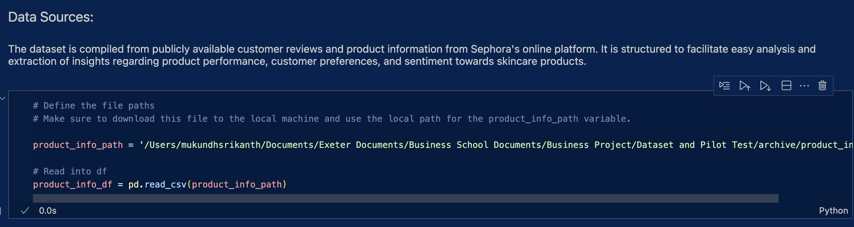

Figure 1 - Make sure product_info_path points to the correct local path. Source: Author's own work.

### The primary output of the **EDA_Stage1.ipynb** notebook is a dataframe named *filtered_product_cluster_df*. This dataframe should be saved to a local path of your choice. When running the second notebook, **Stage1_Stage2.ipynb**, make sure that this output file is correctly referenced by specifying the appropriate path in your local system.

Figure 2 - Please ensure product_info_clusterd_path points to the exact location of the filtered_product_cluster_df file. Source: Author's own work

### Ensure that all necessary **review data files** have been downloaded. It's important that the local paths for these files are correctly specified in the code. Without the correct paths, the notebooks may fail to execute as expected.

Figure 3 - Please ensure that the review_path correctly point to the review files. Source: Author's own work.