Programming Assignment 2: Group Algorithm Comparison Project

Student | Student Number
Jack McCowan | 24950750
Bailey Tucker | 24744334
Mukund Srinivasan | 24832432

Repository: https://github.com/Mukundks2004/adv-algos-assign-2
Video: TODO

Table of Contents

The problem and the algorithms 1
Schoolbook 1
Karatsuba 1
FFT based 2
Theoretical comparison and predictions 3
Karatsuba 3
Experimental methodology 4
Karatsuba 4
Results and analysis 5
Karatsuba 6
What surprised us 10
Karatsuba 10
What we'd do next 11
Karatsuba 12
Individual contributions 12
Jack McCowan 12

Comparison and Benchmarking of Popular Integer Multiplication Algorithms

The problem and the algorithms
Large integer multiplication is a core operation in arbitrary-precision arithmetic. Public-key cryptography depends on it, for example in the modular exponentiation at the heart of RSA and in the field arithmetic of elliptic-curve implementations used by blockchains. Division, square roots and other arbitrary-precision operations are built on top of it.
Problem. Given two non-negative integers a and b, each stored as n limbs of 64 bits in little-endian order (radix B = 2⁶⁴), compute their product a·b as 2n limbs. The operands have equal length, and the result is written to a caller-allocated buffer that does not overlap either input. This is the contract of GMP's mpn_mul_n. Every implementation in this project exposes it as custom_mul_n(result, a, b, n), with any scratch memory allocated in a separate setup step so that only the multiplication itself is timed.
Aim. The goal of the project is to implement several algorithms for this problem and to explain, through a comparative empirical study, why each performs as it does across operand sizes. We deliberately chose algorithms whose theoretical and practical rankings differ. The asymptotically fastest algorithm is not necessarily the fastest at the sizes that arise in practice, and we set out to measure where, and why, the simpler algorithms win.
We implemented the three algorithms described below and compare them against mpn_mul_n from GMP 6.2.1, a production-quality library, as a reference.

Schoolbook
Code: Code/SchoolbookMul.c.
Schoolbook multiplication is the long multiplication taught in primary school, carried out in base 2⁶⁴ rather than base 10. For each limb of a, it multiplies every limb of b by that limb and adds the partial products, with carries, into the corresponding positions of the output. Each of the n limbs of a meets each of the n limbs of b exactly once, so the algorithm performs n² limb multiply-adds and runs in Θ(n²) time. It needs no memory beyond the 2n-limb result.
Schoolbook is the only one of our algorithms that uses no recursion, transforms or floating-point arithmetic. Its inner loop is short and branch-free: one 64 × 64 → 128-bit multiplication, two additions and a carry per step. This gives it the smallest constant factor of the three, so it is the fastest choice for small n, but its quadratic growth makes it by far the slowest as n increases. Karatsuba also uses it as its base case.

Karatsuba
Primary author: Jack McCowan. Code: Code/KaratsubaMul.c.
Karatsuba's algorithm (Karatsuba and Ofman, 1962) was the first to multiply two n-digit numbers in fewer than Θ(n²) digit operations. It is divide and conquer. With B = 2⁶⁴ the limb radix, split each operand at h = ⌈n/2⌉ limbs, a = a₁·B^{h} + a₀ and b = b₁·B^{h} + b₀, so a₀ and b₀ have h limbs and a₁ and b₁ have n − h. Then
a·b = z₂·B^{2h} + z₁·B^{h} + z₀, where z₀ = a₀b₀, z₂ = a₁b₁ and z₁ = a₀b₁ + a₁b₀.
Computing those terms directly needs four half-size products, and T(n) = 4T(n/2) + Θ(n) is still Θ(n²). Karatsuba's insight is that the middle term can be recovered from the other two plus one extra product:
z₁ = z₀ + z₂ − (a₀ − a₁)(b₀ − b₁).
Three half-size multiplications now do the work of four, at the cost of a few extra additions and subtractions. The recurrence becomes T(n) = 3T(⌈n/2⌉) + Θ(n). By the master theorem (a = 3, b = 2, and the Θ(n) work is dominated by nlog23), the solution is Θ(nlog23) ≈ Θ(n^{1.585}). Extra space is Θ(n); our implementation uses about 4n limbs of scratch.
Three implementation decisions matter for the results later in the report:
- A difference rather than a sum in the middle term. The textbook form, (a₀ + a₁)(b₀ + b₁) − z₀ − z₂, can carry into an extra limb, so its recursive product has h + 1 limbs. For n = 2 or 3, h + 1 = n and the recursion never shrinks. |a₀ − a₁| always fits in h limbs, so every recursive product is square and strictly smaller than n (GMP makes the same choice). The price is a sign: if a₀ − a₁ and b₀ − b₁ have the same sign their product is subtracted, otherwise added. Getting this case wrong still produces a plausible-looking number, so our tests target it directly.
- Odd sizes. When n is odd, a₁ is one limb shorter than a₀; the comparison and subtraction treat it as zero-padded.
- A schoolbook base case. At or below a cutoff of 16 limbs (KARATSUBA_THRESHOLD, set at compile time), the implementation calls the group's schoolbook routine. Karatsuba and schoolbook therefore share an inner loop and differ only in the recursion above it. All scratch is allocated in the setup function before timing; z₀ and z₂ go straight into the output buffer, and only the middle product needs scratch.
What sets Karatsuba apart:
- From schoolbook: like schoolbook it uses only exact integer arithmetic on limbs, but it trades multiplications for additions through recursion, the same idea as Strassen's matrix multiplication.
- From the FFT: it never changes representation. There's no transform, no splitting into small digits and no padding to a power of two.
- Input dependence: its operation count depends only on n, not on the operand values (apart from how far carries propagate and which way the sign branch goes).

FFT based
Primary author: Mukund Srinivasan. Code: Code/FftMul.c.
The FFT-based algorithm treats each operand as a polynomial whose coefficients are its digits, so multiplying the integers becomes multiplying two polynomials and then propagating carries. Polynomial multiplication is a convolution of the coefficient sequences, and the fast Fourier transform computes a convolution of length m in Θ(m log m) operations. It evaluates both polynomials at the m-th roots of unity, multiplies the values pointwise, and interpolates back with an inverse transform.
Our implementation splits each limb into 16-bit digits (8-bit digits above 2,048 limbs) and pads the digit sequences with zeros to a power-of-two length no shorter than the product. It then applies an iterative radix-2 complex FFT in double precision. After the inverse transform, each coefficient is rounded to the nearest integer and its excess is carried into the next digit. For a fixed digit size this takes Θ(n log n) time, and the four arrays of doubles need at least 256n bytes of scratch memory.
What sets the FFT apart is that it changes representation. It solves an exact integer problem with approximate floating-point arithmetic, and the answer is correct only while the accumulated rounding error stays below one half. Larger operands produce larger convolution sums and more rounding error, so the digits must shrink as n grows, which is why the implementation switches to 8-bit digits for large inputs.

OpenAI preprint
Primary author: Bailey Tucker (24744334). Code: Code/OpenAiMul.c.
The source is OpenAI, "Integer multiplication below n log n", 23 September 2026. The theorem is one fixed multitape machine that multiplies n-bit integers in O(n (lg n)^(1-kappa)) steps, with kappa = 2^(-182). Harvey and van der Hoeven (2021) had reached O(n log n). The paper claims a power saving on that log factor. The constants are far beyond any input we can store. The proof tells the machine to use schoolbook multiplication below a cutoff, and one hypothesis already needs log2(n) past 2^(2^75).
The file therefore does not time that tape machine. Pasting schoolbook into it would also have duplicated Code/SchoolbookMul.c. What it implements is the exact product step from the paper: split each 64-bit limb into four 16-bit digits, compute their linear convolution, and carry in base 2^16 back into limbs. The convolution is a length-2^k number-theoretic transform modulo P = 2^64 - 2^32 + 1. The length is at least twice the number of digits, so a cyclic convolution matches the linear one. Each coefficient of a product we can allocate sits under P, so the residue is the integer coefficient. If the limbs are not 64 bits, or the length is too large for that prime, the function uses schoolbook.
A short transform is wrong even when the arithmetic looks tidy. Digits 3, 5 convolved with 7, 11 should be 21, then 68, then 55. A cyclic length of 2 adds the 55 onto the 21 and the low digit becomes 76. The length check is there to stop that. The inverse transform also has to divide by the length. Without that scale every coefficient is too big by the length, and the carry builds a different integer.
A null operand, a negative length, and a length that overflows the size math are rejected. An empty length, n = 0, returns. The output may overlap an input, because both operands are copied before the product is written.

Theoretical comparison and predictions

Karatsuba
On paper.
- Asymptotics. Schoolbook is Θ(n²), Karatsuba Θ(n^{1.585}), and FFT multiplication Θ(n log n). With floating point, though, the FFT's digits must shrink as n grows to keep rounding exact. Karatsuba's lead over schoolbook should grow by 2^{0.415} ≈ 1.33× per doubling of n. Each doubling triples Karatsuba's time but only roughly doubles the FFT's, so the FFT must eventually win.
- Constant factors. At the leaves Karatsuba runs exactly the schoolbook loop. Each recursion level adds a few passes of linear work (forming two differences, combining z₀, z₁ and z₂, propagating carries) plus a function call. At small n that overhead outweighs the saving, hence the base case. The FFT does complex floating-point butterflies on 4–8 points per limb plus conversions, so its constants should be much larger than Karatsuba's.
- Memory.
  - Schoolbook needs no scratch.
  - Karatsuba's working set is about 8n limbs (64n bytes): 4n of scratch, the 2n-limb output and the operands. That's 8 MiB at 131,072 limbs, comfortably inside the laptop's 24 MB L3 cache.
  - The FFT keeps four arrays of doubles at least 8n long, at least 256n bytes.
- Input sensitivity. Karatsuba's cost depends only on n. Where n falls relative to cutoff·2^{k} sets the recursion depth and the leaf size, and odd n gives uneven splits. Operand values affect only carry propagation and the sign branch.
Predictions written down before measuring. These come from the first draft of this report (21 October) and the design notes written before the implementation (27 October), restated without revision.
- P1. Karatsuba's running time will grow with an exponent close to log₂3 ≈ 1.585, against 2 for schoolbook.
- P2. Karatsuba will beat schoolbook "beyond a few dozen limbs", and the best cutoff will be close to GMP's own Karatsuba threshold of roughly 20–30 limbs. Our first version used 32.
- P3. Time against n will be a sawtooth rather than a smooth curve, with visible jumps just above each cutoff·2^{k}, where the recursion gains a level.
- P4. Running time will depend on n, not on the operand values.
- P5. The FFT will overtake Karatsuba within the sizes we test. We did not commit to a crossover size.

FFT based
On paper.
- Asymptotics. Two forward transforms and one inverse transform, each Θ(N log N) butterflies, plus Θ(N) for loading digits and carrying, where N is the product digit count rounded up to a power of two. With a fixed digit size that is Θ(n log n) in limbs, against Θ(n^{1.585}) for Karatsuba and Θ(n²) for schoolbook. The digit size is not fixed in our code: it drops from 16 to 8 bits above 2,048 limbs, which doubles N.
- Constant factors. A butterfly is a complex multiply-add on doubles, which is cheap, but N is at least 8n points with 16-bit digits and 16n points with 8-bit digits for n-limb operands. The transform is scalar radix-2, and both the real and imaginary arrays are transformed although the input is real. That is a large constant, so crossovers with the simpler algorithms should come late.
- Memory. Four arrays of N doubles, two twiddle tables of N/2 doubles and a bit-reversal table of N size_t values. At 16,384 limbs N = 262,144, each array is 2 MiB and the total is about 12 MiB, so the working set should spill out of the L2 cache well before the largest sizes.
- Input sensitivity. Time should depend on n and not on the values, but it depends on where n falls between powers of two, because of the padding. Correctness is the value-sensitive part: the rounding error grows with the convolution coefficients, which are largest when every digit is maximal (all-ones operands).
Predictions, written after the measurements. Unlike P1 to P5 and Q1 to Q5, these were not committed to before timing. They are reasoned from the design of the code. P5 and Q3 above remain the original FFT predictions, and the results they missed are discussed in section 5.
- F1. Schoolbook beats the FFT at 16 and 64 limbs, with the FFT roughly an order of magnitude slower at 16 limbs.
- F2. The FFT overtakes schoolbook at a few hundred limbs.
- F3. Above that crossover the FFT's time follows a smooth n log n curve.
- F4. GMP, which is tuned and uses Toom-Cook and its own FFT, stays ahead of this FFT at every size.

OpenAI preprint
On paper.
- Asymptotics. Schoolbook is Θ(n²). The runnable OpenAI function is an Θ(n log n) convolution, the same family as the FFT, with modular multiplies instead of double butterflies. The preprint's o(n log n) tape bound is not in this binary.
- Constant factors. Schoolbook's inner loop is a few arithmetic operations. The number-theoretic transform spends the call on reduction modulo P, and it rebuilds twiddle powers on every call. Its transform length is at least 8n. Above 2,048 limbs the FFT drops to 8-bit digits, so its convolution length is 16n, about twice the OpenAI length. A double butterfly is cheaper than a modular multiply, and the longer transform spends that saving.
- Memory. Schoolbook needs no scratch. The transform keeps two coefficient arrays whose length is at least 8n, plus a bit-reversal table, allocated in setup.
- Input sensitivity. None of the three skips a zero limb. At a fixed n, zeros, all-ones and random limbs should give the same ranking.
Predictions written down before measuring. These are the predictions from the OpenAI notes, left as they were.
Q1. Schoolbook is the fastest of schoolbook, FFT and the OpenAI function at 16 limbs and at 64 limbs.
Q2. The OpenAI function is ahead of schoolbook by 1024 limbs, or, if the constant is worse, by 4096.
Q3. The FFT is ahead of the OpenAI function at every size we try, and ahead of schoolbook by 256 limbs.
Q4. Nothing in the timings looks like the paper's extra log-factor saving against the FFT.
Q5. At a fixed n, zeros, all-ones and random limbs give the same ranking. There was no prediction against GMP.

Experimental methodology

Karatsuba
Correctness first. Correctness was checked in two layers before any timing was trusted.
- Every benchmark run checks itself. Each run compares its result with GMP's mpn_mul_n before the timed loop and aborts on any difference. Across all 2,438 runs behind this report there were no mismatches.
- A structured-input test (Code/KaratsubaTest.c) targets the paths random inputs rarely reach:
  - Inputs: all limbs 2⁶⁴ − 1 (every addition carries), zero, one, only the top limb set, GMP's mpn_random2 (long runs of 0s and 1s), a₀ > a₁, a₀ < a₁, a₀ = a₁ (a zero difference), and squaring with both arguments in the same buffer.
  - Sizes: every n from 1 to 200, plus 255–257, 511–513, 1000, 1023–1025, 2047, 2049, 4095, 4097 and 10,007.
  - Overruns: canary limbs after the output catch writes past the end. Scratch is allocated at exactly its computed size, so AddressSanitizer catches scratch overruns.
  - Builds: cutoffs 1, 2, 3, 4, 8, 32 and 64 under AddressSanitizer and UndefinedBehaviorSanitizer, plus the default at -O2.
  - Result: 51,055 checks, no failures.
  - Testing the test: it caught two deliberately broken versions, one with the sign case inverted and one splitting at ⌊n/2⌋.
Benchmark setup. Code/RunExperiments.sh produces every measurement, and Code/AnalyseResults.py every table and figure; together they take about 14 minutes. Results/README.md records the exact environment.
- Hardware and software. An Intel Core i9-13900H laptop (6 performance and 8 efficiency cores) on mains power, running Ubuntu 22.04 in Docker on WSL2, with gcc 11.4 at -O2 and GMP 6.2.1.
- One measurement is one process for one algorithm, size and repeat. It allocates and touches all buffers, runs setup, warms up 3 times, verifies against GMP, and then times a loop with a monotonic clock, calibrated to run about 0.25 s. At the largest sizes one multiplication exceeds that, so those points are single-shot.
- Fairness.
  - The random seed is the repeat number, so at each size and repeat every algorithm multiplies identical operands.
  - Repeats are the outer loop, so drift in machine state affects all algorithms equally.
  - Only custom_mul_n is timed.
- Variance. Each point has 5 repeats (3 for the fine size sweep), and we report medians. The median run-to-run spread ((max − min)/median) is 11.8%, so we don't read differences under about 15% at a single size. An earlier attempt with other software using about 5 cores ran 40–80% slower and was discarded; the recorded run was made with the host otherwise idle.
Inputs, and why. Operands are uniformly random with the top bit set, so each has exactly n limbs. Karatsuba's cost depends only on n (P4); the structured inputs above are for correctness. So size is the input feature that matters, and the sizes were chosen to probe the recursion:
- Main grid (all algorithms): 8 to 131,072 limbs at alternating ratios of 1.5 and 2, so both powers of two and 1.5·2^{k} sizes appear.
- Schoolbook vs Karatsuba: every even n from 16 to 96, to locate the crossover.
- Cutoff sweep: 18 cutoffs from 1 to 128, each a separate build (-DKARATSUBA_THRESHOLD=k). Sizes were n = 64, 256, 1024 and 4096, plus 1000 and 3000, because with a power-of-two n every cutoff from 2^{j} to 2^{j+1} − 1 gives the same recursion tree.
- Fine size sweep, to test P3: every n from 16 to 2,112 in steps of 8, plus both sides of each level change (16·2^{k} and 16·2^{k} + 1).
- End to end: a chain of 20 modular squarings, x ← x² + 1 mod 2^{64n} − 1.

FFT based
Setup and checks.
- Timed region. FftSetup allocates the digit and twiddle arrays, computes the cos and sin tables and the bit-reversal table, and chooses the digit width and transform length. It runs outside the timer. The timed custom_mul_n does digit loading, three transforms, the pointwise product, rounding and carrying.
- Same inputs, checked. At each size and repeat the FFT multiplies the same random operands as the other algorithms (seed = repeat number). Every result is compared with GMP's mpn_mul_n before timing, and a MISMATCH stops the run. This is the guard for the one thing that can silently go wrong in the FFT, which is floating-point rounding. Results/Raw/errors.log is empty for the full sweep, so no mismatch or failed run was recorded.
- Sizes. The i9 sweep runs the FFT from 8 to 131,072 limbs (5 repeats, medians) and the Ryzen harness table runs it from 16 to 16,384 limbs and up to 2,097,152 in the figure. The two machines are not mixed in any table. The end-to-end chain (20 squarings, 5 iterations) runs the FFT at 16 to 16,384 limbs and is checked against a GMP-only chain.
- What the FFT inputs do not cover. All operands are random with the top bit set. The worst case for rounding error, all-ones operands, was never run through the FFT, and no structured-input test like Karatsuba's exists for it. The 16-bit to 8-bit switch at 2,048 limbs was chosen from an error estimate and not from a measured margin. We have no hardware counters, so the cache explanation below is a hypothesis.

OpenAI preprint
Code/Benchmark, isolated mode. The five-algorithm sweep is schoolbook, Karatsuba, FFT, openai-nlogn and GMP, through 16,384 limbs. Karatsuba, the FFT, the OpenAI function and GMP were then continued through 2,097,152 limbs. Schoolbook was not repeated past 16,384. The FFT file accepts n up to 2²² limbs.
The harness builds operands with the top bit set, so the value has n limbs. Sizes are powers of two, so a doubling factor is readable and the FFT and NTT lengths land on exact powers of two. It checks the product against GMP mpn_mul_n before timing, runs setup first, and times only custom_mul_n. The first sweep used three warmup calls and chose the iteration count to land near 0.25 seconds. The continuation used one warmup, and from 65,536 limbs up Karatsuba, the FFT and the OpenAI function are a single timed call. Each algorithm draws the next pair from one seeded generator, so the four algorithms at one n get different integers. The 256-limb check is why that ranking is still usable: zeros, all-ones and random limbs did not change who won. Raw rows are Deliverables/local-timings.csv and Deliverables/large-timings.csv.
Machine: AMD Ryzen 7 6800H, 16 GB RAM, gcc 13.2.0 at -O2 -std=gnu99, GMP 6.3.0. Every harness row passed the GMP check. Raw rows are in Deliverables/local-timings.csv.
At 256 limbs, zeros, all-ones and a random pair were timed separately: five calls, median, also checked with mpn_mul_n. Those three use a median of five calls. The main table stays the harness mean.

Results and analysis

Karatsuba
n (limbs) | bits | schoolbook | Karatsuba | FFT | GMP | schoolbook ÷ Karatsuba
16 | 1,024 | 0.211 µs | 0.216 µs | 2.66 µs | 0.109 µs | 0.98
32 | 2,048 | 0.853 µs | 0.747 µs | 5.55 µs | 0.347 µs | 1.14
64 | 4,096 | 3.20 µs | 2.39 µs | 11.6 µs | 1.08 µs | 1.34
256 | 16,384 | 52.3 µs | 23.6 µs | 53.6 µs | 9.38 µs | 2.22
1,024 | 65,536 | 816 µs | 229 µs | 332 µs | 71.6 µs | 3.57
4,096 | 262,144 | 12.7 ms | 1.98 ms | 3.72 ms | 0.49 ms | 6.42
32,768 | 2,097,152 | 828 ms | 54.8 ms | 63.7 ms | 5.80 ms | 15.1
131,072 | 8,388,608 | – | 501 ms | 481 ms | 30.6 ms | –
Table K1: median time per multiplication. Results/Tables.md has every size.
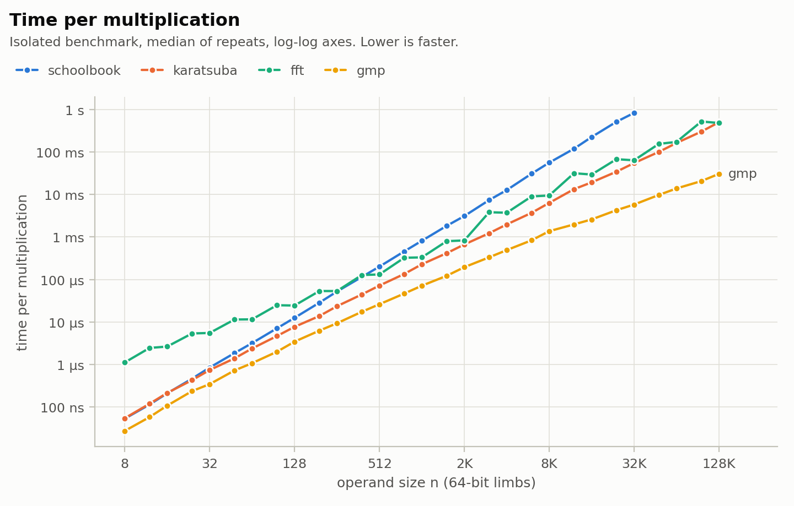
Figure K1: time per multiplication for all four algorithms
Scaling matches the theory (P1 confirmed).
- A least-squares fit of log time against log n for n ≥ 1024 gives Karatsuba an exponent of 1.586, against log₂3 ≈ 1.585. Schoolbook's is 2.02.
- The local exponent falls from 1.97 between 8 and 16 limbs (still pure schoolbook) through 1.79, 1.68 and 1.69, and stays between 1.51 and 1.68 above 256 limbs.
Against schoolbook.
- Karatsuba is first faster at 18 limbs, but by only 3–13% up to about 40 limbs.
- After that its lead grows about 1.33× per doubling, the 2^{0.415} the exponents predict: 2.2× at 256 limbs, 3.6× at 1,024, 6.4× at 4,096 and 15× at 32,768.
The linear work per recursion level explains where the crossover falls:
- Saving: one level replaces an n × n schoolbook product (n² multiply-adds) with three half-size ones (3n²/4), saving n²/4.
- Cost: about 8h ≈ 4n limb additions and subtractions. That's 2h to form the two differences, 4h to build z₁ and 2h to add it into the result.
- Break-even: if a limb addition costs about as much as a multiply-add (plausible, since both are one pass over memory with a carry chain), the level pays off once n²/4 > 4n, i.e. n > 16. That agrees with the measured crossover and with the best cutoff below.
cutoff (limbs) | time vs best
1 | 5.18×
2 | 2.35×
4 | 1.41×
8 | 1.07×
14 | 1.03×
16 | 1.02×
20 | 1.02×
28 | 1.01×
32 | 1.08×
64 | 1.30×
128 | 1.56×
Table K2: time relative to the best cutoff for each size, geometric mean over the six sweep sizes.
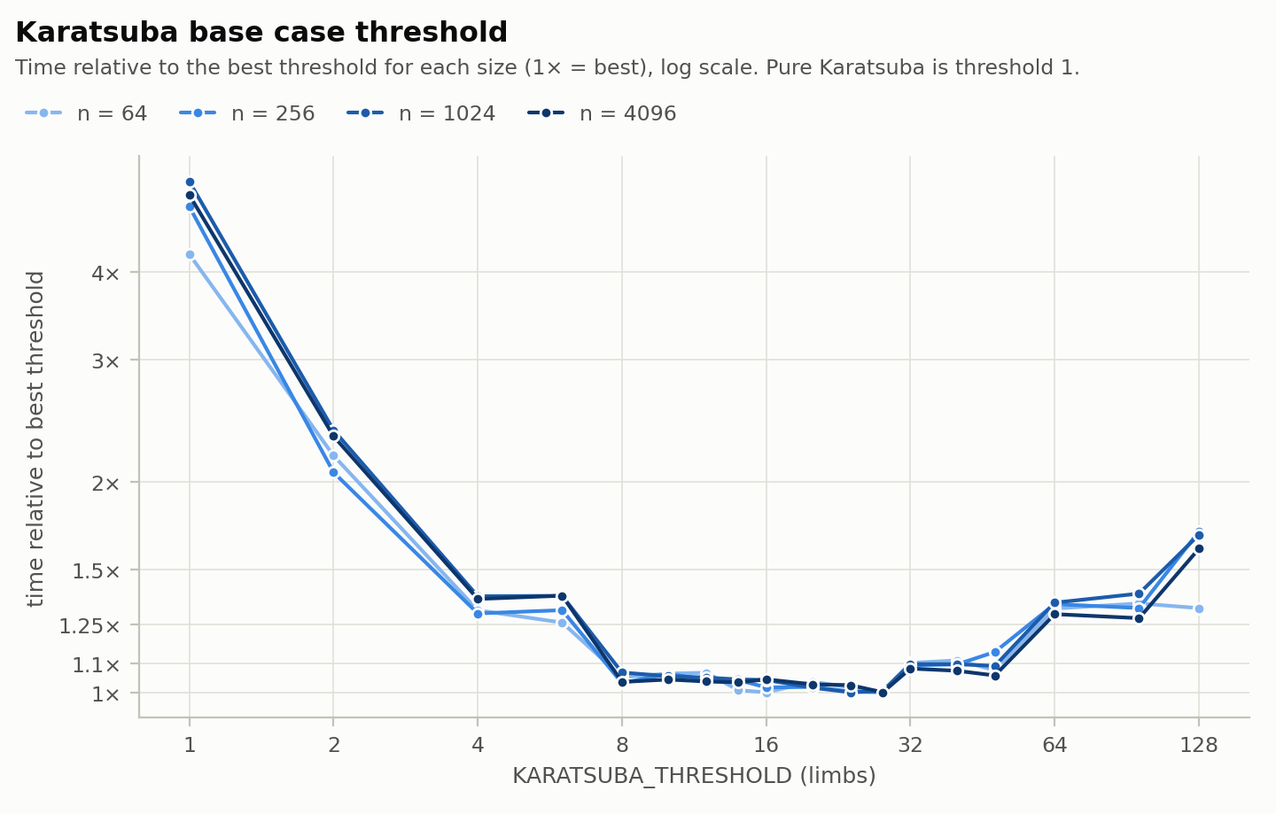
Figure K2: the base case cutoff sweep
The cutoff matters enormously, but its exact value hardly does.
- Pure Karatsuba, recursing to single limbs, is 4–6× slower than the tuned version.
- Every cutoff from 14 to 28 is within 3% of the best. Our first guess of 32 is 8% slower.
- The flat steps in Figure K2 show that for power-of-two n only the leaf size matters. Every cutoff from 2^{j} to 2^{j+1} − 1 builds the same tree, with 2^{j}-limb leaves. Leaves of 16 limbs are best; 8 costs 3–7% more and 32 costs 8–10% more.
The structure explains the flatness. For n = L·2^{d}, the leaves (L limbs at depth d) do 3^{d}·L² = n^{1.585}·L^{0.415} multiply-adds. Level i does about 4n·(3/2)^{i} additions, and summed over the levels that's about 8n·(3/2)^{d} ∝ n^{1.585}·L^{−0.585}. At fixed n the cost is therefore c₁·L^{0.415} + c₂·L^{−0.585}: one term rises with the leaf size and the other falls. A curve like that is flat near its minimum, so halving or doubling L costs only a few percent. At L = 1 the leaf term almost vanishes and the overhead term peaks, with every one-limb product paying for a full recursive call.
n | time | n + 1 | time | change
64 | 2.23 µs | 65 | 2.56 µs | +15%
128 | 7.14 µs | 129 | 7.64 µs | +7%
256 | 22.7 µs | 257 | 23.2 µs | +2%
512 | 67.2 µs | 513 | 68.8 µs | +2%
1,024 | 209 µs | 1,025 | 208 µs | 0%
2,048 | 636 µs | 2,049 | 645 µs | +1%
Table K3: the effect of one extra limb at each change in recursion depth.
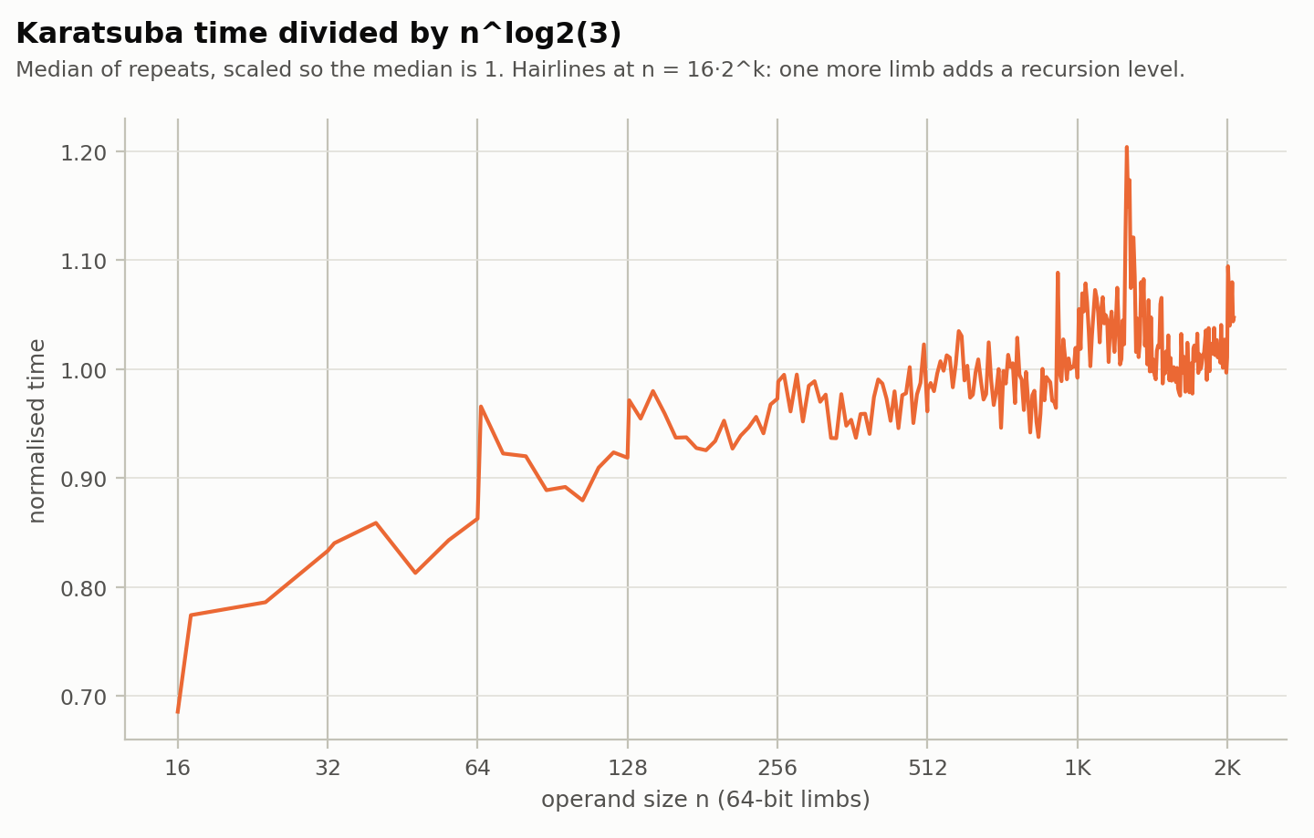
Figure K3: Karatsuba time divided by nlog23
No sawtooth (P3 rejected).
- One limb past 16·2^{k} adds a recursion level, yet from 256 limbs up it changes the time by about 2% or less.
- Figure K3 wiggles, but above 256 limbs the three repeats' curves are essentially uncorrelated (r = 0.03, 0.08 and 0.35), so the wiggles are noise.
- The same cancellation explains it. The extra level halves the leaves, cutting leaf multiply-adds by 25% (3^{d}·16² becomes 3^{d+1}·8²), but adds a level of linear work, and the two roughly balance.
- Only at 65 and 129 limbs, where the tree is shallow and call overhead is a bigger share, does the extra level visibly cost more.
A steady drift instead.
- Time ÷ n^{1.585} rises from 2.78 ns in the 17–32 limb band to 3.68 ns in the 1,025–2,048 band, then levels off.
- Cause: with finite depth d, the linear-work sum is proportional to n^{1.585}·(1 − (2/3)^{d}). So the linear work reaches its long-run share only as the tree deepens: a third of it at d = 1, 80% at d = 4, 94% at d = 7.
- Fit: time/n^{1.585} = A + B·(1 − (2/3)^{d}) over all 271 sizes gives A = 2.15 ns and B = 1.56 ns, matching the measured mean at every depth from 2 to 7 within 1.5%.
- Implication: read literally, the fit says that at large n about 40% of Karatsuba's time goes to additions, subtractions and recursion rather than leaf multiplications. That's a model estimate, not a profile.
Against the FFT.
- Karatsuba is faster at every size up to 32,768 limbs and at 49,152 and 98,304.
- At 65,536 and 131,072 the two tie: their five repeats overlap (154–177 vs 154–183 ms, and 459–512 vs 431–506 ms).
- The FFT ÷ Karatsuba ratio alternates: 0.96–1.88 at powers of two from 1,024 up, and 1.5–3.1 at 1.5·2^{k} sizes.
The reasons are in the FFT's structure:
- Power-of-two padding. It rounds the transform length up to a power of two (FftMul.c:74-79), so its time is flat across each band from 1.5·2^{k} to 2^{k+1} limbs (3.83 ms at 3,072, 3.72 ms at 4,096).
- Smaller digits above 2,048 limbs. It switches from 16-bit to 8-bit digits there to keep double-precision rounding exact (FftMul.c:68). That quadruples the transform and multiplies its time by 4.6 between 2,048 and 3,072 limbs.
- Slower-than-n log n growth. From 4,096 to 131,072 limbs it grows as about n^{1.4}, where n log n predicts n^{1.08}. We suspect memory traffic, though we haven't measured it: its buffers total 24 MiB at 32,768 limbs (the size of L3) and 96 MiB at 131,072.
Karatsuba avoids all three: it handles any n without padding, needs no extra precision as n grows, and its working set stays in cache.
Against GMP.
- GMP is fastest everywhere.
- For n ≤ 64 it is a steady 1.8–2.2× faster, but at those sizes both are essentially running schoolbook, and our schoolbook is already 1.9× slower than GMP at 8 limbs. So this part of the gap is GMP's hand-written assembly against gcc's compiled __int128 loop, a constant factor rather than an algorithmic one.
- The gap then widens to 3.2× at 1,024 limbs, 4.0× at 4,096, 9.5× at 32,768 and 16× at 131,072. Over that range GMP switches to Toom-Cook (exponents log₃5 ≈ 1.46, log₄7 ≈ 1.40 and lower) and then its own FFT; its fitted exponent is 1.23.
End to end.
- In the squaring chain, Karatsuba's time per squaring is within −12% to +7% of its isolated multiplication time at every size from 16 to 16,384 limbs.
- All four algorithms rank the same as in the isolated benchmark at every size. The O(n) reduction and increment are negligible next to the multiplication.

FFT based
Against schoolbook (F1 and F2).
- At 16 limbs the FFT takes 2.647 µs against 0.222 µs for schoolbook, about 12 times slower. At 64 limbs it is 12.46 µs against 3.53 µs. At 256 limbs schoolbook is still just ahead (58.29 µs vs 62.83 µs) and the FFT wins from 512 limbs (140.3 µs vs 231.6 µs). The i9 sweep interpolates the crossover at about 406 limbs, which agrees.
- Why: below the crossover the FFT must pad to a transform at least 8n points long and run three passes of butterflies, while schoolbook does n² multiply-adds on whole 64-bit limbs in a tight loop with no setup. F1 and F2 held.
The curve is a staircase, not n log n (F3 rejected).
- On the Ryzen, going from 2,048 to 4,096 limbs multiplies the time by 5.8 (854.7 µs to 4,940.6 µs) for twice the data. Two things change at once: the digits shrink from 16 to 8 bits, and N grows from 16,384 to 65,536 points. From 4,096 to 8,192 limbs the time grows 2.3 times, which matches N doubling to 131,072 points. From 8,192 to 16,384 limbs it grows 4.2 times for N doubling to 262,144, which is more than doubling.
- On the i9, 3,072 limbs takes 3.83 ms and 4,096 limbs takes 3.72 ms, because both pad to a 65,536-point transform. The 3,072-limb input pays for 4,096 limbs of work. From 4,096 to 131,072 limbs the fitted growth is about n^{1.4}, where n log n predicts n^{1.08}. We suspect memory traffic, since the buffers total 24 MiB at 32,768 limbs and 96 MiB at 131,072, but we have not measured it.
Against Karatsuba, the NTT and GMP.
- Karatsuba is ahead at every Ryzen size: 2.6 times at 256 limbs (23.9 µs vs 62.8 µs), 1.25 times at 2,048 limbs and 2.2 times at 4,096 limbs (2.21 ms vs 4.94 ms). On the i9 the two only tie at 65,536 and 131,072 limbs. The reasons are the three costs listed under Karatsuba: padding, the digit switch, and the n^{1.4} growth.
- The FFT is ahead of the OpenAI NTT through 8,192 limbs (11.38 ms vs 20.15 ms) and behind it from 16,384 limbs (47.48 ms vs 44.10 ms), because above 2,048 limbs the FFT's 8-bit digits make its transform twice as long as the NTT's 16-bit digits.
- GMP wins every row. At 16,384 limbs it takes 2.593 ms against 47.48 ms for the FFT, about 18 times faster, and the i9 sweep has no FFT-versus-GMP crossover anywhere from 8 to 131,072 limbs (F4 held).
End to end.
- In the squaring chain the FFT's time per squaring is within about −24% to +10% of its isolated time from 16 to 16,384 limbs (for example 25.4 ms per squaring against 29.5 ms isolated at 16,384). The O(n) fold and increment are small next to the transforms, so the isolated ranking carries over.

OpenAI preprint
Table O1. Mean time per multiplication from the harness. A blank schoolbook cell was not run.
n (limbs) | schoolbook | Karatsuba | FFT | OpenAI | GMP
16 | 0.222 us | 0.227 us | 2.647 us | 24.69 us | 0.144 us
64 | 3.534 us | 2.440 us | 12.46 us | 88.56 us | 1.481 us
256 | 58.29 us | 23.87 us | 62.83 us | 454.6 us | 13.19 us
512 | 231.6 us | 73.17 us | 140.3 us | 935.6 us | 34.20 us
1,024 | 903.9 us | 224.8 us | 375.9 us | 2,053 us | 88.58 us
2,048 | 3.631 ms | 0.681 ms | 0.855 ms | 4.312 ms | 0.281 ms
4,096 | 14.88 ms | 2.212 ms | 4.941 ms | 9.601 ms | 0.535 ms
8,192 | 58.60 ms | 6.146 ms | 11.38 ms | 20.15 ms | 1.238 ms
16,384 | 233.1 ms | 18.39 ms | 47.48 ms | 44.10 ms | 2.593 ms
32,768 | not run | 55.75 ms | 136.7 ms | 94.83 ms | 7.09 ms
65,536 | not run | 167.0 ms | 304.5 ms | 199.7 ms | 15.35 ms
131,072 | not run | 505.2 ms | 878.1 ms | 420.1 ms | 37.26 ms
262,144 | not run | 1.526 s | 1.843 s | 0.902 s | 84.21 ms
524,288 | not run | 4.616 s | 4.081 s | 1.913 s | 0.176 s
1,048,576 | not run | 13.81 s | 8.695 s | 4.041 s | 0.377 s
2,097,152 | not run | 41.38 s | 20.16 s | 8.237 s | 0.777 s

Figure. Ryzen harness. Schoolbook stops at 16,384 limbs. Karatsuba, the FFT, the OpenAI function and GMP continue through 2,097,152 limbs.
GMP is the fastest on every row through 2,097,152 limbs. At 16 limbs it takes 0.144 µs. At 16,384 limbs it takes 2.593 ms against 44.10 ms for the OpenAI function, about 17×. At 2,097,152 limbs it takes 0.777 s against 8.24 s, about 11×.
Against schoolbook (Q1 and Q2).
Q1. Schoolbook is ahead of the FFT and the OpenAI function at 16 limbs (0.222 µs, 2.647 µs and 24.69 µs) and at 64 limbs (3.534 µs, 12.46 µs and 88.56 µs). GMP is ahead of schoolbook there too.
Q2 missed the hopeful half. At 1,024 limbs schoolbook is 903.9 µs and the OpenAI function is 2,053 µs. At 2,048 limbs schoolbook is still ahead, 3.631 ms against 4.312 ms. The OpenAI function is ahead at 4,096 limbs, 9.601 ms against 14.88 ms. The crossover on this machine is between 2,048 and 4,096 limbs.
Against the FFT (Q3 and Q4).
Q3 held through 8,192 limbs. The FFT is still faster there, 11.38 ms against 20.15 ms for the OpenAI function. At 16,384 limbs the OpenAI function is slightly ahead, 44.10 ms against 47.48 ms. That lead stays. Above 2,048 limbs the FFT uses 8-bit digits, so its transform length is 16n against 8n for the OpenAI function. By 131,072 limbs the FFT takes 878 ms and the OpenAI function takes 420 ms, about twice as long. At 2,097,152 limbs the times are 20.2 s and 8.24 s.
The FFT switches from 16-bit digits to 8-bit digits once n is over 2,048 limbs, so its transform gets longer. The OpenAI function stays on 16-bit digits. The crossover shows up after that switch, not on the switch itself, because at 4,096 limbs the FFT was still ahead.
Schoolbook is still slightly ahead of the FFT at 256 limbs, 58.29 µs against 62.83 µs. The FFT is ahead of schoolbook at 512 limbs, 140.3 µs against 231.6 µs.
Q4 held on the claim it was making. The small lead over the FFT at 16,384 limbs is the 16-bit convolution against an 8-bit double FFT. The preprint's extra log-factor saving is a separate claim, and this binary does not contain it. The later rows show what that digit width costs. The FFT transform is about twice as long, and by 131,072 limbs the FFT takes 878 ms against 420 ms. At 2,097,152 limbs the times are 20.2 s and 8.24 s. The lead settles near two. The lead over Karatsuba keeps opening. GMP stays about 11× faster at that last size, 0.777 s against 8.24 s.
Operand values (Q5).
At 256 limbs, median of five calls, checked with mpn_mul_n. Zeros: OpenAI 329.4 µs, schoolbook 55.80 µs. All ones: OpenAI 354.9 µs, schoolbook 55.50 µs. Random: OpenAI 435.3 µs, schoolbook 55.70 µs. Schoolbook stayed faster. The OpenAI time moved by about 100 µs. The ranking did not.

What surprised us

Karatsuba
1. The FFT took until about 100,000 limbs to catch Karatsuba.
- Expected (P5): the Θ(n log n) algorithm would overtake the Θ(n^{1.585}) one within our size range.
- Measured: Karatsuba was faster at every size up to 32,768 limbs (2 million bits). It only tied at 65,536 and 131,072 limbs (4–8 million bits), and even then it was 1.5–1.7× faster at the sizes in between.
- Why: the asymptotic gap is real; in our data each doubling multiplies Karatsuba's time by 3 and the FFT's by about 2.6. But the FFT started 12–20× behind at small sizes, and it pays three concrete costs Karatsuba doesn't: power-of-two padding (up to 2× at awkward sizes), the forced switch to smaller digits (4.6× between 2,048 and 3,072 limbs), and growth closer to n^{1.4} than n log n.
- Lesson: the exponents told us who wins eventually, not when "eventually" arrives.
2. The sawtooth we predicted never appeared.
- Expected (P3): a jump each time n passed 16·2^{k} and the recursion gained a level. Counting multiplications alone predicts something sharper: a 25% drop in leaf work right after each level change, then a climb back.
- Measured: neither. From 256 limbs up, one extra limb at a level change moves the time by about 2% or less (209 µs at 1,024 limbs, 208 µs at 1,025), and the remaining wiggles don't repeat between runs.
- Why: the leaf saving is real, but the extra level adds linear work, which is dominated by the bottom levels, and the two cancel almost exactly. Our prediction counted only one side of the trade.
3. Without a base case, Karatsuba loses to schoolbook, yet the cutoff barely matters near its best.
- Expected (P2): we knew a base case would help, but not by how much.
- Measured:
  - Pure Karatsuba is slower than plain schoolbook at 256 limbs (110 µs vs 52.3 µs) and at 1,024 limbs (1,107 µs vs 816 µs), and only overtakes it somewhere before 4,096 (9.8 ms vs 12.7 ms). The tuned version takes 1.98 ms at 4,096.
  - Every cutoff from 14 to 28 is within 3% of the best. Our first choice of 32, borrowed from GMP's thresholds, was 8% slower.
- Why: the two-term cost model covers both halves. Overhead dominates when leaves are tiny, and the cost curve is flat around its minimum.
4. Karatsuba spends about 40% of its time adding.
- Expected: Karatsuba is usually described as saving multiplications, and that is how we thought of it.
- Measured: the depth model, which fits the measurements within 1.5%, attributes about 40% of the large-n time to linear work and recursion.
- Why: the number of subproblems grows as 3^{i} while their size shrinks only as 2^{−i}, so level i does (3/2)^{i} times the top level's linear work.
- Caveat and implication: this comes from a two-parameter fit, not a profiler. But if it holds, the multiplications Karatsuba saves are partly paid back in additions, and that is where further speed has to come from.

FFT based
1. The FFT's time is a staircase, and 3,072 limbs costs as much as 4,096.
- Expected (F3): a smooth n log n curve, with each doubling of n costing a little over twice as much.
- Measured: on the i9, 2,048 limbs takes 0.83 ms, 3,072 limbs 3.83 ms and 4,096 limbs 3.72 ms. That is 4.6 times slower for 1.5 times the data, and no faster than the larger input.
- Why: the transform length is the product digit count rounded up to a power of two, and above 2,048 limbs the 8-bit digits double the digit count. So 3,072 limbs needs 49,152 points and is padded to 65,536, the same as 4,096. The FFT is a function of the next power of two, so the cost jumps at every boundary and is flat between them.
2. Accuracy decides the digit size.
- Expected: the digit width was a tuning knob, like Karatsuba's cutoff.
- Measured: it is a correctness limit. The answer is exact only while the accumulated rounding error stays below 0.5, and the error grows with the coefficient size, so the digits have to shrink as n grows. That forced 8-bit digits above 2,048 limbs and caused the jump in the first surprise. Schoolbook and Karatsuba use exact integer arithmetic and have no such limit.
- Caveat: we picked the cutoff from an error estimate and never ran the worst-case all-ones input, so we do not know how much margin it has.
3. The speed worst case and the correctness worst case are different inputs.
- Speed depends only on n (sizes just above a power-of-two boundary are worst), while rounding error depends on the values (all-ones digits are worst). The slowest size is not special for accuracy, and the riskiest values are no slower.

OpenAI preprint
1. Schoolbook was still faster at 2,048 limbs.
Expected (Q2): the OpenAI function would be ahead of schoolbook by 1,024 limbs, or by 4,096 if the constant was worse.
Measured: at 1,024 limbs schoolbook took 903.9 µs and the OpenAI function took 2,053 µs. At 2,048 limbs schoolbook was still ahead, 3.631 ms against 4.312 ms. The OpenAI function was ahead at 4,096 limbs, 9.601 ms against 14.88 ms.
Why: modular reduction, twiddle powers rebuilt inside the call, and four 16-bit digits per limb keep the constant high enough that the schoolbook loop wins through 2,048 limbs.
2. The FFT lead settles near two, Karatsuba is passed at 131,072 limbs, and GMP is not passed.
Expected (Q3): the FFT would stay ahead of the OpenAI function at every size we tried.
Measured: the FFT lead held through 8,192 limbs. At 16,384 limbs the OpenAI function is slightly ahead, 44.10 ms against 47.48 ms, and Karatsuba is ahead of both at 18.39 ms. From 32,768 limbs up the FFT grows by about 2.1× to 2.3× per doubling, with one jump of 2.88 from 65,536 to 131,072. The OpenAI function grows by 2.04× to 2.15×, and Karatsuba by 3.00× to 3.03×. The OpenAI function passes Karatsuba at 131,072 limbs, 420 ms against 505 ms. The FFT is still behind Karatsuba at 262,144 limbs, 1.84 s against 1.53 s, and passes it at 524,288 limbs, 4.08 s against 4.62 s. On the i9 grid that pass was nearer 131,072 limbs.
Why the FFT loses: above 2,048 limbs it uses 8-bit digits, so the transform is longer. The OpenAI function stays on 16-bit digits.
Why GMP does not lose: from 32,768 through 2,097,152 limbs GMP, the FFT and the OpenAI function all about double when n doubles. That is mpn_mul_n in its own FFT, against two longer student transforms. The OpenAI to GMP ratio settles near 11 (13.4 times at 32,768 limbs, 10.6 times at 2,097,152). The FFT is about twice the OpenAI time once the 8-bit length has shown up, because its convolution is 16n digits rather than 8n. At 2,097,152 limbs GMP takes 0.777 s, the OpenAI function 8.24 s, the FFT 20.2 s, and Karatsuba 41.4 s. The OpenAI file refuses a transform longer than 2²⁸. The FFT file refuses n above 2²². Neither cap spends an 11 times gap.

What we'd do next

Karatsuba
- Profile to confirm the 40% estimate, then shrink it. WSL2 doesn't expose hardware counters, so this needs native Linux. Our combine step makes about four separate passes over 2h limbs; fusing them, as GMP does, would cut the linear term directly.
- Separate implementation quality from algorithm in the gap to GMP. Using GMP's own basecase for our 16-limb leaves (mpn_mul_n is pure schoolbook below GMP's Karatsuba threshold) would show how much of the gap is the inner loop and how much is Toom-Cook and FFT.
- Add a squaring variant. The end-to-end workload squares. Karatsuba squaring has no sign case, since (a₀ − a₁)² ≥ 0, and its leaves can use a squaring basecase with about half the multiply-adds.
- Implement Toom-3, the next point on the spectrum: three-way splits, five products instead of nine, Θ(n^{1.465}). Does its crossover with Karatsuba show the same flat optimum?
- Test P4 directly by timing structured operands (all ones, sparse), which we used only for correctness.
- Rerun on dedicated hardware. A desktop with native Linux and a fixed CPU frequency would shrink the 12% spread and pin down the Karatsuba–FFT crossover.

FFT based
- Pack both operands into one complex FFT. Put a in the real part and b in the imaginary part, so one forward transform gives both spectra and removes one of the three transforms.
- Cut the padding. Add a mixed-radix length such as 3·2^{k}, so 3,072 limbs do not pay for 4,096.
- Measure the accuracy margin. Run all-ones and other structured operands through the FFT, record the largest distance from an integer before rounding, and place the 16-bit to 8-bit cutoff by measurement. Balanced (signed) digits would reduce coefficient size and could push the 16-bit range further.
- Test the cache explanation. The twiddle lookup twiddleCos[k * step] strides through memory in the early stages and the working set reaches 24 MiB at 32,768 limbs. A profiler on native Linux would show whether that causes the n^{1.4} growth and the 4.2 times jump from 8,192 to 16,384 limbs.
- Vectorise or use radix-4. See how far that moves the Karatsuba crossover, which is currently at about 65,536 limbs on the i9.

OpenAI preprint
Move the twiddle powers into OpenAiSetup and time again. They are rebuilt on every call, and the harness already times only the multiply after setup.
The lead over schoolbook is visible from 4,096 limbs. The lead over the FFT shows up at 16,384 limbs and then settles near a factor of two, which is the 16-bit transform against the 8-bit one. The lead over Karatsuba shows up at 131,072 limbs for the OpenAI function and at 524,288 limbs for the FFT. Moving the twiddle powers into setup would lower the OpenAI constant. It would not beat GMP. At 2,097,152 limbs the gap to GMP is about 11×.

Individual contributions

Jack McCowan
Primary author of Karatsuba (Code/KaratsubaMul.c) and its structured-input correctness test (Code/KaratsubaTest.c). Beyond Karatsuba, I built the experiment pipeline behind every result in this report:
- Code/RunExperiments.sh: one process per measurement, shared seeds across algorithms, interleaved repeats, and the cutoff and fine-size sweeps.
- Code/AnalyseResults.py: the tables, crossover interpolation, exponent fits and figures.
I ran the benchmark suite, documented the environment and findings in Results/README.md, and added the reproduction instructions to the README.
Bailey Tucker
Primary author of the OpenAI multiplier (Code/OpenAiMul.c). I checked it against mpn_mul_n through the harness, including the large sizes in Table O1, and wrote the OpenAI sections of this report, the matching cue-sheet notes, and Deliverables/local-timings.csv. I record the OpenAI segment of the video.

Mukund Srinivasan
Primary author of schoolbook multiplier and FFT integer multiplier.
Created the main repo, including the testing harness, the scaffolds that all implementations were based off, the structure of the repo including spec, readme with build instructions, deliverables, etc, and all the common interfaces.
I recorded the FFT segment of the video.

