Here as you can see when you check source code you see something off
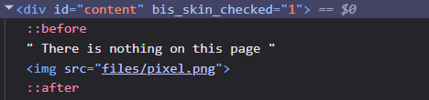
An exposed directory
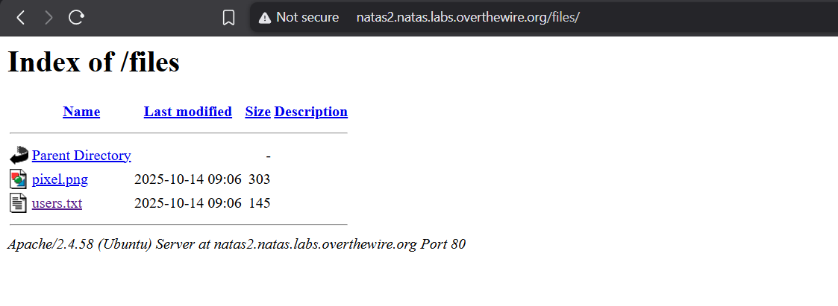
Inside users.txt , you find your password

