

Faculty of Information Technology

Department of Network and communication System

MASHAMI PACIFIQUE

23058

Project Topic Name: IHUZO APIs Collection

**Case study**

**IHUZO DIGITAL COMMERCE (IDC)**

# **Background**

iHuzo Digital Commerce is a digital onboarding   
project by Rwanda ICT Chamber in partnership with Access To Finance Rwanda.

iHuzo (Kinyarwanda for Convenor) project aim is to accelerate the growth of Micro and Small Enterprises (MSEs) through expanding the e-commerce sector in Rwanda for both businesses & individuals. The ICT Chamber in partnership with Access to Finance Rwanda have started this a project to support SMEs to survive COVID19 pandemic by providing digital on-boarding support through ICT Companies as well as training and linkages to credit providers. The project is working with different partners and stakeholders to identify potential beneficiary businesses with the intention to: Provide Support to Micro & SMEs in 6 Areas of Digital On-boarding through matching Digital Platform & Service Providers with MSMEs and iWORKERS.

AFR has identified the need for interventions that would speed up digital adoption and support productive livelihoods for young adults through digital commerce amid the response to the global pandemic and part of an existing national ICT growth strategy. AFR initiated the project: iHuzo (Accelerating growth of Micro and Small Enterprises (MSEs) through expanding the e-commerce sector in Rwanda) with the aim of spurring the growth of livelihoods and employment opportunities through e-commerce, to address the barriers and promote an enabling market system for e-commerce with onboarding MSEs into the digital economy at the core.

**Mission:**

The mission of iHuzo Digital Commerce is to increase trust and quality in the marketplace by addressing challenges of matching, reputation management, information that foster iWorker employment generation.

So the main mission is to create linkages and partnerships with lenders willing to test alternative methods of credit assessment and other development programs promoting the growth of MSEs.

**Vision**:

The Main Vision of iHuzo is onboard up to 1,500 non-digital local MSE businesses into e-commerce and digital commerce platforms

Enhance public-private dialog between government and the private sector to align priorities and address market gaps.

**Business Process**

Projects store of web applications and mobile applications

**PIECES Framework Analysis**

**PERFORMANCE**

**Thoughtput**: Current system BackEnd programmers doesn’t have right to post their APIs and sell

**Response** **time**: There will not delay time.

**INFORMATION**

**Input:** the old system was collecting the full projects on their own and post them to buy.

**Output**: The projects were on web costumers are able to buy online.

**Storage**:Data are stored in database as full projects and Ideas

**ECONOMIC**

Most cost are not known in advance it depends on number of projects and features of project.

**CONTROL SECURITY**

About security the current system is well secure I’m going to change any thing about security.

Data are store in Databases and it is secure enough.

**EFFICIENCY**

* API resources are divided
* Require a lot of time to find and integrate API
* Difficult to understand API documentations.

**Service**

* The system is not easy to learn
* The system is not easy to use
* The system is not allow backEnds to post own APIs
* The system is inflexible to new or exceptional situations
* The system is inflexible to change
* The system is not coordinated with other systems

**AS-IS-MODEL**

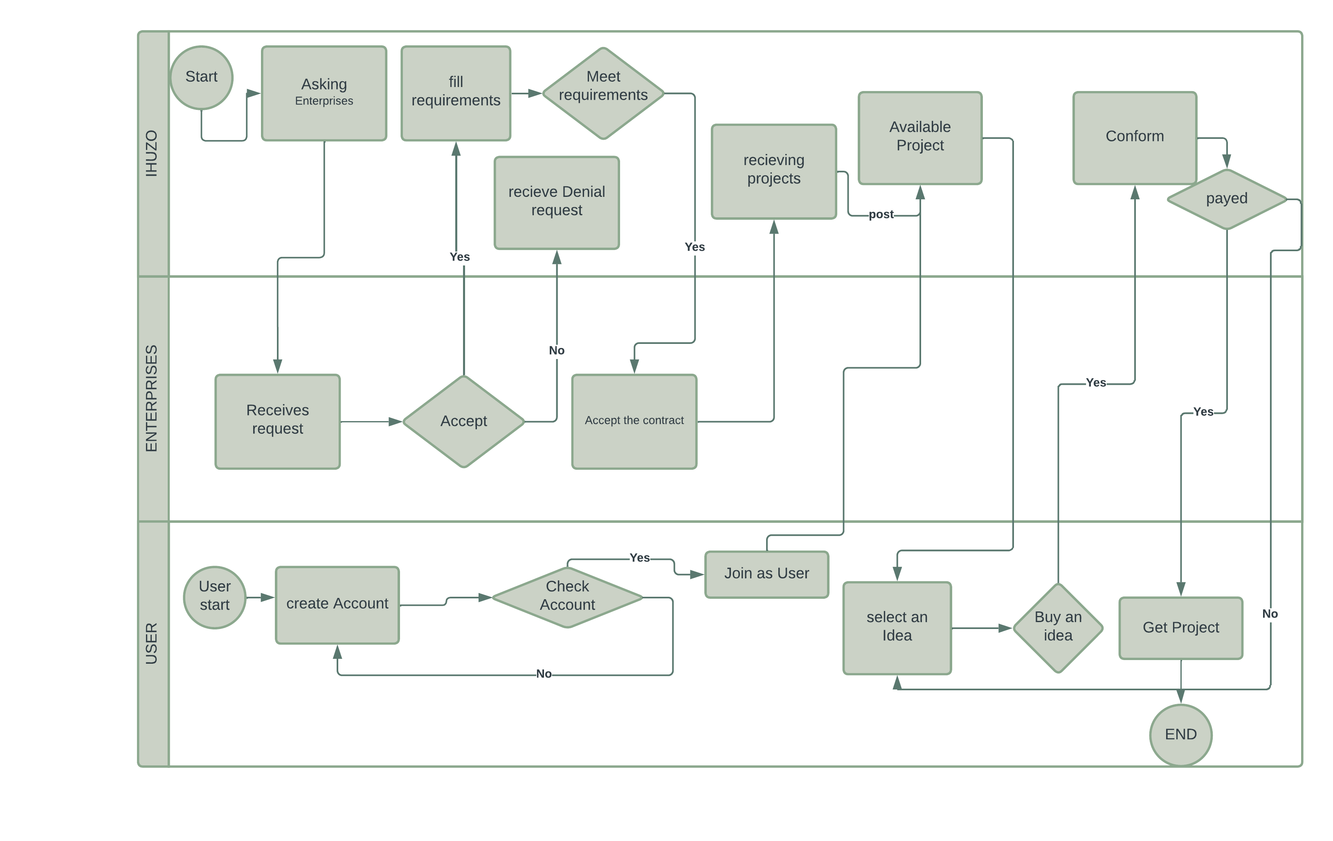

**SOLUTION:** IHUZO COLLECTION APIs