MUNEI MUKWEVHO

DATABASE EXAM

STUDENT NO.20106905

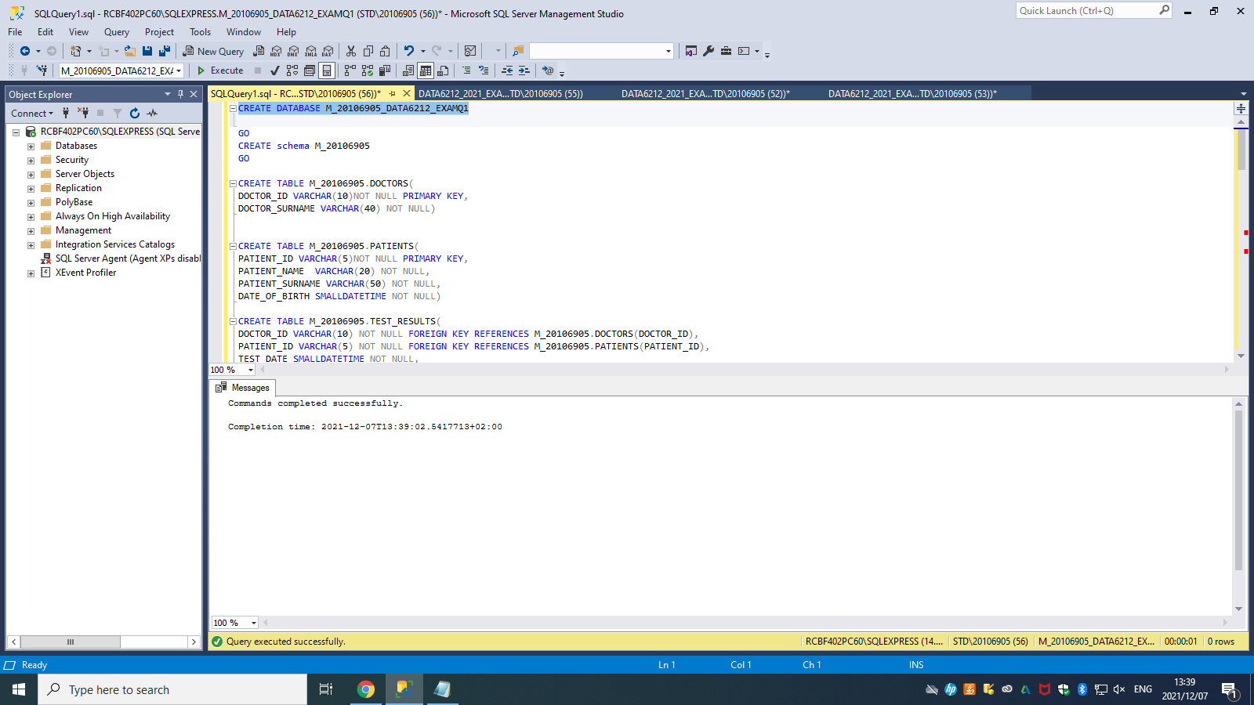

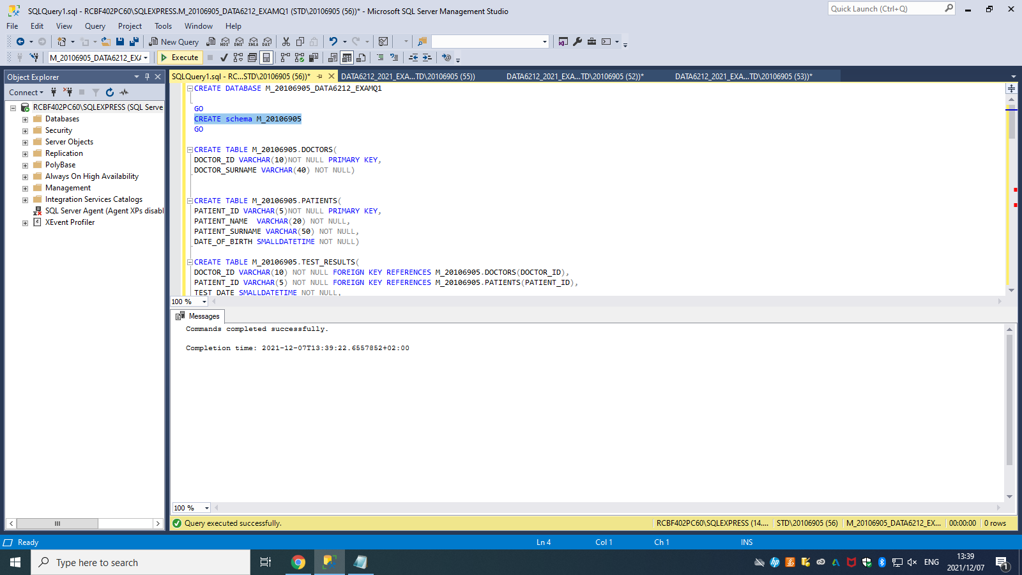

CREATE TABLE M_20106905.DOCTORS(

DOCTOR_ID VARCHAR(10)NOT NULL PRIMARY KEY,

DOCTOR_SURNAME VARCHAR(40) NOT NULL)

CREATE TABLE M_20106905.PATIENTS(

PATIENT_ID VARCHAR(5)NOT NULL PRIMARY KEY,

PATIENT_NAME VARCHAR(20) NOT NULL,

PATIENT_SURNAME VARCHAR(50) NOT NULL,

DATE_OF_BIRTH SMALLDATETIME NOT NULL)

CREATE TABLE M_20106905.TEST_RESULTS(

DOCTOR_ID VARCHAR(10) NOT NULL FOREIGN KEY REFERENCES M_20106905.DOCTORS(DOCTOR_ID),

PATIENT_ID VARCHAR(5) NOT NULL FOREIGN KEY REFERENCES M_20106905.PATIENTS(PATIENT_ID),

TEST_DATE SMALLDATETIME NOT NULL,

TEST_RESULT FLOAT NOT NULL,

PRIMARY KEY(DOCTOR_ID, PATIENT_ID, TEST_DATE))

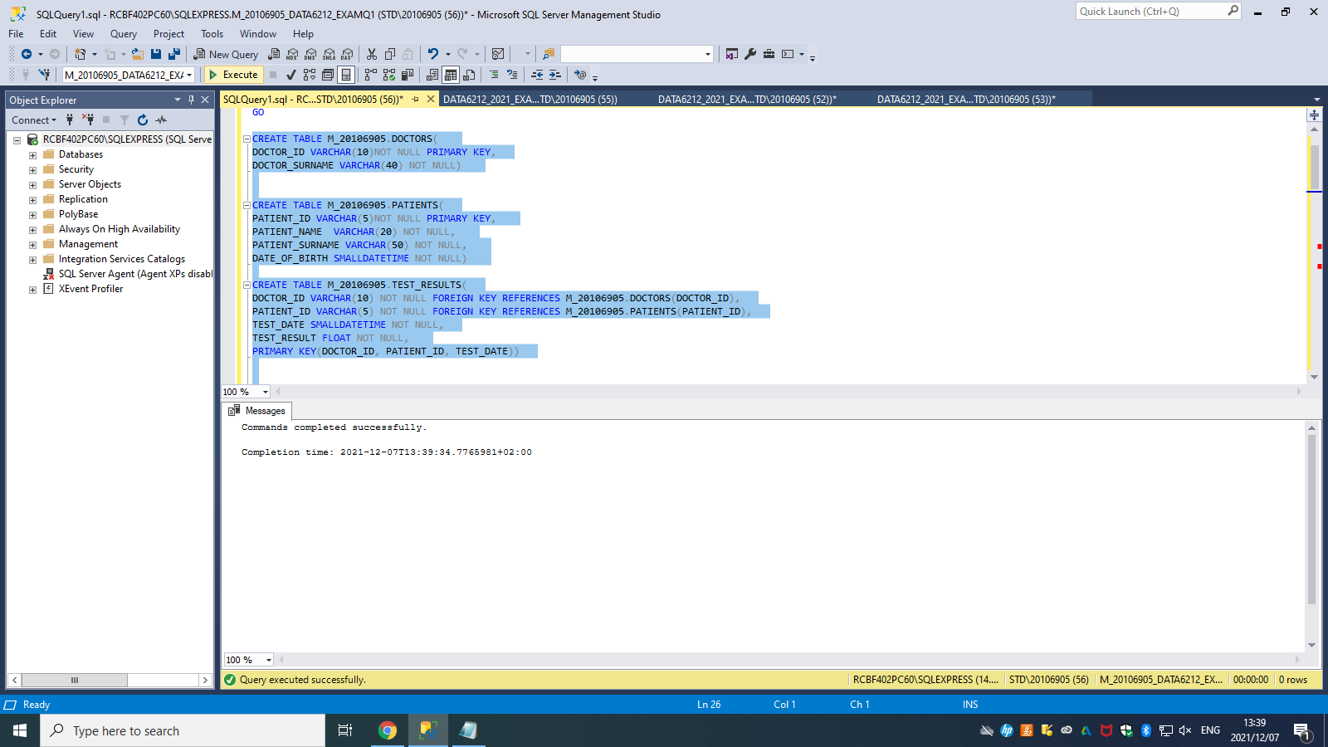

INSERT INTO M_20106905.DOCTORS VALUES

('DR001','Coetzee'),

('DR002','Hasim'),

('DR003','Mbeku'),

('DR004','Phillips')

INSERT INTO M_20106905.PATIENTS VALUES

('PT001','Dominique',' Woolridge','1962‐04‐19'),

('PT002','Nico','Baird','1951‐11‐19'),

('PT003','Derek','Moore','1995‐06‐24'),

('PT004','Neo','Petlele','1947‐12‐29'),

('PT005','Andrew','Crouch','1972‐01‐30')

INSERT INTO M_20106905.TEST_RESULTS VALUES

('DR002','PT001','2021‐02‐05',7.8),

('DR001','PT004','2021‐01‐14',11.1),

('DR002','PT001','2021‐03‐15',8.9),

('DR001','PT004','2021‐02‐28',11.7),

('DR004','PT005','2021‐02‐13',5.6),

('DR002','PT002','2021‐03‐30',7.8),

('DR004','PT002','2021‐05‐03',6.4)

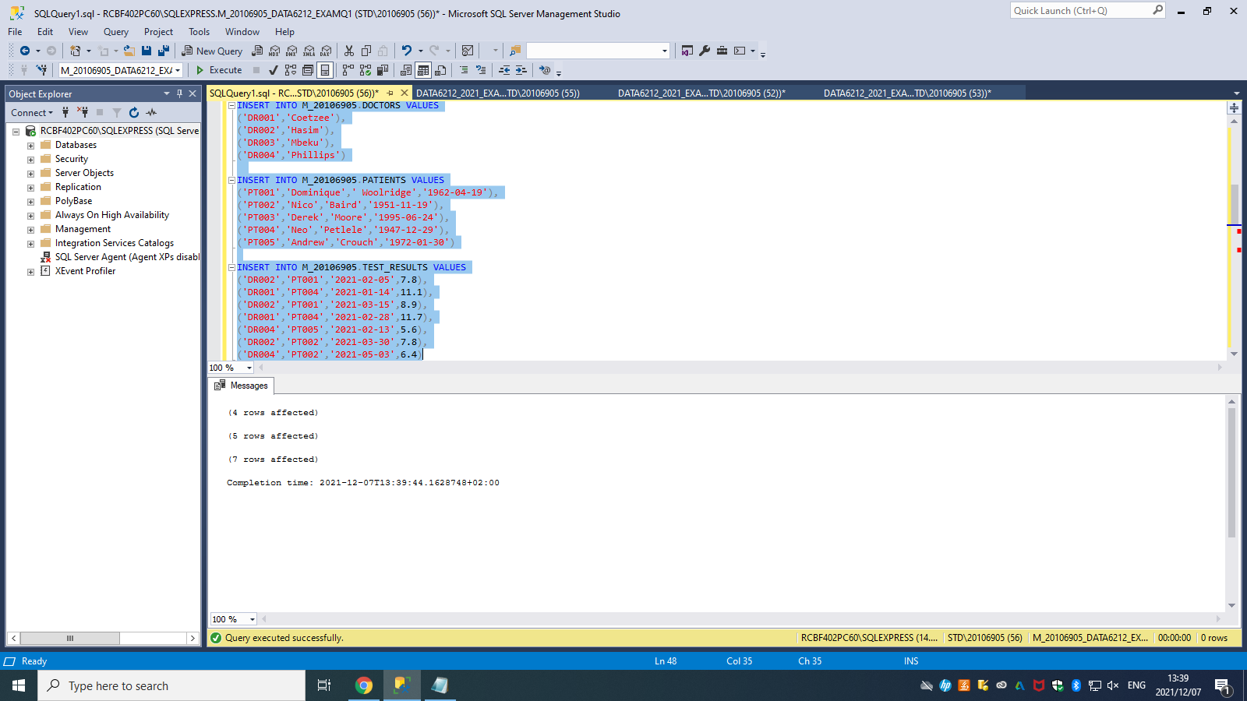

--Q1.1--

CREATE view NormalResult as

select p.PATIENT_NAME , p.Patient_Surname,d.DOCTOR_SURNAME, TR.TEST_DATE,TR.TEST_RESULT

from M_20106905.DOCTORS d,M_20106905.PATIENTS p,M_20106905.TEST_RESULTS TR

where P.PATIENT_ID=TR.PATIENT_ID

and D.DOCTOR_ID = TR.DOCTOR_ID

and TEST_RESULT <7.8

select * from NormalResult

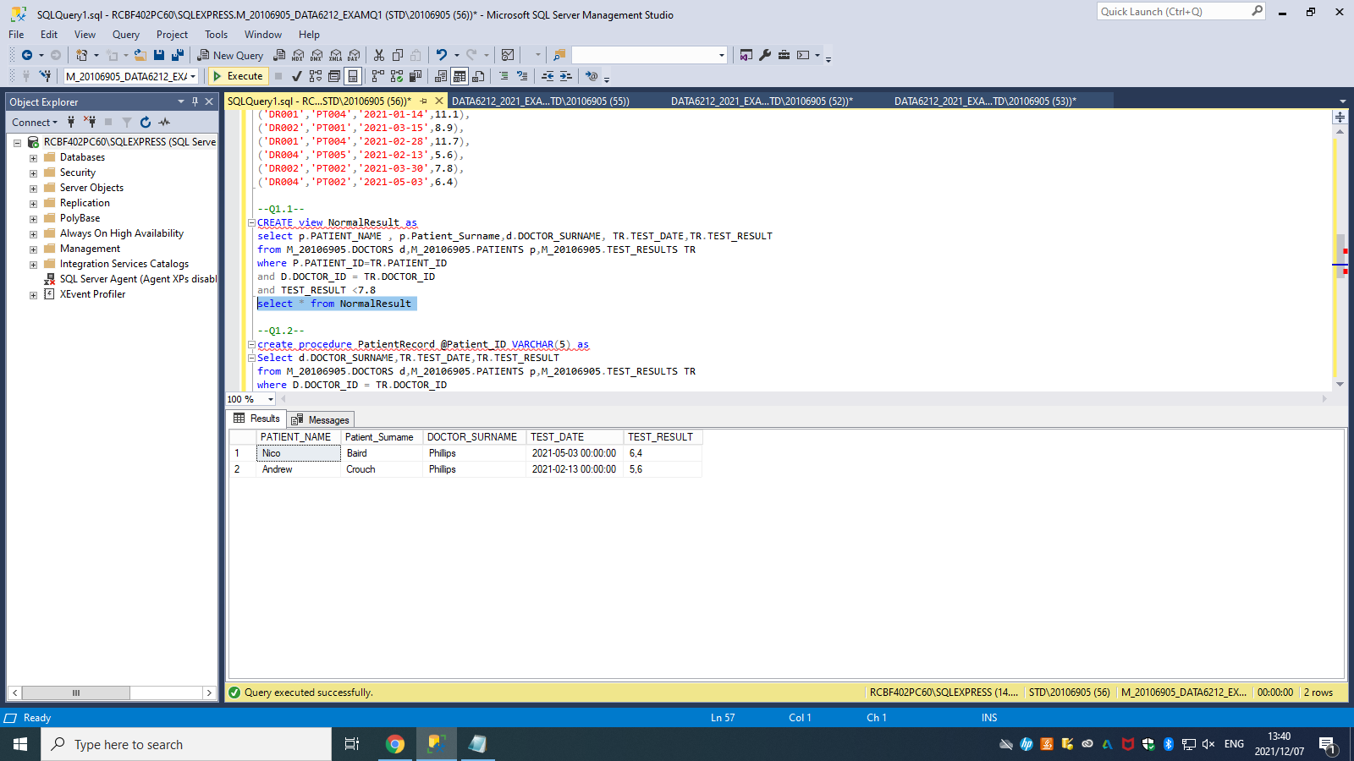

--Q1.2--

create procedure PatientRecord @Patient_ID VARCHAR(5) as

Select d.DOCTOR_SURNAME,TR.TEST_DATE,TR.TEST_RESULT

from M_20106905.DOCTORS d,M_20106905.PATIENTS p,M_20106905.TEST_RESULTS TR

where D.DOCTOR_ID = TR.DOCTOR_ID

and P.PATIENT_ID = TR.PATIENT_ID

and P.PATIENT_ID = @Patient_ID

exec PatientRecord @Patient_ID='PT001'

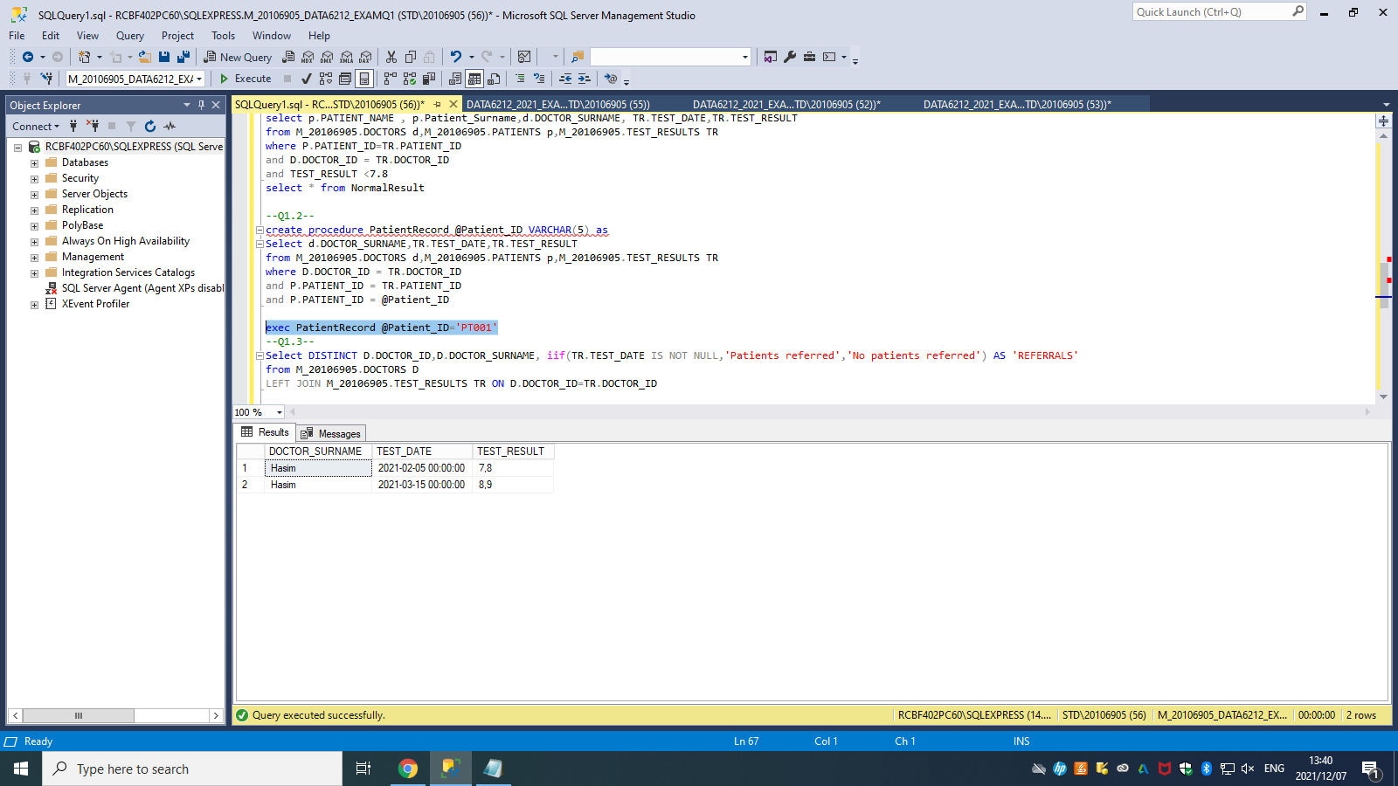

--QUE1.3--

Select DISTINCT D.DOCTOR_ID,D.DOCTOR_SURNAME, iif(TR.TEST_DATE IS NOT NULL,'Patients referred','No patients referred') AS 'REFERRALS'

from M_20106905.DOCTORS D

LEFT JOIN M_20106905.TEST_RESULTS TR ON D.DOCTOR_ID=TR.DOCTOR_ID

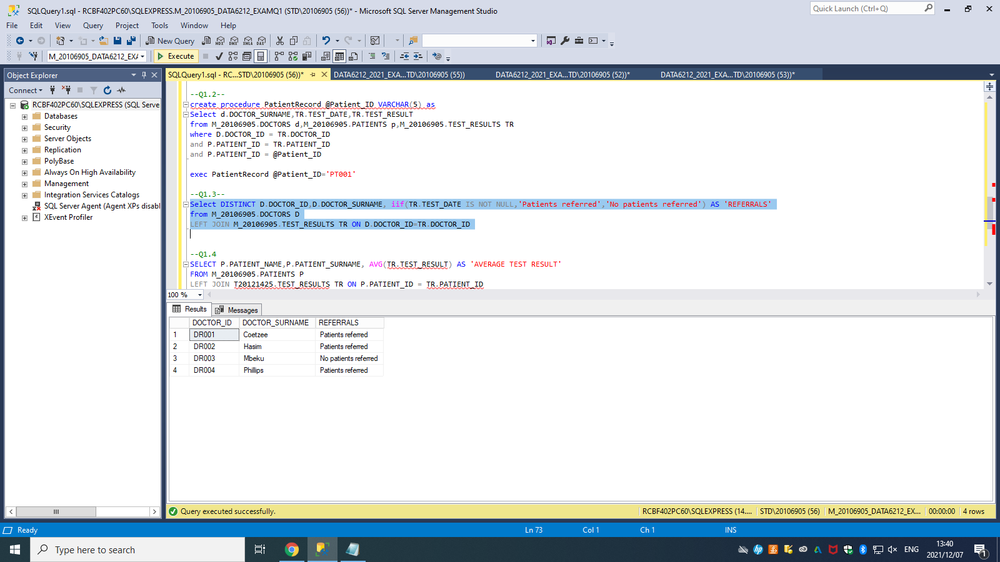

--QUE1.4

SELECT P.PATIENT_NAME,P.PATIENT_SURNAME, AVG(TR.TEST_RESULT) AS 'AVERAGE TEST RESULT'

FROM M_20106905.PATIENTS P

LEFT JOIN M_20106905.TEST_RESULTS TR ON P.PATIENT_ID = TR.PATIENT_ID

GROUP BY P.PATIENT_NAME,P.PATIENT_SURNAME

ORDER BY AVG(TR.TEST_RESULT) desc

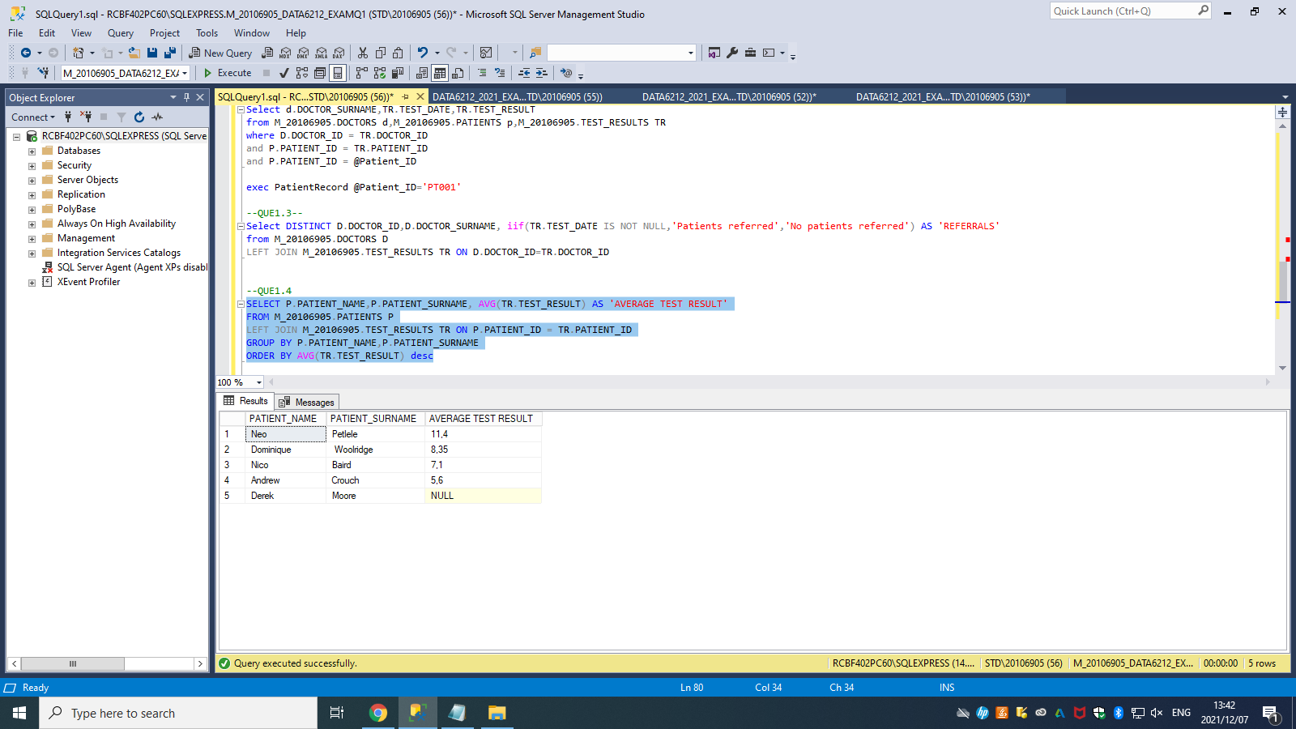

--QUE1.5--

SELECT P.PATIENT_NAME,P.PATIENT_SURNAME

FROM M_20106905.PATIENTS P

left join M_20106905.TEST_RESULTS TR on P.PATIENT_ID=TR.PATIENT_ID

where TR.PATIENT_ID is null

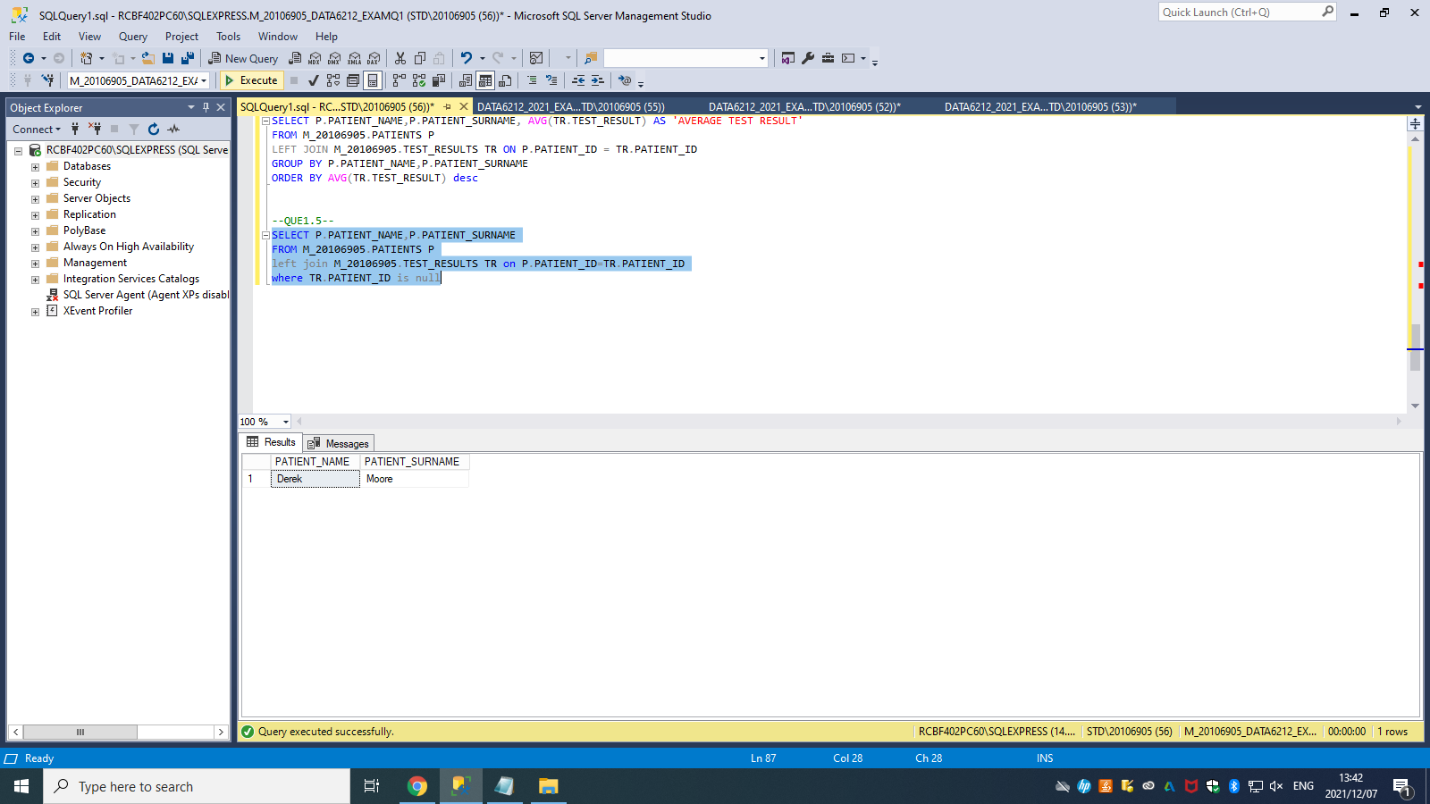

---QUESTION 2---

create database M_20106905_DATA6212_EXAMQ2;

GO

create schema M_20106905;

GO

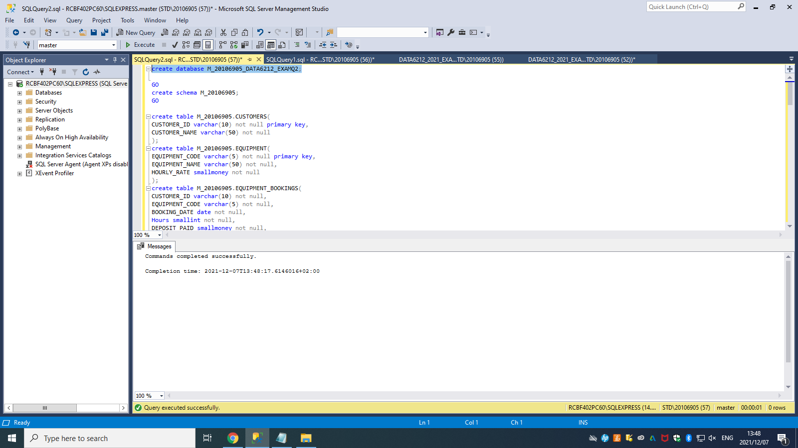

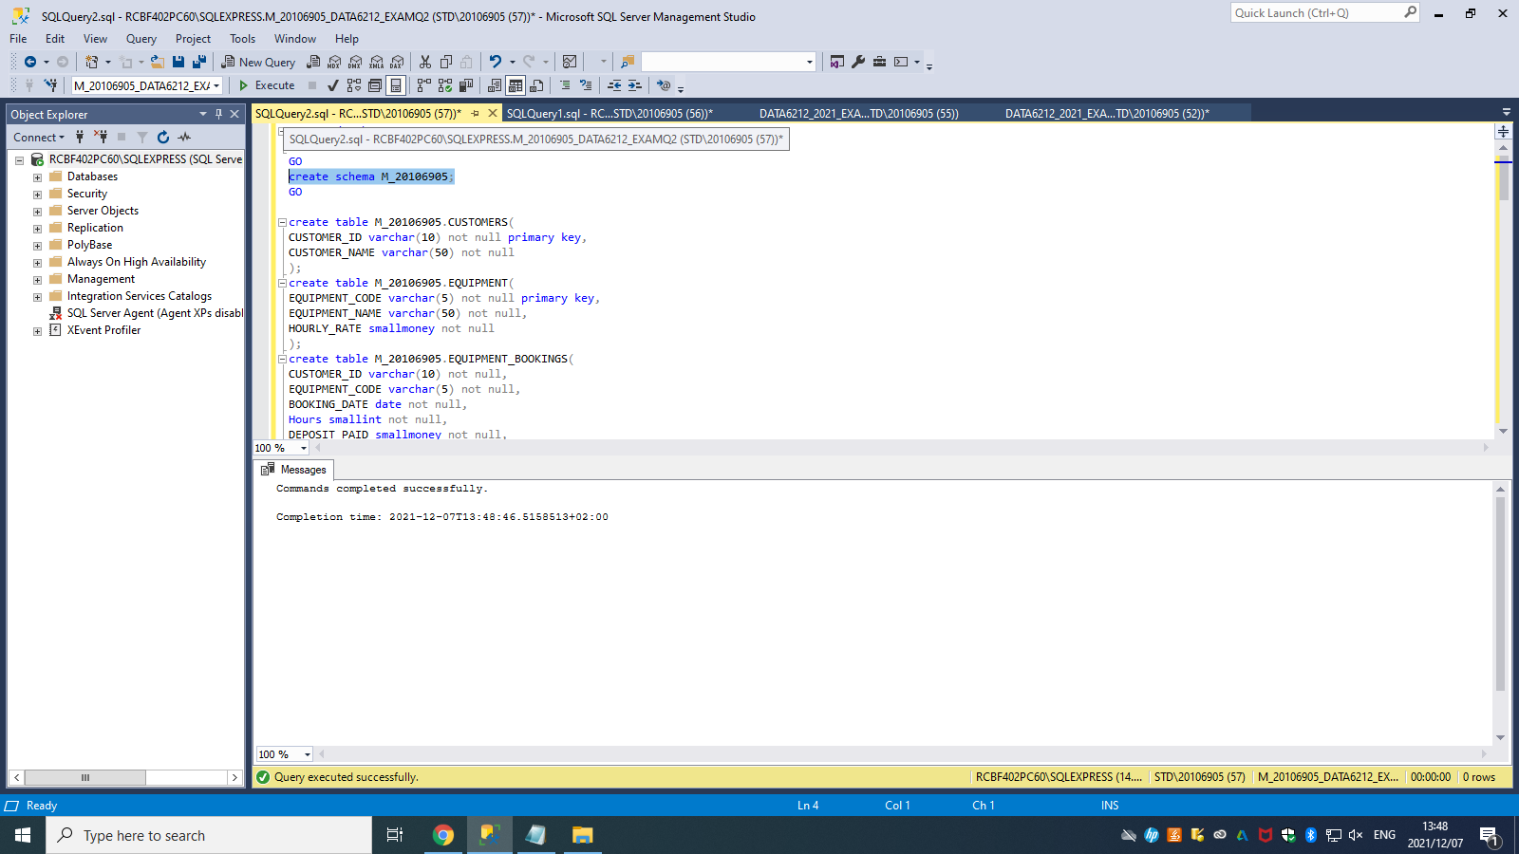

-----QUE2.1------

create table M_20106905.CUSTOMERS(

CUSTOMER_ID varchar(10) not null primary key,

CUSTOMER_NAME varchar(50) not null

);

create table M_20106905.EQUIPMENT(

EQUIPMENT_CODE varchar(5) not null primary key,

EQUIPMENT_NAME varchar(50) not null,

HOURLY_RATE smallmoney not null

);

create table M_20106905.EQUIPMENT_BOOKINGS(

CUSTOMER_ID varchar(10) not null,

EQUIPMENT_CODE varchar(5) not null,

BOOKING_DATE date not null,

Hours smallint not null,

DEPOSIT_PAID smallmoney not null,

foreign key (CUSTOMER_ID) references M_20106905.CUSTOMERS(CUSTOMER_ID),

foreign key (EQUIPMENT_CODE) references M_20106905.EQUIPMENT(EQUIPMENT_CODE),

primary key(CUSTOMER_ID, EQUIPMENT_CODE, BOOKING_DATE)

);

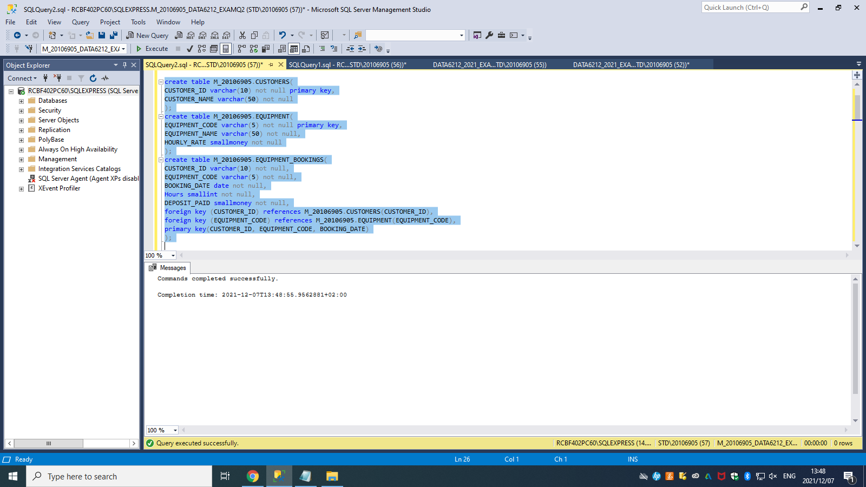

-----QUE2.2------

insert into M_20106905.CUSTOMERS

values

('123456', 'Neo Petlele'),

('246810', 'Derek Moore'),

('369121', 'Pedro Ntaba'),

('654321', 'Thabo Joe'),

('987654', 'Dominique Woolridge');

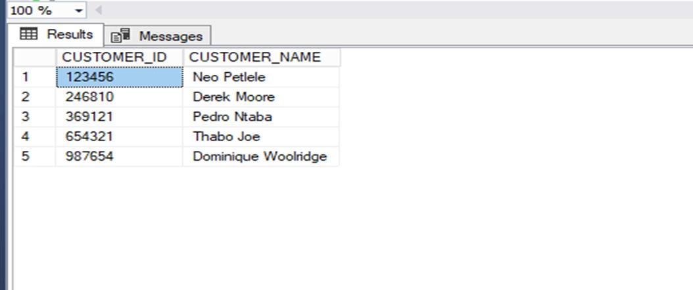

insert into M_20106905.EQUIPMENT

values

('E0001', 'Floor Sander', 250.85),

('E0002', 'Welder', 129.50),

('E0003', 'Compressor', 360.00),

('E0004', 'Hammer Drill', 102.90),

('E0005', 'Tile Lifter', 199.99);

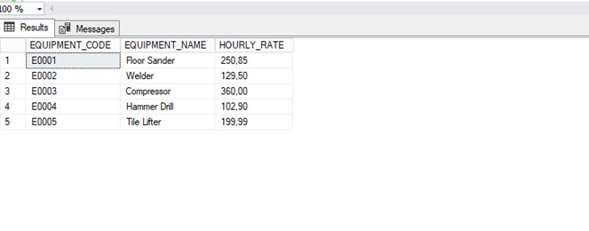

insert into M_20106905.EQUIPMENT_BOOKINGS

values

('123456', 'E0001', '2021‐10‐30', 3, 350.00),

('246810', 'E0005', '2021‐11‐19', 2, 200.00),

('246810', 'E0004', '2021‐10‐15', 5, 300.00),

('654321', 'E0002', '2021‐09‐10', 1, 130.00),

('987654', 'E0001', '2021‐12‐15', 7, 900.00),

('123456', 'E0002', '2021‐11‐01', 3, 200.00),

('246810', 'E0003', '2021‐09‐29', 4, 750.00);

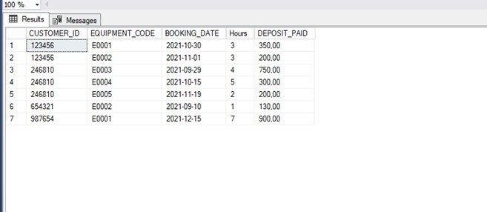

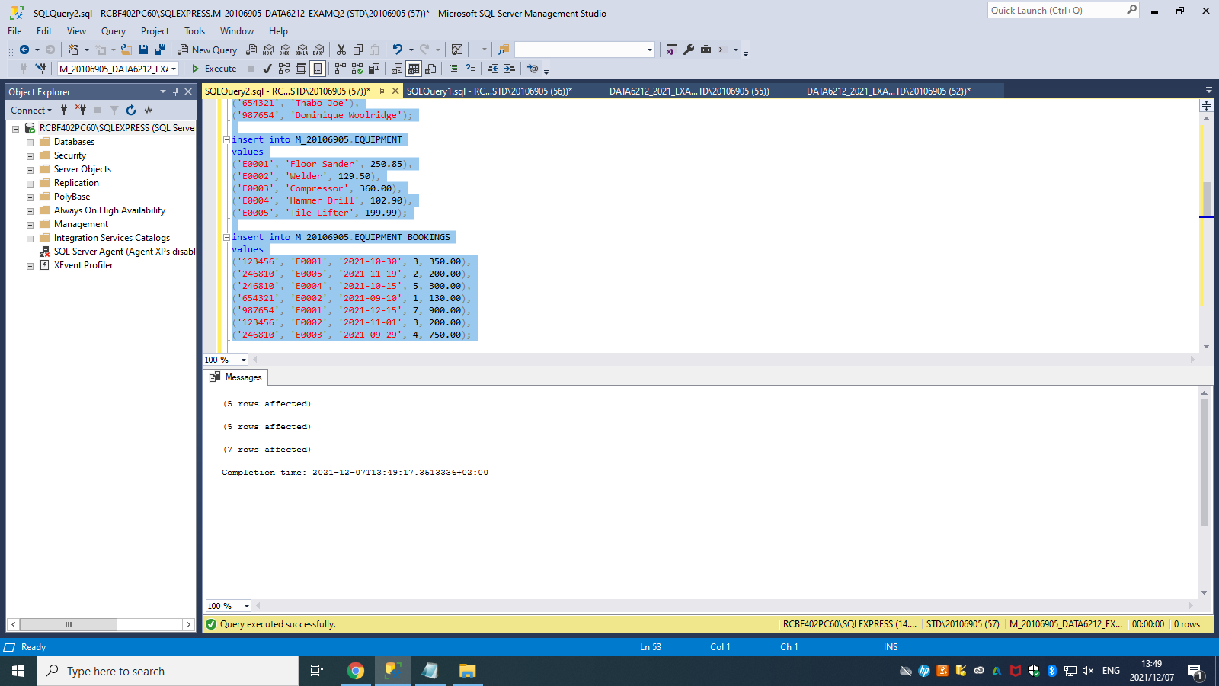

------QUE2.3------

alter table M_20106905.CUSTOMERS

add CONTACT_NUMBER varchar(10);

select * from M_20106905.CUSTOMERS;

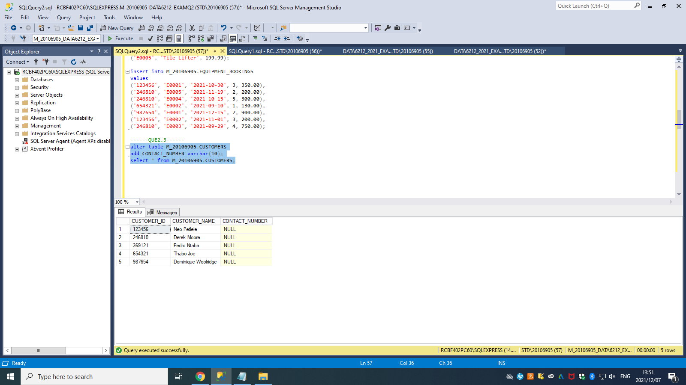

-------QUE2.4------

update M_20106905.CUSTOMERS

set CONTACT_NUMBER = '0833875687'

where CUSTOMER_ID = '123456';

update M_20106905.CUSTOMERS

set CONTACT_NUMBER = '0836914682'

where CUSTOMER_ID = '246810';

update M_20106905.CUSTOMERS

set CONTACT_NUMBER = '0728965412'

where CUSTOMER_ID = '369121';

update M_20106905.CUSTOMERS

set CONTACT_NUMBER = '0847946130'

where CUSTOMER_ID = '654321';

update M_20106905.CUSTOMERS

set CONTACT_NUMBER = '0739718264'

where CUSTOMER_ID = '987654';

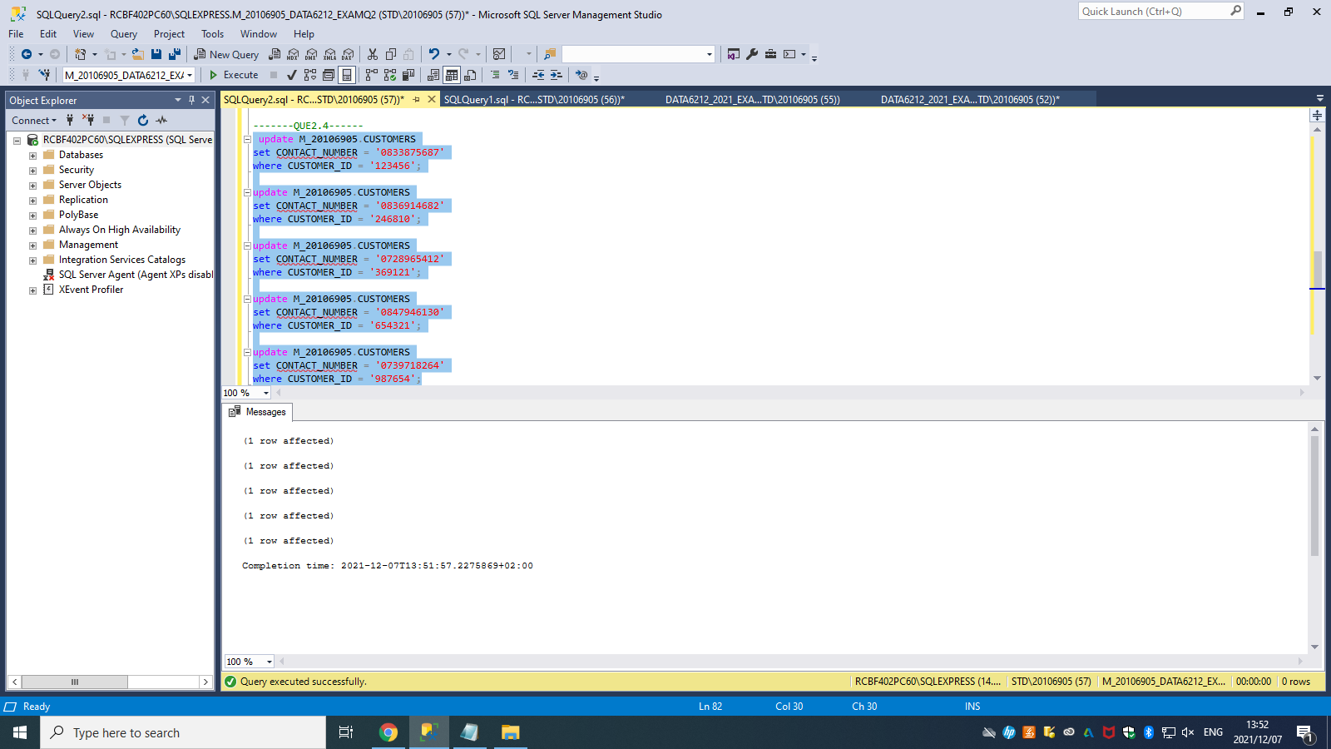

------QUE2.5-------

select CUS.CUSTOMER_ID, CUS.CUSTOMER_NAME

from M_20106905.CUSTOMERS as CUS

left join M_20106905.EQUIPMENT_BOOKINGS as EQUIP

on CUS.CUSTOMER_ID = EQUIP.CUSTOMER_ID

where EQUIP.CUSTOMER_ID is null;

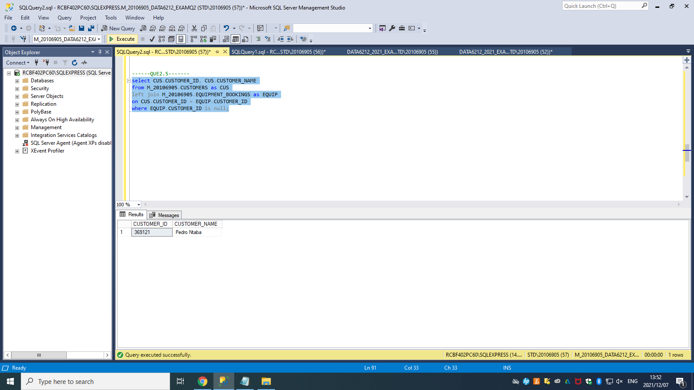

-----QUE2.6------

select CUS.CUSTOMER_ID, CUS.CUSTOMER_NAME, COUNT(EQUIP.CUSTOMER_ID) as 'NUMBEROF EQUIPMENT BOOKINGS'

from M_20106905.CUSTOMERS as CUS

left join M_20106905.EQUIPMENT_BOOKINGS as EQUIP

on CUS.CUSTOMER_ID = EQUIP.CUSTOMER_ID

group by CUS.CUSTOMER_ID, CUS.CUSTOMER_NAME

order by COUNT(EQUIP.CUSTOMER_ID) desc;

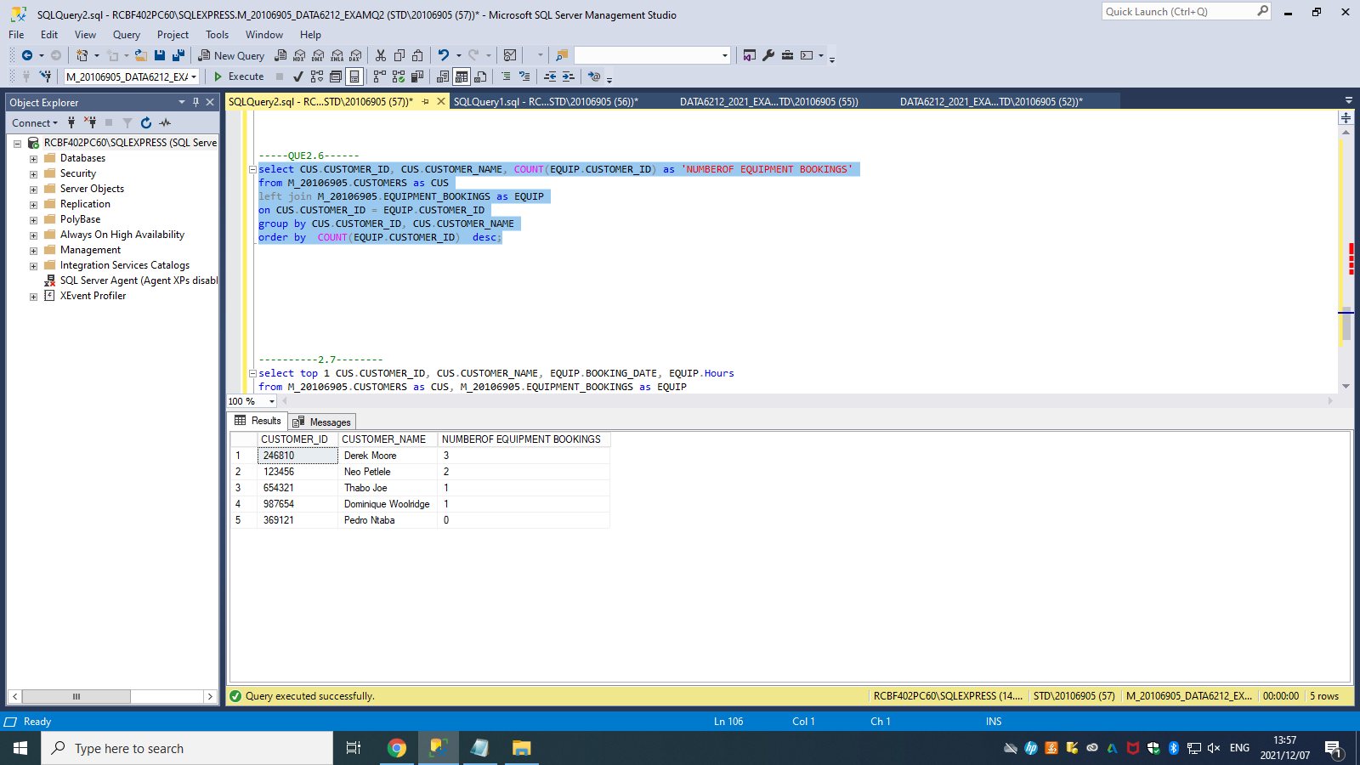

----------QUE2.7--------

select top 1 CUS.CUSTOMER_ID, CUS.CUSTOMER_NAME, EQUIP.BOOKING_DATE, EQUIP.Hours

from M_20106905.CUSTOMERS as CUS, M_20106905.EQUIPMENT_BOOKINGS as EQUIP

where CUS.CUSTOMER_ID = EQUIP.CUSTOMER_ID

order by EQUIP.Hours desc;

