**Job Apply Features Development**

1. Apply option between Jobs and Ad details, Apply option with in color

--Sending profile data & CV to advertiser

--Captcha Installation

--If user is not logged in than it will redirect them to login page or ask them to upload CV, they can able to change their profile using update profile link.

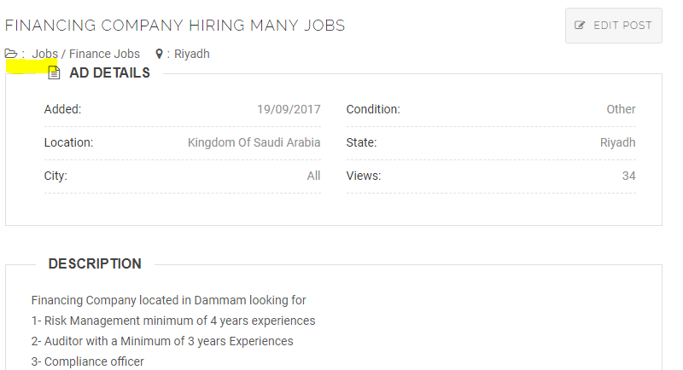

**2) About Me**

--Gender

--Date of birth

--Nationality

--Current Location

--Visa Status

--Driving License

-- Hide my profile from Employers

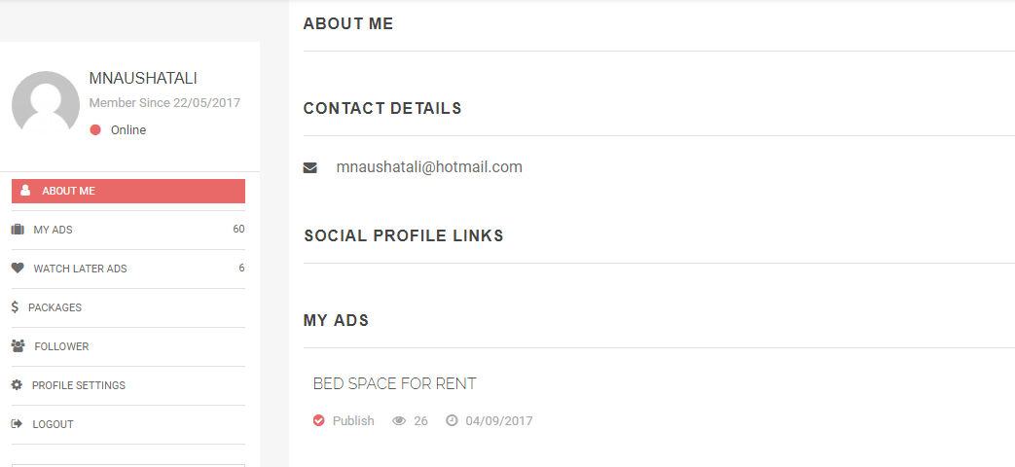

**3) Account settings page**

--My Profile Views

--My applied jobs

--My saved searches

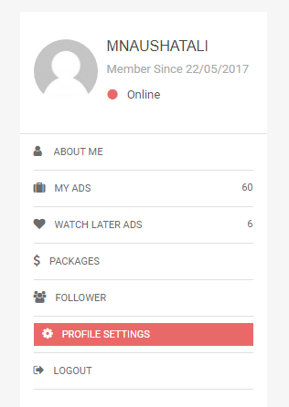

**4) Update your profile**

--Mobile number verification

--I would like to receive email from FGA and its partners

--Industry:

--Job Function:

--Job Level:

--Job Status:

--Bachelor's degree

--Experience:

--Salary:

--Skills:

--Most recent job title

--Skills

--Language Spoken

--Total Work Experience

--Your Academic Degree

--Field of Study

--Upload CV

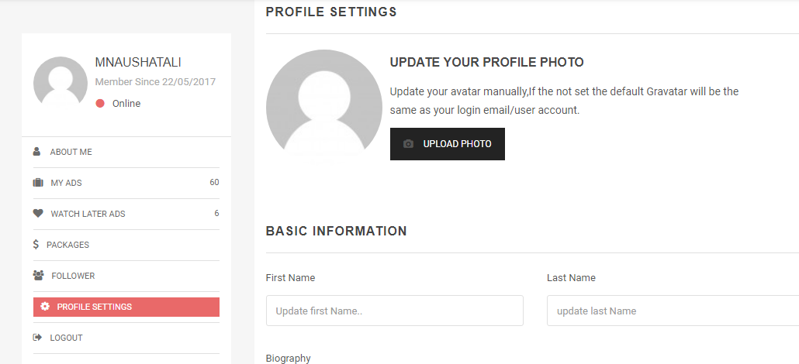

**5) Apply with your CV and Profile**

--Captcha (I am not robot)

--Upload new CV

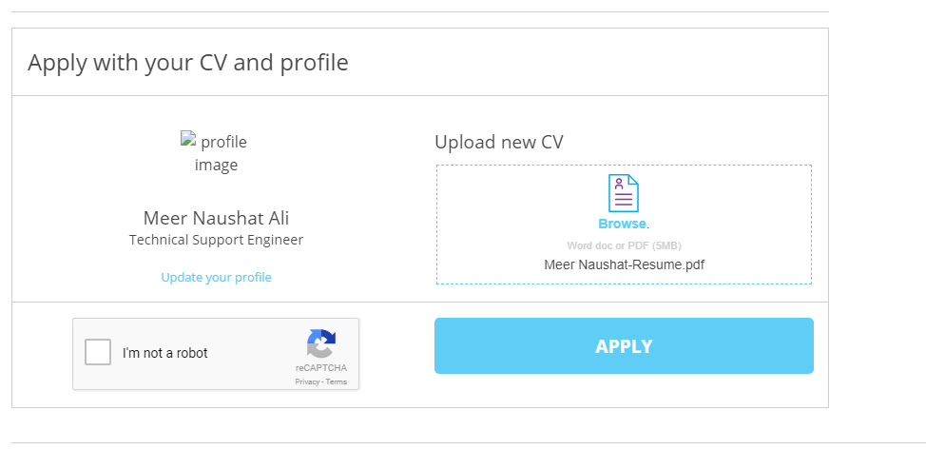

6) **Hide the Featured Category from publically.**

(I will create it from admin) now uncategorized category using for featured ads, but some of users are posting by uncategorized and shows as Featured ADS.

7) When I am selecting for a category Job and sub category Accounts, I see below screen

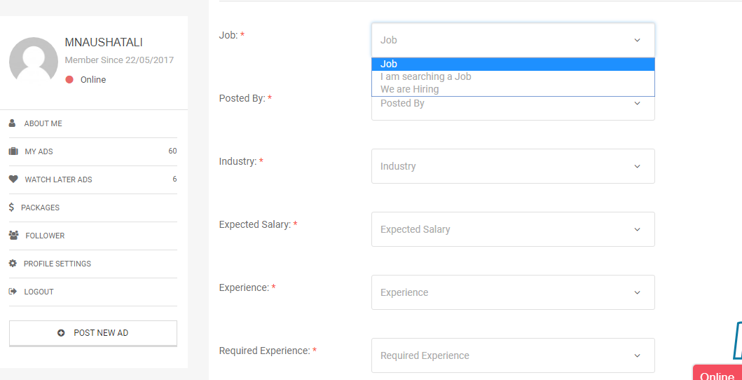

Under Job drop list, There are two options that (I am searching a job and We are hiring)

When I am selecting We are hiring or I am searching a job, as per that option should shows below details.

When I am selecting for “**I am searching**” It should show below tabs only

--Posted by

--Industry

--Expected Salary

--Experience

--Company Size

--Gender

--Notice Period

--Nationality

--Current country

When I am selecting for “**We are hiring**”

--Posted by

--Company /company name/ confidential company

--Industry

-- Salary

--Required experience

--Company Size

--Nationality

--Current country

-- Joining/ Immediately/Urgent/1 month

Note: It should be applied on all sub category like (Job\Accounts )