Git assignments

1.create a directory ‘project_dir’ & cd to ‘project_dir’

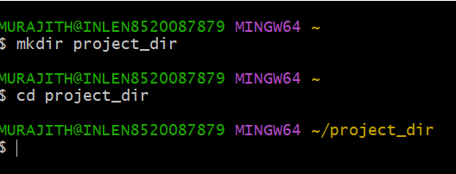

2.Initialize git version database.(git init)

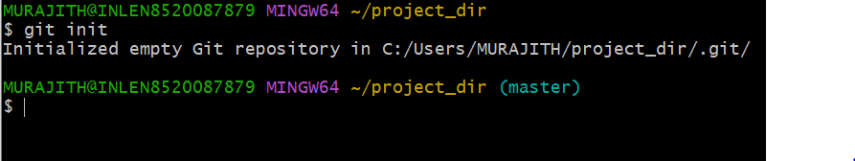

3.Create a new file index.html.

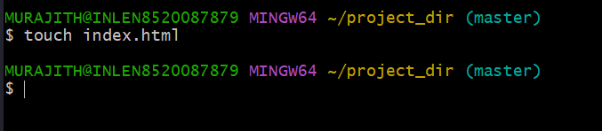

4.check the git status .you should find index.html as untracked file.

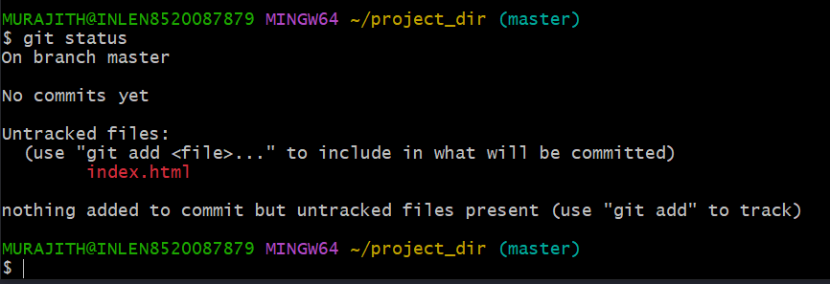

5.stage the index.html file.

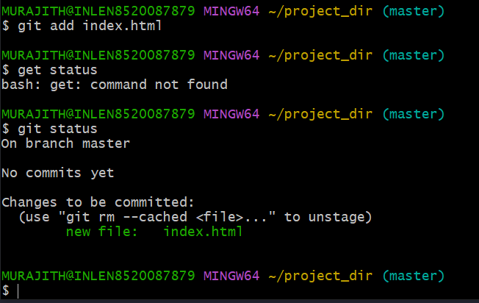

6.commit index.html

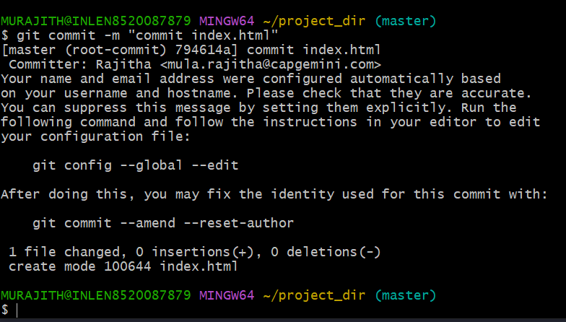

7.Make few change in index.html & Create a new file info.txt file.

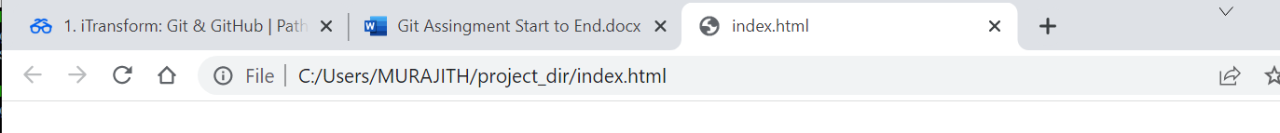

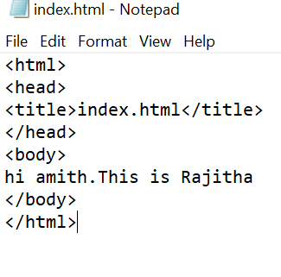

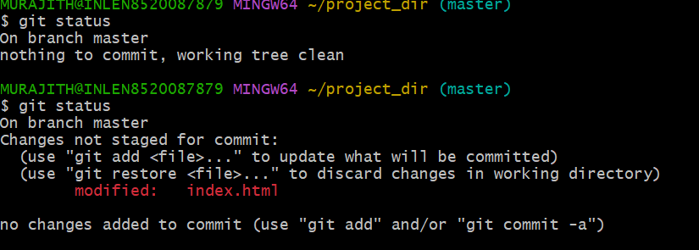

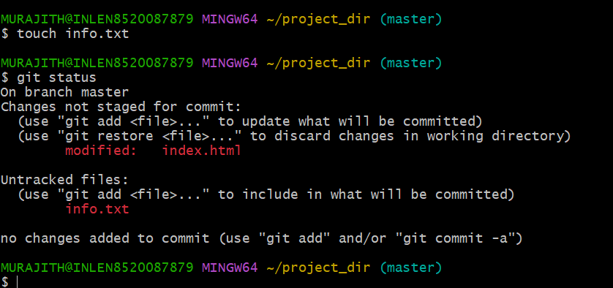

8.Check git status .You should find index.html &info.txt as untracked files

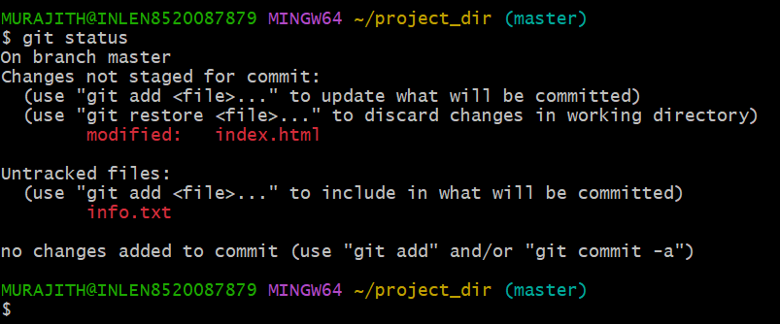

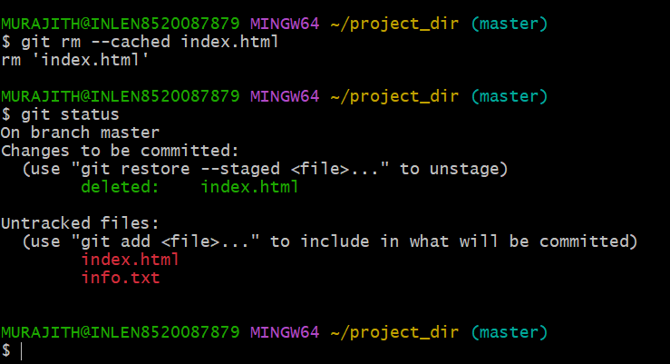

9.Configuration GIT to ignore all txt files

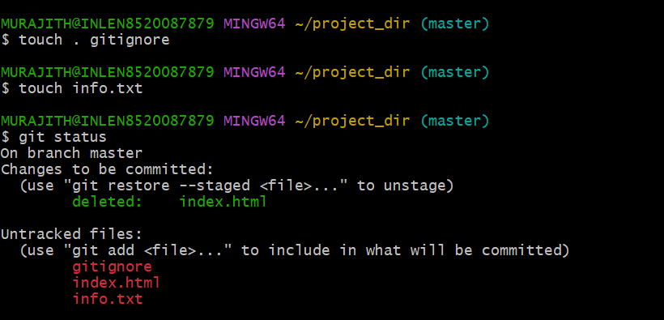

10.Again check the git status.You should find only index.html as untracked files

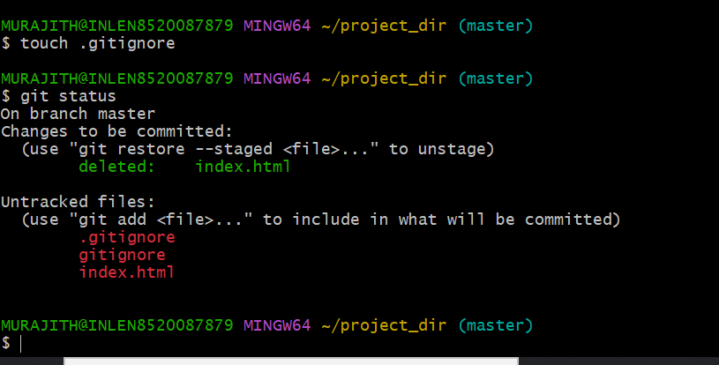

11.State & commit index.html

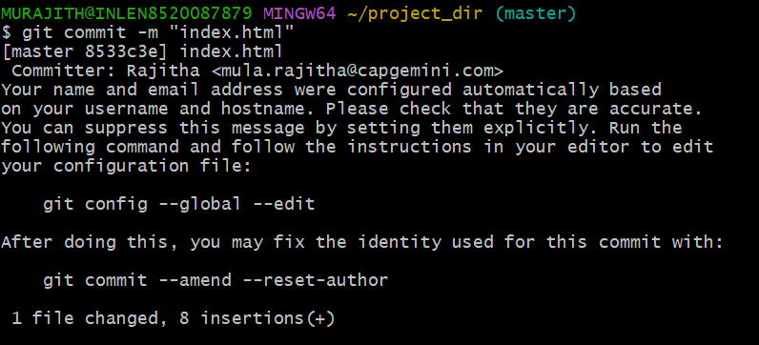

12.Log all your comments so far

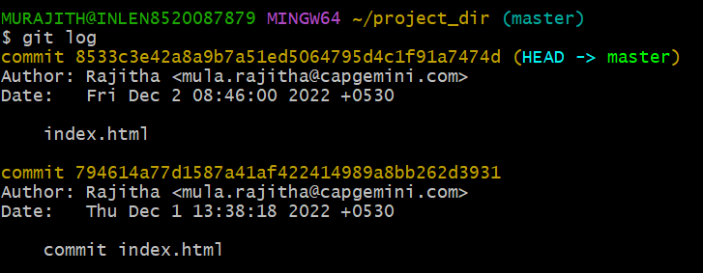

13.Make some changes in index.html

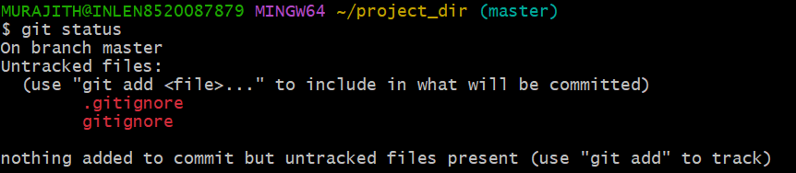

14.Revert the change made in the previous step using git command

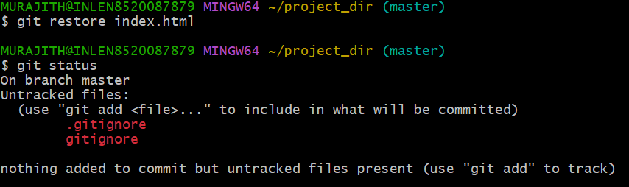

15.Again change index.html

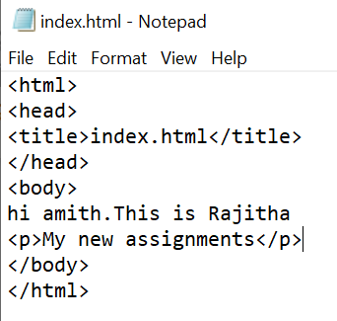

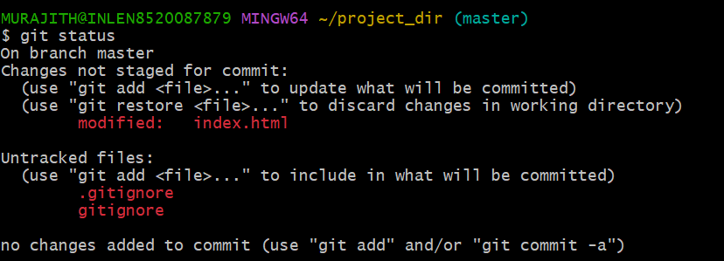

16.Stage index.html

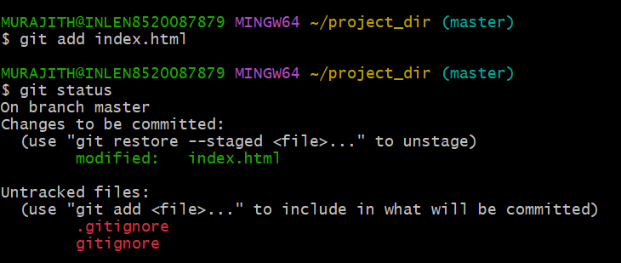

17.Revert back the last stage

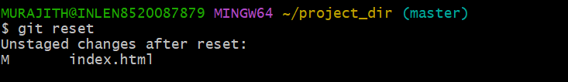

18.Rename ‘add’ command to ‘my-add’

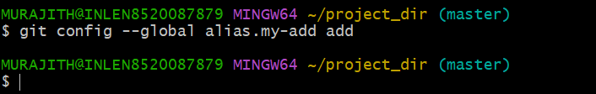

19.Using my_add command Stage index.html again & commit the changes.

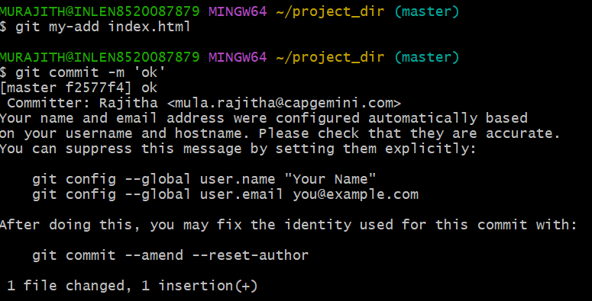

20.Revert the last commit

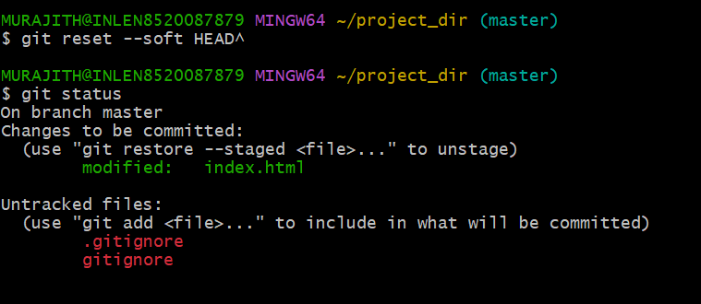

22.Create an empty directory ‘Assignments’ & cd to ‘Assignments’.

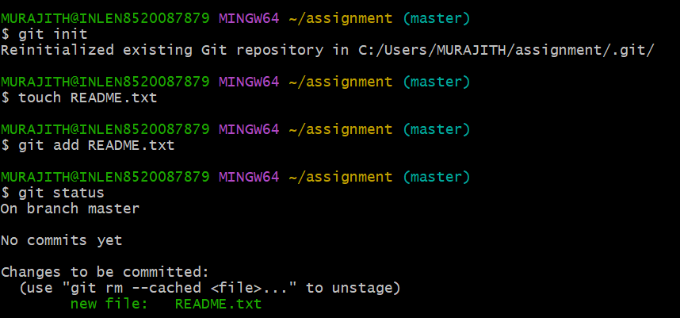

23.Create a file README.txt inside ‘Assignments’ &write few lines about the contents of ‘Assignments’ folder.

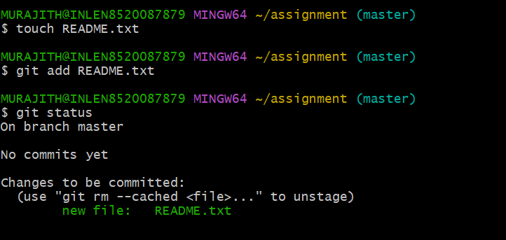

24.Commit README.txt file

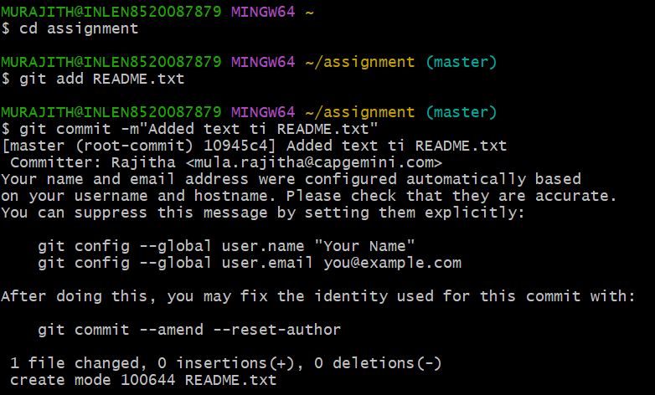

25.Now create a new branch ‘html-assignment

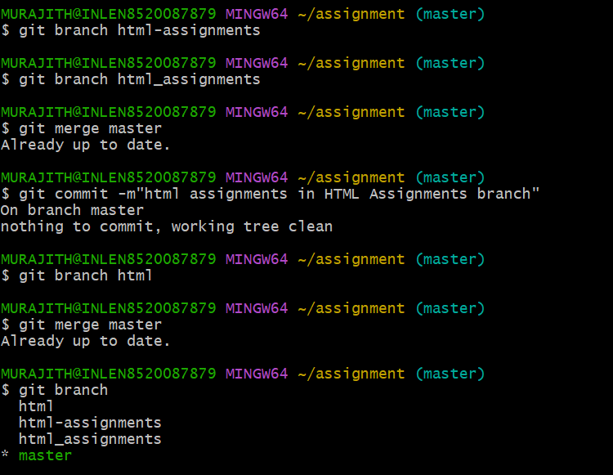

26.Switch to’html-assignments’ branch

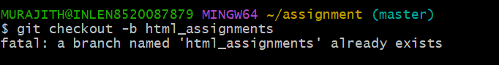

27.Copy all HTML assignments inside ‘Assignments’floder

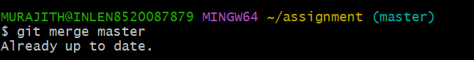

28.Commit HTML assignments into ‘html-assignments’ branch

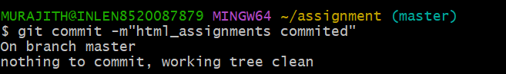

29.Make minor changes into few files belonging to ‘html-assignments’ branch



30.Commit those changed files

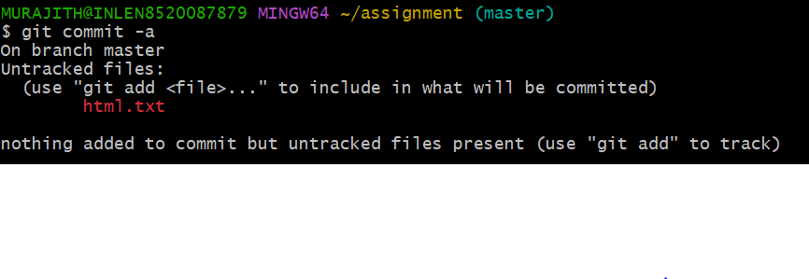31.Switch to master branch

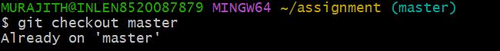

32.Make minor changes into README.txt file & commit those changes into master

33.Again switch to ‘html-assignments’ branch

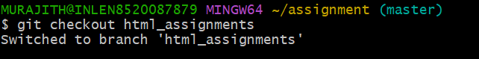

34.Make minor changes into few files belonging to ‘html-assignments’ branch

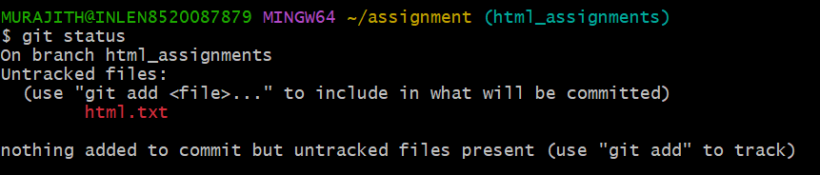

35.Commit those changes

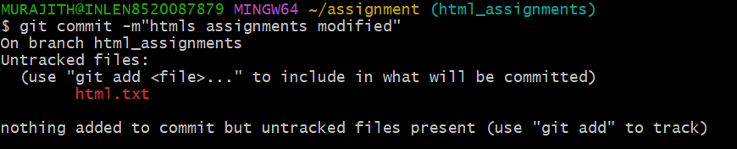

36.Switch to master



37.Merge ‘html-assignments’ branch into master.Confirm all html assignments are shown in master

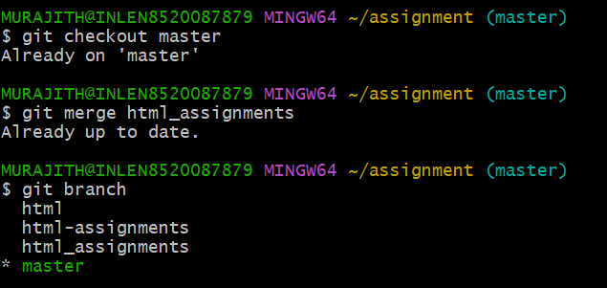

38.Finally delete the ‘html-assignments’ branch

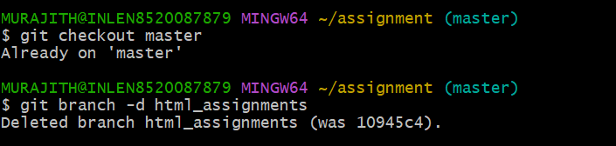

CSS Assignment

1.Create a new branch ‘css-assignment

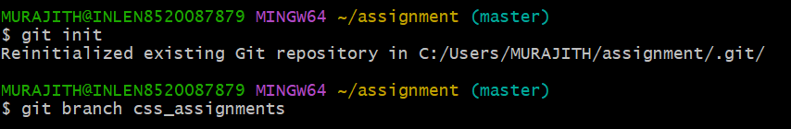

2. Switch to’css-assignments’branch

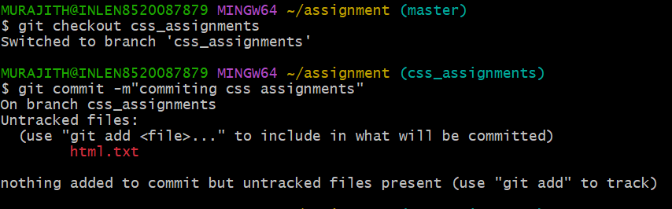

3.Copy all css assignments inside ‘Assignments’ floder

4.Commit CSS assignments into ‘css-assignments’ branch

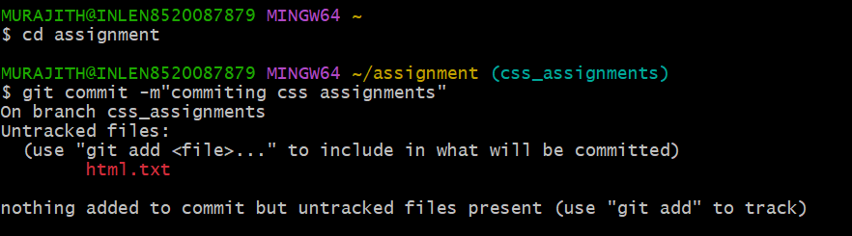

5.Make minor changes into README.txt file on line 1 belonging to ‘css-assignments’ branch

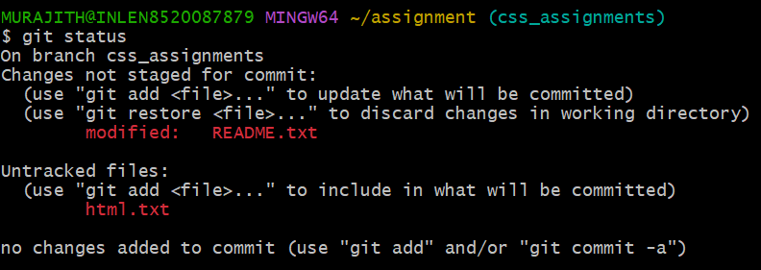

6.Commit those changed files

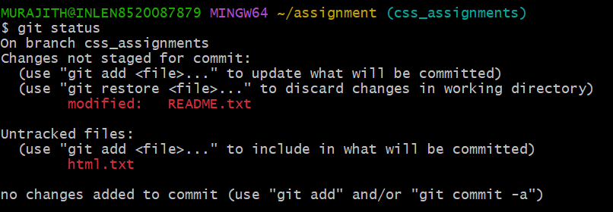

7.Switch to master branch

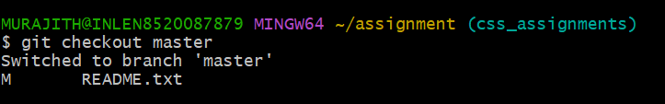

8.Make minor changes into README.txt file on line 3 & commit those changes into master

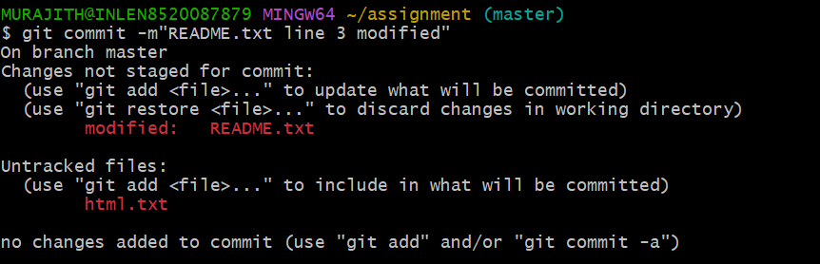

9.Again switch to ‘css-assignment’ branch

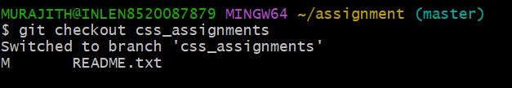

10.Make minor changes into few files belonging to ‘css-assignment’ branch

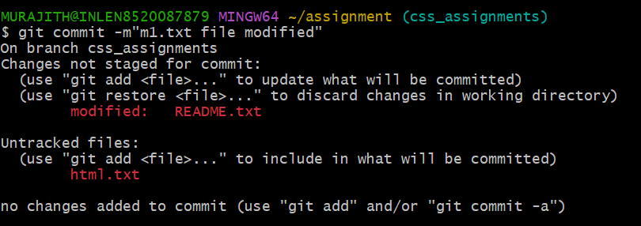

11.Commit those changes



12.Switch to master

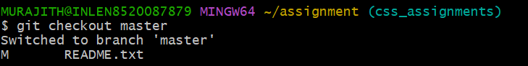

13. Merge ‘css-assignments’ branch into master. Confirm all css assignments are shown in master

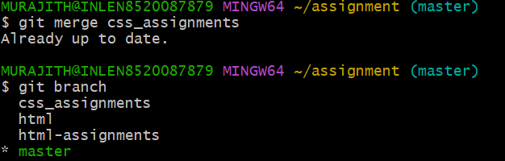

14.Finally delete the ‘css-assignments’ branch

