
MARGARITA PEREZ

123-456-7890 hello@reallygreatsite.com 123 Anywhere St., Any City

Dear Mr. Gallego,

A cover letter allows you to professionally introduce yourself to a prospective employer. Your goal in writing your cover letter should be to encourage the employer to read your resume and consider you for a specific position.

Highlight your achievements, skills, experiences, and training that are relevant to the position you want to get. However, avoid simply repeating the information you included in your resume. Tailor your cover letter to each employer and job. Since you are applying for specific roles, give specific examples and events that demonstrate your ability to perform well if given the position.

Yes, you should maintain a professional air throughout the copy, however, an exceedingly formal tone may turn off those who read it. Remember to also show genuine enthusiasm for the job. You can think of it this way: it’s not a suit-and-tie event, but a smart casual gathering. Steer away from highly personal information and questions about the position. This includes talking about salary expectations and company benefits. Instead, reserve such inquiries for the actual interview.

Best Regards,
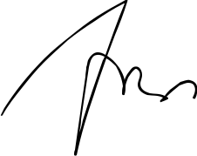

Margarita Perez

