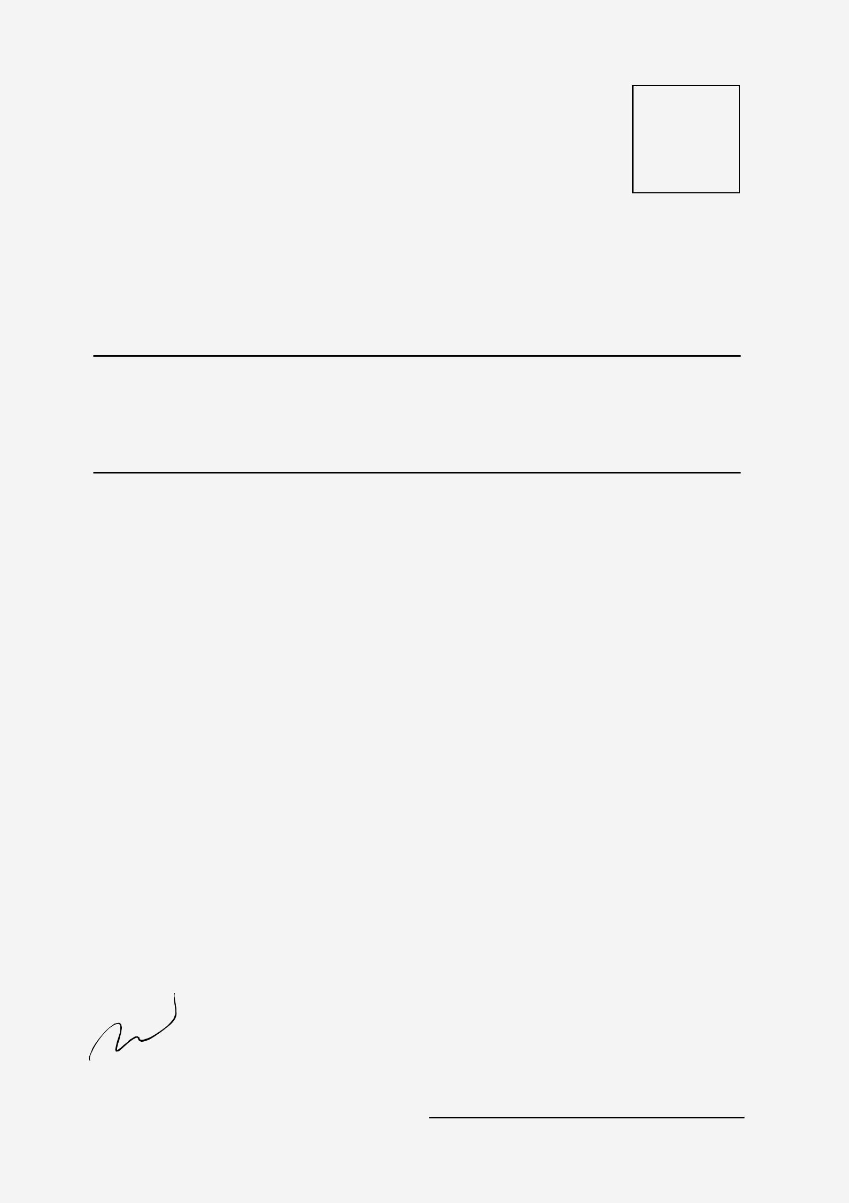
ALDENAIRE
^{A}D

To : | April 7, 2022

Mr. Daniel Gallego

Salford.co

- 123-456-7890

- hello@reallygreatsite.com

- 123 Anywhere St., Any City

A letterhead is the heading at the top of a sheet of letter paper (stationery).

That heading usually consists of a name and an address, and a logo or corporate design, and sometimes a background pattern. The term "letterhead" is often used to refer to the whole sheet imprinted with such a heading. Many companies and individuals prefer to create a letterhead template in a word processor or other software application.

This generally includes the same information as pre-printed stationery but without the additional costs involved. Letterhead can then be printed on stationery (or plain paper) as needed on a local output device or sent electronically. That heading usually consists of a name and an address, and a logo or corporate design, and sometimes a background pattern. The term "letterhead" is often used to refer to the whole sheet imprinted with such a heading.

The term "letterhead" is often used to refer to the whole sheet imprinted with such a heading. Many companies and individuals prefer to create a letterhead template in a word processor or other software application.

Sincerely,

Alfredo Torres

General Manager

