**Chest Exercises**

**Chest Anatomy**

The pectoralis muscle is a large flat, fan shaped muscle that covers the entire upper rib cage. It originates from attachments along our breast bone, collarbones, ribs, and it inserts on each side of your body via a large tendon through your shoulder joint to your upper arm bone.

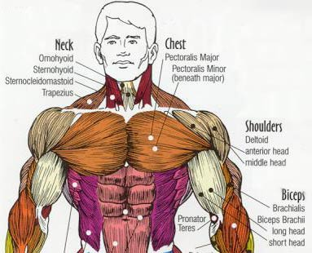

**Chest Exercises**

It is essential that when you do any exercise that you perform the movements correctly, if you don't you will receive less then optimum benefit from the exercise. It is very difficult to unlearn bad exercise habits, so it is best to learn the right exercise technique from the very start.

For each leg workout pick 3 of these exercises and do 4-5 sets (including warm up sets) for each exercise. You can vary the exercises you do for each leg workout.

**Bench Press**