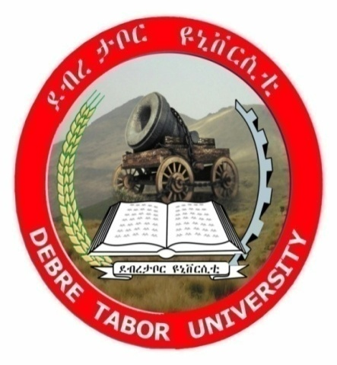

Debere Tabor University
College of natural and computational science
DEPARTMENT OF STATISTICS
Summer Practical Attachment On Ethiopian Red Cross Society North Wollo Branch Office
Name ID NO
Melese Molla 1289

SUBMITTED TO DEPARTEMENT OF STATISTICS

DEBRE TABOR, ETHIOPIA
Sep,2025

Acknowledgment
First, I would like to express my sincere gratitude to Debre Tabor University, College of Natural and Computational Sciences, Department of Statistics for giving me the opportunity to undertake this apprenticeship. I am also deeply thankful to the Ethiopian Red Cross Society, North Wollo Branch, for their continuous support, guidance, and willingness to facilitate my practical learning experience. Finally, I would like to extend my heartfelt appreciation to my advisor for his valuable follow-up, guidance, and encouragement throughout the attachment period.

Abstract
This report summarizes the practical apprenticeship undertaken at the Ethiopian Red Cross Society (ERCS), North Wollo Branch, from July 8 to September 5, 2025. The attachment provided hands-on experience in various humanitarian programs, including data collection and registration of multipurpose cash and livelihood program beneficiaries in Raya Kobo and Gidan Woredas, first aid and transportation services in Woldia Town, environmental protection through afforestation, membership database management, collection of annual fees, and support for youth-friendly recreational activities. These experiences enhanced my skills in data management, statistical reporting, emergency response, community engagement, and administrative tasks. The report also discusses ERCS’s roles, responsibilities, and adherence to the seven Fundamental Principles of the Red Cross, alongside a SWOT analysis highlighting the organization’s strengths, weaknesses, opportunities, and threats. Key lessons learned include the importance of accurate data handling, teamwork, sustainable environmental practices, and youth engagement in fostering social cohesion. Overall, the apprenticeship strengthened my professional competence, applied theoretical knowledge in practical settings, and reinforced my commitment to contributing effectively to humanitarian and community development initiatives.

Table of Contents
Acknowledgment II
Abstract III
Abbreviations/Acronyms V
1. Introduction about Ethiopian Red Cross Society 1
1.1. Background 1
1.2. Mission 2
1.3. Vision 2
1.4. Objective 2
1.5. Core values 2
1.6. Motto 2
1.7. ERCS Organizational Structure 3
1.8. Fundamental principles 3
1.9. Role of the organization 4
1.10. Strength, weakness, opportunity and threat or [SWOT] analysis 4
2. Activity Report 6
2.1. Roles and Responsibilities during the Attachment 6
2.2. Practical Activities / Experience Gained 6
2.3. Lessons Learned 6
3. Recommendations 7
4. Conclusion 7
References 8

Abbreviations/Acronyms

ERCS | Ethiopian Red Cross Society
SWOT | Strength, Weakness, Opportunity, Threat
WASH | Water, Sanitation, and Hygiene

Introduction about Ethiopian Red Cross Society

Background
The International Red Cross and Red Crescent Movement is a global humanitarian network of 80 million people that helps those facing disaster, conflict and health and social problems. It consists of the International Committee of the Red Cross, the International Federation of Red Cross and Red Crescent Societies and the 192 National Red Cross and Red Crescent Societies (1).
The Ethiopian Red Cross Society (ERCS), one of the 192 national Red Cross and Red Crescent societies around the world, was founded on July 8th, 1935, by government edict, following the second Italian invasion of Ethiopia. ERCS began by providing humanitarian services to wounded soldiers and civilian victims. That same year on 25th September 1935, ERCS was officially recognized as the 48th member of the International Federation of Red Cross and Red Crescent Societies (2).
ERCS is auxiliary to the government and yet it is an independent humanitarian organization. It was established and recognized by law through a National Charter adopted in 31th October 1947. The Charter has undergone various parliamentary revisions, the last being in 1999. The current Charter was endorsed by the Parliament in January 2018.
Currently, the Society has a structure consisting of 14 regional offices, 34 zonal branches and 132 district (Woreda) branches, as well as more than 5,800 Kebele Red Cross Committees at the grass root-level. The Society has 6.1 million members, and there are currently over 258,000 volunteers registered throughout the nation, of whom 47,000 are actively engaged in various humanitarian initiatives.
Currently, the North Wollo Branch Office of the Ethiopian Red Cross Society is implementing two major projects with support from the Netherlands Red Cross and Austrian Red Cross. These are the Social Cohesion Project, which working on preventing and supporting of gender based violence survivors and youth friendly services in conflict-affected areas, and the MESELAL Project, which focuses on multipurpose cash assistance, livelihood support, and WASH. Through these initiatives, the branch addresses urgent humanitarian needs while promoting long-term recovery and community resilience in the zone.

Mission
To prevent and alleviate human sufferings through appropriate and timely humanitarian and development interventions, contribute to the wellbeing of humankind and prevalence of peace by mobilizing the public and partners in Ethiopia and around the world.

Vision
To be the leading National Society in Africa.

Objective
The strategic objectives of the Ethiopian Red Cross Society (ERCS) are to:
- Provide effective and timely disaster response, preparedness, and risk reduction programs to vulnerable communities.
- Enhance community health and resilience through First Aid services, ambulance transportation, and Water, Sanitation, and Hygiene (WASH) initiatives.
- Support sustainable livelihoods and food security for crisis-affected populations through multipurpose cash assistance and income-generating activities.
- Promote social cohesion, peace, and the protection of vulnerable groups, including survivors of gender-based violence.
- Strengthen institutional capacity through volunteer recruitment, training, public mobilization, and effective resource management.

Core values
Care – ERCS care about plight of affected and vulnerable people.
Learning – ERCS believe in continuous learning and innovation.
Sensitive – ERCS sensitive to time, gender, disabilities, and environment.
Solidarity – ERCS collaborate with movement and non-movement partners to serve humanity.
Integrity – ERCS walk the talk and strive to be trustworthy.

Motto
We Live for Humanity!

ERCS Organizational Structure
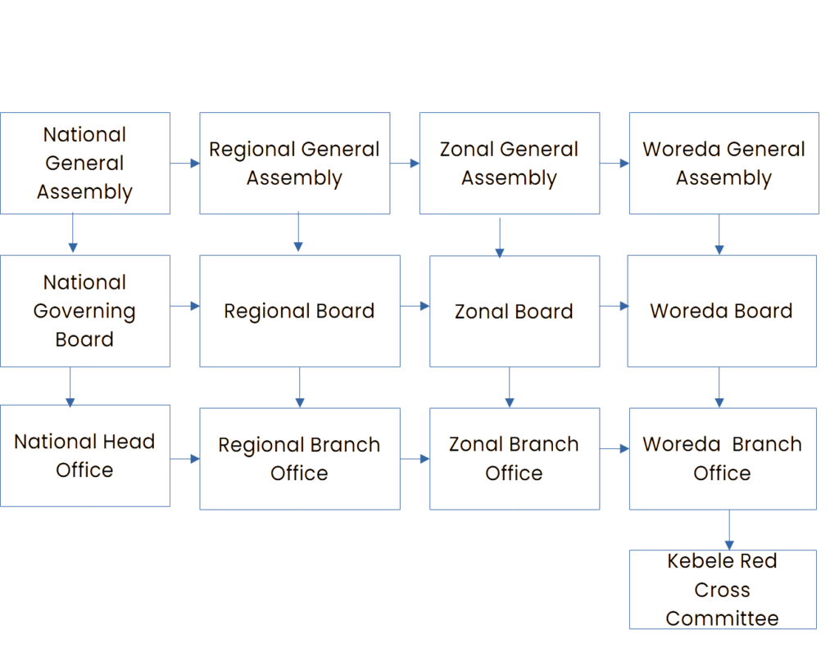

Fundamental principles
The 20th International Conference of the Red Cross in Vienna in 1965 proclaimed seven Fundamental Principles that bind together the National Red Cross and Red Crescent Societies, the International Committee of the Red Cross, and the International Federation of the Red Cross and Red Crescent. These principles ensure the continuity of the Red Cross Red Crescent Movement and its humanitarian work (3).

- Humanity
- Impartiality
- Neutrality
- Independence.
- Voluntary Service
- Unity
- Universality

Role of the organization
The Ethiopian Red Cross Society plays a vital role in promoting humanitarian services and community well-being across the country. The organization is actively engaged in disaster risk management, providing timely responses and interventions to mitigate the impact of natural and human-made disasters. It also focuses on resource mobilization to ensure the availability of financial, material, and human resources necessary for its programs. Through ambulance services and first aid, the society delivers critical medical support to those in need, enhancing emergency response capacity. Additionally, ERCS works on image building by promoting awareness of its mission and strengthening public trust in humanitarian initiatives. The organization is also involved in peace building activities, fostering social cohesion and conflict resolution within communities. Finally, ERCS invests in capacity building by training staff, volunteers, and community members to effectively implement programs and sustainably address local challenges (4).

Strength, weakness, opportunity and threat or [SWOT] analysis
Strength (Internal)  - Having woreda and Kebele Red Cross branches  - Neutrality  - Committed staff members  - Recognized by the government other armed parties  - Covers different programs like health, WASH, livelihood support, disaster response, youth engagement, and peace building | Weakness (Internal)  - Inadequate number of staffs  - Economic dependence from members and volunteers  - Staff turnover
Opportunity (External)  - Positive acceptance from government and other parties around North Wollo  - Digitalization  - Support from other national societies  - Volunteer engagement  - Policy support | Threats (External)  - Increasing in humanitarian demand  - Ongoing conflict around the zone  - Recurrent disasters (drought, famine, epidemics)  - Market inflation makes resource mobilization harder)  - Security risks (risks to staff, volunteers, and facilities in unstable areas).

CHAPTER TWO

METHDOLOGY

Activity Report

Roles and Responsibilities during the Attachment
- Data Collection & Registration: Collected information for multipurpose cash and livelihood program beneficiaries in Raya Kobo and Gidan Woredas.
- Environmental Protection: Participated in afforestation and other environmental protection activities.
- Membership Management: Registered members into the ERCS database and collected annual membership fees.
- Youth Services: Assisted in recreational activities and services for youth-friendly centers

Practical Activities / Experience Gained
During my apprenticeship at the Ethiopian Red Cross Society, I gained extensive practical experience across multiple program areas. I was actively involved in the registration and data collection of multipurpose cash and livelihood program beneficiaries in Raya Kobo and Gidan Woredas, which enhanced my skills in data management, attention to detail, and effective communication with community members. In Woldia Town, I participated in providing first aid and transporting sick individuals, which strengthened my knowledge in emergency response, teamwork, and empathetic service delivery. I also contributed to environmental protection efforts through afforestation activities, fostering an understanding of sustainable community practices. Additionally, I was responsible for membership database management, including registering new members and collecting annual membership fees, which improved my administrative and organizational skills. Furthermore, I supported youth-friendly service activities in recreational areas, gaining experience in community engagement, program coordination, and promoting social cohesion among young people. Overall, these experiences allowed me to apply theoretical knowledge in practical settings, develop professional competencies, and gain a holistic understanding of humanitarian service delivery.

Lessons Learned
- Importance of accurate data collection and management.
- Environmental protection is vital for community sustainability.
- Teamwork and communication are key in humanitarian work.
- Engaging youth through recreational activities promotes social cohesion

Recommendations
- Strengthen digital data management for beneficiary registration.
- Provide additional training in first aid and emergency response for volunteers.
- Expand youth engagement programs to more communities.
- Increase community awareness on environmental protection and afforestation.

Conclusion
In conclusion, the apprenticeship at the Ethiopian Red Cross Society offered invaluable practical experience in both field and administrative settings. By participating in data collection, registration of beneficiaries, first aid services, environmental initiatives, and youth engagement programs, I developed strong skills in data management, statistical reporting, and community service. This practical exposure not only strengthened my technical and analytical abilities but also provided a deeper understanding of program implementation, monitoring, and evaluation within a humanitarian context. Overall, the attachment significantly enhanced my professional competence and reinforced my commitment to contributing effectively to humanitarian and development initiatives.

References
- Forsythe DP. International humanitarian assistance: The role of the Red Cross. Buff. J. Int'l L.. 1996;3:235.
- Qualman, A. K. (2019). Wollo Rehabilitation and Disaster Prevention Projects, Wollo, Ethiopia: Project Implementing Agencies: Ethiopian Red Cross Society, League of Red Cross and Red Crescent Societies. In Rising from the Ashes (pp. 111–133). Routledge.
- International Federation of Red Cross and Red Crescent Societies. (1965). The XXth International Conference of the Red Cross: Proclamation of the Fundamental Principles. International Federation of Red Cross and Red Crescent Societies. Retrieved from https://disasterlaw.ifrc.org/sites/default/files/media/disaster_law/2024-07/IC%2020%20%281965%29%20English.pdf
- ZENEBE A. THE ROLE OF ETHIOPIAN RED CROSS IN DISASTER RISK RIDUCTION AND REHABILITATION IN THA CASE OF QOSHEE AREA ADDISS ABABA (Doctoral dissertation, St. Mary's University).

