# FD : post-member-point-registration-api

Author Name: Developer Guide

Date Of Assignment: 10-09-2021

Date Of Submission: 10-09-2021

Document detail

|  |  |  |  |  |
| --- | --- | --- | --- | --- |
| Name | Description | Version | Comment | Date |
| Developer Guide | Initial Draft | 1.0 |  | 10-09-2021 |

Document Future Scope

|  |
| --- |
|  |
|  |
|  |
|  |
|  |

# FUNCTIONAL REQUIREMENT

# Business Scenario

# Flow diagram

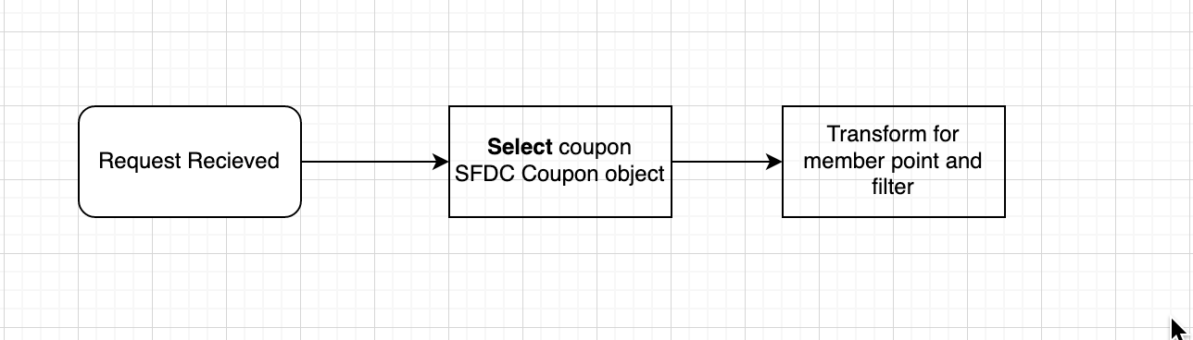

# API Details

|  |  |
| --- | --- |
| **Version** | 1.0.0 |
| **Resource** | /reward |
| **Method** | GET |
| **Objective** | This API will retrieve login credentials |

# INPUT

## Header

|  |  |  |  |
| --- | --- | --- | --- |
| **Field Name** | **Field Rule** | **Mandatory** | **Type** |
| x-cms-transactionId | Use for logging and tracking purposes. Example: hdsfhjdh-jxbv859-sjdf7643-3746bbd  MinLength = 36  MaxLength = 36 | Y | String |
| x-cms-channel | Mobile/WebApp | Y | String |
| X-Cms-OriginLanguage | Original Language | Y | String |
| X-Cms-OriginMarket | Original business market | Y | String |
| Authorization | JWT token | Y | String |

## QueryParam

|  |  |  |  |  |
| --- | --- | --- | --- | --- |
| **Field Name** | **Field Rule** | **Description** | **Mandatory** | **Type** |
| minPoint | 1 | 100 | Y | Integer |
| maxPoint | 1 | 1000 | Y | Integer |
| fromExpiryDate | 1 | 20-10-2021 | Y | Date |
| toExpiryDate | 1 | 20-10-2021 | Y | Date |
| type | 1 | Enum: GiftCard/Coupon/CashAmount | Y | String |

## OUTPUT

### 200:

Body: MIME-Type= application/json

Output message for Forgot Username/Password

|  |  |  |  |  |
| --- | --- | --- | --- | --- |
| **Field Name** | **Field Rule** | **Description** | **Mandatory** | **Type** |
| msg | 1 |  | Y | String |
| code | 1 |  | Y | Integer |
| success | 1 |  | Y | string |
| eventId | 1 |  | Y | string |
| data | 1 |  | Y | object |
| couponId | 1 |  | Y | string |
| type | 1 |  | Y | String |
| expiryDate | 2 |  | Y | Date |
| point | 2 |  | Y | Integer |
| used | 2 |  | Y | Integer |
| available | 2 |  | Y | Integer |
| quota | 2 |  | Y | Integer |

example:

{

"msg" : "successful operation",

"code" : 200,

"success" :true,

"eventId" : "dbfhjsdbhfbdo8ryt876t75ty"

"data" **:**

{

"couponId" :"Mdsah8734873",

"type" : GiftCard,

"expiryDate" : 20-10-2021,

"point" :200,

"used" : 1000,

"available" : 104500,

"quota" : 104500,

}

}

SFDC:

Object : coupon

|  |  |  |  |  |
| --- | --- | --- | --- | --- |
| couponId | 1 |  | Y | string |
| type | 1 |  | Y | String |
| expiryDate | 2 |  | Y | Date |
| point | 2 |  | Y | Integer |
| used | 2 |  | Y | Integer |
| available | 2 |  | Y | Integer |
| quota | 2 |  | Y | Integer |

### 400:

Body: MIME-Type= application/json

Output message for MemberLogin

|  |  |  |  |
| --- | --- | --- | --- |
| **Field Name** | **Field Rule** | **Mandatory** | **Type** |
| msg | 1 | Y | String |
| code | 1 | Y | Integer |
| success | 1 | Y | Boolean |
| eventId | 1 | Y | string |
| error | 1 | Y | Object |
| type | 2 | Y | String |
| title | 2 | Y | String |
| details | 2 | Y | String |

example:

{

msg: "failed operation",

code: 400,

success: false,

eventId: "dbfhjsdbhfbdo8ryt876t75ty"

error:

{

type: "BAD_REQUEST",

title: "Invalid Request",

details: "The input contains invalid data"

}

}

### 401:

Body: MIME-Type= application/json

Output message for MemberLogin

|  |  |  |  |
| --- | --- | --- | --- |
| **Field Name** | **Field Rule** | **Mandatory** | **Type** |
| msg | 1 | Y | String |
| code | 1 | Y | Integer |
| success | 1 | Y | Boolean |
| eventId | 1 | Y | string |
| error | 1 | Y | Object |
| type | 2 | Y | String |
| title | 2 | Y | String |
| details | 2 | Y | String |

example:

{

msg: "failed operation",

code: 401,

success: false,

eventId: "dbfhjsdbhfbdo8ryt876t75ty"

error:

{

type: "UNAUTHORIZED",

title: "Unauthorized",

details: "This endpoint requires all requests to be authenticated"

}

}

### 404:

Body: MIME-Type= application/json

Output message for MemberLogin

|  |  |  |  |
| --- | --- | --- | --- |
| **Field Name** | **Field Rule** | **Mandatory** | **Type** |
| msg | 1 | Y | String |
| code | 1 | Y | Integer |
| success | 1 | Y | Boolean |
| eventId | 1 | Y | string |
| error | 1 | Y | Object |
| type | 2 | Y | String |
| title | 2 | Y | String |
| details | 2 | Y | String |

example:

{

msg: "failed operation",

code: 404,

success: false,

eventId: "dbfhjsdbhfbdo8ryt876t75ty"

error:

{

type: "NOT_FOUND",

title: "Resource not found",

details: "The URI requested is invalid or the resource requested does not exists"

}

}

### 500:

Body: MIME-Type= application/json

Output message for MemberLogin

|  |  |  |  |
| --- | --- | --- | --- |
| **Field Name** | **Field Rule** | **Mandatory** | **Type** |
| msg | 1 | Y | String |
| code | 1 | Y | Integer |
| success | 1 | Y | Boolean |
| eventId | 1 | Y | string |
| error | 1 | Y | Object |
| type | 2 | Y | String |
| title | 2 | Y | String |
| details | 2 | Y | String |

example:

{

msg: "failed operation",

code: 500,

success: false,

eventId: "dbfhjsdbhfbdo8ryt876t75ty"

error:

{

type: "SERVER_ERROR",

title: "Internal server error",

details: "The server encountered an unexpected condition which prevented it from fulfilling the request"

}

}