ROLES, WORKFLOWS, AND HIERARCHY

ScopeIs Team Management System
  - Authority boundaries, operational relationships, principal workflows, and planning diagrams
WORKFORCE PLANNING • SCHEDULING • COVERAGE • OPERATIONS
Document status | Documentation baseline
Version | 1.0
Issued | 26 August 2026
Project stage | Foundation and documentation only
Canonical project reference • No application implementation

Table of Contents
1. System Hierarchy | 3
2. Domain and Module Relationships | 3
3. Role Hierarchy | 4
4. Complete Permission Matrix | 5
5. Super Admin Workflows | 6
6. Admin Workflows | 6
7. Employee Workflows | 6
8. Scheduling Workflow | 7
9. Schedule Publication Workflow | 7
10. Leave Workflow | 8
11. Coverage Validation Workflow | 8
12. Replacement-Request Workflow | 8
13. Certification and Portfolio Notification Workflow | 8
14. Employee-Management Note Visibility | 9
15. Shared Client and Project Notes | 9
16. Private Requester-Assignee Communication | 9
17. Static Planning Map Workflow | 10
18. Client, Project, and Location Relationships | 11
19. Ticket System Integration Boundary | 11
20. Example Operational Scenarios | 12
21. Exceptions and Unresolved Decisions | 14

1. System Hierarchy
The workforce core, operational records, planning functions, and governance services form the product foundation. Provider choices remain replaceable, and the existing Ticket System remains outside the foundation.
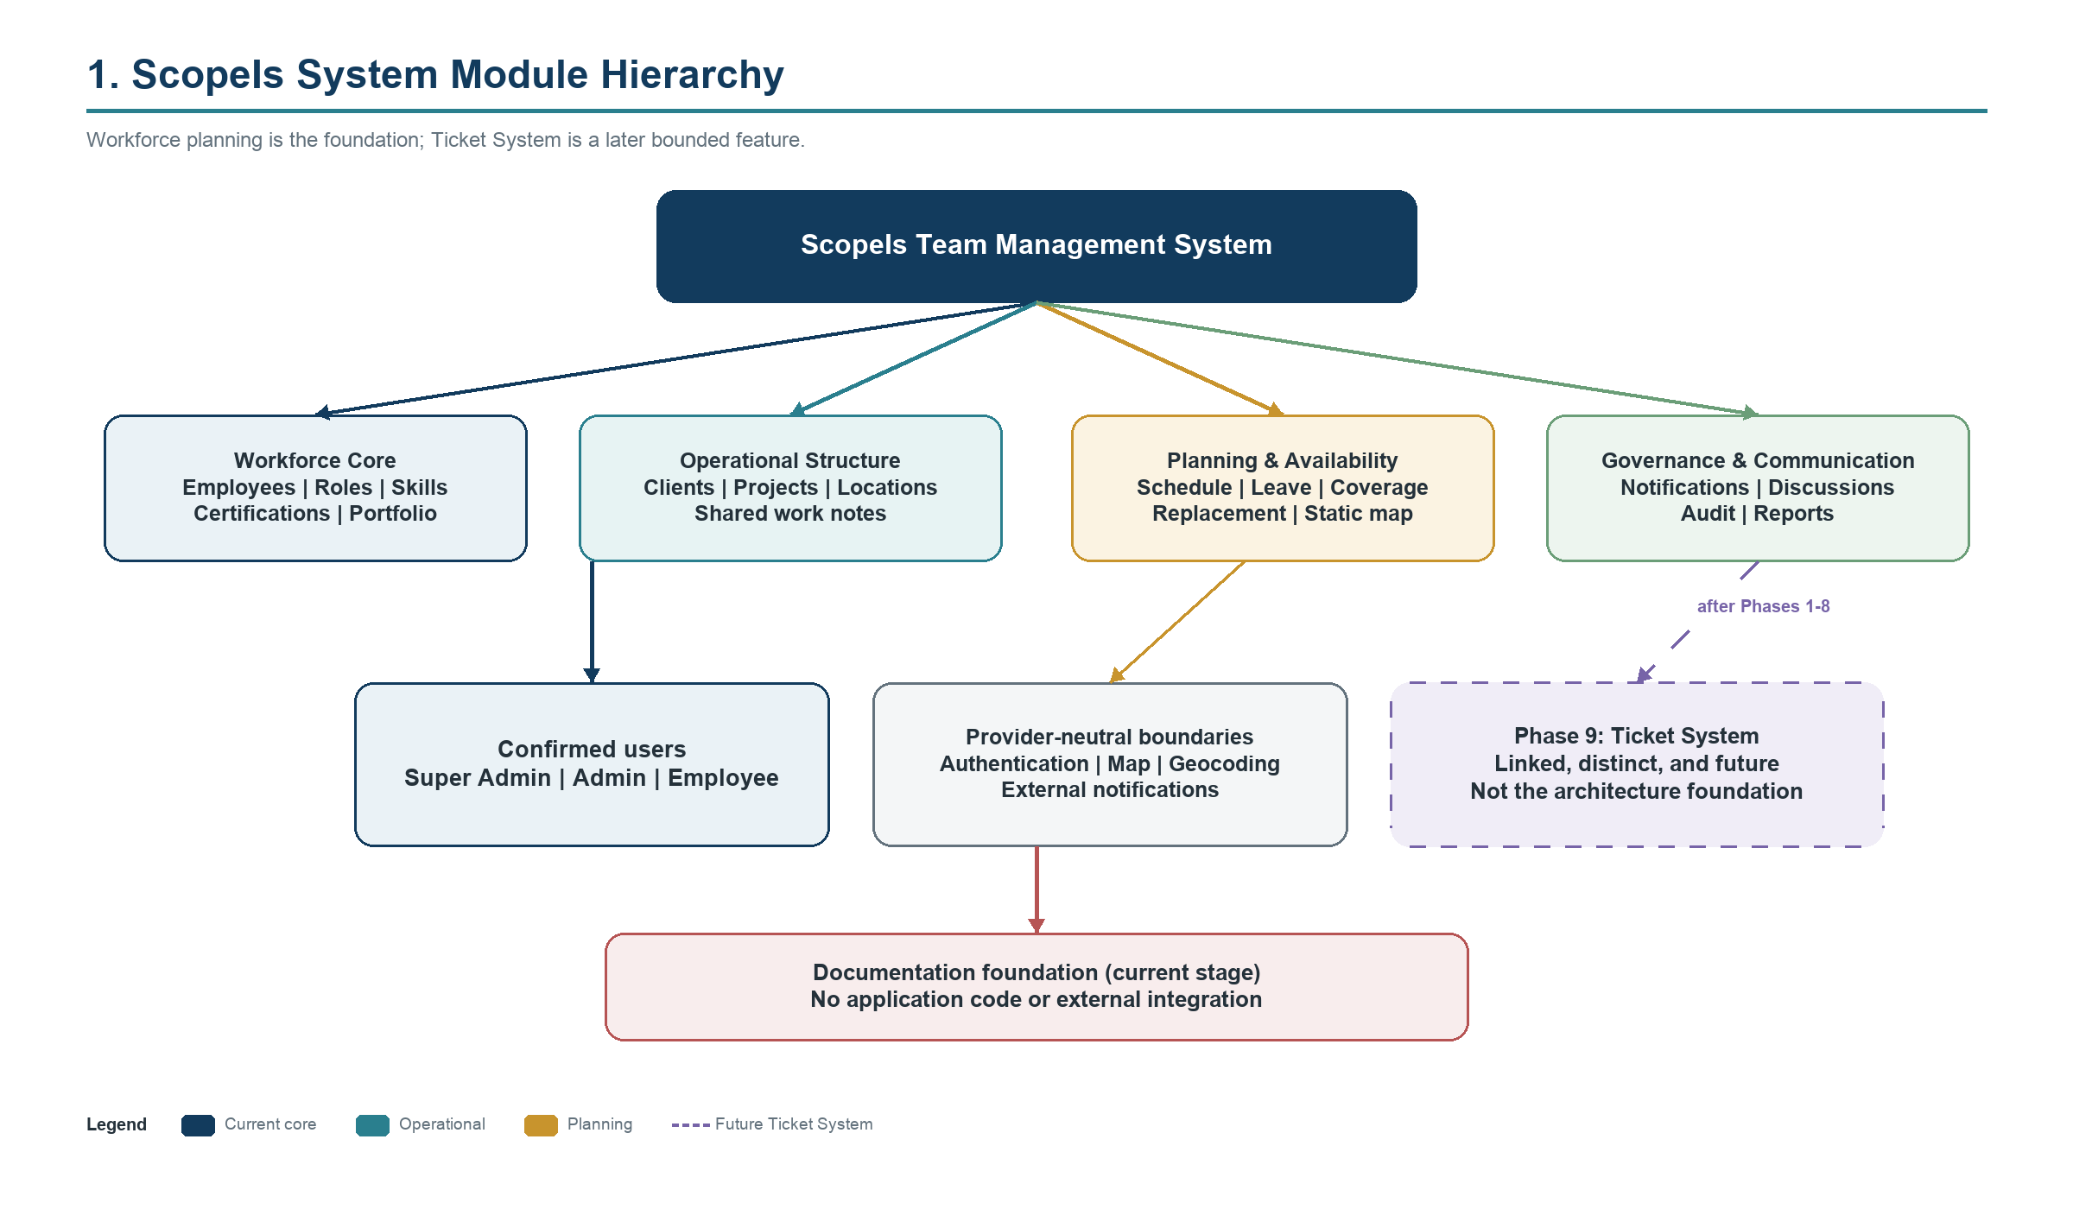
Figure 1. Overall system module hierarchy and Phase 9 boundary

2. Domain and Module Relationships
Employees and capabilities connect to clients, projects, locations, assignments, schedules, leave, coverage, replacements, notes, notifications, audit, and reporting. Labels describe arrangements but do not control availability or permission logic.
- Workforce core: employees, roles, designations, skills, certifications, portfolio, arrangement labels.
- Operational structure: clients, projects, locations, contacts, requirements, shared notes.
- Planning layer: assignments, schedule states, availability, leave, coverage, replacements, static map.
- Governance: private/shared communication models, notifications, audit, reporting, exports.
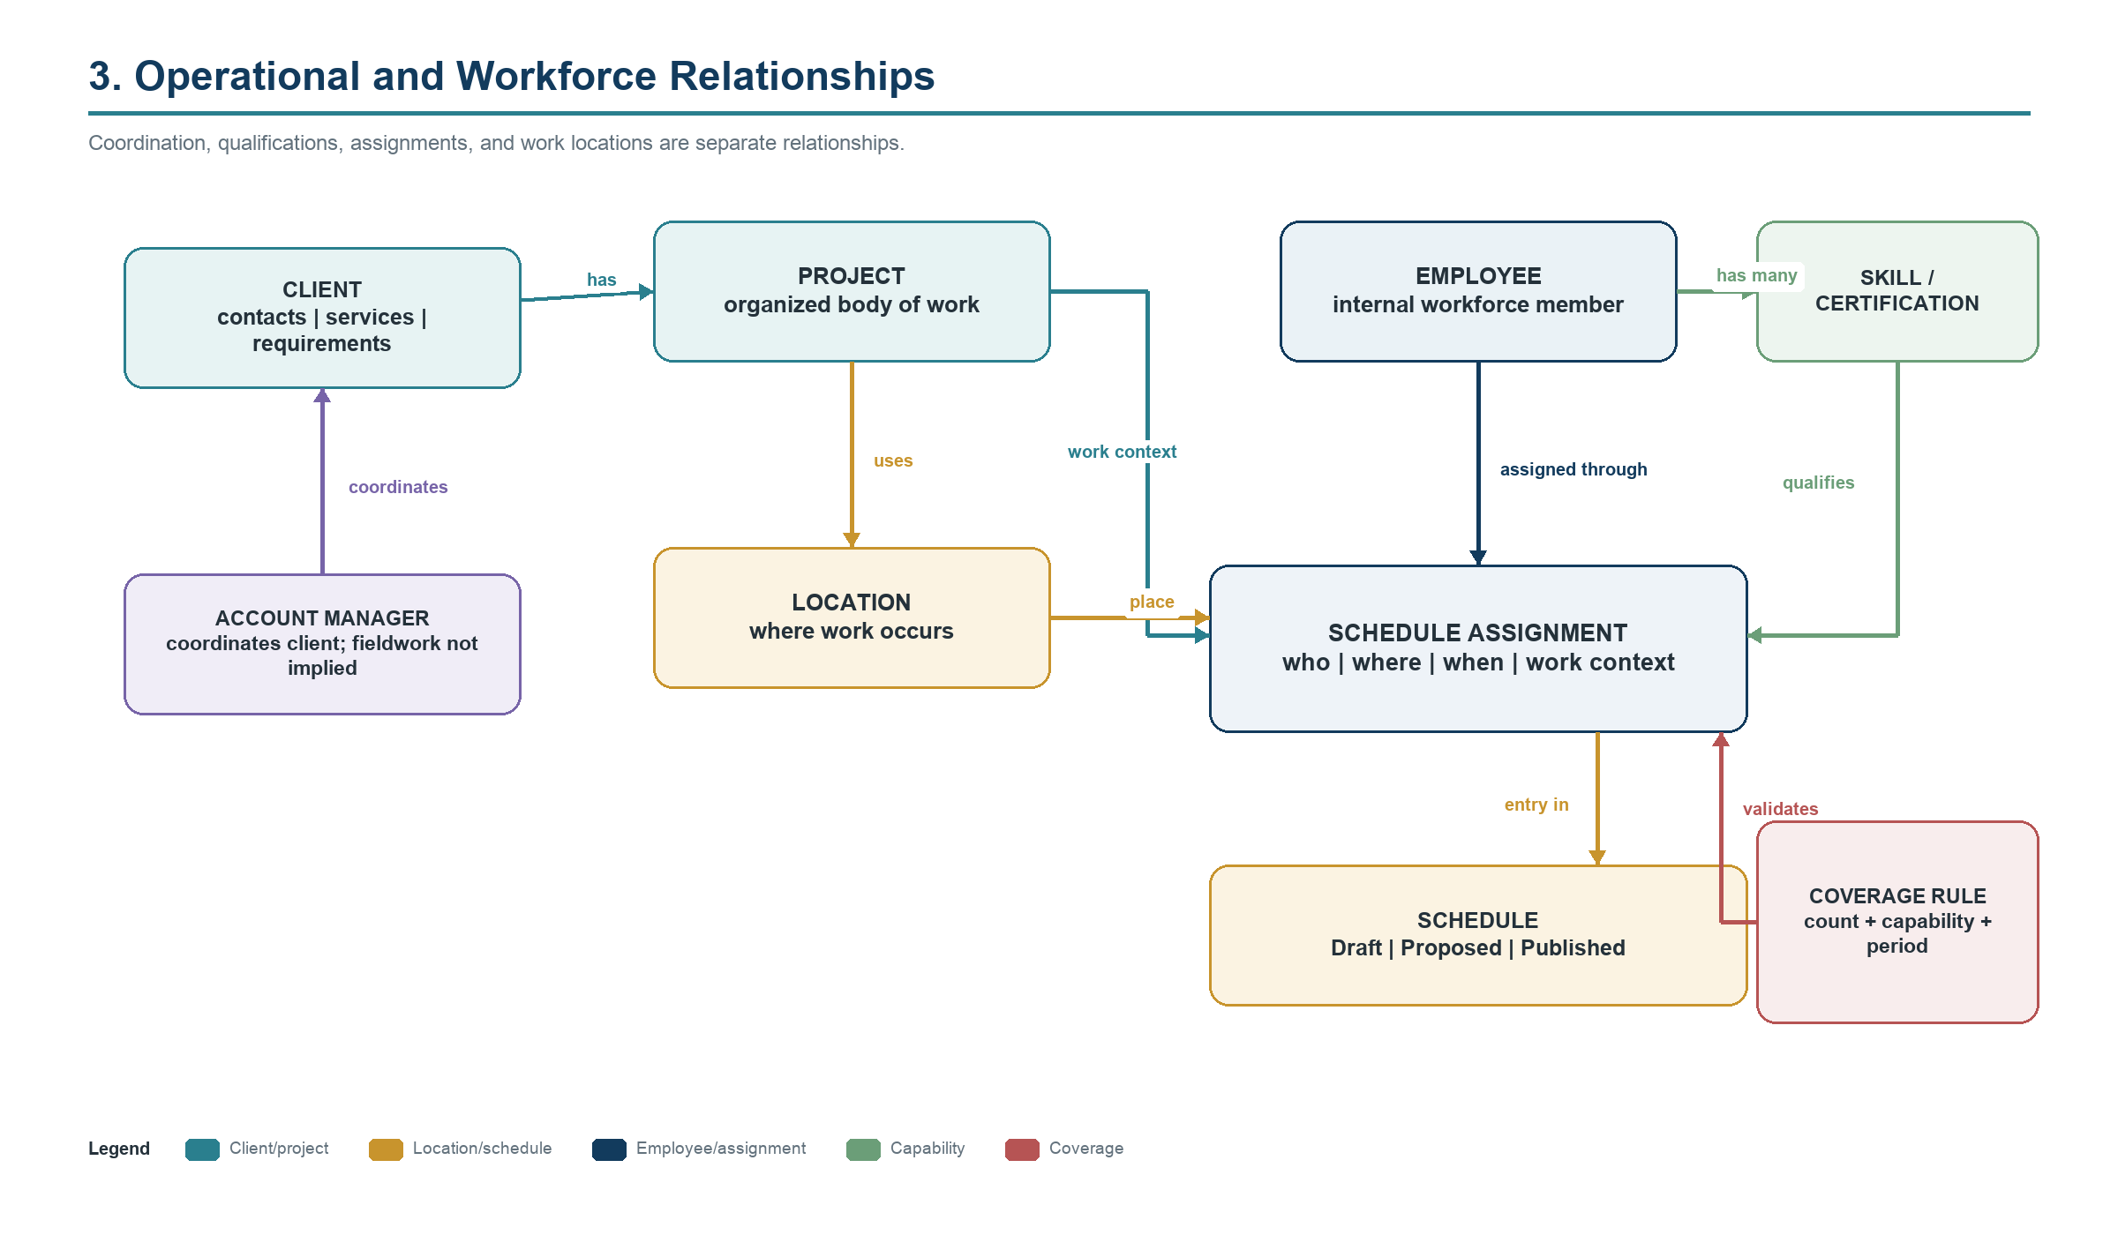
Figure 2. Client, project, location, employee, capability, assignment, schedule, and coverage relationships

3. Role Hierarchy
Super Admin > Admin > Employee is the access hierarchy. Job designations do not grant permissions; Admin access is always intersected with assigned scope.
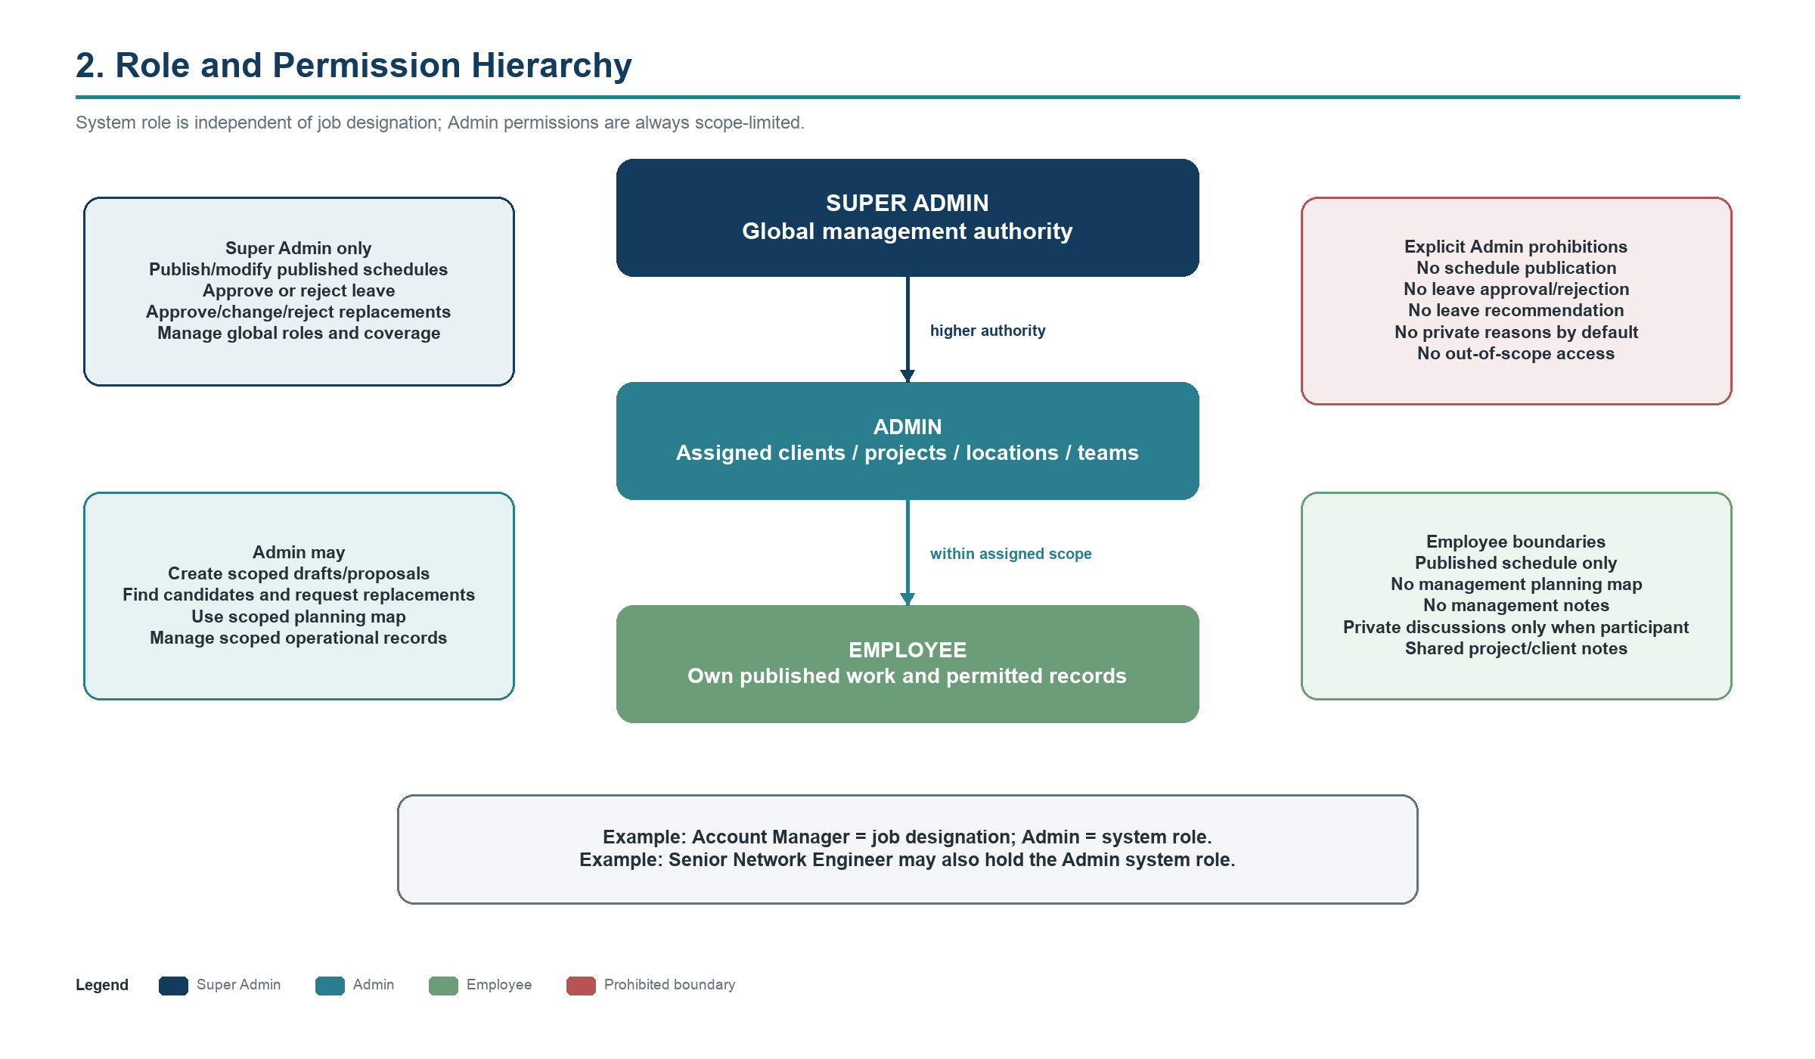
Figure 3. Role hierarchy, authority, scope, and explicit prohibitions

4. Complete Permission Matrix
The table is authoritative unless a later confirmed requirement updates both the matrix and identified requirements.
Capability | Super Admin | Admin | Employee
Manage accounts and roles | Yes | No | No
View workforce data | Global | Assigned scope | Own/permitted
Manage clients/projects/locations | Yes | Assigned scope | View shared work data
Create schedule draft | Yes | Assigned scope | No
Submit schedule proposal | Yes | Assigned scope | No
View unfinished drafts | All | Own/scoped | No
Publish/modify published schedule | Yes | No | No
View published schedule | All | Relevant scope | Own
Submit own leave | Yes | Yes | Yes
See another employee's leave reason | When required | No by default | No
Approve/reject leave | Yes | No | No
Recommend leave outcome | No separate workflow | No | No
Define global coverage rules | Yes | No unless delegated | No
Find replacement candidates | Yes | Assigned scope | No
Submit replacement request | Yes | Assigned scope | No
Approve/change/reject replacement | Yes | No | No
Override significant warning | Authorized + reason | No | No
Access static planning map | Global | Assigned scope | No
Create employee-management note | About Admin/Employee | Scoped Employee | No
Read/add project/client notes | Yes | Yes | Yes
Read request discussion | Participant only | Participant only | Participant only
Reports/exports | Yes | Later-defined scope | No unless confirmed
Integrated tickets | Phase 9 global | Phase 9 scoped | Phase 9 assigned/owned
Non-negotiable boundaries: Admin cannot publish schedules, approve/reject leave, or recommend leave decisions. Employee cannot access the management map. Private request discussions are participant-only.

5. Super Admin Workflows
Super Admin/team manager provides global authority and final decisions.
- Create/deactivate employees, assign roles, and manage designations, skills, arrangement labels, clients, projects, locations, mock accounts, coverage rules, and settings.
- Review all drafts/proposals; publish schedules; modify published schedules with audit and affected-user notification.
- Review complete leave information, evaluate coverage, approve/reject, and record responses or authorized override reasons.
- Review replacement requests and candidates; approve, change, or reject; update the applicable schedule and notifications.
- Review certification/portfolio updates and optionally mark reviewed or verified.
- Access global map, management notes permitted by hierarchy, audit, reports, exports, and later integrated tickets.

6. Admin Workflows
Admins coordinate assigned operational scope without receiving global decision authority.
- View required employee skills and availability within scope and manage assigned clients/projects/locations.
- Create/edit scoped schedule drafts and assignments, resolve visible conflicts, and submit proposals.
- Find qualified replacements, use scoped map information as an aid, and submit replacement requests.
- See employee unavailability without private leave reasons by default; never approve, reject, or recommend leave decisions.
- Create shared client/project notes and permitted management notes about scoped Employees; join request discussions only as a participant.

7. Employee Workflows
Employees interact with published work and their permitted personal records.
- Sign in using a mock account and view today's assignment plus weekly/monthly published schedules.
- View permitted client, project, location, time, and work instructions.
- Submit/cancel permitted pending leave requests and track status; view balances only when rules are implemented.
- Maintain permitted profile fields, certifications, portfolio, CV, and project evidence; receive notifications.
- Read/add shared client/project notes and participate in assignment/request discussions only when requester or assignee.
- Do not see drafts, the management map, other employees' leave reasons, management notes, or nonparticipant discussions.

8. Scheduling Workflow
Planning supports future months, recurring and one-time work, permanent/temporary placements, full-day/timed/multi-day assignments, on-call work, and operational references.
- Create or update a Draft within role and scope.
- Add assignments and run confirmed conflict checks.
- Resolve blockers/warnings or preserve authorized context.
- Admin submits Proposed schedule; Admin cannot publish.
- Super Admin reviews, revises, returns to Draft, or publishes.
- Affected Employees receive publication or post-publication-change notifications and see only their Published entries.
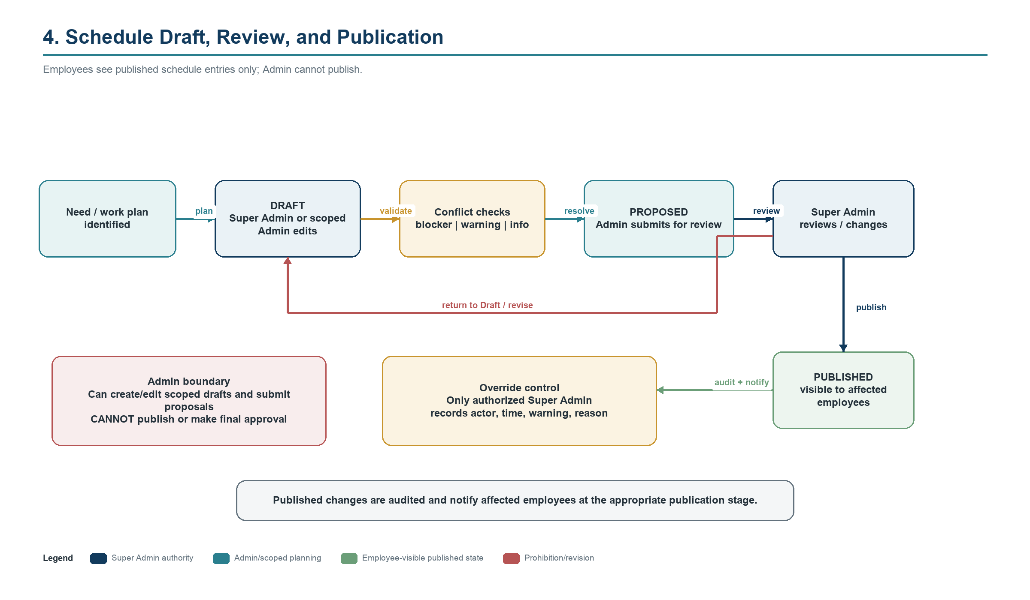
Figure 4. Draft, conflict review, Admin proposal, Super Admin publication, and employee visibility

9. Schedule Publication Workflow
Publication is the boundary between management planning and employee-visible commitments. Super Admin is the only publisher. Significant overrides record actor, time, issue, and reason. Published modifications are auditable and notify affected Employees.

10. Leave Workflow
Employee submits dates and an optional reason; the system stores Pending and notifies Super Admin. Coverage evaluation precedes the Super Admin decision. Admin may see unavailable status but not private reasons by default and does not advise on the outcome.
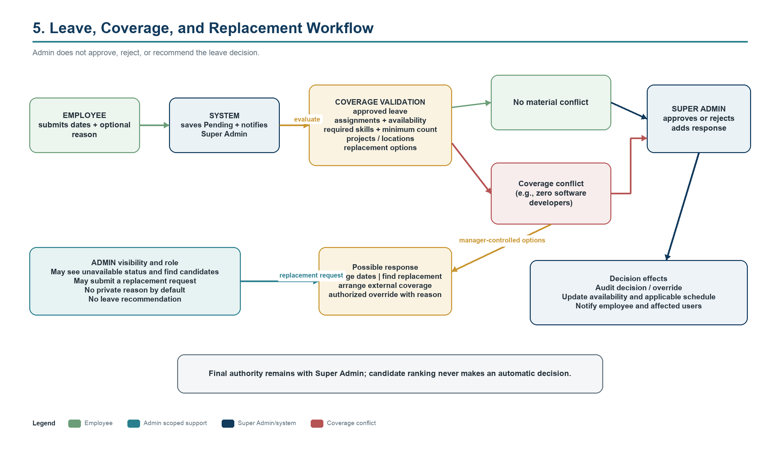
Figure 5. Leave submission, coverage validation, manager-controlled options, and final authority

11. Coverage Validation Workflow
Evaluation uses approved leave, assignments, actual skills, minimum counts, required levels/certifications when confirmed, client/project/location requirements, and replacement availability. Labels alone never determine coverage. Final severity and override policies remain open where not confirmed.

12. Replacement-Request Workflow
Admin identifies a gap, reviews skill/availability/workload/location information, and submits a candidate request. Super Admin approves, changes, or rejects. If approved, the schedule is updated according to its state; publication rules and notifications still apply.

13. Certification and Portfolio Notification Workflow
Employee evidence is saved before management review. Notification, optional review, and possible future verification are separate states.
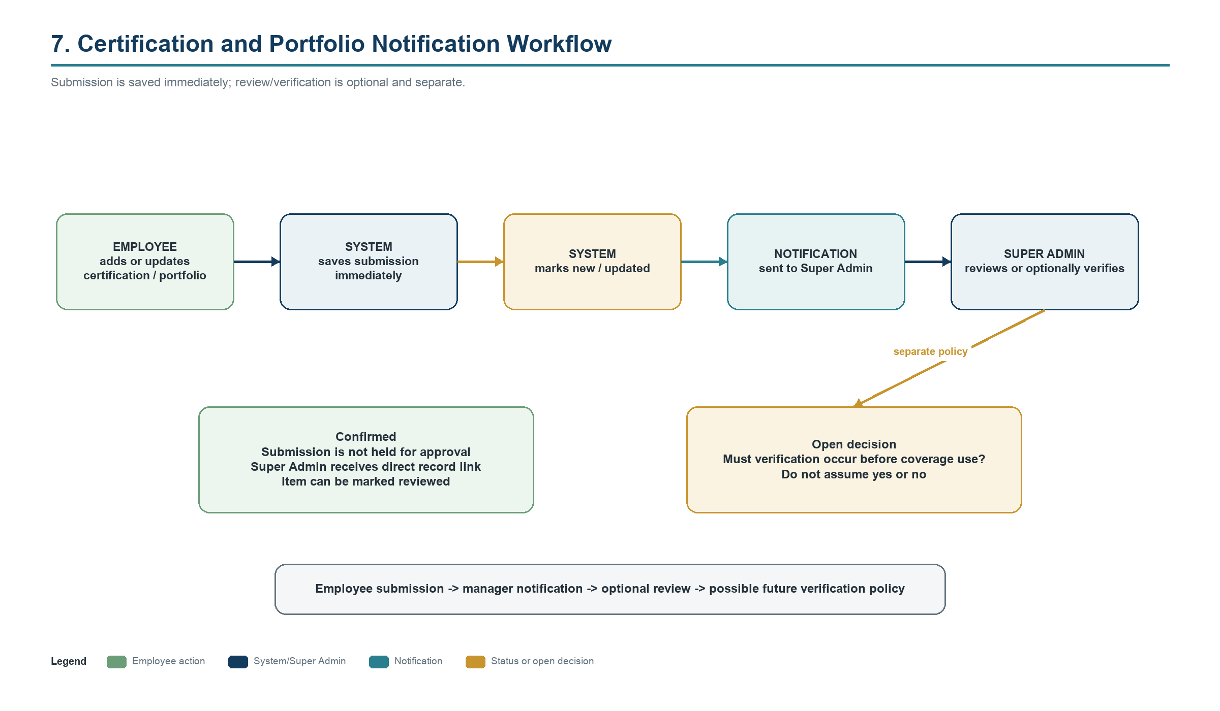
Figure 6. Immediate employee submission, Super Admin notification, and optional review/verification

14. Employee-Management Note Visibility
Super Admin may write about Admins or Employees. Admin may write only about scoped Employees. The author selects private-to-author or shared-upward. Subject Employees never see the note.

15. Shared Client and Project Notes
Every authenticated user may read and add work-related client/project notes. The model remains simple and shared; exact editing/deletion authority is an open decision.

16. Private Requester-Assignee Communication
Assignment/request discussions are not general notes. Only requester and assigned Employee(s) are participants; new messages notify the others; nonparticipants cannot view them.
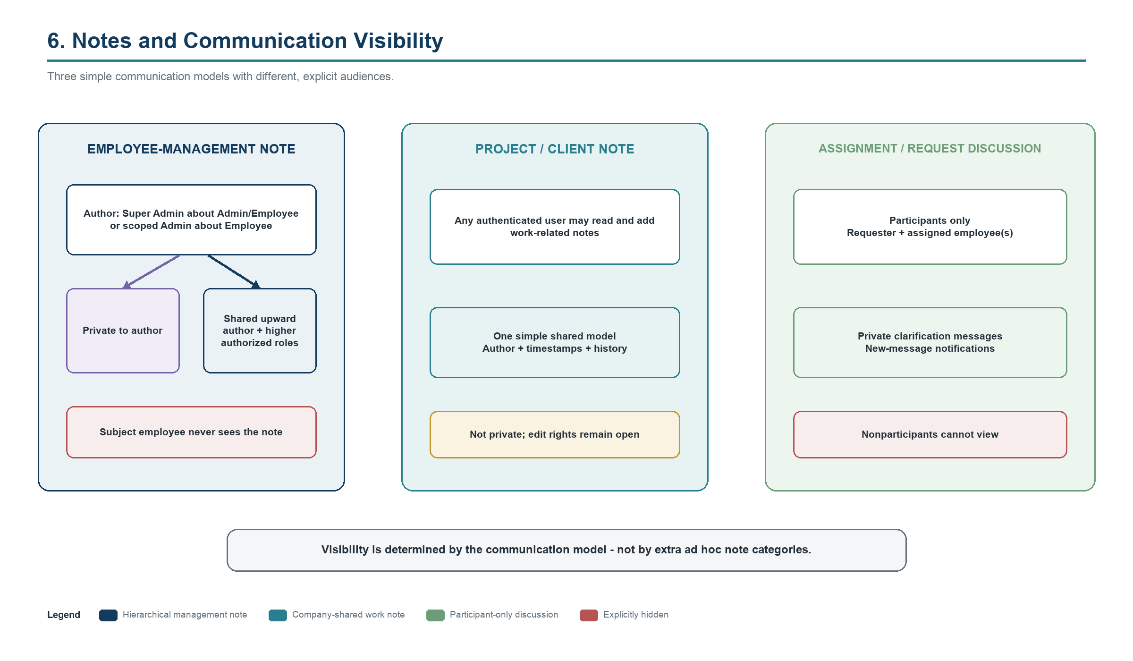
Figure 7. Visibility rules for management notes, shared work notes, and private discussions

17. Static Planning Map Workflow
Authorized managers select a date/period and filters. The map combines stored home address/area, stored work locations, Published schedule data, and role/scope authorization. It displays publication time, filters, legend, and an explicit non-live status.
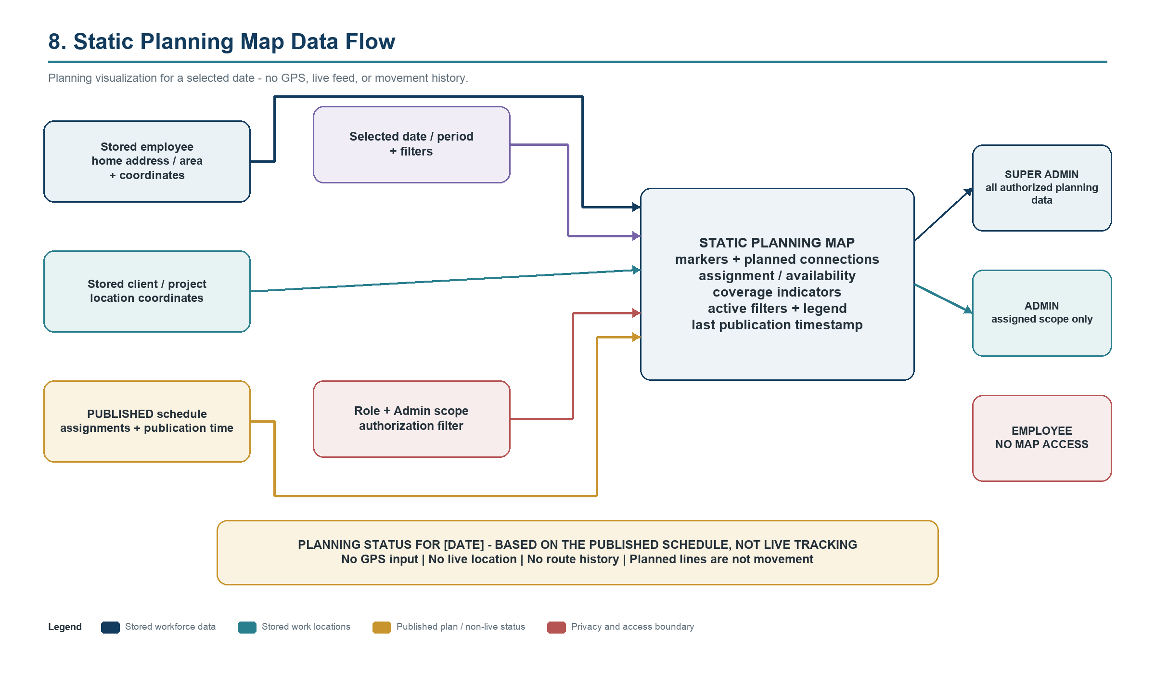
Figure 8. Static planning map inputs, authorization, outputs, and no-live-tracking boundary

18. Client, Project, and Location Relationships
A Client can have Projects and Locations; Projects can span Locations; assignments connect Employees to operational context and time; skills qualify Employees; coverage rules validate capacity. The Account Manager coordinates but does not automatically perform fieldwork.

19. Ticket System Integration Boundary
Ticket integration occurs only after Phases 1-8. Selected ticket dashboard, work log, attachment, export, attribution, administration, and audit foundations may be reuse candidates after inspection. Workforce roles, scopes, storage/privacy choices, and domain distinctions remain authoritative.
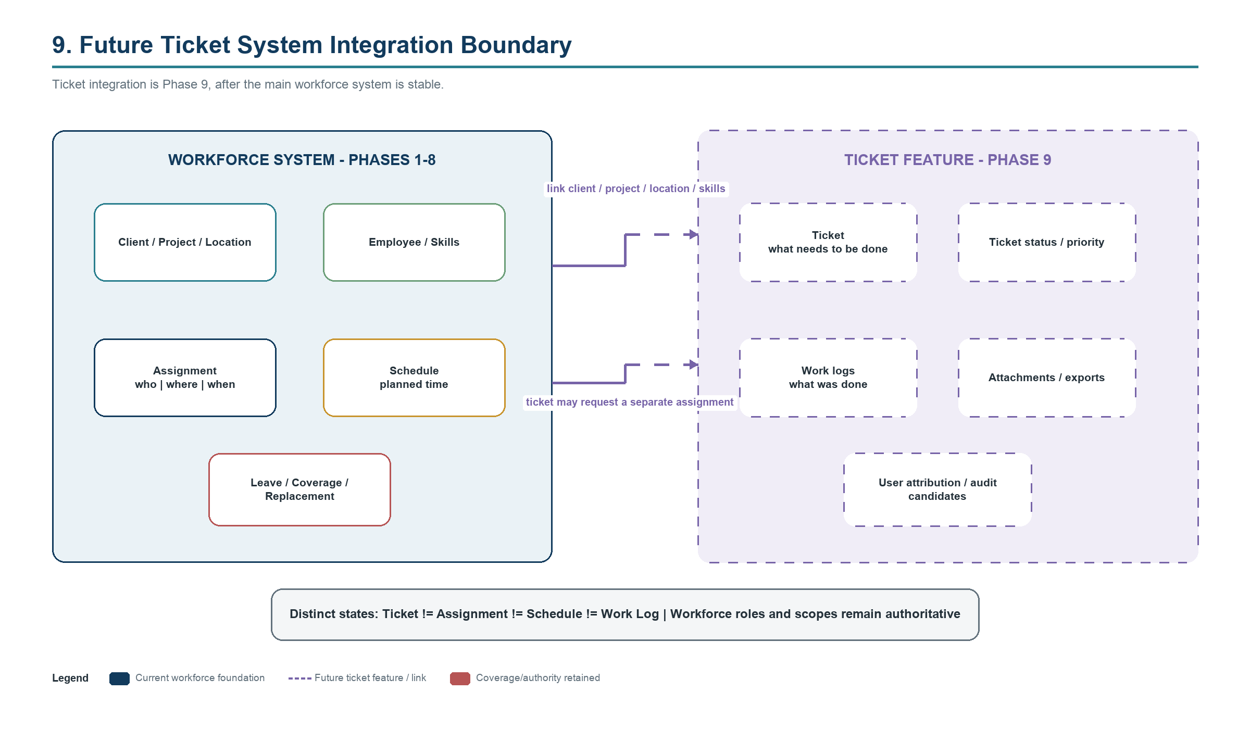
Figure 9. Phase 9 Ticket System integration boundary and distinct domain states

20. Example Operational Scenarios
These scenarios are mandatory acceptance references.

Scenario A - Scarce software-development coverage
- Two software developers exist; one has approved leave.
- The other requests overlapping leave.
- System reports that approval would leave zero software developers available for the affected dates.
- Admin does not recommend an outcome.
- Super Admin rejects, requests different dates, arranges coverage/replacement, or uses an authorized override with reason.

Scenario B - Admin schedules a CCTV site visit
- Account Manager/Admin opens an assigned client requiring CCTV work.
- Admin filters Employees by CCTV capability and availability.
- Admin creates a Draft assignment; system evaluates conflicts.
- Admin submits Proposed schedule.
- Super Admin reviews and publishes.
- Affected Employee receives and views the Published assignment.

Scenario C - Replacement request
- Assigned engineer becomes unavailable.
- Admin reviews qualified available Employees; optional map distance assists but does not decide.
- Admin submits a replacement request.
- Super Admin approves, changes, or rejects.
- Approved change updates the applicable schedule; published changes notify affected Employees.

Scenario D - Certification upload
- Employee uploads certification evidence.
- System saves and marks it new/updated.
- Super Admin receives a direct notification.
- Super Admin reviews or optionally verifies.
- Coverage use follows the later-confirmed verification policy.

Scenario E - Static planning map
- Manager selects a future date and skill filter.
- Map shows protected stored home areas, project locations, and Published assignments within role/scope.
- Manager identifies possible nearby skilled Employees.
- Map states that it uses no live location or GPS feed.

Scenario F - Notes and discussion
- Admin writes a management note about a scoped Employee and chooses private or shared-upward.
- Subject Employee cannot see it.
- Employee adds a project note visible to every authenticated user.
- Requester and assignee exchange private clarification; nonparticipants cannot view it.

Scenario G - Future ticket integration
- Client issue creates a Ticket with required skill and location.
- Ticket initiates a separate assignment request.
- Approved schedule assignment identifies who, where, and when.
- Work logs record actual work.
- Ticket and assignment remain linked but distinct.

21. Exceptions and Unresolved Decisions
The following items must be confirmed before affected logic is implemented. Safe defaults prevent accidental expansion but are not final decisions.
Decision (not finalized) | Why it matters | Safe documentation default
Home address precision | Map privacy and replacement ranking | Protect precise data; use approximate area unless separately authorized
Precise-address permission | Role/scope/audit | Super Admin only until confirmed
Fixed or flexible work hours | Availability and conflicts | Model work pattern; no unconfirmed enforcement
Multiple locations per day | Timed work and travel feasibility | No time overlap; travel rule remains open
Leave year/balances/half-days | Entitlements and calculations | Defer calculation
Holidays/weekends | Availability calendar | No hard-coded calendar
Skill proficiency scale | Search and coverage | Future-configurable; no scale selected
Certification verification for coverage | Safety and eligibility | Show status; do not assume rule
Admin scope model | Authorization across modules | Use abstract assigned scope
Admin creates employees | Account authority | Super Admin only until delegated
Formal proposal action | Schedule interaction/audit | Keep Draft/Proposed/Published states
Shared-note edit rights | Integrity and moderation | Author edits own; final rule open
Additional attachments | Storage/security/retention | Only confirmed profile evidence initially
Map/geocoding provider | Cost/licensing/privacy | Provider-neutral
Distance/travel-time method | Candidate ranking and feasibility | Optional ranking only
External notifications | Identity/delivery/cost | In-app only
Authentication provider | Enterprise identity | Mock accounts only
Ticket migration strategy | Reuse/data/risk | Inspect in Phase 9
Repository strategy | Ownership/architecture | Keep workforce project independent for now
Documentation constraint: No provider, privacy choice, calculation rule, note-edit rule, or migration strategy in the open-decision table is finalized by this document.

