

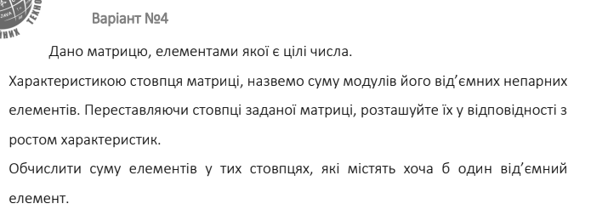

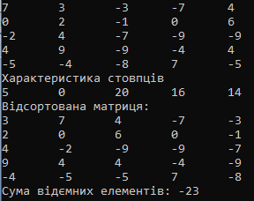

namespace Lab2

{

internal class Program

{

static void Main(string[] args)

{

Console.WriteLine("Hello, World!");

matrix mat = new matrix();

mat.GetMass();

mat.GetCh();

mat.SortMatrix();

}

}

public class matrix

{

Random rnd = new Random();

int[,] mass = new int[5,5];

int[] ch = new int[5];

int sum;

public matrix() {

for (int i = 0; i < 5; i++)

{

for (int j = 0; j < 5; j++)

{

mass[i, j] = rnd.Next(-10, 10);

}

}

for (int j = 0; j < 5; j++)

{

sum = 0;

for (int i = 0; i < 5; i++)

{

if ( mass[i,j] < 0 && (mass[i, j] %2 == 1 || mass[i, j] % 2 == -1))

{

sum += Math.Abs(mass[i, j]);

}

}

ch[j] = sum;

sum = 0;

}

}

public void GetMass()

{

for (int i = 0; i < 5; i++)

{

for (int j = 0; j < 5; j++)

{

Console.Write(mass[i, j] + " \t");

}

Console.WriteLine();

}

}

public void GetCh()

{

Console.WriteLine("Характеристика стовпцiв");

for(int i = 0; i < 5; i++)

{

Console.Write(ch[i] + "\t");

}

Console.WriteLine();

}

public void SortMatrix()

{

Console.WriteLine("Вiдсортована матриця: ");

for (int i = 0; i < 5 - 1; i++)

{

for (int j = i + 1; j < 5; j++)

{

if (ch[i] > ch[j])

{

for (int k = 0; k < 5; k++)

{

int temp = mass[k, i];

mass[k, i] = mass[k, j];

mass[k, j] = temp;

}

int tempChar = ch[i];

ch[i] = ch[j];

ch[j] = tempChar;

}

}

}

int sum = 0;

for (int j = 0; j < 5; j++)

{

bool hasNegative = false;

for (int i = 0; i < 5; i++)

{

if (mass[i, j] < 0)

{

hasNegative = true;

break;

}

}

if (hasNegative)

{

for (int i = 0; i < 5; i++)

{

sum += mass[i, j];

}

}

}

for (int i = 0; i < 5; i++)

{

for (int j = 0; j < 5; j++)

{

Console.Write(mass[i, j] + "\t");

}

Console.WriteLine();

}

Console.WriteLine("Сума вiдємних елементiв: " + sum);

}

}

}