**Furniture Store App Using Django**

Furnish-Zone allows users to easily access comprehensive information on furniture products, including descriptions, pricing, available sizes or variations, and customer reviews. The purchasing process is streamlined and straightforward, requiring just basic customer details and payment information. After placing an order, users can conveniently track their purchases via the order details page. For store administrators, the platform provides an intuitive dashboard to efficiently manage product listings, monitor sales, and maintain inventory levels.

**Scenario based case-study**

Imagine a busy parent shopping for their family's needs. With Furnish-Zone, they can swiftly search for furniture across different categories, compare options by price and customer ratings, and finalize their purchase in just a few clicks. They can then easily access their order details on the go, making it simple to track shipments or modify orders as needed. Meanwhile, the store owner gains access to real-time sales data, enabling them to optimize inventory and allocate resources efficiently.

**Project Goals and Objectives:**

Our key objectives are as follows:

* **User-Friendly Experience:** Develop an intuitive interface that facilitates easy navigation, filtering, and search functionalities.
* **Implement Efficient Inventory:** Ensure real-time tracking of products availability and stock levels.
* **Ensure Scalability:** Develop a scalable architecture that allows future expansion with more products and features.

**TECHNICAL ARCHITECTURE**

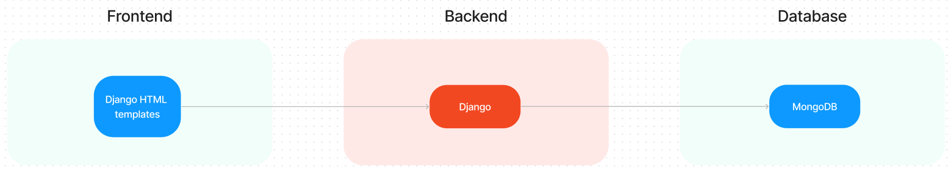

The technical architecture of our Furnish-Zone app follows a client-server model, where the frontend serves as the client and the backend acts as the server. The frontend utilizes the bootstrap library to establish real-time and better UI experience for any user whether it is admin, client or ordinary user working on it.

On the backend side, we employ Django framework to handle the server-side logic and communication.

For data storage and retrieval, our backend relies on MongoDB. MongoDB allows for efficient and scalable storage of user data, etc. It ensures reliable and quick access to the necessary information.

Together, the frontend and backend components, along with Django and MongoDB, form a comprehensive technical architecture for our Furnish-Zone app. This architecture enables real-time communication, efficient data exchange, and seamless integration, ensuring a smooth and immersive booking a property and many more experience for all users.

### PROJECT STRUCTURE

### https://lh7-rt.googleusercontent.com/docsz/AD_4nXd1pRJhqYEA1aMa2G5l8LHKfOpIigfOsxyLS_WyIJT8UjYEGjDXiWhvWbXynPgFbmEHS_dqpyAso3kaDI1vZg_eRFTNLu2smZ4hZ_hYRF5aN3mI3gl7i3-OqqMunlXRpOcdUaY4Rg?key=arjp5m-IfTU98Z9MS6mwCRmx

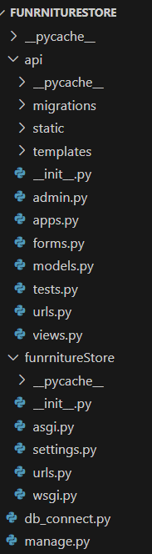

The first image shows the frontend content. It has a well-organized structure with dedicated folders for the API, static files (CSS and images), and templates (admin, and user). The API folder likely contains the code for the application's functionalities. The static folder stores the application's static files, such as Cascading Style Sheets (CSS) used for styling the user interface and images that may be displayed throughout the application. Finally, the templates folder contains the HTML templates that define the application's layout and user interface. These templates are used to dynamically generate the web pages that users will see.

The second image shows details about the server login. It follows a well-defined structure separating the core application logic from the overall project configuration. The application code resides in the Furnish-Zone directory, containing models, views, and templates specific to the Furnish-Zone functionality. The main project directory Furnish-Zone project-wide settings, URL patterns, and management tools. This separation promotes maintainability and scalability as the project grows.

### Features:

## **Extensive Product Catalog**

Furnish-Zone offers an extensive catalogue of furniture products, providing a wide range of categories and options for shoppers. You can easily browse through the catalogue and explore different items, including detailed descriptions, high-quality images, pricing information, and customer reviews, to find the perfect furniture products for your needs.

## **Add to Cart Button**

Each product listing includes a convenient "Add to Cart" button. When you find an item that you'd like to purchase, simply click on the button to add it to your shopping cart. You can adjust quantities or remove items from your cart at any time before checkout.

## **Product Details Page**

Clicking on a product will take you to its detailed page. Here, you can find comprehensive information about the item, including:

* Full product description
* Available sizes, colors, or other variations
* Price and any applicable discounts
* Customer reviews and ratings
* Related or recommended furniture products

## **Secure and Efficient Checkout Process**

Furnish-Zone ensures a secure and efficient checkout process. Your personal and payment information is handled with the utmost care, utilizing industry-standard encryption protocols. We strive to make the purchasing process as quick and hassle-free as possible, with options for guest checkout or creating an account for faster future purchases.

## **Order Confirmation and Tracking Page**

Once you have successfully placed an order, you will receive a confirmation message. You will then be redirected to an order details page, where you can review all the relevant information about your purchase, including:

* Order number and date
* Items purchased and their quantities
* Shipping address and method
* Payment information
* Estimated delivery date

From this page, you can also track your order status as it moves through processing, shipping, and delivery stages.

## **User Account Dashboard:**

Registered users have access to a personalized dashboard where they can:

* View order history and reorder past purchases
* Manage personal information and preferences
* Save multiple shipping addresses
* View and manage wishlist items
* Access personalized product recommendations

These features are designed to provide a seamless and enjoyable shopping experience on the Furnish-Zone platform, from browsing furniture products to completing purchases and managing your account.

### Pre-requisites

Here are the key prerequisites for developing a full-stack application using Django, MongoDB:

**Django: Setting Up Your Project**

Django is a high-level Python framework for building web applications. It streamlines the development process by providing a robust structure and handling common web development tasks.

**Prerequisites:**

* Python (version 3.6 or later recommended)
* pip (Python package installer)

**Installation:**

* Verify Python Installation: Open a terminal or command prompt and type python --version. If Python is installed, you'll see the version number.
* Install pip: If you don't have pip, install it using get-pip.py from https://bootstrap.pypa.io/get-pip.py

**Creating a Django Project:**

* Open a terminal: Navigate to your desired project directory.
* Create a project: Use the following command, replacing mysite with your project name:

django-admin startproject mysite

**Running the Development Server:**

* Navigate to the project directory: Use cd mysite.
* Start the server: Run python manage.py runserver.

**Access Your Application:**

Open http://127.0.0.1:8000/ in your web browser. You should see the Django welcome page, indicating a successful setup.

**MongoDB:**

MongoDB is a flexible and scalable NoSQL database that stores data in a JSON-like format. It provides high performance, horizontal scalability, and seamless integration with Node.js, making it ideal for handling large amounts of structured and unstructured data.

Set up a MongoDB database to store your application's data.

Download: https://www.mongodb.com/try/download/community

Installation instructions: https://docs.mongodb.com/manual/installation/

**HTML, CSS, and JavaScript**: Basic knowledge of HTML for creating the structure of your app, CSS for styling, and JavaScript for client-side interactivity is essential.

**Database Connectivity**: Use a MongoDB driver or an Object-Document Mapping (ODM) library like Mongoose to connect your Django server with the MongoDB database and perform CRUD (Create, Read, Update, Delete) operations. To Connect the Database add the dependency in the pom.xml file

<dependency>

    <groupId>org.springframework.boot</groupId>

    <artifactId>spring-boot-starter-data-mongodb</artifactId>

</dependency>

**Development Environment**: Choose a code editor or Integrated Development Environment (IDE) that suits your preferences, such as Visual Studio Code, Sublime Text, or WebStorm.

• Visual Studio Code: Download from <https://code.visualstudio.com/download>

To run the existing Furnish-Zone App project downloaded from Google Drive, Follow below steps:

Download the code from the drive link provided below.

https://drive.google.com/drive/folders/10sxhVX6W0Oq4763x3FZFKGz4Q9j0x3h_?usp=sharing

Then, open the project in a suitable ide or code editor and run the application using the run button provided.

• The Furnish-Zone app will be accessible at <http://127.0.0.1:8000/>

You have successfully installed and set up the Furnish-Zone application on your local machine. You can now proceed with further customization, development, and testing as needed.

### Application flow

1. **User flow**

?   After registration, users can log in with their credentials.

?   Once logged in, they can browse the product catalog or use the search function to find specific items.

?   Users can view detailed product information, including descriptions, prices, and reviews.

?   They can add desired items to their shopping cart.

?   Users can proceed to checkout by entering shipping details and selecting a payment method.

?   After completing the purchase, they can view their order details and track the shipment.

?   Users can also access their account dashboard to view order history, manage personal information, and save favourite furniture products.

#### **Admin Flow:**

* Admins start by logging in with their credentials.
* Once logged in, they are directed to the Admin Dashboard.
* From the Admin Dashboard, they can:
* Manage product listings (add, edit, or remove furniture products)
* View and process orders
* Manage inventory levels
* Access customer data and support tickets
* View sales reports and analytics
* Manage promotions and discounts
* Configure shipping options and payment gateways

**Project Flow**

### Project setup and configuration

## **Create project folders and files:**

## Now, firstly create the Django project with the below command:

## django-admin startproject project_name

Also, create an app to manage the rest operations with the command given below:

django-admin startapp app_name

1. **Install required tools and software:**

For the Django application to function well, we use the libraries mentioned in the prerequisites. Those libraries include

* Django
* MongoDB
* Corsheader
* Rest_framework

### Backend Development

#### **Set Up Project Structure:**

* Create a project directory using your preferred IDE.
* Open a terminal in the project directory.
* Create an app with the instructions provided above.

#### **Database Configuration:**

* + Set up a MongoDB database either locally or using a cloud-based MongoDB service like MongoDB Atlas.
* Create a database and define the necessary collections for users, properties and applications.

#### **Define API Routes:**

* + Create separate route files for different API functionalities such as authentication, users, furniture products, orders and cart.
* Implement urls and views to handle the app route paths and user requests.

#### **Implement Data Models:**

* + Define MongoDB schemas for the different data entities like users, properties and applications.
* Create corresponding Mongoose models to interact with the MongoDB database.
* Implement CRUD operations (Create, Read, Update, Delete) for each model to perform database operations.

#### **Admin Functionality:**

* Implement routes and controllers specific to admin functionalities such as fetching all the data regarding users, orders and furniture products.

1. **Error Handling:**
   * Implement error handling middleware to catch and handle any errors that occur during the API requests.

* Return appropriate error responses with relevant error messages and HTTP status codes.

**Database development**

* Set up a MongoDB database either locally or using a cloud-based MongoDB service like MongoDB Atlas.
* Create a database and define the necessary collections for users, furniture products, orders and cart.
* Also, let’s see the detailed description for the schemas used in the database.

**1. Users:**

The Users model is the cornerstone of customer management in the Furnish-Zone platform. It stores essential information about each registered user, enabling personalized experiences and secure transactions.

Key features:

* Unique user identification for account management and order tracking
* Secure authentication using email and hashed password
* Storage of multiple shipping addresses for convenient checkout
* Tracking of account activity (creation date, last login)

**2.** **Furniture products Model:**

The Furniture products model is the heart of the Furnish-Zone inventory system. It contains comprehensive information about each item available for purchase, providing customers with all the details they need to make informed buying decisions.

Key features:

* Detailed product information including descriptions, specifications, and images
* Real-time inventory tracking
* Flexible pricing and discount management
* Categorization for easy browsing and searching

**3.Cart Model:**

The Cart model represents the temporary storage of items that a user intends to purchase. It plays a crucial role in the user's shopping experience, allowing them to collect and review items before making a final purchase decision.

Key features:

* Association of selected furniture products with user accounts
* Persistence of cart contents across sessions
* Real-time price and availability updates
* Calculation of total cost including taxes and shipping

**4. Orders Model:**

The Orders model serves as a comprehensive transaction log for all purchases made on the Furnish-Zone platform. It bridges the gap between customer actions and business operations, tracking the entire lifecycle of each order.

Key features:

* Detailed record of each transaction, including items purchased, quantities, and prices
* Order status tracking from processing to delivery
* Integration with payment systems for accurate financial records
* Association with user accounts for order history and reordering

The code for the database connection looks like,

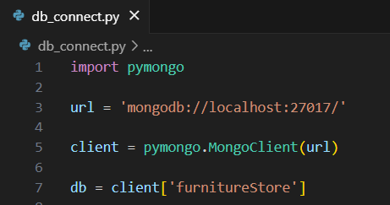

Also, follow the below code to define the database models.

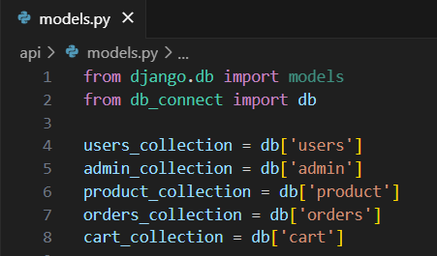

### Frontend development

* **Setup Frontend Application:**

Bringing the Furnish-Zone application to life involves a three-step development process. First, a solid foundation is built using template of Django. This includes creating the initial application structure, and organizing the project files for efficient development. Next, the user interface (UI) comes to life.

**Design UI components:**

Crafting a seamless user experience in Furnish-Zone App requires designing UI components. This involves creating individual elements like buttons, forms, and menus. We'll then define their arrangement and visual style (layout and styling) for a cohesive look. Finally, navigation elements will be implemented to ensure users can easily move between different functionalities within the app.

## Implement frontend logic:

## In the final leg of the frontend development, we'll bridge the gap between the visual interface and the underlying data. It involves the below stages.

* Integration with API endpoints.
* Implement data binding.

### Project Implementation

On completing the development part, we then run the application one last time to verify all the functionalities and look for any bugs in it. The user interface of the application looks a bit like the images provided below.

**Home:**

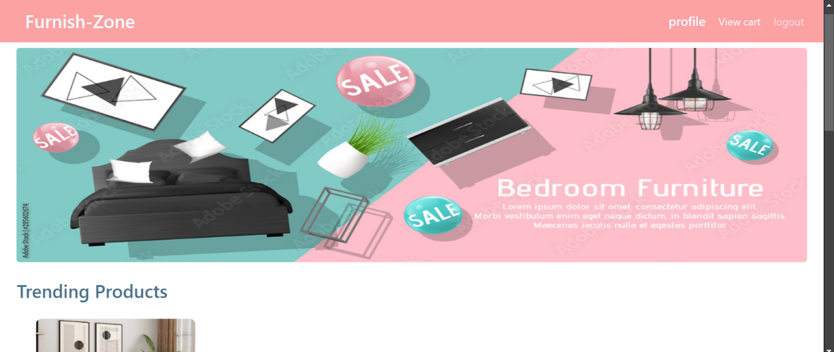

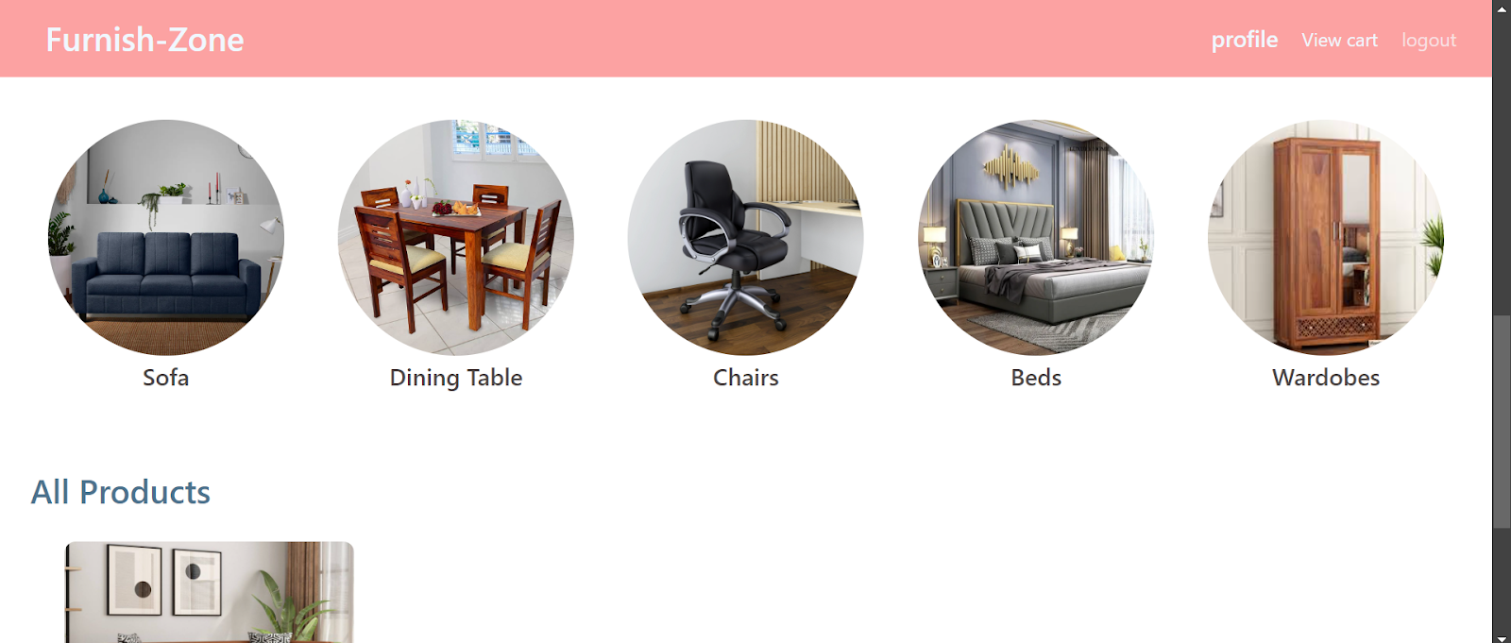

**Login:**

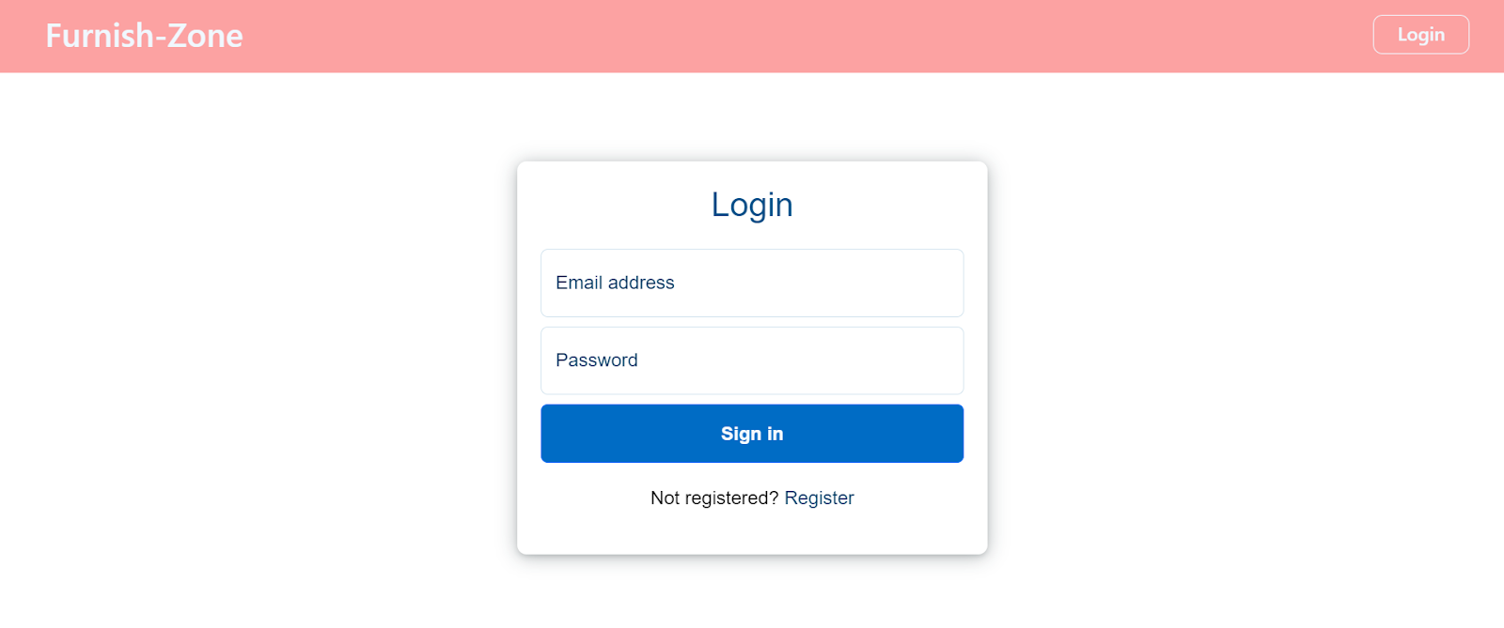

**Register:**

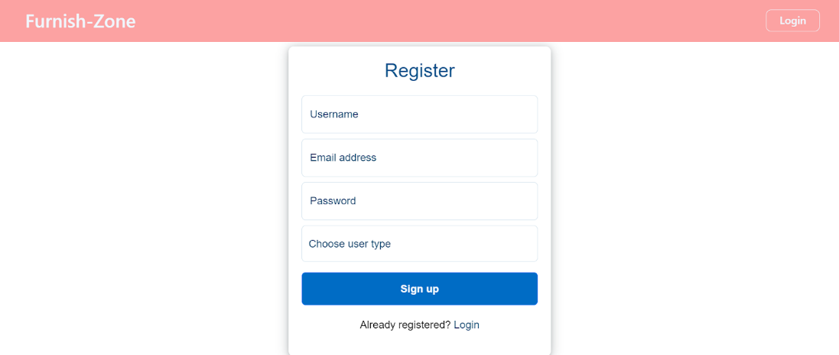

**Category Page:**

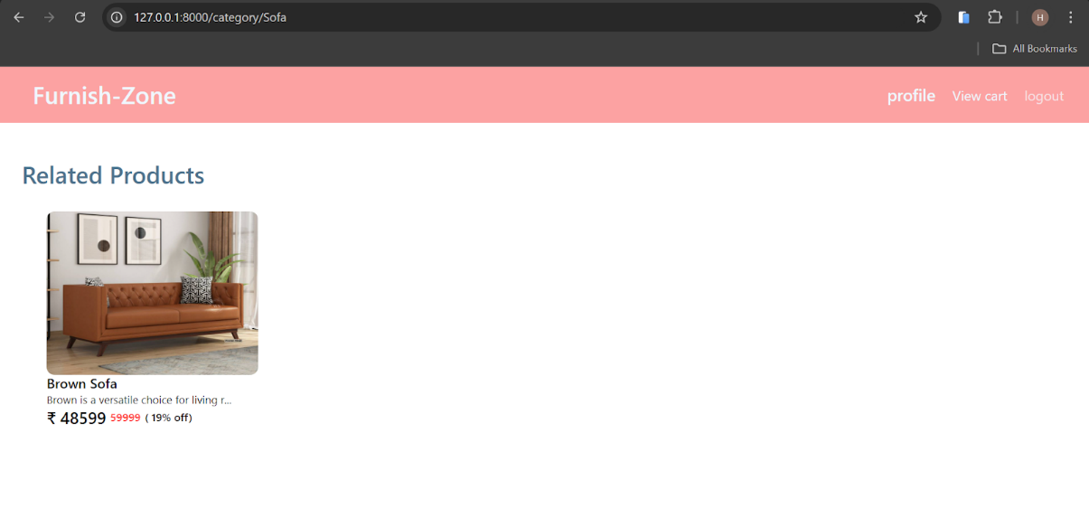

**Profile:**

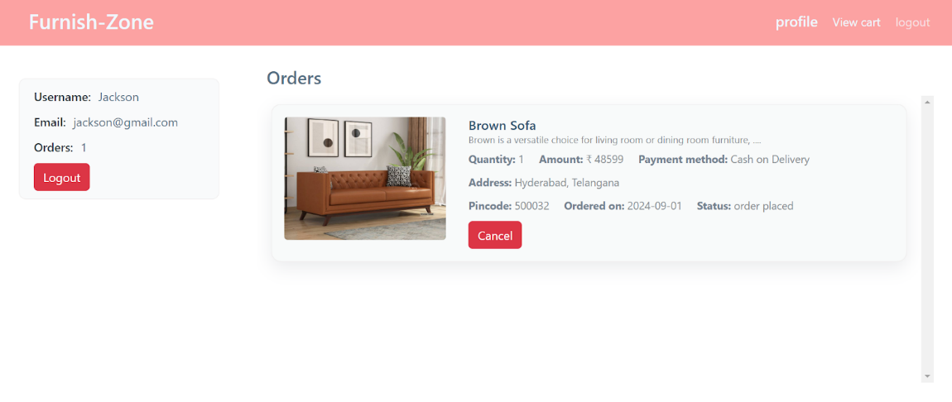

**Admin:**

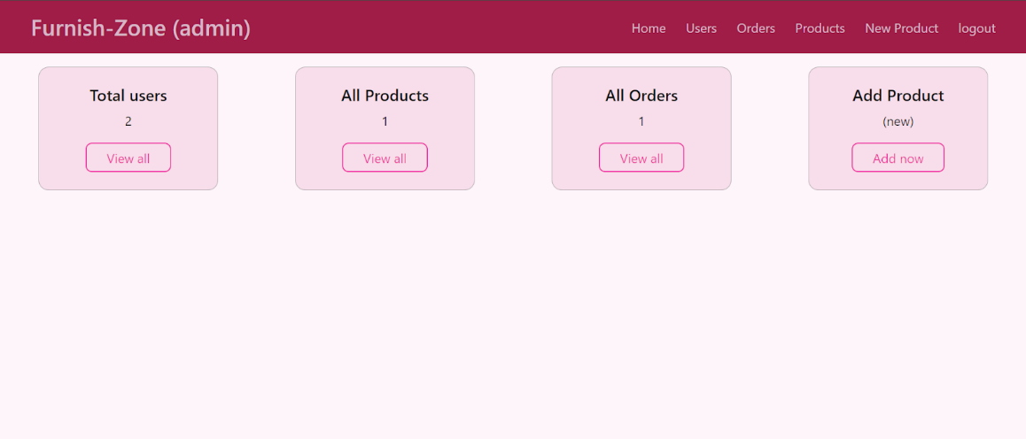

**All Users:**

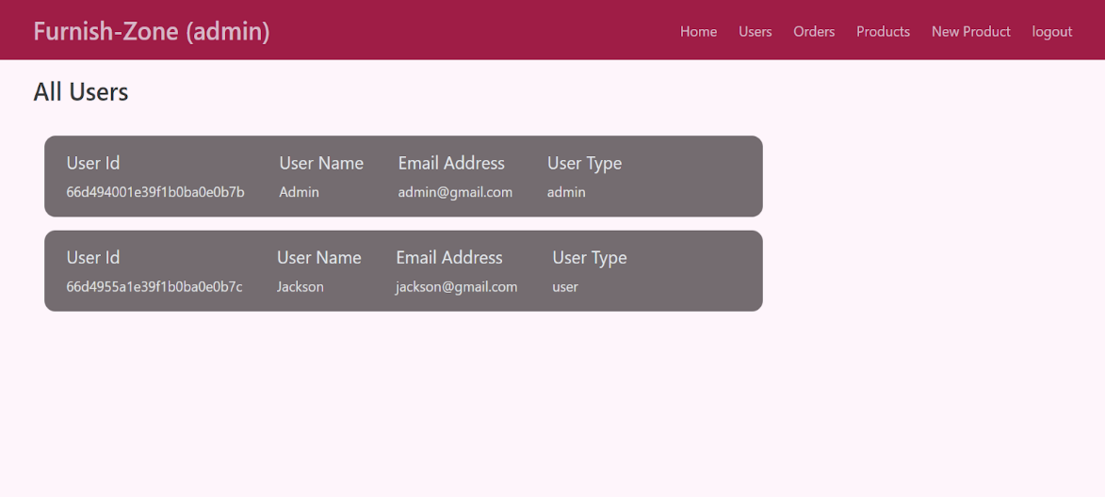

**All Furniture products:**

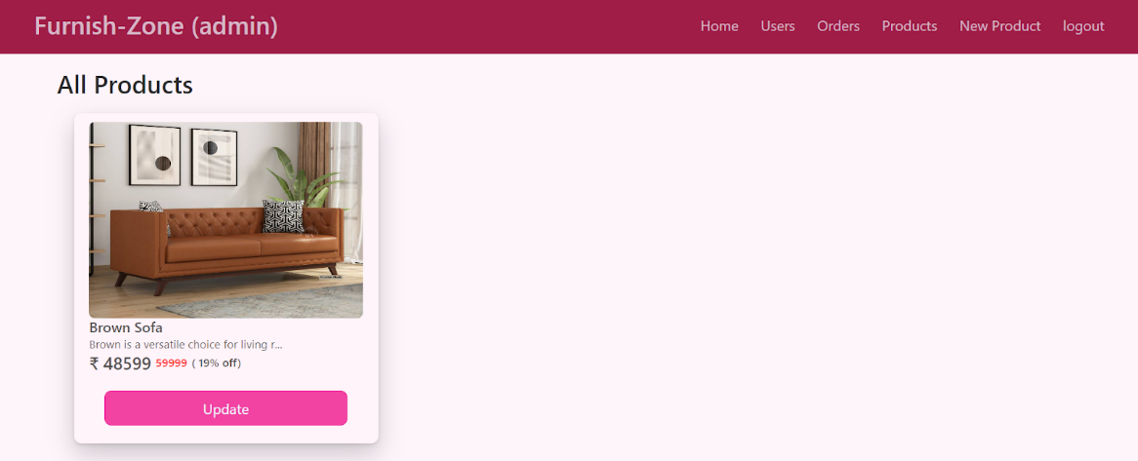

**All Orders:**

