Make admin user

[afiya@localhost ~]$ sudo su –

Update the linux system

[root@localhost ~]# yum update -y

Install git

[root@localhost ~]# yum install git -y

Git download Complete!

Check git version

[root@localhost ~]# git –version

OP-git version 1.8.3.1

check where is git installed

[root@localhost ~]# which git

OP-/bin/git

[root@localhost ~]# git config --global user.name "MullaAfiya"

[root@localhost ~]# git config --global user.email "mullaafiya@gmail.com"

[root@localhost ~]# git config –list

OP-user.name=Afiya

[user.email=mullaafiya@mail.com](mailto:user.email=mullaafiya@mail.com)

Task

Step 1 – write code in workspace area

Step 2 – Add

Step 3 – commit

Step 4 push to Git hub

Initialize git

[root@localhost ~]# git init

OP-Initialized empty Git repository in /root/.git/

Create a file

Check git status

Now add file i.e from workspace area into stagging

Created a file by name Mumbai001

[root@localhost ~]# cat >Mumbai001

Mumbai meri jaan[Cntrl-D]

[root@localhost ~]# cat Mumbai001

Mumbai meri jaan

Check git status

[root@localhost ~]# git status

# On branch master

#

# Initial commit

#

# Untracked files:

# (use "git add <file>..." to include in what will be committed)

#

# .bash_history

# .bash_logout

# .bash_profile

# .bashrc

# .cache/

# .config/

# .cshrc

# .dbus/

# .gitconfig

# .tcshrc

# .viminfo

# .xauthBxiPhA

# .xauthdO3nk0

# .xauthdh4eNr

# .xauthiapGgV

# Mumbai

# Mumbai001

# Myfile

# anaconda-ks.cfg

# initial-setup-ks.cfg

nothing added to commit but untracked files present (use "git add" to track)

[root@localhost ~]#

--This states we are in master branch and did not commit

We have untracked files.

Git Add

[root@localhost ~]# ls

anaconda-ks.cfg initial-setup-ks.cfg Mumbai Mumbai001 Myfile

[root@localhost ~]# git add Mumbai001

[root@localhost ~]# git status

# On branch master

#

# Initial commit

#

# Changes to be committed:

# (use "git rm --cached <file>..." to unstage)

#

# new file: Mumbai001

#

# Untracked files:

# (use "git add <file>..." to include in what will be committed)

#

# .bash_history

# .bash_logout

# .bash_profile

# .bashrc

# .cache/

# .config/

# .cshrc

# .dbus/

# .gitconfig

# .tcshrc

# .viminfo

# .xauthBxiPhA

# .xauthdO3nk0

# .xauthdh4eNr

# .xauthiapGgV

# Mumbai

# Myfile

# anaconda-ks.cfg

# initial-setup-ks.cfg

[root@localhost ~]#

Commit

[root@localhost ~]# git commit -m "commens-my first commit"

[master (root-commit) 4b47abe] commens-my first commit

1 file changed, 1 insertion(+)

create mode 100644 Mumbai001

After commit we have to push the code in to git hub i.e cenralized repository

🡪Create a repository in github

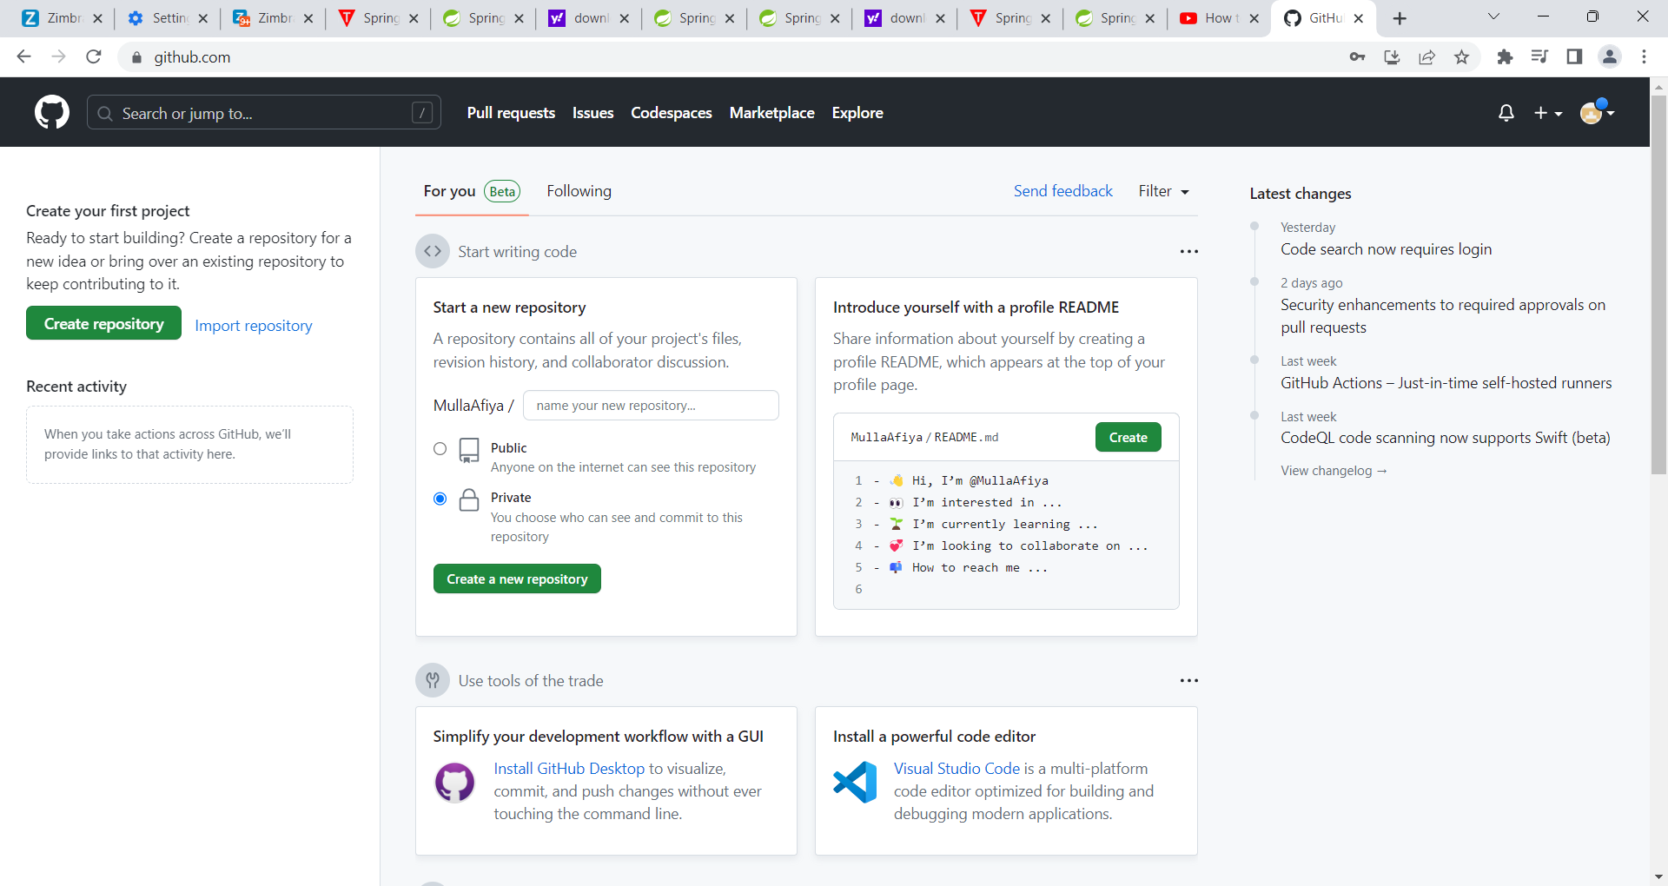

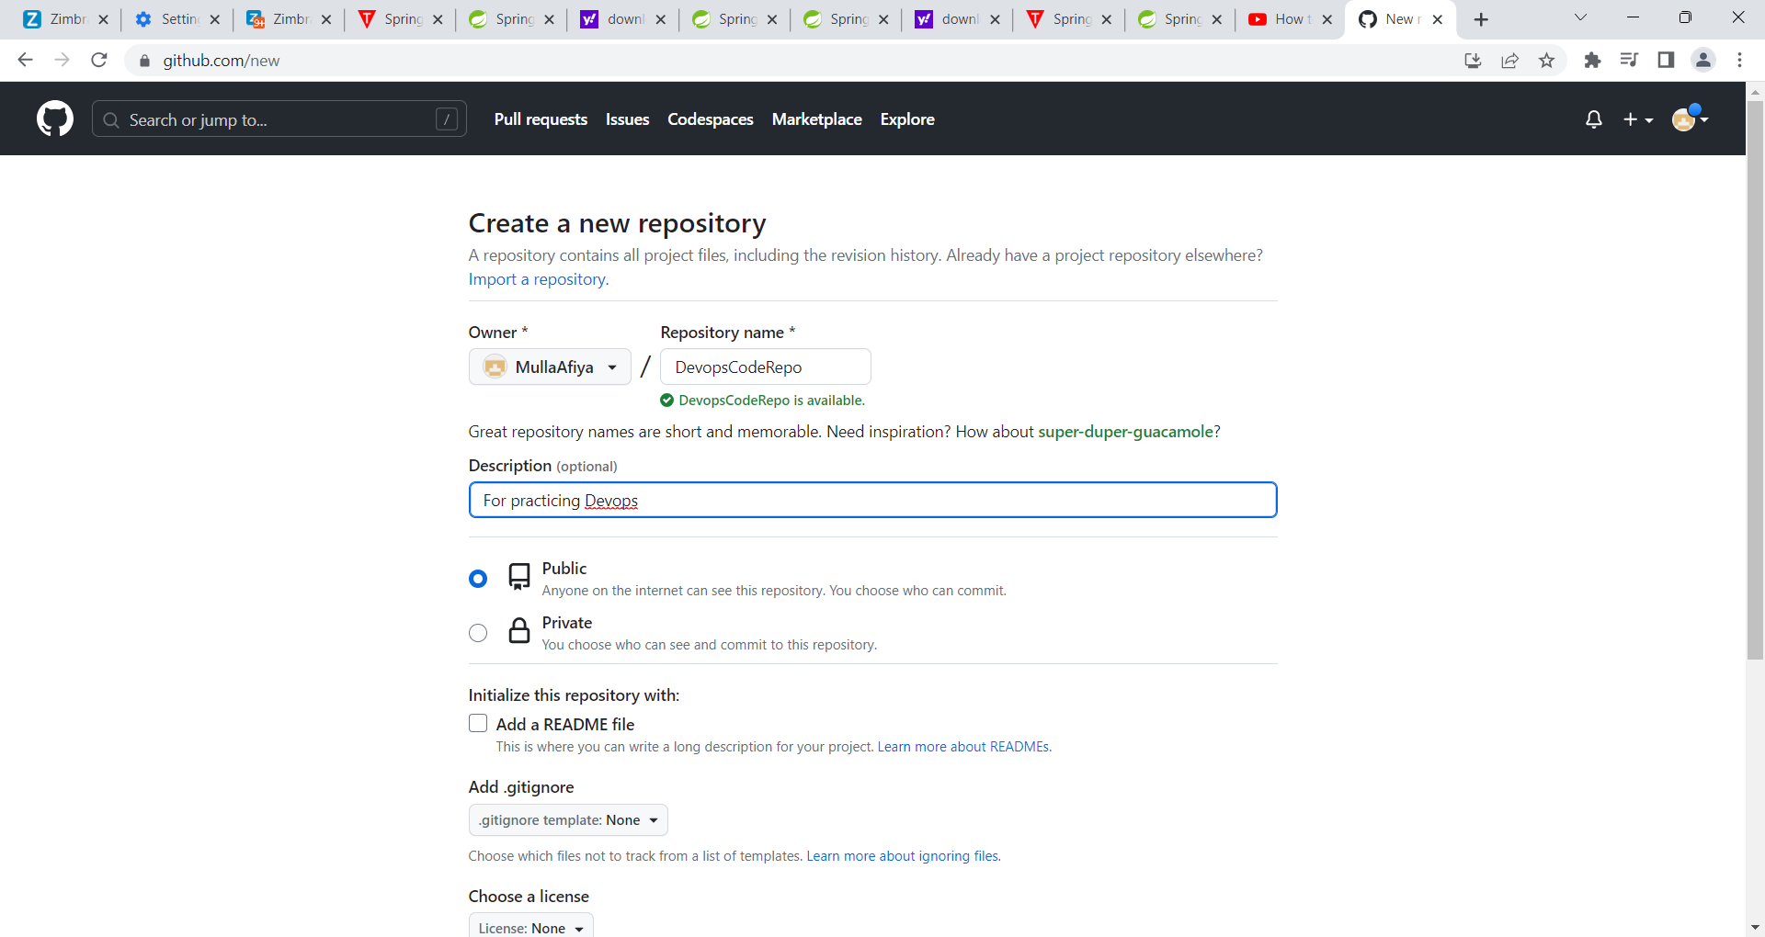

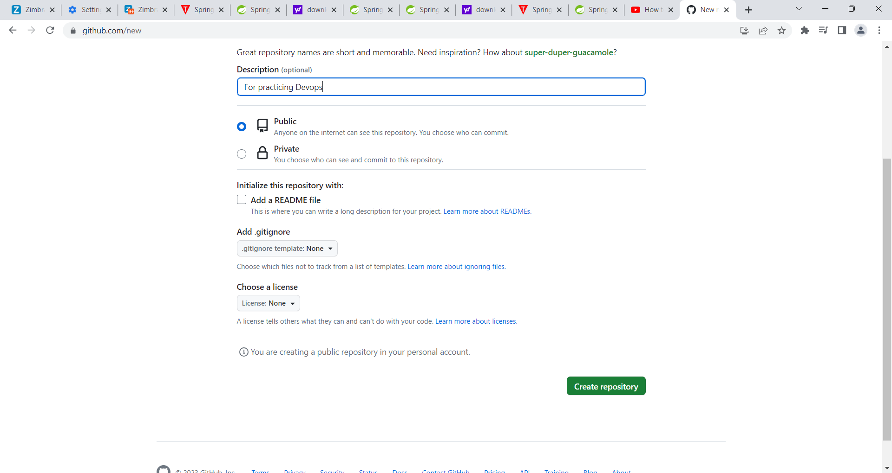

Create a repository

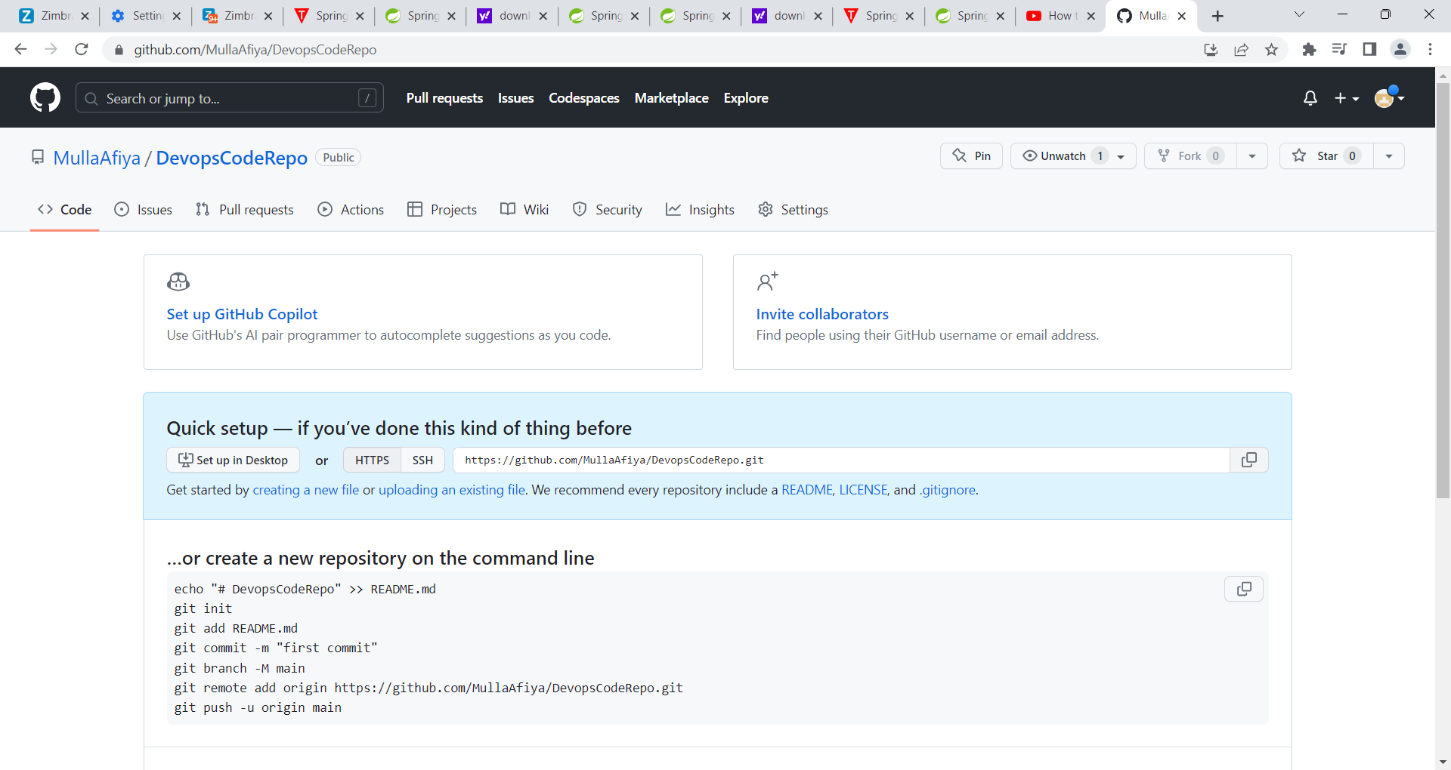

This is your git repository address

<https://github.com/MullaAfiya/DevopsCodeRepo.git>

Now go to your linux.

Adding the repository..

[root@localhost ~]# git remote add oringin <https://github.com/MullaAfiya/DevopsCodeRepo.git>

Pushing into git..