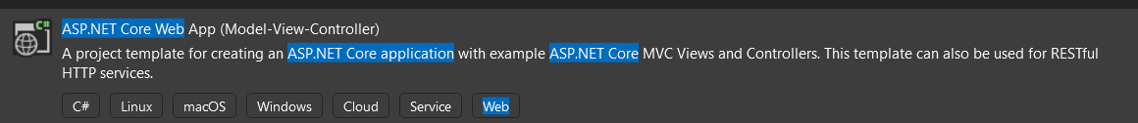

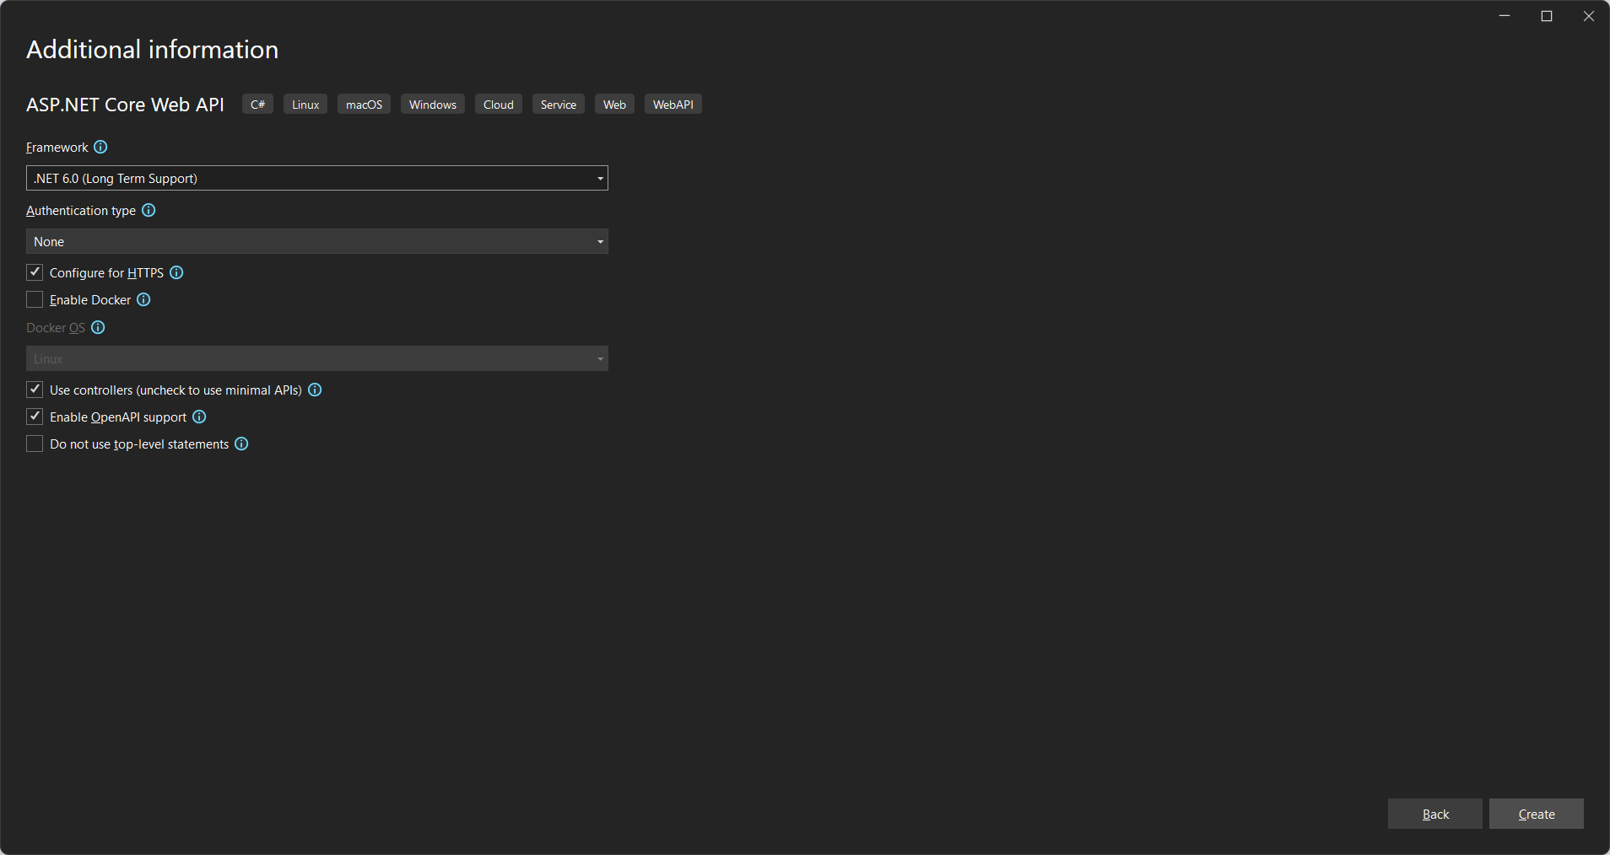

Install package Entity Framework



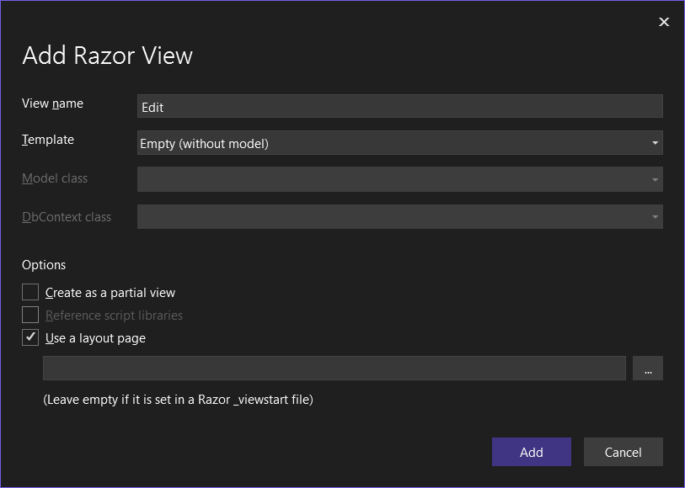

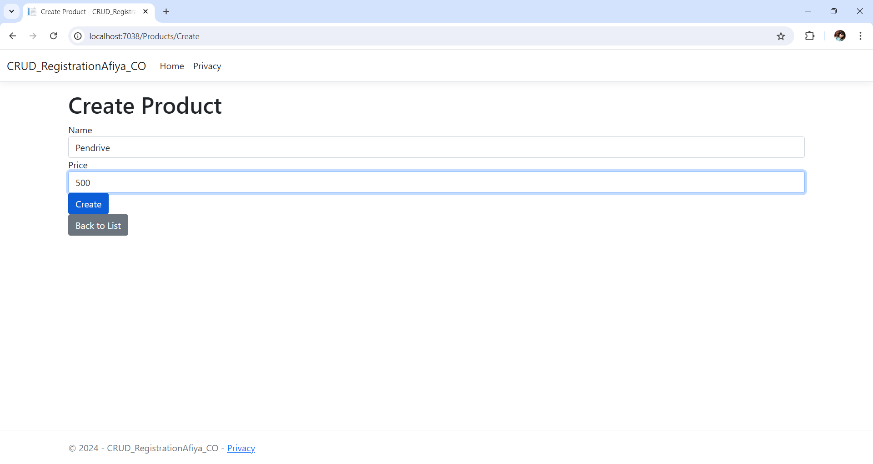

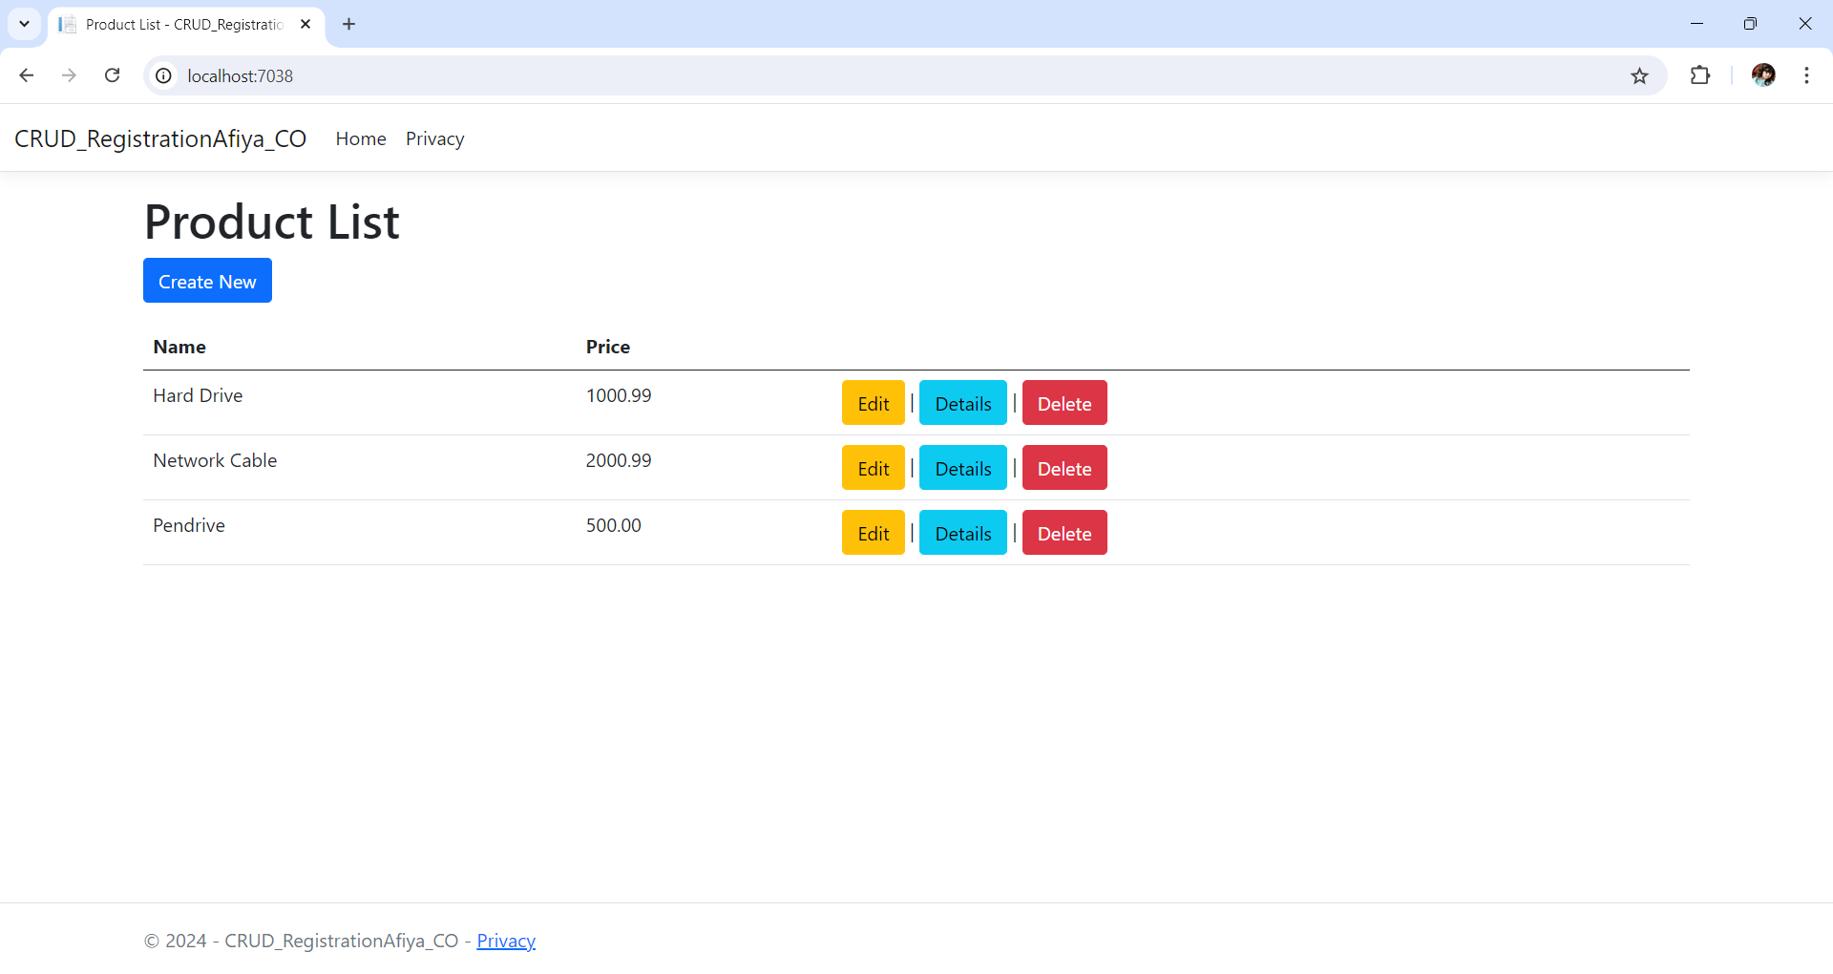

Edit

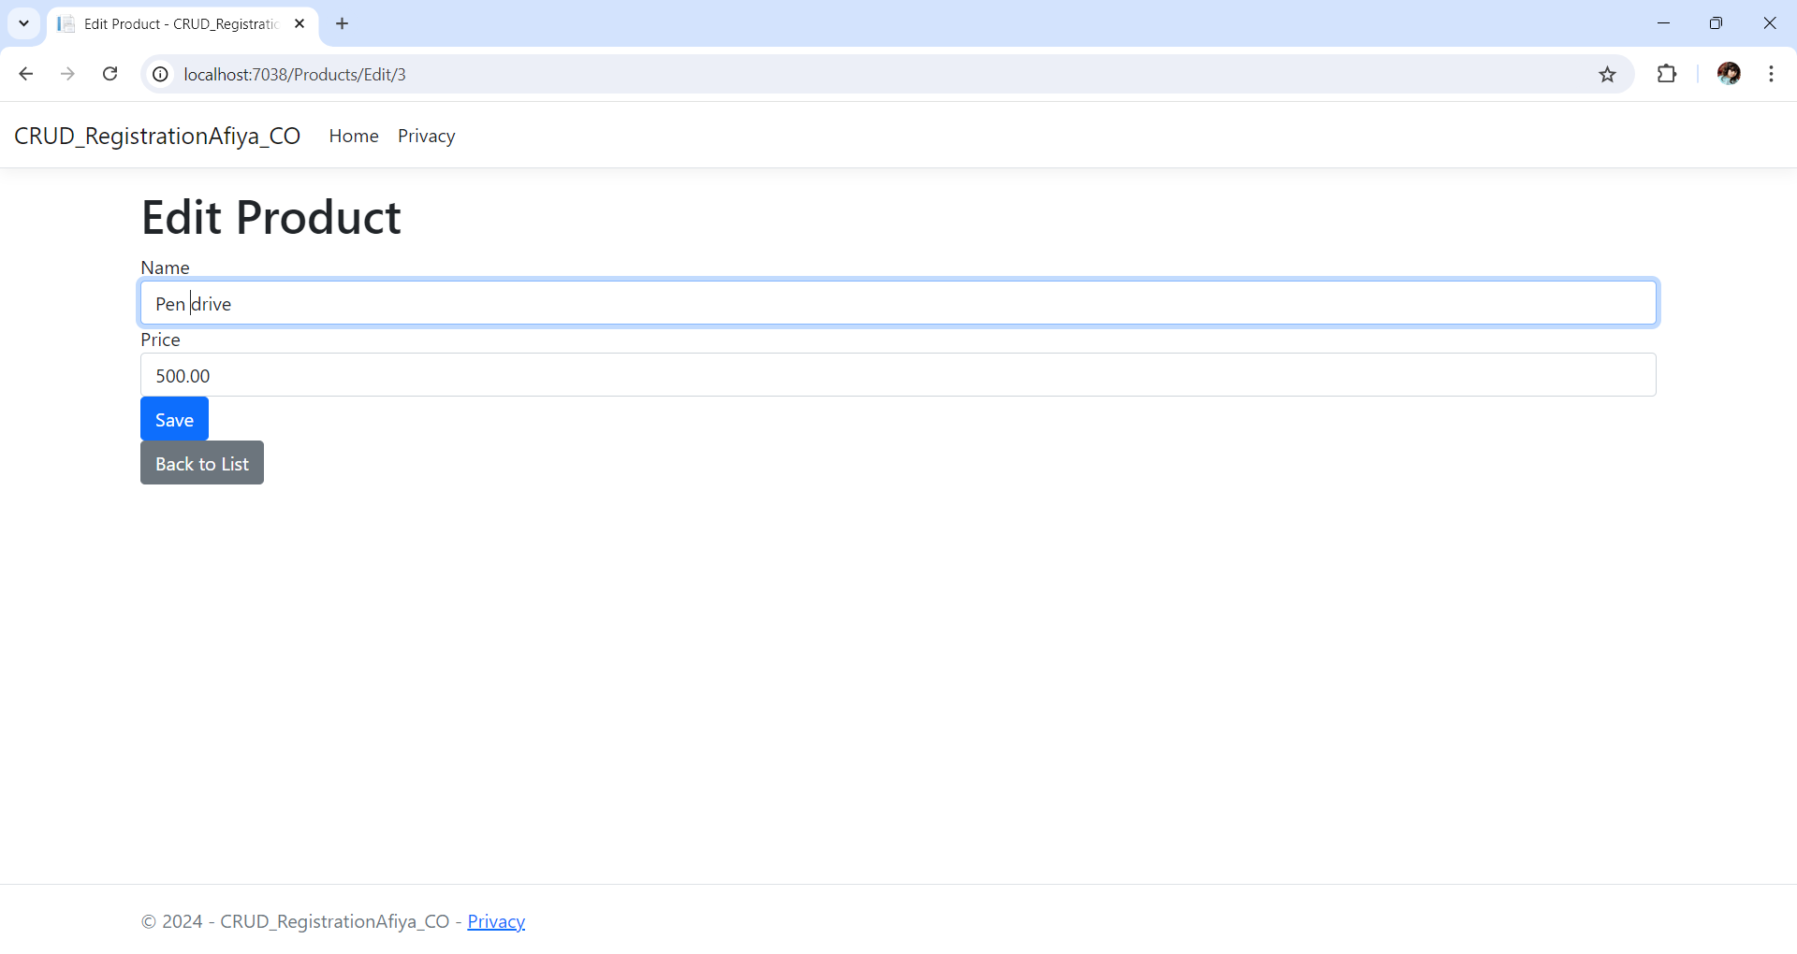

Create database CRUDRegistration

Use CRUDRegistration

CREATE TABLE Products (

Id INT IDENTITY(1,1) PRIMARY KEY,

Name NVARCHAR(100) NOT NULL,

Price DECIMAL(18, 2) NOT NULL

);