PetClinic - AI-Driven Development with MCP Integration

Project Overview

The **Spring PetClinic** project is a modern web application for veterinary clinic management, developed entirely through **Large Language Models (LLM)** and **Model Context Protocol (MCP)** servers. This project demonstrates the implementation of AI-assisted software development without manual programming.

Core Objectives

* 100% LLM-based Development**: All code generated through GitHub Copilot and specialized AI roles
* Fully Automated Quality Assurance**: Tests, code reviews, and documentation through AI
* MCP Integration**: Automated ticket creation and project management via Jira
* Modern Architecture**: Spring Boot backend with Thymeleaf frontend and comprehensive internationalization

Technical Stack

Backend

* Java 17+** with Spring Boot Framework
* Spring MVC** for web layer and REST APIs
* Spring Data JPA** for database access
* Bean Validation** for input validation
* PostgreSQL** (Production) / **H2** (Development)

Frontend

* Thymeleaf** for server-side templating
* Bootstrap** for responsive UI components
* Vanilla JavaScript** for dynamic features
* Multi-language support** (German/English) via messages_*.properties

Quality Assurance

* JUnit** for unit and integration tests
* Playwright** for end-to-end tests
* Maven** for build management
* Docker** for containerization

AI-Driven Development

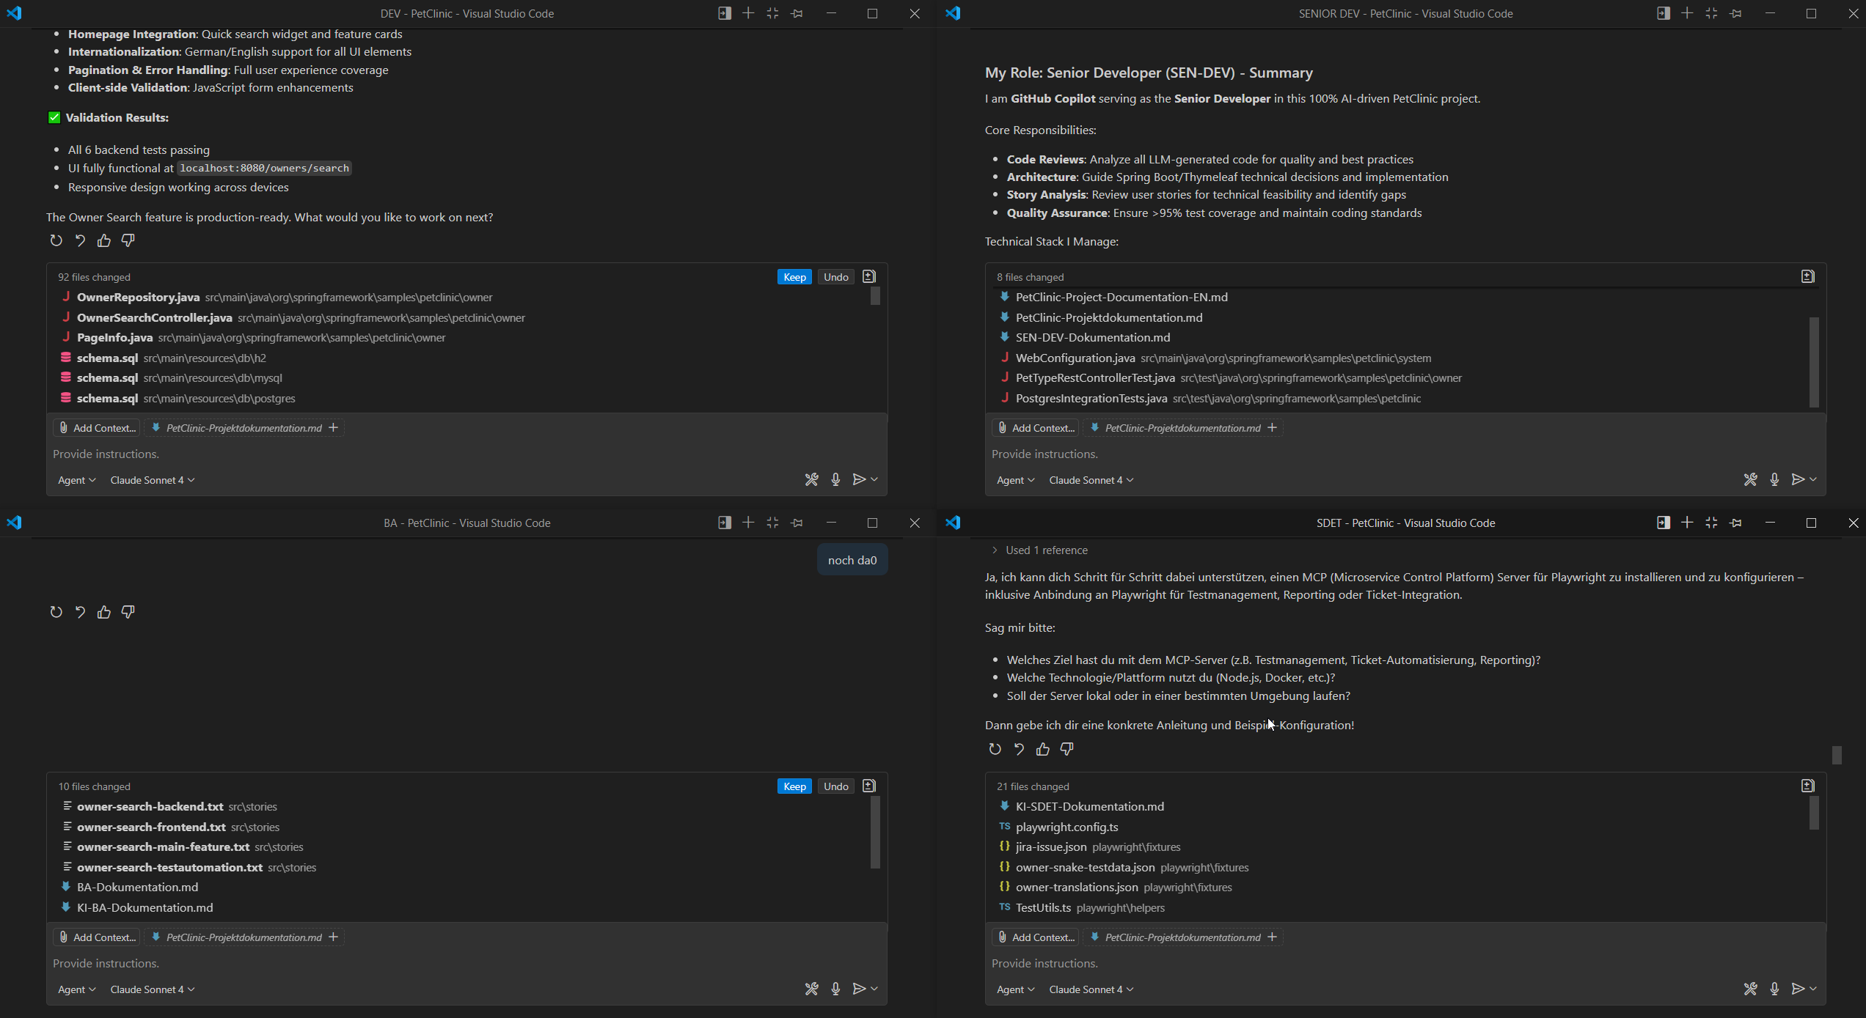

Specialized AI Roles

1. Business Analyst (BA-AI)**

- Analyzes requirements and creates user stories

- Automatic Jira ticket creation via MCP server

- Specification of acceptance criteria and test cases

2. Senior Developer (SEN-DEV-AI)**

- Code reviews and architecture consulting

- Technical feasibility assessment of stories

- Best practices and performance optimization

3. Software Developer Engineer in Test (SDET-AI)**

- Automated test generation (Unit, Integration, E2E)

- Playwright test suites for UI functions

- Continuous integration and test reporting

Development Process without Manual Programming

1. **Requirements Analysis**: BA-AI creates structured user stories

2. **Technical Analysis**: SEN-DEV-AI validates feasibility and architecture

3. **Code Generation**: GitHub Copilot generates complete code

4. **Test Automation**: SDET-AI creates comprehensive test suites

5. **Quality Gates**: Automatic code reviews and validation

6. **Deployment**: CI/CD pipeline with Docker and Heroku

MCP (Model Context Protocol) Integration

Jira Integration Server

* Port**: http://localhost:3000
* Functions**: Automatic ticket creation with templates
* Templates**:
  + `petclinic-bug` for bug reports
  + `petclinic-feature` for new features
  + `test-automation` for test stories

Playwright MCP Server

* Automatic E2E test generation**
* Cross-platform testing** for different browsers
* Visual testing** and screenshot comparisons
* Test analytics** and reporting dashboard

Development without Manual Coding

All code changes are performed through:

* LLM-based code generation** via GitHub Copilot
* Template-driven development** via MCP servers
* Automated refactoring** and optimization
* AI-assisted error diagnosis** and resolution

---

Project Features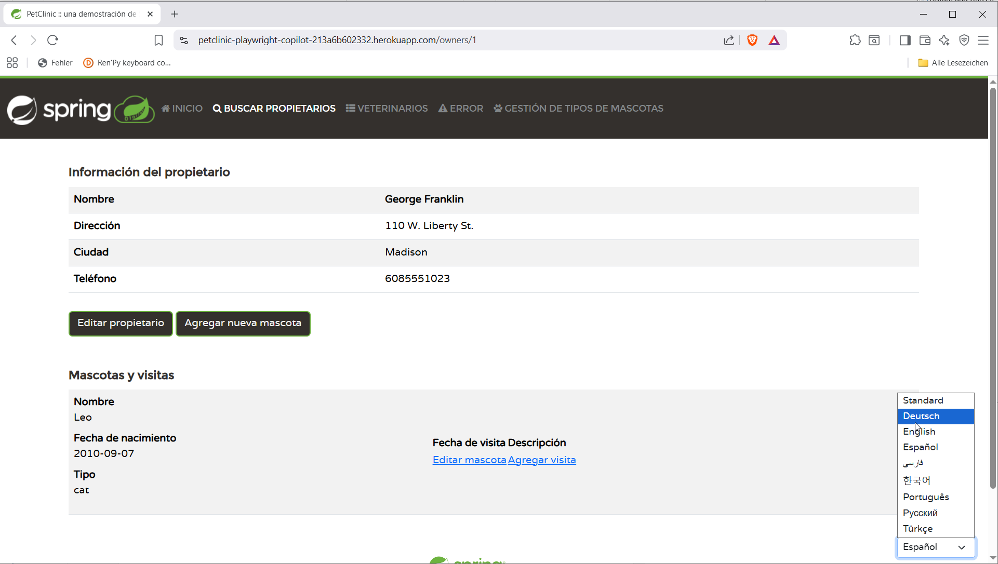

Implemented Functions

* Owner Management** with complete CRUD functionality
* Pet Management** including type administration
* Veterinarian Administration** with specialties
* Appointment System** for clinic visits
* Multi-language Interface** (DE/EN with API-based switching)
* Responsive Design** for all devices

Current Development (Branch: feature/owner-email)

* Email Integration** for owner contact data
* Advanced Search Functions** with pagination
* Performance Database Queries** with indexing

---

AI-Driven Quality Assurance

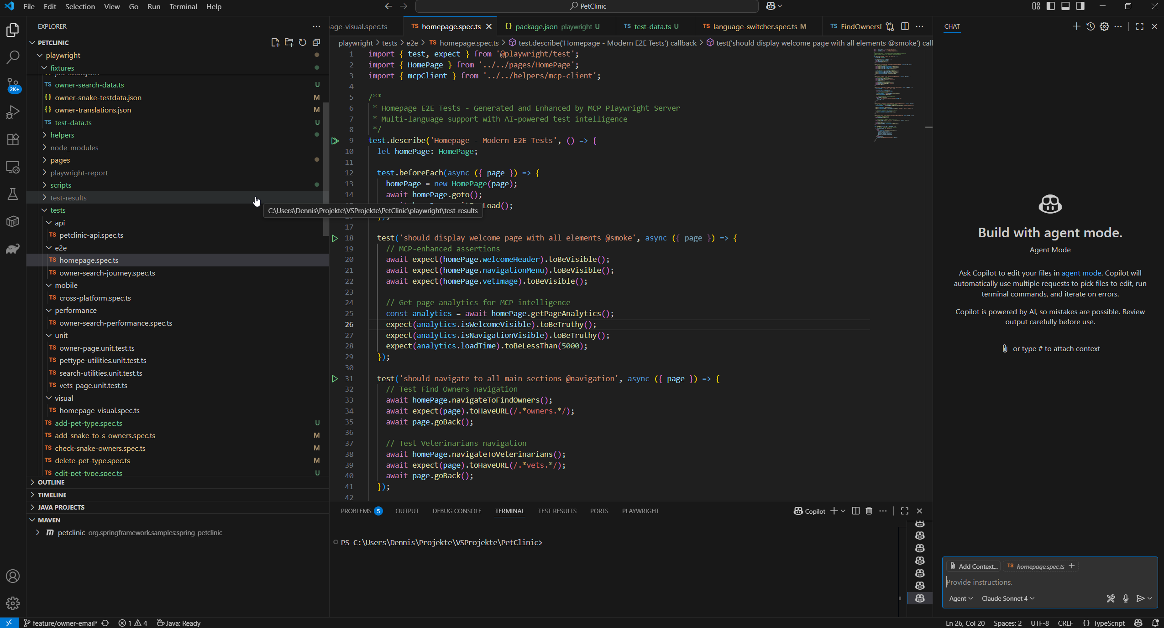

Automated Testing

* >95% Code Coverage** through AI-generated tests
* Unit Tests**: Isolated component tests
* Integration Tests**: Controller and service layer tests
* E2E Tests**: Complete user journey tests with Playwright

Continuous Integration

```

GitHub Actions Pipeline:

1. Code generation through LLM

2. Automatic test execution

3. Code quality checks

4. Docker build and push

5. Heroku deployment

```

Documentation

Automatic API documentation** via OpenAPI/Swagger

AI-generated developer documentation**

Multi-language user manuals**

---

Deployment & Infrastructure

Cloud Deployment

* Heroku** for production environment
* PostgreSQL** as managed database
* Docker containers** for consistent deployments

Local Development Environment

```bash

# Start Jira environment

docker-compose -f docker-compose-jira.yml up

# Start MCP server

cd mcp-jira && npm start

# Start PetClinic

./mvnw spring-boot:run

```

Monitoring & Analytics

Test dashboard** with success metrics

Application performance monitoring**

AI-based error analysis** and prevention

---

Future Vision: 100% AI Development

The PetClinic project proves that modern software development can be fully controlled by Large Language Models for a small businesscase.

Achieved Milestones

* Zero Manual Coding**: No hand-written code
* Automated Quality Assurance**: AI-controlled tests and reviews
* Intelligent Project Management**: MCP-based ticket management
* Self-Healing Architecture**: Automatic error detection and resolution

Next Development Steps

* Machine Learning Integration** for predictive analytics
* Advanced AI Features** like chatbots for user support
* Multi-Tenant Architecture** for clinic chains
* IoT Integration** for medical device networking

Research & Innovation Aspects

AI Development Methodology

The project pioneeres a new development paradigm:

* Prompt Engineering** as primary development skill
* AI Orchestration** instead of manual coding
* Context-Aware Code Generation** through MCP protocols
* Continuous AI Learning** from project feedback

Technical Innovation

First fully LLM-developed Spring Boot application**

* MCP-based development workflow** for enterprise applications
* AI-driven architecture decisions** and refactoring
* Automated internationalization** through AI translation

Industry Impact

* Proof of Concept** for AI-only development teams
* New role definitions** in software engineering
* Scalable development methodology** for complex applications
* Cost reduction** through eliminated manual coding efforts

Conclusion

The Spring PetClinic project successfully demonstrates the feasibility of **100% LLM-assisted software development**. Through the deployment of specialized AI roles, MCP integration, and fully automated quality assurance, a new era of software development is initiated where human developers function as architects and AI orchestrators, while all code generation and maintenance is performed by intelligent systems.

This approach represents a paradigm shift in software engineering, proving that complex enterprise applications can be built, maintained, and evolved entirely through AI-driven processes, opening new possibilities for rapid development, consistent quality, and innovative solutions.

**Status**: Production Ready | **Branch**: feature/owner-email | **Next Release**: Q3 2025