[TITLE]

DESIGN DOCUMENT

By Woowe, Shimura, namo, Mullenratte for the 2024 Brackey’s Game Jam

**Introduction** **2**

Game Summary 2

Inspiration 2

Player Experience 2

Platform 3

Development Software 3

Genre 3

Target Audience 3

**Concept** **3**

Gameplay overview 3

Theme Interpretation (Sacrifice Is Strength) 4

Primary Mechanics 4

Secondary Mechanics 5

**Art** **6**

Theme Interpretation 6

Design 6

**Audio** **7**

Music 7

Sound Effects 7

**Game Experience** **7**

UI 7

Controls 7

**Development Timeline** **8**

## 

## Introduction

### Game Summary Pitch

What is this game about? Is there a twist? What’s the most recognizable part of the game? // ELEVATOR PITCH

### Inspiration

**Snakebird *// Example 1***

Snakebird provides the ingenuity for the player to control **a body that isn't always helpful** and will certainly get in the way more often than aid one’s plan. A long body in that game may be susceptible to support the player from falling but often can **restrict and block certain movement** making puzzle areas much harder to navigate.

**Baba Is You *// Example 2*** 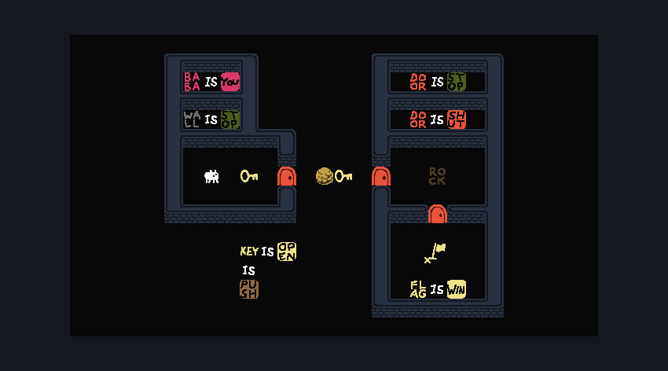

Baba is You is the main inspiration towards the style and mood of the game. Especially graphics-wise to fit the 2-bit graphical prompt, the **minimalist art style** will hold useful to act as a base. Otherwise, the gameplay also further provides inspiration towards level design as an abstract puzzle game.

### Player Experience

The player is given a deserted uninhabited **island**, and is given random effect cards each **round**, such as rain or tree saplings. The player can experiment with the **interactions** different effects have on a tile. The more life he **creates** this way, the higher the habitability meter. Some cards will require a certain habitability score to be played. Likewise, if the player **destroys** life by his actions, the meter decreases.

### Platform

The game is developed to be released on windows PC

### Development Software

* Unity 2022.3.45f1 for designing & programming
* [? // Example: Aseprite] for graphics and UI
* (FL Studio 12 for all music and SFX)

### Genre

Singleplayer, cozy, casual, nature

### Target Audience

This game is marketed to **casual players** who enjoy exploration, love to learn new things via experimentation and who like to see how their immediate actions can affect nature.

## Concept

### Gameplay overview

The player interacts with the world via **effect cards** he draws from a random deck. Each **turn** the player must play one card. Not all cards are positive, though. Natural catastrophes can occur. Once he ends his turn in any of the two ways, time passes and the **consequences** of his choice play out. If the player plays a rain card for example, crops on the affected tiles will grow.

### Theme Interpretation (Example: It’s Spreading)

**‘Spreading’ interpretation – The player starts with only a tiny grain of life on a lifeless island and continually tries to spread it as far as possible, until eventually a whole new habitat has spread from nothingness.**

Sometimes a small crop may be the start of a whole forest, but there are also times where natural disasters take over, such as lightning hitting a tree, resulting in a burning tree that quickly spreads to a wildfire. The player can try to support the spread of creation whilst trying to contain the spread of destruction, and might fail at this sometimes.

### 

### Primary Mechanics

| **Mechanic** |
| --- |
| **Volcanic Rock** a  The base ground tile, inhibiting life from naturally spreading on the island. Sometimes contains spring water or lava. |
| **Soil** a  Fertile ground that can host seedlings and crops. Likes to absorb water. |
| **Grass** a  Lush ground that can host seedlings. Likes to absorb water. Turns into soil when tilled. |
| **Hole** a  Inland holes might fill to become lakes, attracting animals. |
| **Lake** a  Inland holes might fill to become lakes, attracting animals. |
| **Foliage** a  A certain amount of foliage allows new animals in the habitat and can be harvested for twigs and berries. |
| **Tree** a  Trees attract birds and bees, and can be harvested for fruit or cut down for wood. |

## Art

### Design

The game will follow an isometric pixel art style with roughly a resolution of 32x32. The color palette makes use of rather saturated colors to support the **cozy** and **casual** approach of the gameplay. Since the gameplay mainly focuses on changing the environment, the art will be the most important and probably also most time consuming aspect of the development.

## Audio

### Music

To fit the relaxing theme, the music will be kept very simplistic and subtle.

### Sound Effects

Sound effects will play an important role in polishing the game. Every action the player takes will result in the addition or removal of natural environmental sound effects (e.g. birds chirping). For UI and interaction feedback, some clicking and plopping sounds will be used.

## Game Experience

### UI

To create a visual contrast to the game world, the UI will be made in a high resolution.

### Controls

**Mouse**

Drag & Drop cards

Select tiles by clicking

## Development Timeline

**MINIMUM VIABLE PRODUCT**

| **#** | **Assignment** | **Type** | **Status** | **Finish By** | **Notes** |
| --- | --- | --- | --- | --- | --- |
| 1 | Design Document | Other | Finished | Jan 20, 2024 |  |
| 2 | Create tile assets | Art | In progress | Jan 23, 2024 |  |
| 3 | Main menu theme | Audio | Not started | Jan 26, 2024 | Can be really short, player won’t be on main menu for long |
| 4 | UI / Main menu | Coding | Not started | Jan 25, 2024 | Button UI, screen transition, title screen |
| 5 | Level theme | Audio | Not started | Jan 25, 2024 |  |
| 6 | Player tile selection & simple pathfinding | Coding | Finished | Jan 23, 202420, 2024 |  |
| 7 | Effect Cards (Create/Destroy Tile, Weather effect (Rain, wind), seedling) | Coding | Not started | Jan 24,  2024 | Multi cell masses act together to collide with walls |
| 8 | Turn System | Coding | Not started | Jan 23, 2024 | Play card each turn, draw Card each turn, show effects between turns |
| 9 | Score System | Coding | Not started | Jan 24, 2024 | + creating life  - destroying life |
| 10 | Special effects UI, Post-Processing | Art | Not started | Jan 26, 2024 | Dust particles during movement |
| 11 | Effect Animations | Art | Not started | Jan 26, 2024 | Idle blinks, movement polish |
| 12 | Sound effects | Audio | Not started | Jan 26, 2024 | Player movement, UI interaction |
| 13 | Pause menu | Coding | Not started | Jan 26, 2024 | Access to the main menu or resetting the level |
| 14 | Level design | Other | In progress | Jun 27, 2022 |  |
| 15 | Any extra polish | Other | Not started | Jan 26, 2024 |  |
| 16 | SUBMIT | Other | Not started | Jan 26, 2024 | Create Itch Page and upload |