## Project Tender

# Project: SSCI-APP

Kobus Coetzee

Team: Men at Work

Ivan Henning (13008219)

Muller Potgieter (12003672)

Johan van Rooyen (11205131)

Herman WillemKeuris (13037618)

Department of Computer Science, University of Pretoria

Date: 2015-05-04

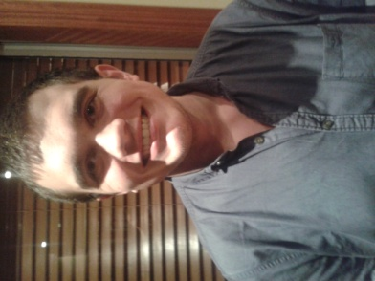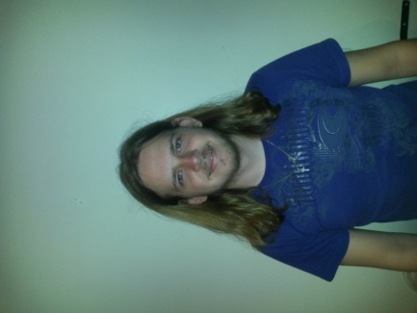

# The Team

## Ivan Henning



### Interests

* IT programming
* Latest technology
* Gaming
* Sport (cricket, rugby and hockey)

### Technical Skills

Experienced in coding in the following languages/mark-ups/standards:

C, C++, C#, Java, Pascal, HTML, CSS, XML, XSLT, JavaScript, JNode, PHP, AJAX, JQuery and MySQL.

Experience in working in the following fields:

* Operating Systems
* Networks
* Website Development
* Web Systems (server- and client side processing)
* Database management

### Past Experiences

* I am experienced in C and Java and have worked on the open source operating system MINIX.
* Have also worked on a small server and client program sending text messages to each other.

### Non-technical Strengths

* Work well in a team to accomplish goals.
* Quick learner.
* Organised.
* Work well under pressure.
* I'm realistic and debate matters logically.
* Task orientated and objective.
* Thinks outside of the box.

### What makes you want to do the project?

The project about Instant Messaging, which is the buzz word at the moment and is getting bigger every day, looks interesting and would present a challenge especially as it involves the latest technology and apps that people use in their daily lives. My past experience gained would come in very handy in completing this project and the experience that I'll gain would be valuable in the future.

## Joseph Jurgen Muller Potgieter



### Interests

* Reading
* Computer Games
* Documentaries

### Technical Skills

* C++ and C
* Java
* HTML, CSS and Javascript Coding
* PHP Development
* SQL Programming (Database Management)

### Past Experiences

* Worked in team projects for university assignments.
* Competed in public speaking, meaning I am comfortable in such situations

### Non-technical Strengths

* Comfortable in groups
* Good time manager
* Dedicated worker

### What makes you want to do the project?

The project seems as though it will present an interesting challenge and provide an educational experience that will benefit me in future endeavors.

## Johan van Rooyen



### Interests

* Fishing
* Hunting
* Adrenaline sports
* Computer Games
* Website design
* Electronic components and building small appliances

### Technical Skills

* C++ and C
* Java
* HTML, CSS and Javascript Coding
* PHP Development
* SQL Programming (Database Management)
* Novice Android Development
* Technical Support

### Past Experiences

* Worked as a web developer for 12 months in 2011, writing new and editing existing sites, managing resources on a remote server and working in weekly sprints to finish the project.
* Worked with an international team on a web design project, where meetings took place over Skype and collaborating through an private server made transfer of resources possible.

### Non-technical Strengths

* Good Communication skills
* Collaborate well with a team
* Good business knowledge
* Knowledge of Law in South Africa
* Good time management
* Organizational and Management skills
* Great problem solving abilities
* Go-getter
* Work well under pressure

### What makes you want to do the project?

This project will provide a good experience to me for future reference, since we will be working on an existing technology that is already out there and has been used by the public for quite some time. This will force me to work harder, as there is a lot of expectations to live up to and a lot of eyes on the project.

## Herman WillemKeuris



### Interests

* My two greatest interests are music and IT (especially Artificial Intelligence, Web design and multimedia orientated software).

### Technical Skills

Experienced in coding in the following languages/mark-ups/standards:

C, C++, Java, Python, Delphi, HTML, CSS, XML, JavaScript, JNode, PHP, AJAX, JQuery and MySQL

Experience in working in the following fields:

* Operating Systems
* Networks
* Web Systems (server- and client side processing)
* Database management

### Past Experiences

* I am very experienced in coding in C and Java and have some experience in working with simple operating systems which might prove useful when working with android systems.

### Non-technical Strengths

* Work well in group settings.
* Hard working.
* Practically orientated (like to plan out things in advance rather than progressing without clear goals or expectations).
* Good at abstracting complex data systems into more understandable and manageable segments.
* Quick learner.

### What makes you want to do the project?

I am very interested in programs associated with social media (e.g. social networking) and designing mobile applications. I’m also interested in how programs handle different types of multimedia (such as video and recordings) and would be very interested in learning more about, and using, Session Initiation Protocol elements. I’m also interested in the chance to learn more about cryptography in social applications such as IM’s.

# Project Execution

**Methodology:**

We will be making use of the waterfall development methodology.

The waterfall method is a sequential and logical design process which “flows” through various stages of the software development process. Our design process will be split into the following phases:

* Requirements: Deciding on requirements.
* Design: Writing out requirements (System Requirements Document) and Design Documentation (including Plan for Software Aspects of Certification (PSAC) and Software Development Process (SDP) documents).
* Implementation: writing source code and Software Verification Cases and Procedures (SVCP).
* Verification: Testing and writing of the Software Versions Repository (SVR) (i.e. reviewing the code).
* Maintenance: Writing of the final reports such as the Statistical Analysis System document (SAS), the Software Configuration Management Record (SCMR) and a Software Quality Assurance document (SQA).

**Client communication:**

We will be kept in constant contact with client in the form of emails, sms’s, WhatsApp messages and in person meetings every few weeks (these meetings will be more frequent during the implementation phase). We will also make a GitHub repository available so that any interested party can keep tabs on our progress.

**Initial ideas:**

* Make a simple interface to view the program of the conference. Selecting a session automatically adds it to the user’s schedule.
* The scheduler will try to organise all the user’s sessions and alert the user if there are any clashes, changes in the sessions or if two consecutive sessions are spaced inconveniently far apart.
* Have each user have a profile which could contain information regarding any previous contributions they made at conferences which made use of this app.
* Display a session’s average rating an hour after the session has ended (to give those who attended some time to rate and comment on the session using the app).

**Technologies:**

The app will be developed:

* in a Linux environment
* using Eclipse IDE with the Android Developer Tools (ADT) plugin (for android systems)
* and Xcode IDE (for iOS systems)

All source code will be coded in either C or Java.

**Final product:**

The final product will have the following functionality:

* Conference program look-up: a simple way of seeing the program for the entire conference (e.g. when a session is starting, where it’s held, how long it is, etc.).
* Venue guide: Interactive map/guide of the conference which will easily guide the user to the sessions they wish to attend.
* Personalised scheduler: A semi-autonomous scheduler which will try to help the user plan a schedule which does not contain any conflicting sessions.
* Push notifications: A notification system which the conference organisers can use to alert the user of anything important (e.g. changes in a session). Also helps alert the user to scheduler related notifications (such as when a scheduled session is about to start).
* Abstract, poster and presentation search features: A searchable database containing information relevant to the conference and the work of the speakers at the conference. This could contain abstracts of papers, posters, previous research, etc. The user will have the option of emailing these documents to themselves for easy access later.
* Note taking functionality: A simple, easy to use notepad function.
* Chat: An interface for having one-on-one or group discussions with other users of the app.
* Tutorial and posters: A feature which lists available tutorials and posters which the user can visit and allows the user to add it to their schedule.
* Rating and feedback forms: A method to rate, comment and give feedback on sessions and symposiums.
* Social Media Integration: The app will contain links to popular social networks such as Facebook, Twitter and LinkedIn. The user will also be able to do various actions related with these websites such as share information about the conference, or of a specific session, on Facebook or Twitter, or link their “conference app” profile to their Facebook profile.