SUPPLEMENTARY METHODS

PCR conditions

First round PCR reactions were performed in 25 µl reaction volumes with 0.3mM each dNTP, 0.5 µM primers, 0.5 units of Kapa HiFiTM HotStart DNA Polymerase (Cape Town, SA), and an input volume equivalent to 500 total plasmid templates. Cycling conditions were 95°C for 2 min, followed by 35 cycles of 98°C for 20 sec, 64°C for 30 sec, and 72°C for 90 sec, followed by a final extension of 72°C for 5 min. Primers for first round PCR are listed in Table S1.

Second round PCR conditions were identical to first round, except that primer concentrations were changed to 0.4 µM and 1µl of each first round reaction was combined and used as starting template. Cycling were 95°C for 2 min, followed by 5 cycles of 98°C for 20 sec, 58°C for 30 sec, and 72°C for 90 sec, followed by 30 cycles of 98°C for 20 sec, 64°C for 30 sec, and 72°C for 90 sec, followed by a final extension of 72°C for 5 min. Second round primers included a Roche MID, key (5’-TCAG-3’), and 454 adaptor sequence (A-5’-CGTATCGCCTCCCTCGCGCCA-3’ or B-5’-CTATGCGCCTTGCCAGCCCGC-3’) at the 5’ end of the primer, in addition to the HIV-1 specific primer sequence at the 3’ end shown in Table S1 (only the HIV-specific sequences are shown).

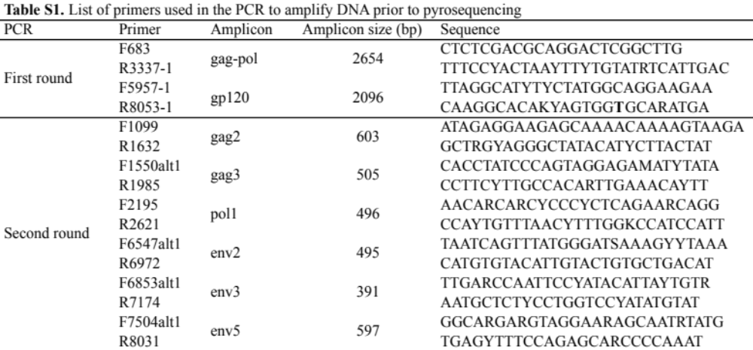
Second round amplicon size includes the 454 sequencing adapter, key and MID barcode.

