FACULTY OF SCIENCE, TECHNOLOGY, ENGINEERING, ART AND DESIGN
DEPARTMENT OF INFORMATION TECHNOLOGY
DATABASE PROGRAMMING YEAR: TWO
SEMESTER: TWO
LECTURER: HITANGHU MOSES
DATE:24/MAY/2026
By Group Four

STUDENT NAME | : | REG NO
KULABA BRENDAH | : | 24/U/BEICT/0014/M/DAY
NAJJEMBA DAMALIE DORCAS | : | 24/U/BEICT/0029/M/DAY
NABASALIZI SHERINAH | : | 24/U/BEICT/0042/M/DAY
NAKALEMA ANGELLA | : | 24/U/BEICT/0026/M/DAY
KALUHANGI SIRAGI | : | 24/U/BEICT/0014/M/DAY

CASE STUDY
Masaka Agri Supplier

PROBLEM IDENTIFICATION AND ANALYSIS

Background
Masaka Agri-Supplies Ltd is a medium-sized agricultural input supply business located in Masaka City, Uganda. The company supplies seeds, fertilizers, pesticides, and farm tools to local farmers and retailers. The company works with over 30 suppliers and processes approximately 50 purchase orders monthly.

1.2 Description of the Problem
The company currently manages supplier operations using manual paper records and Excel spreadsheets. This approach has resulted in data redundancy, delayed order processing, payment confusion, no audit trail, and poor decision-making capabilities.

Current Method Used
Supplier information is recorded in notebooks, orders are placed via phone calls, payments are tracked using manual calculations, and reports are compiled manually from various Excel files.

Limitations of the Current System
The current system has no central database, making retrieval difficult. Manual calculations cause arithmetic errors. No order tracking exists. No payment reminders lead to late penalties. No performance metrics prevent identification of best suppliers. No audit trail makes error tracking impossible.

Justification for Computerized Solution
An Oracle database solution is justified because it provides centralized data storage, data integrity through constraints, automated calculations, security through roles and privileges, and audit capabilities through triggers.

General Objective
To design and implement an Oracle database system for Masaka Agri-Supplies Ltd that manages suppliers, products, purchase orders, invoices, and payments.

Specific Objectives
- To design a normalized database with tables for suppliers, products, purchase orders, invoices, and payments
- To implement constraints that enforce business rules including primary keys, foreign keys, unique constraints, and check constraints
- To develop stored procedures for recording payments and generating outstanding balance reports
- To implement triggers that prevent overpayments, automatically update invoice statuses, and maintain audit trails
- To implement database security through roles and privileges for ADMIN, MANAGER, and CLERK users

BUSINESS RULES

Supplier Rules
A supplier must have a unique supplier ID. A supplier must have a name and phone number. A supplier can supply zero or many products. A supplier can receive zero or many purchase orders. A supplier can issue zero or many invoices.

Product Rules
A product must have a unique product ID. A product must have a name and unit of measurement. A product can be supplied by zero or many suppliers. A product can appear on zero or many purchase orders.

Purchase Order Rules
A purchase order must have a unique PO number. A purchase order must be linked to exactly one supplier. A purchase order must have an order date. A purchase order can have one or many line items.

Invoice Rules
An invoice must have a unique invoice number per supplier. Invoice amount must be greater than zero. Invoice status can be UNPAID, PARTIAL, or PAID.

Payment Rules
A payment must be linked to exactly one invoice. Payment amount must be greater than zero. Total payments for an invoice cannot exceed the invoice amount.

User Rules
A user must have a unique username. User role can be ADMIN, MANAGER, or CLERK. Only ADMIN users can manage other users.

ENTITY RELATIONSHIP DIAGRAM (ERD)

ERD Diagram
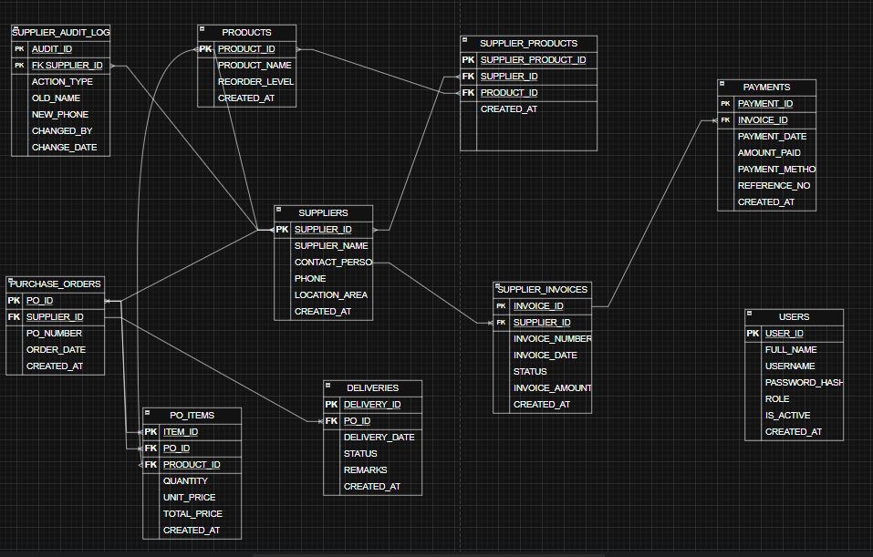

Text Representation of ERD
LEGEND: PK = Primary Key, FK = Foreign Key,

Cardinality Summary
Relationship | Cardinality
SUPPLIERS → PURCHASE_ORDERS | 1 : M
SUPPLIERS → SUPPLIER_INVOICES | 1 : M
SUPPLIERS → PRODUCTS | M : M
PURCHASE_ORDERS → PO_ITEMS | 1 : M
PURCHASE_ORDERS → DELIVERIES | 1 : M
SUPPLIER_INVOICES → PAYMENTS | 1 : M

DATABASE IMPLEMENTATION

Tables Created
The database consists of nine tables:
Table | Description
USERS | System user accounts
SUPPLIERS | Supplier company information
PRODUCTS | Product catalog
SUPPLIER_PRODUCTS | Junction table linking suppliers to products
PURCHASE_ORDERS | Purchase order headers
PO_ITEMS | Purchase order line items
DELIVERIES | Delivery tracking
SUPPLIER_INVOICES | Supplier invoices
PAYMENTS | Payment records

Screenshot: All Tables
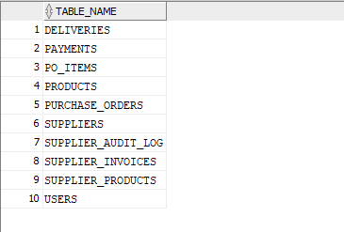

DDL STATEMENTS

USERS Table
sql
CREATE TABLE USERS (
USER_ID NUMBER GENERATED BY DEFAULT AS IDENTITY PRIMARY KEY,
FULL_NAME VARCHAR2(100) NOT NULL,
USERNAME VARCHAR2(50) NOT NULL UNIQUE,
PASSWORD_HASH VARCHAR2(255) NOT NULL,
ROLE VARCHAR2(10) DEFAULT 'CLERK' CHECK (ROLE IN ('ADMIN', 'MANAGER', 'CLERK')),
IS_ACTIVE NUMBER(1) DEFAULT 1 CHECK (IS_ACTIVE IN (0, 1)),
CREATED_AT DATE DEFAULT SYSDATE
);

SUPPLIERS Table
sql
CREATE TABLE SUPPLIERS (
SUPPLIER_ID NUMBER GENERATED BY DEFAULT AS IDENTITY PRIMARY KEY,
SUPPLIER_NAME VARCHAR2(120) NOT NULL,
CONTACT_PERSON VARCHAR2(100),
PHONE VARCHAR2(20) NOT NULL,
LOCATION_AREA VARCHAR2(100),
CREATED_AT DATE DEFAULT SYSDATE
);

PRODUCTS Table
sql
CREATE TABLE PRODUCTS (
PRODUCT_ID NUMBER GENERATED BY DEFAULT AS IDENTITY PRIMARY KEY,
PRODUCT_NAME VARCHAR2(120) NOT NULL,
UNIT VARCHAR2(20) NOT NULL,
REORDER_LEVEL NUMBER DEFAULT 10 CHECK (REORDER_LEVEL >= 0),
CREATED_AT DATE DEFAULT SYSDATE
);

SUPPLIER_PRODUCTS Table
sql
CREATE TABLE SUPPLIER_PRODUCTS (
SUPPLIER_PRODUCT_ID NUMBER GENERATED BY DEFAULT AS IDENTITY PRIMARY KEY,
SUPPLIER_ID NUMBER NOT NULL,
PRODUCT_ID NUMBER NOT NULL,
CREATED_AT DATE DEFAULT SYSDATE,
CONSTRAINT UK_SUPPLIER_PRODUCT UNIQUE (SUPPLIER_ID, PRODUCT_ID),
CONSTRAINT FK_SP_SUPPLIER FOREIGN KEY (SUPPLIER_ID) REFERENCES SUPPLIERS(SUPPLIER_ID) ON DELETE CASCADE,
CONSTRAINT FK_SP_PRODUCT FOREIGN KEY (PRODUCT_ID) REFERENCES PRODUCTS(PRODUCT_ID) ON DELETE CASCADE
);

PURCHASE_ORDERS Table
sql
CREATE TABLE PURCHASE_ORDERS (
PO_ID NUMBER GENERATED BY DEFAULT AS IDENTITY PRIMARY KEY,
PO_NUMBER VARCHAR2(30) NOT NULL UNIQUE,
SUPPLIER_ID NUMBER NOT NULL,
ORDER_DATE DATE NOT NULL,
CREATED_AT DATE DEFAULT SYSDATE,
CONSTRAINT FK_PO_SUPPLIER FOREIGN KEY (SUPPLIER_ID) REFERENCES SUPPLIERS(SUPPLIER_ID) ON DELETE CASCADE
);

PO_ITEMS Table
sql
CREATE TABLE PO_ITEMS (
ITEM_ID NUMBER GENERATED BY DEFAULT AS IDENTITY PRIMARY KEY,
PO_ID NUMBER NOT NULL,
PRODUCT_ID NUMBER NOT NULL,
QUANTITY NUMBER NOT NULL CHECK (QUANTITY > 0),
UNIT_PRICE NUMBER(14,2) NOT NULL CHECK (UNIT_PRICE > 0),
TOTAL_PRICE NUMBER(14,2) GENERATED ALWAYS AS (QUANTITY * UNIT_PRICE) VIRTUAL,
CREATED_AT DATE DEFAULT SYSDATE,
CONSTRAINT FK_PITEM_PO FOREIGN KEY (PO_ID) REFERENCES PURCHASE_ORDERS(PO_ID) ON DELETE CASCADE,
CONSTRAINT FK_PITEM_PRODUCT FOREIGN KEY (PRODUCT_ID) REFERENCES PRODUCTS(PRODUCT_ID)
);

DELIVERIES Table
sql
CREATE TABLE DELIVERIES (
DELIVERY_ID NUMBER GENERATED BY DEFAULT AS IDENTITY PRIMARY KEY,
PO_ID NUMBER NOT NULL,
DELIVERY_DATE DATE NOT NULL,
STATUS VARCHAR2(20) DEFAULT 'COMPLETE' CHECK (STATUS IN ('COMPLETE', 'PARTIAL', 'PENDING')),
REMARKS VARCHAR2(255),
CREATED_AT DATE DEFAULT SYSDATE,
CONSTRAINT FK_DELIVERY_PO FOREIGN KEY (PO_ID) REFERENCES PURCHASE_ORDERS(PO_ID) ON DELETE CASCADE
);

SUPPLIER_INVOICES Table
sql
CREATE TABLE SUPPLIER_INVOICES (
INVOICE_ID NUMBER GENERATED BY DEFAULT AS IDENTITY PRIMARY KEY,
SUPPLIER_ID NUMBER NOT NULL,
INVOICE_NUMBER VARCHAR2(50) NOT NULL,
INVOICE_DATE DATE NOT NULL,
INVOICE_AMOUNT NUMBER(14,2) NOT NULL CHECK (INVOICE_AMOUNT > 0),
STATUS VARCHAR2(20) DEFAULT 'UNPAID' CHECK (STATUS IN ('UNPAID', 'PARTIAL', 'PAID')),
CREATED_AT DATE DEFAULT SYSDATE,
CONSTRAINT UK_SUPPLIER_INVOICE UNIQUE (SUPPLIER_ID, INVOICE_NUMBER),
CONSTRAINT FK_INVOICE_SUPPLIER FOREIGN KEY (SUPPLIER_ID) REFERENCES SUPPLIERS(SUPPLIER_ID) ON DELETE CASCADE
);

PAYMENTS Table
sql
CREATE TABLE PAYMENTS (
PAYMENT_ID NUMBER GENERATED BY DEFAULT AS IDENTITY PRIMARY KEY,
INVOICE_ID NUMBER NOT NULL,
PAYMENT_DATE DATE NOT NULL,
AMOUNT_PAID NUMBER(14,2) NOT NULL CHECK (AMOUNT_PAID > 0),
PAYMENT_METHOD VARCHAR2(30) NOT NULL CHECK (PAYMENT_METHOD IN ('CASH', 'MOBILE_MONEY', 'BANK_TRANSFER')),
REFERENCE_NO VARCHAR2(60),
CREATED_AT DATE DEFAULT SYSDATE,
CONSTRAINT FK_PAYMENT_INVOICE FOREIGN KEY (INVOICE_ID) REFERENCES SUPPLIER_INVOICES(INVOICE_ID) ON DELETE CASCADE
);

DML STATEMENTS (SAMPLE DATA)

Insert Users
sql
INSERT INTO USERS (FULL_NAME, USERNAME, PASSWORD_HASH, ROLE, IS_ACTIVE)
VALUES ('Administrator', 'admin', 'admin123', 'ADMIN', 1);

INSERT INTO USERS (FULL_NAME, USERNAME, PASSWORD_HASH, ROLE, IS_ACTIVE)
VALUES ('John Manager', 'manager', 'pass123', 'MANAGER', 1);

INSERT INTO USERS (FULL_NAME, USERNAME, PASSWORD_HASH, ROLE, IS_ACTIVE)
VALUES ('Sarah Clerk', 'clerk', 'pass123', 'CLERK', 1);

Insert Suppliers
sql
INSERT INTO SUPPLIERS (SUPPLIER_NAME, CONTACT_PERSON, PHONE, LOCATION_AREA)
VALUES ('Masaka Seed Traders', 'Nabwire Sarah', '+256772100210', 'Masaka Town');

INSERT INTO SUPPLIERS (SUPPLIER_NAME, CONTACT_PERSON, PHONE, LOCATION_AREA)
VALUES ('Bukakata Agro Inputs', 'Ssenfuma Denis', '+256703440122', 'Bukakata');

INSERT INTO SUPPLIERS (SUPPLIER_NAME, CONTACT_PERSON, PHONE, LOCATION_AREA)
VALUES ('Nyendo Farm Supplies', 'Kato Brian', '+256751334455', 'Nyendo');

Screenshot: Suppliers Data
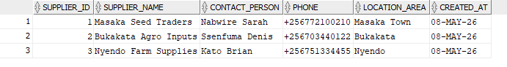

Insert Products
sql
INSERT INTO PRODUCTS (PRODUCT_NAME, UNIT, REORDER_LEVEL)
VALUES ('Maize Seeds (10kg)', 'bag', 30);

INSERT INTO PRODUCTS (PRODUCT_NAME, UNIT, REORDER_LEVEL)
VALUES ('NPK Fertilizer 50kg', 'bag', 40);

INSERT INTO PRODUCTS (PRODUCT_NAME, UNIT, REORDER_LEVEL)
VALUES ('Knapsack Sprayer', 'piece', 15);

INSERT INTO PRODUCTS (PRODUCT_NAME, UNIT, REORDER_LEVEL)
VALUES ('Pesticide 1L', 'bottle', 25);

Screenshot: Products Data
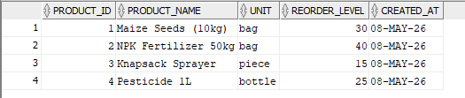

Insert Supplier-Product Relationships
sql
INSERT INTO SUPPLIER_PRODUCTS (SUPPLIER_ID, PRODUCT_ID) VALUES (1, 1);
INSERT INTO SUPPLIER_PRODUCTS (SUPPLIER_ID, PRODUCT_ID) VALUES (1, 2);
INSERT INTO SUPPLIER_PRODUCTS (SUPPLIER_ID, PRODUCT_ID) VALUES (2, 2);
INSERT INTO SUPPLIER_PRODUCTS (SUPPLIER_ID, PRODUCT_ID) VALUES (3, 3);
INSERT INTO SUPPLIER_PRODUCTS (SUPPLIER_ID, PRODUCT_ID) VALUES (3, 4);

Insert Purchase Orders
sql
INSERT INTO PURCHASE_ORDERS (PO_NUMBER, SUPPLIER_ID, ORDER_DATE)
VALUES ('PO-2026-001', 1, DATE '2026-05-01');

INSERT INTO PURCHASE_ORDERS (PO_NUMBER, SUPPLIER_ID, ORDER_DATE)
VALUES ('PO-2026-002', 2, DATE '2026-05-02');

INSERT INTO PURCHASE_ORDERS (PO_NUMBER, SUPPLIER_ID, ORDER_DATE)
VALUES ('PO-2026-003', 3, DATE '2026-05-03');

Insert PO Items
sql
INSERT INTO PO_ITEMS (PO_ID, PRODUCT_ID, QUANTITY, UNIT_PRICE) VALUES (1, 1, 100, 12000);
INSERT INTO PO_ITEMS (PO_ID, PRODUCT_ID, QUANTITY, UNIT_PRICE) VALUES (1, 2, 50, 25000);
INSERT INTO PO_ITEMS (PO_ID, PRODUCT_ID, QUANTITY, UNIT_PRICE) VALUES (2, 2, 30, 28000);
INSERT INTO PO_ITEMS (PO_ID, PRODUCT_ID, QUANTITY, UNIT_PRICE) VALUES (3, 3, 10, 85000);
INSERT INTO PO_ITEMS (PO_ID, PRODUCT_ID, QUANTITY, UNIT_PRICE) VALUES (3, 4, 20, 35000);

Screenshot: Purchase Orders with Calculated Totals
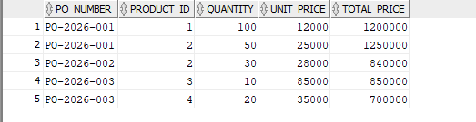

Insert Deliveries
sql
INSERT INTO DELIVERIES (PO_ID, DELIVERY_DATE, STATUS, REMARKS)
VALUES (1, DATE '2026-05-02', 'COMPLETE', 'Delivered in full');

INSERT INTO DELIVERIES (PO_ID, DELIVERY_DATE, STATUS, REMARKS)
VALUES (2, DATE '2026-05-04', 'PARTIAL', 'Awaiting balance stock');

Insert Supplier Invoices
sql
INSERT INTO SUPPLIER_INVOICES (SUPPLIER_ID, INVOICE_NUMBER, INVOICE_DATE, INVOICE_AMOUNT, STATUS)
VALUES (1, 'INV-MAS-001', DATE '2026-05-02', 2450000.00, 'PARTIAL');

INSERT INTO SUPPLIER_INVOICES (SUPPLIER_ID, INVOICE_NUMBER, INVOICE_DATE, INVOICE_AMOUNT, STATUS)
VALUES (2, 'INV-BUK-001', DATE '2026-05-04', 840000.00, 'UNPAID');

Insert Payments
sql
INSERT INTO PAYMENTS (INVOICE_ID, PAYMENT_DATE, AMOUNT_PAID, PAYMENT_METHOD, REFERENCE_NO)
VALUES (1, DATE '2026-05-03', 1000000.00, 'MOBILE_MONEY', 'MM-AGRI-1001');

CONSTRAINTS

Screenshot: All Constraints
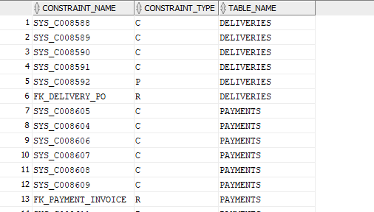

Constraint Summary
Table | Primary Key | Foreign Keys | Unique | Check
USERS | USER_ID | - | USERNAME | ROLE, IS_ACTIVE
SUPPLIERS | SUPPLIER_ID | - | - | -
PRODUCTS | PRODUCT_ID | - | - | REORDER_LEVEL
SUPPLIER_PRODUCTS | SUPPLIER_PRODUCT_ID | SUPPLIER_ID, PRODUCT_ID | (SUPPLIER_ID,PRODUCT_ID) | -
PURCHASE_ORDERS | PO_ID | SUPPLIER_ID | PO_NUMBER | -
PO_ITEMS | ITEM_ID | PO_ID, PRODUCT_ID | - | QUANTITY>0, UNIT_PRICE>0
DELIVERIES | DELIVERY_ID | PO_ID | - | STATUS
SUPPLIER_INVOICES | INVOICE_ID | SUPPLIER_ID | (SUPPLIER_ID,INVOICE_NUMBER) | INVOICE_AMOUNT>0, STATUS
PAYMENTS | PAYMENT_ID | INVOICE_ID | - | AMOUNT_PAID>0, PAYMENT_METHOD

STORED PROCEDURES

Procedure 1: RECORD_PAYMENT
This procedure records a payment and automatically updates the invoice status.
sql
CREATE OR REPLACE PROCEDURE RECORD_PAYMENT (
P_INVOICE_ID IN NUMBER,
P_PAYMENT_DATE IN DATE,
P_AMOUNT_PAID IN NUMBER,
P_PAYMENT_METHOD IN VARCHAR2,
P_REFERENCE_NO IN VARCHAR2 DEFAULT NULL
) IS
V_INVOICE_AMOUNT SUPPLIER_INVOICES.INVOICE_AMOUNT%TYPE;
V_TOTAL_PAID NUMBER;
V_NEW_STATUS VARCHAR2(20);
BEGIN
SELECT INVOICE_AMOUNT INTO V_INVOICE_AMOUNT
FROM SUPPLIER_INVOICES
WHERE INVOICE_ID = P_INVOICE_ID;

INSERT INTO PAYMENTS (INVOICE_ID, PAYMENT_DATE, AMOUNT_PAID, PAYMENT_METHOD, REFERENCE_NO)
VALUES (P_INVOICE_ID, P_PAYMENT_DATE, P_AMOUNT_PAID, P_PAYMENT_METHOD, P_REFERENCE_NO);

SELECT NVL(SUM(AMOUNT_PAID), 0) INTO V_TOTAL_PAID
FROM PAYMENTS
WHERE INVOICE_ID = P_INVOICE_ID;

IF V_TOTAL_PAID = 0 THEN
V_NEW_STATUS := 'UNPAID';
ELSIF V_TOTAL_PAID < V_INVOICE_AMOUNT THEN
V_NEW_STATUS := 'PARTIAL';
ELSE
V_NEW_STATUS := 'PAID';
END IF;

UPDATE SUPPLIER_INVOICES SET STATUS = V_NEW_STATUS
WHERE INVOICE_ID = P_INVOICE_ID;

COMMIT;
DBMS_OUTPUT.PUT_LINE('Payment recorded. Invoice status: ' || V_NEW_STATUS);
END RECORD_PAYMENT;
/

Screenshot: Invoice Before Payment
Shows status = 'UNPAID'

Procedure 2: GET_SUPPLIER_OUTSTANDING
This procedure generates a report of suppliers with outstanding balances.
sql
CREATE OR REPLACE PROCEDURE GET_SUPPLIER_OUTSTANDING (
P_SUPPLIER_ID IN NUMBER DEFAULT NULL
) IS
CURSOR SUPPLIER_CURSOR IS
SELECT S.SUPPLIER_NAME,
NVL(SUM(SI.INVOICE_AMOUNT), 0) AS TOTAL_INVOICED,
NVL(SUM(P.AMOUNT_PAID), 0) AS TOTAL_PAID,
NVL(SUM(SI.INVOICE_AMOUNT), 0) - NVL(SUM(P.AMOUNT_PAID), 0) AS OUTSTANDING
FROM SUPPLIERS S
LEFT JOIN SUPPLIER_INVOICES SI ON S.SUPPLIER_ID = SI.SUPPLIER_ID
LEFT JOIN PAYMENTS P ON SI.INVOICE_ID = P.INVOICE_ID
WHERE (P_SUPPLIER_ID IS NULL OR S.SUPPLIER_ID = P_SUPPLIER_ID)
GROUP BY S.SUPPLIER_NAME
HAVING NVL(SUM(SI.INVOICE_AMOUNT), 0) - NVL(SUM(P.AMOUNT_PAID), 0) > 0
ORDER BY OUTSTANDING DESC;
BEGIN
DBMS_OUTPUT.PUT_LINE('==================================================');
DBMS_OUTPUT.PUT_LINE('OUTSTANDING SUPPLIER BALANCES');
DBMS_OUTPUT.PUT_LINE('Generated on: ' || TO_CHAR(SYSDATE, 'DD-MON-YYYY HH24:MI:SS'));
DBMS_OUTPUT.PUT_LINE('==================================================');
DBMS_OUTPUT.PUT_LINE(RPAD('Supplier Name', 30) || RPAD('Invoiced', 18) || RPAD('Paid', 18) || RPAD('Balance', 18));
DBMS_OUTPUT.PUT_LINE('--------------------------------------------------');

FOR REC IN SUPPLIER_CURSOR LOOP
DBMS_OUTPUT.PUT_LINE(
RPAD(SUBSTR(REC.SUPPLIER_NAME, 1, 28), 30) ||
RPAD(TO_CHAR(REC.TOTAL_INVOICED, '999,999,999.00'), 18) ||
RPAD(TO_CHAR(REC.TOTAL_PAID, '999,999,999.00'), 18) ||
RPAD(TO_CHAR(REC.OUTSTANDING, '999,999,999.00'), 18)
);
END LOOP;

DBMS_OUTPUT.PUT_LINE('==================================================');
END GET_SUPPLIER_OUTSTANDING;
/

Screenshot: Outstanding Report
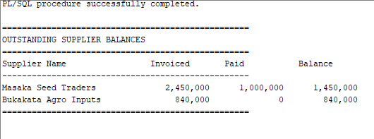
[SCREENSHOT 9: EXEC GET_SUPPLIER_OUTSTANDING;]
Shows formatted report with supplier names, invoiced amounts, paid amounts, and balances

TRIGGERS

Trigger 1: CHECK_PAYMENT_AMOUNT
This trigger prevents payments from exceeding the invoice amount.
sql
CREATE OR REPLACE TRIGGER CHECK_PAYMENT_AMOUNT
BEFORE INSERT OR UPDATE ON PAYMENTS
FOR EACH ROW
DECLARE
V_INVOICE_AMOUNT SUPPLIER_INVOICES.INVOICE_AMOUNT%TYPE;
V_TOTAL_PAID NUMBER;
BEGIN
SELECT INVOICE_AMOUNT INTO V_INVOICE_AMOUNT
FROM SUPPLIER_INVOICES
WHERE INVOICE_ID = :NEW.INVOICE_ID;

SELECT NVL(SUM(AMOUNT_PAID), 0) + :NEW.AMOUNT_PAID INTO V_TOTAL_PAID
FROM PAYMENTS
WHERE INVOICE_ID = :NEW.INVOICE_ID;

IF V_TOTAL_PAID > V_INVOICE_AMOUNT THEN
RAISE_APPLICATION_ERROR(-20001,
'Payment cannot exceed invoice amount. Invoice: ' || TO_CHAR(V_INVOICE_AMOUNT));
END IF;
END CHECK_PAYMENT_AMOUNT;
/

Screenshot: Trigger Prevents Overpayment
*Shows ORA-20001 error*
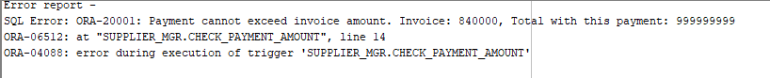

Trigger 2: UPDATE_INVOICE_STATUS_AFTER_PAYMENT
This trigger automatically updates invoice status after payments.
sql
CREATE OR REPLACE TRIGGER UPDATE_INVOICE_STATUS_AFTER_PAYMENT
AFTER INSERT OR UPDATE ON PAYMENTS
FOR EACH ROW
DECLARE
V_INVOICE_AMOUNT SUPPLIER_INVOICES.INVOICE_AMOUNT%TYPE;
V_TOTAL_PAID NUMBER;
V_NEW_STATUS VARCHAR2(20);
BEGIN
SELECT INVOICE_AMOUNT INTO V_INVOICE_AMOUNT
FROM SUPPLIER_INVOICES
WHERE INVOICE_ID = :NEW.INVOICE_ID;

SELECT NVL(SUM(AMOUNT_PAID), 0) INTO V_TOTAL_PAID
FROM PAYMENTS
WHERE INVOICE_ID = :NEW.INVOICE_ID;

IF V_TOTAL_PAID = 0 THEN
V_NEW_STATUS := 'UNPAID';
ELSIF V_TOTAL_PAID < V_INVOICE_AMOUNT THEN
V_NEW_STATUS := 'PARTIAL';
ELSE
V_NEW_STATUS := 'PAID';
END IF;

UPDATE SUPPLIER_INVOICES
SET STATUS = V_NEW_STATUS
WHERE INVOICE_ID = :NEW.INVOICE_ID;
END UPDATE_INVOICE_STATUS_AFTER_PAYMENT;
/

Trigger 3: LOG_SUPPLIER_CHANGES (Audit Trail)
This trigger creates an audit log when suppliers are modified.
sql
CREATE TABLE SUPPLIER_AUDIT_LOG (
AUDIT_ID NUMBER GENERATED BY DEFAULT AS IDENTITY PRIMARY KEY,
SUPPLIER_ID NUMBER NOT NULL,
ACTION_TYPE VARCHAR2(10) CHECK (ACTION_TYPE IN ('INSERT', 'UPDATE', 'DELETE')),
OLD_NAME VARCHAR2(120),
NEW_NAME VARCHAR2(120),
OLD_PHONE VARCHAR2(20),
NEW_PHONE VARCHAR2(20),
CHANGED_BY VARCHAR2(50),
CHANGE_DATE DATE DEFAULT SYSDATE
);

CREATE OR REPLACE TRIGGER LOG_SUPPLIER_CHANGES
AFTER INSERT OR UPDATE OR DELETE ON SUPPLIERS
FOR EACH ROW
DECLARE
V_ACTION VARCHAR2(10);
V_USER VARCHAR2(50);
BEGIN
SELECT USER INTO V_USER FROM DUAL;

IF INSERTING THEN
V_ACTION := 'INSERT';
INSERT INTO SUPPLIER_AUDIT_LOG (SUPPLIER_ID, ACTION_TYPE, NEW_NAME, NEW_PHONE, CHANGED_BY)
VALUES (:NEW.SUPPLIER_ID, V_ACTION, :NEW.SUPPLIER_NAME, :NEW.PHONE, V_USER);
ELSIF UPDATING THEN
V_ACTION := 'UPDATE';
INSERT INTO SUPPLIER_AUDIT_LOG (SUPPLIER_ID, ACTION_TYPE, OLD_NAME, NEW_NAME, OLD_PHONE, NEW_PHONE, CHANGED_BY)
VALUES (:OLD.SUPPLIER_ID, V_ACTION, :OLD.SUPPLIER_NAME, :NEW.SUPPLIER_NAME, :OLD.PHONE, :NEW.PHONE, V_USER);
ELSIF DELETING THEN
V_ACTION := 'DELETE';
INSERT INTO SUPPLIER_AUDIT_LOG (SUPPLIER_ID, ACTION_TYPE, OLD_NAME, OLD_PHONE, CHANGED_BY)
VALUES (:OLD.SUPPLIER_ID, V_ACTION, :OLD.SUPPLIER_NAME, :OLD.PHONE, V_USER);
END IF;

COMMIT;
END LOG_SUPPLIER_CHANGES;
/

DATABASE SECURITY

Roles Created
sql
CREATE ROLE SUPPLIER_ADMIN;
CREATE ROLE SUPPLIER_MANAGER;
CREATE ROLE SUPPLIER_CLERK;

Privileges Granted
ADMIN Role (Full Access):
sql
GRANT SELECT, INSERT, UPDATE, DELETE ON SUPPLIERS TO SUPPLIER_ADMIN;
GRANT SELECT, INSERT, UPDATE, DELETE ON PRODUCTS TO SUPPLIER_ADMIN;
GRANT SELECT, INSERT, UPDATE, DELETE ON PURCHASE_ORDERS TO SUPPLIER_ADMIN;
GRANT SELECT, INSERT, UPDATE, DELETE ON PO_ITEMS TO SUPPLIER_ADMIN;
GRANT SELECT, INSERT, UPDATE, DELETE ON SUPPLIER_INVOICES TO SUPPLIER_ADMIN;
GRANT SELECT, INSERT, UPDATE, DELETE ON PAYMENTS TO SUPPLIER_ADMIN;
GRANT SELECT ON SUPPLIER_AUDIT_LOG TO SUPPLIER_ADMIN;
MANAGER Role (No DELETE):
sql
GRANT SELECT, INSERT, UPDATE ON SUPPLIERS TO SUPPLIER_MANAGER;
GRANT SELECT, INSERT, UPDATE ON PRODUCTS TO SUPPLIER_MANAGER;
GRANT SELECT, INSERT, UPDATE ON PURCHASE_ORDERS TO SUPPLIER_MANAGER;
CLERK Role (Only SELECT and INSERT):
sql
GRANT SELECT, INSERT ON SUPPLIERS TO SUPPLIER_CLERK;
GRANT SELECT, INSERT ON PRODUCTS TO SUPPLIER_CLERK;
GRANT SELECT, INSERT ON PURCHASE_ORDERS TO SUPPLIER_CLERK;

Application Users
sql
CREATE USER admin_user IDENTIFIED BY admin123;
CREATE USER manager_user IDENTIFIED BY manager123;
CREATE USER clerk_user IDENTIFIED BY clerk123;

GRANT SUPPLIER_ADMIN TO admin_user;
GRANT SUPPLIER_MANAGER TO manager_user;
GRANT SUPPLIER_CLERK TO clerk_user;

GRANT CONNECT, RESOURCE TO admin_user;
GRANT CONNECT TO manager_user;
GRANT CONNECT TO clerk_user;

Role Privileges

VERIFICATION QUERIES

View All Suppliers
sql
SELECT * FROM SUPPLIERS;

View Outstanding Invoices
sql
SELECT S.SUPPLIER_NAME, SI.INVOICE_NUMBER, SI.INVOICE_AMOUNT,
NVL(SUM(P.AMOUNT_PAID), 0) AS PAID,
SI.INVOICE_AMOUNT - NVL(SUM(P.AMOUNT_PAID), 0) AS BALANCE
FROM SUPPLIER_INVOICES SI
JOIN SUPPLIERS S ON SI.SUPPLIER_ID = S.SUPPLIER_ID
LEFT JOIN PAYMENTS P ON SI.INVOICE_ID = P.INVOICE_ID
GROUP BY S.SUPPLIER_NAME, SI.INVOICE_NUMBER, SI.INVOICE_AMOUNT
HAVING SI.INVOICE_AMOUNT - NVL(SUM(P.AMOUNT_PAID), 0) > 0;

CONCLUSION

Summary of Achievements
The Supplier Management System for Masaka Agri-Supplies Ltd was successfully implemented using Oracle Database. All exam requirements were met:
- Nine tables with proper relationships were created
- All constraints (PK, FK, UNIQUE, CHECK, DEFAULT) were implemented
- Two stored procedures (RECORD_PAYMENT and GET_SUPPLIER_OUTSTANDING) were developed
- Three triggers (payment validation, status update, audit logging) were implemented
- Database security with three roles and three users was established

Recommendations
Future enhancements should include password hashing for security, email notification triggers, and export functionality for reports.
APPENDIX A: COMPLETE SQL SCRIPT
The complete SQL script is provided as a separate file named Supplier_MGR.sql.

