**Summary:**

1. The layout file of Android application is under the layout folder
2. Thus, the layout check should mainly conduct here

**Issue:**

1. The android has already implement some of the requirements
2. The compatibility for some layout setting such as

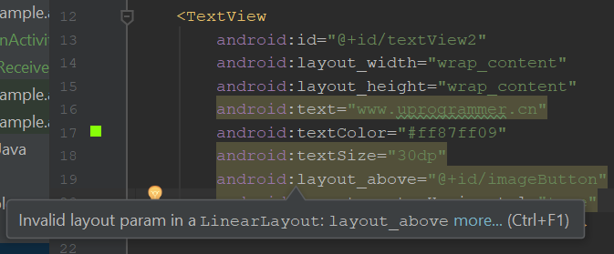

1. The concern of color
2. Hard to achieve change in real-time
3. How to use the plugin in terms of dynamic web design