**Schedule Outline**

1. Android Learning
   1. Fundamental Knowledge √
      1. Android code structure √
      2. Where to change UI √
   2. Develop a mock testing application *ing*
2. Rule Document Analysis
   1. Read through all documentation *ing*
   2. Analysis and categorize the rules
3. Rules Translation
   1. Register and number the rules
   2. Categorize or rate the test data according to rules

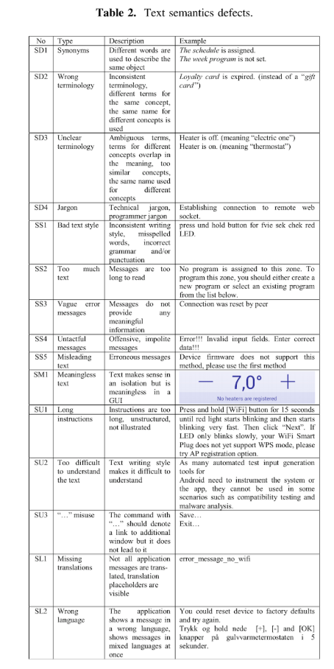

1. Detection algorithm
   1. Decide what kind of algorithm is needed? *ing*

Static hard-coding or ML and NN?

* 1. Try test with hard-coding rules detection

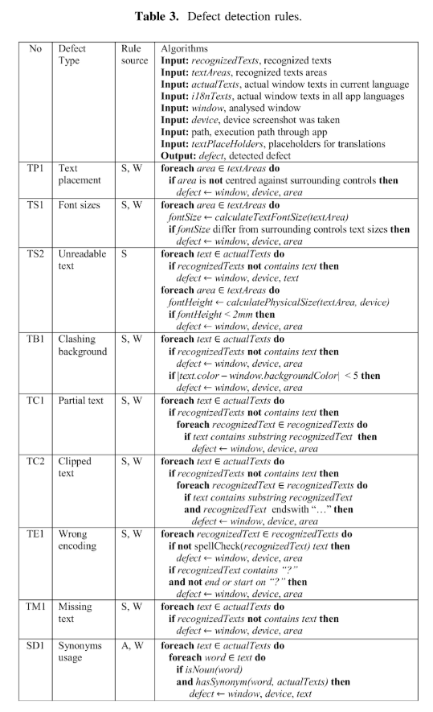

1. Code implementation
   1. Sample screenshot image test
   2. Integrate test