1/15/2019

LogSearch System

DOCUMENTATION

Xie, Shae

Contents

Development Tools 3

Program 4

Back-End 4

1. Elasticearch 4

2. Logstash 6

WebServer 8

1. Nodejs 8

2. Ajax + JQuery 9

Front-End 10

1. Kibana 10

2. Plotly 12

3. UI 14

Study Guide 17

Back-End 17

1. Elasticearch 17

2. Logstash 19

WebServer 20

1. Nodejs 20

2. Ajax 21

3. JQuery 22

Front-End 22

1. Kibana 22

2. Plotly 23

Program Language 24

Configuration 24

File Structure 24

Deploy 26

Open ES Server 27

Open Web Server 27

Data Update 28

Update Text Files 28

Update Database 29

Future Challenge 31

PDF Functionality 31

More Diagrams 31

Search Accuracy 31

Database Presentation 32

# Development Tools

Three parts of the whole system:

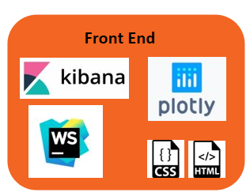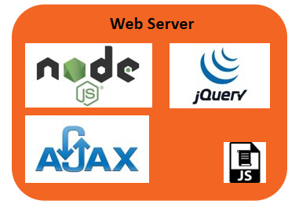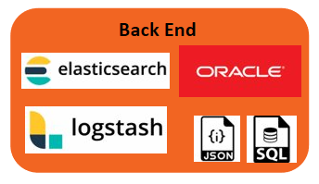

# Program

This section introduces technical details and explains the code.

## Back-End

### Elasticearch

The most operation in elasticsearch is query according to the given keywords.

*File:/stage3_v3 /server_searchengine_v3.js*

There are three different ways to search:

1. Target Folder : text files only

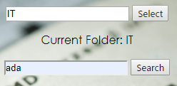

**var** index = "logstash-db_log-2019.1.3"; // the recent ES database

**var** results_number = 100;

index: index, // the ES database name   
type: 'doc',  
size: results_number, // number of return result  
body:{   
 query:{ // query body  
 bool:{  
 must:[  
 {match:{"type":"txt"}}, // search in all test files  
 {match_phrase:{"message": keyword}},// search keyword as whole phrase  
 {match:{"log_folder": folder}} // match the keyword  
 ]  
 }  
 },  
 aggs: { // group the query result  
 type: {  
 terms: {  
 "field": "type.keyword"  
 },  
 aggs: {  
 folder: { // group by folder firstly  
 terms: {  
 "field": "log_folder.keyword"  
 },  
 aggs: {   
 log: { // group by log name then   
 terms: {  
 "field": "log_name.keyword"  
 }  
 }  
 }  
 }  
 }  
 }  
 },  
 _source:["log_time", "log_date","log_name","message","log_folder","type"]

// only show partial attributes  
}

1. Search in both database and all files: all data

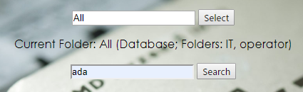

index: index,  
type: 'doc',  
size: results_number,  
body:{  
 query:{  
 bool:{  
 should:[   
 {match:{db_message:{"query":keyword, "operator":"and"}}}, // database  
 {match_phrase:{"message":keyword}} // files  
 ]  
 }  
 },  
 aggs: {  
 type: {  
 terms: {  
 "field": "type.keyword"  
 },  
 aggs: {  
 folder: {  
 terms: {  
 "field": "log_folder.keyword"  
 },  
 aggs: {  
 log: {  
 terms: {  
 "field": "log_name.keyword"  
 }  
 }  
 }  
 }  
 }  
 }  
 }  
}

1. Show the overall data statics



index: index,  
type: 'doc',  
size: results_number,  
body: {  
 aggs: {  
 type: {  
 terms: {  
 "field": "type.keyword"  
 },  
 aggs: {  
 folder: {  
 terms: {  
 "field": "log_folder.keyword"  
 },  
 aggs: {  
 log: {  
 terms: {  
 "field": "log_name.keyword"  
 }  
 }  
 }  
 }  
 }  
 }  
 }  
}

### Logstash

Logstash is needed when import and update data, as well as connect to the conventional database and parse text file.

*File: /conf/logstash/*

1. Import and parse data from text files under folders

input {

file{

path => "C:/Mulong/logs/operator/480b5c800056afd8-(BRCM_PL_TNR-BARTMP36).txt"

Set file path

start_position => "beginning"

codec => multiline{

Define log segment

negate => true

pattern => "(^|\[INFO\]\[)(\d+\-\w+\-\d+)\s(\d+\:\d+\:\d+)"

what => "previous"

Differentiate from database

}

add_field => {"type" => "txt"}

}

}

filter {

grok {

Parse unique log format

break_on_match => false

match => {"message"=>

"(^|\[INFO\]\[)(?<log_date>\d+\-\w+\-\d+)\s(?<log_time>\d+\:\d+\:\d+\.?\d*)[\]\s\t]*(?<log_content>.*)"}

match => {"path"=>"(?<log_folder>[^\/]*)\/(?<log_name>[^\/]*\.(log|txt))"}

}

}

1. Connect to database

input{

jdbc{

jdbc_driver_library => "c:\Mulong\jdbc\ojdbc8.jar"

jdbc_driver_class => "Java::oracle.jdbc.driver.OracleDriver"

jdbc_connection_string => "jdbc:oracle:thin:user/123@//server:1521/pin"

Connect to the DB server

jdbc_user => "user"

jdbc_password => "123"

statement_filepath => "C:\Mulong\git\github\Elasticsearch-nodejs-UI\nodejs_project_AMD\sql\1.sql"

Table name

Content you wanna select

type => "todo"

}

jdbc{

jdbc_driver_library => "c:\Mulong\jdbc\ojdbc8.jar"

jdbc_driver_class => "Java::oracle.jdbc.driver.OracleDriver"

jdbc_connection_string => "jdbc:oracle:thin:user/123@//server:1521/pin"

jdbc_user => "user"

jdbc_password => "123"

statement_filepath => "C:\Mulong\git\github\Elasticsearch-nodejs-UI\nodejs_project_AMD\sql\2.sql"

Adding when import new table

type => "userpreferences"

}

## WebServer

### Nodejs

Used to build the web server and excuse the search query according to input keyword, as well as send back the result to front-end.

*File:/stage3_v3 /server_router_v3.js*

Initial page

The first page sent when link to the system.

// *** router start ***  
app.get('/', **function** (req, res) {  
 res.sendfile(__dirname + '/public/index_v3.html');  
});

1. Main server: trigger the search engine.

app.get('/getkeyword', **function** (req, res) {  
 // get keyword from request  
 **var** search = {  
 'folder': req.query.folder,  
 'keyword': req.query.keyword,  
 'show_all': req.query.show_all  
 };  
 keycontent = search['keyword'];  
 folder = search['folder'];  
 console.log("\n\ninput folder: " + folder);  
 console.log("Input keyword: " + keycontent);  
  
 // trigger the search engine  
 // search by given keywords  
 es.elasticSearch(search, **function** (result) {  
 **var** response = {}; // the final return response  
 **if**(result){  
 // return variables  
 **var** disp = {}; // the table on website  
 **var** draw_data = {}; // the data for drawing diagram  
 // show all or show details  
 **if**(search['show_all']){  
 disp = ui.disp_overview(result, draw_data);  
 }  
 **else**{  
 **var** overview = ui.disp_overview(result, draw_data);  
 disp = ui.disp_detail(result, keycontent);  
  
 disp['txt'] = overview['txt'] + disp['txt'];  
 disp['db'] = overview['db'] + disp['db'];  
 }  
  
 // gather the results  
 response['disp'] = disp;  
 response['draw_data'] = draw_data;  
 response['status'] = 1;  
 res.setHeader('Content-Type', 'text/html');  
 res.end(JSON.stringify(response));  
 }  
 **else**{  
 response['disp'] = "<h3>No related result found by given keyword in target folder: " + search['folder'] + '/' + search['keyword'] + "</h3>";  
 response['status'] = -1;  
 res.end(JSON.stringify(response));  
 }  
 });  
});

1. Download file from local server

app.get('/download', **function** (req, res) {   
 **var** file = __dirname + '\\logs\\' + req.query.file;  
 console.log("Download " + file);  
 res.set({  
 'Content-Type': 'application/octet-stream',  
 'Content-Disposition': 'attachment; filename=' + req.query.file  
 });  
 fs.createReadStream(file).pipe(res);  
});

### Ajax + JQuery

Use to transfer data and collect the return data from the server, as well as defining the on_click function.

*File:/stage3_v3/public/index_v3.html*

<script type="application/javascript">  
 // ajax data transfer  
 $('#show_all').click(**function** () {  
 $.ajax({  
 url: '/getkeyword',  
 type: 'get',  
 data: {  
 show_all: "show_all"  
 },  
 success: **function** (data) {  
 // parse the string data into Json  
 **var** data_json = eval('(' + data + ')');  
 // display result  
 document.getElementById('folder_name').innerText = 'Current Folder: All logs and database on server';  
 document.getElementById('table_txt').innerHTML = data_json['disp']['txt'];  
 document.getElementById('table_db').innerHTML = data_json['disp']['db'];  
  
 // change display area  
 document.getElementById('rt').style.display = 'block';  
 document.getElementById('rt').style.backgroundColor = '#00B7FF';  
 document.getElementById('nav_bar').style.display = 'block';  
 document.getElementById('nav_data_source').style.display = 'block';  
 document.getElementById('search_failed').style.display = 'none';  
 document.getElementById('disp_table').style.display = 'block';  
 document.getElementById('disp_plot').style.display = 'none';  
  
 // change button status  
 document.getElementById('butt_table').className = 'active';  
 document.getElementById('butt_plot').className = '';  
  
 plot(data_json['draw_data']);  
 }  
 })  
 });

## Front-End

### Kibana

Kibana is only a test tool in this project to check the correctness of the ES query statement.

Another important function of Kibana is to set the property of each data field (columns of each table in traditional database), it’s called mapping.

*File: /conf/mapping*

1. Query



Check all data in current ES database

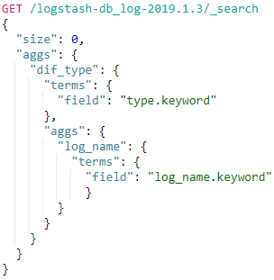

Similar grammar as ES query

Kibana is a great place if you want to inspect your database and test your query statement.

1. Mapping *

This is highly important for importing data from traditional Oracle /MySQL database, otherwise the full-text (all filed) search may not be achieved.

Notes:

1. In the “settings”, the number_of_shards is always 5 to guarantee the performance.
2. Logstash can help to reset property of columns in old traditional database automatically if no customized mapping is given, BUT you need to do that by yourself manually if you want to achieve full-text search.
3. To achieve full-text search, you need to add a “copy_to” attribute to each field. And copy all the fields to that single field.
4. All the field that copy to the same filed required same type (usually text)
5. If you want to give multiple properties to one field, use “fields” setting
6. “Keyword” type is required if you want to do aggregation in this field.

<https://www.elastic.co/guide/en/elasticsearch/reference/current/copy-to.html>

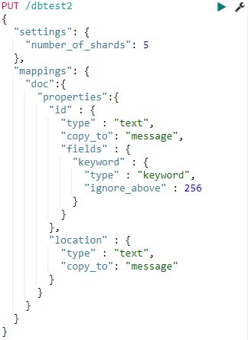

Alternative type of this field

Set the new property for each field

Set the number of shards, 5 usually

All fields should be copy to somewhere to achieve full-text search

New type of this field (column)

Every column in before database needs a new property

Example of create a new Index (Database in MySQL)

### Plotly

Plotly is a convenient tool to visualize the result to see the trend and distribution. It is built on JavaScript and the code is embedded in script.

*File:/stage3_v3 /public/index_v3.html*

Note:

The source code package of plotly is needed before using.

<script src="public/plotly-latest.min.js"></script>

Import the source code

// draw the diagram

// data format sample: [“log1”:10, “log2”:10, “logn”:16]   
**function** plot(data) {  
 **var** div = document.getElementById('disp_plot');  
 **var** x = [];  
 **var** y = [];  
  
 **for** (**var** i **in** data){  
 x.push(i);  
 y.push(data[i]);  
 }  
  
 // line, bar, scatter diagram  
 **var** plot_data = [{  
 x: x, y: y, type: 'bar' // 'line','bar','scatter'  
 }];  
 **var** layout = {  
 title: "Results in Each Log",  
 xaxis:{  
 title: "Log Name",  
 showgrid: **false**,  
 zeroline: **false** },  
 yaxis:{  
 title: "Appear Time",  
 showgrid: **false**,  
 zeroline: **false** }  
 };  
  
 // pie diagram  
 // var plot_data = [{  
 // value: y, labels: x, type: 'pie'  
 // }];  
 // var layout = {height: 400, width: 500};  
  
  
 Plotly.newPlot(div, plot_data, layout, {responsive:**false**});  
}

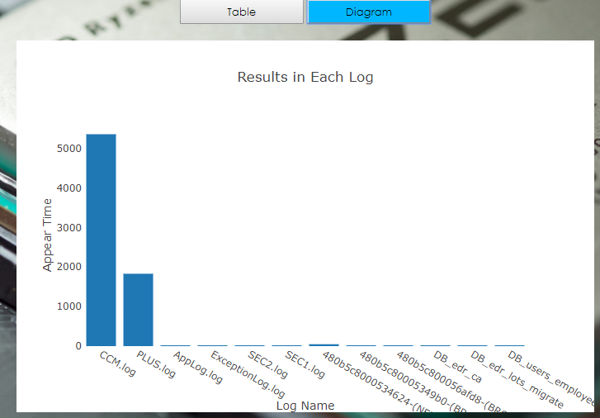

Diagram of result draw in Plotly.js

### UI

Like the traditional web user-interface, JS + HTML + CSS is used in this system.

*File:/stage3_v3 /public/index_v3.html,*

*/stage3_v3/ui_v3.js*

Note:

Use F12 in web browser to inspect the source code and the relative block.

1. ui.js

This part is for reformatting the search result and presenting on the HTML table in the webpage.

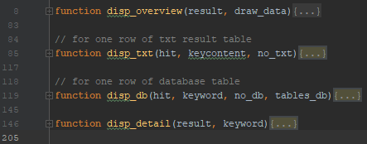

Reformat the result of text

Gather the details of result

Reformat the result of database

Show overview of result

The structure of the ui.js

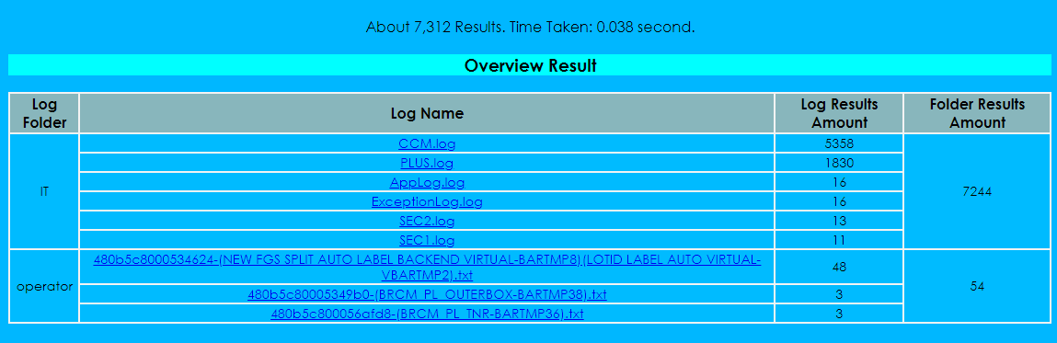

Show overview of result

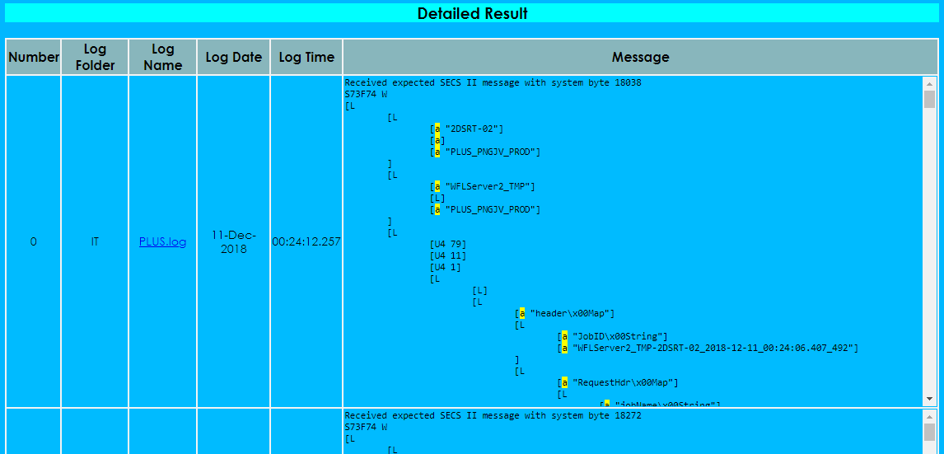

Show the details of result

1. index.html

The HTML part is for building blocks on webpage, nothing needs special illustration.

But there are some dynamic logic needs to be noticed.

The most important line of code is the form of

document.getElementById('input_keyword').style.display = 'block';

“’.style.display’ = ‘block’” means change the display status and make this element visible. If “’.style.display’ = ‘none”, then this element is hidden.

Therefore, the dynamic logic part is mainly about change the display status so that change the subpage of presentation

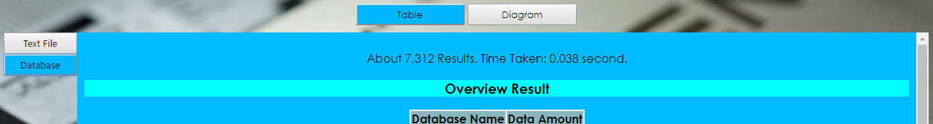

Four buttons for four subpages

For instance, once the “butt_tab” element is clicked, the “nav_data_source” element is not hidden, and this button will change its own color to mark its status.

butt_tab.onclick = **function** () {  
 // display area  
 table.style.display = 'block';  
 plot.style.display = 'none';  
 document.getElementById('nav_data_source').style.display = 'block';  
  
 // change button status  
 butt_plot.className = '';  
 **this**.className = 'active';  
  
 document.getElementById('rt').style.backgroundColor = '#00BBFF';  
};

1. CSS

Like the normal usage, the CSS is for setting style of the webpage elements.

There are several places need to be noticed:

button{  
 font-family: "Yu Gothic UI";  
 overflow: hidden;  
}  
button.active{ // change the button that class name is “active”  
 background-color: #00B7FF;  
}  
button:hover{  
 background-color: #00B7FF;  
}  
button:active { // set the response of mouse event  
 background-color: #00B7FF;  
 transform: translateY(2px);  
}

Press F12 in web browser to inspect the element when you want to change the style of some elements.

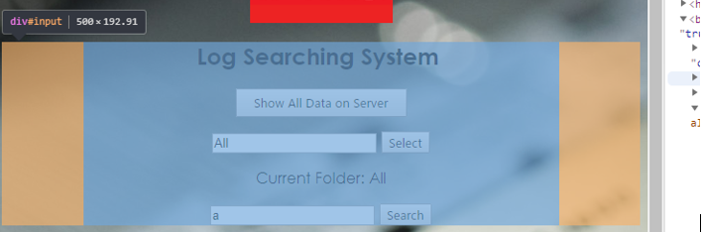

The element id is “input”

# Study Guide

For the sake of time, the future developer taking this project is suggested to flow this learning map drawn on the previous experience and errors.

## Back-End

The back-end of this system is mainly the search engine and data pre-processing system.

### Elasticearch

As the core of this system, the fundamental or even advanced knowledge is required at the first beginning in order to understand the basic requirement of this project.

*Learning Map*:

*Reference*:

Official Website:

<https://www.elastic.co/guide/cn/index.html>

<https://www.elastic.co/guide/index.html> *(English)*

Overall Introduce:

<https://blog.csdn.net/yezonggang/article/details/80064394>

Download and Installation:

<https://blog.csdn.net/weidong22/article/details/79062851>

Query (use combine with Kibana):

<https://www.elastic.co/guide/en/elasticsearch/client/javascript-api/current/quick-start.html> *(English)*

<https://blog.csdn.net/tototuzuoquan/article/details/78303095>

<https://www.elastic.co/guide/en/elasticsearch/reference/current/query-dsl-multi-match-query.html>

<https://www.elastic.co/guide/en/elasticsearch/reference/current/query-dsl-match-query-phrase-prefix.html> *(English)*

<http://n3xtchen.github.io/n3xtchen/elasticsearch/2017/07/05/elasticsearch-23-useful-query-example> *(Recommend)*

Blog Series (Recommend):

<http://www.cnblogs.com/ginb/p/6637236.html>

<http://www.cnblogs.com/ginb/p/elasticsearch.html>

<http://www.cnblogs.com/ginb/p/6993299.html>

<http://www.cnblogs.com/ginb/p/7000427.html>

JavaScript API:

<https://www.elastic.co/guide/en/elasticsearch/client/javascript-api/current/quick-start.html> *(English)*

Mapping:

<https://my.oschina.net/davidzhang/blog/811511>

https://stackoverflow.com/questions/37861279/how-to-index-a-pdf-file-in-elasticsearch-5-0-0-with-ingest-attachment-plugin?rq=1

### Logstash

Logstash is the tool to import and update data in Elasticseach’s database. It has the ability to parse unstructured files such as .log, .txt using regular expression. As well as transfer the data in existing Oracle/MySQL database into the Elasticsearch Database directly.

*Learning Map*:

*Reference*:

Official Website:

<https://www.elastic.co/products/logstash>

<https://www.elastic.co/guide/en/logstash/current/getting-started-with-logstash.html> (Series of Install, Guide) *(English)*

Basic Using:

<https://www.cnblogs.com/yincheng/p/logstash.html>

Parse Test Files:

<https://www.elastic.co/guide/en/logstash/6.5/advanced-pipeline.html> *(English)* <http://trumandu.github.io/2016/10/24/logstash%E4%BD%BF%E7%94%A8%E6%95%99%E7%A8%8B/>

Connect to ES: <https://blog.csdn.net/wangnan9279/article/details/79287820>

Connect to Oracle Database (JDBC):

<https://blog.csdn.net/wjacketcn/article/details/50960843> <https://blog.csdn.net/laoyang360/article/details/75452953>

<https://discuss.elastic.co/t/logstash-jdbc-input-oracle-settings/26996> *(English)*

## WebServer

The Webserver Part is responsible for transferring the keywords user inputs and return the result that the elasticsearch engine generates back to the front-end.

### Nodejs

Nodejs is a powerful tool built on JavaScript, it’s easy to operate and expand with other API such as Elasticsearch.

*Learning Map*:

*Reference*:

Official Website + Download:

<https://nodejs.org/en/> *(English)*

Introduce:

<https://codeburst.io/the-only-nodejs-introduction-youll-ever-need-d969a47ef219> *(English)*

Tutorial Series (Recommend):

<https://www.w3schools.com/nodejs/> *(English)*

Connect to ES:

<https://www.oschina.net/translate/search-engine-node-elasticsearch>

Asynchronization (Advanced):

<https://www.jb51.net/article/63070.htm>

<https://m.jb51.net/article/84148.htm>

### Ajax

Ajax is a popular tool used when building webpage, here we also use it as the tool to transfer data between the web server and the front end.

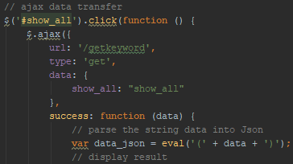

*Transfer data by Ajax combined with JQuery*

*Learning Map*:

*Reference*:

Introduce:

<https://www.w3schools.com/xml/ajax_intro.asp>

Tutorial Series (Recommend):

<https://www.w3schools.com/xml/ajax_intro.asp>  *(English)*

<http://www.runoob.com/ajax/ajax-tutorial.html>

Data Transmission:

<https://www.jb51.net/article/57874.htm> *(Recommend)*

### JQuery

JQuery is a simple alternative of JavaScript, but it has lots of special functions and unique language format. It is used in this system to combine with Ajax.

It’s not as important as other modules in this system, thus no detailed study of this section in this doc.

## Front-End

The work of front-end is to reformat and present the search result that transferred by the server and generated by the back-end engine, as well as collect the keywords inputted by user.

### Kibana

Kibana is part of the ELK (Elasticsearch – Logstash – Kibana) application stack. It is a tool to visualize the result, but it is replaced by our own webpage and only serve as the query – testing tool to inspect the elasticsearch database.

*Learning Map*:

*Reference*:

Official Website: <https://www.elastic.co/guide/cn/kibana/current/index.html> <https://www.elastic.co/guide/en/kibana/current/index.html> *(English)*

Download:

<https://www.elastic.co/downloads/kibana>

Connect with ES:

<https://www.elastic.co/guide/cn/kibana/current/connect-to-elasticsearch.html>

Tutorial:

<https://www.elastic.co/guide/en/kibana/current/index.html> *(English)*

### Plotly

Plotly is a powerful and flexible graphic plugin built for JavaScript. It is used for visualization in this system.

*Learning Map*:

*Reference*:

Official Website, Download, Tutorial:

<https://plot.ly/javascript/>

## Program Language

I believe a qualified software engineer is capable of handling any unfamiliar program language in very short term in grammar–level. Language is too easy to worry that much for a brilliant programmer. Therefore, this documentation dose not contain detailed guide of any program language, the reader could find various tutorials of basic language grammar knowledge in Google.

# Configuration

This section is about how to active the whole system and some daily routine.

## File Structure

The directory structure of the program is shown below.



Root directory

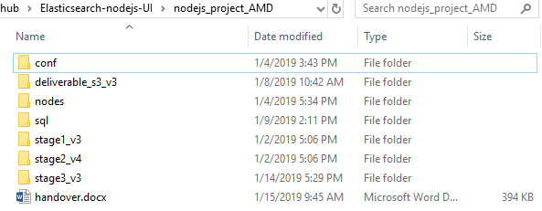

Secondary directory

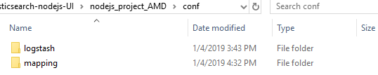

*/conf:*

Contains the logstash configuration files needed when update data and mapping setting using in Kibana to set property of data fields (columns)

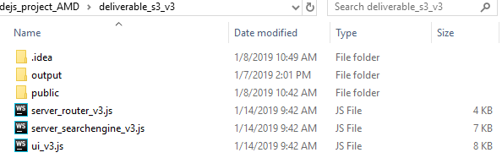

Search result copy

HTML, CSS, images

Main server

*/deliverable*:

The latest version of the system, could be treated as the useable version for daily use, but development should not in here

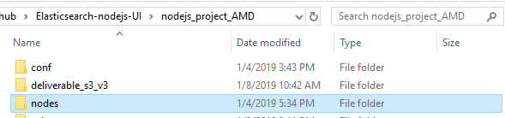

*/nodes:*

Elasticsearch database copy

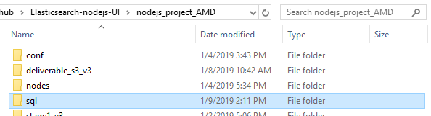

*/sql:*

SQL statement, used when transfer data from Oracle/MySQL

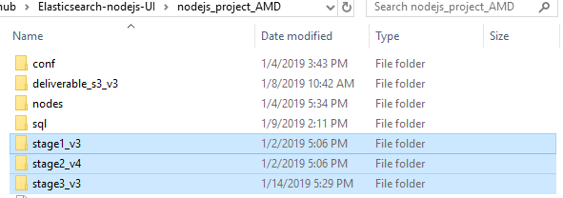

*/stage*_v*:*

History versions, development and system update should perform here

## Deploy

When all current development is done, life becomes easy. To run the system, there are only two servers need to be active.

Open web server

Open elasticseach server

### Open ES Server

After importing data, excuse the ‘.bat’ to active the server before doing anything.

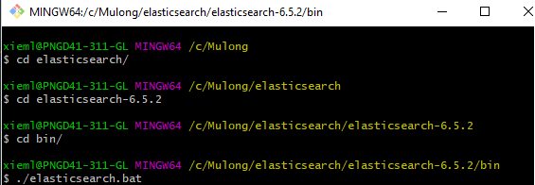

Or go to *elasticsearch/bin* and click the “.bat” file.

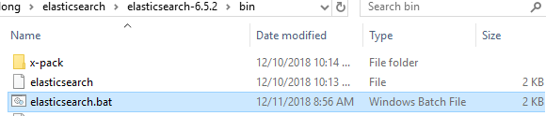

### Open Web Server

Open the main server “server_router”, and run it as running a normal node.js program.

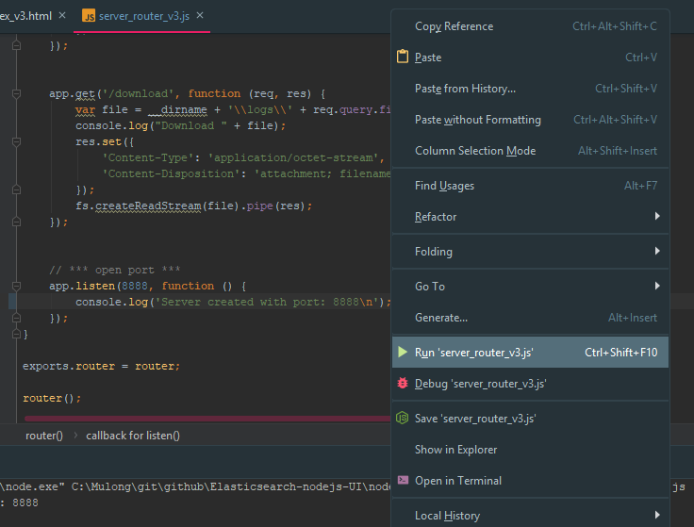

## Data Update

Use Logstash to update the ES database.

### Update Text Files

1. Put new text file under any directory

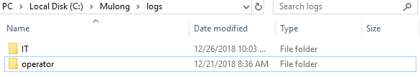

The current folders

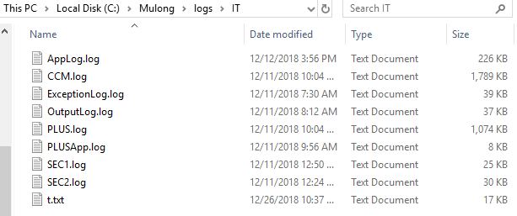

Put new file here

1. Open *logstash/config/logprocess.conf*

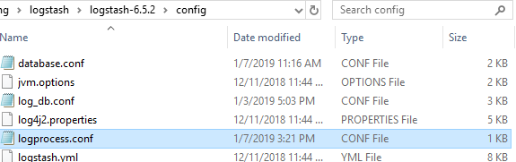

1. Change few lines of configuration

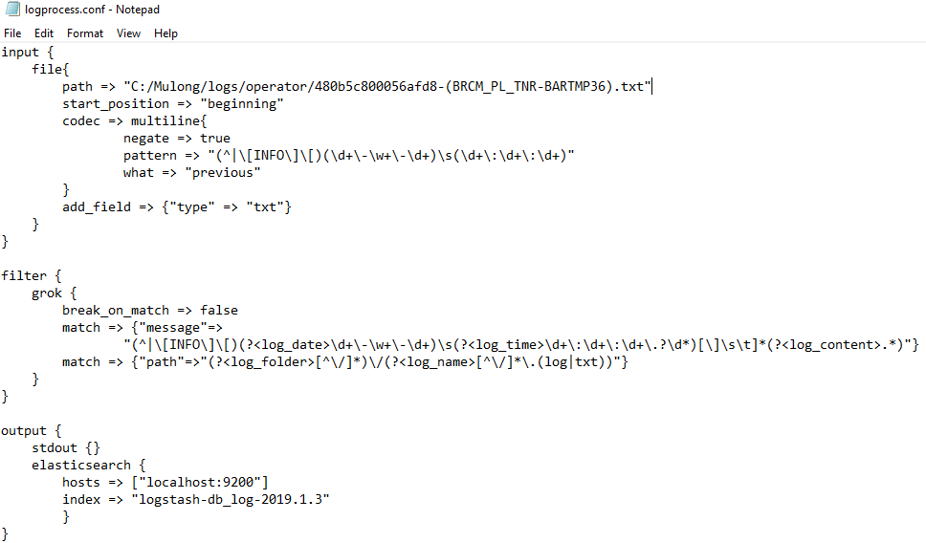

Change log content format if needed

Change target database if needed

Change log segment format if needed

Change path

1. Excuse the new configuration.



### Update Database

1. Write SQL statement to select the whole table or any part you want.

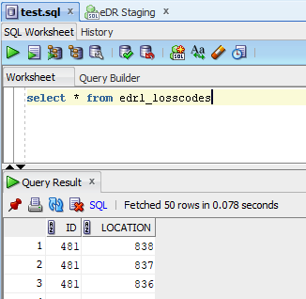

And save it under */sql*

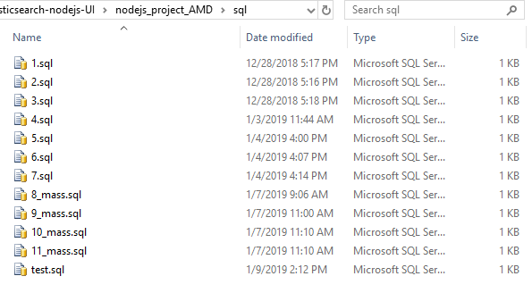

1. Change the config file.

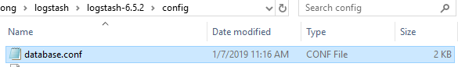

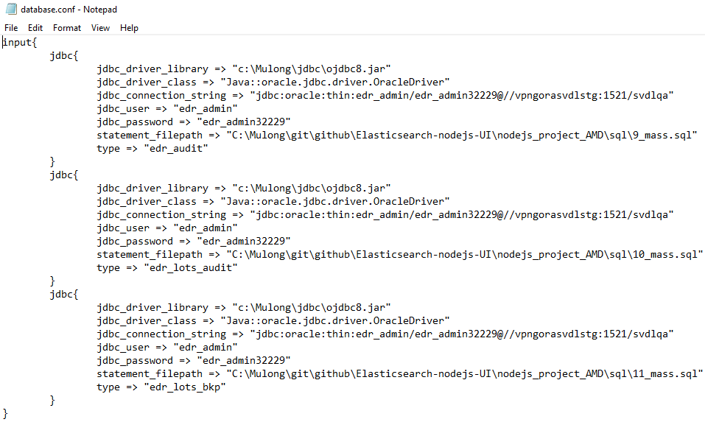

New SQL

New table name

Copy this jdbc for every new table

1. Excuse the new configuration.



# Future Challenge

For the reason of time, this system is still not perfect and has zone to improve and expand.

The challenges here are all advanced topics, the future solver is required insight and comprehension of previous knowledge before going ahead.

## PDF Functionality

A new requirement is searching in .pdf file, but based on current knowledge, it is inevitable to convert the pdf files one by one before importing into ES database.

The future developer is suggested to use some other languages to write a script to achieve conversion and then pipeline to ES.

## More Diagrams

The visualization functionality is now a simple demo, the future taker might can draw various diagrams to meet different needs.

The future developer is suggested to not only learn how to draw different diagram, also need to know how to expand the user interface to present those graphs in a user-friendly way.

## Search Accuracy

The system is still now using testing data sample, but for the sake of time, all the fields of database is reset as “text”, which may bring some unwanted results.

The future developer is suggested to learn to master “match_phrase”, “term”, “query_string” and other advanced query methods.

It is very import to consider carefully what type or multiple-types should be assigned to different data filed when setting a new mapping.

## Database Presentation

A non-important drawback of this system is that only limited result could be presented on webpage.

The future developer is suggested to add “show more” functionality.