11/2/2020
Adjusted image: 29029.jpg
Objective:
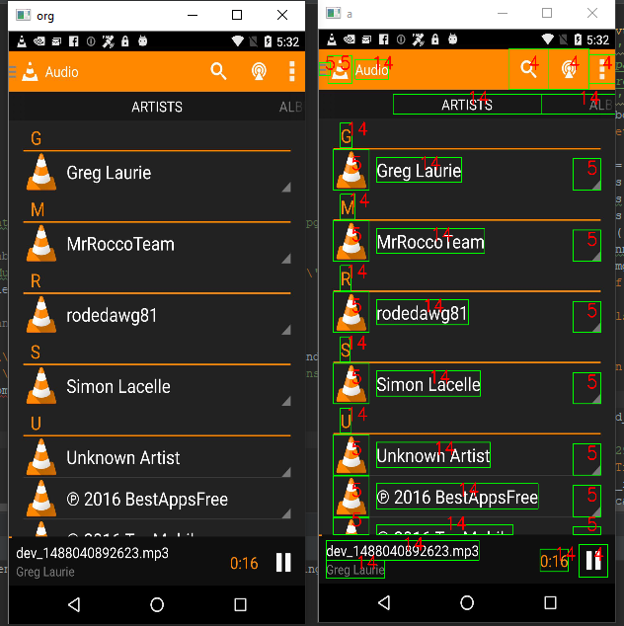
- All graphic elements
- All words
Problem
- Binary objects conglutination
- Incorrect classification
