**Technical Details**

**Pre-processing**

As most of other computer vision techniques, the first step of this system is pre-processing, which aims to remove redundant information in the original color image and convert it into binary image consisting of only two values, 0(black) and 255(white) for subsequent operations.

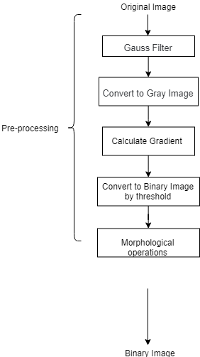

**Figure 1. Flow Diagram of Pre-processing**

Figure 1. shows the flow path of the pre-processing. The first step is passing through the Gauss Filter to blur the original image to reduce the level of noise. But this step is optional in UI detection case, because the UI image, unlike natural pictures, suffer less from imbalanced light and complex environment.

After being converted to gray image, the next critical step is calculating gradient. In conventional methods of computer vision, gradient is always used to detect the edge of potential objects in images. In this case, however, the gradient is not only applied to find the potential boundary of UI elements, but also to solve one of the trickiest problems, the disturbance from image components.

Before introducing more details, Figure 3 presents results by directly utilizing popular object detection methods in UI elements detection. A typical misrecognition in those result is that the content of the image element on the webpage are wrongly recognized as UI components.

 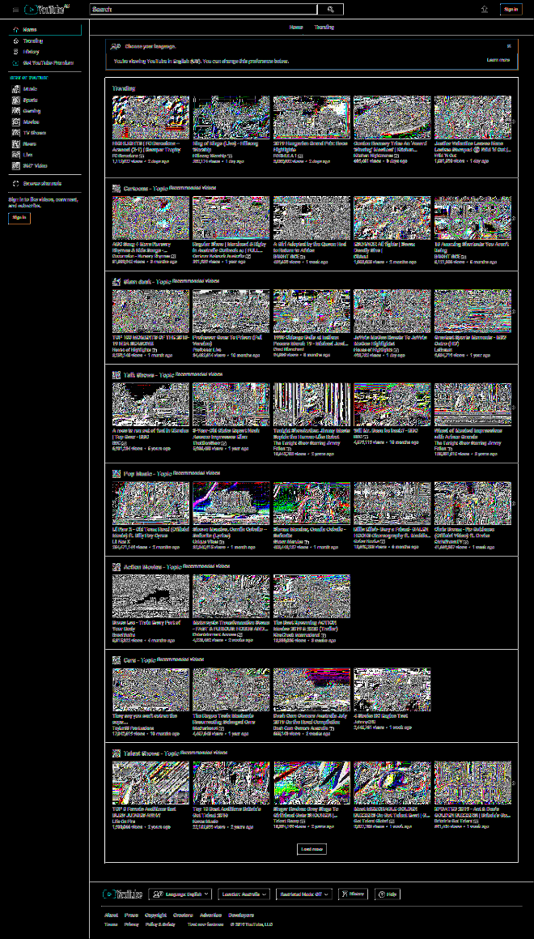

**Figure 2. Calculate the gradient of the original image**



**Figure 3. Poor performance by directly using deep learning object detection methods**