MediClaim Orchestrator
Multi-Agent Cashless and Reimbursement Claim Processing
Project Report
A hospital system and an insurer / TPA system that process a health-insurance claim end to end with CrewAI agents, n8n workflows and deterministic engines, on local open models

Repository: github.com/Multi-Agent-MediClaim-Orchestrator/Sohail-Ahmed
Prepared by: the project team
October 2026 · Version 1.0

Abstract
Cashless and reimbursement health-insurance claims in India still move between hospitals and insurers as bundles of scanned documents that people read, check and re-key. A discharge can wait hours for approval, and errors on either side lead to queries, short payments and rejections. This project builds two independent, cooperating systems that automate the work while keeping people in charge of every decision that matters.
On the hospital side, documents are scanned for viruses, read with OCR, classified, masked for personal data and turned into structured fields; the claim is assembled from the bills, checked against twelve validation rules, and given an estimate of the admissible amount computed from the patient's own policy wording before it is submitted. On the insurer side, seven AI agents verify identity, authenticity and coverage, map bill lines and summarise the case, a deterministic engine computes the payable amount, and a decision gate routes the claim to automatic approval, one approver or two approvers. Queries, replies, decisions and settlement flow between the two systems through a signed API, and both keep a tamper-evident audit trail.
The agents are built with CrewAI (Agents, Tasks, Crews and Flows with guardrails), the business processes run on n8n, and every number and gate is decided by tested code. All models run locally through Ollama (gemma4 and nomic-embed-text), so no patient data leaves the machine and no paid API keys are needed. The whole system starts and runs with one command (make demo). On a MacBook Air it passed end to end on the real model, and the offline variant passed all seven claim scenarios; the evaluation on 300 synthetic cases shows complete agreement of the calculation engine with an independent reference and no wrongful automatic approvals.
Contents
Abstract 2
1. Executive summary 4
2. Background: health-insurance claims in India 5
2.1 Cashless and reimbursement claims 5
2.2 Who does what 5
2.3 What makes it hard 5
3. Problem statement and objectives 6
3.1 Problem statement 6
3.2 Objectives 6
3.3 Scope 6
3.4 Constraints 6
4. Solution overview 7
4.1 Design principles 7
4.2 Where AI is used, and where it is not 7
5. System architecture 9
5.1 Components 9
5.2 Deployment view: containers and processes 9
5.3 Interface rules 10
6. End-to-end claim workflow 11
6.1 Step by step 11
6.2 Claim states 12
6.3 Decision gate 12
7. Multi-agent design with CrewAI 13
7.1 CrewAI concepts we use 13
7.2 Hospital crew 13
7.3 Insurer crew 14
7.4 Example: a guardrail at work 15
7.5 Offline mode 15
8. Admissible-amount estimate before submission 16
8.1 Method 16
8.2 Worked example 16
9. Workflow automation with n8n 17
9.1 Screenshots of the real workflows 17
10. Document intelligence and knowledge retrieval 20
10.1 doc-pipeline 20
10.2 vision-service 20
10.3 rag-service 20
11. Calculation engine and validation rules 21
12. Data, privacy, security and audit 22
12.1 Synthetic data 22
12.2 Privacy (DPDP-minded) 22
12.3 Security 22
12.4 Audit 22
13. One-command deployment 23
14. Testing and evaluation 25
14.1 Automated tests 25
14.2 End-to-end scenarios 25
14.3 Evaluation 25
15. Results 26
15.1 Real-model run 26
15.2 Offline run 26
15.3 Observations 26
16. Limitations 27
17. Future recommendations and roadmap 28
17.1 Short term (next 4-6 weeks) 28
17.2 Medium term (3-6 months) 28
17.3 Long term 28
18. Conclusion 29
References 30
Appendix A. Glossary 31
Appendix B. Repository structure 32
Appendix C. Command reference 33
Appendix D. Agent service endpoints 34
Appendix E. More n8n workflow screenshots 35
Appendix F. Design decisions log (summary) 37

1. Executive summary
What we built. Two systems, a hospital and an insurer / TPA, that together process a health-insurance claim from the first uploaded document to the bank payout. Each side has its own API, database, workflows, AI agents and user interface, and they talk only through a versioned, signed REST contract.
Why. The manual process is slow (hours from discharge to approval), error-prone (arithmetic, missing documents, wrong categories) and opaque (the hospital does not know what the insurer will pay until it pays). Our design targets all three: automation for speed, deterministic checks for correctness, and quoted evidence plus an estimate for transparency.
How. AI agents do what only language models can do well: read unstructured text, map free-text bill lines, find and quote policy clauses, and draft polite, grounded messages. Code does everything that must be exact: arithmetic, policy rules, identity matching, routing and the final money. Humans approve anything above ₹50,000, and two approvers anything above ₹5,00,000.
Area | Outcome
Agents | 11 CrewAI agents (4 hospital, 7 insurer) in 4 CrewAI Flows; every model call guarded
Workflows | 32 n8n workflows (13 hospital, 19 insurer)
One command | make demo (real model) and make demo-offline (no model) bring up everything and run a claim end to end
Real-model run | Passed on a MacBook Air (Apple Silicon): claim built, verified, auto-approved, settled, audit verified; 166 s claim run
Scenarios | 7/7 passed offline: auto, reviewer, dual approval, rejection, three query rounds, duplicate callbacks, bank retry
Quality | 1,000+ automated tests; calculation agreement 1.00; wrongful automatic approvals 0.00
Privacy | Local models only, PII masked before any model call, no paid keys, synthetic data only

The remaining gaps are clearly bounded: retrieval citation precision (0.61 against a 0.90 target, measured offline), a few success metrics not yet measured (manual baseline, time to submit, queries per claim), and moving the insurer's step order fully into the CrewAI Flow. Section 17 lays out the plan.

2. Background: health-insurance claims in India

2.1 Cashless and reimbursement claims
A cashless claim is settled directly between a network hospital and the insurer (often through a Third-Party Administrator, TPA): the patient pays only what the policy does not cover. A planned cashless admission needs a pre-authorisation; at discharge the hospital submits the final claim. A reimbursement claim is paid to the patient after they settle the bill themselves and submit the documents. The same verification applies to both; only the payee and the timing differ.

2.2 Who does what
Party | Role in a claim
Patient / member | Holds the policy; provides identity proof and the policy card at admission
Hospital billing desk | Collects bills, discharge summary, prescriptions and reports; assembles and submits the claim; answers queries
Billing officer | Reviews the assembled claim and signs it off before submission
Insurer / TPA reviewer | Checks identity, authenticity, coverage and the amounts; raises queries; recommends a decision
Approver / senior reviewer | Approves or rejects above set amounts
Bank | Pays the settled amount to the hospital (cashless) or the member (reimbursement)

2.3 What makes it hard
- Unstructured, noisy input. Scanned or photographed documents with stamps, handwriting, skew and low resolution.
- Policy complexity. Room-rent caps with proportional deductions on related charges, ICU caps, procedure sub-limits, co-payments, deductibles, waiting periods, exclusions and non-payable items all interact, and the wording changes by product version and date.
- Back-and-forth. Missing or unclear documents lead to queries; each round can take a day; after three rounds the case escalates.
- Trust and privacy. Claims contain identity numbers and diagnoses. India's Digital Personal Data Protection Act, 2023 (DPDP) sets duties on how such data is processed.

3. Problem statement and objectives

3.1 Problem statement
Problem
Build a multi-agent system that takes a hospital's claim from raw documents to a submission-ready claim, verifies and decides it on the insurer's side, and handles queries and settlement, so that discharge-to-approval time drops from hours to minutes while every decision above a threshold stays with a human, every step is auditable, and no patient data leaves the organisation.

3.2 Objectives
- Automate document intake: virus scan, OCR, classification, extraction and PII masking.
- Assemble the claim from the bills and validate it before a person sees it.
- Interpret the policy on the hospital side (sub-limits, co-pays, non-payables) and estimate the admissible amount before submission.
- Verify the claim on the insurer side with specialised agents, compute the payable amount exactly, and route the decision by risk and amount.
- Run the query loop (raise, triage, grounded reply, escalate) and settlement end to end.
- Use CrewAI for the agents and n8n for the business workflows, as required by the course.
- Start and run everything with a single command, and measure the results.

3.3 Scope
In scope | Out of scope
Cashless and reimbursement; planned and emergency admissions | Real pre-authorisation (a simulated record is assumed)
Document intake, completeness, claim build and submission | Real insurer, TPA, bank, ABDM or NHCX integrations
Identity, authenticity, coverage, calculation, decision gate | Real patient data, production hosting, commercial use
Multi-round query loop with escalation; settlement via a simulator | Fraud analytics across insurers
Admin configuration, audit explorer, evaluation harness | Mobile apps

3.4 Constraints
- No paid API keys and no patient data leaving the machine: all models run locally through Ollama.
- Commodity hardware: one laptop, 16 GB RAM minimum, no GPU required.
- Synthetic data only: members, policies, hospitals and documents are generated, with known ground truth for evaluation.

4. Solution overview
The solution is two systems that mirror the real world: the hospital and the insurer are separate organisations with separate data. Each system owns its API, database, workflow engine, agents and user interface. The only link is a versioned REST contract with HMAC signatures and idempotency keys, plus signed callbacks in the other direction.
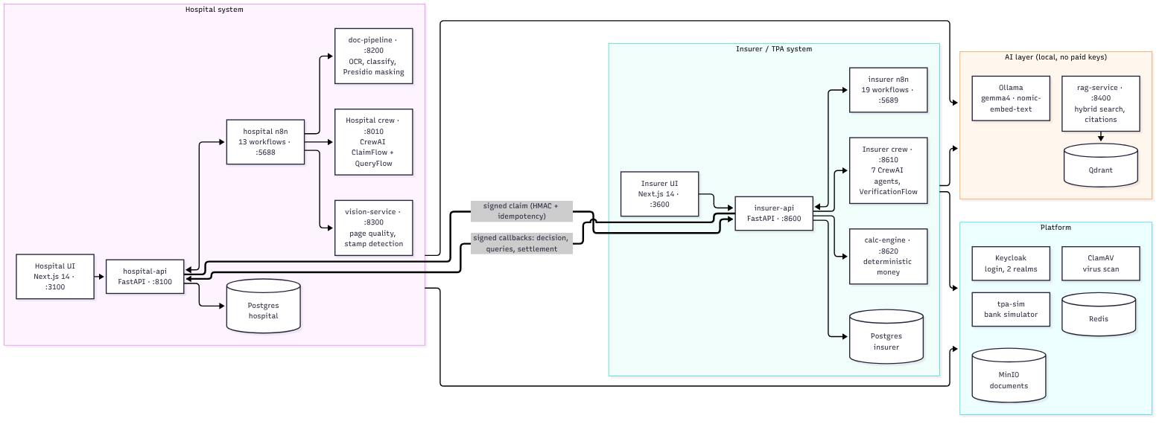
Figure 1: System architecture: hospital system, insurer / TPA system, AI layer and platform services

4.1 Design principles
Principle | What it means in the code
Deterministic first | Routing, completeness, identity matching, arithmetic and payout are code. Models only read text, map lines and draft messages; code checks and can override their answers.
Configuration over code | Document requirements, thresholds, deadlines and policy rules are versioned database rows; each decision records the versions it used.
Human authority | The system recommends; people decide above ₹50,000, and two people above ₹5,00,000. Any blocker sends a claim to a person.
Privacy by construction | Identity documents never go to a model; text is masked first; a PII guard runs before every model call; models are local.
Evidence over confidence | Gates use parser confidence, quotes and code checks, never a model's self-reported confidence.
Everything auditable | Every agent output, human edit and approval is an append-only, hash-chained event on both sides.
Fixable before fatal | A missing document or stamp becomes a needs-info request, not a rejection.

4.2 Where AI is used, and where it is not
Task | Done by | Why
OCR, classification, field extraction | doc-pipeline (rules + model, two passes) | Unstructured scans; two independent passes must agree
Mapping unknown bill lines | CrewAI agents (hospital and insurer) | Free text; code limits answers to the allowed categories
Reading policy wording, quoting clauses | CrewAI agents + RAG | Long natural-language documents; quotes are verified
Drafting queries and replies | CrewAI agents | Natural language; grounding guardrails reject invented facts
Arithmetic, caps, co-pay, sub-limits | calc-engine (code) | Must be exact and reproducible
Identity match, completeness, routing | Code | Rules with known answers; auditable
Approve / reject above thresholds | People | Accountability

5. System architecture

5.1 Components
Table 1: Main components
Component | Technology | Port | Responsibility
hospital-ui | Next.js 14 | 3100 | Desk, officer and admin screens; live status
hospital-api | FastAPI, SQLAlchemy, Alembic | 8100 | Cases, documents, completeness, router, claim builder, submission outbox, queries, audit
hospital n8n | n8n 2.41.6 | 5688 | 13 workflows: intake, completeness, build, submission, queries, reminders
hospital crew | CrewAI 1.15.23 | 8010 | ClaimFlow and QueryFlow: claim build/repair, estimate, triage, grounded replies
doc-pipeline | Poppler, Tesseract, Presidio | 8200 | Parse, classify, mask, two-pass extraction
vision-service | OpenCV, NumPy | 8300 | Page quality, stamp detection, registry match
insurer-ui | Next.js 14 | 3600 | Reviewer, approver and admin workspace
insurer-api | FastAPI, SQLAlchemy, Alembic | 8600 | Receipt, verification engine, decision gate, queries, settlement
insurer n8n | n8n 2.41.6 | 5689 | 19 workflows: verification steps, decision gate, queries, escalation, settlement
insurer crew | CrewAI 1.15.23 | 8610 | 7 agents; VerificationFlow and QueryFlow
calc-engine | Python (Decimal) | 8620 | Payable amount; used in process by insurer-api and as a library by the hospital
rag-service | Own hybrid search on Qdrant | 8400 | Policy wording, guidelines, precedents; filtered and cited retrieval
tpa-sim | FastAPI | 8500 | Bank / TPA simulator for payouts and scripted queries
Ollama | gemma4, nomic-embed-text | 11434 | Local language and embedding models
Platform | Postgres 16 ×2, Redis 7, MinIO, ClamAV, Keycloak 25 | various | Data, queues, documents, virus scan, login

5.2 Deployment view: containers and processes
make demo runs the stateful platform in Docker containers and the Python services as host processes (faster to restart and easier to debug on a laptop). Three Docker networks keep data apart: the hospital database is reachable only on hospital_net, the insurer database only on insurer_net, and the shared services sit on shared_net as well as both private networks. The two n8n containers use host networking so they can call the host services.
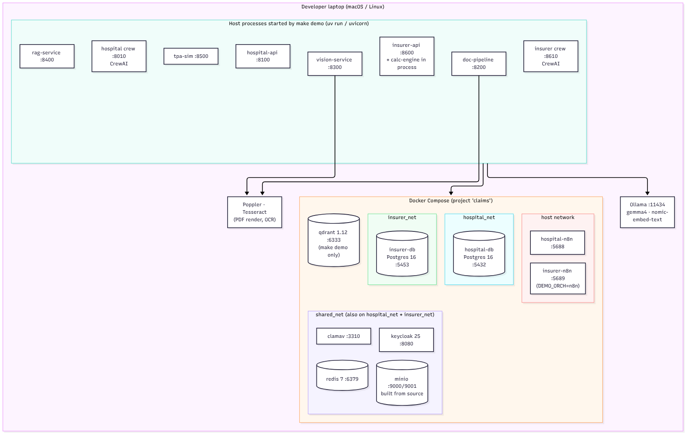
Figure 2: Deployment view: Docker containers by network, host processes, Ollama and the PDF/OCR tools

5.3 Interface rules
- UIs call only their own API; the two APIs never share a database.
- Hospital ↔ insurer traffic goes only through the versioned REST contract, signed with HMAC and carrying an idempotency key; callbacks are signed the same way.
- n8n calls the APIs with a service account; the crews never write to a database: they return validated objects that the API checks and stores.
- The hospital's knowledge-base token can read only hosp_* collections; the insurer's collections are closed to it.

6. End-to-end claim workflow
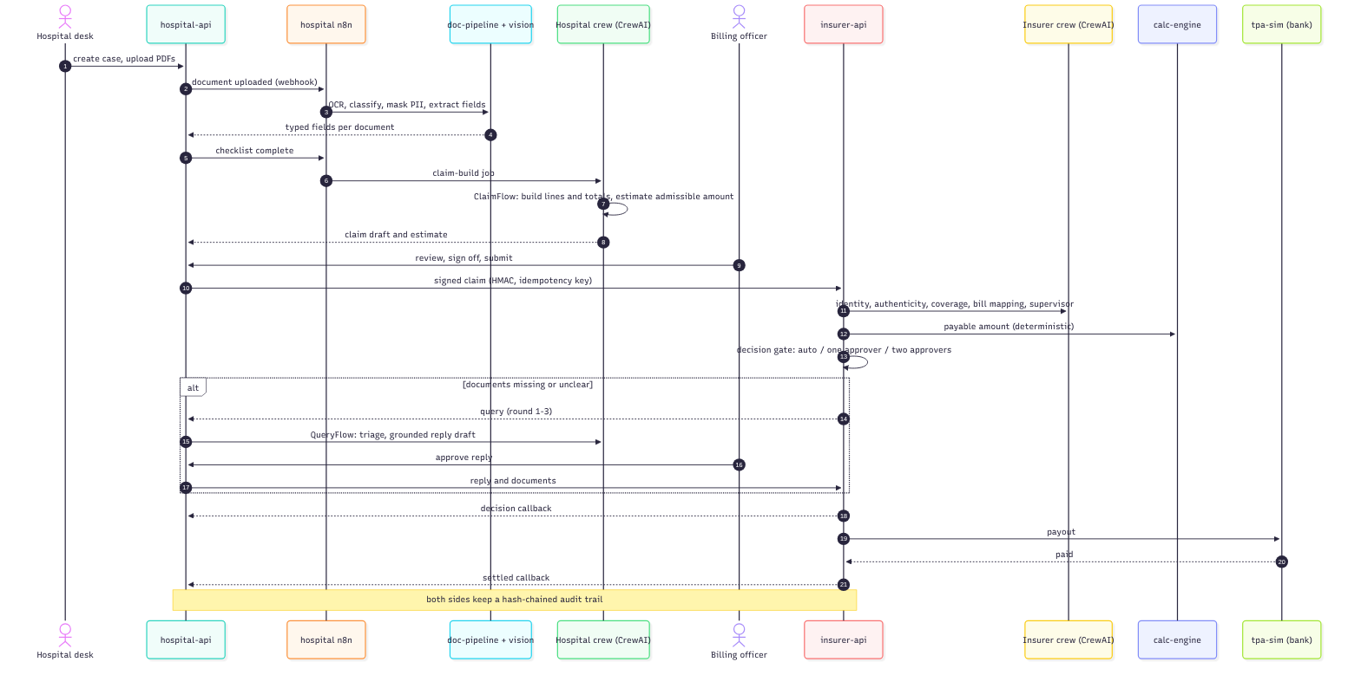
Figure 3: Claim lifecycle from upload to settlement (sequence of calls)

6.1 Step by step
- Intake. The desk creates a case and uploads PDFs. hospital-api checks size and type, scans each file with ClamAV, stores it encrypted in MinIO and triggers the n8n intake workflow.
- Reading. n8n calls vision-service (page quality, stamps) and doc-pipeline (text layer or OCR, classification, Presidio masking, two-pass field extraction). Low-confidence pages go to review.
- Completeness. hospital-api compares the documents with the configured checklist (for example prescription, pharmacy bill, final bill, plus procedure bill or implant sticker when relevant) and asks for what is missing.
- Claim build (CrewAI ClaimFlow). The hospital crew assembles bill lines and totals in code, asks the category-mapper agent only for unknown lines, then estimates the admissible amount from the policy wording and the calculation engine.
- Validation and sign-off. hospital-api applies validation rules V01-V12 (totals, quantity × rate, dates, identity, ICD-10 codes, duplicates, pre-auth excess, room-rent cap, document integrity). The billing officer reviews, edits if needed, sees the estimate and signs off.
- Submission. A signed, idempotent submission goes to insurer-api through an outbox with retries.
- Verification. insurer-api runs document fetch, completeness, identity, authenticity, coverage and calculation. Each AI step calls its CrewAI agent; code computes the facts and the money.
- Decision gate. A clean claim of ₹50,000 or less is approved automatically; above that one approver decides; above ₹5,00,000 two approvers. Blockers, warnings or degraded steps always send it to a person.
- Queries. If something is missing or unclear, the insurer's query drafter writes the query; the hospital's QueryFlow triages it and drafts a grounded reply for the officer to approve. After three rounds the case escalates to a senior reviewer.
- Settlement and audit. The decision is sent back by signed callback; the payout goes through the bank simulator; both audit chains are verified.

6.2 Claim states
Hospital case states | Insurer case states
draft → docs_pending → docs_complete → building_claim → ready_for_review → submitted → acknowledged → under_query → approved / partially_approved / rejected → settled → closed | received → verifying → needs_info → ready_for_decision → awaiting_approval → approved / partially_approved / rejected / escalated → settled → closed

6.3 Decision gate
Table 2: Decision tiers (insurer-api gate.py)
Tier | When | Who decides
auto | Clean claim, amount ≤ T_auto (₹50,000), identity score above threshold, no blockers, warnings, flags or degraded steps | The system (recorded with the reason)
reviewer / single approver | Amount > T_auto, or any flag or warning | One reviewer or approver
dual approver | Amount > T_four (₹5,00,000), or rejection of a large claim | Approver and senior reviewer

7. Multi-agent design with CrewAI

7.1 CrewAI concepts we use
Concept | Meaning | Where in our code
Agent | A role, a goal and a backstory, bound to a model | config/agents.yaml on both sides
Task | One piece of work with an expected output | One task per model call (team.py, crewai_team.py)
Crew | Agents and tasks run in a process (sequential here) | A one-task sequential crew per call
Flow | Owns state and order: @start, @listen, @router | ClaimFlow, QueryFlow (hospital); VerificationFlow, QueryFlow (insurer)
Guardrail | Checks a task's output; a failure is sent back to the agent | Grounding rules, quote checks, schema checks
Custom LLM | A BaseLLM subclass that CrewAI calls | BridgeLLM / GatewayBridge: our own clients behind CrewAI

Every agent reaches the model through a small bridge, so the protections that existed before CrewAI stay in front of every call: the PII guard, the Ollama circuit breaker, JSON repair, token accounting, the degraded-model flag and Langfuse tracing. CrewAI's memory and knowledge features are switched off (they default to OpenAI embeddings) and telemetry is opted out. Agents have no tools: deterministic tools run in the flow steps and as guardrails, because small local models are unreliable at multi-step tool use.

7.2 Hospital crew
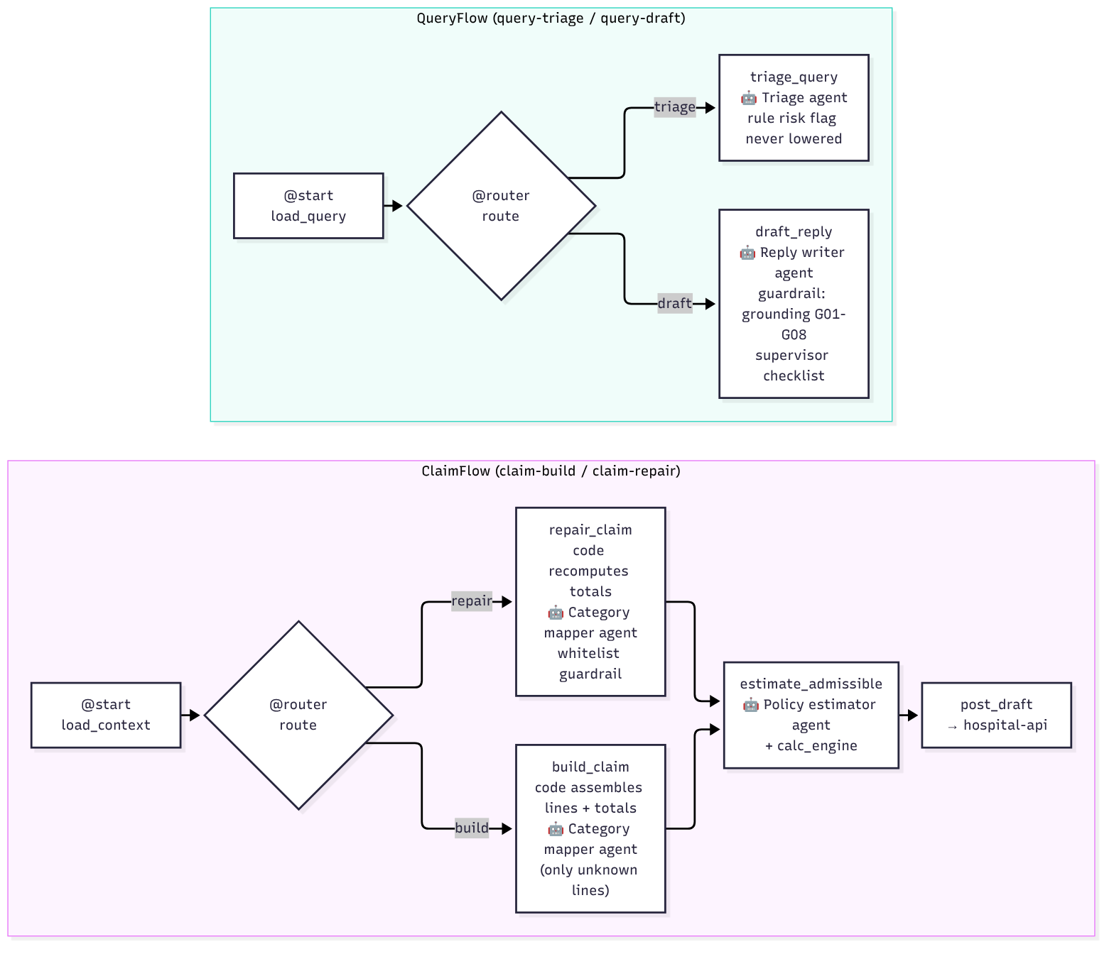
Figure 4: Hospital CrewAI flows: ClaimFlow (build, repair, estimate) and QueryFlow (triage, draft)
Agent | Input → output | Guardrail / code control
Category mapper (local model) | Unlabelled bill lines → category per line | Only allowed categories accepted; others ignored
Policy estimator | Policy wording excerpts → room %, ICU %, co-pay %, sub-limit with quotes | Quote must be in the wording and contain the number; code parser overrides
Query triage officer | Insurer query → send documents / clarify, escalation risk | Rule-based risk flag can be raised, never lowered
Claims desk reply writer | Numbered evidence → reply with verbatim citations | Grounding rules G01-G08, one retry; supervisor checklist

7.3 Insurer crew
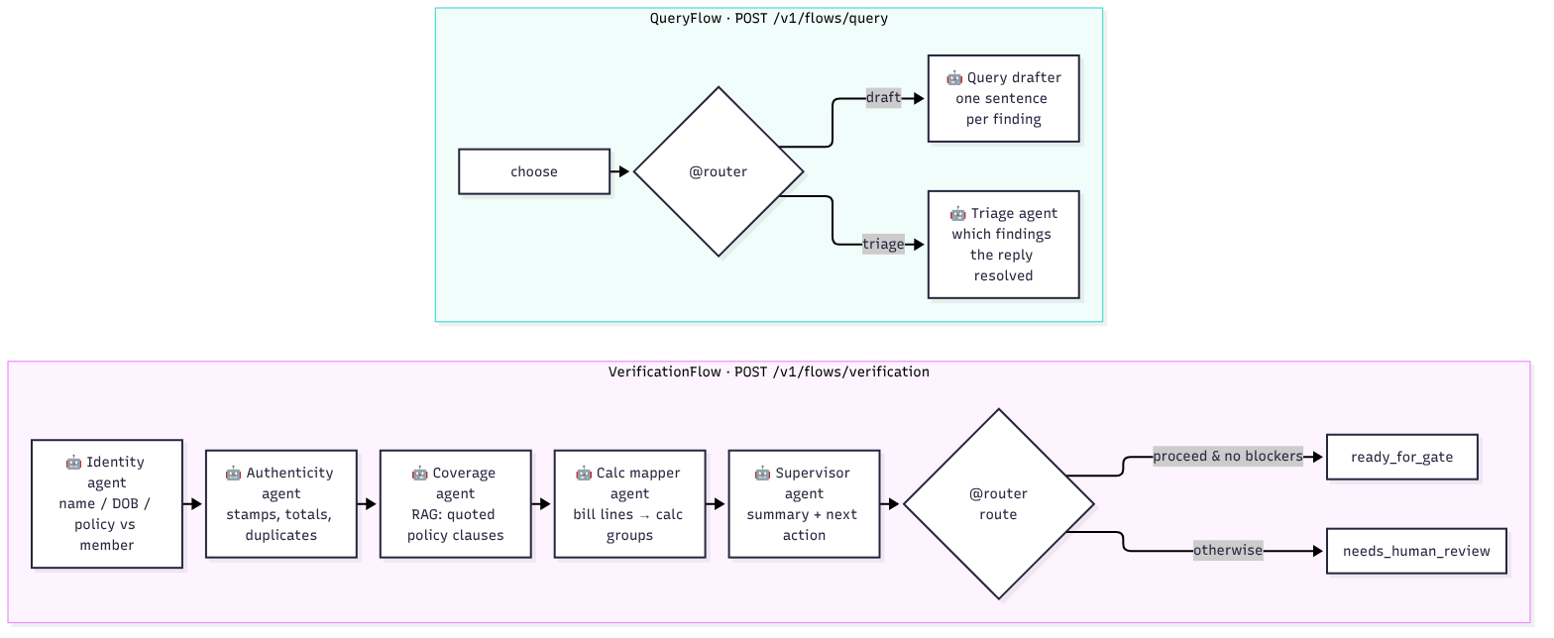
Figure 5: Insurer CrewAI flows: VerificationFlow with routing, and QueryFlow
Agent | What it does | What code still decides
Identity | Reconciles patient, member and ID-document fields | Name score, DOB and policy matches are facts it cannot contradict
Authenticity | Explains stamp, total, duplicate and tamper signals | Anomalies without a code signal or evidence are dropped; severity capped
Coverage | Finds and quotes policy clauses (RAG) | Quotes must appear in retrieved text; else insufficient evidence
Calc mapper | Maps unknown lines to calculation groups | Keyword rules first; calc-engine owns money
Supervisor | Summary for the reviewer, next action | 'Proceed' downgraded if any blocker exists
Query drafter | One sentence per open finding | Forbidden phrases and invented amounts stripped
Triage | Which findings a reply resolved | Code check of attached documents overrides

The seven agents keep their HTTP endpoints, so insurer-api and the n8n step workflows call them per step. Two Flow endpoints chain them: POST /v1/flows/verification (identity → authenticity → coverage → calc mapper → supervisor → proceed or human review) and POST /v1/flows/query (draft or triage). A failed step is recorded as a blocker, so the flow routes the claim to a person.

7.4 Example: a guardrail at work
Grounded reply (hospital QueryFlow)
Attempt 1: the agent writes "The room rent was 99999 as recorded in the file."
Guardrail: "number not found in the record: 99999" → sent back to the agent.
Attempt 2: "The room rent of 10000.00 is as billed in the record." with a verbatim quote → accepted; supervisor checklist passes.

7.5 Offline mode
With CREW_LLM=rules (hospital) and INS_CREW_LLM=offline (insurer), the same Flows, agents and guardrails run on deterministic stand-in models that claim nothing on their own. This makes the full pipeline testable in seconds and gives a safe fallback for live demonstrations.

8. Admissible-amount estimate before submission
Today a hospital learns what the insurer will pay only after submission. The estimate closes that gap: before sign-off, the officer sees the expected payable amount and the policy terms behind it, quoted from the wording.
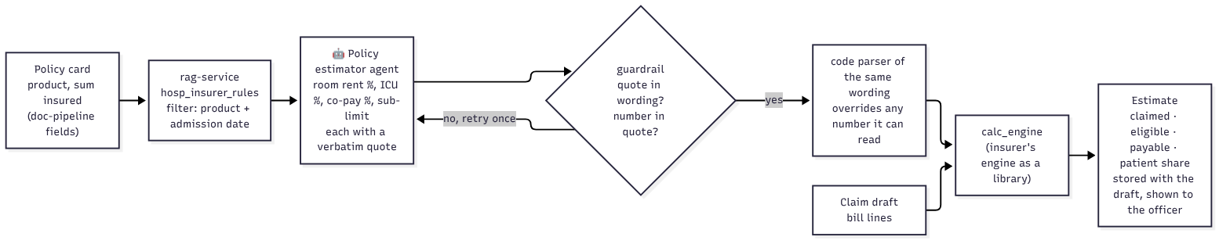
Figure 6: Policy estimate pipeline: policy card, wording, agent with guardrail, code parser, calculation engine

8.1 Method
- Read the product and sum insured from the policy card (doc-pipeline fields product_name, sum_insured).
- Retrieve the product's wording from the hospital's knowledge base, filtered by product and the admission date, so the version in force is used.
- The policy-estimator agent reports room rent %, ICU %, co-pay % and the procedure sub-limit, each with a verbatim quote; the guardrail rejects quotes that are not in the wording or do not contain the number.
- A code parser reads the same wording; where it can read a term, its number wins (term_overridden_by_code).
- The insurer's calculation engine, used as a library, applies non-payable exclusions, room caps, sub-limits and co-pay to the bill lines.

8.2 Worked example
Item | Amount (₹) | Rule
Claimed (room 4 days × 2,500; appendectomy 45,000; attendant charge 800) | 55,800
Attendant service charge | − 800 | Non-medical, excluded
Room rent 2,500 / day | 0 | Below cap: 1.0% × 3,00,000 = 3,000 / day
Eligible | 55,000
Co-payment 10% | − 5,500 | "A co-payment of 10% applies"
Estimated payable | 49,500 | Patient pays 6,300

The estimate is advice, never a gate. Waiting periods and exclusions need the insurer's member history, so the estimate assumes they pass and says so; if the card, the knowledge base or the terms are missing, it records "unavailable" with the reason and the claim continues.

9. Workflow automation with n8n
n8n runs the business processes: triggers, webhooks, retries, waits, reminders, SLAs and escalations. The workflows are thin by design: they call the APIs, which hold the rules. They are generated from code (build_flows.py), linted, versioned in Git, and imported automatically when the container starts.
Table 3: Hospital workflows (13)
Workflow | Purpose
hosp-intake-document | Per upload: verify webhook secret, idempotency, duplicate check, virus-scan result, vision quality, doc-pipeline parse (two passes), classification, mark needs-review or failed
hosp-completeness-loop | Recompute the checklist and request missing documents
hosp-claim-build | Start the CrewAI claim-build job; a cron returns stuck builds
hosp-submission-watch | Follow the submission outbox and acknowledgements
hosp-query-intake / query-draft / query-sla | Receive insurer queries, ask the crew for triage and a draft, enforce the reply SLA
hosp-reminders, hosp-sweeper, hosp-error | In-app reminders, cleanup of stale work, central error handling
hosp-u1-auth, u2-idem, u3-poll | Reusable sub-workflows: service token, idempotency, polling

Table 4: Insurer workflows (19)
Workflow | Purpose
00-04 common | Error handler, token, API caller, crew caller, event emitter
10 verification main | Run the steps in order and finalise the run
11-16 steps | Document fetch, completeness, identity, authenticity, coverage, calculation
20-21 decision | Decision gate (notify approvers) and final decision
30-31 queries | Query sent and query response handling
40, 50, 60 | Escalation, settlement, SLA and housekeeping cron

9.1 Screenshots of the real workflows
The following screenshots are the project's actual workflows in the n8n editor (n8n 2.41.6), laid out with n8n's tidy-up. The red triangles mark nodes whose credentials are configured at runtime by the container.
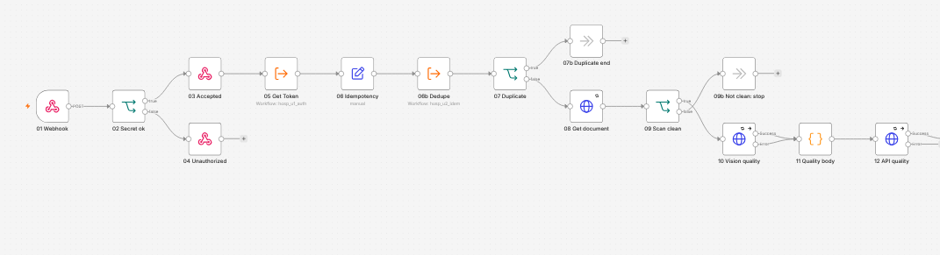
Figure 7: Hospital intake workflow (part 1): webhook, secret check, idempotency, duplicate and virus-scan gates, vision quality
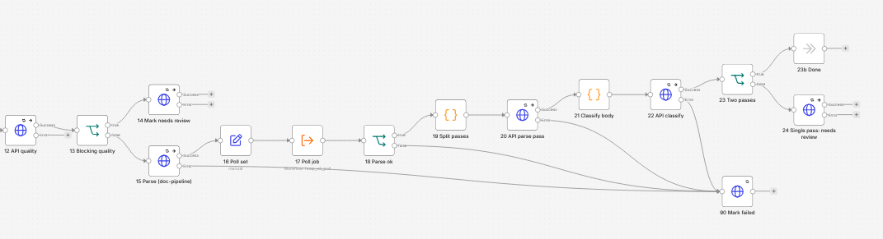
Figure 8: Hospital intake workflow (part 2): doc-pipeline parse, two-pass split, classification, needs-review and failure paths
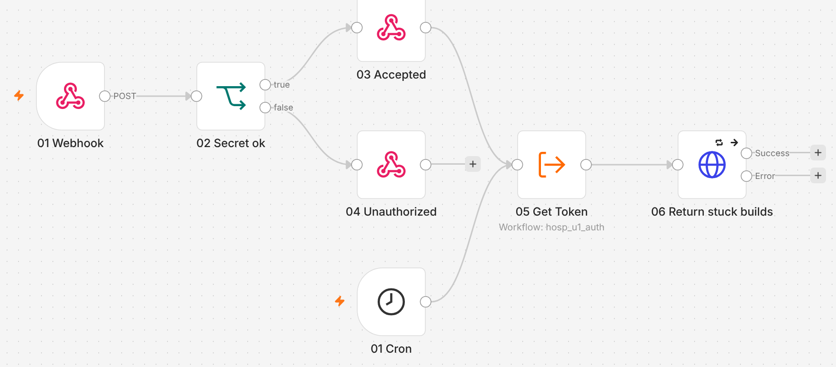
Figure 9: Hospital claim-build workflow: authenticated trigger, token, and the cron that returns stuck builds
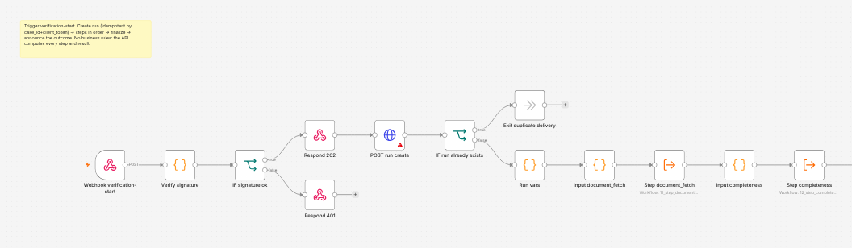
Figure 10: Insurer verification main (part 1): signed webhook, run creation, duplicate-delivery guard
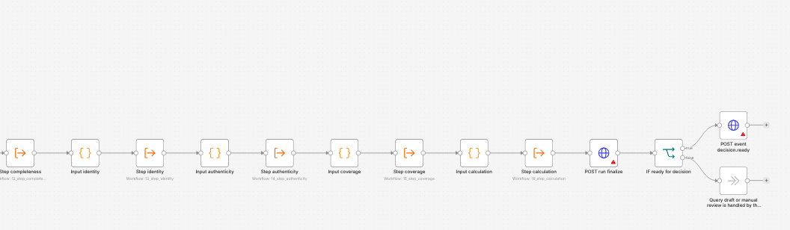
Figure 11: Insurer verification main (part 2): each verification step as a sub-workflow, finalise, decision-ready event
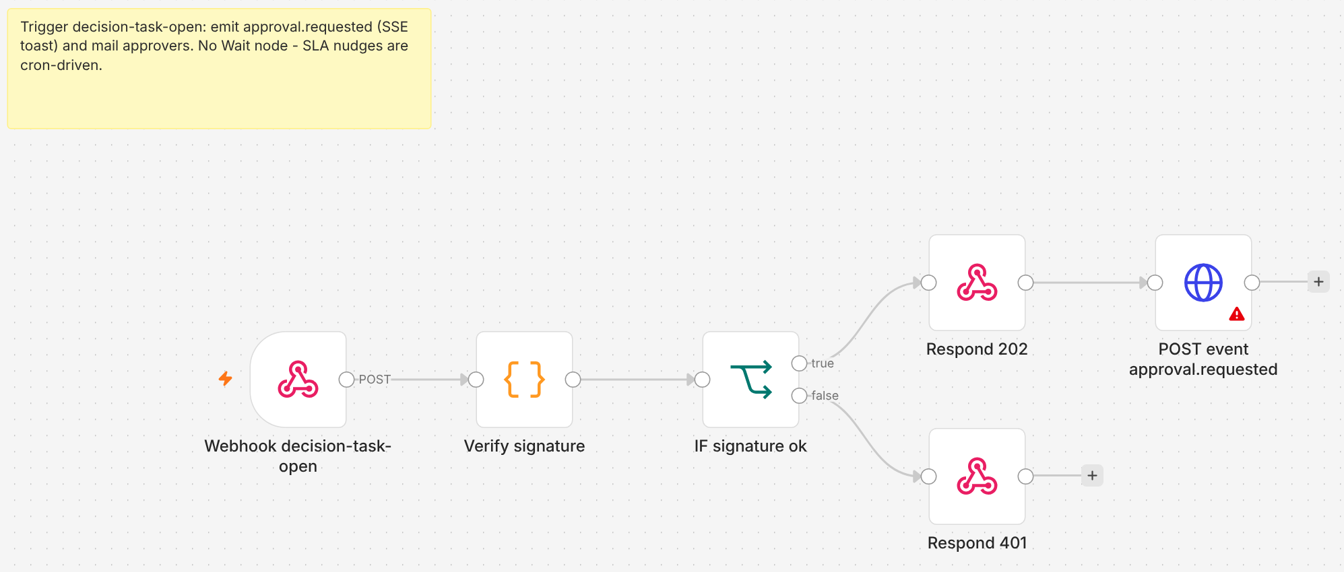
Figure 12: Insurer decision gate: signature check and approval request
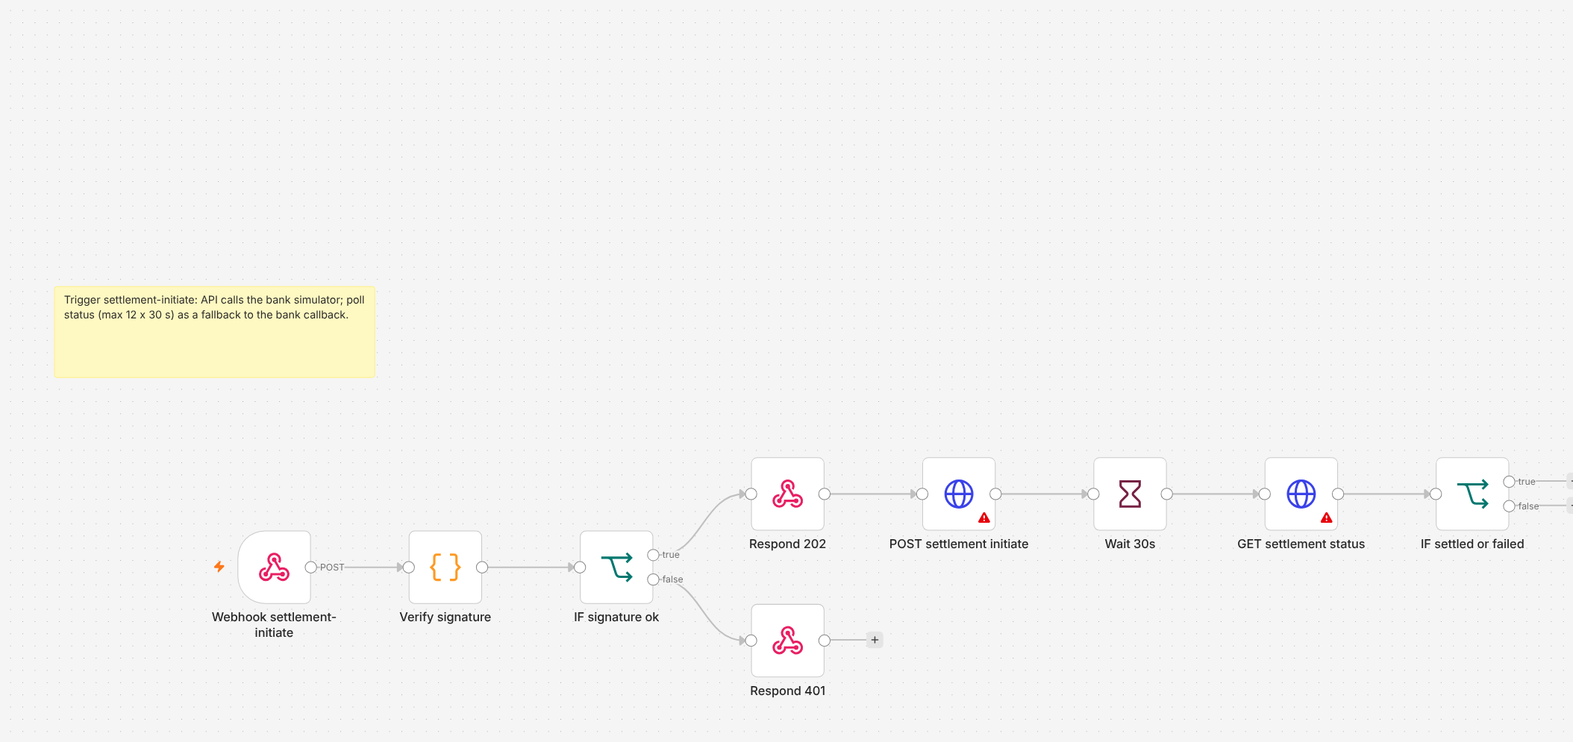
Figure 13: Insurer settlement workflow

10. Document intelligence and knowledge retrieval

10.1 doc-pipeline
Stage | What happens
Render | Text layer with pdftotext; pages without text are rendered with pdftoppm and read with Tesseract OCR
Classify | Weighted keyword rules per document type (final bill, pharmacy bill, discharge summary, policy card, ...)
Mask | Presidio (with spaCy) finds names, phone numbers, Aadhaar, PAN and e-mail; text is masked before any cloud-capable model
Extract | Typed fields per document type with quotes; two independent passes must agree; a value without supporting text is dropped
Validate | Amounts, dates and critical fields; low parse confidence marks the document for review

10.2 vision-service
Measures page quality (blur, skew, contrast) and detects hospital stamps with a learned detector (a random forest on candidate regions, trained on synthetic stamps; held-out precision/recall 0.99/0.97 against 0.74/0.56 for the classical baseline). Bills must carry a stamp.

10.3 rag-service
A retrieval service built for this project: documents are chunked by section, embedded with nomic-embed-text and stored in Qdrant; queries combine dense (vector) and sparse (keyword) search with reranking, filter by product, version and effective date (as_of), and return quotable chunks with citation ids. Collections are separated by owner: ins_policy_wording, ins_medical_guidelines, ins_case_history for the insurer, and hosp_insurer_rules, hosp_case_context for the hospital; tokens are scoped so neither side reads the other's collections.

11. Calculation engine and validation rules
The calculation engine is pure Python with Decimal arithmetic and no model calls. It takes the policy snapshot, member, admission facts, mapped bill lines and a versioned rule set, and returns per-line results, deductions with reasons, flags and a full trace.
Table 5: Calculation steps
Step | Rule
S0 prechecks | Policy in force, premium paid (with grace days)
S1 waiting periods | Initial, pre-existing disease and procedure-specific waiting periods
S2 exclusions | Excluded ICD prefixes and tags; non-medical items
S3 sub-limits | Per-procedure limits by sum insured
S4 room rent | Daily room / ICU cap as % of sum insured; proportional deduction on linked professional charges
S5 caps | Line caps (e.g. ambulance), pre/post-hospitalisation windows
S6 eligible | Eligible total after the above
S7-S8 deductible, co-pay | Per-claim deductible; co-pay (age or network conditions)
S10 sum insured | Remaining sum insured caps the payable
S11-S12 | Allocation back to lines; invariants (no negative amounts, totals reconcile)

Table 6: Hospital claim validation rules
Rule | Check
V01, V02 | Line items add up to gross; gross − discounts = claimed
V03 | Quantity × unit price = line amount
V04 | Each line cites a document and page in this case
V05 | Admission and discharge dates match the case; lines dated within the stay
V06 | Patient name and date of birth match the record
V07 | At least one ICD-10 diagnosis code
V08 | Bill document totals match the claim lines
V09 | Possible duplicate lines
V10 | Claimed amount over the pre-authorised amount
V11 | Room rent above the configured daily maximum (warning)
V12 | Every referenced document belongs to the case and passed the virus scan

12. Data, privacy, security and audit

12.1 Synthetic data
A generator creates members, policies, hospitals and claim cases with realistic bills and documents (ReportLab PDFs, then degraded: blur, skew, noise, stamps, handwriting-like marks), together with the ground truth for every field. Archetypes cover clean claims, missing documents, total mismatches, room-rent overruns, sub-limits, exhausted sum insured and identity mismatches.

12.2 Privacy (DPDP-minded)
- Identity documents are never sent to a model; text is masked with Presidio before any model that could leave the machine.
- A regex PII guard (Aadhaar, PAN, phone, e-mail) runs on the final prompt before every model call; a hit fails the job with its own error code.
- All models run locally through Ollama; CrewAI telemetry is opted out; no provider API keys exist in the system (a CI job checks for leaked keys).
- Sensitive columns are encrypted at the application level; documents are stored with server-side encryption.

12.3 Security
- Keycloak with two realms (hospital, insurer) and role-based access in both APIs.
- HMAC-signed requests with idempotency keys between the systems; signed callbacks.
- ClamAV virus scan on every upload; size and type checks.
- Prompt-injection defence: document text is wrapped as untrusted data, instruction-like text is neutralised, and a 20-document injection corpus is part of the tests.

12.4 Audit
Both sides write an append-only audit trail in which each event carries the hash of the previous one. Any change to a past event breaks the chain. Every end-to-end run verifies both chains as its last step.

13. One-command deployment
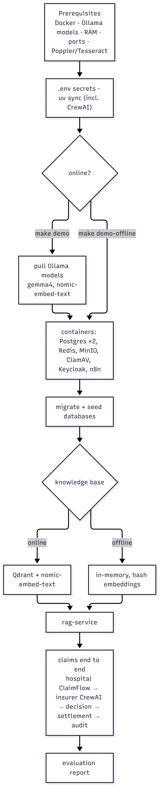
Figure 14: What `make demo` does, online and offline
Command | What it does | Time
make demo-check | Checks Docker, Ollama and models, RAM, free ports, Poppler and Tesseract | seconds
make demo-offline | Whole pipeline with no model; in-memory knowledge base | 2-3 min
make demo | Whole pipeline on gemma4 with Qdrant and nomic-embed-text | about 3 min per claim on an M-series Mac
make demo-down | Stops background services and containers; data kept | seconds

Every step is idempotent and logs to .e2e-logs/demo/<step>.log; a failure is repeated after the summary with the last log lines. The prerequisites check names any program holding a needed port and gives the install command for missing tools.

14. Testing and evaluation

14.1 Automated tests
Area | What is tested
Contract | Models, state machines, HMAC, idempotency, audit chain
hospital-api | Auth and roles, cases, documents, completeness, router, claim builder, submission, queries, SSE (467 tests with the contract)
Crews | Hospital crew 58 tests, insurer crew 210 tests: agents, guardrails, flows, PII, injection corpus, timeouts, idempotency
calc-engine | Unit and property tests against hand-checked cases
doc-pipeline, vision, RAG, simulators, synthetic data | Stage tests, detector evaluation, retrieval metrics, generator invariants
insurer-api | Receipt, decision flow, gate, queries, golden end-to-end, security suite
UIs | Type check, lint, build; Playwright browser tests

14.2 End-to-end scenarios
Scenario | What it proves
auto | A clean claim is approved without a person, paid and audited
reviewer | A claim above ₹50,000 waits for one approver
dual | A claim above ₹5,00,000 needs two approvers
reject | A reviewer rejects with a reason code; nothing is paid
queries | Two answered query rounds; an unanswered third escalates to a senior
callbacks | Duplicate and out-of-order callbacks do not change a settled claim
bank_retry | The bank fails the first payout; the insurer retries; the hospital ends settled

14.3 Evaluation
Table 7: Evaluation on 300 synthetic cases (seed 42)
Suite | Metric | Value | Target | Pass
calc | Agreement with independent reference calculator | 1.00 | 0.995 | Yes
gate | Decision route correctness | 1.00 | 1.00 | Yes
gate | Wrongful automatic approvals | 0.00 | 0.00 | Yes
mapper | Bill-line mapping accuracy | 1.00 | 0.97 | Yes
identity | Match recall / mismatch recall | 1.00 / 1.00 | 0.98 / 0.95 | Yes
rag | Recall@5 · MRR · nDCG@5 | 0.93 · 0.80 · 0.83 | 0.85 · 0.60 · 0.70 | Yes
rag | Citation precision | 0.61 | 0.90 | No
rag | Insufficient-evidence · temporal-trap · numeric faithfulness | 1.00 · 1.00 · 1.00 | 0.90 · 0.95 · 1.00 | Yes

15. Results

15.1 Real-model run
make demo on a MacBook Air (Apple Silicon, Docker Desktop) with gemma4 and nomic-embed-text: every step passed; the claim run (hospital ClaimFlow → submission → insurer CrewAI verification → automatic approval → settlement → audit) took 166 seconds.
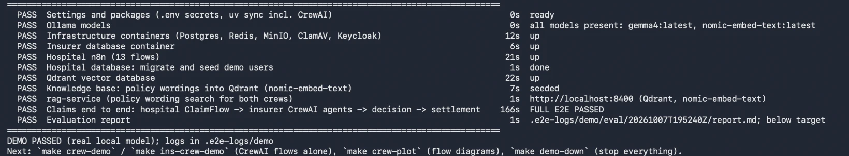
Figure 15: Summary of the real-model run on a MacBook Air (terminal output)
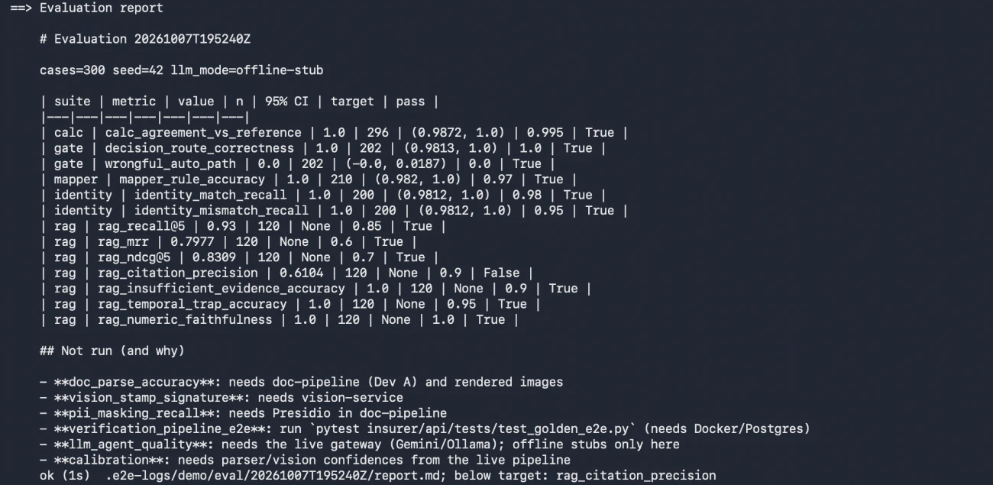
Figure 16: Evaluation report as printed by the same run

15.2 Offline run
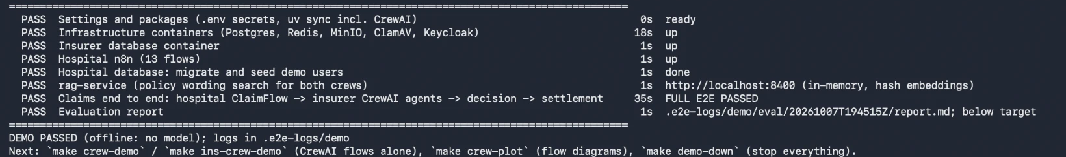
Figure 17: Summary of the offline run on the same machine (claim run 35 s)

15.3 Observations
- The estimate surfaces real disagreements. For early-2026 stays the HEALTH-PLUS-GOLD wording in force (version 1) says 20% co-pay, while the insurer's rule set for that product says 0%: estimates read lower than the insurer pays. In practice this is exactly the kind of policy-configuration error a hospital wants to catch.
- Deterministic overrides matter. In offline runs the stand-in model reports no identity issue, yet the code's identity facts flag the mismatch and the claim goes to a person.
- Portability. Running on a Mac exposed issues that Linux hid (a removed MinIO image, an amd64-only ClamAV image, Docker Desktop host networking, missing PDF tools); all are fixed or checked by make demo-check.

16. Limitations
- Citation precision 0.61 against 0.90, measured with offline stub embeddings; real embeddings may change it, and chunking and reranking need work.
- Success metrics not yet measured: manual baseline time, time to submit, queries per claim, manual steps saved, estimate accuracy against the insurer's amount.
- Orchestration: insurer-api still sequences verification (inline or via n8n) and calls each CrewAI agent per step; the CrewAI VerificationFlow is used by the demo, checks and evaluation.
- Speed on CPU: a real-model reply draft can take minutes on a laptop.
- Synthetic data only: stamp-detector and OCR numbers are measured on synthetic scans; real scans are untested.
- Hospital Document and Validation crews are still code services rather than CrewAI crews.

17. Future recommendations and roadmap

17.1 Short term (next 4-6 weeks)
- Add the missing success metrics: a timed manual baseline, time to submit, queries per claim, manual steps saved, and estimate vs final payable.
- Raise citation precision: section-aware chunking, stricter quote selection and a cross-encoder reranker; re-measure with real embeddings.
- Align the synthetic policy data (wording versions vs insurer rule sets) and add a consistency check.
- Let insurer-api run verification through the CrewAI VerificationFlow (INS_ORCHESTRATOR=crew), keeping the gate in code.

17.2 Medium term (3-6 months)
- Move document intake and validation into CrewAI crews with the existing rules as guardrails.
- Pre-authorisation flow and enhancement requests, using the same agents.
- GPU or hosted inference for speed, with masking kept in front of any non-local model.
- Pilot on de-identified real scans to calibrate OCR, classification and the stamp detector.

17.3 Long term
- Integrate with India's National Health Claims Exchange (NHCX) and ABDM health records instead of the simulators.
- Cross-claim fraud and anomaly analytics on the insurer side, with explainable signals.
- Multi-hospital, multi-insurer deployment with tenant isolation, monitoring dashboards and SLA reporting.
- Formal DPDP compliance review: consent records, retention schedules and data-principal requests.

18. Conclusion
The project shows that a claim can travel from raw scanned documents to settlement with AI agents doing the reading and writing, deterministic code doing the deciding, and people approving what matters. CrewAI gives the agents clear roles, guardrails and flows; n8n gives the processes visibility and control; the calculation engine and validation rules give exact, explainable money; and local models keep patient data on the machine. The system runs with one command, passes its scenarios and evaluation, and has a concrete roadmap for the remaining gaps.

References
All links accessed October 2026.
CrewAI documentation (Agents, Tasks, Crews, Flows, guardrails) https://docs.crewai.com
n8n documentation https://docs.n8n.io
Ollama https://ollama.com
Gemma models (Google) https://ai.google.dev/gemma
nomic-embed-text on Ollama https://ollama.com/library/nomic-embed-text
Qdrant documentation https://qdrant.tech/documentation/
FastAPI https://fastapi.tiangolo.com
Pydantic https://docs.pydantic.dev
SQLAlchemy https://docs.sqlalchemy.org
PostgreSQL 16 https://www.postgresql.org/docs/16/
Microsoft Presidio (PII detection and anonymisation) https://microsoft.github.io/presidio/
Tesseract OCR https://github.com/tesseract-ocr/tesseract
Poppler PDF utilities https://poppler.freedesktop.org
MinIO object storage (source) https://github.com/minio/minio
Keycloak https://www.keycloak.org/documentation
ClamAV https://docs.clamav.net
Redis https://redis.io/docs/
Next.js https://nextjs.org/docs
Docker Compose https://docs.docker.com/compose/
uv (Python packaging) https://docs.astral.sh/uv/
Langfuse (LLM tracing) https://langfuse.com/docs
Insurance Regulatory and Development Authority of India (IRDAI) https://irdai.gov.in
Digital Personal Data Protection Act, 2023 (MeitY) https://www.meity.gov.in/data-protection-framework
Ayushman Bharat Digital Mission (ABDM) and NHCX https://abdm.gov.in
WHO ICD-10 classification https://icd.who.int/browse10

Appendix A. Glossary
Term | Meaning
Cashless claim | Hospital is paid directly by the insurer for covered costs
Reimbursement claim | Member pays the hospital and is repaid by the insurer
TPA | Third-Party Administrator that processes claims for insurers
Sum insured (SI) | Maximum the insurer pays in a policy year
Room-rent cap | Daily limit on room charges, usually % of SI; overruns trigger proportional deductions
Sub-limit | Maximum payable for a specific procedure
Co-payment | Share of each admissible claim the member pays
Admissible amount | What the insurer is expected to pay after all policy rules
T_auto, T_four | Approval thresholds: ₹50,000 (auto) and ₹5,00,000 (two approvers)
Guardrail | A check on an agent's output; failures are sent back to the agent
RAG | Retrieval-augmented generation: answers grounded in retrieved documents
HMAC | Keyed hash that signs messages so they cannot be forged or altered
DPDP | Digital Personal Data Protection Act, 2023 (India)

Appendix B. Repository structure
contract/ shared API contract: models, enums, state machines, HMAC, idempotency, audit chain
hospital/api/ hospital-api (FastAPI, Alembic migrations 0001-0023)
hospital/crew/ CrewAI ClaimFlow, QueryFlow, policy estimate (config/agents.yaml, flows.py, team.py)
hospital/n8n/ 13 generated workflows
hospital/ui/ Next.js desk / officer / admin
insurer/api/ insurer-api (receipt, verification engine, gate, queries, settlement)
insurer/crew/ 7 CrewAI agents, VerificationFlow, QueryFlow (crewai_team.py, flows.py)
insurer/calc_engine/ deterministic payout calculator
insurer/n8n/ 19 generated workflows
insurer/ui/ Next.js reviewer / approver / admin
services/ doc-pipeline, vision-service, rag-service, tpa-sim
data/ synthetic generator and evaluation harness
eval/ insurer-side evaluation (run_eval.py)
infra/ Docker Compose, Keycloak, MinIO, Redis, ClamAV, Postgres init
scripts/ demo.py (make demo), end-to-end runs, checks
docs/ plan, decisions, runbook, diagrams, images

Appendix C. Command reference
Command | Purpose
make demo / make demo-offline | Whole system end to end, with or without the model
make demo-check / make demo-down | Prerequisites only / stop everything
make init | Create .env with generated secrets; install all Python packages
make up-infra | Start Postgres (hospital), Redis, MinIO, ClamAV, Keycloak; create buckets
make up-insurer, make up-n8n, make up-insurer-n8n, make up-rag | Insurer database; hospital n8n; insurer n8n; Qdrant
make migrate, make seed, make migrate-insurer, make seed-insurer | Database schemas and demo data
make seed-kb, make run-rag | Load policy wordings into Qdrant; run rag-service
make crew-demo, make ins-crew-demo, make crew-plot | CrewAI flows alone; flow diagrams
make check-crew | Insurer agents on the real model against known answers
make e2e-hospital, make e2e-full | Scripted end-to-end runs
make test, make test-insurer | Test suites
make diagrams | Render the Mermaid diagrams to PNG and SVG

Appendix D. Agent service endpoints
Service | Endpoint | Purpose
hospital crew | POST /v1/jobs/claim-build, claim-repair | Run ClaimFlow
hospital crew | POST /v1/jobs/query-triage, query-draft | Run QueryFlow
hospital crew | GET /v1/jobs/{id}, GET /v1/agents, GET /v1/health | Job state, agent list, health
insurer crew | POST /v1/identity/analyze, /v1/authenticity/analyze, /v1/coverage/analyze | Single agents
insurer crew | POST /v1/calc/map-lines, /v1/supervisor/summarize, /v1/query/draft, /v1/query/triage | Single agents
insurer crew | POST /v1/flows/verification, /v1/flows/query | CrewAI Flows

Appendix E. More n8n workflow screenshots
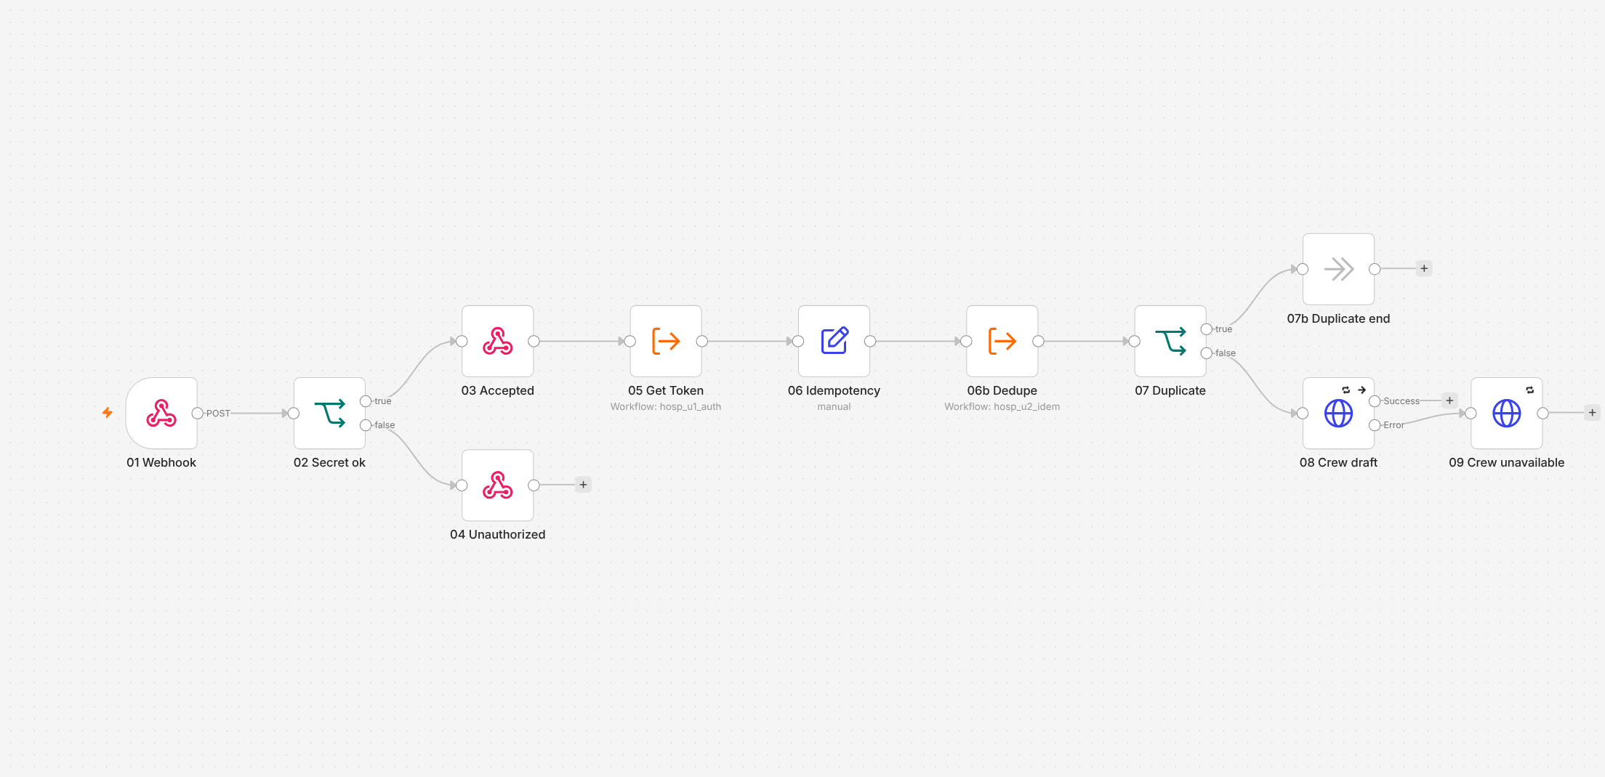
Figure 18: Hospital query-draft workflow
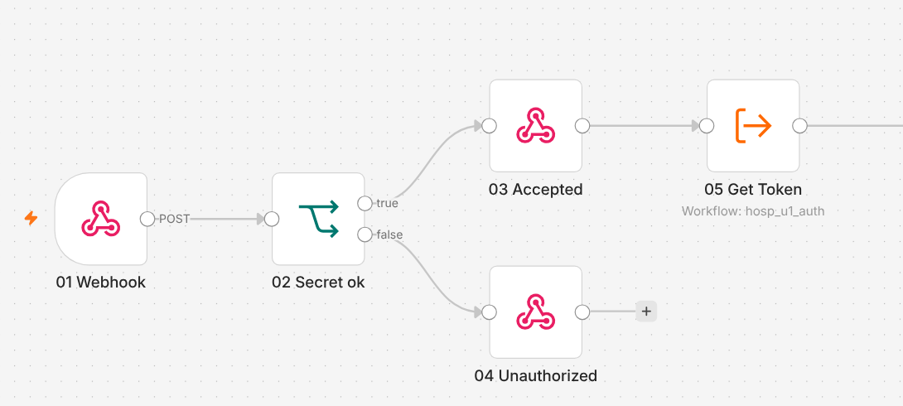
Figure 19: Hospital completeness loop (part 1)
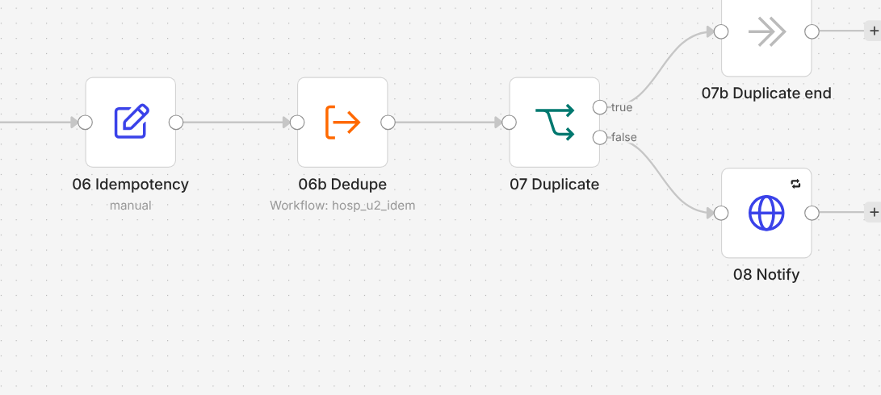
Figure 20: Hospital completeness loop (part 2)
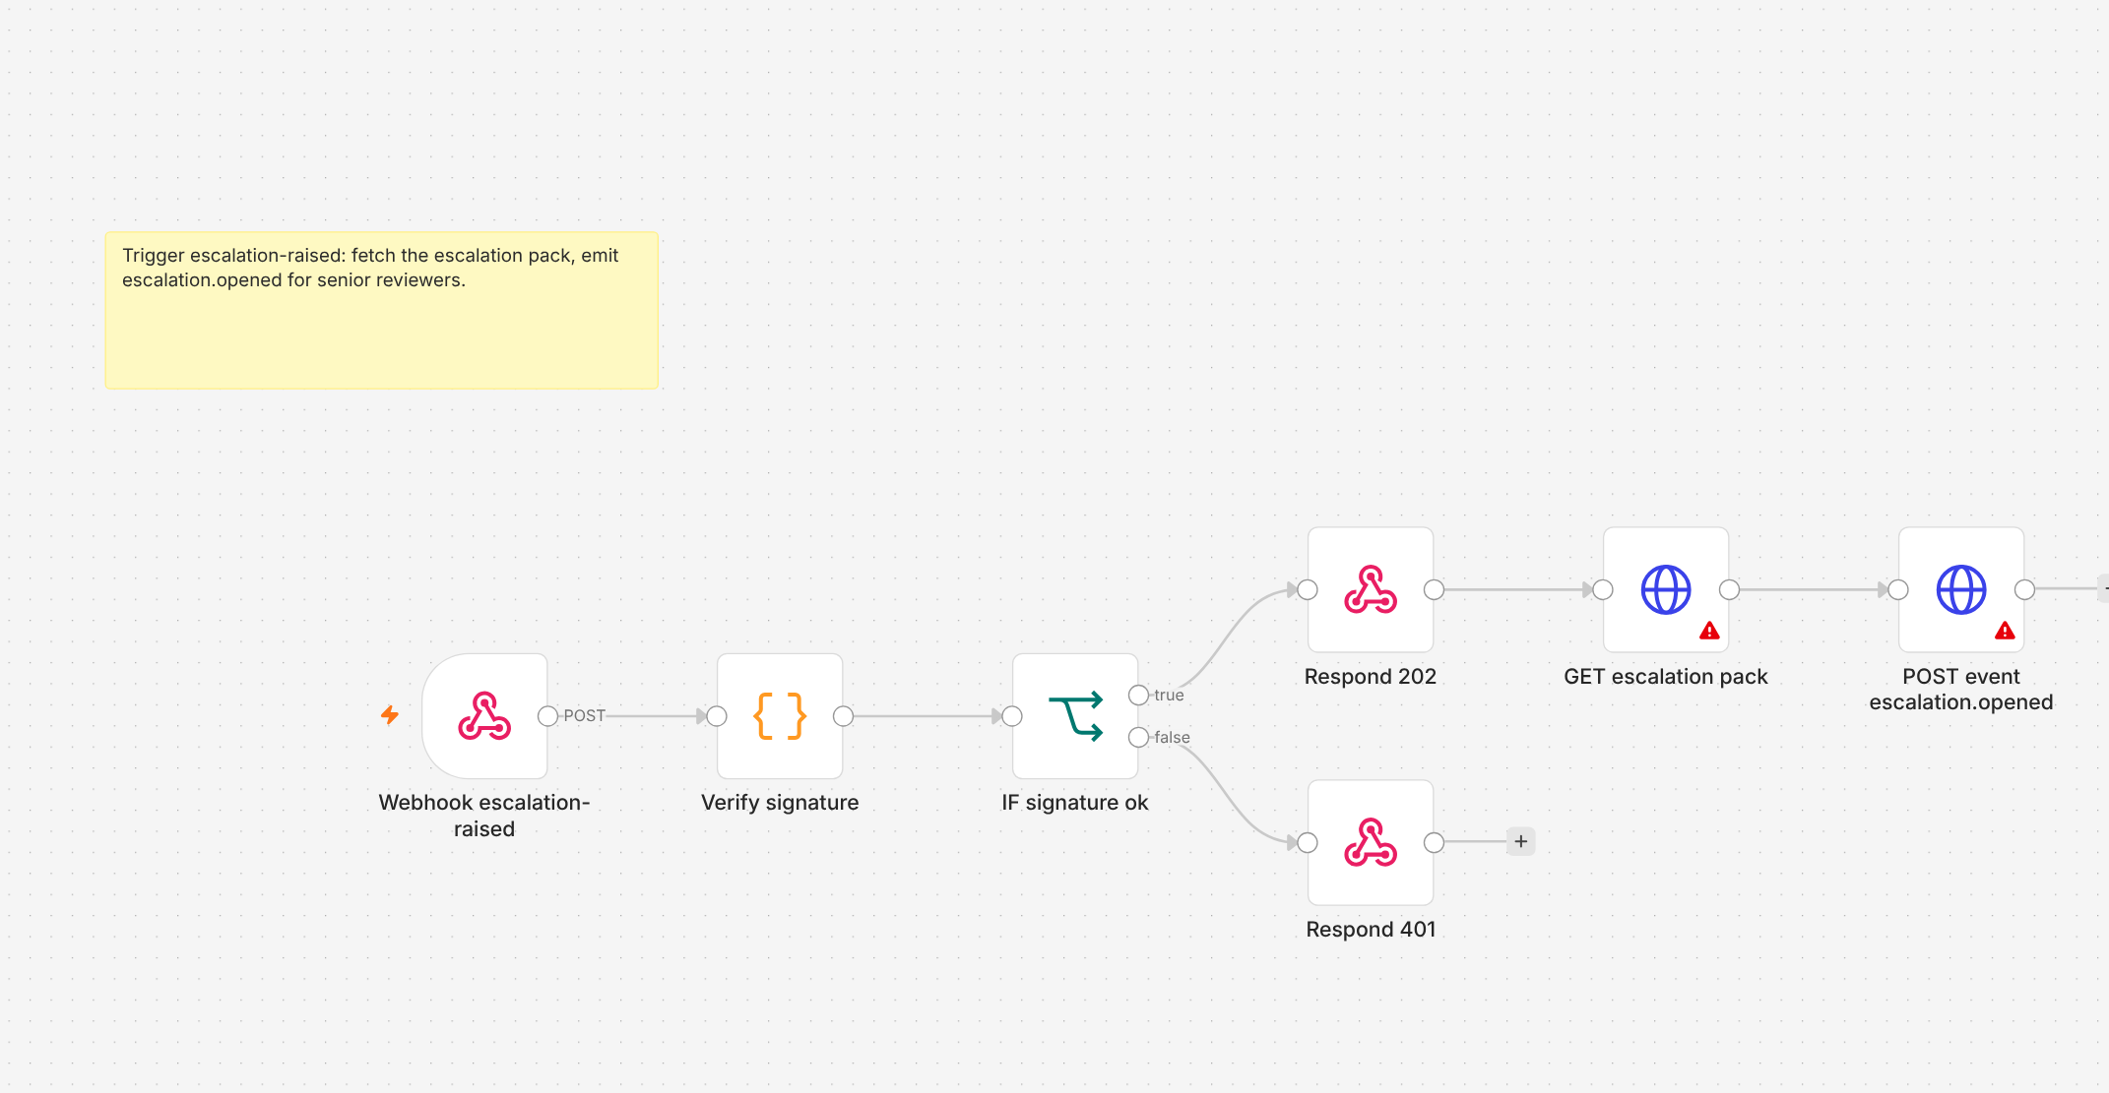
Figure 21: Insurer escalation workflow
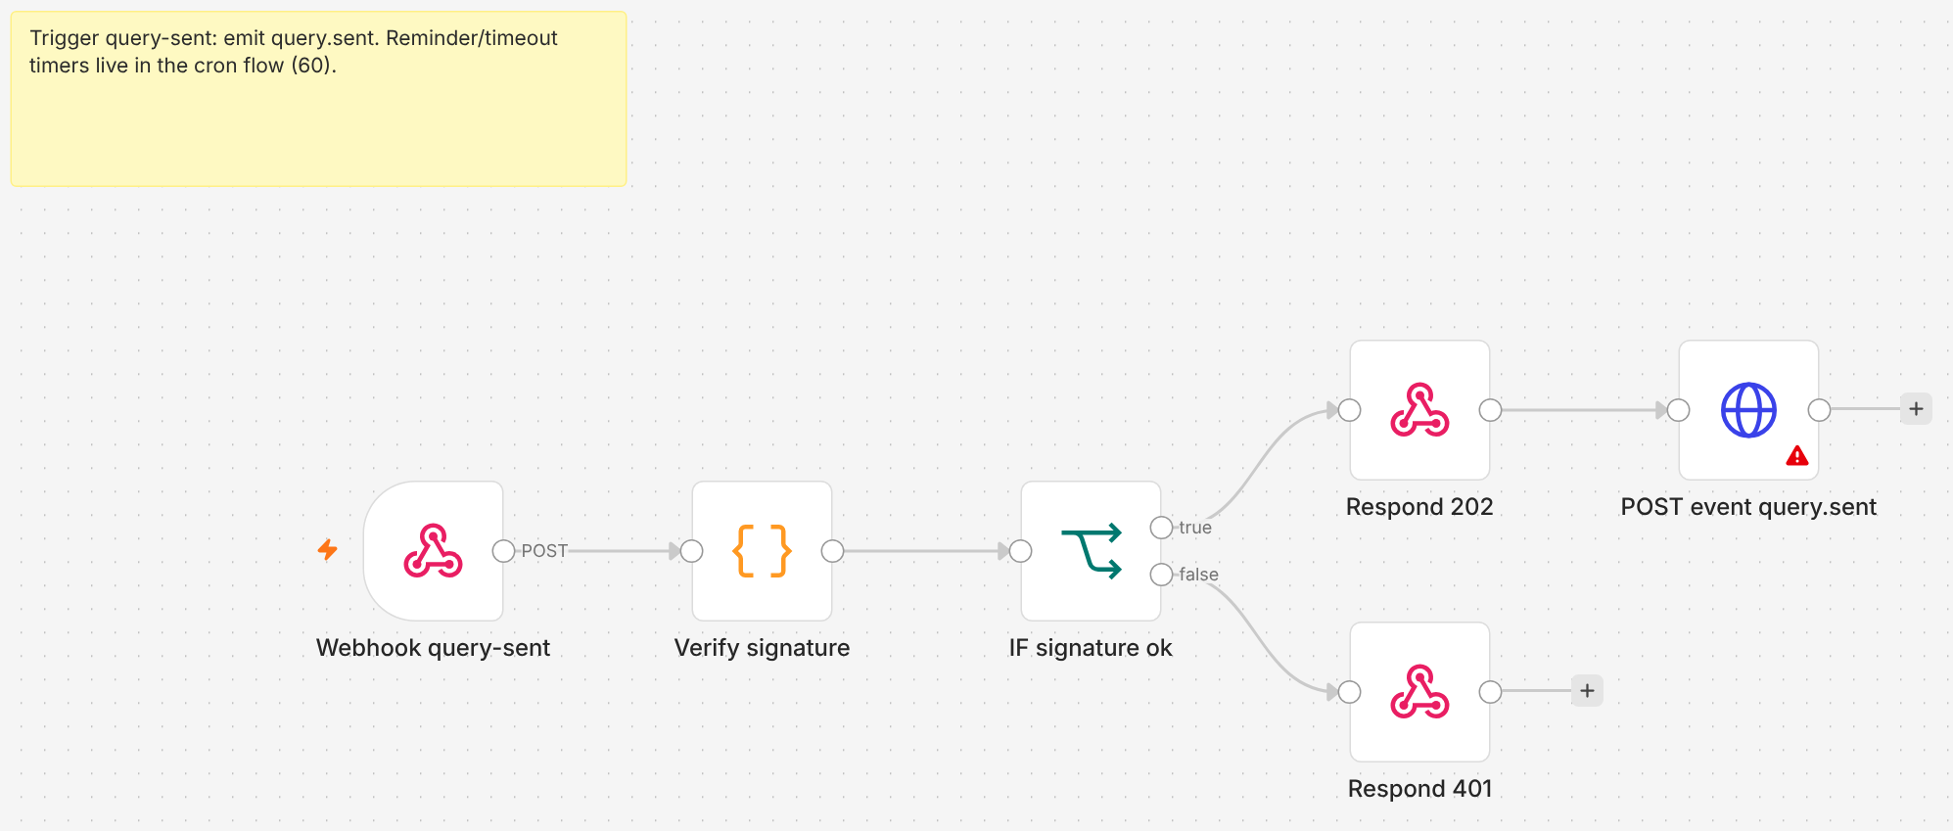
Figure 22: Insurer query-sent workflow

Appendix F. Design decisions log (summary)
Decision | Reason
CrewAI for all agents, behind the existing HTTP endpoints | Course requirement; no change for APIs, n8n and UIs
Agents without tools; deterministic tools in flow steps and guardrails | Small local models are unreliable at multi-step tool use
Ollama only, no provider keys | Privacy and cost; DPDP-minded
Calculation engine as code, reused by the hospital | Exact, testable money on both sides
Qdrant instead of Pinecone, Langfuse instead of LangSmith | Local and free; patient data stays on the machine
MinIO built from source | The public image was removed from Docker Hub
Multi-arch ClamAV image | Native on Apple Silicon

