Phase 6, 7, 8 and 9 — Explained in Simple Words
This file explains what was built in Phases 6–8, why, what results we measured in the real simulator, and how to run everything yourself. It is the companion of Phase2_3_Explained.pdf (Phases 0–5 concepts are not repeated here). Read it top to bottom once before the evaluation.

1. Where we are in the story
Phases 2–3 built the world and taught the robot to drive in a straight line and follow a known circle. Phase 6 is where all the pieces finally work together as one mission:
The robot looks for the blue package P3 with its camera, plans a route with A*, drives there, picks it (a placeholder for now), plans a second route to Zone B, delivers, and prints a mission report. It decides all of this by itself — nothing is scripted.
Phase 7 collects the proof (numbers, plots, screenshots), Phase 8 makes sure the presentation tells exactly that story, and Phase 9 is the to-do list for the final evaluation (we deliberately did not build it yet — see the last section).

2. Phase 6 — Planning ↔ control integration & the FSM

2.1 The state machine (FSM) in plain words
The robot's brain runs a finite state machine — a fixed list of states with rules for moving between them. You can explain it with a flow chart:
State | What the robot does | When it leaves
IDLE | Loads the task ("pick P3 → Zone B") | immediately
FIND_PACKAGE | Rotates in place; the camera looks for a big blue blob | 5 detections in a row → NAVIGATE; 2 full turns with nothing → ERROR
NAVIGATE | Chooses a stand-off point 0.45 m from the package (on the robot's side), plans A*, drives there | reached → PICK
PICK | Stops 1 s, logs the distance. Placeholder — the real grab comes in the final eval | after the pause → PLAN_DELIVERY
PLAN_DELIVERY | Plans A* from here to the centre of Zone B | path found → DELIVER; none → ERROR
DELIVER | Follows the waypoints to the zone | inside 0.15 m → DONE
DONE | Stops, prints the mission report | terminal
ERROR | Stops, prints the reason | terminal

Every transition is printed to the console, e.g. [FSM] [t=25.3s] STATE: PICK -> PLAN_DELIVERY. The same lines go into the run log, so a grader can replay the whole mission from logs/run.csv.
Why a state machine? Because "find the package" needs different behaviour than "drive precisely". The FSM is also trivial to test without the simulator: the pytest suite drives it through the whole mission with a fake planner and a pretend robot body.

2.2 What "planning glue" means (6.1)
plan_to(start, goal) is the one function everything uses. It does four steps: snap the points onto the grid → run A* on the inflated map → shorten the path with line-of-sight checks → resample it every 0.3 m. The console prints one line per plan:
[FSM] A* path: 21 waypoints, 5.54 m, 11.6 ms, 1675 expansions
That single line is the answer to "is A* working?" — it shows the path length, the computation time (milliseconds) and how many grid cells the search explored.

2.3 The in-sim dashboard and the status LED (6.10, 6.11)
The robot carries a small Display like a screen on top. At 2 Hz it draws: the known map (grey = obstacle, orange = safety inflation), the current planned route (orange dots + lines), the robot (blue dot with a heading tick) and the current FSM state as text. There is also an LED whose colour mirrors the state (blue = searching, orange = picking, green = done, red = error). Both are pure extras — if they break, the mission still works.

2.4 Repeatability mode (6.8)
One run proves little. config.CAMPAIGN_STARTS stores 10 different start poses. Running
RUN_INDEX=3 webots worlds/warehouse.wbt
teleports the robot to start pose number 3 before the mission and logs to logs/run_3.csv. After 10 runs, python tools/analyze_logs.py writes docs/evidence/runs_summary.md with the success rate, mission time and final goal error per run.

3. Phase 7 — Evidence, metrics, documentation

3.1 The evidence chain
Every claim in the report must point at a file. The chain is:
run in Webots → logs/*.csv → tools/*.py → docs/evidence/* → slides
python tools/check_evidence.py prints an inventory of all expected artefacts with P0/P1 status (written to docs/evidence/inventory.md). At the time of writing exactly one P0 item is still open: the ≤60 s screen recording (run_full.mp4) — everything else exists.

3.2 The metrics that matter (measured 2026-10-07)
Metric | Value | Evidence file
Full mission | FIND → NAVIGATE → PICK → DELIVER → DONE in 69.2 s, 8.2 m driven, replans 0 | logs/run.csv, metrics.md
Package position estimate | (−2.99, −0.57) vs true (−3.10, −0.50) → 0.13 m error | console + position_estimate.md
Cross-track error while following | mean 0.4 cm, max 6.2 cm | metrics.md
LiDAR ray order | index increases clockwise (SIGN = −1, offset 0.02 rad) | lidar_validation.md
LiDAR range accuracy | median \ | measured − expected\
Final goal error | robot stopped (2.90, −0.83) vs Zone B (3.0, −0.9) → 0.12 m | run.csv last row
A* optimality | cost == Dijkstra on 60 random grids | pytest
Unit tests | 63/63 green | pytest

The LiDAR story is worth telling in the viva. The first mission runs estimated the package 0.6 m short of its true position. Diagnosis: we assumed LiDAR ray 0 points to the robot's right and indices go counter-clockwise. To check it we logged 1321 raw scans while the robot rotated one full turn (DRIVE_TEST_MODE=lidar), then compared every ray against the known map offline (tools/calibrate_lidar.py). The best-fitting convention is the mirror image of our assumption. After setting LIDAR_ANGLE_SIGN = -1 in config.py, the estimate error dropped from 0.6 m to 0.13 m. Lesson: never trust an axis convention you have not measured.
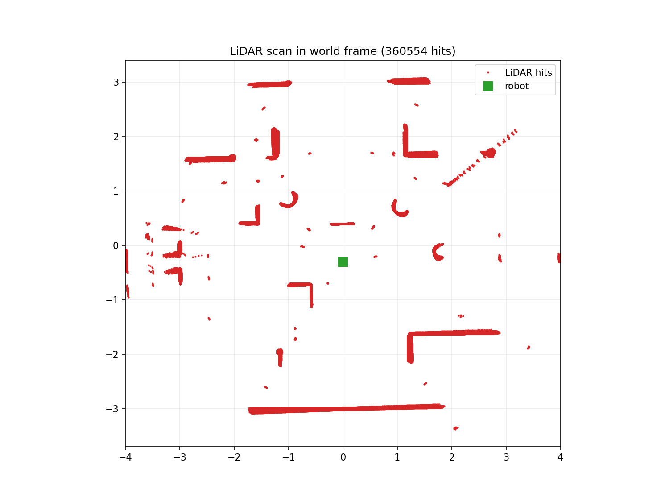

3.3 Planned vs actual (the money plot)
tools/plot_run.py re-plans the A* route from the logged run and overlays the actual trajectory, coloured by FSM state. The DELIVER leg hugs the planned line — that is PID heading control doing its job. The figure below is regenerated automatically by tools/analyze_logs.py after every run.
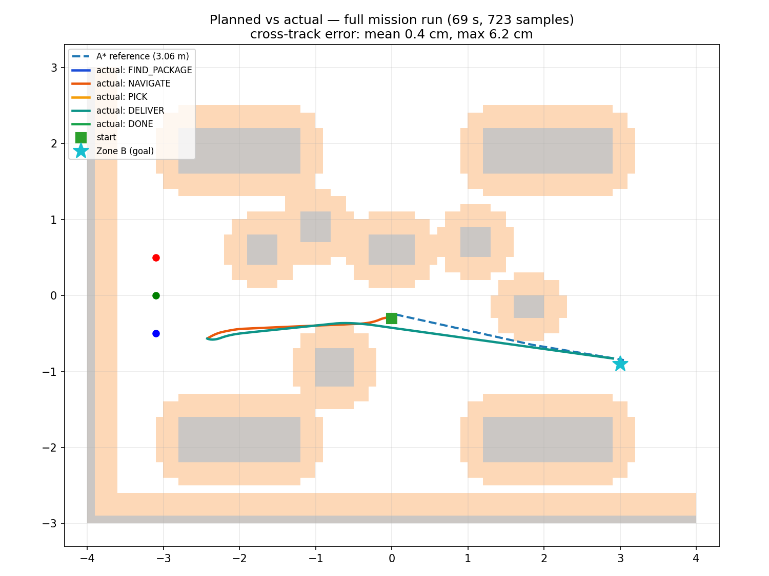

3.4 The documents (7.3–7.7)
File | What a grader finds there
docs/architecture.md | Block diagram + one plain-language paragraph per module + A/B/C ownership
README.md | Install, run, test, campaign and evidence commands
docs/qa_prep.md | 29 likely viva questions with short answers
docs/demo_script.md | 5-minute demo flow, recording steps, per-slide presenter table
docs/project_report.md | Report skeleton with the real numbers already filled in

4. Phase 8 — the deck and the rehearsal
The deck IntelliBot_MidTerm_Review.pptx (10 slides, built with tools/build_deck.js) was updated to match the measured reality:
- slide 8 now has a green column "Measured on the robot" (kinematics
error ≤ 1 %, odometry drift 2.2 cm/4.7°, the 69 s mission, detector 100 % on real frames) and an orange column "still to measure";
- the challenges listed are the ones we actually hit (see §5);
- docs/demo_script.md assigns every slide a primary presenter (A/B/C)
with a backup, plus the exact steps to record the fallback video (Webots: Tools → Movie → Record Movie).
Rehearsal rule: every number said aloud must exist in `docs/evidence/` — if you cannot point at the file, do not say the number.

5. Problems we hit and fixed (great viva stories)
- "The robot does not move at all." The Webots console said
The controller directory has not been found … Starting the <generic> controller instead. Cause: the controllers/intellibot_controller/ and controllers/drive_test/ folders were missing (deleted together with uncommitted work). Fix: restore from git. Lesson: the <name>/<name>.py folder next to worlds/ is the controller — without it Webots plugs in an empty generic brain.
- The robot picked the wrong "package". After adding a small
decorative ball, FIND_PACKAGE happily "found P3" next to it: the ball was painted saturated blue — exactly the package colour the HSV detector looks for. Fix: desaturate the ball to grey. Lesson: the environment and the detector share colour semantics; colours are an interface.
- Package estimate 0.6 m short — the mirrored LiDAR ray order, see
§3.2.
- The run log kept growing after DONE — simulationQuit did not
terminate batch runs reliably, so the controller now breaks its own loop 2 s after DONE/ERROR and writes one final CSV row with the terminal state.
- Sphere physics warning — Webots limits Sphere.subdivision to 5;
we had 12. Fix: subdivision 4 (plenty for a 15 cm ball).

6. How to run everything (cheat sheet)
# 0) tests first (no Webots needed)
python -m pytest tests/ -q # 63 passed
# 1) regenerate both worlds from config
python tools/generate_world.py # writes worlds/ + worlds_output/
# 2) the mission demo (GUI): press the play button
webots worlds/warehouse.wbt
# console shows [FSM] transitions, A* lines, MISSION REPORT
# 3) validation runs (CLI, fast)
DRIVE_TEST_MODE=worldcheck webots --batch --mode=fast --stdout --stderr --minimize worlds/warehouse_drive_test.wbt
DRIVE_TEST_MODE=lidar webots --batch --mode=fast --stdout --stderr --minimize worlds/warehouse_drive_test.wbt
python tools/calibrate_lidar.py # ray order + accuracy + lidar_scan.png
# 4) analysis + evidence
python tools/analyze_logs.py # metrics.md, odometry overlay, planned_vs_actual
python tools/check_evidence.py # what evidence exists / is missing
# 5) repeatability campaign (Phase 6.8)
RUN_INDEX=0 webots worlds/warehouse.wbt # ... up to RUN_INDEX=9
python tools/analyze_logs.py # -> runs_summary.md
The recording for the final P0 item: start the mission in the GUI, Tools → Movie → Record Movie, stop after MISSION REPORT, save as docs/evidence/run_full.mp4.

7. Phase 9 — what is deliberately left for the final evaluation
Item | The hook that already exists
Dynamic obstacle appears mid-route → robot re-plans | add_obstacle_world, path_is_blocked, follower BLOCKED status — all unit-tested
Real pickup (attach & carry) | supervisor access + Connector { autoLock } recipe in the samples audit
Collision counter | bumper sample (TouchSensor), mission report already prints the field
Detector robustness (lighting, distances) | capture mode + eval_detector.py pipeline ready
In-sim dashboard upgrade, second robot, Dijkstra/RRT comparison | display_supervisor / emitter_receiver samples audited

The rule we followed: build the hook now, build the feature later — every final-eval item plugs into something that is already tested.

